INDEX NUMBER : PS2765

REGISTRATION NUMBER : EU|IS|2019|PHY|15

NAME : A.Aruntha

COURSE CODE : CS4163

**ASSIGNMENT -01**

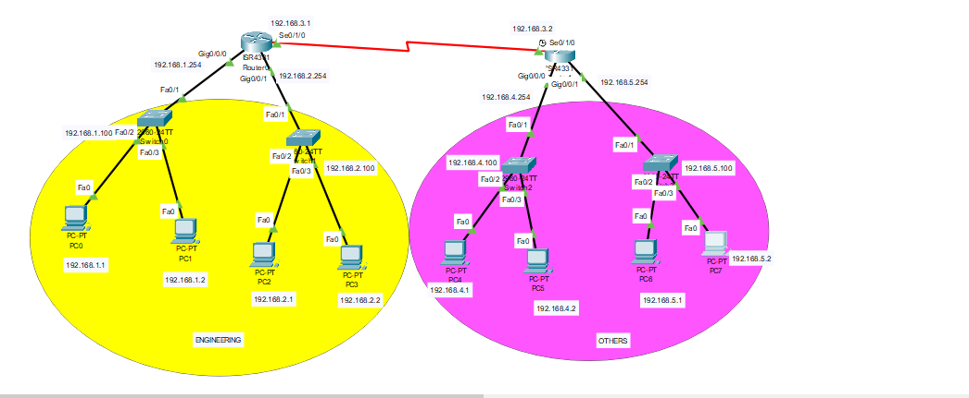

**Task 01**

* Ip addressing table for above diagram devices

**Layer 1**

|  |  |  |  |  |  |
| --- | --- | --- | --- | --- | --- |
| **Department** | **Device name** | **Port name** | **Ip address** | **subnet mask** | **Gateway** |
| Engineering | Pc 0 | Fa0 | 192.168.1.1 | 255.255.255.0 | 192.168.1.254 |
|  | Pc 1 | Fa0 | 192.168.1.2 | 255.255.255.0 | 192.168.1.254 |
|  | Pc 2 | Fa0 | 192.168.2.1 | 255.255.255.0 | 192.168.2.254 |
|  | Pc 3 | Fa0 | 192.168.2.2 | 255.255.255.0 | 192.168.2.254 |
|  |  |  |  |  |  |
| Others | Pc 4 | Fa0 | 192.168.4.1 | 255.255.255.0 | 192.168.4.254 |
|  | Pc 5 | Fa0 | 192.168.4.2 | 255.255.255.0 | 192.168.4.254 |
|  | Pc 6 | Fa0 | 192.168.5.1 | 255.255.255.0 | 192.168.5.254 |
|  | Pc 7 | Fa0 | 192.168.5.2 | 255.255.255.0 | 192.168.5.254 |

**Layer 2**

|  |  |  |  |  |  |
| --- | --- | --- | --- | --- | --- |
| **Department** | **Device name** | **Port name** | **Ip address** | **subnet mask** | **Gateway** |
| Engineering | S1 | Fa0/1,  Fa0/2,  Fa0/3 | 192.168.1.100 | 255.255.255.0 | 192.168.1.254 |
|  | S2 | Fa0/1,  Fa0/2,  Fa0/3 | 192.168.2.100 | 255.255.255.0 | 192.168.2.254 |
|  |  |  |  |  |  |
| Others | S3 | Fa0/1,  Fa0/2,  Fa0/3 | 192.168.4.100 | 255.255.255.0 | 192.168.4.254 |
|  | S4 | Fa0/1,  Fa0/2,  Fa0/3 | 192.168.5.100 | 255.255.255.0 | 192.168.5.254 |

**Layer 3**

|  |  |  |  |  |  |
| --- | --- | --- | --- | --- | --- |
| **Department** | **Device name** | **Port name** | **Ip address** | **subnet mask** | **Next Hop** |
| Engineering | R1 | Gig0/0/0,  Gig0/0/1,  Se0/1/0 | 192.168.3.1 | 255.255.255.0 | 192.168.3.2 |
|  |  |  |  |  |  |
| Others | R2 | Gig0/0/0,  Gig0/0/1,  Se0/1/0 | 192.168.3.2 | 255.255.255.0 | 192.168.3.1 |

* Output of after the ip addressing and routing all devices among them.

**Engineering department pc0 ping with others department pc7**

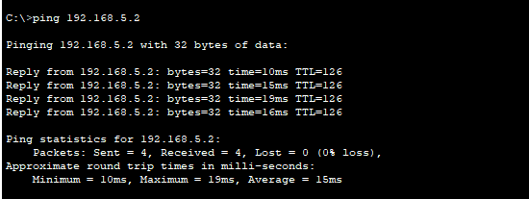

**Others department pc7 ping with Engineering department pc0**

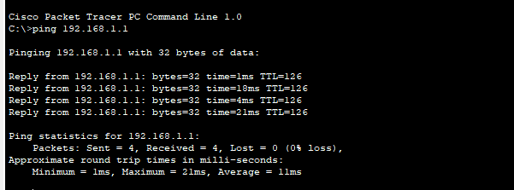

**Task 02**

* SDN configuration

**For R1**

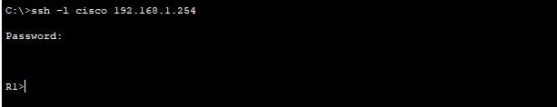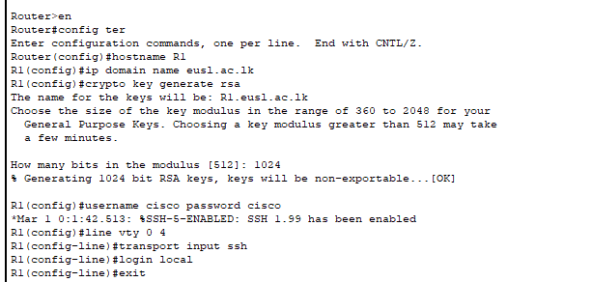

**For R2**

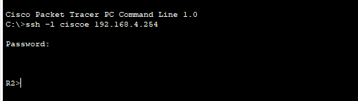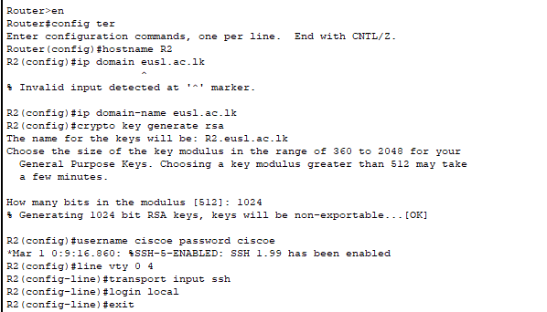

**For S1**

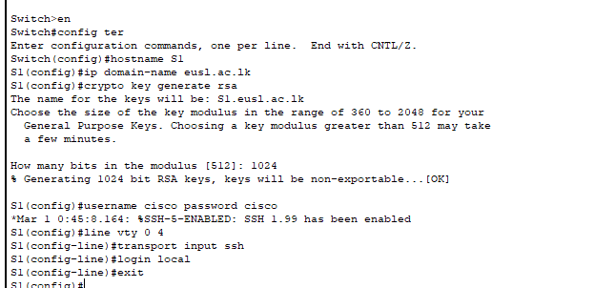

**For S2**

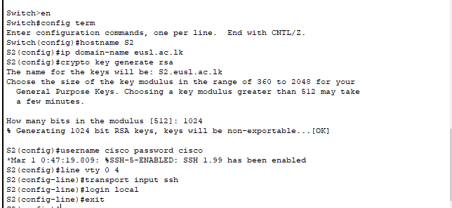

**For S3**

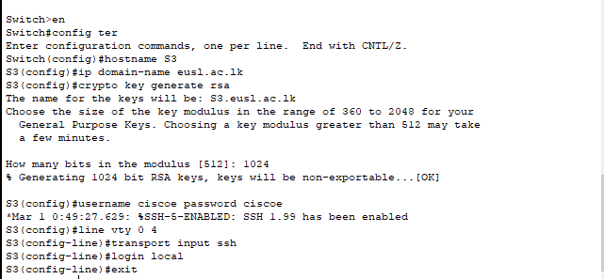

**For S4**

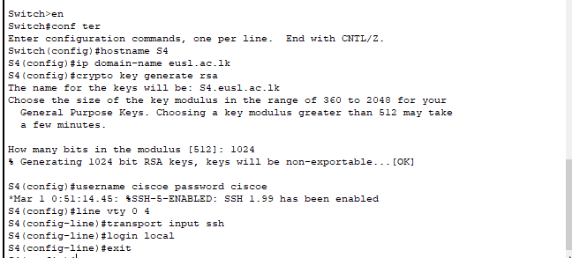

* **Security policies and ACL outputs**

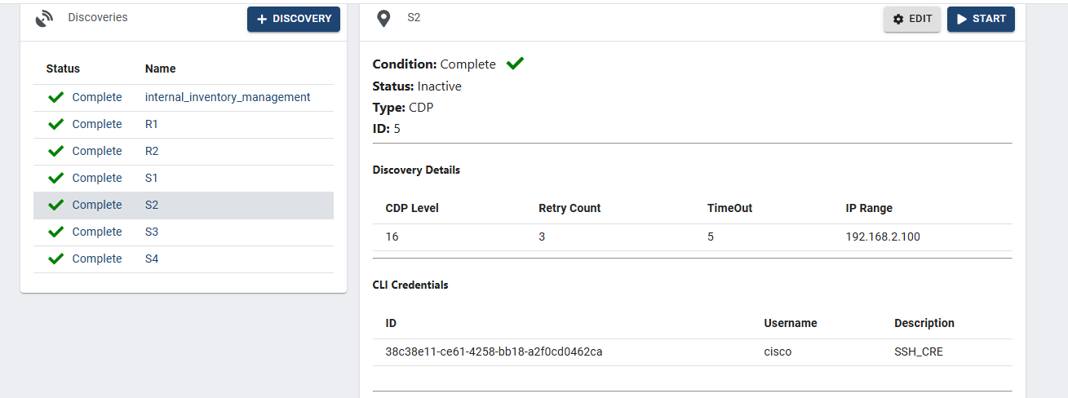

* **After SDN configuration pinging outputs**

Engineering department pc0

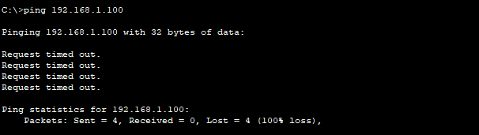

Engineering department pc3

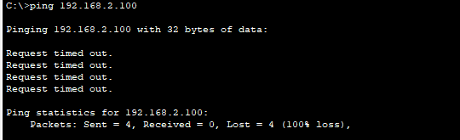

Others department pc4

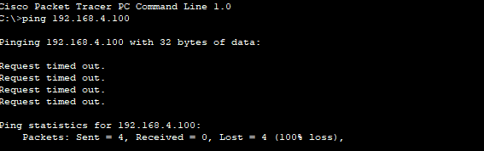

Others department pc7

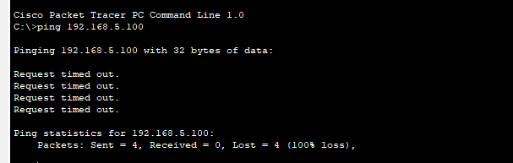

Reason for unable to pinging are :

* A firewall
* Controller setting
* A management interface no bridged to the data plane.