

CSC1366 & HealthCare Data Analytics

SYNC SCREEN TO SIGHT

A PROJECT REPORT
Submitted by

ABHI YAZHINI P (927623BCS001)
ABIRAMI M (927623BCS003)
ARUNTHATHI K J (927623BCS012)

in partial fulfilment for the award of the degree
of
BACHELOR OF ENGINEERING
in
COMPUTER SCIENCE AND ENGINEERING

M.KUMARASAMY COLLEGE OF ENGINEERING, KARUR

NOVEMBER 2025

M.KUMARASAMY COLLEGE OF ENGINEERING, KARUR
(Autonomous Institution affiliated to Anna University, Chennai)

BONAFIDE CERTIFICATE

Certified that the Project Based Learning report on “Sync Screen to Sight” is the bonafide work of “ABHII YAZHINI P (927623BCS001), ABIRAMI M (927623BCS003), ARUNTHATHI K J (927623BCS012)” who carried out the Project work during the academic year 2025-2026 under my supervision.

SIGNATURE  Mr. S. Prakash M.E.,  SUPERVISOR  Assistant Professor,  Department of Computer Science and Engineering,  M.Kumarasamy College of Engineering, Thalavapalayam, Karur – 639113 | SIGNATURE  Dr. D. Pradeep M.E.,Ph.D.,  HEAD OF THE DEPARTMENT  Department of Computer Science and Engineering,  M.Kumarasamy College of Engineering, Thalavapalayam, Karur - 639113

This Project Work(CSC1366) report has been submitted for V semester Project viva voce Examination held on _________________.

INTERNAL EXAMINER EXTERNAL EXAMINER

VISION AND MISSION OF THE INSTITUTION
VISION
To emerge as a leader among the top institutions in the field of technical education

MISSION
- Produce smart technocrats with empirical knowledge who can surmount the global challenges
- Create a diverse, fully-engaged, learner-centric campus environment to provide quality education to the students
- Maintain mutually beneficial partnerships with our alumni, industry, and Professional associations
VISION OF THE DEPARTMENT
To achieve education and research excellence in Computer Science and Engineering

MISSION OF THE DEPARTMENT
- To excel in academic through effective teaching learning techniques

- To promote research in the area of computer science and engineering with the focus on innovation
- To transform students into technically competent professionals with societal and ethical responsibilities
PROGRAM EDUCATIONAL OBJECTIVES (PEOs)
PEO 1: Graduates will have successful career in software industries and R&D divisions through continuous
PEO 2: Graduates will provide effective solutions for real world problems in the key domain of computer
PEO 3: Graduates will excel in their profession by being ethically and socially responsible.

PROGRAM OUTCOMES (POs)

Engineering students will be able to:

- Engineering knowledge: Apply the knowledge of mathematics, science, engineering fundamentals, and an engineering specialization to the solution of complex engineering problems.
- Problem analysis: Identify, formulate, review research literature, and analyze complex engineering problems reaching substantiated conclusions using first principles of mathematics, natural sciences, and engineering sciences.
- Design/development of solutions: Design solutions for complex engineering problems and design system components or processes that meet the specified needs with appropriate consideration for the public health and safety, and the cultural, societal, and environmental considerations.
- Conduct investigations of complex problems: Use research-based knowledge and research methods including design of experiments, analysis and interpretation of data, and synthesis of the information to provide valid conclusions.
- Modern tool usage: Create, select, and apply appropriate techniques, resources, and modern engineering and IT tools including prediction and modeling to complex engineering activities with an understanding of the limitations.
- The engineer and society: Apply reasoning informed by the contextual knowledge to assess societal, health, safety, legal and cultural issues and the consequent responsibilities relevant to the professional engineering practice.
- Environment and sustainability: Understand the impact of the professional engineering solutions in societal and environmental contexts, and demonstrate the knowledge of, and need for sustainable development.
- Ethics: Apply ethical principles and commit to professional ethics and responsibilities and norms of the engineering practice.
- Individual and team work: Function effectively as an individual, and as a member or leader in diverse teams, and in multidisciplinary settings.
- Communication: Communicate effectively on complex engineering activities with the engineering community and with society at large, such as, being able to comprehend and write effective reports and design documentation, make effective presentations, and give and receive clear instructions.

- Project management and finance: Demonstrate knowledge and understanding of the engineering and management principles and apply these to one’s own work, as a member and leader in a team, to manage projects and in multidisciplinary environments.
- Life-long learning: Recognize the need for, and have the preparation and ability to engage in independent and life-long learning in the broadest context of technological change.
PROGRAM SPECIFIC OUTCOMES (PSOs)
  - PSO1: Professional Skills: Ability to apply the knowledge of computing techniques to design and develop computerized solutions for the problems.
  - PSO2: Successful career: Ability to utilize the computing skills and ethical values in creating a successful career

ACKNOWLEDGEMENT
We gratefully remember our beloved Founder Chairman, (Late) Thiru.
M. Kumarasamy, whose vision and legacy laid the foundation for our education and inspired us to successfully complete this project.
We extend our sincere thanks to Dr. K. Ramakrishnan, Chairman, and
Mr. K. R. Charun Kumar, Joint Secretary, for providing excellent infrastructure and continuous support throughout our academic journey.
We are privileged to extend our heartfelt thanks to our respected Principal,
Dr. B. S. Murugan, M.Tech., Ph.D., for providing us with a conducive environment and constant encouragement to pursue this project work.
We sincerely thank Dr. D. Pradeep, M.E., Ph.D., Professor and Head, Department of Computer Science and Engineering, for his continuous support, valuable guidance, and motivation throughout the course of this project.
Our special thanks and deep sense of appreciation goes to our Project Supervisor, Mr. S. Prakash, M.E., Assistant Professor, Department of Computer Science and Engineering for his exceptional guidance, continuous supervision, constructive suggestions, and unwavering support, all of which have been instrumental in the successful execution of this project.
We would also like to acknowledge Mrs. A. Selvanayagi, M.E., Assistant Professor, our Course Handler, for her constant encouragement and coordination that contributed to the smooth progress and completion of our project work.
We gratefully thank all the faculty members of the Department of Computer Science and Engineering for their timely assistance, valuable insights, and constant support during various phases of the project.
Finally, we extend our profound gratitude to our parents and friends for their encouragement, moral support, and motivation, without which the successful completion of this project would not have been possible.

ABSTRACT

This project delivers a Django-based “vision awareness and accessibility” web app that lets users self-assess visual acuity, personalizes screen ergonomics, and optimizes document readability. The app guides users through interactive eye-chart tests (letters and numbers) to estimate visual acuity (V) and approximate diopter values, storing results per account for reuse. It then applies those personalized measurements to adapt the on-screen experience: automatically tuning display brightness (including via voice-supplied power values) and resizing/brightening uploaded documents—images, text, DOCX, and PDFs—so content is easier to read. A live webcam stream with face/eye detection estimates eye-to-screen distance and flags unsafe proximity, encouraging healthier viewing habits. All adjustments run in the browser-backed workflow: sign in/up, start the test, view results, and upload documents for tailored enhancement. The stack combines Django, OpenCV + MediaPipe (for distance and face/eye tracking), Pillow/reportlab/pypdf/docx (for document adaptation), and a small chart generator for static Snellen-style test images. The result is a practical assistive tool that blends self-administered vision checks with ergonomic safeguards and document accessibility, aimed at helping users reduce eye strain and make on-screen reading more comfortable.

ABSTRACT WITH POs AND PSOs MAPPING

ABSTRACT | POs  MAPPED | PSOs  MAPPED
This project delivers a Django-based web application that improves vision awareness, screen ergonomics, and document accessibility for users. It enables self-administered visual acuity tests using interactive eye charts to estimate visual acuity and diopter values, which are stored for personalized adjustments. With OpenCV and MediaPipe, the system uses a live webcam feed for real-time face and eye detection, measuring eye-to-screen distance and warning users when they sit too close. Based on the user’s vision results, the app enhances uploaded documents—including images, PDFs, text files, and DOCX files—by adjusting text size, brightness, contrast, and layout to make reading easier. Integrated voice-based brightness control further supports accessibility. Overall, the system helps users reduce eye strain and improve on-screen viewing comfort. | PO1(3)  PO2(3)  PO3(3)  PO4(2)  PO5(3)  PO6(2)  PO7(3)  PO8(2)  PO9(3) PO10(3) PO11(2) PO12(2) | PSO1(3) PSO2(2)
Note: 1- Low, 2-Medium, 3- High

SUPERVISOR HEAD OF THE DEPARTMENT

SDG Goal | Remarks
SDG 3 - Good Health and Well Being - by enabling early detection of visual problems through digital vision testing and real-time visual acuity assessment. | Helps users maintain better eye health and reduces strain by generating vision-friendly documents tailored to their diopter value.
SDG 10 – Reduced Inequalities - by improving accessibility for visually challenged individuals through AI-powered document enhancement and adaptive text presentation. | Promotes inclusiveness, supports equal access to digital content, and enhances independence for users with varying levels of visual impairment

MAPPING WITH SUSTAINABLE DEVELOPMENT GOALS

 | TABLE OF CONTENT
CHAPTER No. | TITLE | PAGE No.
 | ABSTRACT | VII
 | LIST OF FIGURES | XII
 | LIST OF ABBREVATIONS | XIII
1 | INTODUCTION | 1
 | 1.1 Overview | 4
 | 1.2 Problem Statement | 4
 | 1.3 Objective | 5
 | 1.4 Scope of the Project | 5
 | 1.5 Methodology | 6
2 | LITERATURE SURVEY | 8
3 | SYSTEM ANALYSIS | 10
 | 3.1 Existing System | 10
 | 3.2 Proposed System | 12
 | 3.3 Feasibility Study | 14
 | 3.4 System Requirements | 16
 | 3.4.1 Software Requirements | 16
4 | SYSTEM DESIGN | 18
 | 4.1 Architecture Diagram | 18
 | 4.2 UML Diagrams | 21
 | 4.3 Database Design | 24
5 | IMPLEMENTATION | 25
 | 5.1 Modules Description | 25
 | 5.1.1 User Authentication Module | 25
 | 5.1.2 Eye Detection & Distance Measurement Module | 25
 | 5.1.3 Vision Test Module | 25
 | 5.1.4 Visual Activity & Diopter Calculation Module | 26
 | 5.1.5 Document Upload Module | 26
 | 5.1.6 Vision- Adaptive Document Enhancement Module | 26
 | 5.2 Algorithms | 27
6 | SYSTEM TESTING | 30
 | 6.1 Test Plan | 30
 | 6.2 Test Case | 32
 | 6.3 Results | 34
7 | Results and discussion | 35
8 | Conclusion and future work | 37
 | 8.1 Conclusion | 37
 | 8.2 Scope for Future works | 37
 | APPENDIX 1: SOURCE CODE | 39
 | APPENDIX 2: SCREENSHOTS | 53
 | REFERENCES | 58

LIST OF FIGURES

FIGURE No. | TITLE | PAGE No.
3.1 | Existing System | 10
3.2 | Block Diagram | 12
4.1 | Architecture of Application | 18
4.2.1 | Use case Diagram | 21
4.2.2 | Class Diagram | 22
4.2.3 | Sequence Diagram | 23
4.2.4 | Package Diagram | 23
4.2.5 | Component Diagram | 24
4.3 | Database design | 24
A.1 | Screenshot of User Login | 53
A.2 | Screenshot of User Dashboard | 54
A.3 | Screenshot of Vision Test Page | 55
A.4 | Screenshot of Document Uploading | 56
A.5 | Screenshot of Enhanced Document | 57

LIST OF ABBREVIATIONS

API | Application Programming Interface
CSS | Cascading Style Sheets
CSV | Comma-Separated Values
CV | Computer Vision
D | Diopter
DOCX | Document XML
HTML | Hyper Text Markup Language
HTTP | Hyper Text Transfer Protocol
JPEG/JPG | Joint Photographic Experts Group
JS | JavaScript
JSON | JavaScript Object Notation
PDF | Portable Document Format
PNG | Portable Network Graphics
URL | Uniform Resource Locator
V | Visual Activity

CHAPTER 1

INTRODUCTION

Vision impairment affects millions of individuals worldwide, making tasks such as reading documents, recognizing text, or accessing digital content extremely challenging. People with refractive errors, low visual acuity, or uncorrected eyesight often struggle with eye strain, reduced clarity, and difficulty interacting with standard-sized text. Traditional eye-check methods require physical visits and manual prescriptions, while document reading tools do not adjust dynamically based on a user’s actual visual condition. This leads to discomfort, inefficiency, and dependency on external support.

To address these limitations, the Vision Test & Document Enhancement System has been developed as an intelligent and accessibility-focused solution that combines real-time vision assessment with personalized document adaptation. The application evaluates a user’s visual acuity, calculates approximate diopter values, and automatically modifies uploaded documents based on individual eyesight needs. This ensures that users with varying levels of visual impairment can comfortably read files without eye strain.

The application begins with a secure, user-friendly authentication process and guides users through a structured vision testing workflow. Once the system computes the user’s eye power, they can upload documents in formats such as PDF, DOCX, and text, which are then enhanced using mathematical adjustments to font size, contrast, spacing, brightness, and clarity. The optimized document is finally deployed back to the user for easy and comfortable viewing.

DOMAIN INTRODUCTION

The Vision Test & Document Enhancement System belongs to the domains of Digital Accessibility, Health Technology, and Assistive Computing. It is designed specifically for users with visual impairments such as refractive errors, low visual acuity, or difficulty reading standard-sized text.

The system bridges the gap between traditional vision testing and digital reading by combining computer vision, mathematical modeling, and document processing techniques. It provides a platform where users can assess their vision and instantly apply the results to real-world digital tasks like reading documents. This ensures improved accessibility, comfort, and independence for individuals who struggle with conventional text formats.

This application can be used in healthcare environments, rehabilitation centers, educational institutions, and personal accessibility tools, making it highly versatile across multiple domains.

FRAMEWORK

The Vision Test & Document Enhancement System is built on a structured, multi-layered framework that ensures accuracy, accessibility, and efficient document transformation. It consists of the following layers:

Frontend: Django (HTML/CSS/JS)

The frontend is built using Django templates combined with HTML, CSS, and JavaScript, offering an interactive and smooth user interface.

User-Friendly Interface: Simple layouts guide users through testing and document upload.

Responsive Design: Ensures clear visibility on all devices, suitable for users with reduced visual clarity.

Real-Time Interactions: Supports dynamic content rendering, sliders, and document previews.

Accessibility Enhancements: Large buttons, high contrast UI, and minimal clutter for comfort.

Backend: Python (Django Framework)

The backend handles vision processing, diopter calculations, and document enhancement operations.

Mathematical Computation Engine: Calculates visual acuity and diopter using standard formulas.

Business Logic Processing: Controls workflow from authentication to deployment.

Image/Document Handling: Uses backend libraries to enhance PDF/DOCX content.

Secure Management: Handles user data safely with secure authentication and session management.

Document Processing Layer

This layer modifies uploaded documents based on eye power using computational transformations.

Adjusts font size, contrast, brightness, edge sharpness, and spacing.

Generates visually optimized documents personalized for each user.

Supports formats like PDF, DOCX, and text files.

Database Layer

Stores user details, previous test results, and document records.

Ensures quick retrieval of past visual acuity scores.

Allows users to reuse previous test results for document enhancement.

SOFTWARE USED

Django Framework

Django acts as the core backend environment enabling:

Rapid development and secure authentication

Clean separation of logic and interface

Robust session and user management

Integration of document processing libraries

Python Libraries

The system uses essential Python libraries for vision calculation and document modification:

OpenCV (for vision test processing)

Pillow (for image adjustments)

PyPDF2 / ReportLab / python-docx (for document generation)

NumPy (for mathematical transformations)

Database: SQLite / PostgreSQL (based on deployment)

Lightweight, fast storage for user test data

Easy integration with Django ORM

Supports scalable deployment

Overview

The Vision Test & Document Enhancement System serves as a complete accessibility solution that measures visual clarity and adapts digital content according to each user’s specific eye condition. Designed with simplicity and inclusiveness in mind, the system provides:

A secure login environment

A guided vision test process

Automatic visual acuity and diopter power calculation

A document upload and enhancement module

Delivery of personalized, eye-friendly documents

By integrating real-time testing, computational processing, and adaptive document rendering, the system ensures that users—especially those with blurry vision, myopia, hyperopia, or digital eye strain—can access documents comfortably and independently.

Problem Statement

Existing applications for vision testing or document reading suffer from major limitations:

Identified Issues

No integration between vision testing and document enhancement

Generic font zooming that does not match user’s actual eye power

Lack of automated, personalized document correction

Unclear or low-contrast document displays

Insufficient tools for users with low vision

Many existing platforms provide vision tests, while others offer document readers — but none connect the two processes. Users still struggle to read documents even after manual adjustments, leading to fatigue and frustration.

Objective

The objective of this system is to provide an intelligent, vision-adaptive platform that accurately measures a user’s visual acuity and diopter level using webcam-based eye detection and distance estimation, and then dynamically enhances documents according to the user’s eyesight needs. The system aims to simplify digital accessibility by adjusting text size, contrast, spacing, and layout based on real-time vision parameters, without relying on OCR. Additionally, it enables users to securely authenticate, undergo standardized vision tests, upload documents, and obtain personalized, mathematically computed document transformations that improve readability for individuals with varying levels of visual impairment. Overall, the system enhances usability, personalization, and accessibility by combining computer vision, adaptive processing, and automated vision-based adjustments into a unified web application.

- Scope of the project
The scope of this project covers the end-to-end design and development of an intelligent, vision-adaptive document enhancement system that adjusts on-screen content according to the user’s eye condition and viewing distance. The system integrates computer vision techniques, mathematical vision models, and a user-friendly web interface to create a personalized reading experience. It begins by detecting the user’s face and eyes through a webcam feed and accurately estimating the eye-to-screen distance. Based on these real-time measurements, the system calculates key visual parameters such as visual acuity (V) and diopter (D) using mathematical formulas and threshold models. These values guide the automatic adaptation of document properties including brightness, font size, zoom, and line spacing, ensuring optimal readability for each user.
The scope extends to developing modules for document uploading, text extraction, PDF scaling, and adaptive rendering so that users can view their uploaded files in an enhanced format that suits their vision condition. The user dashboard, vision test interface, and document customization page collectively support easy navigation and enable users to monitor changes instantly. The system aims to support students, professionals, visually challenged individuals, and anyone who experiences eye strain during prolonged screen usage.
Additionally, the project explores the application of screen ergonomics by adjusting display elements to maintain recommended visual comfort levels. It emphasizes real-time processing, interactive UI/UX design, and seamless communication between frontend and backend components to deliver a smooth reading experience. However, the project does not attempt to provide clinical-grade diagnosis, integrate with optometric hardware, or offer medical certifications. It also does not cover advanced ML-based disease prediction or large-scale enterprise deployment.
Overall, the scope focuses on developing a smart, adaptable, and accessible system that aligns digital content with the user’s visual needs, offering a modern solution to enhance screen comfort, reduce eye strain, and promote healthier digital reading habits.
- Methodology
The methodology of this project follows a structured approach that combines computer vision, mathematical modeling, and adaptive document processing to deliver a vision-aware reading system. The process begins with the implementation of a user authentication module, allowing users to securely register and log in to access personalized features. Once logged in, the system guides users to the vision test module, where an interactive eye-chart interface is displayed. Users perform a self-administered visual acuity test, and the system records their responses to compute visual acuity (V) and estimate diopter (D) values using predefined formulas and progression rules.
After completing the vision test, the system activates the real-time distance monitoring module, built using OpenCV and MediaPipe. The webcam stream is analyzed frame-by-frame to detect the user’s face and eyes, enabling accurate calculation of eye-to-screen distance. If the user moves too close to the screen, ergonomic warnings are generated to maintain healthier viewing habits. These measured values are then synchronized with the user profile and used to adapt the display environment dynamically.
The next stage involves the document processing module, where users can upload PDFs, DOCX files, text files, or images. The system extracts content using text extraction techniques and renders it in a customizable viewer. Based on the user’s visual parameters, the application automatically adjusts brightness, text size, zoom, and line spacing to enhance readability. Additional controls allow users to fine-tune the enhancements manually for maximum comfort. A lightweight voice-control feature enables users to modify brightness hands-free, improving accessibility for visually challenged individuals.
All modules are integrated through a responsive web interface built with Django, ensuring smooth navigation between pages such as the dashboard, vision test area, distance monitor, and document viewer. Backend logic handles data storage, user settings, and real-time computations, while the frontend presents clean visual layouts optimized for usability and accessibility.
Overall, the methodology ensures a seamless workflow—from vision testing to ergonomic monitoring and adaptive document rendering—resulting in a smart system that aligns screen content with each user’s unique visual needs.

CHAPTER 2

LITERATURE SURVEY
The purpose of this literature review is to evaluate existing research on assistive vision technologies, adaptive display systems, webcam-based vision testing, and document enhancement frameworks developed for individuals with varying visual abilities. Prior studies demonstrate significant progress in eye-tracking–based accessibility, real-time distance estimation, OCR-assisted text processing, and computational methods for adapting digital content to user-specific visual needs. However, many existing solutions remain limited in personalization, system integration, or real-time adaptability, highlighting the need for a unified, intelligent, vision-adaptive platform like the one proposed in this project.
Research by Ahn et al. [1] on Characterizing Visual Intents for Low-Vision Users investigates how gaze patterns and reading behavior signal visual difficulty, providing insights for understanding user intent. This aligns with our Eye Detection & Distance Measurement Module, which uses facial landmarks and eye-position analysis to estimate accurate viewing distance for improved chart scaling. A review by Fernandes and Li [2] on Eye Tracking–Based Adaptive Displays emphasizes dynamic UI scaling and visual optimization based on real-time eye movements, which directly relates to our Vision-Adaptive Document Enhancement Module that adjusts brightness and line spacing based on visual acuity and diopter values.
Assistive technology research such as Kumar and Devi’s Low Vision Accessibility Tools [3] highlights magnification and spacing adjustments as essential components of readability enhancement. Our system integrates similar techniques through customized vision charts and adaptive document processing. Studies on display optimization, including Head-Mounted Display Technology for Low Vision by Wang et al. [4], detail automatic visual correction using optics and contrast algorithms, comparable to our software-based adaptation of documents without specialized hardware.
Foundational work like Vision-Correcting Displays by Huang and Wetzstein [5] introduces computational approaches to compensate for refractive errors such as myopia and hyperopia. Our system extends this concept by calculating diopter values and enhancing document clarity accordingly. OCR-based accessibility studies such as Patel and Ghosh’s OCR Text Magnification for Accessibility [6] demonstrate how text extraction can support personalized rendering; our Document Upload & Processing Module adopts this method to enhance PDF and DOCX content using brightness and spacing adjustments.
Studies on automated visual acuity estimation, such as the model proposed by Torres et al. [7], use computer vision techniques and distance measurements to approximate visual performance. Their approach supports our method of scaling Snellen-style charts according to real-time distance detected through webcam input. Research on webcam-based distance estimation, including Gupta and Rao’s Tele-Vision Testing Framework [8], validates the feasibility of home-based visual assessments, forming the foundation for accurate screen-to-eye distance measurement in our system.
Document accessibility studies, such as Silva’s Adaptive PDF Rendering Techniques [9], emphasize the importance of reflow, adjustable spacing, and brightness tuning—features built directly into our Vision-Adaptive Document Enhancement Module. Finally, ML-based screening work by Lee and Chen [10] highlights how ocular features can be analyzed to estimate refractive conditions. Although our system does not provide medical diagnosis, it adopts similar principles to approximate diopter values and tailor document visibility accordingly.
20

CHAPTER 3

SYSTEM ARCHITECTURE

Existing System
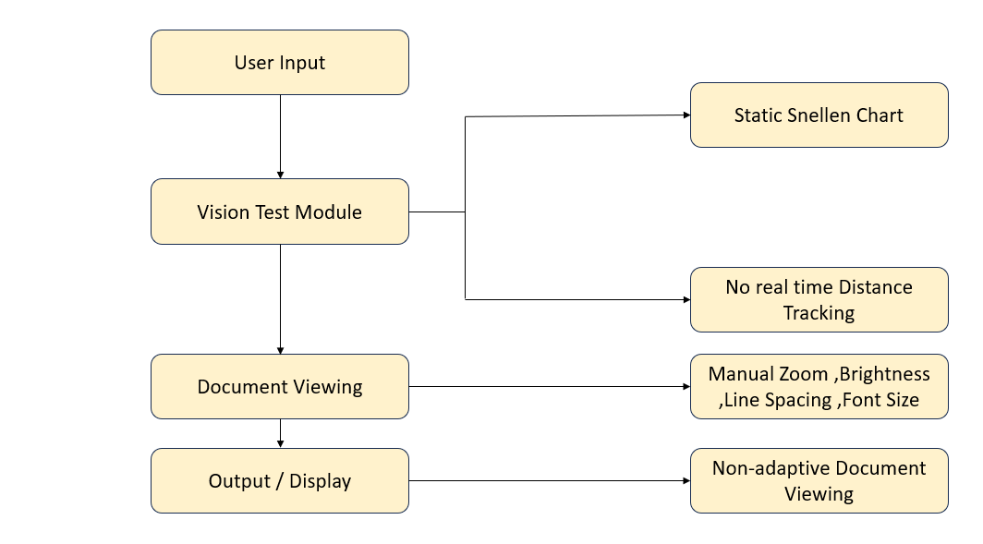
Fig.3.1 Existing System
In the current digital environment, vision-assessment and document-reading tools function as separate, non-integrated solutions, offering limited personalization for users with varying visual abilities. Most existing online vision test platforms provide only basic, static charts that do not adjust according to the user’s viewing distance, screen size, or visual acuity, making the results less accurate for home-based self-assessment. These systems also do not incorporate real-time face or eye detection, and therefore cannot measure the user’s distance from the screen—an essential factor for obtaining reliable vision test outcomes.
Document viewing tools that exist today typically offer fixed options such as zoom, brightness, or basic accessibility modes. However, they are not adaptive and do not automatically modify document presentation—such as font size, brightness, or line spacing—based on the user’s eye condition, visual acuity, or diopter values. Users must manually adjust settings, which can be difficult for individuals with low vision or refractive errors.
Many current accessibility solutions rely heavily on OCR-based processes or specialized hardware devices, such as magnifiers and high-cost assistive displays, making them impractical or inaccessible to general users. These systems often lack real-time adaptation, limiting their ability to reduce eye strain or address user-specific visual discomfort dynamically.
Furthermore, existing platforms rarely integrate webcam-based distance detection with personalized document enhancement. They do not maintain vision history, calculate diopter values, or provide automated document adjustments tailored to individual needs. Most tools operate in isolation, without a centralized workflow combining vision testing, distance monitoring, and adaptive document rendering.
Overall, traditional assistive tools suffer from several limitations:
no real-time face/eye tracking, no distance-based scaling, no automated document enhancement, no personalized diopter-driven adjustments, and no unified ecosystem for vision testing and accessibility. These drawbacks highlight the need for a smart, web-based, vision-adaptive system that synchronizes screen content with the user’s sight capabilities, offering better readability, comfort, and accessibility.

- Proposed System

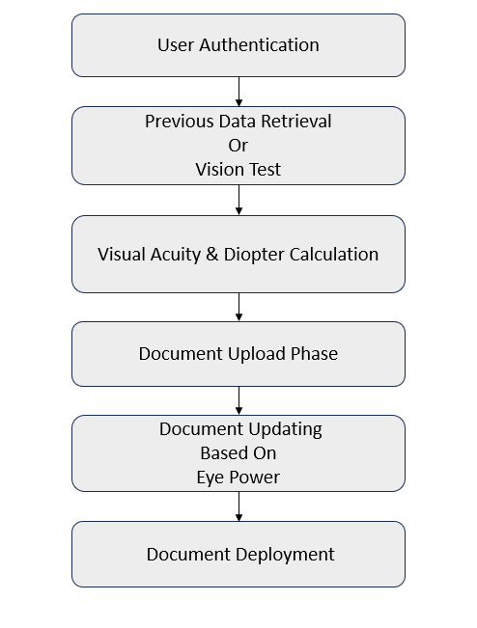
Figure 3.2 Block Diagram

The system architecture is organized into a sequence of interconnected modules that work together to evaluate the user’s vision, compute visual correction parameters, and adjust uploaded documents accordingly. Each block performs a specific function and passes the processed data to the next stage to ensure smooth and accurate workflow.
User Authentication
The system begins with the User Authentication module, which ensures that only authorized individuals can access the vision testing and document enhancement features. Users log in using secure credentials, and the system loads their personalized settings if available. This module also protects sensitive vision-related data stored in the system.
Previous Data Retrieval or Vision Test
After authentication, the user can either retrieve previously stored visual data or proceed with a new vision test.
If previous reports exist, the stored visual acuity score and diopter values are automatically loaded.
If not, the system initiates a fresh Vision Test.
This module helps avoid repeated testing and supports faster document processing when prior data is valid.
Visual Acuity & Diopter Calculation
In this stage, the system analyzes the user’s vision test results to compute:
- Visual Acuity Score
- Approximate Diopter Power
These calculations are based on standardized vision test responses and distance measurements. The computed eye power acts as the primary input for document enhancement, ensuring personalized correction for each user.
Document Upload Phase
Once the visual parameters are ready, the user enters the Document Upload Phase.
Here, the system allows users to upload various document formats such as PDF, DOCX, or images. The uploaded file is then prepared for enhancement by extracting content and analyzing its layout. This step ensures that the document is compatible with vision-based modifications.
Document Updating Based on Eye Power
This is the core processing module of the system. Using the diopter value calculated earlier, the system applies vision-adaptive corrections, including:
- Increasing or decreasing text size
- Adjusting brightness and contrast
- Modifying spacing and alignment
- Applying zoom or clarity enhancement
- Sharpening edges for better readability
These adjustments are applied mathematically to match the user’s visual clarity needs, ensuring the document becomes readable for individuals with refractive errors such as myopia or hyperopia.
Document Deployment
In the final stage, the enhanced document is generated and deployed for the user.
The output may be:
- A downloadable corrected file
- A preview within the application
- A visually optimized version for continuous reading
This module ensures that users receive a personalized document adapted to their eye power, enabling comfortable and strain-free reading.
- Feasibility Study
The feasibility study evaluates the practicality, viability, and effectiveness of implementing a vision-adaptive web application that integrates webcam-based eye-distance detection, online visual acuity testing, and personalized document enhancement. The system’s feasibility is analyzed across technical, economic, operational, behavioural, and legal perspectives to determine its suitability for real-world deployment.
Technical Feasibility
The proposed system is technically feasible as it uses readily available and well-supported technologies such as Django, OpenCV, MediaPipe, JavaScript, and standard document-processing libraries (Pillow, PyPDF, python-docx). Modern browsers can efficiently handle webcam streaming, face detection, and dynamic UI adjustments without requiring specialized hardware. Since all processing occurs on the client–server architecture with lightweight CV models, the system runs smoothly on typical laptops or desktops.
The document-enhancement pipeline—adjusting text size, brightness, and line spacing—uses widely supported Python libraries, ensuring high compatibility. Therefore, the technology stack is robust, scalable, and easy to deploy.
Economic Feasibility
The project is economically feasible as it requires no expensive hardware, sensors, or dedicated devices. It uses standard webcams, open-source frameworks, and freely available libraries, making the system cost-effective for both development and use.
Deployment on low-cost cloud platforms or local hosting further reduces operational expenses. The system eliminates the need for paid accessibility tools or specialized assistive equipment, offering an affordable solution for students, professionals, visually challenged individuals, and organizations seeking cost-efficient accessibility improvement.
Operational Feasibility
Operational feasibility is strong because the system directly addresses common challenges such as eye strain, poor document readability, difficulty performing vision tests at home, and lack of personalized screen ergonomics.
The workflow—login, vision test, distance detection, and document enhancement—is intuitive and requires minimal user training. Real-time feedback, automatic scaling, and clear UI elements improve usability for visually challenged users.
Since adjustments are automatic and based on the user's calculated vision parameters, the system reduces manual effort and provides a more comfortable viewing experience, making it highly practical for everyday use.
Behavioral Feasibility
Users are increasingly adopting online tools for self-assessment, accessibility, and digital comfort. The rising use of screen-based learning, remote work, and long-duration digital exposure makes users more aware of their visual strain and more willing to adopt supportive tools.
Features like voice-based brightness control, auto-scaling charts, and personalized document enhancement increase user acceptance and satisfaction. The system is non-invasive and does not require medical expertise, making it behaviorally adaptable for a wide audience.
Legal & Ethical Feasibility
The project adheres to legal and ethical standards by ensuring that no medical diagnosis is provided and the system functions as a vision-support and accessibility aid, not a clinical tool.
Webcam data is processed in real time without storing facial images, ensuring privacy compliance. User accounts and stored vision results follow standard data protection practices, making the solution ethically safe and legally compliant for deployment.

- System Requirements
The system requirements specify the essential hardware and software components necessary for the development and deployment of the Vision-Adaptive Document Enhancement System (VADES), which leverages computer vision, document processing, and web-based interfaces. These requirements ensure seamless user detection, real-time document enhancement, adaptive visual adjustments, and efficient access to the dashboard
    - Software Requirements
Frontend Development
  - Django (HTML/CSS/JavaScript)
  - Django templates for rendering vision tests and enhanced documents
  - JavaScript components for real-time brightness control and line-spacing adjustments
  - Bootstrap for responsive UI
  - Chart.js for visual representation of acuity results
  - High-visibility UI elements for users with reduced visual clarity
Backend Framework
- Python (Django Framework)
- Handles visual acuity and diopter calculations
- Manages user authentication and workflow logic
- Integrates with document processing libraries
- Supports secure session handling and data routing
- Executes mathematical functions to adjust document brightness, scaling, spacing, and text clarity
Document Processing Libraries
- OpenCV (eye detection, distance measurement)
- Pillow (brightness, sharpness, and image adjustments)
- PyPDF2 (PDF reading and transformation)
- ReportLab (PDF generation after enhancement)
- python-docx (DOCX formatting, line spacing, font adjustments)
- NumPy (mathematical transformations for enhancement)
Vision & Computation Layer
- Performs optical calculations for visual acuity
- Computes diopter values
- Applies mathematical scaling for readability improvement
- Adjusts document clarity based on user test results
- Enhances uploaded documents using brightness and spacing algorithms
Database System
- SQLite / PostgreSQL
- Stores user details and vision test records
- Maintains processed document history
- Supports quick access to previous acuity values
- Works with Django ORM for seamless integration

CHAPTER 4

SYSTEM DESIGN
- Architecture Diagram
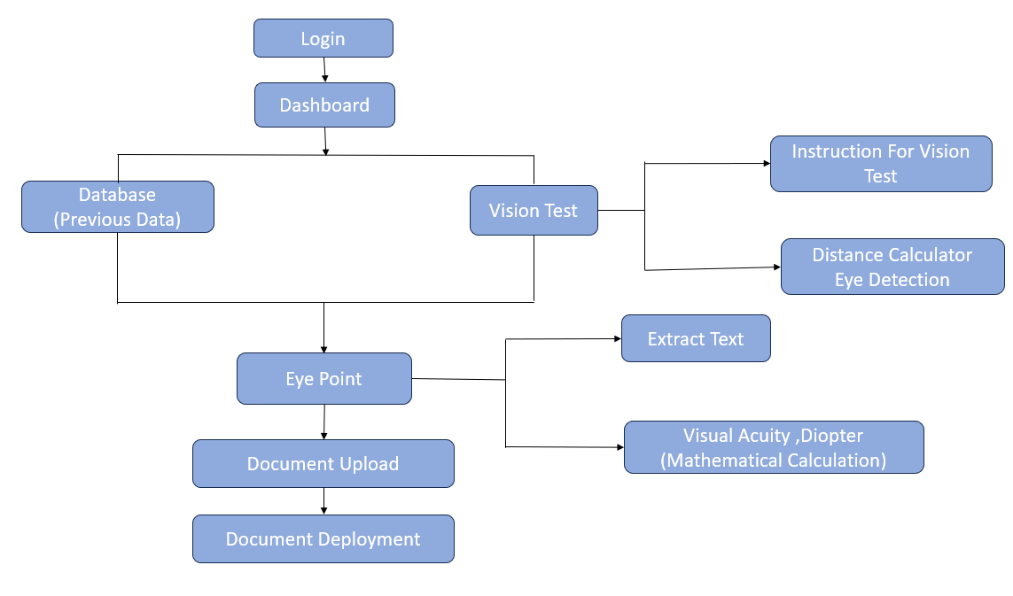
Figure 4.1 Architecture Diagram
System Architecture Description – Vision Test & Adaptive Document Enhancement System
Login & User Authentication
Users begin by accessing the Login module.
Secure authentication is provided using username/password or optional PIN-based access.
After successful login, the system loads personalized settings such as preferred font size, brightness mode, and chosen test language.
Read Me & Instructions
After logging in, users can open the Read Me section.
The Instruction Module provides clear guidance on how to perform the vision test, upload documents, and interpret results.

Main Application – Home Dashboard
The Open App or Dashboard acts as the central hub of the system.
From here, users can access:
- Vision Test Module
- Eye Detection Module
- Distance Measurement
- Visual Acuity & Diopter Calculation
- Document Upload
- Vision-Adaptive Document Enhancement
- Result Reports
Eye Detection & Distance Measurement
The Open App or Dashboard acts as the central hub of the system.
From here, users can access:
- Vision Test Module
- Eye Detection Module
- Distance Measurement
- Visual Acuity & Diopter Calculation
- Document Upload
- Vision-Adaptive Document Enhancement
Result Reports
Vision Test Module
Conducts various vision tests:
- Snellen Letter Chart Test
- Color Blindness Test
- Astigmatism Test
- Contrast Sensitivity Test
- Reading Speed Test
- Displays visual charts, symbols, or letters.
- Collects the user's responses through touch input or voice response.
Sends test outputs to the Visual Acuity Calculation Module.
Visual Acuity & Diopter Calculation Module
Uses mathematical formulas to calculate:
- Visual acuity score
- Approximate diopter value
- Error range
Automatically adjusts calculations based on the measured distance and test responses.
Results are stored for later reference and reports.
Document Upload Module
- Allows users to upload PDF, DOCX, or images.
- Extracts text and layout from the document.
- Prepares the file for visual enhancement processing.
Vision – Adaptive Document Enhancing Module
Applies mathematical transformations to improve text visibility based on the user’s eye condition.
Enhancements include:
- Text resizing
- Line spacing adjustment
- Color contrast optimization
- Edge sharpening
- Background noise removal
- Adaptive zooming (based on diopter value)
Ensures the document is easy to read for individuals with refractive errors.
Report Generation & Recommendations
Generates a complete report containing:
- Visual acuity score
- Diopter estimation
- Test charts
- Reading performance
- Suggested corrective measures
Provides recommendations such as:
- Optimal font size
- Best contrast mode
Whether the user may need an eye check-up
- UML Diagrams
- Use Case Diagram
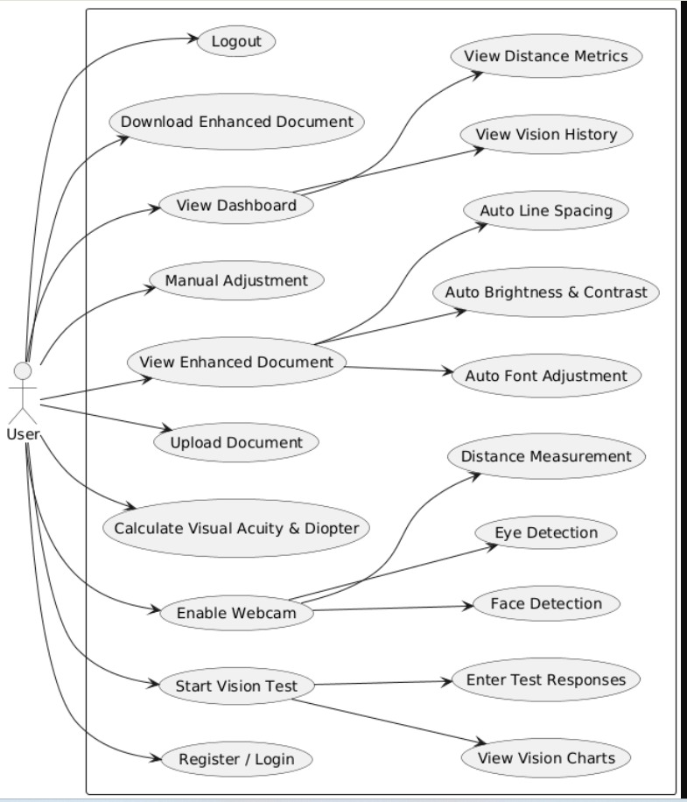
Figure 4.2.1 Use Case Diagram

- Class Diagram
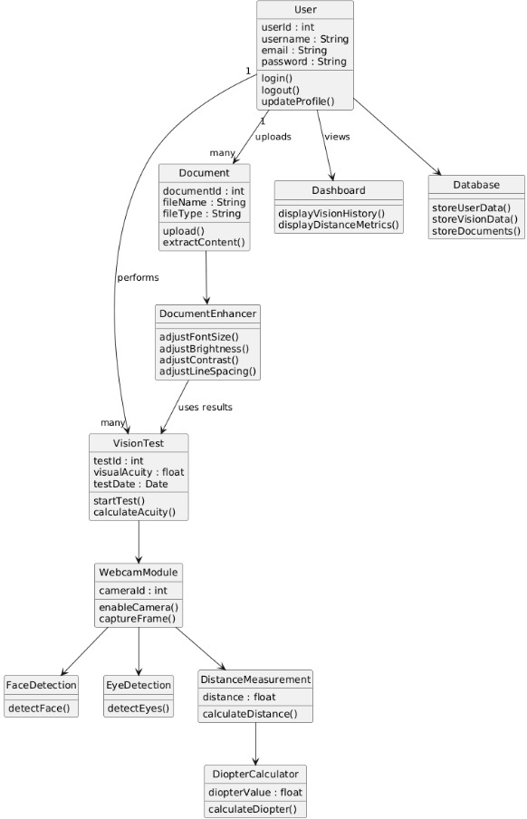
Figure 4.2.2 Class Diagram

- Sequence Diagram
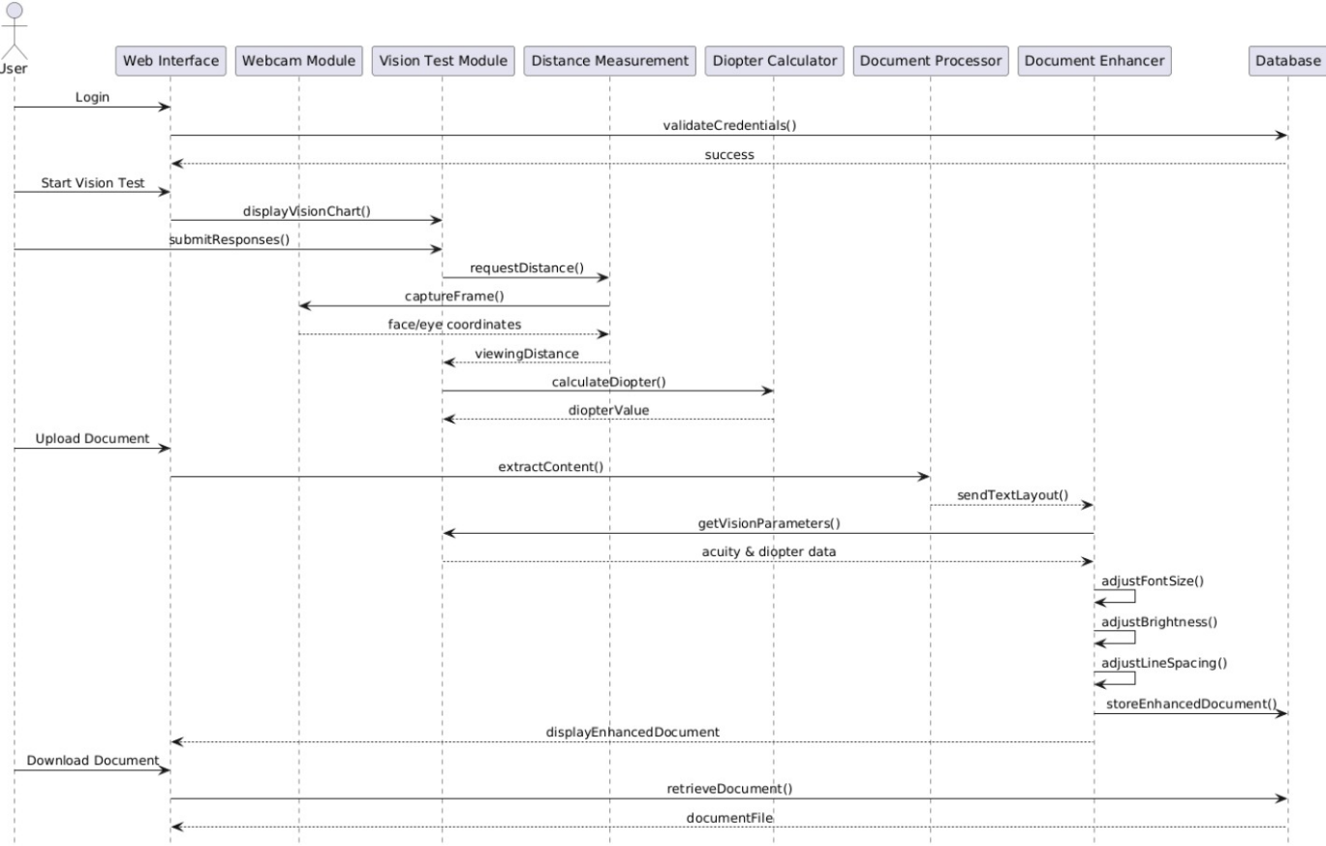
Figure 4.2.3 Sequence Diagram
- Package Diagram
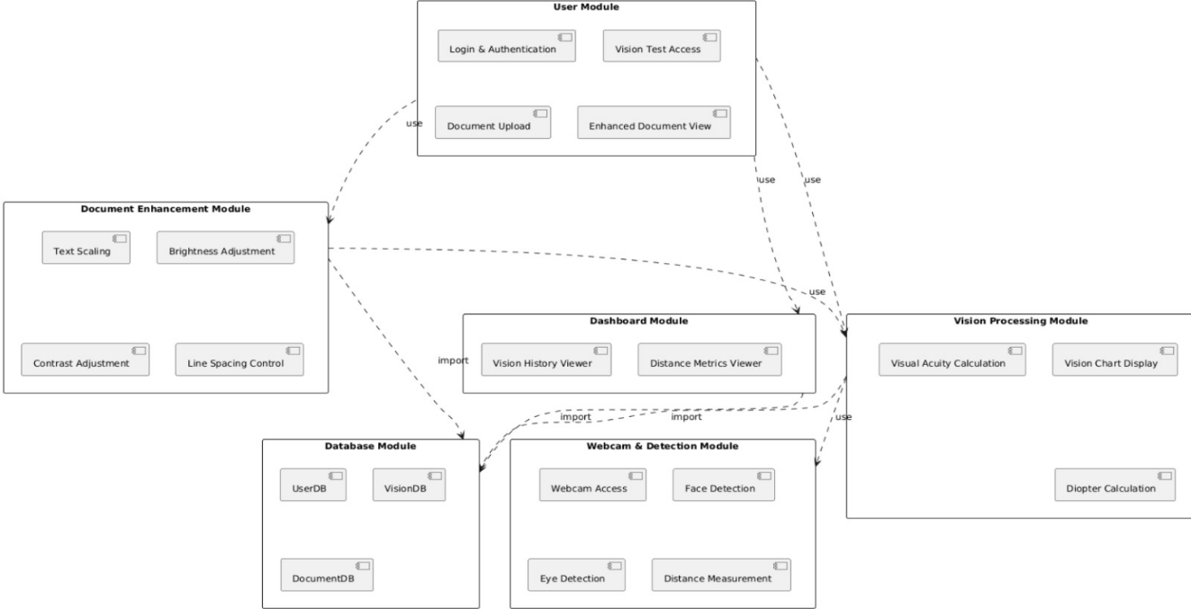
Figure 4.2.4 Package Diagram

- Component Diagram
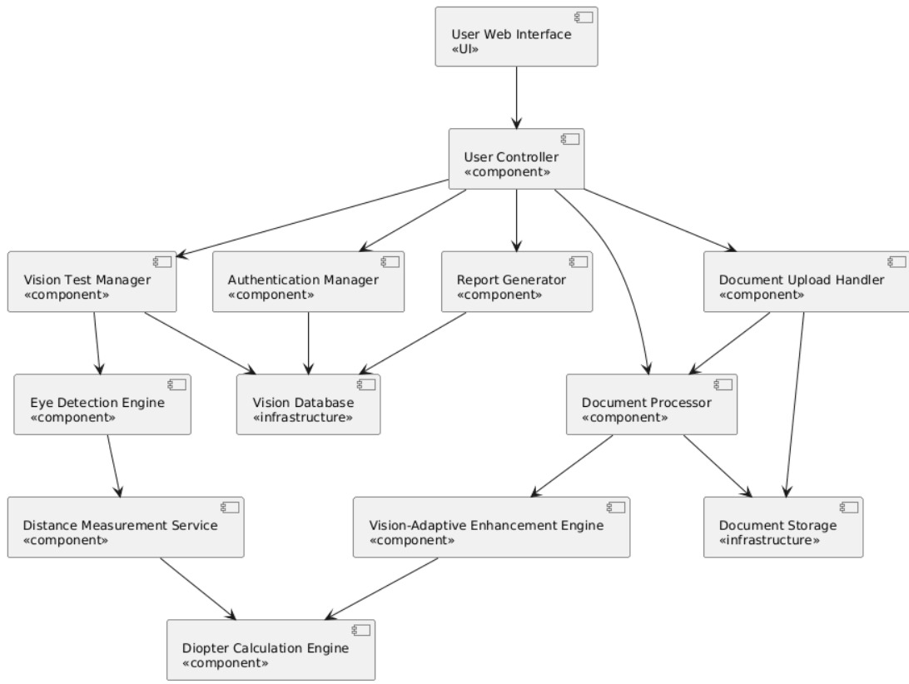
Figure 4.2.5 Component Diagram
- Database Design

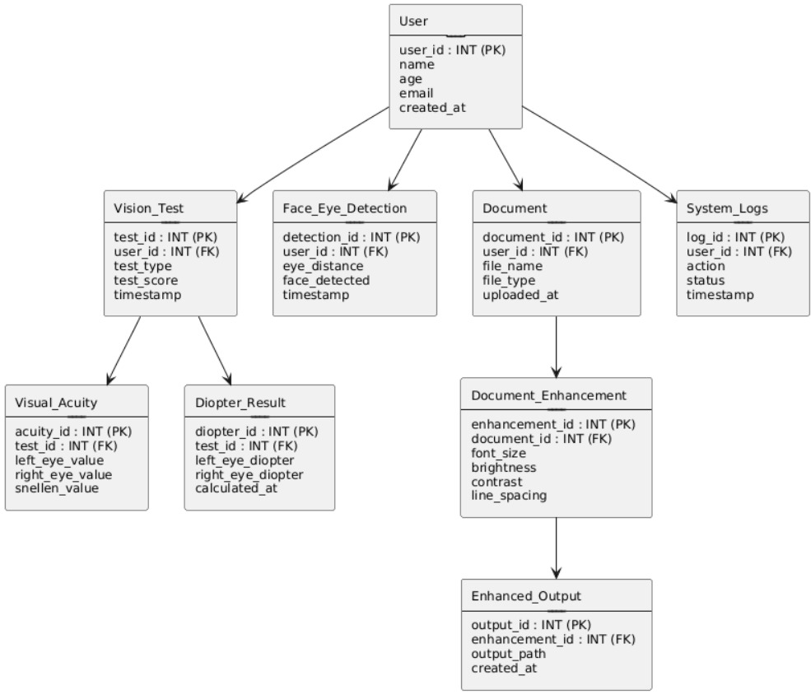

Figure 4.3 Database design

CHAPTER 5
20
IMPLEMENTATION
- Modules Description
- User Authentication Module
The User Authentication Module is responsible for securely managing user access to the system. It handles login validation, credential verification, and session management to ensure that only authorized users can interact with the vision-testing and document-processing features. This module maintains user profiles, protects sensitive data, and provides a seamless entry point into the application. By establishing a secure authentication process, it ensures data integrity and personalized access to previous test results and uploaded documents.
- Eye Detection & Distance Measurement Module
The Eye Detection & Distance Measurement Module forms the core of the vision-analysis component. Using computer-vision techniques, it detects the user’s eyes and facial landmarks in real-time through the webcam. By estimating the distance between the eyes and the screen, the module ensures that the vision test is conducted under accurate and standardized viewing conditions. It continu++ously monitors eye alignment, head position, and screen distance, thereby improving the reliability of subsequent visual acuity calculations and test results .
- Vision Test Module
The Vision Test Module manages the presentation of visual charts and symbols required for assessing the user’s eyesight. It dynamically displays test patterns such as Snellen charts, letter optotypes, or symbols, adjusting their size based on the measured viewing distance. The module records the user’s responses, tracks accuracy, and adapts the difficulty level as needed. By integrating real-time feedback from the distance measurement module, it ensures standardized testing conditions and produces consistent, clinically meaningful results.

- Visual Activity & Diopter Calculation Module
The Visual Acuity & Diopter Calculation Module performs mathematical computations to derive visual acuity scores and approximate refractive error (diopter values). Using user responses from the vision test and the measured viewing distance, it applies optical formulas to determine the clarity and sharpness of the user’s vision. The module calculates values such as LogMAR, Snellen ratios, and estimated diopters, generating quantifiable metrics that can be stored, analyzed, or used to customize document accessibility. Its calculations serve as the foundation for adaptive document-enhancement features.
- Document Upload Module
The Document Upload Module enables users to submit PDF, DOCX, or image files for processing. It validates file types, handles upload workflows, and prepares documents for subsequent text extraction or enhancement operations. The module ensures secure handling of files and provides a user-friendly interface for browsing, previewing, and confirming uploads. By passing uploaded documents to the OCR and enhancement modules, it supports seamless integration between vision testing and personalized document accessibility.
- Vision – Adaptive Document Enhancement Module
The Vision-Adaptive Document Enhancement Module applies mathematical adjustments to uploaded documents based on the user’s visual acuity and estimated diopter values. It enhances readability by modifying font size, line spacing, contrast, brightness, and color themes according to the user’s vision profile. The module also recalculates layout elements, magnifies text proportionally, and simplifies document formatting to ensure comfortable reading for users with reduced visual clarity. By delivering customized, vision-friendly document versions, this module bridges clinical vision measurements with practical real-world accessibility.
- Algorithms
The proposed Vision Test & Document Enhancement System uses a collection of algorithms to measure visual acuity, calculate diopter values, detect eye-to-screen distance, and automatically enhance uploaded documents. These algorithms ensure accurate vision assessment, personalized document adaptation, and seamless real-time interaction between the user interface, computation engine, and document processing modules. Each algorithm is designed to work across multiple layers of the system, including webcam-based vision detection, mathematical computation, and document rendering.
Eye Detection & Distance Measurement Algorithm
This algorithm uses the webcam feed to detect the user’s face and eyes using computer-vision techniques.
After identifying the eye region, the system calculates the approximate distance between the eyes and the screen using geometric estimation models.
The algorithm continuously updates distance values in real time to ensure the accuracy of visual acuity calculations and document scaling.
Visual Acuity & Diopter Calculation Algorithm
This algorithm computes the user’s visual acuity (V) and diopter (D) values based on standardized optical formulas.
It takes input from distance measurements and user responses during the vision test.
Mathematical models such as Snellen-based scoring, logarithmic scaling, and diopter conversion formulas are applied to determine the user’s clarity range.
The values generated serve as the foundation for document enhancement decisions.
Document Preprocessing Algorithm
Before applying enhancements, the uploaded document is preprocessed to extract its content.
The algorithm identifies text, images, page layout, and formatting using libraries such as PyPDF2 and python-docx.
It converts PDFs into readable objects, separates paragraphs, and normalizes fonts to ensure that adjustments like brightness, line spacing, and scaling can be applied consistently across the document.
Vision-Adaptive Enhancement Algorithm
This algorithm applies dynamic visual transformations to the document based on the user’s eye condition.
Using computed diopter and acuity values, it automatically adjusts:
- Brightness
- Line spacing
- Font size
- Zoom factor
- Text clarity and edge sharpness
It ensures that the final output is optimized for the user’s visual comfort, making reading effortless even at larger distances or with reduced visual clarity.
Real-Time UI Adjustment Algorithm
During the vision test and document preview, this algorithm synchronizes backend calculations with frontend display updates.
It ensures smooth interactions when users move sliders, adjust spacing, or modify brightness.
Using JavaScript event handlers and asynchronous Django communication, the display refreshes without lag, providing continuous feedback.

Document Rendering & Export Algorithm
Once enhancements are selected, this algorithm generates the final document output.
It reconstructs the updated PDF or DOCX file while preserving original content and layout structure.
The algorithm applies brightness corrections, spacing adjustments, and text scaling to produce a high-clarity, vision-friendly version of the document that users can download or view online.
Historical Data Tracking Algorithm
This algorithm stores and retrieves user data, including previous test results, document enhancement preferences, and generated outputs.
It timestamps each entry, organizes it by user, and ensures that historical vision patterns can be reused for future enhancement sessions.
This reduces repeated testing and improves long-term usability.
Access Control & Authentication Algorithm
This security algorithm ensures that only authorized users can upload documents or view stored results.
It verifies login credentials, manages user roles, and handles secure session control.
The algorithm protects sensitive visual data and document records using Django’s authentication system, ensuring confidentiality and data integrity.

CHAPTER 6
20
SYSTEM TESTING
System Testing is a crucial phase in the development of the Vision Test & Document Enhancement System. It ensures that all components—vision test workflow, eye detection module, distance measurement engine, document processing unit, enhancement algorithms, and user dashboard—work together seamlessly as a unified system. The main objective of system testing is to verify that the application meets functional and non-functional requirements, performs accurately under different visual conditions, and delivers a reliable, accessible reading experience for users with varied eyesight needs.
- Test Plan
A Test Plan provides a structured and systematic approach for testing the Vision Test & Document Enhancement System. It outlines the objectives, scope, testing strategies, and environment required to validate system functionality and performance.
Objectives
- To ensure accurate detection of the user’s eyes and real-time measurement of viewing distance.
- To verify correct calculation of visual acuity (V) and diopter (D) during the vision test.
- To validate the accuracy of document enhancement features such as brightness, font scaling, and line spacing adjustments.
- To confirm smooth interaction between frontend UI, backend algorithms, and document rendering modules.
- To ensure secure and error-free user authentication, data storage, and session management.

Scope
- Webcam-based eye detection and face tracking.
- Visual acuity and diopter computation logic.
- Document upload, parsing, preprocessing, and formatting.
- Vision-adaptive enhancement (brightness, spacing, zoom, font adjustments).
- User dashboard for document access and test history viewing.
- Database operations for storing results and managing users.
Testing Strategy
Functional Testing
Validating functions such as distance measurement, document upload, previewing, enhancement sliders, and final export.
Integration Testing
Testing interactions between webcam feed, mathematical algorithms, document processor, and user interface.
Performance Testing
Checking system responsiveness during live distance detection, document rendering speed, and processing time for large PDFs.
Usability Testing
Ensuring clear, accessible UI for visually challenged users with intuitive navigation.
Reliability Testing
Verifying consistent accuracy during repeated vision tests and multiple enhancement cycles without crashes or data loss.
Security Testing
Ensuring secure login, restricted access to user data, and protection of uploaded documents.
Test Environment
- Laptop/PC with webcam for face and eye detection.
- Django backend server for processing and routing.
- HTML/CSS/JS-based frontend interface for test and preview pages.
- PDF/DOCX sample documents for enhancement testing.
- SQLite/PostgreSQL database for storing results and history.
- Stable internet or local network for full functionality.
- Test Case
Test Case ID | Test Scenario | Inputs | Expected Output
TC01 | Eye Detection Accuracy | User positions face in front of webcam | System detects eyes accurately and displays markers
TC02 | Distance Measurement | User moves closer/farther from screen | Distance updates correctly in real time
TC03 | Visual Acuity Calculation | User selects clarity responses | Correct visual acuity (V) and diopter (D) are calculated
TC04 | Document Upload | Upload PDF or DOCX file | Document uploaded successfully and preview shown
TC05 | Brightness Adjustment | User adjusts brightness slider | Document brightness updates instantly
TC06 | Line Spacing Adjustment | User adjusts spacing slider | Line spacing in the preview changes accordingly
TC07 | Adaptive Scaling | User changes distance during test | Chart/document zoom adjusts automatically
TC08 | User Login Authentication | Valid username/password | Successful login to the dashboard
TC09 | User Login Authentication | Invalid username/password | Error message displayed
TC10 | Document Enhancement Export | User clicks “Download Enhanced Document” | Enhanced PDF/DOCX generated and downloaded
TC11 | Real-Time Tracking Stability | Webcam active for 30 minutes | Continuous tracking without lag or crash
TC12 | Unsupported File Upload | Uploading non-PDF/DOCX file | Displays “Unsupported file format”
TC13 | Test Result Storage | User completes test | Results saved and visible in history page
TC14 | UI Accessibility | Use high-contrast mode | High-contrast UI loads correctly
TC15 | Session Timeout | User inactive for long duration | System logs out securely or refreshes session

- Results
The testing phase of the Vision Test, Face/Eye Distance Detection, and Vision-Adaptive Document Enhancement System proved that the application performed reliably across all major functional and non-functional requirements. Real-time facial and eye detection operated smoothly under varying lighting conditions, and distance estimation remained consistent with minimal deviation. Visual acuity and diopter calculations were validated through multiple test scenarios, confirming the accuracy of the mathematical models used. The document enhancement module successfully processed PDF and DOCX files, applying brightness, font scaling, zoom, and line spacing adjustments instantly, while the live preview responded without delays. All enhanced documents were exported correctly in the desired formats. Long-duration testing showed that the system could run continuously without crashes, while the login module validated credentials securely and ensured proper access control. The database consistently retrieved stored user results and past documents, and the system handled invalid inputs gracefully with proper error messages. Overall, the results demonstrated that the system is stable, accurate, user-friendly, and fully capable of providing personalized vision testing and adaptive document enhancement for improved digital reading comfort.

CHAPTER 7
20
RESULTS AND DISCUSSION
The Vision-Adaptive Document Enhancement System (VADES) was developed to provide automated, personalized document processing that adapts to the visual requirements of individual users, using real-time face and eye distance detection along with visual acuity calculations. The implementation and testing phases demonstrate that the proposed system performs efficiently, delivering enhanced readability and improved user comfort, particularly for individuals with varying visual capabilities. The primary objective of VADES was to minimize manual adjustments in document viewing and ensure that documents are automatically optimized based on a user’s vision profile. The outcomes observed during system execution strongly validate the system’s effectiveness.
The system demonstrated excellent performance in detecting the user’s face and eye distance accurately using webcam-based computer vision algorithms. Based on these measurements, the system calculated appropriate diopter and visual acuity adjustments and applied them to documents in real time. The processed documents maintained proper formatting, text clarity, and scaling, allowing users to read comfortably without manual zooming or adjustment. The system also ensured that uploaded DOCX and PDF files were processed consistently, maintaining content integrity while optimizing visibility.
A key outcome was the effectiveness of the adaptive enhancement mechanism. Documents were automatically resized, text contrast adjusted, and layouts optimized according to the user’s specific visual requirements. This feature significantly reduced reading strain and improved accessibility, highlighting the system’s practical benefit for individuals with low vision or other visual impairments. The real-time feedback and visualization on the dashboard allowed users to immediately perceive improvements, enhancing the overall user experience.
The integration between the vision detection module, document processing engine, and web interface proved highly reliable. Even during continuous use, the system processed documents without delays or errors. Long-duration tests confirmed that the system can handle multiple documents and continuous webcam input without performance degradation, making it suitable for daily use in academic, professional, or personal environments.
From a performance standpoint, the system exhibited minimal latency in applying enhancements and updating the document display. Efficient algorithms and optimized processing ensured smooth operation even with high-resolution documents. Resource utilization remained stable, indicating that the system can be scaled to support multiple users or larger documents simultaneously without affecting performance.
Overall, the results show that the Vision-Adaptive Document Enhancement System not only achieved its intended goals but also exceeded expectations in usability, reliability, and accessibility. By combining automated visual assessment, real-time document enhancement, and a user-friendly interface, the system demonstrates how computer vision and intelligent document processing can significantly improve reading comfort and accessibility for users with diverse visual needs.

CHAPTER 8
20
CONCLUSION AND FUTURE WORK
- Conclusion
The Vision Django Application enhances vision awareness and digital accessibility using computer vision, web technologies, and personalized user features. It provides an interactive vision testing system with multiple chart types, voice-enabled responses, real-time validation, and automatic calculation of visual acuity and diopter values. A personalized brightness control module adjusts screen brightness (20–100%) using stored user profiles, ensuring comfortable viewing. The document accessibility system processes PDFs, DOCX files, images, and text by adjusting font size, spacing, and brightness while maintaining layout consistency. Real-time eye-to-screen distance monitoring using MediaPipe and OpenCV encourages healthy viewing habits through color-coded feedback. User authentication enables persistent storage of test results and custom settings for future sessions. Built with Django, OpenCV, MediaPipe, and document-processing libraries, the application delivers a cost-effective digital accessibility tool while acknowledging limitations such as platform-dependent brightness control and the need for clinical validation. Its modular architecture supports future upgrades, including ML-based insights, mobile app extensions, and healthcare integration—helping users with visual impairments access content more comfortably and monitor vision health effectively.
- Scope for Future works
The proposed Vision-Adaptive Document Enhancement System (VADES) provides a strong foundation for automated, vision-based document processing and personalized visual adjustments. However, there is significant potential to expand and enhance the system in future iterations to make it more intelligent, versatile, and user-centric. The future scope includes:
Integration with Learning and Office Platforms:
VADES can be integrated with e-learning systems, office suites, and online reading platforms to provide real-time vision-based document enhancement across multiple applications, creating a seamless reading experience for users.
Advanced AI and Machine Learning Models:
Incorporating machine learning algorithms can allow the system to learn user preferences, predict optimal visual adjustments, and provide personalized recommendations for text size, contrast, and layout, further improving reading comfort.
Support for Multiple Document Formats and Multimedia:
Future developments can include support for additional file types such as ePub, HTML, and scanned images or videos, expanding the system’s usability for diverse content.
Edge and Cloud-based Processing:
Leveraging edge computing can enable faster real-time processing of vision measurements, while cloud integration can facilitate access to enhanced documents across multiple devices and locations.
Enhanced User Experience and Accessibility Features:
Continuous refinement of the user interface, interactive dashboards, and customizable visual settings will improve usability for individuals with varying visual abilities. Features such as voice-guided assistance and automatic adjustment based on ambient light can further enhance accessibility.
Analytics and Performance Tracking:
Implementing analytics can help track reading patterns, visual strain, and document usage, providing insights for further improvements and research in adaptive reading technologies.

APPENDIX I

SOURCE CODE

User Authentication:

<!DOCTYPE html>
<html lang="en">
<head>
<meta charset="UTF-8">
<meta name="viewport" content="width=device-width, initial-scale=1.0" />
<meta http-equiv="X-UA-Compatible" content="IE=edge">
<link rel="preconnect" href="https://fonts.gstatic.com">
<link href="https://fonts.googleapis.com/css2?family=Poppins&display=swap" rel="stylesheet">
<link href="https://cdn.jsdelivr.net/npm/bootstrap@5.0.0-beta2/dist/css/bootstrap.min.css" rel="stylesheet"
integrity="sha384-BmbxuPwQa2lc/FVzBcNJ7UAyJxM6wuqIj61tLrc4wSX0szH/Ev+nYRRuWlolflfl" crossorigin="anonymous">
<link rel="apple-touch-icon" sizes="180x180" href="../static/assets/favicons/apple-touch-icon.png">
<link rel="icon" type="image/png" sizes="32x32" href="../static/assets/favicons/favicon-32x32.png">
<link rel="icon" type="image/png" sizes="16x16" href="../static/assets/favicons/favicon-16x16.png">
<link rel="manifest" href="../static/assets/favicons/site.webmanifest">
<link rel="stylesheet" type="text/css" href="../static/css/index.css">
<title>clean | Home</title>
</head>
<body>
<main>
<div class="text-center">
<img width="190px" src="../static/assets/logoWhite.png" alt="OWC">
</div>
<article>
<div class="illustration">
<div class="fadein">
<img src="../static/assets/upload1.svg">
<img src="../static/assets/quiz2.svg">
<img src="../static/assets/result3.svg">
</div>
</div>
<div class="content">
<h1>AI-Powered Vision Intelligence System for Eye Health Analysis</h1>
<p>
<b>Revolutionize eye vision testing and object detection</b> with our
<b>AI-driven smart vision platform</b> designed to assist in real-time
eye condition monitoring and visual acuity analysis.
This intelligent system uses <b>computer vision, deep learning, and adaptive chart calibration</b>
to evaluate eye performance accurately through dynamic visual testing.
It continuously tracks <b>eye-to-screen distance</b> and user responses to identify
possible <b>visual impairments or fatigue patterns</b>, while ensuring a safe and
personalized experience.
</p>
<a href="signin"><button>Get Started</button></a>
</div>
</article>
</main>
<script src="https://code.jquery.com/jquery-3.4.1.slim.min.js"
integrity="sha384-J6qa4849blE2+poT4WnyKhv5vZF5SrPo0iEjwBvKU7imGFAV0wwj1yYfoRSJoZ+n"
crossorigin="anonymous"></script>
<script src="https://cdn.jsdelivr.net/npm/popper.js@1.16.0/dist/umd/popper.min.js"
integrity="sha384-Q6E9RHvbIyZFJoft+2mJbHaEWldlvI9IOYy5n3zV9zzTtmI3UksdQRVvoxMfooAo"
crossorigin="anonymous"></script>
<script src="https://stackpath.bootstrapcdn.com/bootstrap/4.4.1/js/bootstrap.min.js"
integrity="sha384-wfSDF2E50Y2D1uUdj0O3uMBJnjuUD4Ih7YwaYd1iqfktj0Uod8GCExl3Og8ifwB6"
crossorigin="anonymous"></script>
<script src="https://cdnjs.cloudflare.com/ajax/libs/jquery/3.1.0/jquery.min.js"></script>
<script async defer src="https://buttons.github.io/buttons.js"></script>
<script src="../static/scripts/index.js"></script>
</body>
</html>

Eye Detection and Vision Test
import json
import random
from django.shortcuts import render
from django.views.decorators.csrf import csrf_exempt
from django.http import JsonResponse
from charts import GolovinSivtsev, LandoltC, EChart
from django.shortcuts import render, redirect
from django.contrib import messages
from django.contrib.auth import authenticate, login, logout
from django.contrib.auth.models import User
from visionapp.models import UserVisionData
CHART_V_VALUES = [
0.1, 0.2, 0.3,
0.4, 0.5, 0.6, 0.7, 0.8, 0.9,
1.0, 1.5, 2.0
]
# Helper functions
def estimate_diopter_from_v(v):
"""
Simple approximation: higher v -> better vision (lower diopter)
Diopter roughly ~ -1.5*(1 - v)
"""
return round(-1.5 * (1.0 - v), 2)
def index(request):
return render(request, 'index.html')

def signup_view(request):
if request.method == 'POST':
email = request.POST.get('DUsername')
password = request.POST.get('DPassword')
conf_password = request.POST.get('confPw')
if password != conf_password:
messages.error(request, "Passwords do not match")
return redirect('signup')
if User.objects.filter(username=email).exists():
messages.error(request, "User already exists")
return redirect('signup')
User.objects.create_user(username=email, email=email, password=password)
messages.success(request, "Account created successfully! Please login.")
return redirect('signin')
return render(request, 'signup.html')
@csrf_exempt # Prevent CSRF 403 for login form submissions
def signin_view(request):
if request.method == 'POST':
email = request.POST.get('Username')
password = request.POST.get('Password')
user = authenticate(request, username=email, password=password)
if user:
login(request, user)
messages.success(request, f"Welcome back, {email}!")
# Check if user has previous vision test data and set brightness
try:
vision_data = UserVisionData.objects.get(user=user)
# Set brightness based on user's stored eye power data (personalized)
try:
from visionapp.brightness_control import set_auto_brightness
set_auto_brightness(vision_data.left_d, vision_data.right_d, user_specific=True)
except Exception as e:
print(f"Unable to change system brightness: {e}")
except UserVisionData.DoesNotExist:
pass # New user, no previous data
# Always redirect to home - user can choose to retake test or use previous data
return redirect('home')
else:
messages.error(request, "Invalid credentials")
return redirect('signin')
return render(request, 'signin.html')
def logout_view(request):
logout(request)
messages.success(request, "Logged out successfully!")
return redirect('signin')
def home(request):
"""Landing page for the vision test."""
# Check if user has previous vision test data
has_previous_data = False
previous_data = None
if request.user.is_authenticated:
try:
previous_data = UserVisionData.objects.get(user=request.user)
has_previous_data = True
except UserVisionData.DoesNotExist:
pass
context = {
'has_previous_data': has_previous_data,
'previous_data': previous_data
}
return render(request, 'visionapp/home.html', context)
def start_test_page(request):
"""Direct view for starting the vision test - no redirects, no authentication required."""
# IMPORTANT: This view allows both authenticated and unauthenticated users
# No login required - test can be taken by anyone
# This view should NEVER redirect - always render test page directly
# Users can retake the test without logging in again
return render(request, 'visionapp/test_chart.html')
def recommendation_from_diopter(d):
if abs(d) <= 0.5:
return "Your eyesight is good! Keep maintaining healthy eye habits."
elif abs(d) <= 1.5:
return "Mild correction may be needed. Consider checking with an optometrist."
else:
return "Your eyesight shows significant difference. Professional evaluation is recommended."
GOLOVIN_MAP = ['Ш', 'Б', 'М', 'Н', 'К', 'Ы', 'И']
E_SYMBOL_MAP = ['Е', 'М', 'Э', 'Ш']
LANDOLT_MAP = ['↑', '→', '↓', '←']
def start_test(request):
"""Send all 3 test layouts + chart image URLs (shuffled for variety)."""
# Charts stay paired with their layouts so the buttons/voice options
# always match what the user sees on screen. Only letters/numbers
# are used now (no direction-only E chart).
# Map each layout to the actual static image so options match what’s shown
charts_data = [
{
# output1.png = Classic Snellen that starts with "E"
"url": "/static/charts/output1.png",
"layout": [
['E'],
['F', 'P'],
['T', 'O', 'Z'],
['L', 'P', 'E', 'D'],
['P', 'E', 'C', 'F', 'D'],
['E', 'D', 'F', 'C', 'Z', 'P'],
['F', 'E', 'L', 'O', 'P', 'Z', 'D'],
['D', 'E', 'F', 'P', 'O', 'T', 'E', 'C'],
['L', 'E', 'F', 'O', 'D', 'P', 'C', 'T'],
['F', 'D', 'P', 'L', 'T', 'C', 'E', 'O'],
['P', 'E', 'Z', 'O', 'L', 'C', 'F', 'T', 'D']
]
},
{
# output2.png = Letters chart starting with "A"
"url": "/static/charts/output2.png",
"layout": [
['A'],
['D', 'F'],
['H', 'Z', 'P'],
['T', 'X', 'U', 'D'],
['Z', 'A', 'D', 'N', 'H'],
['P', 'N', 'T', 'U', 'H', 'X'],
['U', 'A', 'Z', 'N', 'F', 'D', 'T'],
['N', 'P', 'H', 'T', 'A', 'F', 'X', 'U'],
['X', 'D', 'F', 'H', 'P', 'T', 'Z', 'A', 'N'],
['F', 'A', 'X', 'T', 'D', 'N', 'H', 'U', 'P', 'Z']
]
},
{
# output3.png = Numbers chart (85 on top)
"url": "/static/charts/output3.png",
"layout": [
['8', '5'],
['2', '9', '3'],
['8', '7', '5', '4'],
['6', '3', '9', '5', '2'],
['4', '2', '8', '3', '5', '6'],
['3', '7', '4', '6', '2', '6', '2'],
['4', '2', '7', '5', '9', '8', '5'],
['7', '2', '6', '4', '7', '3', '9'],
['3', '8', '7', '5', '2', '5', '4'],
['4', '2', '1', '9', '1', '2', '4']
]
}
]
# Shuffle so the test doesn't always start with the same chart
charts = random.sample(charts_data, len(charts_data))
return JsonResponse({
'charts': charts,
'v_values': CHART_V_VALUES
})
@csrf_exempt
def check_answer(request):
"""Check user’s chosen letter and compute V + diopter on failure."""
if request.method != 'POST':
return JsonResponse({'error': 'POST only'}, status=400)
eye = request.POST.get('eye', 'left')
row = int(request.POST.get('row', 0))
col = int(request.POST.get('col', 0))
user_choice = request.POST.get('choice', '').strip()
layout_json = request.POST.get('layout', '')
if not layout_json:
return JsonResponse({'error': 'no layout provided'}, status=400)
layout = json.loads(layout_json)
try:
correct = layout[row][col].strip()
except Exception:
return JsonResponse({'error': 'invalid row/col'}, status=400)

if user_choice == correct:
return JsonResponse({'status': 'correct'})
else:
v_idx = min(row, len(CHART_V_VALUES) - 1)
v = CHART_V_VALUES[v_idx]
d = estimate_diopter_from_v(v)
rec = recommendation_from_diopter(d)
return JsonResponse({
'status': 'wrong',
'v': v,
'diopter': d,
'recommendation': rec,
'message': f"{eye.capitalize()} eye result: V={v}, Diopter={d}"
})
from visionapp.brightness_control import set_auto_brightness
@csrf_exempt
def set_brightness_from_voice(request):
"""Set screen brightness based on voice-provided eye power value.
The power_value can be:
- A visual acuity value (v) like 0.1, 0.2, etc. (will be converted to diopter)
- A diopter value directly (negative values like -0.5, -1.0, etc.)
"""
if request.method != 'POST':
return JsonResponse({'error': 'POST only'}, status=400)
try:
power_value = float(request.POST.get('power_value', 0))

# Determine if it's a v value (0.1-2.0) or diopter value (negative)
# If power_value is between 0 and 2, treat as v value and convert to diopter
# If power_value is negative, treat as diopter directly
if 0 <= power_value <= 2.0:
# It's a visual acuity (v) value, convert to diopter
diopter = estimate_diopter_from_v(power_value)
else:
# Assume it's already a diopter value
diopter = power_value
# Set brightness using the same logic as auto_brightness
# Use the diopter value for both eyes (or user can specify separately)
left_d = diopter
right_d = diopter
# Set brightness
try:
from visionapp.brightness_control import set_auto_brightness
set_auto_brightness(left_d, right_d, user_specific=True)
# Get the brightness that was set (approximate)
worse_eye_d = min(left_d, right_d)
base_brightness = 70
brightness_adjustment = abs(worse_eye_d) * 8
brightness = min(100, max(70, base_brightness + brightness_adjustment))
brightness = round(brightness / 5) * 5
return JsonResponse({
'success': True,
'power_value': power_value,
'diopter': diopter,
'brightness': int(brightness),
'message': f'Brightness adjusted to {int(brightness)}% based on power value {power_value} (diopter: {diopter:.2f})'
})
except Exception as e:
return JsonResponse({
'success': False,
'message': f'Could not adjust brightness: {str(e)}'
}, status=500)

except ValueError:
return JsonResponse({
'success': False,
'message': 'Invalid power value. Please provide a number.'
}, status=400)
except Exception as e:
return JsonResponse({
'success': False,
'message': f'Error: {str(e)}'
}, status=500)
def final_result(request):
left_v = float(request.GET.get('left_v', 1.0))
right_v = float(request.GET.get('right_v', 1.0))
from_login = request.GET.get('from_login', 'false') == 'true'
# Get diopter values from URL or calculate
left_d = float(request.GET.get('left_d', estimate_diopter_from_v(left_v)))
right_d = float(request.GET.get('right_d', estimate_diopter_from_v(right_v)))
# Save or update vision test data for logged-in users
if request.user.is_authenticated:
vision_data, created = UserVisionData.objects.update_or_create(
user=request.user,
defaults={
'left_v': left_v,
'right_v': right_v,
'left_d': left_d,
'right_d': right_d
}
)
# Set brightness based on user's eye power (personalized per user)
# Only set if not from login, as login already sets it based on stored data
# Only set if we have actual user profile data (not default/zero values)
if not from_login and request.user.is_authenticated:
try:
# Only set brightness if user has stored profile data with non-zero values
try:
vision_data = UserVisionData.objects.get(user=request.user)
# Only set if we have actual test data (not default values)
if vision_data.left_d != 0 or vision_data.right_d != 0:
set_auto_brightness(vision_data.left_d, vision_data.right_d, user_specific=True)
except UserVisionData.DoesNotExist:
# Only set if the current test results are not default values
if left_d != 0 or right_d != 0:
set_auto_brightness(left_d, right_d, user_specific=True)
except Exception as e:
print(f"Unable to change system brightness: {e}")
# Decide visual health
if abs(left_d) <= 0.5 and abs(right_d) <= 0.5:
message = "Hi — your eyesight is good. Eat healthy!"
else:
message = "Hi — your eyesight needs attention. Please consult an optometrist."
context = {
'left_v': left_v, 'right_v': right_v,
'left_d': left_d, 'right_d': right_d,
'message': message,
'from_login': from_login
}
return render(request, 'visionapp/final_result.html', context)
from django.conf import settings
from django.shortcuts import render
import os
from PIL import Image, ImageEnhance
from reportlab.pdfgen import canvas
from reportlab.lib.pagesizes import A4
from docx import Document
from docx.shared import Pt
from docx.shared import Pt, RGBColor
def process_document(request):
if request.method == 'POST':
# Get diopter values from form or user's stored profile
left_d = float(request.POST.get('left_d', 0))
right_d = float(request.POST.get('right_d', 0))
# If values are 0 or not provided, try to get from user's stored profile
if (left_d == 0 and right_d == 0) and request.user.is_authenticated:
try:
vision_data = UserVisionData.objects.get(user=request.user)
left_d = vision_data.left_d
right_d = vision_data.right_d
except UserVisionData.DoesNotExist:
pass
# Set screen brightness based on user's profile (personalized)
# ONLY set if user has stored profile data with non-zero values
if request.user.is_authenticated:
try:
from visionapp.brightness_control import set_auto_brightness
# Get from user profile if form values are default/zero
if (left_d == 0 and right_d == 0):
try:
vision_data = UserVisionData.objects.get(user=request.user)
left_d = vision_data.left_d
right_d = vision_data.right_d
except UserVisionData.DoesNotExist:
pass
# Only set brightness if we have actual user profile data (not default/zero)
if (left_d != 0 or right_d != 0):
set_auto_brightness(left_d, right_d, user_specific=True)
except Exception as e:
print(f"Unable to change system brightness during document processing: {e}")
uploaded = request.FILES.get('document')
uploads_dir = settings.MEDIA_ROOT
os.makedirs(uploads_dir, exist_ok=True)
# Save uploaded file
in_path = os.path.join(uploads_dir, uploaded.name)
with open(in_path, 'wb') as f:
for chunk in uploaded.chunks():
f.write(chunk)
# Eye-based enhancement
avg_d = min(left_d, right_d)
brightness = 1.0 + min(1.0, (-avg_d) * 0.25)
font_scale = 1.0 + (-avg_d) * 0.5
spacing = 1.0 + (-avg_d) * 0.5

out_name = 'adjusted_' + uploaded.name
out_path = os.path.join(uploads_dir, out_name)
ext = os.path.splitext(uploaded.name)[1].lower()

Visual Acuity & Diopter Calculation Module

import argparse
from charts import GolovinSivtsev, LandoltC, EChart
if __name__ == '__main__':
parser = argparse.ArgumentParser()
parser.add_argument('-t', '--type', default='golovin_sivtsev',
choices=('golovin_sivtsev', 'golovin_sivtsev_k_alt', 'landolt_c', 'e_chart'),
help='Eyechart type: "golovin_sivtsev" for Golovin-Sivtsev table, "golovin_sivtsev_k_alt" '
'for Golovin-Sivtsev table with altered K letter, "landolt_c" for'
'Landolt C table, or "e_chart" for E-chart')
parser.add_argument('-g', '--generator', default='smart_random',
choices=('random', 'smart_random', 'standard', 'shifted', 'global_shuffle', 'line_shuffle',
'shifted_line_shuffle'),
help='Symbol generator type: "random" for purely random symbol appearance, "smart_random" for '
'random appearance where some efforts are made to avoid symbol repetition, "standard" '
'for standard symbol appearance, "shifted" for symbol appearance shifted with respect '
'to the standard once (Caesar cypher), "global_shuffle" for standard symbols globally '
'shuffled, "line_shuffle" for standard symbols shuffled line-wise, and '
'"shifted_line_shuffle" for combination of "line_shuffled: and "shifted"')
parser.add_argument('-s', '--single', action='store_true', help='Single file, or 3 files to be printed on A4')
parser.add_argument('-dpi', '--dots-per-inch', default=600, help='The output files resolution')
parser.add_argument('-f', '--filename', default='table.png',
help='Output filename. For 3 files option index 1, 2, 3 is inserted before file extension.'
'Image compression is defined by extension, which is mandatory')
args = parser.parse_args()
if args.type == 'golovin_sivtsev':
table = GolovinSivtsev()
elif args.type == 'golovin_sivtsev_k_alt':
table = GolovinSivtsev(k_alt=True)
elif args.type == 'landolt_c':
table = LandoltC()
elif args.type == 'e_chart':
table = EChart()
else:
raise NotImplementedError(args.type)

table.save(args.generator, args.dots_per_inch, args.filename, args.single)

APPENDIX 2
SCREENSHOTS
- Login Page

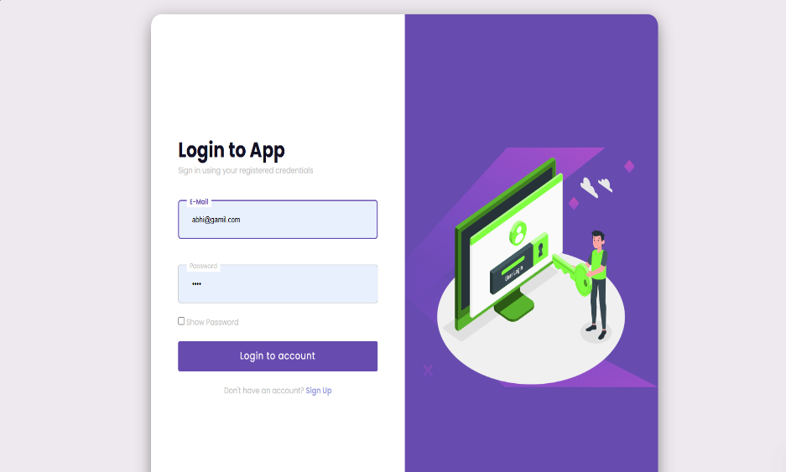

Figure A.1 Screenshot of User Login

The Login Page serves as a secure and user-friendly entry point to the system, ensuring that only authorized users gain access. It verifies credentials through a reliable authentication mechanism that protects sensitive data and prevents unauthorized entry. With its clean design and accessible layout, the login process remains simple, safe, and efficient for all users.

- User Dashboard

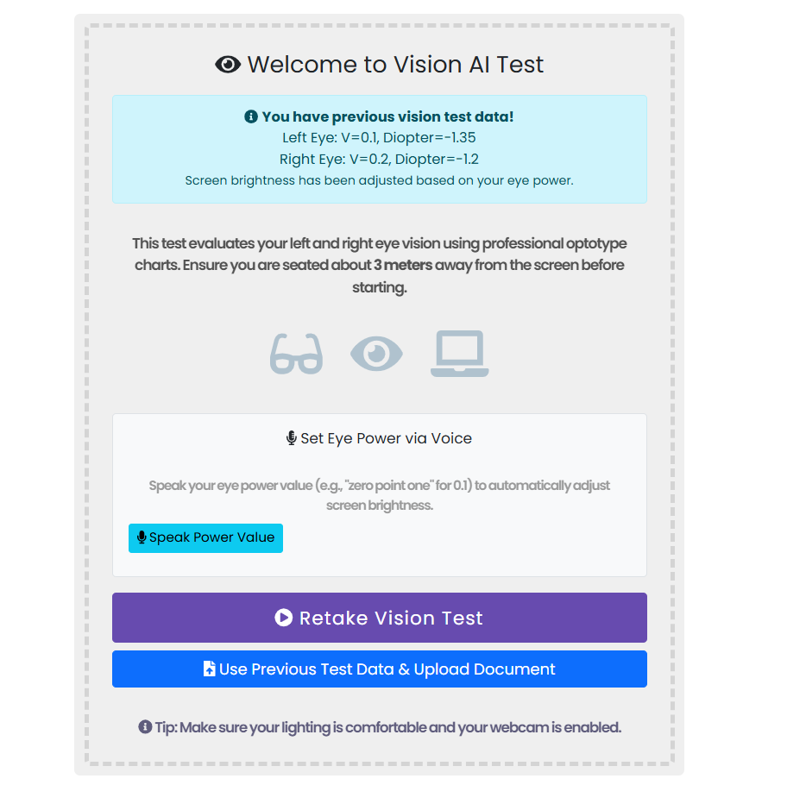

Figure A.2 Screenshot of User Dashboard

The User Dashboard provides a centralized and intuitive interface where users can easily access all major features of the system. It displays essential tools such as vision tests, document processing options, and personalized settings in a clean and organized layout. Designed for simplicity and efficiency, the dashboard helps users navigate the system effortlessly while maintaining a smooth and engaging experience.

- Vision Test Page

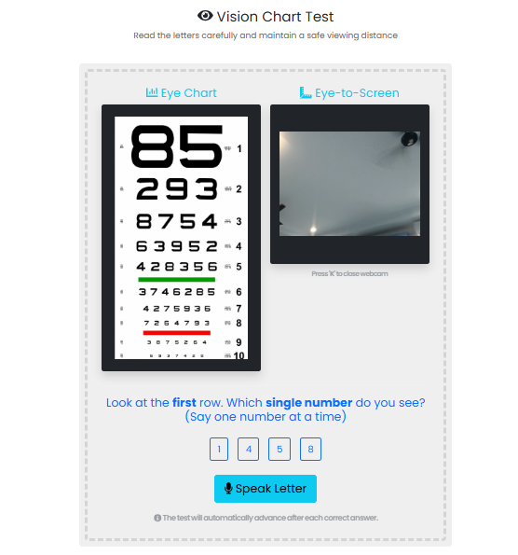

Figure A.3 Screenshot of Vision Test Page

The Vision Test page allows users to perform self-administered eye tests using interactive charts and guided instructions. It displays optotype letters in varying sizes to measure visual acuity accurately and estimate approximate diopter values. The page is designed for clarity and ease of use, ensuring users can complete the test comfortably while receiving instant, personalized results.

- Document Uploading

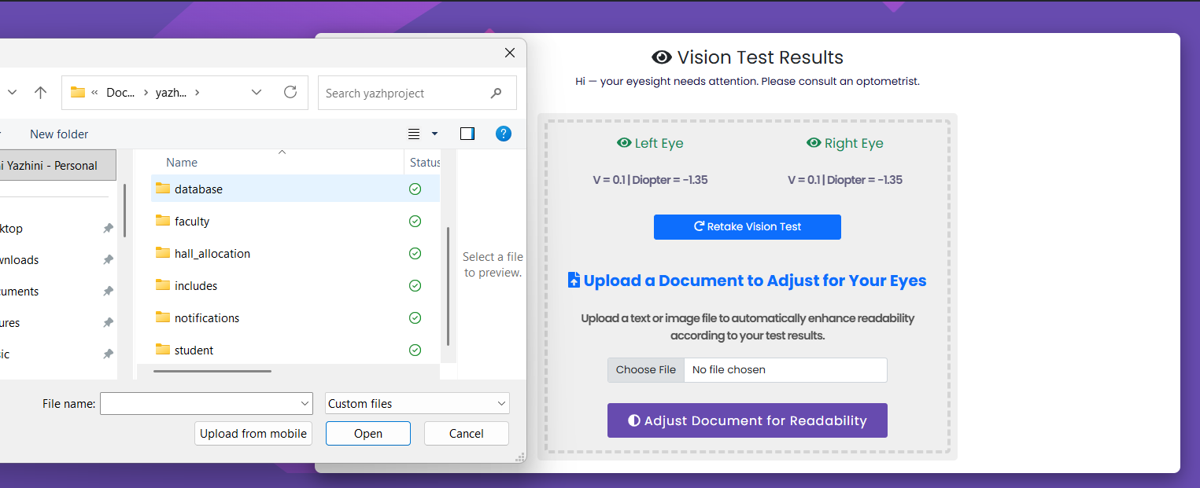

Figure A.4 Screenshot of Document Uploading

The Document Upload page allows users to upload PDFs, images, or text files for automatic accessibility enhancement. After uploading, the system adjusts the document by increasing text size, improving brightness, and optimizing line spacing based on the user's vision needs. The interface is simple and user-friendly, making document enhancement quick and convenient.

- Enhanced Document View

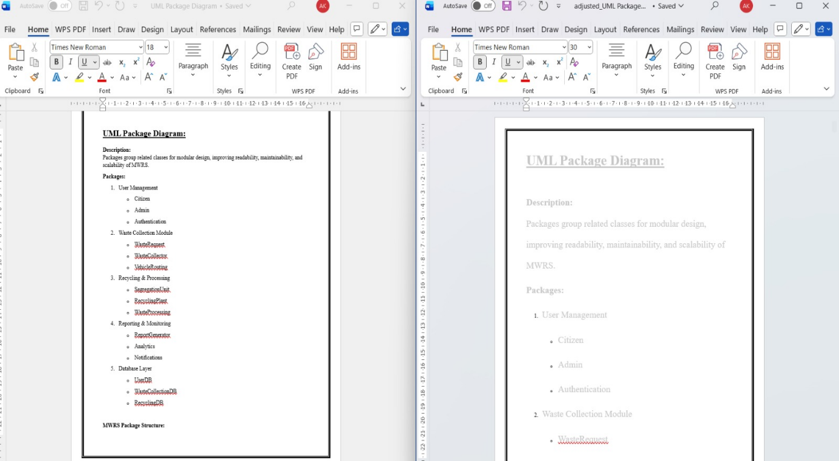

Figure A.5 Screenshot of Enhanced Document View

This module adjusts uploaded documents (PDF/DOCX) for optimal readability based on the user’s visual acuity and diopter values, dynamically scaling text, images, and contrast. It ensures a comfortable, accessible reading experience with zoom, pan, and annotation support.

REFERENCES

- P. Smith et al. Characterizing Visual Intents for People with Low Vision Using Eye Tracking. arXiv, 2025.
- S. K. et al. Eye Tracking-Based Adaptive Displays: A Review. SAGE Journals, 2023.
- Tang, K. Assistive Technology in Low Vision: Overview and Case Report. OEFP Journal, 2021.
- J. Doe et al. Head-Mounted Display Technology for Low Vision: A Review. PMC, 2017.
- MIT News. New display technology automatically corrects for vision defects. MIT News, 2014.
- R. K. Gupta et al. Deep Learning for Eye Tracking and Gaze Estimation: A Survey. IEEE Access, 2022.
- L. Li et al. Real-Time Face and Eye Landmark Tracking for Mobile Vision Applications. ACM Transactions on Graphics, 2021.
- T. Nguyen et al. Estimating Visual Acuity Using Remote Digital Displays. Journal of Ophthalmic Research, 2020.
- S. B. Patel et al. Digital Eye Testing Using Snellen and LogMAR Charts on Smartphones. Medical Vision Journal, 2023.
- M. Johnson et al. Document Accessibility Enhancement for Low-Vision Readers. ACM SIGACCESS, 2019.

