University Alumni Management System

1. Title (2 Marks)
University Alumni Management System using Object-Oriented Design

2. Problem Statement (5 Marks) (Paragraph)
Universities often struggle to maintain effective communication with their alumni after graduation. Information about alumni achievements, contributions, and participation in events is scattered, leading to poor engagement. Alumni also find it difficult to stay connected with their peers and the university. The problem is the absence of a centralized system that manages alumni data, events, donations, job postings, and communication in a secure and user-friendly manner.

3. Description of System (5 Marks) (Paragraph)
The Alumni Management System provides a digital platform to strengthen the bond between the university and its alumni. It allows alumni to register, update their profiles, network with peers, attend events, contribute donations, and access job opportunities. The system also helps administrators manage alumni data, organize events, send notifications, and generate reports. This enhances communication, fundraising, and long-term alumni engagement.
4. UML Diagrams (20 Marks)
Use case
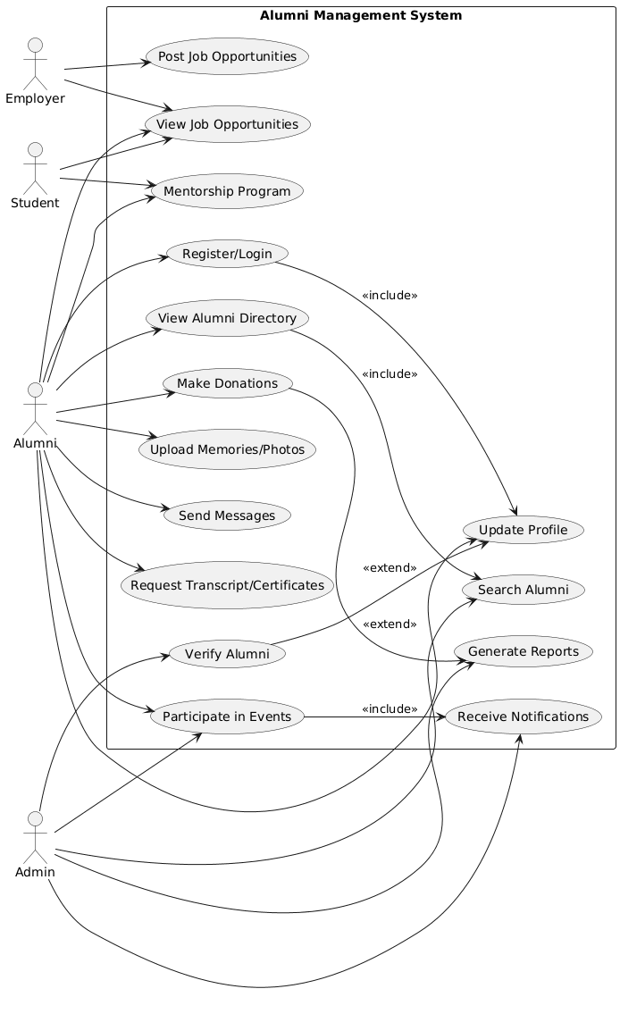

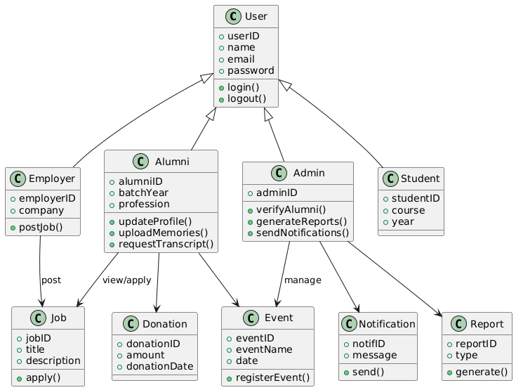

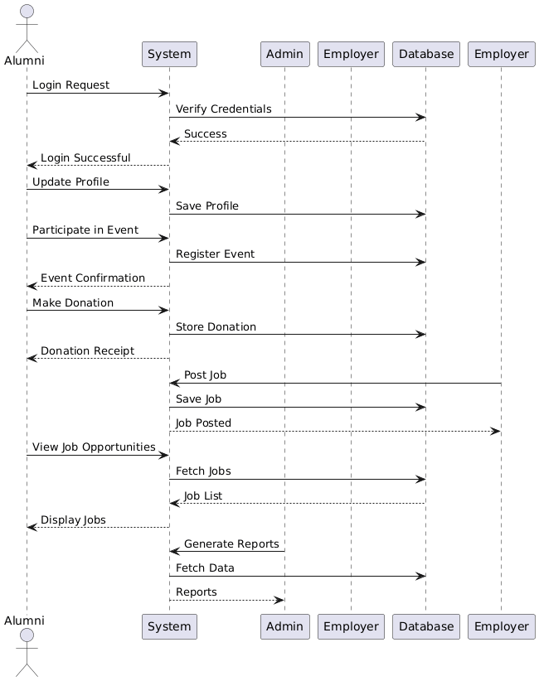
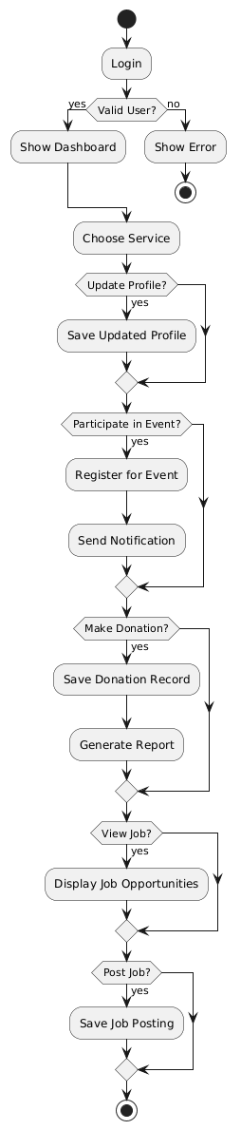
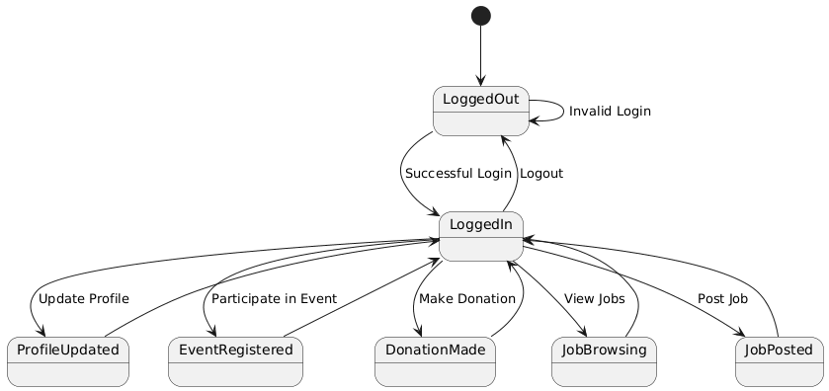
✅ Use Case Diagram
Actors
- Alumni – Former students, they can register/login, update profile, donate, participate in events, apply for jobs, join mentorship, share memories, request transcripts.
- Admin – Manages the system by verifying alumni, generating reports, managing events, sending notifications.
- Employer – Posts job opportunities and lets alumni/students apply.
- Student – Current students who can view jobs and participate in mentorship programs.
Use Cases
- Register/Login
- Update Profile
- View Alumni Directory
- Search Alumni
- Participate in Events
- Upload Memories/Photos
- Make Donations
- Generate Reports
- Receive Notifications
- Post Job Opportunities
- View Job Opportunities
- Mentorship Program
- Send Messages
- Request Transcript/Certificates
- Verify Alumni
Relationships
- Include:
  - Register/Login → Update Profile (users complete their profile after login).
  - Participate in Events → Receive Notifications (event reminders included).
  - View Alumni Directory → Search Alumni (search is part of directory browsing).
- Extend:
  - Make Donations → Generate Reports (reports extend donation records).
  - Verify Alumni → Update Profile (profile approval is extended by verification).
Explanation
This diagram models all user interactions in the Alumni Management System. Alumni, Admin, Employers, and Students perform different actions within the system. The relationships show optional or mandatory connections between tasks.

✅ Class Diagram
Classes
- User (abstract class) → Attributes: userID, name, email, password; Methods: login(), logout().
- Alumni → alumniID, batchYear, profession; Methods: updateProfile(), uploadMemories(), requestTranscript().
- Student → studentID, course, year.
- Admin → adminID; Methods: verifyAlumni(), generateReports(), sendNotifications().
- Employer → employerID, company; Methods: postJob().
- Job → jobID, title, description; Methods: apply().
- Event → eventID, eventName, date; Methods: registerEvent().
- Donation → donationID, amount, donationDate.
- Notification → notifID, message; Methods: send().
- Report → reportID, type; Methods: generate().
Relationships
- Inheritance: Alumni, Student, Admin, and Employer inherit from User.
- Associations: Alumni can join Events, make Donations, and apply for Jobs. Employer can post Jobs.
- Dependency: Admin depends on Report and Notification for management.
Explanation
This diagram shows the static structure of the system. It defines data storage (attributes) and behaviors (methods). Inheritance reduces redundancy while associations model the system’s functionality.

✅ Sequence Diagram
Flow
- Alumni sends Login request → System verifies with Database → Login successful.
- Alumni updates profile → System saves profile.
- Alumni participates in event → System registers event → Confirmation sent.
- Alumni makes a donation → System stores donation → Receipt given.
- Employer posts a job → System saves job → Job posted confirmation.
- Alumni views job opportunities → System fetches job list → Jobs displayed.
- Admin generates reports → System fetches data → Reports generated.
Explanation
This diagram captures real-time interactions between actors, system, and database. It shows how requests flow step by step from users to the system and back.

✅ Activity Diagram
Activities
- User logs in.
- If login valid → show dashboard, else error.
- Choose a service:
  - Update profile
  - Participate in event → notification sent
  - Make donation → donation recorded & report generated
  - View job opportunities
  - Post job opportunity
- End of session.
Explanation
This diagram represents the workflow of the system. Each activity is a step, with decision nodes showing different user choices. It highlights the flexibility of services offered to alumni, students, admins, and employers.

✅ State Machine Diagram
States
- LoggedOut → Initial state.
- LoggedIn → After successful login.
- ProfileUpdated → When user updates profile.
- EventRegistered → When alumni register for events.
- DonationMade → After making donations.
- JobBrowsing → When viewing job opportunities.
- JobPosted → When employer posts a job.
- LoggedOut → Returning state when session ends.
Explanation
This diagram captures state transitions of a user in the system. Starting from LoggedOut, users transition through multiple states depending on actions, and finally return to LoggedOut. It models the dynamic behavior of the system.

Components of UML Diagrams
- Actors
  - Actors represent the people, systems, or organizations that interact with the system.
  - Example: In our Alumni Management System, actors are Alumni, Admin, Employer.
- Use Cases
  - Use cases describe the specific functions or actions the system performs for the actors.
  - Example: Register/Login, Update Profile, Make Donation, Participate in Events.
- Classes
  - Classes are blueprints of objects that define attributes (data) and methods +(functions).
  - Example: Alumni, Admin, Employer, Event, Donation, Job, Notification.
- Objects
  - Objects are instances of classes that represent real entities at runtime.
  - Example: An Alumni named “John”, an Event called “Annual Meet 2025”.
- Messages
  - Messages are the communications or interactions exchanged between objects in sequence diagrams.
  - Example: Alumni → System: Register for Event or System → Admin: Notify Registration.
- Activities
  - Activities represent the workflow or tasks performed in the system, often shown in activity diagrams.
  - Example: Login → Update Profile → Register for Event → Donate → Apply for Job.
- States
  - States describe the condition of an object at a particular point in time.
  - Example: Logged In, Profile Updated, Event Registered, Donation Made.
- Transitions
  - Transitions show how an object moves from one state to another due to an action or event.
  - Example: Login → Profile Updated when the user edits their details.
- Relationships
  - Relationships define how different elements in the system are connected.
  - Types: Association, Aggregation, Composition, Dependency, Include, Extend.
  - Example: Alumni is associated with Event and Donation, Admin manages Events.
- Diagrams
- UML diagrams are visual models that represent system design and behavior.
- Types used: Use Case, Class, Sequence, Activity, State Machine.

6. Relationships Used with Explanation (5 Marks) (Points)
- Association → Alumni linked to Events, Donations, Jobs.
- Aggregation → Admin manages multiple events.
- Composition → Alumni owns personal Profile.
- Dependency → System depends on Admin to confirm registrations.
- Include/Extend → Donations extend Reports, Login includes Profile Update.

7. Conclusion (3 Marks) (Paragraph)
The University Alumni Management System helps maintain strong relationships between alumni and the university. It provides features like networking, event participation, donations, and job opportunities in a structured way. Using UML diagrams, the system’s structure and behavior are clearly modeled, ensuring a robust and scalable design. This project demonstrates how object-oriented design enhances communication, efficiency, and long-term engagement between universities and their alumni.

