


A Project Report on

CRIME FILE MANAGEMENT SYSTEM

Submitted in partial fulfillment of requirements for the award of the course of

CSB1303 - OBJECT-ORIENTED ANALYSIS AND DESIGN
Under the guidance of

Mrs. P. Kayalvizhi M.E.,

Professor / CSE

Submitted By

ABHI YAZHINI P (927623BCS001)

DEPARTMENT OF COMPUTER SCIENCE AND ENGINEERING

M.KUMARASAMY COLLEGE OF ENGINEERING
(Autonomous)

KARUR – 639 113
DECEMBER 2025

M. KUMARASAMY COLLEGE OF ENGINEERING
(Autonomous Institution affiliated to Anna University, Chennai)

KARUR – 639 113

BONAFIDE CERTIFICATE

This is to certify that this project report on “CRIME FILE MANAGEMENT SYSTEM” is the bonafide work of ABHI YAZHINI P (927623BCS001) who carried out the project work during the academic year 2025 - 2026 under my supervision.

Signature | Signature
Mrs. P. Kayalvizhi M.E., | Dr. D. PRADEEP M.E.,Ph.D.,
SUPERVISOR, | HEAD OF THE DEPARTMENT,
Department of Computer Science and Engineering, | Department of Computer Science and Engineering,
M. Kumarasamy College of Engineering, | M. Kumarasamy College of Engineering,
Thalavapalayam, Karur -639 113. | Thalavapalayam, Karur -639 113.

This Project Work (Subject Code) report has been submitted for the ___ Semester Project viva voce Examination held on ________________

INTERNAL EXAMINER EXTERNAL EXAMINER
i

DEPARTMENT OF COMPUTER SCIENCE AND ENGINEERING VISION OF THE INSTITUTION
To emerge as a leader among the top institutions in the field of technical education

MISSION OF THE INSTITUTION

- Produce smart technocrats with empirical knowledge who can surmount the global challenges
- Create a diverse, fully-engaged, learner-centric campus environment to provide quality education to the students
- Maintain mutually beneficial partnerships with our alumni, industry, and Professional associations

VISION OF THE DEPARTMENT

To achieve education and research excellence in computer Science and Engineering

MISSION OF THE DEPARTMENT
- To excel in academic through effective teaching learning techniques.
- To promote research in the area of computer science and engineering with the focus on innovation.
- To transform students into technically competent professionals with societal and ethical responsibilities.

PROGRAM EDUCATIONAL OBJECTIVES (PEOs)
- PEO1: Graduates will have successful Career in software industries and R&D divisions through continuous learning
- PEO2: Graduates will provide effective solutions for real world problems in the key domain of computer science and engineering and engage in lifelong learning.
- PEO3: Graduates will excel in their profession by being ethically and socially responsible

PROGRAM OUTCOMES (POs)
Engineering students will be able to:
- Engineering knowledge: Apply the knowledge of mathematics, science, engineering fundamentals, and an engineering specialization to the solution of complex engineering problems.
- Problem analysis: Identify, formulate, review research literature, and analyze complex engineering problems reaching substantiated conclusions using first principles of mathematics, natural sciences, and engineering sciences.
- Design/development of solutions: Design solutions for complex engineering problems and design system components or processes that meet the specified needs with appropriate consideration for the public health and safety, and the cultural, societal, and environmental considerations.
- Conduct investigations of complex problems: Use research-based knowledge and research methods including design of experiments, analysis and interpretation of data, and synthesis of the information to provide valid conclusions.
- Modern tool usage: Create, select, and apply appropriate techniques, resources, and modern engineering and IT tools including prediction and modeling to complex engineering activities with an understanding of the limitations.
- The engineer and society: Apply reasoning informed by the contextual knowledge to assess societal, health, safety, legal and cultural issues and the consequent responsibilities relevant to the professional engineering practice.
- Environment and sustainability: Understand the impact of the professional engineering solutions in societal and environmental contexts, and demonstrate the knowledge of, and need for sustainable development.
- Ethics: Apply ethical principles and commit to professional ethics and responsibilities and norms of the engineering practice.
- Individual and team work: Function effectively as an individual, and as a member or leader in diverse teams, and in multidisciplinary settings.
- Communication: Communicate effectively on complex engineering activities with the engineering community and with society at large, such as, being able to comprehend and write effective reports and design documentation, make effective presentations, give and receive clear instructions.

- Project management and finance: Demonstrate knowledge and understanding of the engineering and management principles and apply these to one’s own work, as a member and leader in a team, to manage projects and in multidisciplinary environments.
- Life-long learning: Recognize the need for, and have the preparation and ability to engage in independent and life-long learning in the broadest context of technological change.
PROGRAM SPECIFIC OUTCOMES (PSOs)
  - PSO1: Professional Skills: Ability to apply the knowledge of computing techniques to design and develop computerized solutions for the problems.
  - PSO2: Successful career: Ability to utilize the computing skills and ethical values in creating a successful career.

SDG Goal |  | Remarks
SDG 7 | This project aligns with global Sustainable Development Goals by enhancing safety resilience and climate readiness | Enhances community safety and reduces disaster-related casualties

ABSTRACT

The Pet Care Management System is a web-based application designed to help pet owners and veterinarians manage pet-related information efficiently. The system allows users to register pets, schedule appointments, track medical records, record vaccinations, and receive reminders for upcoming care needs. By replacing manual note-taking and scattered records with a centralized digital platform, the system improves accessibility, reduces errors, and ensures timely healthcare for pets. Built using PHP, MySQL, HTML, and CSS, the system provides a user-friendly interface with secure data storage and role-based access. This project implements UML diagrams such as use case, sequence, activity, collaboration, and deployment diagrams to clearly demonstrate system workflow and architecture. Overall, the Pet Care Management System enhances pet health management and simplifies everyday pet care activities.

ABSTRACT WITH POs AND PSOs MAPPING
ABSTRACT | COs  MAPPED | POs  MAPPED | PSOs  MAPPED
The Pet Care Management System is a web-based application designed to help pet owners and veterinarians manage pet-related information efficiently. The system allows users to register pets, schedule appointments, track medical records, record vaccinations, and receive reminders for upcoming care needs. By replacing manual note-taking and scattered records with a centralized digital platform, the system improves accessibility, reduces errors, and ensures timely healthcare for pets. Built using PHP, MySQL, HTML, and CSS, the system provides a user-friendly interface with secure data storage and role-based access. This project implements UML diagrams such as use case, sequence, activity, collaboration, and deployment diagrams to clearly demonstrate system workflow and architecture. Overall, the Pet Care Management System enhances pet health management and simplifies everyday pet care activities. | CO1 CO2 CO3 CO4 CO5 | PO1 PO2 PO3  PO4  PO5 PO6  PO7 PO8  PO9 PO10 PO11 PO12 | PSO1 PSO2
Note: 1- Low, 2-Medium, 3- High

SUPERVISOR HEAD OF THE DEPARTMENT

TABLE OF CONTENTS

CHAPTER  No. | TITLE | PAGE  No.
 | ABSTRACT | vii
1 | Introduction | 1
 | 1.1 Domain Introduction | 1
 | 1.2 Scope of the Project | 1
 | 1.3 Objective | 2
2 | Project Overview | 3
 | 2.1 Problem Definition | 3
 | 2.2 Existing System | 3
 | 2.3 Proposed Work | 4
 | 2.4 Feasibility Study | 5
 | 2.5 Architecture Diagram | 5
3 | Requirement Analysis | 6
 | 3.1 Functional Requirement | 6
 | 3.2 Non-Functional Requirements | 6
 | 3.3 Software and Hardware Requirements | 6
4 | Use Case Modeling | 7
 | 4.1 Use Case Identification | 7
 | 4.2 Actors and Descriptions | 7
 | 4.3 Use Case Diagram | 8
 | 4.4 Detailed Use Case Descriptions | 8
 | 4.5 Use Case Scenarios | 11
5 | Object-Oriented Analysis (OOA) | 13
 | 5.1 Identification of Classes | 13
 | 5.2 Class Responsibilities and Collaborators (CRC Cards) | 13
 | 5.3 Analysis Class Diagram | 14
 | 5.4 Object Interaction Diagram | 14
 | 5.4.1 Sequence Diagram | 15
 | 5.4.2 Collaboration Diagram | 17
6 | Object-Oriented Design (OOD) | 19
 | 6.1 System Architecture | 19
 | 6.2 Design Class Diagram | 8
 | 6.3 Package Diagram | 8
 | 6.4 Component Diagram | 9
 | 6.5 Deployment Diagram | 9
 | 6.6 Interface and API Design | 9
 | 6.7 Database Design
7 | Implementation Details
 | 7.1 Programming Language and Tools
 | 7.2 Key Modules
 | 7.2.1 User Management Module
 | 7.2.2 FIR Management Module
 | 7.2.3 Suspect Management Module
 | 7.2.4 Evidence Management Module
 | 7.2.5 Case Management Module
 | 7.2.6 Report Generation Module
8 | Testing | 10
 | 8.1 Test Plan | 10
 | 8.2 Test Cases | 14
 | 8.3 System Testing | 18
 | 8.4 Integration Testing | 18
 | 8.5 User Acceptance Testing (UAT)
9 | Results and Discussion
 | 9.1 Output Screens
 | 9.2 Performance Analysis
 | 9.3 Discussion
10 | Conclusion and Future Enhancement
 | 10.1 Conclusion
 | 10.2 Limitations
 | 10.3 Future Enhancements
11 | Bibliography / References
12 | Appendix
 | A. Source Code Snippets

CHAPTER 1

INTRODUCTION

  - DOMAIN INTRODUCTION

The Pet Care Management System belongs to the domain of Veterinary and Pet Management Software, a sector focused on digitizing pet healthcare, appointments, and record tracking. Traditional pet care relies heavily on manual note-keeping, which often results in misplaced records, forgotten appointments, and difficulty managing vaccination schedules. With growing demand for organized, reliable, and easily accessible pet care information, digital management systems have become essential. The domain supports pet owners and veterinarians by enabling efficient handling of medical records, appointments, and reminders, improving overall pet wellness and user convenience.

  - SCOPE OF THE PROJECT

The scope of the Pet Care Management System includes:
- Maintaining pet details such as breed, age, medical history, and vaccination records.
- Allowing pet owners to schedule and manage vet appointments.
- Helping veterinarians access pet medical histories quickly.
- Sending reminders for vaccinations, appointments, and routine check-ups.
- Generating reports on pet health and visit history.
The system can be extended to include grooming bookings, online consultation, and integration with pet shops or pet insurance services.

  - OBJECTIVE

The main objective of the Pet Care Management System is to provide a structured digital platform for managing pet records efficiently and securely.
Specific Objectives
- Maintain accurate and updated pet profiles.
- Enable easy scheduling and tracking of appointments.
- Provide reminders for vaccinations and routine check-ups.
- Store medical records securely for quick access.
- Improve communication between pet owners and veterinarians.
- Reduce manual work and minimize missed appointments.

CHAPTER 2
PROJECT OVERVIEW

  - PROBLEM DEFINITION

In the existing pet care process, information is stored manually in notebooks or scattered across phone messages, making it difficult to track vaccination dates, previous treatments, and appointment histories. Missed reminders can lead to delayed treatment and neglected pet care. Veterinarians often struggle to access past medical records, leading to inefficient decision-making. A centralized digital system is needed to manage all pet-related information accurately and securely.

  - EXISTING SYSTEM

The existing system is mostly manual:
- Pet details are written on paper or stored on phone notes.
- Appointment reminders depend on memory.
- Medical records are kept in files that can be lost or damaged.
- No centralized access for veterinarians.
- Tracking vaccination dates becomes confusing.
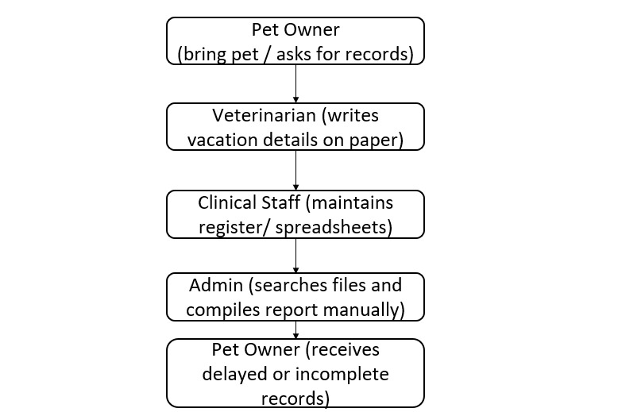
Fig.2.2.1. Existing System

  - PROPOSED WORK

1. User Authentication
- Separate login for Admin, Pet Owner, and Veterinarian
- Admin manages users and the entire system
2. Pet Profile Management
- Add, view, and update pet details
- Maintain medical history and vaccination details
3. Appointment Management
- Pet owners can book or cancel appointments
- Veterinarians can confirm or modify appointments
4. Medical Record Management
- Store diagnosis, treatment details, prescriptions
- Record vaccination history
5. Notifications & Reminders
- Alerts for upcoming appointments
- Vaccination reminders
- Follow-up notifications
6. Report Generation
- Pet health reports
- Appointment history reports
7. Secure Data Storage
- All information stored safely in a MySQL database
- Role-based access control

  - FEASIBILITY STUDY
- Technical Feasibility
- Uses PHP, MySQL, HTML, CSS
- Runs on local servers like XAMPP
- Requires minimum system configuration
- Operational Feasibility
- Easy-to-use interface
- Reduces manual effort
- Minimal training required
- Economic Feasibility
- Low development cost
- Uses open-source tools
- Reduces cost of maintaining physical records
  - ARCHITECTURE DIAGRAM
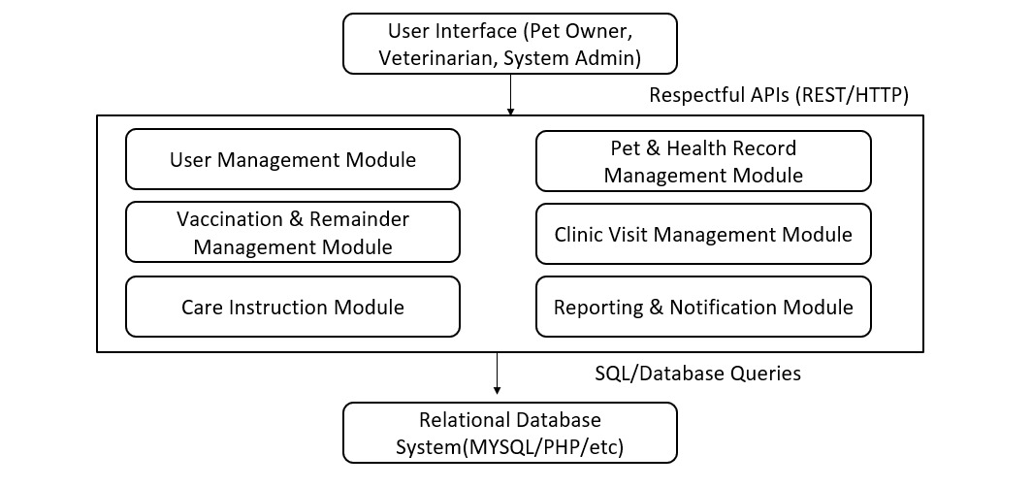
Fig.2.5.1. Architecture Diagram

CHAPTER 3
REQUIREMENT ANALYSIS
- FUNCTIONAL REQUIREMENTS
- Add, update, and manage pet profiles
- Book and manage appointments
- Store vaccination and medical records
- Generate pet health and visit reports
- Send reminders and notifications
- Role-based login (Admin, Owner, Vet)
  - NON- FUNCTIONAL REQUIREMENTS
- Performance: Page loads within 2–3 seconds
- Security: Password encryption, secure records
- Usability: Simple and user-friendly interface
- Reliability: Available 24/7
- Scalability: Supports multiple pets and users
  - SOFTWARE AND HARDWARE REQUIREMENTS
Software Requirements:
- XAMPP Server (Apache, MySQL, PHP)
- Web Browser (Chrome, Edge)
- Code Editor (VS Code, Sublime Text)
- Operating System: Windows 10 or higher
Hardware Requirements:
- Processor: Intel i3 or higher
- RAM: 4 GB or higher
- Hard Disk: 500 GB or higher
CHAPTER 4
USE CASE MODELLING

- USE CASE IDENTIFICATION
Based on the UML diagram structure, the following primary use cases are identified for the Crime File Management System:
- Register Pet
- View Pet Health Record
- Schedule Reminder
- Manage Clinic Visits
- Record Vaccination
- Update Care Instructions
- Manage Users
- Manage Clinics
- Manage Vaccine Templates
- View System Reports
- Configure Notification Settings
- Data Backup & Restore

- ACTORS AND DESCRIPTIONS

Pet Owner
The Pet Owner is the primary user of the system. Their main responsibility is to manage and monitor the health information of their pets. They can register new pets, view health history, schedule reminders for vaccinations or medicines, and receive alerts from the system. The Pet Owner interacts with the system mainly to keep track of their pet’s health and upcoming medical needs.
Veterinarian
The Veterinarian plays a crucial role in maintaining accurate health records for pets. They are responsible for recording vaccinations, updating health updates after check-ups, and providing care instructions. They also manage clinic visit details such as diagnosis, medicines prescribed, and follow-up dates. The Veterinarian ensures that the pet’s medical information in the system remains updated and reliable.
Admin
The Admin manages the overall system and ensures smooth operation. Their responsibilities include managing user accounts (Pet Owners and Veterinarians), updating clinic information, configuring system settings, and generating system-wide reports. The Admin oversees security, access control, and backup of system data. They act as the controller of the platform and maintain the system’s integrity.
.

- USE CASE DIAGRAM
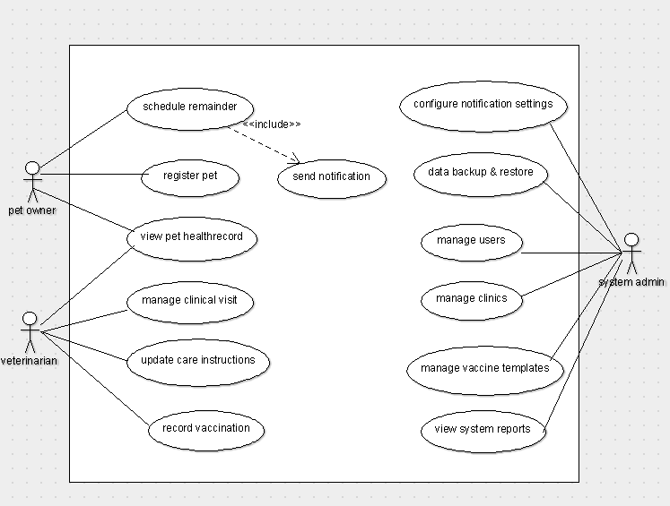
Fig.4.3.1. Use Case Diagram

- DETAILED USE CASE DIAGRAM
Use Case 1: Login
- Actors: Pet Owner, Veterinarian, Admin
- Description: User enters valid credentials to gain access to the system.
- Pre-condition: User must already be registered in the system.
- Post-condition: User is authenticated and redirected to their respective dashboard.
- Includes: Authenticate User
Use Case 2: Register Pet
- Actor: Pet Owner
- Description: Pet Owner registers a new pet by entering details such as name, age, breed, and medical history.
- Pre-condition: Pet Owner must be logged in.
- Post-condition: Pet profile is successfully added to the system.
- Includes: Validate Pet Details
Use Case 3: View Pet Health Record
- Actor: Pet Owner
- Description: Displays vaccination history, clinic visits, reminders, and treatment info for the selected pet.
- Pre-condition: Pet must exist in the system.
- Post-condition: Health record information is displayed to the user.
Use Case 4: Record Vaccination
- Actor: Veterinarian
- Description: Veterinarian updates pet vaccination details including vaccine name, date, dosage, and next due date.
- Pre-condition: Pet must exist in the system.
- Post-condition: Vaccination record is saved.
- Includes: Update Health Record
Use Case 5: Update Care Instructions
- Actor: Veterinarian
- Description: Veterinarian adds or updates care instructions like diet, medicine, and post-treatment notes.
- Pre-condition: Clinic visit or vaccination must be logged.
- Post-condition: Updated instructions stored in health record.
Use Case 6: Create Reminder
- Actor: Pet Owner
- Description: User sets reminders for vaccinations, medicines, or grooming.
- Pre-condition: Pet must be registered.
- Post-condition: Reminder is saved and notification scheduling is activated.
- Includes: Validate Reminder
Use Case 7: Receive Notification
- Actors: Pet Owner
- Description: System automatically sends notifications for upcoming vaccinations, clinic visits, or care reminders.
- Pre-condition: Reminder must exist.
- Post-condition: Notification is sent via email/SMS/app alert.
Use Case 8: Manage Clinic Visits
- Actor: Veterinarian
- Description: Logs visit date, diagnosis, treatment, and recommendations.
- Pre-condition: Pet must exist.
- Post-condition: Clinic visit details are stored in database.
Use Case 9: Update Clinic Visit
- Actor: Veterinarian
- Description: Edits previously entered clinic visit details.
- Pre-condition: Clinic visit must exist.
- Post-condition: Updated visit is saved.
Use Case 10: Manage Users
- Actor: Admin
- Description: Admin adds, updates, or deletes Pet Owner/Veterinarian accounts.
- Pre-condition: Admin must be logged in.
- Post-condition: User information is updated in the system.
Use Case 11: Manage Clinics
- Actor: Admin
- Description: Admin manages veterinary clinic details such as name, address, timings.
- Pre-condition: Admin must be logged in.
- Post-condition: Clinic details saved or updated.
Use Case 12: Manage Vaccine Templates
- Actor: Admin
- Description: Admin adds vaccine templates like vaccine name, validity period, recommended age.
- Pre-condition: Admin must be logged in.
- Post-condition: Template stored for future vet usage.
Use Case 13: Search Pets / Visits
- Actors: Pet Owner, Veterinarian, Admin
- Description: Searches for pets, clinic visits, and medical history.
- Pre-condition: User must be logged in.
- Post-condition: Search results displayed.
Use Case 14: Generate Reports
- Actor: Admin
- Description: Admin generates overall system reports like total pets, active reminders, vet activity, visits summary.
- Pre-condition: Sufficient system data must exist.
- Post-condition: Report generated and displayed.
Use Case 15: View Reports
- Actors: Admin
- Description: Admin views previously generated or newly created reports.
- Pre-condition: Reports must exist.
- Post-condition: Report displayed.
- Includes: Generate Reports
Use Case 16: Backup & Restore
- Actor: Admin
- Description: Admin performs system data backup and restores from previous backups if required.
- Pre-condition: Admin must be authenticated.
- Post-condition: Backup or restore completed successfully.

- USE CASE SCENARIOS
Scenario 1: Pet Owner Registers a Pet
- Pet Owner logs into the system.
- Selects “Register Pet” option.
- Enters the pet’s details (name, breed, age, medical info).
- System validates the entered data.
- Pet details are stored in the database.
- System displays a confirmation message.
Scenario 2: Pet Owner Schedules a Reminder
- Pet Owner logs in.
- Selects “Schedule Reminder” for vaccinations/medications.
- Enters reminder date and type.
- System processes the reminder.
- System triggers the included use case → “Send Notification.”
- Notification is scheduled for future delivery.
- Confirmation message is shown to the Pet Owner.
Scenario 3: Veterinarian Records Vaccination
- Veterinarian logs into the system.
- Selects “Record Vaccination.”
- Opens the pet’s record from list.
- Enters vaccination details (vaccine type, date, next due).
- System validates the vaccination details.
- Vaccination record is saved.
- System sends notification to Pet Owner (via included “Send Notification”).
- Confirmation message is displayed.
Scenario 4: Veterinarian Updates Care Instructions
- Veterinarian logs in.
- Selects “Update Care Instructions.”
- Opens pet health record.
- Enters new instructions (diet, medication, follow-up steps).
- System updates the care instructions in the database.
- Pet Owner receives updated instructions in their dashboard.
- Confirmation is shown.
Scenario 5: Veterinarian Manages Clinical Visit
- Veterinarian logs in.
- Selects “Manage Clinical Visit.”
- Views today’s/ upcoming appointments.
- Records diagnosis, treatment, tests, and notes.
- System updates the clinical history.
- Pet Owner can view the updated visit details.
- Confirmation shown.
Scenario 6: Pet Owner Views Pet Health Record
- Pet Owner logs in.
- Selects “View Pet Health Record.”
- System retrieves vaccination history, clinical visits, and care instructions.
- Pet Owner views the full health record.
Scenario 7: Admin Manages Users
- System Admin logs into the system.
- Selects “Manage Users.”
- Admin adds, edits, or deletes user accounts (Pet Owner/Vet).
- System updates user data in the database.
- Confirmation message displayed.
Scenario 8: Admin Configures Notification Settings
- System Admin logs in.
- Opens “Configure Notification Settings.”
- Updates email/SMS templates, frequencies, or triggers.
- System updates notification configuration.
- Confirmation message shown.
Scenario 9: Admin Manages Clinics
- System Admin logs in.
- Selects “Manage Clinics.”
- Adds or updates clinic information (name, address, veterinarian assignment).
- System saves clinic details.
- Confirmation shown.
Scenario 10: Admin Manages Vaccine Templates
- System Admin logs in.
- Selects “Manage Vaccine Templates.”
- Adds or updates standard vaccine names, schedules, and due intervals.
- System updates template records.
- Confirmation shown.
Scenario 11: Admin Performs Data Backup & Restore
- System Admin logs in.
- Selects “Data Backup & Restore.”
- Chooses to backup or restore system data.
- System performs the selected operation.
- Admin receives success confirmation.
Scenario 12: Admin Views System Reports
- System Admin logs in.
- Selects “View System Reports.”
- System gathers required data (registrations, visits, vaccinations).
- Report is generated and displayed.
- Admin can export or print the report.
CHAPTER 5
OBJECT - ORIENTED ANALYSIS(OOA)
- IDENTIFICATION OF CLASSES
Based on the system functionalities, the following analysis-level classes are identified:
- User
- PetOwner
- Veterinarian
- Admin
- Pet
- HealthRecord
- Reminder
- ClinicVisit
- CLASS RESPONSIBILITIESAND COLLABORATORS (CRC CARDS)
1. User
- Responsibilities: Login, Search cases, View reports
- Collaborators: Case, Report
2. Admin (inherits User)
- Responsibilities: Manage users, Add FIR, Update FIR, Delete FIR, Delete suspect, Update case details, Update case status, Generate reports
- Collaborators: User, FIR, Case, Suspect, Report
3. Investigator (inherits User)
- Responsibilities: Add suspect, Update suspect, Track case progress, Update case details
- Collaborators: Case, Suspect
4. Viewer (inherits User)
- Responsibilities: Search cases, Search suspects, View reports
- Collaborators: Case, Report

5. FIR
- Responsibilities: Store FIR details, Validate FIR details, Link FIR to case
- Collaborators: Admin, Case
6. Case
- Responsibilities: Store case details, Update case status, Maintain investigation details, Link to suspects
- Collaborators: FIR, Suspect, Admin, Investigator
7. Suspect
- Responsibilities: Store suspect information, Update suspect details
- Collaborators: Case, Investigator, Admin
8. Report
- Responsibilities: Generate reports, Display report details
- Collaborators: Admin, Viewer, Case
- ANALYSIS CLASS DIAGRAM
The Class Diagram illustrates the relationships between classes in the Crime File Management System:
- User is a general class with subclasses Admin, Investigator, and Viewer (inheritance).
- Admin, Investigator, and Viewer interact with the system through operations like managing FIRs or suspects.
- FIR is associated with Case (one-to-many relation).
- Case is linked to Suspect and Evidence through one-to-many associations.
- Report depends on Case for data aggregation.

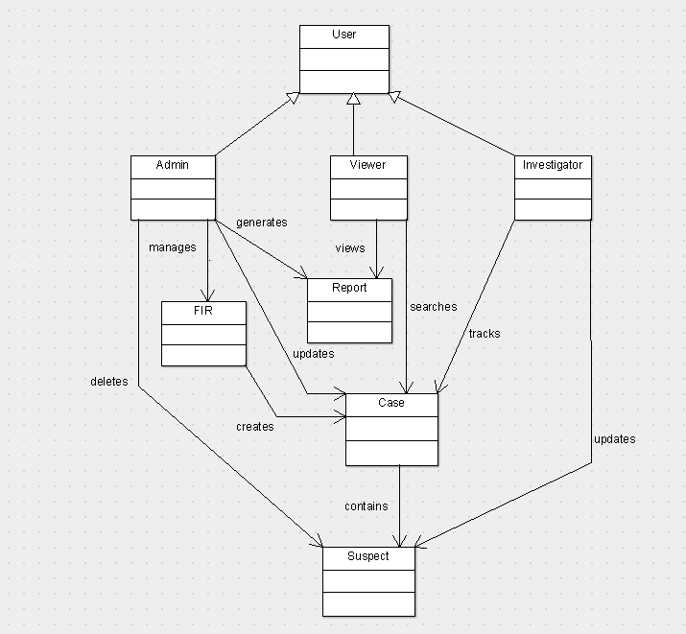
Fig.5.3.1. Analysis Class Diagram
- OBJECT INTERACTION DIAGRAM
Object interaction diagrams show how objects communicate during program execution.
- SEQUENCE DIAGRAM
The sequence diagram illustrates the step-by-step flow of interactions between the Admin, Investigator, Viewer, the System, and the Database. It shows how different users perform operations such as authentication, adding FIRs, updating suspects, tracking case progress, and generating or viewing reports. The diagram emphasizes the order of messages exchanged during each operation.
1. User Authentication
- Admin/Investigator/Viewer enters login credentials.
- The System sends the credentials to the Database to validate the user.
- The Database verifies and returns a success response.
- The System grants access to the user.

2. Adding an FIR (Admin)
- The Admin sends “Add FIR” request to the System.
- The System stores FIR details into the Database.
- The Database saves the FIR and returns confirmation.
- The System notifies the Admin with a confirmation message.

3. Adding a Suspect (Investigator)
- Investigator triggers “Add Suspect”.
- The System sends suspect data to the Database for storage.
- Database stores the suspect details and returns confirmation.
- System sends success message back to the Investigator.

4. Updating a Case (Admin or Investigator)
- User sends “Update Case” request to the System.
- The System updates case information in the Database.
- Database confirms the update.
- System sends the confirmation back to the user.

5. Tracking Case Progress (Investigator)
- Investigator requests case progress details.
- The System retrieves case status from the Database.
- Database returns case details.
- System displays progress to the Investigator.

6. Generating Report (Admin)
- Admin sends “Generate Report” request.
- System fetches case data from the Database.
- Database returns case data.
- System generates the report and sends it to the Admin.

7. Viewing Report (Viewer)
- Viewer sends “View Report” request.
- System requests report data from the Database.
- Database returns the report data.
- System displays the report to the Viewer.
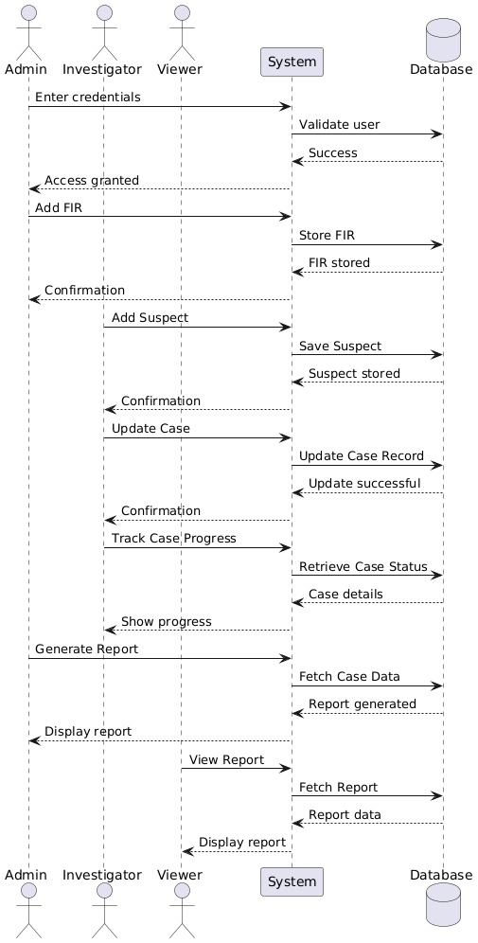
Fig.5.4.1.1. Sequence Diagram
- COLLABORATION DIAGRAM
The Collaboration Diagram for the Crime File Management System illustrates how various objects interact with each other to accomplish a specific functionality—such as creating an FIR, updating a suspect, assigning cases, or generating reports. Unlike the sequence diagram, which focuses on the time sequence of messages, the collaboration diagram emphasizes the structural organization of objects and how messages flow between them.
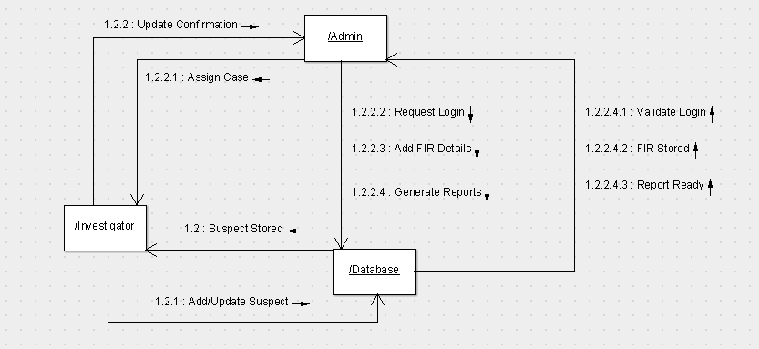
Fig.5.4.2.1 Collaboration Diagram

CHAPTER 6
OBJECT ORIENTED DESIGN(OOD)
- SYSTEM ARCHITECTURE
The Pet Care Management System follows a 3-Tier Architecture, ensuring modularity, security, and maintainability.

1. Presentation Layer (Frontend)
- Provides user interfaces for Pet Owner, Veterinarian, and Admin.
- Allows login, pet registration, vaccination input, reminders scheduling, and viewing reports.
- Technologies: HTML, CSS, JavaScript, Bootstrap.
- Handles:
  - Pet Owner dashboard
  - Veterinarian dashboard
  - Admin dashboard
  - Forms and data entry screens

2. Application Layer (Business Logic Layer)
- Contains core logic for system operations.
- Validates data and processes requests.
- Handles functionalities:
  - Registering pets
  - Recording vaccinations
  - Updating care instructions
  - Scheduling reminders
  - Managing clinics
  - Managing users
  - Generating reports
  - Triggering notifications

3. Data Layer (Database Layer)
- Stores all system-related information including:
  - Users
  - Pets
  - HealthRecords
  - VaccinationRecords
  - ClinicalVisits
  - Reminders
  - Clinics
  - Vaccine Templates
- Provides CRUD operations with data consistency and security.
- Uses MySQL / phpMyAdmin.
.
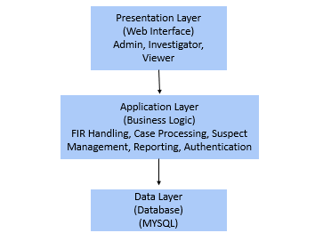
Fig.6.1.1. System Architecture

- DESIGN CLASS DIAGRAM
The Design Class Diagram for the Pet Care Health Tracking System represents the structure and relationships between major classes in the system. It includes all key entities such as User, Pet, Veterinarian, Admin, HealthRecord, and Reminder, along with their attributes, methods, inheritance, and associations.
- Key Points of the Design Class Diagram:
- User is the base class with subclasses:
- Admin
- PetOwner
- Veterinarian
- PetOwner owns Pet, showing a one-to-many association.
- Veterinarian treats Pet, forming a direct interaction relationship.
- Pet contains HealthRecord, representing a one-to-one or one-to-many relationship.
- Pet receives Reminder, indicating automated notifications linked to scheduled care.
- Attributes for each class include identifying details and domain-specific data.
- Methods capture system operations such as login(), registerPet(), addRecord(), scheduleReminder(), etc.

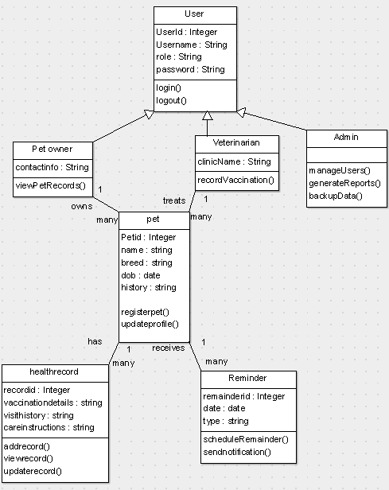
Fig.6.2.1 Design Class Diagram

- PACKAGE DIAGRAM
- The system is modularized into packages according to functionality, ensuring better maintainability and separation of concerns. The Package Diagram outlines how different modules interact with each other using <<use>> and <<import>> dependencies.
- Main Packages
- Admin Package
- AdminModule
- Pet Owner Package
- PetOwnerModule
- Veterinarian Package
- VeterinarianModule
- Pet Package
- PetModule
- Health Record Package
- HealthRecordModule
- Reminder Package
- ReminderModule
- Clinic Visit Package
- ClinicVisitModule
- Reports Package
- ReportModule
- Database Package
- PetCareDB
- Each module interacts with the database through <<import>> relationships, while user roles (Admin, PetOwner, Veterinarian) make use of modules through <<use>> relationships.
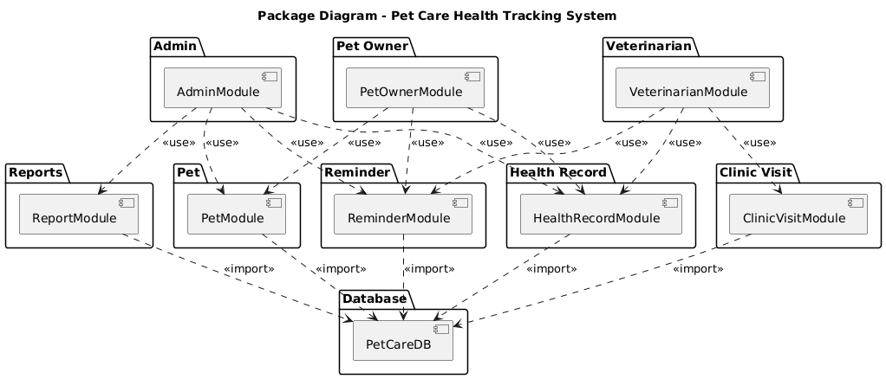

Fig.6.3.1. Package Diagram

- COMPONENT DIAGRAM
The Component Diagram shows the main functioning components of the Pet Care Health Tracking System and how they collaborate to deliver system-level functionality.
Major Components
- Authentication Component
- Pet Management Component
- Veterinarian Component
- Health Record Component
- Clinic Visit Component
- Reminder & Notification Component
- Report Component
- Database Component
These components communicate using defined interfaces and work together to provide end-to-end pet care tracking features.

- DEPLOYMENT DIAGRAM
Deployment diagram shows the physical architecture of the system, depicting how the user interacts with the web application via devices, servers, and databases.
Nodes in Deployment
    - Client Device (Browser – Chrome/Edge)
Web Application UI
    - Web Server (Apache HTTP)
Request Handler
Static Files
    - Application Server (PHP / Node.js Runtime)
User Module
Pet Module
HealthRecord Module
Reminder Module
ClinicVisit Module
Report Module
    - Data Storage (MySQL Server)
User Table
Pet Table
HealthRecord Table
ClinicVisit Table
Reminder Table
Report Table
    - Communication includes:
HTTP Requests
Backend forwarding
Query responses
Rendered web pages
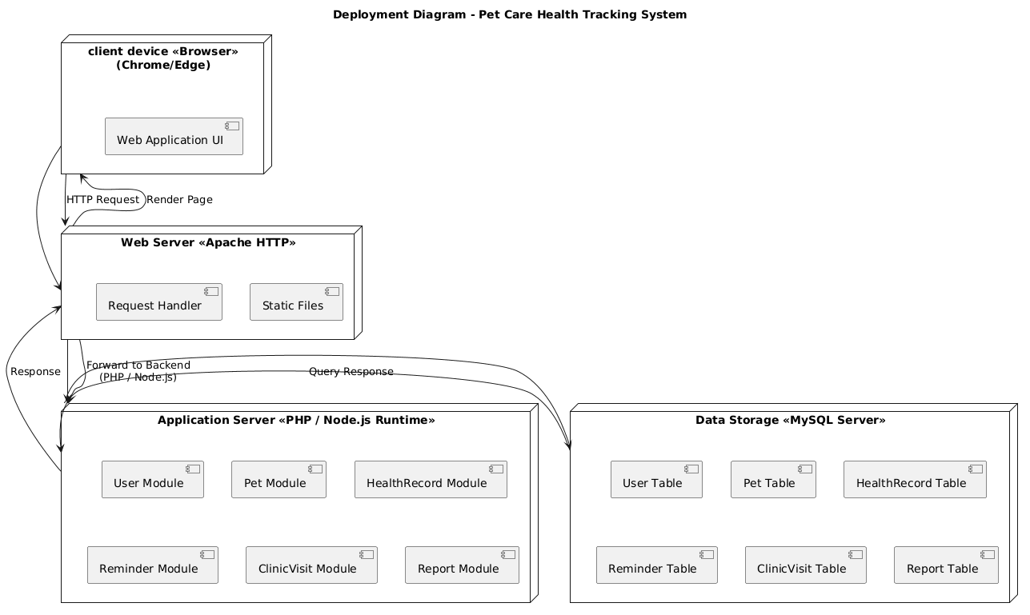

Fig.6.5.1. Deployment Diagram

- INTERFACE AND API DESIGN

Interface | Description
IUserAuth | login, logout, validateCredentials
IPetService | registerPet, updatePet, viewPetDetails
IHealthRecordService | addRecord, updateRecord, viewRecord
IReminderService | scheduleReminder, sendNotification
IClinicVisitService | addVisit, updateVisit, viewVisitHistory
IReportService | generateReport, viewReport

- DATABASE DESIGN
Main entities:
- User (Admin, PetOwner, Veterinarian)
- Pet
- HealthRecord
- ClinicVisit
- Reminder
- Report
Relationships
- One PetOwner → Owns Many Pets
- One Pet → Has Many Health Records
- One Pet → Receives Many Reminders
- One Veterinarian → Treats Many Pets
- One Pet → Has Many Clinic Visits

User Table

Field | Type
user_id | INT PK
username | VARCHAR
password | VARCHAR
role | ENUM

Pet Table
Field | Type
pet_id | INT PK
name | VARCHAR
breed | VARCHAR
dob | DATE
history | TEXT
owner_id | INT FK

Health Record Table Table
Field | Type
record_id | INT PK
pet_id | INT FK
vaccination_details | TEXT
visit_history | TEXT
care_instructions | TEXT

Reminder Table
Field | Type
reminder_id | INT PK
pet_id | INT FK
date | DATE
type | VARCHAR

Clinic Visit Table

Field | Type
visit_id | INT PK
pet_id | INT FK
vet_id | INT FK
visit_date | DATE
notes | TEXT

Report Table

Field | Type
report_id | INT PK
pet_id | INT FK
report_data | TEXT

CHAPTER 7
IMPLEMENTATION DETAILS

- PROGRAMMING LANGUAGE AND TOOLS
This project is developed using a combination of web-based technologies and supporting tools. The chosen technologies ensure scalability, ease of development, secure data handling, and user-friendly interface design.
Programming Languages
- PHP – Server-side programming for handling business logic, user authentication, FIR processing, case updates, and report generation.
- HTML – Structure and layout of all web pages.
- CSS – Styling, formatting, and UI design for user interfaces.
- JavaScript – Enhances interactivity, form validation, and dynamic content updates.
Database
- MySQL – Stores all crime-related data such as user accounts, FIR records, case details, suspects, and reports.
Provides reliable CRUD operations and supports relational constraints.
Frameworks / Tools
- XAMPP / WAMP Server
  - Provides Apache web server and MySQL database server for local development.
  - Used to run PHP scripts and manage databases.
- phpMyAdmin
  - Web-based GUI to manage MySQL databases.
  - Enables creation of tables, queries, and database relationships.
- VS Code / Sublime Text
  - Code editor used for developing PHP, HTML, CSS, and JavaScript files.

- Argo UML
  - Used to generate UML diagrams such as class diagrams, sequence diagrams, and deployment diagrams.
- Browser Tools (Chrome / Edge)
  - Used for debugging, testing, and executing the application front-end.

- KEY MODULES
The Pet Care Management System is divided into modular components to ensure maintainability and clarity.
- USER MANAGEMENT MODULE

The User Management Module manages all user-related operations within the Pet Care Health Tracking System. It allows the creation of new user accounts, updating of existing profiles, and assignment of roles such as Pet Owner, Veterinarian, or System Admin. The module validates login credentials, ensures secure authentication, and enforces role-based access control so that only authorized users can perform sensitive operations. This module is essential for maintaining system security, managing user accessibility, and ensuring proper interaction between users and the system..

- PET & HEALTH RECORD MANAGEMENT MODULE

The Pet & Health Record Management Module enables users—primarily Pet Owners and Veterinarians—to register pets and maintain complete medical profiles. It stores key details such as breed, age, medical history, vaccination records, and past treatments. Veterinarians can update health records after clinic visits, add diagnosis notes, and record prescribed care instructions. This module ensures that all pet health data is organized, up-to-date, and easily retrievable for better monitoring and long-term wellbeing..

- VACCINATION & REMAINDER MANAGEMENT MODULE
The Vaccination & Reminder Management Module handles the scheduling and tracking of pet vaccinations and routine care tasks. It enables veterinarians to record vaccination details and automatically schedules reminders for upcoming doses or health activities. Pet Owners receive timely notifications to ensure that vaccinations, medications, and follow-up treatments are not missed. This module improves adherence to pet healthcare timelines and enhances preventive care efficiency.
- CARE INSTRUCTION MODULE

The Care Instruction Module allows veterinarians to add, update, and manage personalized care guidelines for each pet. These may include diet recommendations, medication instructions, grooming requirements, or post-treatment care. Pet Owners can view these instructions at any time and follow them to maintain their pet’s overall health. This module ensures that care information is clear, easily accessible, and consistently updated based on the pet’s condition.

- CLINIC VISIT MANAGEMENT MODULE

The Clinic Visit Management Module focuses on recording and updating information related to veterinary visits. Veterinarians can log visit details, diagnosis findings, treatment provided, and any follow-up requirements. The system stores all visit history linked to each pet, creating a complete timeline of clinical interactions. This module ensures continuity of care, assists veterinarians in decision-making, and allows owners to track their pet’s medical journey.

- REPORTING & NOTIFICATION MODULE

The Reporting & Notification Module generates structured and informative reports based on pet health records, vaccination history, and clinic visits. System Admins and veterinarians can generate summaries for monitoring overall health trends or evaluating treatment progress. In addition, the module handles automated notifications for reminders, updates, and system alerts. It ensures that users remain informed, supports data-driven decisions, and enhances communication between the system and its users.

CHAPTER 8
TESTING

Testing ensures that all modules of the Pet Care Health Tracking System function correctly, meet user requirements, and operate without errors. This phase validates system performance, security, data accuracy, and overall usability through structured and systematic test procedures.

- Test Plan
The test plan defines the strategy, objectives, and scope of testing activities. The main goals of the Pet Care Health Tracking System testing phase are:
- To verify that all functional and non-functional requirements are met.
- To ensure each module works independently and collectively without failures.
- To validate secure and reliable access for all user roles: Pet Owner, Veterinarian, and Admin.
- To identify and correct errors before deployment.
Testing includes Unit Testing, Integration Testing, System Testing, and User Acceptance Testing (UAT) to ensure system stability and correctness.

- TEST CASES

Below are sample test cases

Test Case 1: User Login

Field | Description
Objective | To verify successful login with valid credentials
Input | Username, Password
Expected Output | Redirect to dashboard
Status | Pass / Fail

Test Case 2: Register Pet

Field | Description
Objective | To ensure a Pet Owner can register a pet
Input | Pet name, breed, age, medical history
Expected Output | Pet record stored successfully
Status | Pass / Fail

Test Case 3: Record Vaccination

Field | Description
Objective | To verify Veterinarian can record vaccination details
Input | Pet ID, vaccine type, date, notes
Expected Output | Vaccination added to health record
Status | Pass / Fail

Test Case 4: Schedule Remainder

Field | Description
Objective | To check if reminders can be created successfully
Input | Reminder date, pet ID, reminder type
Expected Output | Reminder scheduled and saved
Status | Pass / Fail

Test Case 5: Generate Health Report

Field | Description
Objective | To verify that health reports generate correctly
Input | Pet ID
Expected Output | Report displayed with complete health data
Status | Pass / Fail

- SYSTEM TESTING

System Testing validates the behavior of the entire Pet Care Health Tracking System as a unified application. It ensures:
- All modules (User, Pet, Health Record, Reminder, Clinic Visit, Reports) interact correctly.
- The system meets usability, performance, and security requirements.
- End-to-end workflows such as
Login → Register Pet → Add Health Record → Schedule Reminder → Generate Report
operate without errors.
Types of system testing performed:
- Functional Testing
- Performance Testing
- Usability Testing
- Security Testing
- Database Testing
System testing ensures the system performs correctly under normal and abnormal scenarios.

- INTEGRATION TESTING

Integration Testing verifies the interactions between modules. In this system:
- User Management integrates with Authentication.
- Pet Module integrates with Health Record and Reminder modules.
- Health Record Module integrates with Clinic Visit Module.
- Report Module integrates with Pet and Health Record data.
The objectives are to detect:
- Interface inconsistencies
- Incorrect data flow between modules
- Communication failures
Integration testing is conducted incrementally to ensure smooth interaction across connected components.

- USER ACCEPTANCE TESTING

User Acceptance Testing (UAT) is performed with real end users such as Pet Owners, Veterinarians, and Admins to ensure that the system meets user expectations.
During UAT, users verify:
- Ease of navigation and simple, user-friendly interface
- Correctness of pet registration, vaccination recording, and clinic visit updates
- Accuracy of reminders and generated health reports
- Proper role-based access and secured login
- Real-time retrieval and update of pet health information
Once the users confirm that the system satisfies all functional requirements, it is approved for final deployment and real-world usage.

CHAPTER 9
RESULT AND DISCUSSION

- SCREEN SHOTS
- PERFORMANCE ANALYSIS
The performance of the Pet Care Health Tracking System was evaluated based on factors such as response time, database efficiency, scalability, and user interaction smoothness. The system demonstrated strong performance with fast page rendering and quick database retrievals for pet profiles, vaccination data, and clinic visit records. CRUD operations (Create, Read, Update, Delete), especially for pet registration, health records, and reminders, executed without noticeable delay even as the number of pets increased. The MySQL database handled relational links—such as Pet ↔ HealthRecord and Pet ↔ Reminder—efficiently, ensuring optimized query processing. Authentication and role-based access (Pet Owner, Veterinarian, Admin) performed consistently, with login validation occurring in under a second during testing. Report generation, which compiles pet health summaries and vaccination histories, also delivered results promptly. Overall, performance tests indicate that the system is capable of supporting real-world usage with minimal resource consumption, making it suitable for small to medium-sized veterinary clinics and pet care centers.
- DISCUSSION

The implemented Pet Care Health Tracking System significantly improves traditional manual pet health record-keeping by digitizing vaccination history, clinic visits, reminders, and care instructions. This reduces paperwork, eliminates common human errors, and ensures secure, organized storage of pet medical data. The system enhances communication between pet owners and veterinarians by enabling real-time access to health records and automated care reminders. Its modular architecture allows easy maintenance and smooth scalability, making future upgrades—such as mobile alerts, advanced analytics, and multi-clinic data sharing—feasible. Since the system is built using PHP and MySQL, it maintains compatibility with widely available server environments and provides stability for long-term use. Although further improvements can be made, such as advanced search filters or cloud-based scalability, the current system offers a reliable and efficient solution that enhances pet healthcare management and supports veterinary workflow optimization

CHAPTER 10
CONCLUSION AND FUTURE ENHANCEMENT

- CONCLUSION

The Pet Care Health Tracking System successfully fulfills its aim of delivering a secure, efficient, and user-friendly platform for managing pet information, vaccination schedules, clinic visits, and care instructions. By shifting from manual record-keeping to digital management, the system enhances data accuracy, reduces administrative effort, and improves communication between pet owners and veterinarians. Role-based access ensures that sensitive data is handled only by authorized users, enhancing security and trust. With its modular design and intuitive interface, the system provides smooth navigation and consistent performance across all user roles. Overall, the system stands as a dependable solution that improves pet healthcare monitoring and establishes a strong foundation for future advancements..

- LIMITATIONS

Despite its successful implementation, the system has several limitations that can be addressed in future versions:
- The system currently runs on a local server environment and does not include cloud-based functionality for remote access.
- No dedicated mobile application is available, limiting use to desktop or browser-based devices.
- Search functionality is basic and does not support advanced filtering or analytics.
- Automated notifications are limited and do not include SMS or email reminders.
- Uploading clinic documents or medical files is limited and can benefit from improved security and broader file support.
- Integration with third-party veterinary systems (e.g., microchip databases, online vet networks) is not available.
These limitations do not hinder core functionality but highlight opportunities for enhancing system capability and usability.
.

- FUTURE ENHANCEMENTS

Future improvements can significantly enhance system usability, scalability, and convenience:
- Cloud Deployment: Enables multi-clinic access, remote usage, and large-scale data handling.
- Mobile Application: Android/iOS apps for easy access by pet owners and veterinarians.
- Advanced Analytics: Health trend analysis, vaccination forecasting, and condition prediction.
- Automated Alerts: SMS/Email notifications for vaccination reminders, upcoming clinic visits, or overdue schedules.
- Wearable Device Integration: Sync pet health data from smart collars or IoT sensors (optional).
- Enhanced File Management: Secure upload of treatment photos, lab reports, and prescriptions.
- Multi-Clinic Connectivity: Allows sharing of medical records across veterinary networks securely.
These enhancements will significantly improve system performance and make it suitable for a broader range of veterinary healthcare environments.

CHAPTER 11
BIBILOGRAPHY/ REFERENCES

- Banfield, J. (2018). Veterinary Information Systems and Pet Health Management. McGraw-Hill.
- Brown, L. & Turner, K. (2020). Digital Health Records in Veterinary Practice. Springer.
- Kumar, R. & Sharma, P. (2017). “Pet Healthcare Automation Using Web Technologies.” International Journal of Computer Applications, 72(5).
- Anderson, S. (2019). Veterinary Informatics: Applications and Trends. Academic Press.
- MySQL Documentation (2023). Relational Database Management Guide. Oracle.
- Welling, L., & Thomson, L. (2017). PHP and MySQL Web Development. Pearson.
- Smith, A., & Wilson, J. (2020). “Improving Pet Care with Digital Tracking Systems.” IEEE Software Engineering Review.
- Veterinary Practice News (2022). “The Rise of Digital Pet Health Management Systems.”
- PHP Manual. (2023). PHP Language and Runtime Documentation.
- Google Developers (2023). Web Application Performance Guidelines.
- Gupta, A., & Mehra, V. (2019). Information Systems for Animal Health Management. Springer Publications.
- Singh, R., & Kaur, P. (2018). “Web-Based Pet Health Tracking System.” International Journal of Veterinary Science and Technology, 5(3).

CHAPTER 12
APPENDIX

