Department of Computer Science and Engineering

GATE QUESTIONS

COMPILER DESIGN

S. No. | Name of the Topic | Number of Questions | Page Number
1 | Introduction to Compiler | 11 | 1
2 | Lexical Analyzer | 13 | 6
3 | Parsing | 20 | 14
4 | Syntax Directed Translation and Run Time Environemnt | 6 | 31
5 | Code generation | 11 | 35

COURSE COORDINATOR HOD-CSE

UNIT I – INTRODUCTION TO COMPILER

1. The process of assigning load addresses to the various parts of the program and adjusting the code and data in the program to reflect the assigned addresses is called (GATE CS 2001) a) Assembly
- Parsing
- Relocation
- Symbol resolution
Answer: (c)
Relocation is the process of replacing symbolic references or names of libraries with actual usable addresses in memory before running a program. It is typically done by the linker during compilation (at compile time), although it can be done at runtime by a relocating loader. Compilers or assemblers typically generate the executable with zero as the lowermost starting address. Before the execution of object code, these addresses should be adjusted so that they denote the correct runtime addresses.
Relocation is typically done in two steps:
- Each object code has various sections like code, data, .bss etc. To combine all the objects to a single executable, the linker merges all sections of similar type into a single section of that type. The linker then assigns runtime addresses to each section and each symbol. At this point, the code (functions) and data (global variables) will have unique runtime addresses.
- Each section refers to one or more symbols which should be modified so that they point to the correct runtime addresses.

2. Consider a program P that consists of two source modules M1 and M2 contained in two different files. If M1 contains a reference to a function defined in M2 the reference will be resolved at (GATE CS 2004) a) Edit time
- Compile time
- Link time
- Load time
Answer (c)
Compiler transforms source code into the target language. The target language is generally in binary form known as object code. Typically, an object file can contain three kinds of symbols:
- defined symbols, which allow it to be called by other modules,
- undefined symbols, which call the other modules where these symbols are defined, and * local symbols, used internally within the object file to facilitate relocation.
When a program comprises multiple object files, the linker combines these files into a unified executable program, resolving the symbols as it goes along.

3. A loader is a program that
- program that places programs into memory and prepares them for execution.
- program that automates the translation of assembly language into machine language.
- program that accepts a program written in a high level language and produces as object program
- None of these

Answer: A

4. A system program that setup an executable program in main memory ready for execution is A) assembler
- linker
- loader
- load and go
Answer: C

5. Uniform symbol table
- contains all constants in the program
- is a permanent table of decision rules in the form of patterns for matching with the uniform symbol table to discover syntactic structure.
- consists of full or partial list of the token's as they appear in the program created by Lexical analysis and used for syntax analysis and interpretation.
- a permanent table which lists all key words and special symbols of the language in symbolic form.
Answer: C

6. Assembler is a program that
- places programs into memory and prepares them for execution
- automates the translation of assembly language into machine language
- accepts a program written in a high level language and produces an object program. D) None of these

Answer: B

7. Compiler can diagnose
- grammatical errors only
- logical errors only
- grammatical as well as logical errors
- None of these
Answer: A

8. A system program that set-up an executable program in main memory ready for execution is A) assembler
- linker
- loader
- text editor

Answer: C

9. Type checking is normally done during
- lexical analysis
- syntax analysis
- syntax directed translation
- code optimization
Answer: C

10. Match the following according to input(from the left column) to the compiler phase(in the right column) that process it:
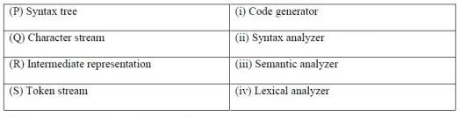
- P -> (ii), Q -> (iii), R -> (iv), S -> (i)
- P -> (ii), Q -> (i), R -> (iii), S -> (iv)
- P -> (iii), Q -> (iv), R -> (i), S -> (ii)
- P -> (i), Q -> (iv), R -> (ii), S -> (iii)

GATE-CS-2017 (Set 2)
Answer: (C)
Explanation: P – iii Syntax tree is input to semantic analyser Q – iv Character stream is input to lexical analyser.
R – i Intermediate code is input to code generator S -ii Token stream is input to syntax analyser.

11. Which one of the following statements is FALSE?
- Context-free grammar can be used to specify both lexical and syntax rules.
- Type checking is done before parsing.
- High-level language programs can be translated to different Intermediate Representations.
- Arguments to a function can be passed using the program stack.
GATE CS 2018
Answer: (B)
Explanation: Type checking is done at semantic analysis phase and parsing is done at syntax analysis phase. And we know Syntax analysis phase comes before semantic analysis. So Option (B) is False.
All other options seems Correct.

UNIT II – LEXICAL ANALYSIS

- In some programming languages, an identifier is permitted to be a letter following by any number of letters or digits. If L and D denote the sets of letters and digits respectively, which of the following expressions defines an identifier? GATE – CS - 1995
Answer : B

- The minimum possible number of states of a deterministic finite automaton that accepts a regular language L = {w1aw2 | w1, w2 {a,b}* , |w1| = 2, w2>=3} is_______
- 3
- 5
- 8
- 7
GATE-CS-2017 (Set 2)
Answer: C

3. The length of the shortest string NOT in the language (over Σ = {a, b}) of the following regular expression is ______________.
a*b*(ba)*a*
- 2
- 3
- 4
- 5
GATE-CS-2014-(Set-3)
Answer: (B)
Explanation: All the strings that can be generated till length-2 are definitely present in this language.
Now, let’s look at the strings of length-3; {aaa, aab, aba, abb, baa, bab, bba, bbb} . String “bab” cannot be generated from given language. so, the string “bab” is the shortest string not acceptable by given regular expression.

4.
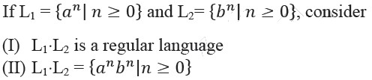
of the following is CORRECT?
- Only (I)
- Only (II)
- Both (I) and (II)
- Neither (I) nor (II)
GATE-CS-2014-(Set-2)
Answer: (A)
Explanation: L1.L2 is definitely regular, since regular languages are closed under concatenation.
But L1.L2 = { a^{n}b^{n} | n ≥ 0 } is not correct. Because both variable are independent of each other.
L1.L2 = { a^{n}b^{m} | n ≥ 0 , m ≥ 0 } is possible.
Therefore, only statement (i) is TRUE.

5. Let L1 = {w ∈ {0,1}∗ | w has at least as many occurrences of (110)’s as (011)’s}.
Let L2 = { ∈ {0,1}∗ | w has at least as many occurrences of (000)’s as (111)’s}.
Which one of the following is TRUE?
A L1 is regular but not L2 B L2 is regular but not L!
- Both L2 and L1 are regular
- Neither L1 nor L2 are regular
GATE-CS-2014-(Set-2)
Answer: (A)
Explanation: L1 is regular
let us consider the string 011011011011
In this string, number of occurrences of 011 are 4 but when we see here 110 is also occurred and the number of occurrence of 110 is 3.
Note that if i add a 0 at the last of string we can have same number of occurrences of 011 and 110 so this string is accepted. We can say if the string is ending with 011 so by appending a 0 we can make 110 also.
Now string2: 110110110110 in this number of occurrences of 110 is 4 and 011 is 3 which already satisfy the condition
So we can observe here that whenever 110 will be there string will be accepted So with this idea we can build an automata for this. Therefore, it is regular.

6. Which one of the following is TRUE? GATECS2014Q25
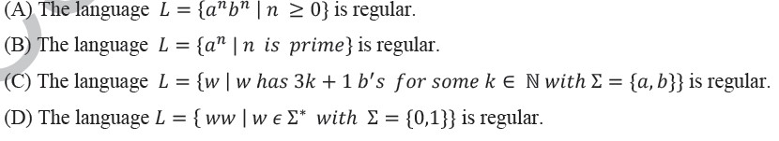
A A B B
- C
- D
GATE-CS-2014-(Set-1)
Answer: (C)
Explanation: (A) L = {a n b n |n >= 0} is not regular because there does not exists a finite automaton that can
derive this grammar. Intuitively, finite automaton has finite memory, hence it can’t track number of as. It is a standard CFL though.
- L = {a n b n |n is prime} is again not regular because there is no way to remember/check if
current n is prime or not. Hence, no finite automaton exists to derive this grammar, thus it
is not regular.
- L = {w|w has 3k+1 bs} is a regular language because k is a fixed constant and we can easily emulate L as a ∗ ba ∗ …..ba ∗ such that there are exactly 3k + 1 bs and a ∗ s surrounding each b in the grammar.
D) L = {ww| w ∈ Σ ∗ } is again not a regular grammar, infact it is not even a CFG. There is no way to remember and derive double word using finite automaton.
Hence, correct answer would be (C).

7. The number of tokens in the following C statement is (GATE 2000) printf("i = %d, &i = %x", i, &i);
- 3
- 26
- 10
- 21
Answer - C Tokens are: printf
(
"i=%d, &i=%x"
, i ,
&
i )
;

8. In a compiler, keywords of a language are recognized during
- parsing of the program
- the code generation
- the lexical analysis of the program

- dataflow analysis
GATE CS 2011
Answer - C

9. The lexical analysis for a modern computer language such as Java needs the power of which one of the following machine models in a necessary and sufficient sense?
- Finite state automata
- Deterministic pushdown automata
- Non-Deterministic pushdown automata
- Turing Machine
GATE CS 2011
Answer – A

10. Consider the following statements: (I) The output of a lexical analyzer is groups of characters. (II) Total number of tokens in printf("i=%d, &i=%x", i, &i); are 11. (III) Symbol table can be implementation by using array and hash table but not tree. Which of the following statement(s) is/are correct?
- Only (I)
- Only (II) and (III)
- All (I), (II), and (III)
- None of these
GATE CS Mock 2018 | Set 2
Answer: (D)
Explanation: (I) The output of a lexical analyzer is tokens.
- Total number of tokens in printf("i=%d, &i=%x", i, &i); are 10.
- Symbol table can be implementation by using array, hash table, tree and linked lists.
So, option (D) is correct.

11. Consider the DFAs M and N given above. The number of states in a minimal DFA that accepts the language L(M) ∩ L(N) is __________.
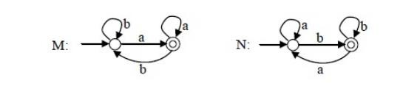
- 0
- 1
- 2
- 3
GATE-CS-2015 (Set 1)
Answer: (B)
Explanation: In DFA M: all strings must end with ‘a’.
In DFA N: all strings must end with ‘b’.
So the intersection is empty.
For an empty language, only one state is required in DFA. The state is non-accepting and remains on itself for all characters of alphabet.

12. A lexical analyzer uses the following patterns to recognize three tokens T1, T2, and T3 over the alphabet {a,b,c}. T1: a?(bc)*a T2: b?(ac)*b T3: c?(ba)*c Note that ‘x?’ means 0 or 1 occurrence of the symbol x. Note also that the analyzer outputs the token that matches the longest possible prefix. If the string bbaacabc is processes by the analyzer, which one of the following is the sequence of tokens it outputs?
- T1T2T3
- T1T1T3
- T2T1T3
- T3T3
GATE CS 2018
Answer: (D)
Explanation: 0 or 1 occurrence of the symbol x.
T1 : (b+c)* a + a(b+c)* a
T2 : (a+c)* b + b(a+c)* b
T3 : (b+a)* c + c(b+a)* c

Given String : bbaacabc
Longest matching prefix is ” bbaac ” (Which can be generated by T3)
The remaining part (after Prefix) “abc” (Can be generated by T3)

So, the answer is T3T3

13.
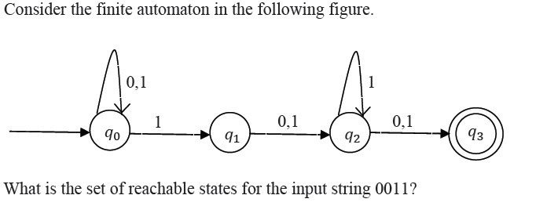
- {q0, q1, q2}
- {q0, q1}
- {q0, q1, q2, q3}
- {q3}
GATE-CS-2014-(Set-1)
Answer: (A)
Explanation:
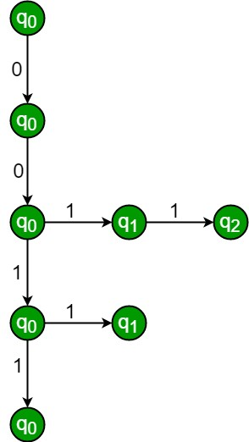
So, q0, q1 and q2 are reachable states for the input string 0011, but q3 is not.
So, option (A) is answer.

UNIT III – SYNTAX ANALYSIS

1. Consider the following languages.
L1 = {a^{p} | p is a prime number}
L2 = {a^{n}b^{m}c^{2m} | n >= 0, m >= 0}
L3 = {a^{n}b^{n}c^{2n} | n >= 0}
L4 = {a^{n}b^{n} | n >= 1}

Which of the following are CORRECT ? I. L1 is context free but not regular.
- L2 is not context free.
- L3 is not context free but recursive
- L4 is deterministic context free
- I, II and IV only
- II and III only
- I and IV only
- III and IV only
GATE-CS-2017 (Set 2)
Answer: (D)

Explanation:
L1 =a p | p is prime : is context sensitive not context free

L2 is context free

L3 is not context free because we are not sure when to pop b and push a, because it is comparison between three consecutive terminals Clearly L4 is deterministic context free because we are sure of pushing a into stack first and on

seeing b we are sure of popping a.

2. Let L1 and L2 be any context-free language and R be any regular language. Then, which of the following is correct ? I. L1 ∪ L2 is context-free.
- L1' is context-free.
- L1-R is context-free.
- L1 ∩ L2
- I, II and IV only
- I and III only
- II and IV only
- I only
GATE-CS-2017 (Set 2)
Answer: (B)

Explanation: Context free language are closed under union and difference with regular language.
It is not closed under complementation and intersection . Complement of CFL is recursive language.

3. Identity the language generated by following grammar where S is the start variable.
S --> XY
- --> aX | a
- --> aYb | ∈
- {a^{m} b^{n}| m>=n, n>0 }
- {a^{m} b^{n}| m>=n, n>=0 }
- {a^{m} b^{n}| m>n, n>=0 }
- {a^{m} b^{n}| m>n, n>0 }
GATE-CS-2017 (Set 2)
Answer: (C)

Explanation:
S --> XY
- --> aX | a // This produces only "a"
- --> aYb | // This produces and "a" for every "b" Option (A) and (B) are wrong because n can be zero also due to epsilon in Y
Option (D) is wrong because Y–>aYb produces equal number of a’s and b’s.
Since there is one variable X which produces at least one a.
Therefore numbers of a’s are always greater than numbers of b’s.

4. Which of the following statements is false? (GATE CS 2001)
- An unambiguous grammar has same leftmost and rightmost derivation
- An LL(1) parser is a top-down parser
- LALR is more powerful than SLR
- An ambiguous grammar can never be LR(k) for any k
Answer: (a)
If a grammar has more than one leftmost (or rightmost) derivation for a single sentential form, the grammar is ambiguous. The leftmost and rightmost derivations for a sentential form may differ, even in an unambiguous grammar

5. Which of the following derivations does a top-down parser use while parsing an input string? The input is assumed to be scanned in left to right order (GATE CS 2000).
- Leftmost derivation
- Leftmost derivation traced out in reverse
- Rightmost derivation
- Rightmost derivation traced out in reverse
Answer (a)
Top-down parsing (LL)
In top down parsing, we just start with the start symbol and compare the right side of the different productions against the first piece of input to see which of the productions should be used.
A top down parser is called LL parser because it parses the input from Left to right, and constructs a Leftmost derivation of the sentence.
Algorithm (Top Down Parsing)
- In the current string, choose leftmost nonterminal.
- Choose a production for the chosen nonterminal.
- In the string, replace the nonterminal by the right-hand-side of the rule.
- Repeat until no more nonterminals.
LL grammars are often classified by numbers, such as LL(1), LL(0) and so on. The number in the parenthesis tells the maximum number of terminals we may have to look at at a time to choose the right production at any point in the grammar.
The most common (and useful) kind of LL grammar is LL(1) where you can always choose the right production by looking at only the first terminal on the input at any given time. With LL(2) you have to look at two symbols, and so on. There exist grammars that are not LL(k) grammars for any fixed value of k at all, and they are sadly quite common.
Let us see an example of top down parsing for following grammar. Let input string be ax.
S -> Ax
A -> a
A -> b
An LL(1) parser starts with S and asks “which production should I attempt?” Naturally, it predicts the only alternative of S. From there it tries to match A by calling method A (in a recursive-descent parser). Lookahead a predicts production
A -> a
The parser matches a, returns to S and matches x. Done. The derivation tree is:
S
/ \
A x
| a
6. Given the following expression grammar:
E -> E * F | F+E | F F -> F-F | id
which of the following is true? (GATE CS 2000)
(a) * has higher precedence than + (b) – has higher precedence than *
- + and — have same precedence
- + has higher precedence than *
Answer(b)
Precedence in a grammar is enforced by making sure that a production rule with higher precedence operator will never produce an expression with operator with lower precedence.
In the given grammar ‘-’ has higher precedence than ‘*’
7. Consider the grammar defined by the following production rules, with two operators and +
- --> T * P
- --> U | T * U
- --> Q + P | Q
- --> Id
- --> Id
Which one of the following is TRUE?
- + is left associative, while is right associative
- + is right associative, while is left associative
- Both + and are right associative
- Both + and are left associative
GATE-CS-2014-(Set-2)
Answer: (B)

Explanation: From the grammar we can find out associative by looking at grammar.

Let us consider the 2nd production
T -> T * U
T is generating T*U recursively (left recursive) so * is left associative.

Similarly
P -> Q + P
Right recursion so + is right associative.
So option B is correct.
NOTE: Above is the shortcut trick that can be observed after drawing few parse trees.
One can also find out correct answer by drawing the parse tree.
8. Consider the following grammar p --> xQRS
- --> yz|z
- --> w|∈
- -> y
Which is FOLLOW(Q)?
- {R}
- {w}
- {w, y}
- {w, ∉} Answer: C
Follow(Q) = {First(R)}
First(R) = {w, ∈}
Follow(Q) = {w, First(S)}
First(S) = {y}
Therefore Follow(Q) = {w, y}

9. Which one of the following grammars is free from left recursion?
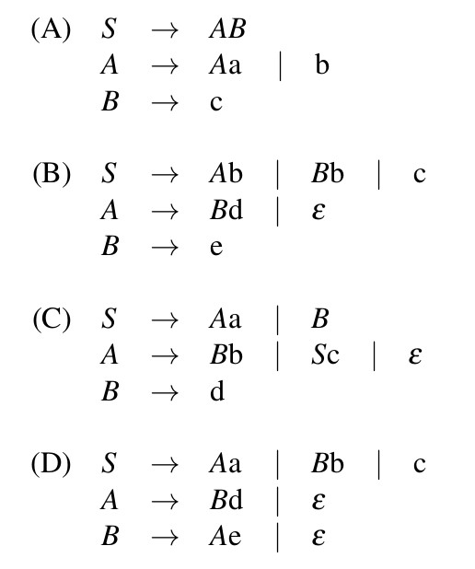
A A B B
- C
- D
GATE-CS-2016 (Set 2)
Answer: (B)

Explanation: Grammar A has direct left recursion because of the production rule: A->Aa.
Grammar C has indirect left recursion because of the production rules:S-> Aa and A->Sc
Grammar D has indirect left recursion because of production rules : A-> Bd and B-> Ae Grammar B doesn’t have any left recursion (neither direct nor indirect).

10. If G is grammar with productions S → SaS | aSb | bSa | SS | where S is the start variable, then which one of the following is not generated by G?
- abab
- aaab
- abbaa
- babba
GATE-CS-2017 (Set 1)
Answer: D

11. Consider the grammar with non-terminals N = {S,C,S1 },terminals T={a,b,i,t,e}, with S as the start symbol, and the following set of rules:
S --> iCtSS1|a
S1 --> eS|ϵ
C --> b
The grammar is NOT LL(1) because:
- it is left recursive
- it is right recursive
- it is ambiguous
- It is not context-free.
GATE-CS-2007
Answer: (C)

Explanation:

A LL(1) grammar doesn’t give to multiple entries in a single cell of its parsing table. It has only single entry in a single cell, hence it should be unambiguous.
Option A is wrong. Grammar is not left recursive. For a grammar to be left recursive a production should be of form A->Ab, where A is a single Non-Terminal and b is any string of grammar symbols.

Option B is wrong. Because a right recursive grammar has nothing to do with LL(1).

Option D is wrong. Because the given grammar is clearly a Context Free Grammar. A grammar is CFG if it has productions of the form A->(V T)* , where A is a single nonterminal and V is a set of Non-terminals and T is a set of Terminals.

Hence Option C should be the correct one. i.e. the grammar is ambiguous.
But let’s see how the grammar is ambiguous.

If the grammar is ambiguous then it should give multiple entry in a cell while making its parsing table. And Parse table is made with the aid of two functions : FIRST and FOLLOW.

A parsing table of a grammar will not have multiple entries in a cell( i.e. will be a LL(1) grammar) if and only if the following conditions hold for each production of the form A->α|β

- FIRST(α) ∩ FIRST(β) = Φ

- if FIRST(α) contains ‘ ε ‘ then FIRST(α) ∩ FOLLOW (A) = Φ and vice-versa.

Now,

For the production , S->iCtSS1|a, rule 1 is satisfied, because FIRST(iCtSS1) ∩ FIRST(a) = {i} ∩ {a} = Φ
For the production, S1->eS|ε, rule 1 is satisfied, as FIRST(eS) ∩ FIRST(ε) = {e} ∩ {ε} = Φ
. But here due to ‘ε’ in FIRST, we have to check for rule 2. FIRST(eS) ∩ FOLLOW(S1) = {e} ∩ {e, $} ≠ Φ . Hence rule 2 fails in this production rule. Therefore there will be multiple entries in the parsing table, hence the grammar is ambiguous and not LL(1).

12. Consider the following expression grammar G.
E -> E - T | T
T -> T + F | F F -> (E) | id
Which of the following grammars are not left recursive, but equivalent to G.
A)
E -> E - T | T
T -> T + F | F
F -> (E) | id

B)
E -> TE'
E' -> -TE' | ε
T -> T + F | F
F -> (E) | id

C)
E -> TX
X -> -TX | ε
T -> FY
Y -> +FY | ε
F -> (E) | id

D)
E -> TX | (TX)
X -> -TX | +TX | ε
T -> id
A A
B B
C C
DGATE-CS-2017 (Set 2) D

Answer: (C)
Explanation: We know for left recursion : A -> Aα/β
After removing left recursion it can be written as
A->βA’
A’->αA’/ε
Thus for : E->E- T/T α= -T , β= T . thus new production after removing left recursion is E->TE’ and E’->- TE’/ ε
T->FT’ and T’->+FT’/ ε F->(E)/id .

13. For the grammar below, a partial LL(1) parsing table is also presented along with the grammar. Entries that need to be filled are indicated as E1, E2, and E3. \epsilon is the empty string, $ indicates end of input, and, | separates alternate right hand sides of productions.
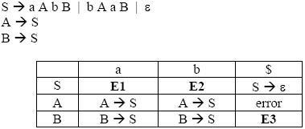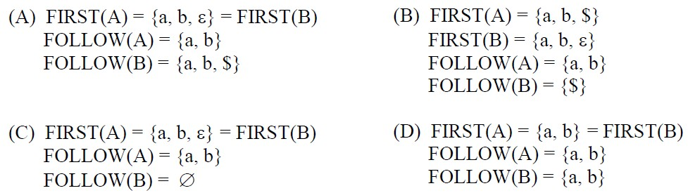

- A
- B
- C
- D
GATE CS 2012
Answer: (A)

Explanation:

First(X) - It is the set of terminals that begin the strings derivable from X.

Follow(X) - It is the set of terminals that can appear immediately to the right of X in some sentential form.

Now in the above question,

FIRST(S) = { a, b, epsilon}
FIRST(A) = FIRST(S) = { a, b, epsilon}
FIRST(B) = FIRST(S) = { a, b, epsilon}
FOLLOW (A) = { b , a }
FOLLOW (S) = { $ } U FOLLOW (A) = { b , a , $ }
FOLLOW (B) = FOLLOW (S) = { b ,a , $ }

epsilon corresponds to empty string.

14. Which of the following suffices to convert an arbitrary CFG to an LL(1) grammar?
(GATE CS 2003)
- Removing left recursion alone
- Factoring the grammar alone
- Removing left recursion and factoring the grammar
- None of the above
Answer: (D)
Explanation: Removing left recursion and factoring the grammar do not suffice to convert an arbitrary CFG to LL(1) grammar.

15. What is the maximum number of reduce moves that can be taken by a bottom-up parser for a grammar with no epsilon- and unit-production (i.e., of type A -> є and A -> a) to parse a string with n tokens?
- n/2
- n-1
- 2n-1
- 2n
GATE CS 2013
Answer: (B)

Explanation: Given in the question, a grammar with no epsilon- and unit-production (i.e., of type A -> є and A -> a).

To get maximum number of Reduce moves, we should make sure than in each sentential form only one terminal is reduced. Since there is no unit production, so last 2 tokens will take only 1 move.

So To Reduce input string of n tokens, first Reduce n-2 tokens using n-2 reduce moves and then Reduce last 2 tokens using production which has . So total of n-2+1 = n-1 Reduce moves.

Suppose the string is abcd. ( n = 4 ).

We can write the grammar which accepts this string as follows:
S->aB
B->bC
C->cd
The Right Most Derivation for the above is:

S -> aB ( Reduction 3 )
-> abC ( Reduction 2 )
-> abcd ( Reduction 1 )
We can see here that no production is for unit or epsilon. Hence 3 reductions here.

We can get less number of reductions with some other grammar which also does’t produce unit or epsilon productions,

S->abA
A-> cd
The Right Most Derivation for the above as:

S -> abA ( Reduction 2 )
-> abcd ( Reduction 1 ) Hence 2 reductions.

But we are interested in knowing the maximum number of reductions which comes from the 1st grammar. Hence total 3 reductions as maximum, which is ( n – 1) as n = 4 here.

Thus, Option B.
16. Consider the following grammar.
S -> S * E
S -> E
E -> F + E
- -> F
- -> id
Consider the following LR(0) items corresponding to the grammar above.
- S -> S * .E
- E -> F. + E
- E -> F + .E
Given the items above, which two of them will appear in the same set in the canonical sets-of-items for the grammar?
- (i) and (ii)
- (ii) and (iii)
- (i) and (iii)
- None of the above
GATE-CS-2006

Answer: (D)

Explanation: Let’s make the LR(0) set of items. First we need to augment the grammar with the production rule S’ -> .S , then we need to find closure of items in a set to complete a set.
Below are the LR(0) sets of items.
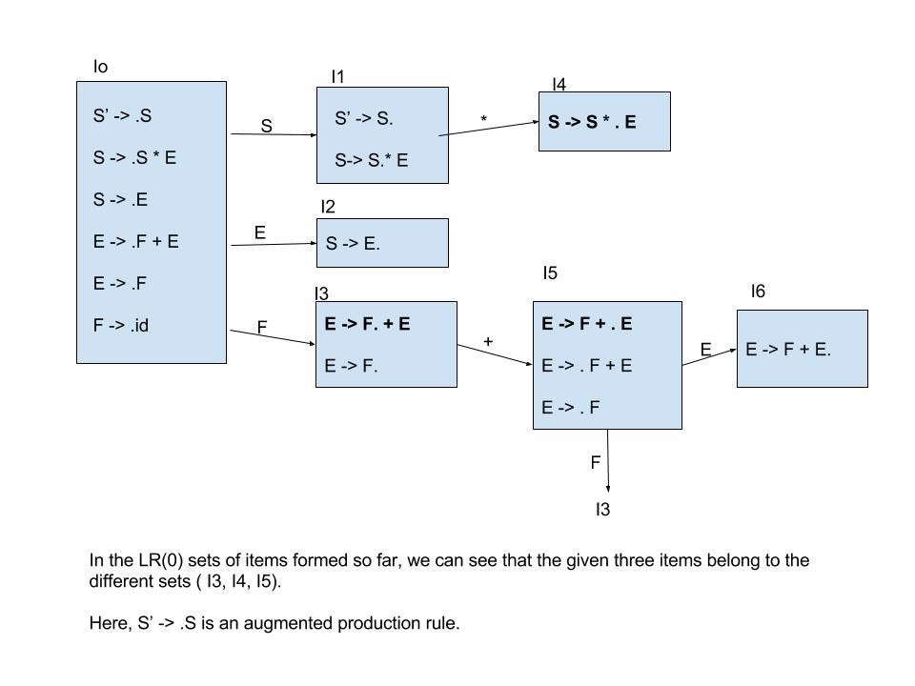

17. Assume that the SLR parser for a grammar G has n1 states and the LALR parser for G has n2 states. The relationship between nl and n2 is (GATE CS 2003)
- n1 is necessarily less than n2
- n1 is necessarily equal to n2
- n1 is necessarily greater than n2
- none of the above
GATE-CS-2017
Answer: (B)

18. Which of the following statements about the parser is/are correct? I. Canonical LR is more powerful than SLR.
- SLR is more powerful than LALR.
- SLR is more powerful than canonical LR.
- I only
- II only
- III only
- II and III only
GATE-CS-2017 (Set 2)
Answer: A

19. A canonical set of items is given below
S --> L. > R Q --> R.
On input symbol < the set has
- a shift-reduce conflict and a reduce-reduce conflict.
- a shift-reduce conflict but not a reduce-reduce conflict.
- a reduce-reduce conflict but not a shift-reduce conflict.
- neither a shift-reduce nor a reduce-reduce conflict.
GATE CS 2014
Answer: (D)

Explanation: The question is asked with respect to the symbol ‘ < ‘ which is not present in the given canonical set of items. Hence it is neither a shift-reduce conflict nor a reducereduce conflict on symbol ‘<‘.

Hence D is the correct option.

But if the question would have asked with respect to the symbol ‘ > ‘ then it would have been a shift-reduce conflict.

20. Which of the following statements related to merging of the two sets in the corresponding LALR parser is/are FALSE?
- Cannot be merged since look aheads are different.
- Can be merged but will result in S-R conflict.
- Can be merged but will result in R-R conflict.
- Cannot be merged since goto on c will lead to two different sets.
- 1 only
- 2 only
- 1 and 4 only
- 1, 2, 3, and 4
GATE CS 2013
Answer: (D)

Explanation: The given two LR(1) set of items are :

X -> c.X, c/d
X -> .cX, c/d X -> .d, c/d and X -> c.X, $
X -> .cX, $
X -> .d, $
The symbols/terminals after the comma are Look-Ahead symbols.

These are the sets of LR(1) ( LR(1) is also called CLR(1) ) items.
The LALR(1) parser combines those set of LR(1) items which are identical with respect to their 1st component but different with respect to their 2nd component.

In a production rule of a LR(1) set of items, ( A -> B , c ) , A->B is the 1st component , and the Look-Ahead set of symbols, which is c here, is the second component.

Now we can see that in the sets given, 1st component of the corresponding production rule is identical in both sets, and they only differ in 2nd component ( i.e. their look-ahead symbols) hence we can combine these sets to make a a single set which would be :
X -> c.X, c/d/$
X -> .cX, c/d/$
X -> .d, c/d/$
This is done to reduce the total number of parser states.

Now we can check the statements given.
Statement 1 : The statement is false, as merging has been done because 2nd components i.e. look-ahead were different.
Statement 2 : In the merged set, we can’t see any Shift-Reduce conflict ( because no reduction even possible, reduction would be possible when a production of form P -> q. is present)
Statement 3 : In the merged set, we can’t see any Reduce-Reduce conflict ( same reason as above, no reduction even possible, so no chances of R-R conflict )
Statement 4: This statement is also wrong, because goto is carried on Non-Terminals symbols, not on terminal symbols, and c is a terminal symbol.

Thus, all statements are wrong, hence option D.

UNIT IV – SYNTAX DIRECTED TRANSLATION AND RUN TIME ENVIRONMENT

1. Consider the grammar with the following translation rules and E as the start symbol.
E -> E1 #T {E.value = E1.value * T.value}
| T {E.value = T.value}
T -> T1 & F {T.value = T1.value + F.value}
|F {T.value= F.value}
F -> num {F.value = num.value}
Compute E.value for the root of the parse tree for the expression:2 # 3 & 5 # 6 &4. (GATE CS 2004) a) 200
- 180
- 160
- 40 Answer: (c)
Explanation:
We can calculate the value by constructing the parse tree for the expression 2 # 3 & 5 # 6 &4. Alternatively, we can calculate by considering following precedence and associativity rules. Precedence in a grammar is enforced by making sure that a production rule with higher precedence operator will never produce an expression with operator with lower precedence.
In the given grammar ‘&’ has higher precedence than ‘#’.
Left associativity for operator * in a grammar is enforced by making sure that for a production rule like S -> S1 * S2 in grammar, S2 should never produce an expression with *. On the other hand, to ensure right associativity, S1 should never produce an expression with *.
In the given grammar, both ‘#’ and & are left-associative.
So expression 2 # 3 & 5 # 6 &4 will become
((2 # (3 & 5)) # (6 & 4))
Let us apply translation rules, we get ((2 * (3 + 5)) * (6 + 4)) = 160.

2. Consider the following Syntax Directed Translation Scheme (SDTS), with nonterminals {S, A} and terminals {a, b}}.
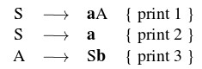
Using the above SDTS, the output printed by a bottom-up parser, for the input aab is
- 1 3 2
- 2 2 3
- 2 3 1
- Syntax Error
GATE-CS-2016 (Set 1)
Answer: (C)
Explanation: Bottom up parser builds the parse tree from bottom to up, i.e from the given string to the starting symbol. The given string is aab and starting symbol is S.

so the process is to start from aab and reach S.
=>aab ( given string)
=>aSb (after reduction by S->a, and hence print 2)
=>aA (after reduction by A->Sb, and hence print 3)
=>S (after reduction by S->aA, and hence print 1)

As we reach the starting symbol from the string, the string belongs to the language of the grammar.
Another way to do the same thing is :- bottom up parser does the parsing by RMD in reverse.
RMD is as follows:

=>S
=> aA (hence, print 1)
=> aSb (hence, print 3)
=> aab (hence, print 2)
If we take in Reverse it will print : 231

3. Which one of the following is NOT performed during compilation?
- Dynamic memory allocation
- Type checking
- Symbol table management
- Inline expansion
GATE-CS-2014-(Set-2)

4. In a bottom-up evaluation of a syntax directed definition, inherited attributes can
- always be evaluated
- be evaluated only if the definition is L--attributed
- be evaluated only if the definition has synthesized attributes
- never be evaluated
GATE CS 2003
Answer: (B)

Explanation: A Syntax Directed Definition (SDD) is called S Attributed if it has only synthesized attributes.

L-Attributed Definitions contain both synthesized and inherited attributes but do not need to build a dependency graph to evaluate them.

5, Consider the translation scheme shown below
S → T R
R → + T {print ('+');} R | ε
T → num {print (num.val);}
Here num is a token that represents an integer and num.val represents the corresponding integer value. For an input string ‘9 + 5 + 2’, this translation scheme will print (A) 9 + 5 + 2
- 9 5 + 2 +
- 9 5 2 + +
- + + 9 5 2
GATE CS 2003
Answer: (B)

Explanation: Let us make the parse tree for 9+5+2 in top down manner, left first derivation.

Steps:
- Exapnd S->TR
- apply T->Num...
- apply R -> +T...
- appy T->Num...
- apply R-> +T..
- apply T-> Num..
- apply R-> epsilon
After printing through the print statement in the parse tree formed you will get the answer as 95+2+

6. Consider the syntax directed definition shown below.
S → id : = E {gen (id.place = E.place;);}
E → E1 + E2 {t = newtemp ( ); gen (t = El.place + E2.place;); E.place = t}
E → id {E.place = id.place;}
Here, gen is a function that generates the output code, and newtemp is a function that returns the name of a new temporary variable on every call. Assume that ti’s are the temporary variable names generated by newtemp.
For the statement ‘X: = Y + Z’, the 3-address code sequence generated by this definition is
- X = Y + Z
- t1 = Y + Z; X = t1
- t1 =Y; t2 = t1 + Z; X = t2
- t1 = Y; t2 = Z; t3 = t1 + t2; X = t3
GATE CS 2003
Answer: (B)

Explanation: It must be B. The production E –> E + E is used only one time and hence only one temporary variable is generated.

UNIT V – CODE OPTIMIZATION AND CODE GENERATION

1. Consider the following grammar: stmt -> if expr then else expr; stmt | ε expr -> term relop term | term term -> id | number
id -> a | b | c
number -> [0-9]

where relop is a relational operate (e.g < >, ….), ε refers to the empty statement, and if ,then, else are terminals. Consider a program P following the above grammar containing ten if terminals. The number of control flows paths in P is ____________. For example, the program if e1 then e2 else e3
has 2 control flow paths, e1 -> e2 and e1 -> e3
- 20
- 1024
- 2048
- 10
GATE-CS-2017 (Set 1)
Answer: (B)

Explanation: Number of control flow paths for 10 if terminals

if then else ; stmt
if then else ; if then else ; stmt
…………..
10 times.

Observe that there is a semi-colon after every if structure.
Since, every if structure has 2 control flows.
Therefore, 1st terminal has 2 control flows,
2nd terminal has 2 control flows,
3rd terminal has 2 control flows,
………..
9th terminal has 2 control flows, and 10th terminal has 2 control flows.
Using multiplication law of counting, we get
= 2*2*2*2*2……10 times = 2^10 = 1024 number of control flow paths for 10 if terminals.
1024 is correct answer.

2. A variable x is said to be live at a statement Si in a program if the following three conditions hold simultaneously:
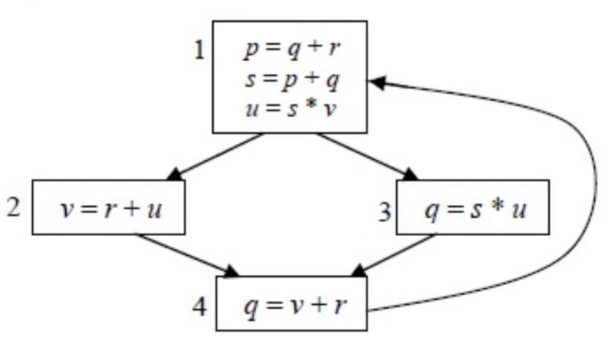
1. There exists a statement Sj that uses x 2. There is a path from Si to Sj in the flow graph corresponding to the program
3. The path has no intervening assignment to x including at Si and Sj
The variables which are live both at the statement in basic block 2 and at the statement in basic block 3 of the above control flow graph are
- p, s, u
- r, s, u
- r, u
- q, v
GATE-CS-2015 (Set 1)
Answer: (C)

Explanation: Live variable analysis is useful in compilers to find variables in each program that may be needed in future.

As per the definition given in question, a variable is live if it holds a value that may be needed in the future. In other words, it is used in future before any new assignment.

3. Consider the intermediate code given below:
- i = 1
- j = 1
- t1 = 5 * i
- t2 = t1 + j
- t3 = 4 * t2
- t4 = t3
- a[t4] = –1
- j = j + 1
- if j <= 5 goto(3)
- i = i + 1
- if i < 5 goto(2)
The number of nodes and edges in the control-flow-graph constructed for the above code, respectively, are
- 5 and 7
- 6 and 7
- 5 and 5
- 7 and 8
GATE-CS-2015 (Set 2)
Answer: (B)

Explanation: Below is control flow graph of above code.
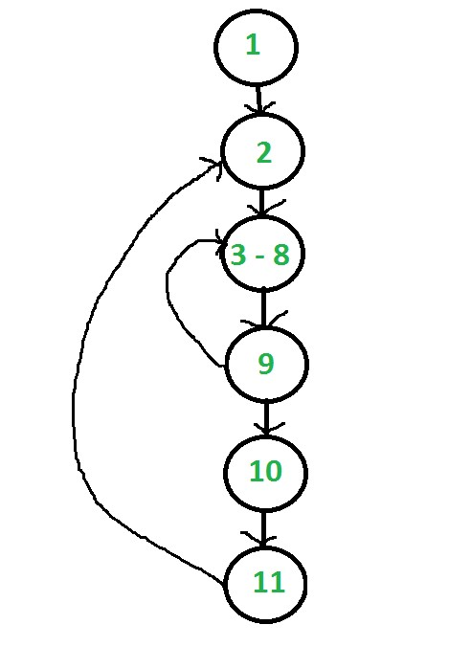

4. For a C program accessing X[i][j][k], the following intermediate code is generated by a compiler. Assume that the size of an integer is 32 bits and the size of a character is 8 bits.
t0 = i 1024 t1 = j 32 t2 = k 4 t3 = t1 + t0 t4 = t3 + t2 t5 = X[t4]
Which one of the following statements about the source code for the C program is
CORRECT?
- X is declared as “int X[32][32][8]”.
- X is declared as “int X[4][1024][32]”.
- X is declared as “char X[4][32][8]”.
- X is declared as “char X[32][16][2]”.
GATE CS 2014
Answer: (A)
Explanation: The final expression can be simplified in form ofi, j and k by following the intermediate code steps in reverse order t5 = X[t4] = X[t3 + t2]
= X[t1 + t0 + t2]
= X[i*1024 + j*32 + k*4]
= X + i*1024 + j*32 + k*4
Since k is multiplied by 4, the array must be an int array.
We are left with 2 choices (A and B) among the 4 given choices.

X[i][j][k]’th element in one dimensional array is equivalent to
X[i*M*L + j*L + k]’th element in one dimensional array
(Note that multi-dimensional arrays are stored in row major order in C).

So we get following equations

j*L*4 = j*32, we get L = 8 (4 is the sizeof(int)) i*1024 = i*M*L*4, we get M = 1024/32 = 32
Therefore option A is the only correct option as M and L are 32 and 8 respectively only in option A.

5. Consider the basic block given below.
a = b + c c = a + d d = b + c e = d - b a = e + b The minimum number of nodes and edges present in the DAG representation of the above basic block respectively are
- 6 and 6
- 8 and 10
- 9 and 12
- 4 and 4
GATE – CS – 2014 (Set 3)
Answer: (A)
Explanation: Simplifying the given equations :

- = b + c (given) e = d – b (given)
=> d = b + c and e = c

- = d – b (given) a = e + b (given)
=> a = d

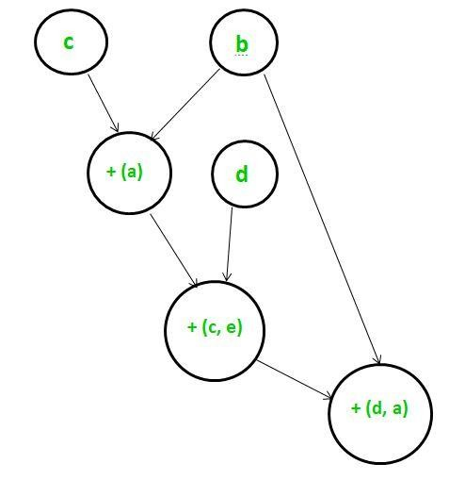
Thus, the given DAG has 6 nodes and 6 edges.

6. One of the purposes of using intermediate code in compilers is to
- make parsing and semantic analysis simpler.
- improve error recovery and error reporting.
- increase the chances of reusing the machine-independent code optimizer in other compilers.
- improve the register allocation.
GATE-CS-2014-(Set-3)
Answer: (C)

Explanation: After semantic Analysis, the code is converted into intermediate code which is language independent, the advantage of converting into intermediate code is to improve the performance of code generation and to increase the chances of reusing the machineindependent code optimizer in other compilers.

7. Which one of the following is FALSE?
- A basic block is a sequence of instructions where control enters the sequence at the beginning and exits at the end.
- Available expression analysis can be used for common subexpression elimination.
- Live variable analysis can be used for dead code elimination.
- x = 4 5 => x = 20 is an example of common subexpression elimination.
GATE-CS-2014-(Set-1)
Explanation: (A) A basic block is a sequence of instructions where control enters the sequence at the beginning and exits at the end is TRUE.
(B) Available expression analysis can be used for common subexpression elimination is TRUE. Available expressions is an analysis algorithm that determines for each point in the program the set of expressions that need not be recomputed. Available expression analysis is used to do global common subexpression elimination (CSE). If an expression is available at a point, there is no need to re-evaluate it.
(C)Live variable analysis can be used for dead code elimination is TRUE.
(D) x = 4 5 => x = 20 is an example of common subexpression elimination is FALSE.
Common subexpression elimination (CSE) refers to compiler optimization replaces identical expressions (i.e., they all evaluate to the same value) with a single variable holding the computed value when it is worthwhile to do so.
Below is an example In the following code:
a = b * c + g; d = b * c * e; it may be worth transforming the code to:
tmp = b * c; a = tmp + g; d = tmp * e;

8. Some code optimizations are carried out on the intermediate code because
- they enhance the portability of the compiler to other target processors
- program analysis is more accurate on intermediate code than on machine code
- the information from dataflow analysis cannot otherwise be used for optimization
- the information from the front end cannot otherwise be used for optimization

Answer: (A)

Explanation: Option (B) is also true. But the main purpose of doing some code-optimization on intermediate code generation is to enhance the portability of the compiler to target processors. So Option A) is more suitable here.

Intermediate code is machine/architecture independent code. So a compiler can optimize it without worrying about the architecture on which the code is going to execute (it may be the same or the other ). So that kind of compiler can be used by multiple different architectures.

In contrast to that, suppose code optimization is done on target code, which is machine/architecture dependent, then the compiler has be specific about the optimizations on
that kind of code. In this case the compiler can’t be used by multiple different architectures, because the target code produced on different architectures would be different. Hence portability reduces here.

9. In a simplified computer the instructions are:

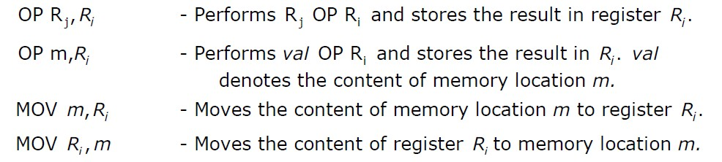

The computer has only two registers, and OP is either ADD or SUB. Consider the following basic block:

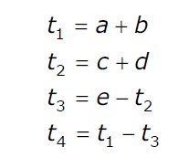

Assume that all operands are initially in memory. The final value of the computation should be in memory. What is the minimum number of MOV instructions in the code generated for this basic block?
- 2
- 3
- 5
- 6

Answer: (B)

Explanation:
For Instructions of t2 and t3
- MOV c, t2
- OP d, t2(OP=ADD)
- OP e, t2(OP=SUB)

For Instructions of t1 and t4
- MOV a, t1
- OP b, t1(OP=ADD)
- OP t1, t2(OP=SUB)

- MOV t2, a(AS END Value has To be in the MEMORY)

10. Which one of the following is FALSE?
- A basic block is a sequence of instructions where control enters the sequence at the beginning and exits at the end.
- Available expression analysis can be used for common subexpression elimination.
- Live variable analysis can be used for dead code elimination.
- x = 4 5 => x = 20 is an example of common subexpression elimination.

Answer: (D)

Explanation: (A) A basic block is a sequence of instructions where control enters the sequence at the beginning and exits at the end is TRUE.

(B) Available expression analysis can be used for common subexpression elimination is TRUE. Available expressions is an analysis algorithm that determines for each point in the program the set of expressions that need not be recomputed. Available expression analysis is used to do global common subexpression elimination (CSE). If an expression is available at a point, there is no need to re-evaluate it.

(C)Live variable analysis can be used for dead code elimination is TRUE.

(D) x = 4 5 => x = 20 is an example of common subexpression elimination is FALSE. Common subexpression elimination (CSE) refers to compiler optimization replaces identical expressions (i.e., they all evaluate to the same value) with a single variable holding the computed value when it is worthwhile to do so.

Below is an example

In the following code:

a = b * c + g; d = b * c * e;

it may be worth transforming the code to:

tmp = b * c; a = tmp + g; d = tmp * e;

11. Consider the following C code segment.

for (i = 0, i<n; i++)
{ for (j=0; j<n; j++)
{ if (i%2)
{
x += (4*j + 5*i); y += (7 + 4*j);
}
}
}
Which one of the following is false?
- The code contains loop invariant computation
- There is scope of common sub-expression elimination in this code
- There is scope of strength reduction in this code
- There is scope of dead code elimination in this code
Answer: (D)

Explanation: Question asks about false statement

4*j is common subexpression elimination so B is true.

5*i can be moved out of inner loop so can be i%2.
Means, A is true as we have loop invariant computation.

Next, 4*j as well as 5*i can be replaced with a = - 4; before j loop then a = a + 4; where 4*j is computed, likewise for 5*i. C is true as there is scope of strength reduction.
By choice elimination, we have D.
Step 6 should have been enough, if the question hadn’t asked for final value in memory and rather be in register. The final step require another MOV, thus a total of 3.

