**Form Elements or tags**

Form is created or designed using form elements or tags

Form elements are used for creating UI (User interface).

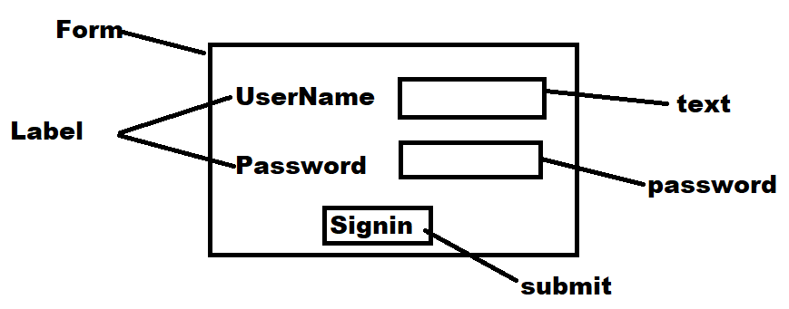

**Label**

Label is used for creating caption for input element

Label is used to identify input element (OR) data.

**Syntax:**

<label for=”name”>text</label>

Name is used to identify the label.

This name is used as an id for input element.

By clicking on label, the input element can focused using linking with id.

**Input**

**HTML5** supports various types of input elements or types.

<input type=text name=”name” id=”id of label”>

It is used to input text.

Value inside input field is identified with name.

**Submit, Reset, Button**

HTML 5.0 provides 3 types of buttons

1. Submit button

This button is having predefined functionality. When end user click on submit button the form data is submitted to given url. (OR) when end user clicks on submit button action is performed.

Syntax:

<input type=”submit” value=”text”>

Value is used to change display text, the default display text form input type submit is submit.

1. Reset button

This button is having predefined functionality. When end user click on reset button the form data is cleared.

**Syntax:**

<input type=”reset” value=”text”>

1. Button

Input button does not have any predefined functionality. This functionality must be defined by programmer using java script.

**Syntax:**

<input type=”button” value=”text” onclick=function>

**Example:**

<!DOCTYPE *html*>

<html *lang*="en">

<head>

    <meta *charset*="UTF-8">

    <meta *name*="viewport" *content*="width=device-width, initial-scale=1.0">

    <title>Document</title>

    <style>

        fieldset

        {

            font-size: 20px;

            font-weight: bold;

            padding:50px;

        }

        label {

            border: 1px solid black;

            color:blue;

        }

        .s {

            font-size: 20px;

            font-family: Arial, Helvetica, sans-serif;

            padding: 20px;

            background-color: aqua;

            color:red;

            border-color: blueviolet;

            border-radius: 15px;

            width: 150px;

        }

    </style>

</head>

<body>

    <form *action*="index.html">

        <fieldset>

            <legend>User Information</legend>

            <label *for*="uname">UserName</label>

            <input *type*="text" *name*="uname" *id*="uname"><br><br>

            <label *for*="name">Name</label>

            <input *type*="text" *name*="name" *id*="name"><br><br>

            <input *type*="submit" *value*="Login" *class*="s">

            <input *type*="reset" *value*="clear" *class*="s">

            <input *type*="button" *value*="validate" *class*="s">

        </fieldset>

    </form>

</body>

</html>

**<input type=”password”>**

This input type used to input password values. The content input inside password field is not visible.

<!DOCTYPE *html*>

<html *lang*="en">

<head>

    <meta *charset*="UTF-8">

    <meta *name*="viewport" *content*="width=device-width, initial-scale=1.0">

    <title>Login Form</title>

    <style>

    </style>

</head>

<body>

    <form>

        <table border="1" *width*="80%">

            <caption>Login</caption>

        <tr>

        <td><label *for*="uname">UserName</label></td>

        <td><input *type*="text" *name*="uname" *id*="uname" *required*></td>

        </tr>

        <tr>

            <td><label *for*="pwd">Password</label></td>

            <td><input *type*="password" *name*="pwd" *id*="pwd" *required*></td>

        </tr>

        <tr>

            <td><input *type*="submit"></td>

            <td><input *type*="reset"></td>

        </tr>

       </table>

    </form>

</body>

</html>

**Attribute**

**required** : if this attribute is assigned to any input field, input is required before submitting form.