**What is Web?**

Web is a part of internet or restricted access on internet is called web.

Web also called WWW (World Wide Web) or W3 is a system of interconnected public web pages accessible through the Internet

Web is invented by a person called Tim Berners Lee

Web standards are maintained by a non profitable organization called W3C (World Wide Web Consortium). Standards defines set of rules and regulations for developing web applications or web sites.

Current version of web is Web3.

**What is web site and web application?**

**What is web site?**

Web site a collection of static resources

1. Web pages
2. Images
3. Videos
4. Audios

In website end user cannot interact.

A web site is read only.

**What is web application?**

Web application is collection of static resources and dynamic resources.

In web application end user interact with application.

Example: Signin, Signup,…

Web applications required server side programming

Software required for developing web application or web site

1. VSCode is IDE (Visual Studio Code)

<https://code.visualstudio.com/download>

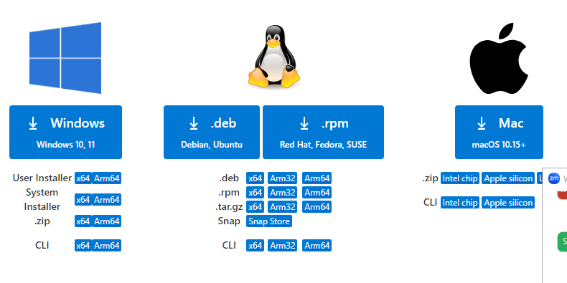

**Extensions**

1. VScode icons
2. Inteliescence CSS
3. LiveServer

**Server**

Server is a program/software which serves resources to one or more than client. Server works based on two things

1. Request (input)
2. Response (Output)

Types of servers

1. Local Server
2. Cloud Server

**Local Server**

A server install in system is called local server

If application is installed in local server, it accessed by one person.

**Cloud Server**

Installing web application/web site on cloud server, which allows web application go live. It is accessed by the entire people worldwide.

**Directory structure of web application or website**

Web application or web site is collection of programs/resources. These resources are organized by following rules and regulations.

1. Create project folder
   1. Public
   2. Src

All public resources are stored in public folder.

1. Images
2. Videos
3. Audio
4. Doc
5. Html or htm
6. Css

All server side programs are stored in src folder

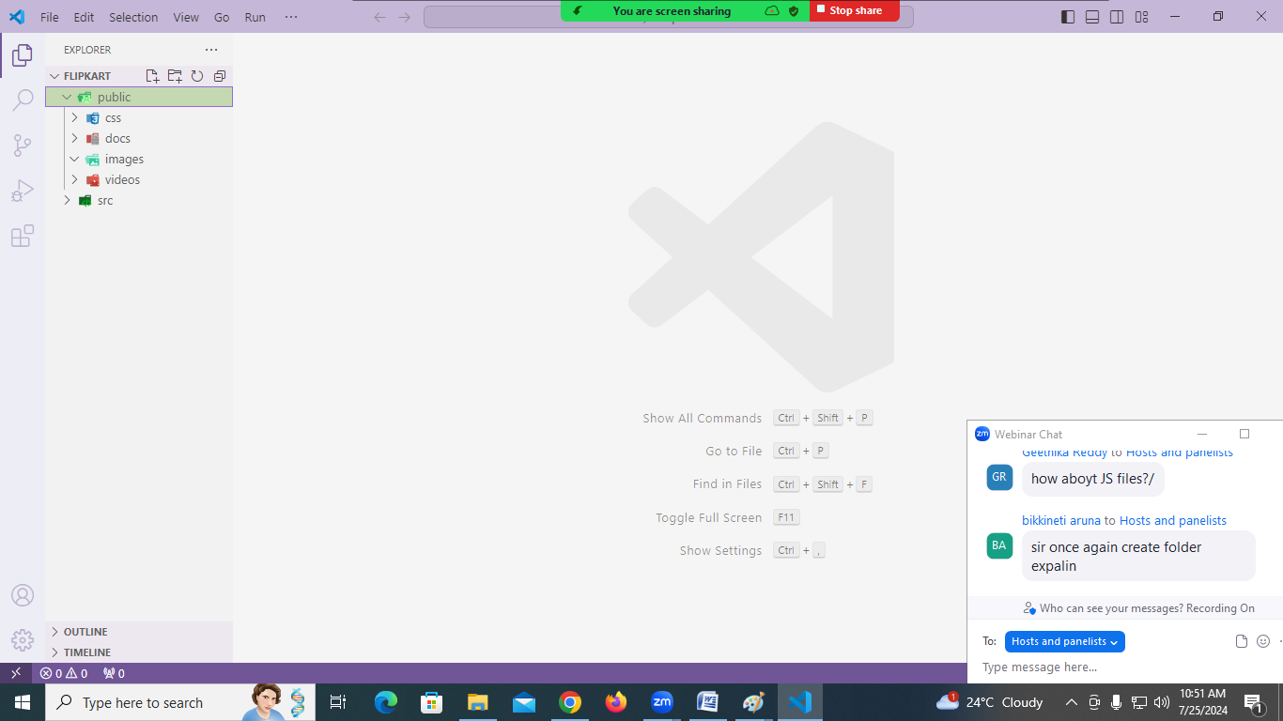

codewithsatishgupta

[pythonbygupta@gmail.com](mailto:pythonbygupta@gmail.com)