**IN HTML 4.0 frameset**

Frameset element represents frames

**Syntax:**

<frameset>

<frame src=”path”></frame>

<frame src=”path”></frame>

</frameset>

Note: frameset element is deprecated (not available) and it is not supported all the browsers.

**Attributes of frameset**

**Rows : defines number of rows**

**Cols : defines number of cols**

**Attributes of frame**

src: path/context which has to be displayed within frame

**Example:**

<!DOCTYPE *html*>

<html>

    <head>

        <title>frameset</title>

    </head>

        <frameset *cols*="50%,50%">

            <frame *src*="index.html"></frame>

            <frame *src*="courses.html"></frame>

        </frameset>

</html>

**HTML Tables**

Tables represent data.

Table is grid, which consist of number of rows and columns.

This table is represented using <table> tag/element.

Table required some more child elements to represent rows and columns.

1. <thead> : grouping hreader
2. <tbody> : content of table
3. <tfooter> : grouping footer
4. <caption> : caption for making table as SEO friendly
5. <tr> : table row
6. <td> : table data
7. <th> : table heading
8. <colgroup> : this is used for grouping columns

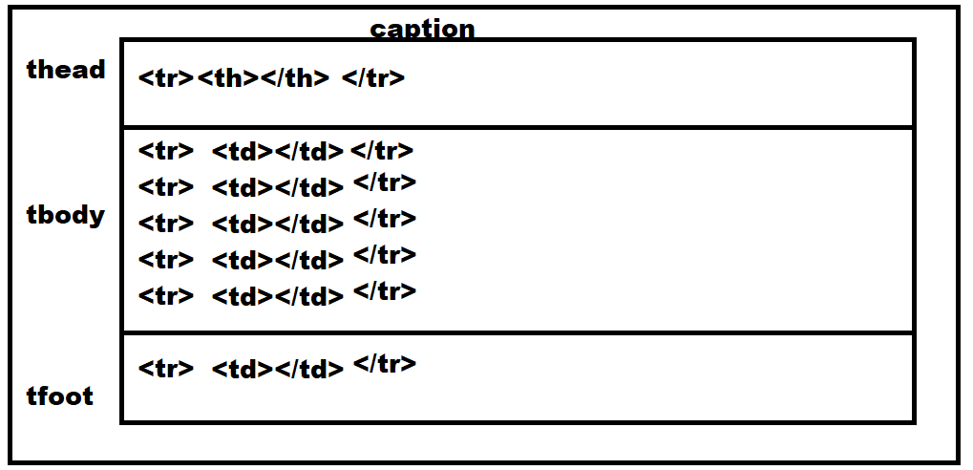

**Attributes**

1. **frame,rules,groups**

**frame :** the frame represents table border.

The values of frame can be “box|lhs|rhs|above|below|none”

Syntax:

<table frame=“box|lhs|rhs|above|below|none”>

**rules :** the rules are given as rows or cols

The value of rules can be

**Syntax:**

**<table rules=”rows|cols|all |groups|none”>**

**groups** : this allows to group cols. This grouping can be applied by using span tag/element.

Note: to apply column group, the rules must be groups.

**Syntax:**

**<table>**

**<colgroup span=”n columns”>**

**</table>**

**Example:**

<!DOCTYPE *html*>

<html *lang*="en">

<head>

    <meta *charset*="UTF-8">

    <meta *name*="viewport" *content*="width=device-width, initial-scale=1.0">

    <title>IPL</title>

</head>

<body>

    <table *width*="100%" *frame*="box"  *rules*="groups">

        <caption>Test Ranking</caption>

        <colgroup *span*="2"></colgroup>

        <thead>

            <tr>

                <th>Pos</th>

                <th>Team</th>

                <th>Players</th>

                <th>Rating</th>

                <th>Career Best Rating</th>

            </tr>

        </thead>

        <tbody>

            <tr>

                <td>01</td>

                <td><img *src*="images/ind.JPG" >IND</td>

                <td>Rohit Sharma</td>

                <td>1000</td>

                <td>923 v India at Edgbaston 2022</td>

            </tr>

            <tr>

            <td>02</td>

            <td><img *src*="images/eng.JPG" >ENG</td>

            <td>Joe Root</td>

            <td>872</td>

            <td>923 v India at Edgbaston 2022</td>

        </tr>

        <tr>

            <td>03</td>

            <td><img *src*="images/nz.JPG" >NZ</td>

            <td> Kane Williamson</td>

            <td>859</td>

            <td>919 v Pakistan at Christchurch 2021</td>

        </tr>

        <tr>

            <td>04</td>

            <td><img *src*="images/pak.JPG" >PAK</td>

            <td> Babar Azam</td>

            <td>768</td>

            <td>882 v New Zealand at Karachi 2022</td>

        </tr>

        </tbody>

        <tfoot>

            <tr><th>ICC Test Ranking</th></tr>

        </tfoot>

    </table>

</body>

</html>