2. Defining **“document scope”**

Document scope is defined using <html>…</html>

Every web page or document must start with <html> and end with </html>

**Syntax:**

<html>

</html>

If multiple documents defined inside html file/page, all these documents merged inside one document/web page.

<html> element is having an attribute called “lang”, this attribute defines language, date, time and currency format.

**Syntax:**

<html lang=”en-in”>

<html lang=”en-us”>

<html lang=”en-fr”>

<html lang=”en-uk”>

**This document scope is divided into two parts**

1. head
2. body

HTML document is divided into two parts 1. head 2.body

**Syntax:**

<html>

<head>

</head>

<body>

</body>

</html>

The content defined inside head is stored inside memory. Whenever browser required it read from memory, without reading from server. This avoids round trip.

This content defined inside body it does not store inside memory, whenever browser required it read from server.

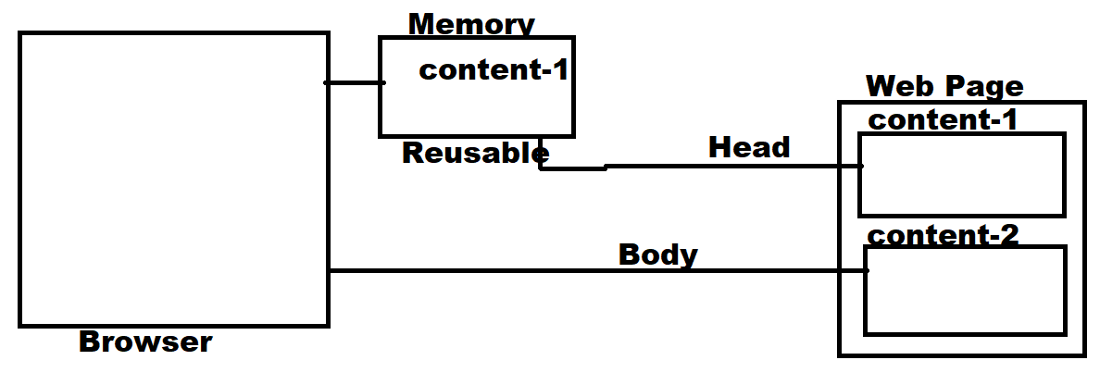

**head**

head tag is used to define,

1. page title
2. page is responsive
3. seo friendly or seo optimization
4. external resources
5. scripting

**<title>…</title>**

This tag is defined inside head.

This tag is used to define page title, which is displayed on title bar.

This title also used in SEO Optimization.

**Syntax: <title> … </title>**

**Example:**

<!DOCTYPE *html*>

<html *lang*="en-in">

<head>

    <title>Flipcart</title>

</head>

</html>

**<link>**

This tag is used to link external resources

1. css files
2. favicon

There can be multiple <link> tags within head.

**What is favicon?**

Icon is a image, which is displayed before title on title bar.

This image must have extension “ico”

This size of this image must be small (15x15px)

**Syntax:**

<link rel=’relation-type’ href=”resource name/path”>

Name of this image must favicon.ico or any other name. this image can be in png,ico formats.

codewithsatishgupta