The following tags are used inside <head> tag

1. <title>
2. <link>
3. <meta>
4. <script>
5. <style>

**meta**

meta tag is used to define meta data.

Meta data is providing information data

meta tag defines information about web page

meta tag is used to make webpage responsive and SEO friendly

**Responsive**

Creating page responsive, the web page content fit according to devices and screen.

For making page as responsive there are various approaches and one of the approaches is using meta tag.

<meta name=”viewport” content=”width=device-width, initial-scale=1”>

viewport : it is nothing but on which device web page viewed

desktop, mobile, tab, samrtwatch

content : define the content should adjusted according to width of device.

Initial-scale : Zoom percentage 1 🡪 100% 1.5 🡪 150%

**Note: this meta tag can be used more than one time**

Testing webpage on simulator

**Open Chrome**

**Search mobile simulator chrome extension and install**

[**https://chromewebstore.google.com/detail/mobile-simulator-responsi/ckejmhbmlajgoklhgbapkiccekfoccmk**](https://chromewebstore.google.com/detail/mobile-simulator-responsi/ckejmhbmlajgoklhgbapkiccekfoccmk)

**open chrome browser and type following URL for open project**

[**http://127.0.0.1:5500/public/index.html**](http://127.0.0.1:5500/public/index.html)

if you want test edge browser

click right mouse button on webpage and select inspect

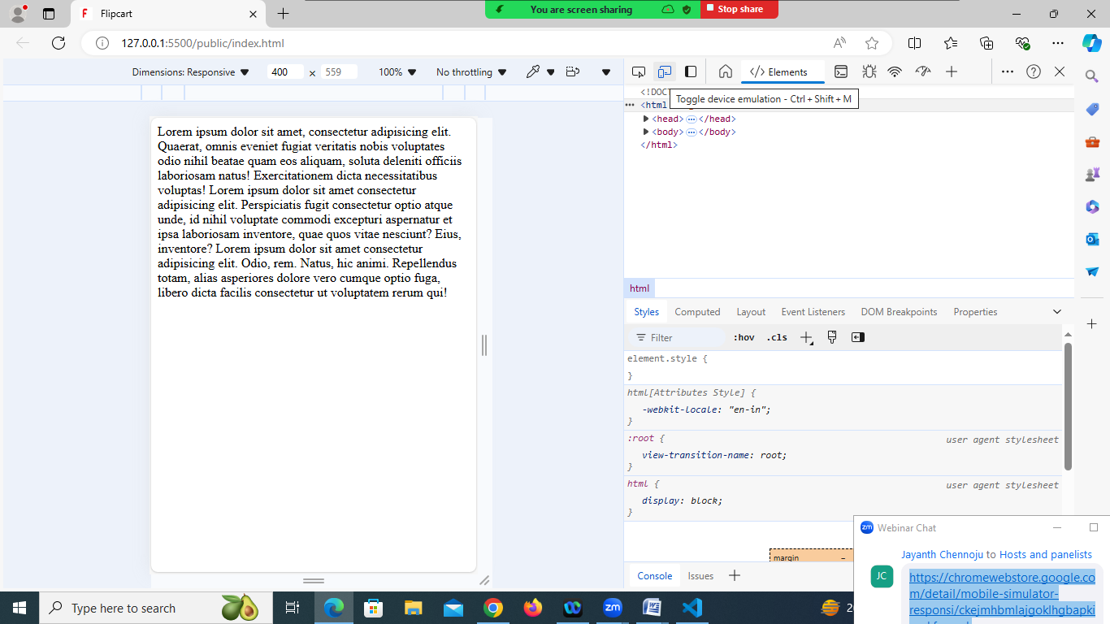

This tag is used to refresh the web page every 2 seconds

<meta http-equiv=”refresh” content=”2”>

**SEO friendly**

The webpage developed by programmer/web developer must be SEO friendly, it mean search engine must identify your web page.

<meta charset=”UTF-8”>

**UTF stands** UNICODE transformation Format, which define set characters used by web page

UTF-8 🡪 English (1byte – 8bits)

UTF -16,UTF-32,UTF-64 these are character set of other languages.

<!DOCTYPE *html*>

<html *lang*="en-in">

<head>

    <title>Flipcart</title>

    <link *rel*="icon" *href*="images/favicon1.png">

    <meta *name*="viewport" *content*="width=device-width, initial-scale=2">

    <meta *http-equiv*=”refresh” *content*=”5”>

</head>

<body>

    Lorem ipsum dolor sit amet, consectetur adipisicing elit. Quaerat, omnis eveniet fugiat veritatis nobis voluptates odio nihil beatae quam eos aliquam, soluta deleniti officiis laboriosam natus! Exercitationem dicta necessitatibus voluptas!

    Lorem ipsum dolor sit amet consectetur adipisicing elit. Perspiciatis fugit consectetur optio atque unde, id nihil voluptate commodi excepturi aspernatur et ipsa laboriosam inventore, quae quos vitae nesciunt? Eius, inventore?

    Lorem ipsum dolor sit amet consectetur adipisicing elit. Odio, rem. Natus, hic animi. Repellendus totam, alias asperiores dolore vero cumque optio fuga, libero dicta facilis consectetur ut voluptatem rerum qui!

</body>

</html>

codewithsatishgupta

[pythonbygupta@gmail.com](mailto:pythonbygupta@gmail.com)