**action**

Action is event which is executed when end user click on submit button.

When end user click on submit button form data is submitted to resource given in action.

**method**

Method defines HTTP request method.

**What is request?**

Input given by end user to the server is called request.

**What is response?**

The output given by server to the client is called response

In internet client/server communication is done using HTTP protocol.

HTTP stands for Hyper Text Transfer Protocol.

HTTP provides various request methods

1. GET
2. POST
3. PUT
4. DELETE
5. PATCH

**GET:**

GET is request to read information from server but not writing information to server.

Example:

1. Type URL in browser and press enter
2. Query data or information

In request method GET, the data is concatenated with URL

The data is visible on URL bar.

Secured data cannot send using GET method.

Always data send as text format.

Using GET we cannot send large amount of data because URL length. This maximum length of URL is 2048 characters.

GET request is not secured,

1. Visible on URL
2. URL injection

**POST**

In request method POST, the data is send as part request body (OR) send as stream. It is not visible on Address/URL bar.

POST is request writing information to server.

Example:

Inserting data/registration

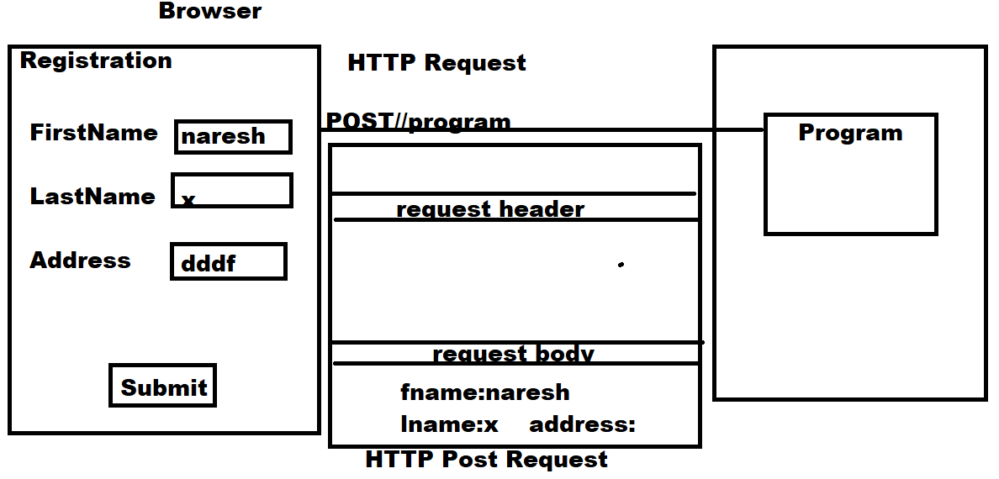

**In post request,**

1. Any type of data can be send
2. There is no restriction on sending of data
3. There is no chance of URL injection

**target**

This attribute where display generated response.

The value of target can be,

_self

_blank

[pythonbygupta@gmail.com](mailto:pythonbygupta@gmail.com)