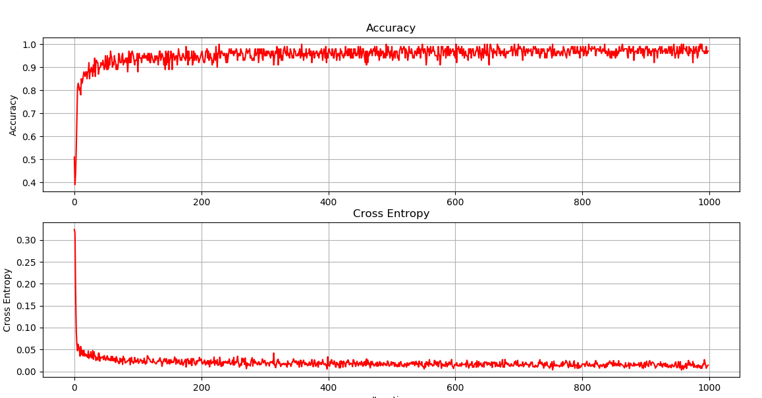

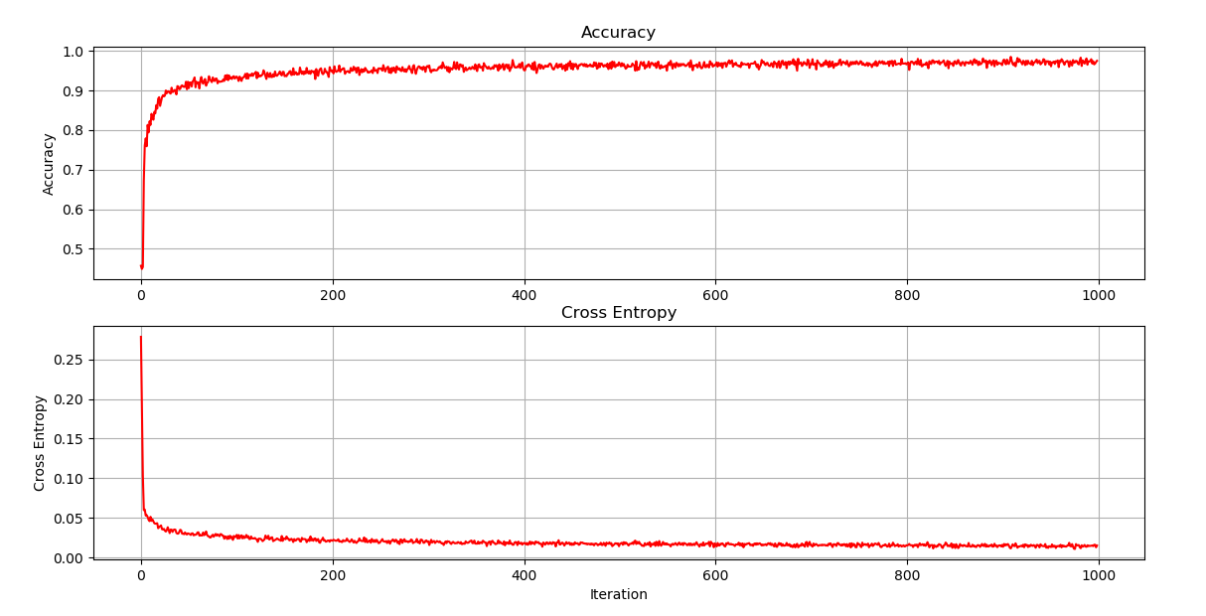

**Look at Green curve:**

**L1 = 4 L2 = 4**

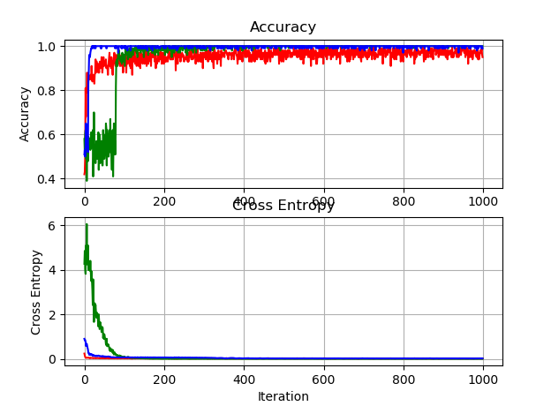

**L1 = 8 L2 = 4**

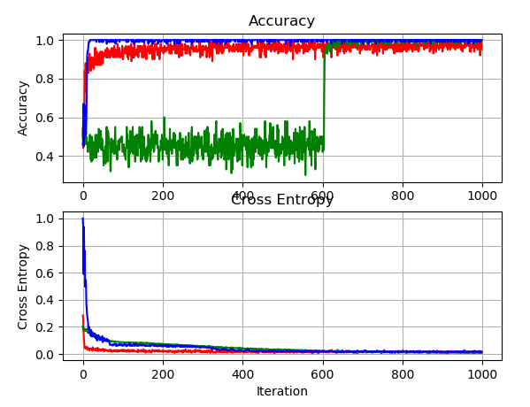

**L1 = 16 L2 = 8**

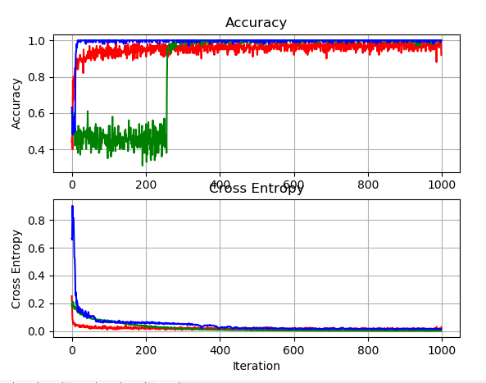

**L1 = 32 L2 = 16**

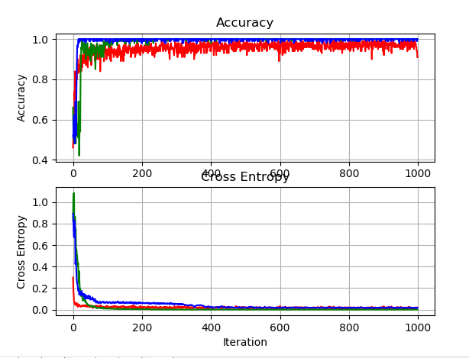

**L1 = 64 L2 = 32**