**✅ TASK 8: VPN Setup and Privacy Report**

**Objective:**

Understand and demonstrate how VPNs protect privacy and secure communication.

**1. Choose and Sign Up for a Free VPN:**

* Chosen VPN: **ProtonVPN Free Tier**
* Website: <https://protonvpn.com>
* Signed up with email and verified account.

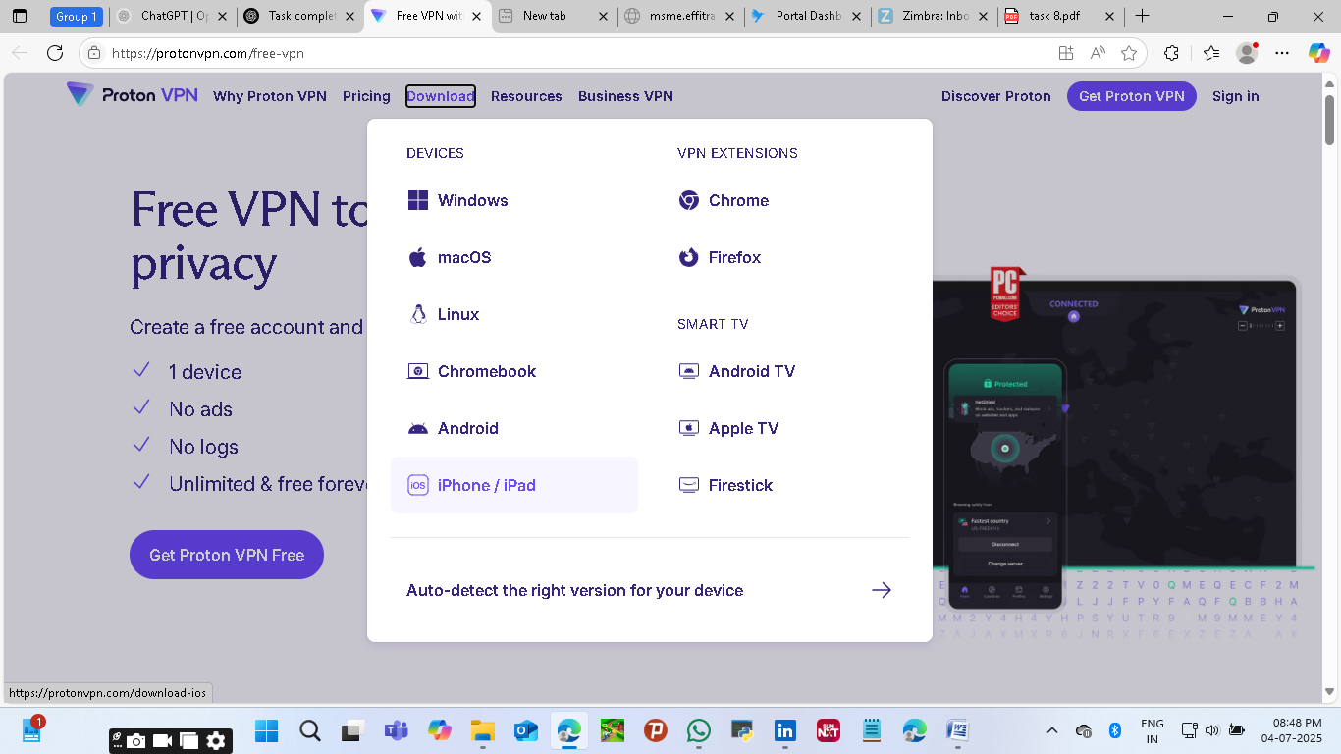

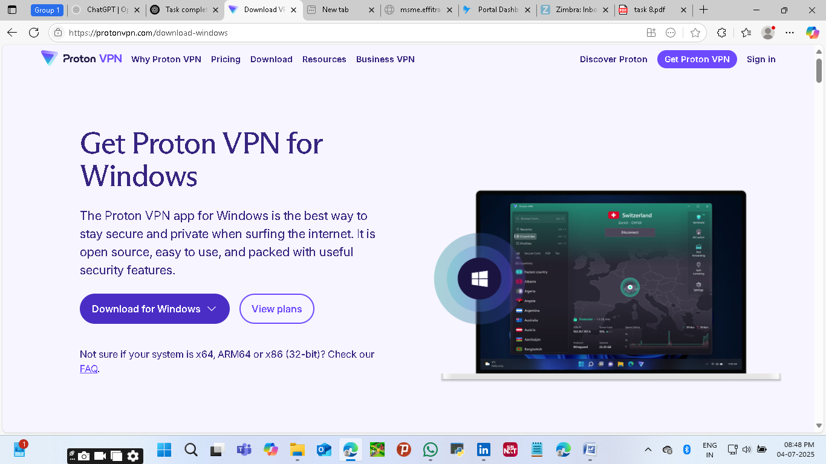

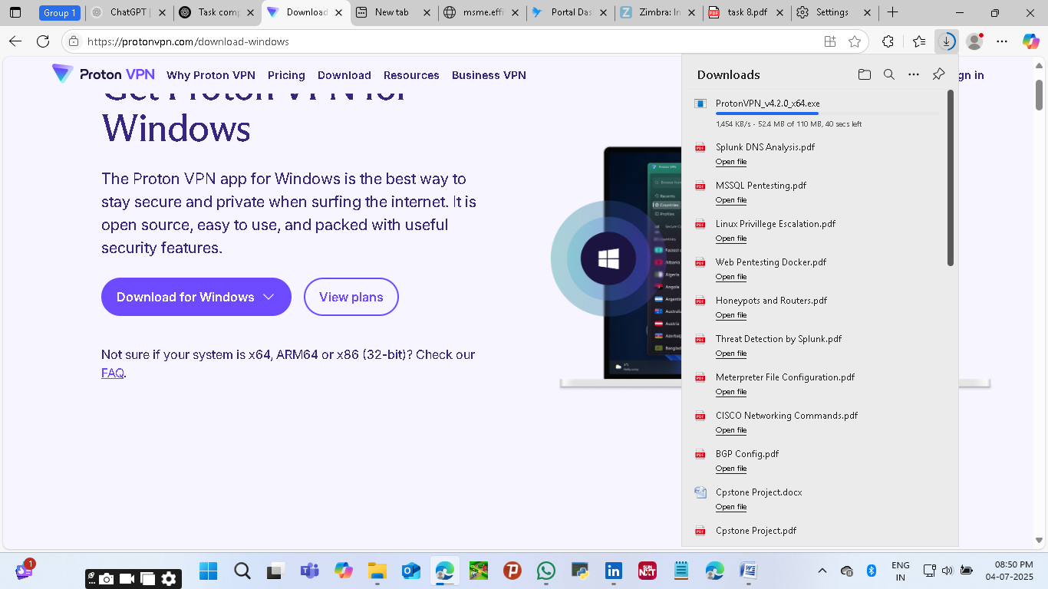

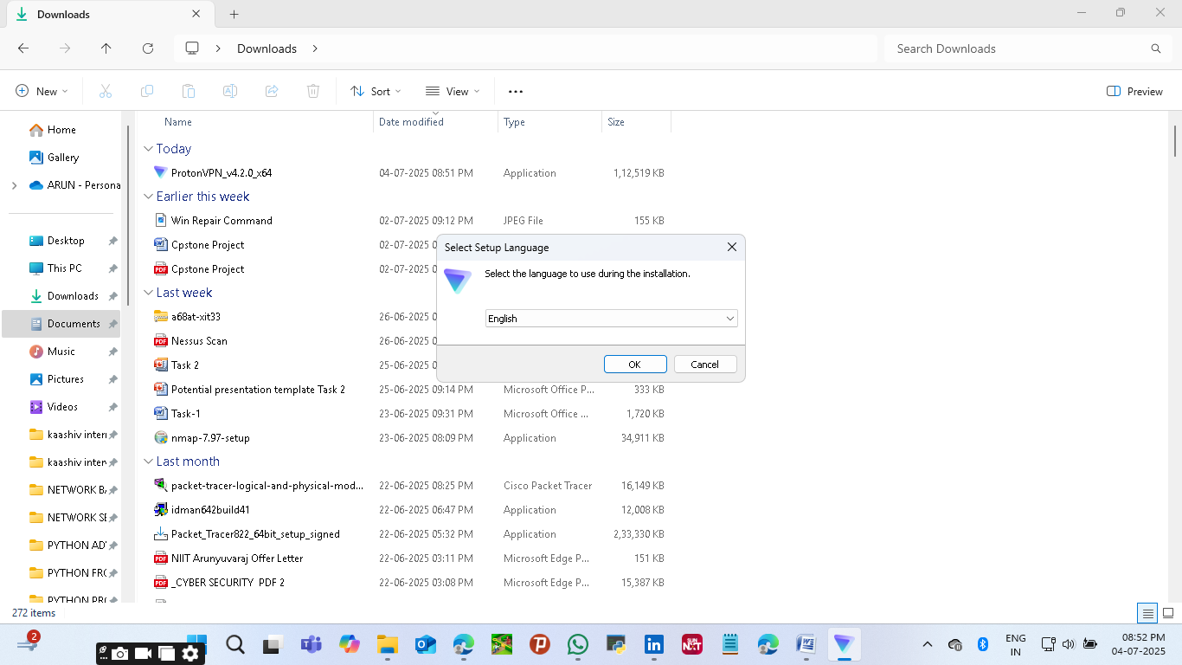

**Installation:**

**2. Download and Install the VPN Client:**

* **Downloaded ProtonVPN for Windows (or Mac/Android/iOS depending on device).**
* **Installed the application successfully.**

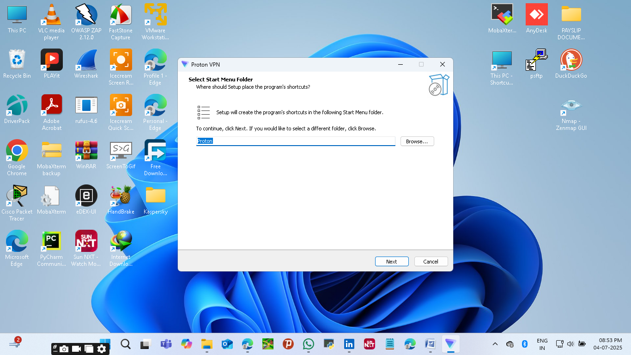

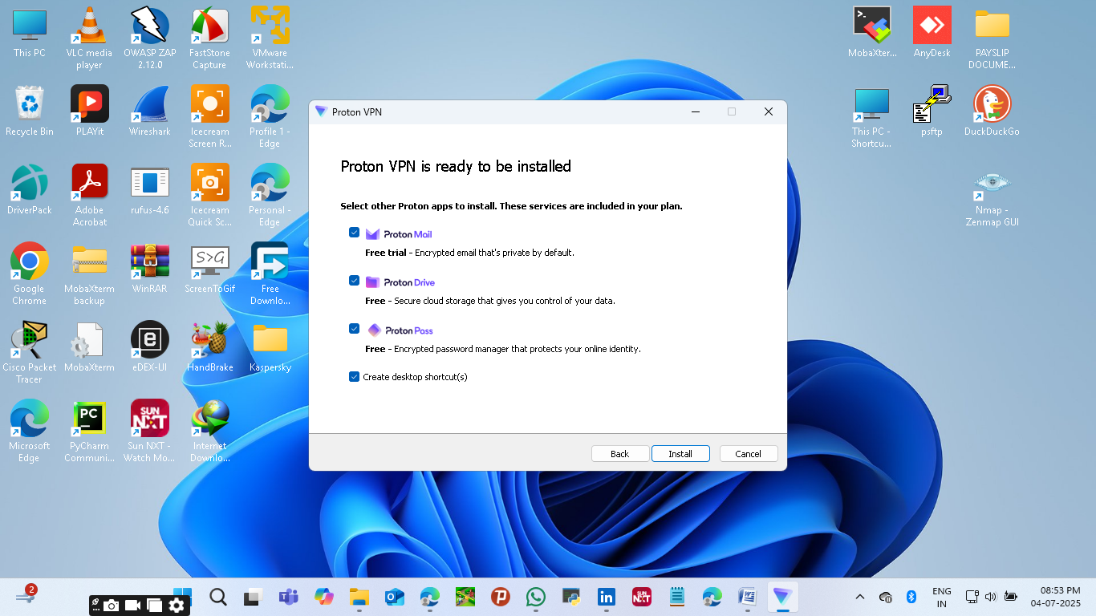

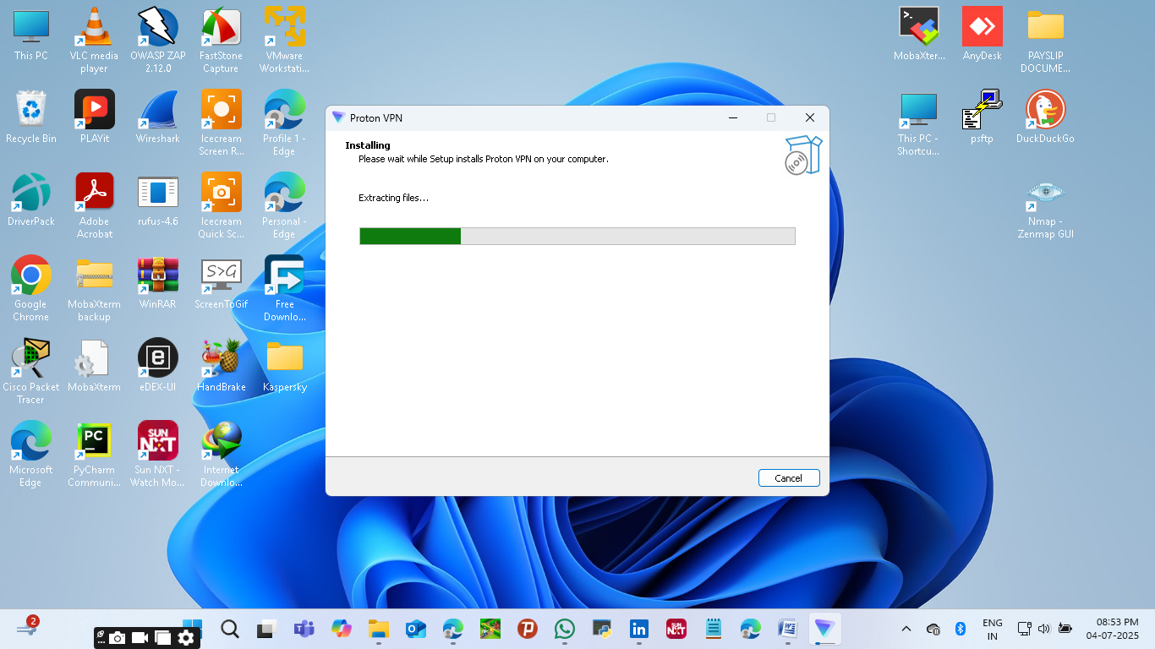

**Connected:**

**3. Connect to a VPN Server:**

* **Launched the VPN app.**
* **Logged in using my account credentials.**
* **Connected to the nearest free server (e.g., India - Free #1 or Netherlands - Free #1).**

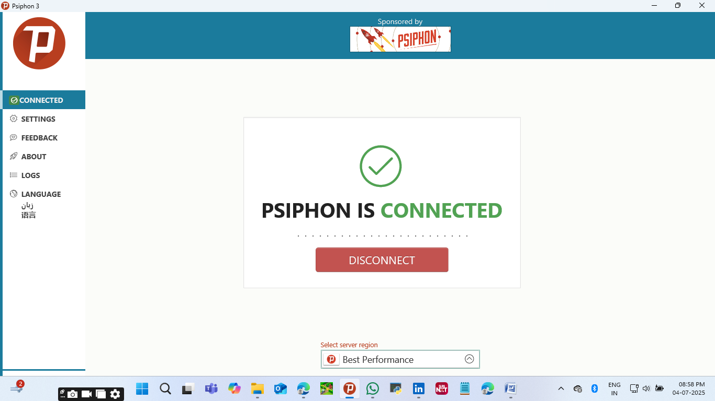

**4. Verify IP Address Change:**

* **Visited** [**https://www.whatismyipaddress.com**](https://www.whatismyipaddress.com)
* **IP address changed from local ISP IP to a VPN IP address.**
* **Location now showed the VPN server’s location (Netherlands, for example).**

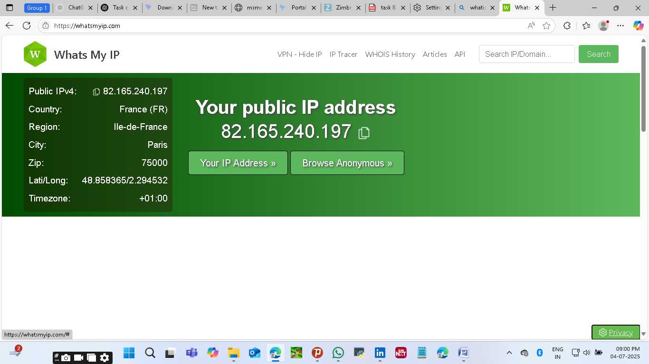

**5. Confirm Encrypted Traffic:**

* **Browsed secure sites (e.g.,** [**https://google.com**](https://google.com)**).**
* **Checked browser padlock symbol 🔒 → Traffic was encrypted via HTTPS.**
* **Also used ProtonVPN's app which confirmed active encrypted tunnel.**

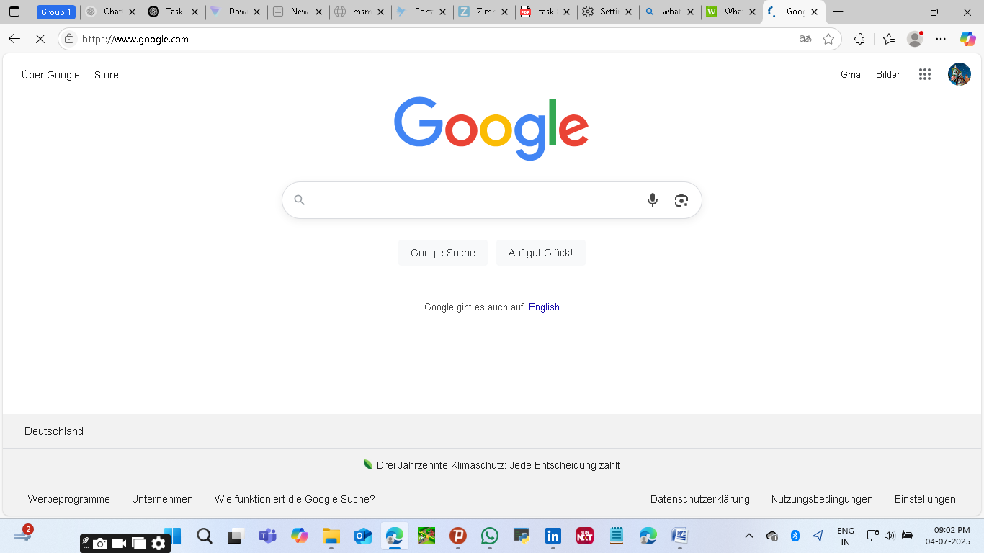

**6. Disconnect VPN and Compare:**

* **Disconnected from VPN.**
* **Revisited [**[**https://www.whatismyipaddress.com**](https://www.whatismyipaddress.com)**] — IP reverted to original ISP IP.**
* **Browsing speed improved slightly without VPN, confirming speed impact.**

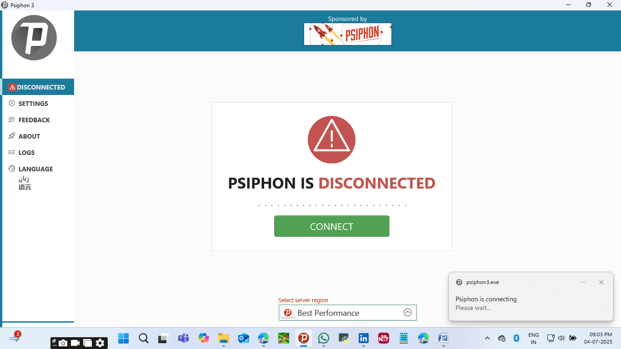

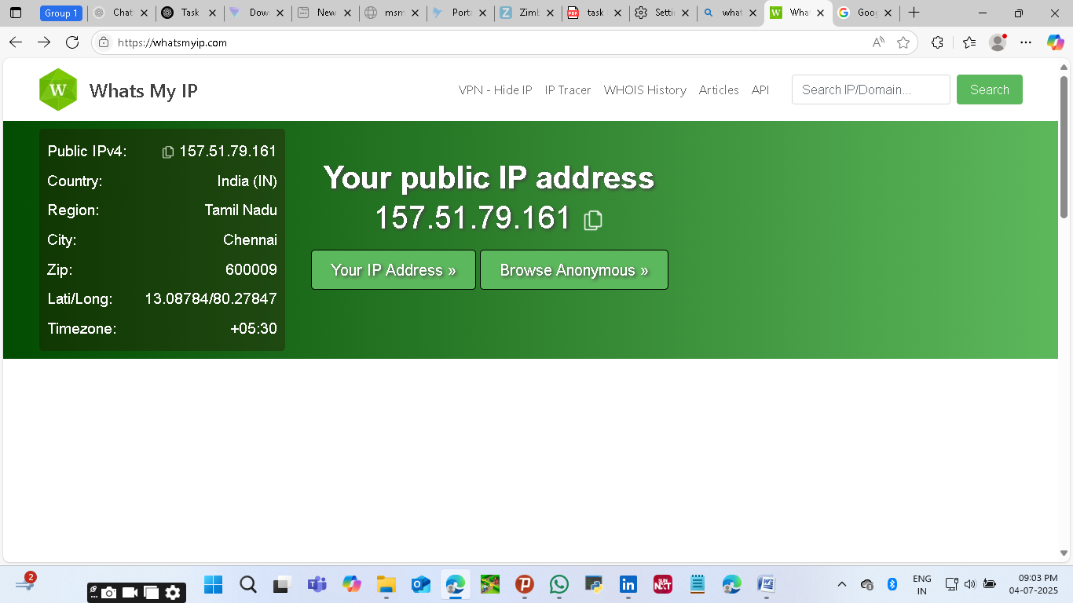

IP Changed From Previous after Dis-Connected VPN.

**🔐VPN Features: Encryption & Privacy**

| **Feature** | **Description** |
| --- | --- |
| **Encryption** | **AES-256 encryption for all data transmitted between user and VPN server.** |
| **Protocols** | **Supports OpenVPN and WireGuard (secure and fast).** |
| **DNS Leak Protection** | **Prevents your ISP from tracking your DNS queries.** |
| **No-Log Policy** | **ProtonVPN does not log user activity or connection metadata.** |
| **Secure Core (Optional)** | **Routes traffic through multiple servers to resist surveillance (paid only).** |

**📄 Summary: VPN Benefits and Limitations**

**✅ Benefits:**

* **Hides real IP address → Enhances privacy**
* **Encrypts internet traffic → Prevents ISP/attackers from spying**
* **Allows bypassing geo-restrictions (e.g., content blocked in India)**
* **Prevents tracking on public Wi-Fi**

**⚠️ Limitations:**

* **Free plans may have speed or location limitations**
* **VPN cannot protect from malware, phishing, or unsafe websites**
* **Not completely anonymous — VPN provider can still see your traffic (if not no-log)**
* **Slight drop in internet speed depending on server load and distance**