# Transforming Retailer-Customer Experience Using BlockChain Approach

**ABSTRACT**

**Motivation and Relevance**

The business sector is an ever-growing sector with the need to satisfy the customer demands alongside making considerable profits for the growth of the industry and self-interest. With all the new and upcoming technologies, it was only natural for the commercial businesses like retailers of supermarkets to incorporate emerging technologies like targeted marketing, diversity marketing, transactional marketing and various other strategies to generate more business profit. In the transactional marketing approach the owners of supermarket entice their customers with attractive offers and schemes for growth in their sales. One of the ways was the introduction of shopping coupons by the retail outlets in which the customers were provided with some loyalty points by the retailer on shopping above certain specified amount. These loyalty points could be redeemed by the customer as per the schemes put forward by the retailer.

With the emergence of technology every investor today is keen on reducing the labour cost and increase their profit margins. Reducing the cost on labour will enable the businessmen to get higher gains from their businesses and expand their market. The current retailer outlets involve a lot of casual employees. Infact more than nine lakh American employees are seen as casual labourers in such outlets. With the use of technology if one could really automate the entire process of buying goods from such outlets then the future retailers would definitely enjoy profits more than what the outlet business is offering the retailers today.

**Current State of Art**

The development of distributed ledger technology that is, blockchain has led to the emergence of essential applications to payment, clearing, and settlement in the wholesale markets. The responsibility of financial establishments as mediators in trading, clearing and settlements for their customers can be minimised to zero using the blockchain technology potentially decreasing waiting time of huge transactions from days to minutes. The ease of the process of transferring digital currency like Bitcoin and transparency in record maintenance is facilitated by means of peer –to-peer network, cryptography and distributed data storage .Lael Brainard in the paper titled :”The Use Of Distributed Ledger Technologies in Payment, Clearing and Settlement, Board Of Governors Of The Federal Reserve System at Institute Of International Finance Blockchain Roundtable, Washington D.C. in April 14, 2016 has elaborated the use of blockchain in payment, clearing and settlement.

The customers today spend several minutes in the cash counter lines to buy the items that they desire to purchase. It is quite evident that by using technology this time consuming shopping experience can be liberalised to make the shopping experience of the customers more convenient.

**Problem Statement**

One thing common in the way the supermarkets conduct business today is that they offer discounts and issue coupons to customers who shop above a specified amount. This kind of marketing strategy called transactional marketing is effectively applied in supermarkets like more megastores, Big Bazaar, Central, Croma, D-Mart, Hypercity, Reliance Fresh and Westside. But these supermarket retailers maintain a local database at every store which doesn’t provide the customer the flexibility to avail the discounts granted to them in other outlets of the supermarket. Moreover the discount schemes in various branches of the supermarket may be different and hence due to lack of awareness of the customer about the several schemes the customer and the business may lose out on their win–win situation. All this is attributed to the absence of a central transparent server connecting all the outlets of the supermarket.

Moreover, several customers today have a common complaint on the time spent in the checkout line for purchasing the items from the store that they desire to buy. Our objective is to build a pay as you choose the item.

Companies like Amazon and Microsoft are working towards check-out free retail technology. Amazon has recently launched a cashier-free convenience store without lines or check-out counters in the company’s hometown of Seattle. Our vision is to enable the customers pick the items that they want and walk out of the store as soon as they are done with their shopping.

**Objectives**

Our proposed system offers a reward based system using blockchain technology to maintain a blockchain of customers pertaining to an offer proposed by the retailer, common to all the outlets of the retailer and issuance of Value-coins (the cryptocurrency of the reward based system) to the customers on the purchase of every stipulated amount.

Our project also aims at simplifying the customer experience when it comes to shopping. The customers today have to stand for several minutes in the cash counter to pay their bills. Such a situation can be avoided by enabling the customer to pay soon after they have finished adding items to their cart. This can be done by enabling the customer to scan the barcodes of the product using their phones and finally pay the total amount.

**Methodology**

Our main idea is to make a blockchain of customers for a supermarket which is shared amongst its various outlets along with the accumulation of credits. Our proposed system includes the customer credits provided by the retailer upon shopping above a specified amount, to be accumulated in the customers block. Collectively, such blocks form a blockchain of the customer accounts altogether for the company, which is shared amongst the network of the company’s outlet present in various cities to maintain a proper distributed ledger. The system will allow us to:

1. Make credits called Value-coins with a fixed limit. This limit of how many Value-coins are to be generated in total is decided by the retailer based on the profit margin.

2. Create an autonomous private Blockchain with rules on how many Value-coins will be issued to the customer on spending how much money.

3. Transactions are validated and details of transactions are added to the customer block.

4. In case, the number of Value-coins issued to the customers reaches the limit, it indicates the end of the specific offer scheme.

With the use of blockchain technology the customer would be liberalised from physically possessing discount coupons at the time of redemption, be fully aware of the existing discount schemes and their redemption validity. Thus the use of Blockchain system in supermarkets would ensure a safe, secure and a transparent means for transaction record maintenance and granting of credits to the customer based on the various shopping schemes proposed by the retailer. Moreover, since the concept of blockchain would be used the supermarket retailer would be freed from the cost of maintaining a central server as each time a new transaction occurs the currently active customers could mine them and verify the validity of the transaction.

As the idea is to ease the customer experience our aim is also to save the customer’s precious time by helping the customer from not standing in long queues of the checkout line. To do this the customer simply needs to scan the barcode printed in the products that he/she desires to buy using their phone, pay for it through their phone and walk out of the store soon after their payment is done.

**Tools and Technologies**

1. Android
2. Java
3. Blockchain
4. Cryptography
5. Networking

**Expected Outcome**

To understand the working of the proposed system let us consider a discount scheme consisting of 100 Value-coins where in each value coin is awarded to a customer for every 1000 rupees of purchase made by them which means if a customer makes a purchase of Rs. 1000 the customer will get 1 Value-coin, if the customer makes a purchase of Rs. 2500 the customer will get 2 Value-coins, if the customer makes a purchase of Rs 3999 the customer will get 3 Value-coins and so on. Let’s say according to the discount scheme when the customer gets 5 Value-coins then the customer can redeem and avail a discount of Rs. 250 in his or her total transaction. So if the customer makes a purchase of Rs. 5000. The customer gets 5 Value-coins and so the customer’s total amounts to Rs. 4750 on using the 5 Value-coins that the customer has got as per the discount scheme for transaction.

Each time the customer picks an item he scans the barcode printed on the product and in this way the item gets added to his cart. After the customer has completed their shopping; the customer can then pay the amount using his phone and walk out of the store thereby saving the time that would be spent standing in the cash counter to pay for the items that the customer wishes to purchase.

**Proposed Architecture**

The overall system architecture is as shown in figure 1. Figure 2 gives a vivid description of how the blockchain of customer transactions pertaining to a retailer is created.

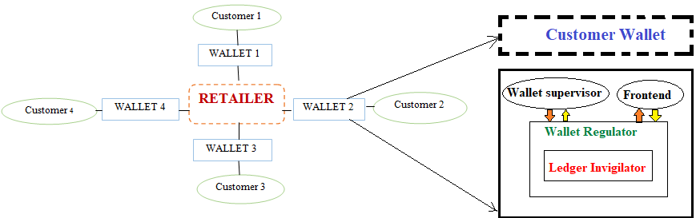

**Fig. 1.** System Architecture

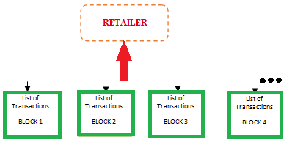 **Fig. 2.** List of transaction blocks that form the blockchain of the retailer

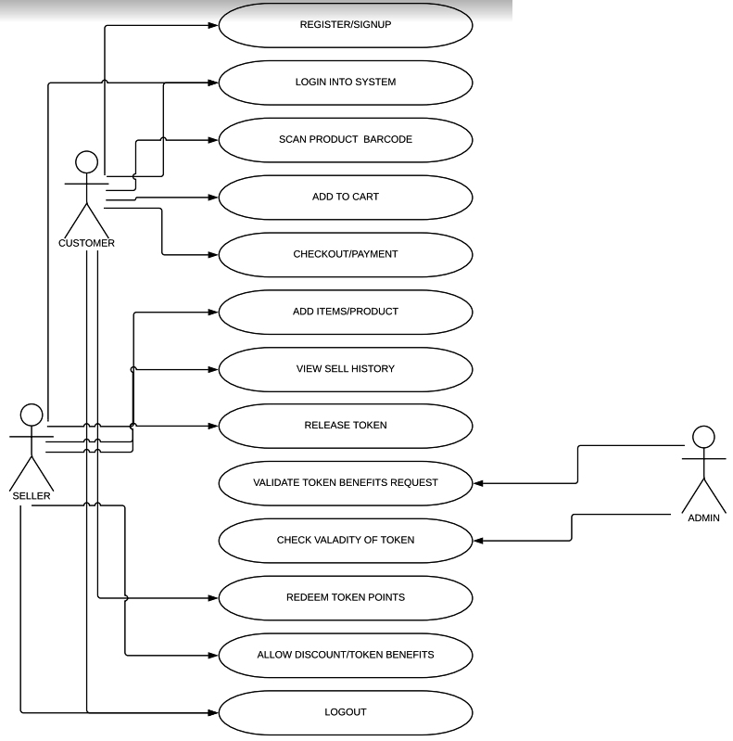

**Prototype implementation details**

The blockchain of the proposed system is created using an ArrayList of objects that are blocks which represent a customer of the retailer.

Structure of Block

Index – int

Timestamp – string

Amount – int

Hash – string

prevHash – string

Definitions:

Index: maintains the position of data record in the blockchain.

Timestamp: This is automatically determined and is recorded when the data is written.

Amount: Represents the transaction of the customer in temrs of Value-Coins

Hash: The cryptographic hash algorithm which is implemented using SHA 256.

prevHash: Hash of previous record in the chain.

Customer Transaction

Algorithm 1 illustrates the detailed steps and procedure involved in customer trabsaction.

**Algorithm 1** Customer Transaction

1. Begin
2. Enter the transaction amount in the customer transaction prompt.
3. Fetch the customer input.
4. Create a new block with the data. By using
5. generateBlock()
6. isBlockValid()
7. replaceChain()
8. Broadcast the newly created block to the other peers in the network.
9. After the addition of the new block in the peer records the user is prompted to perform another transaction.
10. End

Algorithm 2 describes the broadcasting of the latest state of the blockchain every 5 seconds to the peers in the network. The peers will receive it and check it.

**Algorithm 2** Routine Message

1. Begin
2. if (new chain lenght<=present chain length)
3. discard it.
4. else
5. accept it if it is larger.
6. End if
7. End

Algorithm 3 explains how the bock is validated before adding the transaction into the chain.

**Algorithm 3** Validate Block

1. Begin
2. isBlockValid (newblock,oldblock){
3. if(oldblock.Index+1 != newblock.Index)
4. return false;
5. if (oldblock.hash !=newblock.prevhash)
6. return false;
7. if(calculatehash(newblock)!=newblock.hash)
8. return false;
9. return true;
10. **}**
11. End

Algorithm 4 adds the block into the chain after the block validation.

**Algorithm 4 Replace chain**

1. Begin
2. replacechain(newblocks [] Block){
3. if(length(newBlocks) >len(Blockhash))
4. Blockchain=new Blocks;
5. }
6. End