**Mini Project Report**

**On**

Guard Pilot

Submitted for the partial fulfillment of Bachelor of Engineering

by

1. **Abhishek Koul (1SI15CS002)**

**2. Arup Das (1SI15CS015)**

**Under the guidance of**

Mr. G Bhaskar

M. Tech

Assistant Professor



**Department of Computer Science and Engineering**

**Siddaganga Institute of Technology, Tumkur – 572103**

(An Autonomous Institution, Affiliated to VTU, Belagavi & Recognized by AICTE, New Delhi)

**2017-2018**

**SIDDAGANGA INSTITUTE OF TECHNOLOGY,** TUMAKURU-3

(**An Autonomous Institution, Affiliated to VTU, Belagavi & Recognized by AICTE, New Delhi)**

DEPARTMENT OF COMPUTER SCIENCE & ENGINEERING



**CERTIFICATE**

This is to certify that that the Mini project work entitled “Guard Pilot” is a bonafide work carried out by **Abhishek Koul(1SI15CS002) and**  **Arup Das(1SI15CS015)** of VI semester **Computer Science and Engineering**, **SIDDAGANGA INSTITUTE OF TECHNOLOGY** for the partial fulfillment of Bachelor of Engineering during the academic year 2017-2018.

**Signature of the Guide Signature of the Convener**

**Name:** G. Bhaskar A.V. Krishna Mohan

**Designation:** Assistant professor Assistant professor

**Signature of the HOD**

**Dr R. Sumathi**

**Prof. and Head, Dept. of CSE**

**Name of the Examiners: Signature with Date**

1. **j**

**ACKNOWLEDGEMENT**

With reverential pranams, we express our sincere gratitude and salutation to His Holiness **Dr. Sree Sivakumara Swamigalu** of Sree siddaganga Mutt for his unlimited blessings.

First and foremost, we wish to express our deep sincere feelings of gratitude to our institution, **Siddaganga Institute of Technology** for providing us for completing our project successfully.

We are grateful to **Dr. M.N. Channabasappa**, Director, Siddaganga Institute of Technology, Tumakuru for his cooperation and encouragement.

We express our kind thanks to **Dr. Shivakumaraiah**, principal, Siddaganga Institute of Technology Tumakuru for his encouragement towards student’s attitude.

We express our heartfelt thanks to **Dr. R. Sumathi**, Professor and Head, Department of Computer Science and Engineering, Siddaganga Institute of Technology, Tumakuru for her suggestions and advice.

We express our gratitude and humble thanks to our project guide **Mr. G.** **Bhaskar**, Assistant Professor, Department of Computer Science and Engineering, Siddaganga Institute of Technology, Tumakuru for guiding and facilitating to complete our Mini-Project successfully.

We are conscious of the fact that we have received cooperation in many ways from the **Teaching, Technical and supporting staffs** of the Department of Computer Science and Engineering and we are grateful to all for their cooperation.

We express heartfelt gratitude to our **parent and friends** for their constant moral support and encouragement throughout this work.

**ABSTRACT**

Trains are considered the lifeline of India. Everyday millions of people use the railway services to travel to different parts of India, but one problem which has been prevalent in Indian Railways is the problem of Train Derailment. Train Derailment refers to the removal of train from its track during its motion leading to casualties.

A fishplate, splice bar or joint bar is a metal bar that is bolted to the ends of two rails to join them together in a track. These bolts may loosen up when the train passes over the rail lines, the rails get separated and the train derails from its track.

Cracks in the rails are more prevalent during summers. When temperature rises, the rail tracks expand. This causes a lot of stress on the screws to keep the tracks fixed to the ground. The two railway tracks laid together are then pushed against each other. At night the rail tracks contract and return to their original state there by puling against each other. The constant tussle leads to weakening of joints.

The solution to this problem involves a separate mechanical device (named as Guard Pilot) which will be running in front of the train and analyzing the tracks for cracks and loose joints with the help of some high speed cameras implementing image processing algorithm. Thus analyzing and processing the condition of the tracks. This Guard will be running at a distance of more than the emergency braking distance of the train so that as soon as it communicates with the train of any upcoming reason to worry, emergency brakes could be applied and the disaster can be avoided.

**Table of Contents**

|  |  |  |
| --- | --- | --- |
| **Sl No.** | **Chapter Name** | **Page No.** |
| 1 | Introduction | 1-2 |
| 2 | Literature Survey | 3-4 |
| 3 | Requirement Specification | 5 |
| 4 | Design and Implementation | 6-13 |
| 5 | Results | 14-16 |
| 6 | Conclusion | 17 |
|  |  |  |

**CHAPTER 1**

**INTRODUCTION**

In today’s world, transport, being one of the biggest drainers of energy, its sustainability and safety are issues of paramount importance[1]. In India, rail transport occupies a prominent position in quenching the ever burg owing needs of a rapidly growing economy. Today’s most of the railroad investigation is manually conducted by track examiners[3]. Practically, it is not easy to investigate the thousands of railway track by trained human examiners. Cracks appear in tracks, wheels due to lack of maintenance. This lack of maintenance isn’t due to procrastination of the Railway Staff but only because tracks are extra-busy with dozens of trains also due to the run of trains on a daily basis[2]. Maintenance needs time which Indian Railways is unable to find as passengers won’t tolerate cancellation of their train trips or mega blocks of their train route tracks Hence it takes too much time to inspect the defected railway tracks and then inform to the railway authority people. However, in terms of the reliability and safety parameters, global standards have not yet been truly reached. Though rail transport in India is growing at a rapid pace, the associated safety infrastructure facilities have not kept up with the mentioned proliferation[4]. The proper operation and maintenance of transport infrastructure has a great impact on the economy.

The Indian Railway has the world’s fourth largest railway network in the world, next to the United States, Russia and China. The railway traverses the length and breadth of the country and carry over 20 million passengers and 2 million tons of freight daily. It is one of the world’s largest commercial or utility employers, with more than 1.6 million employees[5]. Although there is a tremendous growth in Indian Railways, this system is still plagued by a number of problems which require immediate attention. The principal problem is the lack of efficient and cost effective technology to detect problems in the rail tracks and the lack of proper maintenance. Railway inspection is thus undoubtedly a necessary control procedure that has to be performed periodically in order to control the quality of the railways and prevent future accidents in the case of deficiencies on the railway[6]. Safety in railways is one of the key issues for the public transportation companies and a fast and efficient inspection system is important to ensure the safety of railways[5].

Traditional rail inspection methods include destructive techniques, such as coring, and non-destructive techniques, such as hammer sounding. But these methods can just “cover limited area and have limited effectiveness in identifying possible sites of deterioration”[8]. As the Rail track inspection is a necessary task in railway maintenance and is required to periodically inspect the rail track by trained human operator, who is walking along the track & searching for defects. Such type of monitoring system is unacceptable for slowness and lack of objectivity. So it clearly proves that this inspection will take too much time to recover from faults and does not guarantee accurate results.

The high frequency of trains and the unreliability of manual labor have put forth a need for an automated system to monitor the presence of crack and other anomalies on the railway lines. In this project we have proposed a proto type for addressing the problem of derailment. A derailment occurs when a vehicle such as a train runs off its rails. When a train lunges from the tracks, it can cause physical damage, but it can also seriously injure passengers aboard and passers-by in the nearby area.

Usually, the derailment of a train can be caused by an operational error, the mechanical failure of tracks, such as broken rails, or the mechanical failure of the wheels. In emergency situations, deliberate derailment with derails or catch points is sometimes used to prevent a more serious accident. Currently there is no particular solution proposed to this problem. Various organizations have been working on this specified project using the drone technology (i.e. using drone for surveillance of the rails) but no absolute solution has been provided as such.

The main objective of the project is to identify the anomalies on the railway track using the setup called “Guard Pilot” which can be implemented in live by Railway authorities. The proposed setup would make the inspection and maintenance of railways tracks easier and help them to monitor efficiently by replacing the human inspection which is currently followed. The design of this setup is very simple and can be easily adopted by the present system. It requires less amount of capital input than the other existing proposed solutions. Our solution is self-driven and doesn’t require as much supervision as is required by the other solutions. Its potential customer includes all the Indians who would rely on the Indian Railways for long distance transportation.

**CHAPTER 2**

**LITERATURE SURVEY**

It is evident that the issue at hand which is train derailment is a matter of serious concern. The following section highlights the same.

**2.1 NUMBER & TYPE OF ACCIDENTS**

By far, the highest number of accidents are because of derailments & accidents at level crossings. Nine (9) out of Ten (10) railway accidents during 2009-10 and 2014-15 have been due to derailments and accidents at level crossings.  The other type of accidents includes collisions, etc. But their number is relatively much lower. Two of the most recent mishaps that have taken place due to train derailments are the Puri-Haridwar Utkal Express and Mahakaushal Express. The derailment of the Puri-Haridwar Utkal Express on 19 August, 2017, was an unfortunate accident that led to a casualty of more than 20 passengers and injured over 200 people. On 30 March 2017 - eight coaches of Mahakaushal Express got derailed near Uttar Pradesh's Kulpahar, injuring 52 passengers. The histogram in **Fig. 2.1.1** and the pie-chart in **Fig. 2.1.2** clearly depict that derailments are the major reason for train accidents in Indian Railways.

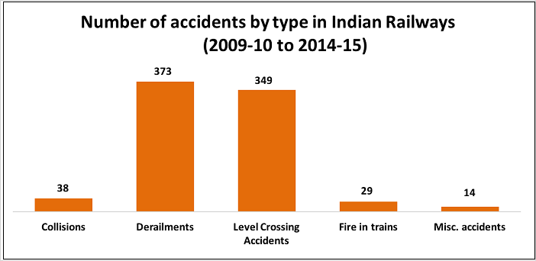

**Fig 2.1.1**: Number of Accidents in Indian Railways

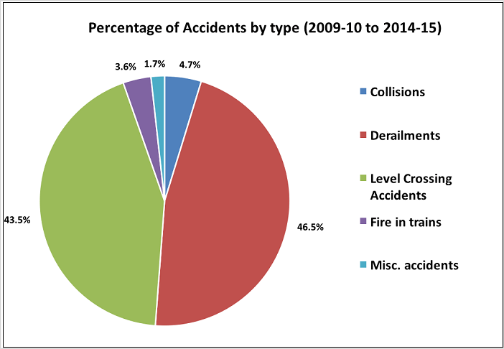

**Fig 2.1.2**: Percentage of accidents in Indian Railways

**2.2 TRAIN ACCIDENTS PER MILLION KILOMETERS RUN**

The trains of the Indian Railways are clocking more passenger kilometers each year. From 2.08 lakh kilometers in 1980-81, the number of passenger kilometers reached 11.47 lakh kilometers in 2014-15. Train accidents per million kilometers run are an important parameter to understand the occurrence of accidents and if there has been any improvement over the years. This parameter has continuously decreased from 2009-10 to 2013-14 but again increased in 2014-15 in 2009-10, it has come to down to 0.10 in 2013-14, but it again increased to 0.11 in 2014-15. **Fig. 2.2.1** illustrates the above data in the form a graph.

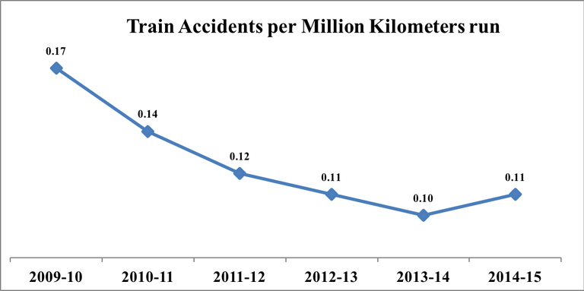

**Fig 2.2.1**: Accidents per kilometre run

**2.3 NUMBER OF CASUALTIES**

Though the number of accidents in 2009-10 was more than the number of accidents in 2010-11, 235 were killed in 2010-11 compared to only 67 in 2009-10. The accidents in 2010-11 were more fatal compared to the other years. The number of those killed has been on the decline since 2010-11 only to increase in 2014-15. **Fig. 2.3.1** depicts the number of casualties from the year 2009-15.

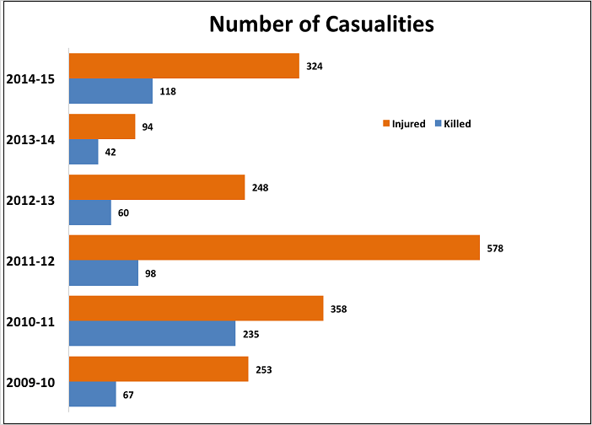

**Fig 2.3.1**: Number of Causalities

**CHAPTER 3**

**REQUIREMENTS SPECIFICATIONS**

The technical specifications of our model are as described below.

* 1. **TECHNICAL SPECIFICATIONS**

|  |  |  |
| --- | --- | --- |
| Microcontroller | ATmega328 | ATmega2560 |
| Operating Voltage | 5V | 5V |
| Input Voltage(recommended) | 7-12V | 7-12V |
| Digital I/O Pins | 14 (out of which 6 provide PWM) | 54 (out of which 15 provide PWM) |
| Analog Input Pins | 6 | 16 |
| DC Current per I/O Pin | 40 mA | 40 mA |
| DC Current for 3.3V Pin | 50 mA | 50 mA |
| Flash Memory | 32 KB | 256 KB |
| SRAM | 2 KB | 8 KB |
| EEPROM | 1 KB | 4 KB |
| Clock Speed | 16 MHz | 16 MHz |

**Table 3.1.1**:Technical Specifications of Arduino ATmega328 and Arduino ATmega2560

* 1. **HARDWARE REQUIREMENTS**

|  |  |
| --- | --- |
| * Device | : Personal Computer |
| * Graphical Processing unit | : 2gb + |
| * RAM | : 4gb + |

* 1. **SOFTWARE REQUIREMENTS**

|  |  |
| --- | --- |
| * Operating system | : Windows, Mac OS X and Linux |
| * Coding Language | : C or C++ |
| * IDE | : Arduino 1.8 |

**CHAPTER 4**

**DESIGN AND IMPLEMENTATION**

**4.1 DESIGN**

A **derailment** occurs when a vehicle such as a train runs off its rails. When a train lunges from the tracks, it can cause physical damage, but it can also seriously injure passengers aboard and passers-by in the nearby area.

Usually, the derailment of a train can be caused by a collision with another object, an operational error, the mechanical failure of tracks, such as broken rails, or the mechanical failure of the wheels. In emergency situations, deliberate derailment with derails or catch points is sometimes used to prevent a more serious accident.

The solution involves a separate mechanical device (named as ***Guard Pilot***) which will be running in front of the train and analyzing the tracks processing the condition of the tracks. This Guard will be running at some offset from the train so that as soon as it communicates with the train about any upcoming reason for concern, brakes could be applied and the disaster could be avoided.

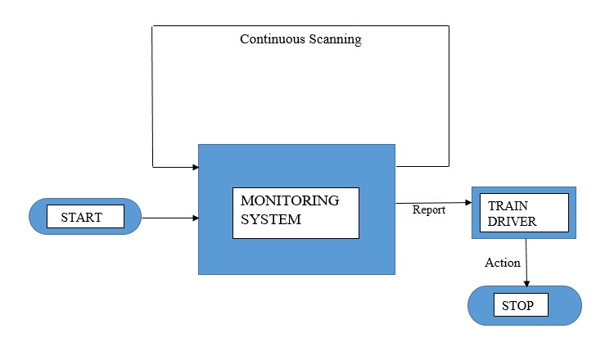

**Fig. 4.1.1**:Process Flow Diagram of Guard Pilot

**Fig. 4.1.1** shows the overall process flow of the fault detection mechanism.

The various states of the guard pilot is described below:

1. START – This is the starting state from which the Guard pilot starts moving along with the processing of the tracks. It starts collecting the input through the various sensors installed on the system and sends the inputs to the processor on the system for computation purposes.
2. MONITORING SYSTEM – This is the core part which performs the error checking on the input stream of data and decides whether it’s safe for the passage of the train or not. This decision leads to either of the two results:

* If it’s result is that, it’s safe for passage of the train then it doesn’t take any action and simply continues to scan the further tracks.
* If it’s result is that, it’s not safe for the train to pass over the analysed track then this result is reported to the train driver.

1. TRAIN DRIVER –The train driver is at the receiving end of this system. The actions to be taken in case the guard pilot reports of an error while analysing the track is decided by the train driver. The train driver immediately applies the braking system to stop the train.
2. STOP –This is the final state to which the train remains in after the braking system has effectively brought the train to a standstill.

The proposed guide pilot is capable of saving not just the lives of the passengers aboard on the train but it also saves the amount that could potentially be spent on repairing the train damaged due to its derailment. Further, by reporting the train driver about the upcoming danger well in advance the train can be brought halted by applying normal breaking system. This prevents the railway tracks from getting damaged due to sudden application of emergency brakes.

Lastly, the expenses involved in getting the guard pilot in the operational state is much less than the cost of life and the infrastructure that it safeguards from being damaged.

**4.2 IMPLEMENTATION**

The Implementation involves a prototype model of the original system which is implemented using 2 LFRs (Line Following Robots) which simulate the train and the Guard Pilot respectively.

The first LFR running on the surface will analyze the track for any disconnection or anomaly, if the embedded sensors detect that the track is not a continuous one but rather has a discontinuity, it sends the warning message using the communication module to the LFR behind (simulating the train).

Now, after receiving the message from the LFR in front about the unsuitable environment this LFR stops automatically thus avoiding any problems ahead.

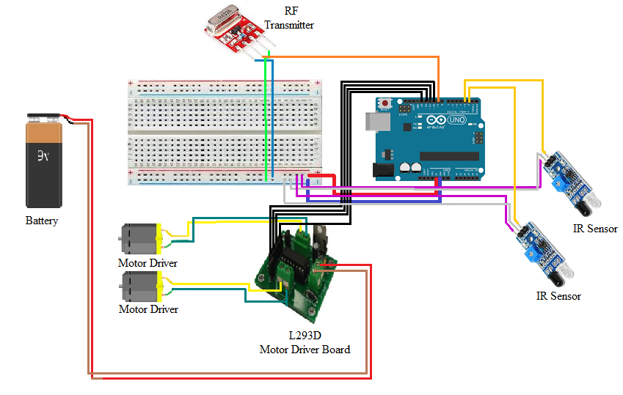

**Fig 4.2.1**: Guard Pilot Circuit Diagram

The **Fig. 4.2.1** depicts the circuit design of the Guard Pilot system which shows all the connections with the components as shown.

CODE FOR THE GUARD PILOT:

#include <SoftwareSerial.h>// import the serial library

#include <VirtualWire.h>

const int transmit_pin = 9;

SoftwareSerial Genotronex(5, 6); // RX, TX

void send(char*);

int r,l;

void setup() {

// put your setup code here, to run once:

Genotronex.begin(9600);

Serial.begin(9600);

Genotronex.println("Bluetooth On please press 1 or 0 blink LED ..");

pinMode(10,OUTPUT); //10,11 for left motor

pinMode(11,OUTPUT);

pinMode(12,OUTPUT); //12,13 for right motor

pinMode(13,OUTPUT);

pinMode(4,INPUT); // At pin no:4 we will connect the right light sensor which will act as an input device

pinMode(3,INPUT);

Serial.println("setup");

vw_set_tx_pin(transmit_pin);

vw_setup(2000);

}

void loop() {

// put your main code here, to run repeatedly:

r=digitalRead(4); // Reading the input of right sensor and storing the value in pin no:4 of

//Arduino

l=digitalRead(3); // Reading the input of left sensor and storing the value in pin no:3 of

//Arduino

if(r==HIGH && l==HIGH) // If both left & right sensor are on white surface

{ // the left & right motor will go forward

digitalWrite(10,LOW);

digitalWrite(11,HIGH);

digitalWrite(12,LOW);

digitalWrite(13,HIGH);

Serial.println("FORWARD");

delay(1000);

}

else if(l==HIGH && r==LOW) // If left sensor is on white and right sensor is on black surface

{ // the left motor will go forward & right motor will go backward

digitalWrite(10,LOW);

digitalWrite(11,HIGH);

digitalWrite(12,LOW);

digitalWrite(13,HIGH);

send("1");

Serial.println("Stop");

delay(1000);

}

else if(l==LOW && r==HIGH) // If left sensor is on white and right sensor is on black

//surface

{ // the left motor will go backward & right motor will go forward.

digitalWrite(10,LOW);

digitalWrite(11,HIGH);

digitalWrite(12,LOW);

digitalWrite(13,HIGH);

send("1");

Serial.println("Stop");

delay(1000);

}

else if(l==LOW && r==LOW) // If left sensor is on white and right sensor is on black surface

{ // the left motor will go backward & right motor will go forward.

digitalWrite(10,LOW);

digitalWrite(11,HIGH);

digitalWrite(12,LOW);

digitalWrite(13,HIGH);

send("1");

Serial.println("Stop");

delay(1000);

}

}

void send (char *msg){

vw_send((uint8_t *)msg, strlen(msg));

//vw_wait_tx();

while(*msg!='\0')

Serial.print(*msg++);

Serial.println();

}

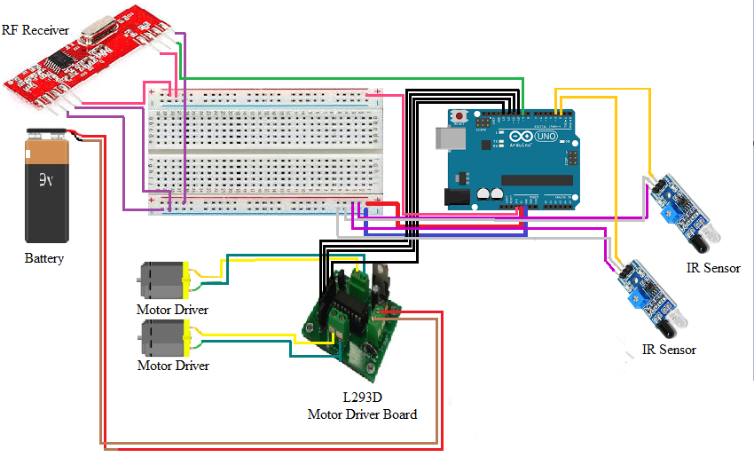

**Fig. 4.2.2**: Train Simulator Circuit Diagram

The **Fig. 4.2.2** depicts the circuit design of the Guard Pilot system which shows all the connections with the components as shown above.

CODE FOR THE RECEIVING SIDE:

#include <VirtualWire.h>

const int receive_pin = 9;

int r,l;

void setup(){

Serial.begin(9600);

pinMode(10,OUTPUT); //10,11 for left motor

pinMode(11,OUTPUT);

pinMode(12,OUTPUT); //12,13 for right motor

pinMode(13,OUTPUT);

pinMode(4,INPUT); // At pin no:4 we will connect the right light sensor which will act as

// an input device

pinMode(3,INPUT);

Serial.println("setup");

vw_set_ptt_inverted(true);

vw_set_rx_pin(receive_pin);

vw_setup(2000);

vw_rx_start();

}

void loop(){

uint8_t buf[VW_MAX_MESSAGE_LEN];

uint8_t buflen = VW_MAX_MESSAGE_LEN;

r=digitalRead(4); // Reading the input of right sensor and storing the value in pin no:4 of

// Arduino

l=digitalRead(3); // the left & right motor will go forward

if (vw_get_message(buf, &buflen)){

for (int i = 0; i < buflen; i++){

if(buf[0]=='1')

{Serial.println("STOP");

while(1)

{ digitalWrite(10,LOW);

digitalWrite(11,LOW);

digitalWrite(12,LOW);

digitalWrite(13,LOW);}

}

}

}

else {

digitalWrite(10,HIGH);

digitalWrite(11,LOW);

digitalWrite(12,HIGH);

digitalWrite(13,LOW);

Serial.println("frwd");

delay(1000);}

}

**CHAPTER 5**

**RESULTS**

The outcome the project involves the construction of a prototype model for the simulation of the train and Guard Pilot respectively. The **Fig. 5.1** gives the final structure of the LFR, which acts as the Guard Pilot and processes the lines for any discontinuity.

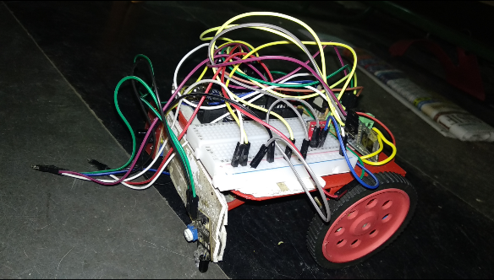

**Fig. 5.1**: Guard Pilot

The Guard Pilot is embedded with Infrared Sensors which are responsible for both the detection of the discontinuity and keeping the guard pilot of the specified path. This is the primary detection phase which is continuously scanning and detecting for the anomalies. Once a break or gap is detected by the Infrared Sensors that particular sensor sends the signal to the Arduino board. If either side or both of the sensors send the signal that an anomaly is detected, then this signal is processed by the Arduino board and appropriate measure is taken by it upon receiving the input from the IR sensors the Arduino board send a signal to the LFR behind it (which is simulating the train) to stop. This signal from the front LFR to back LFR is sent via the Radio Frequency Module (RF-Module) embedded on it.

The Sender part of this RF- Module is associated with the first LFR which emits Radio Frequency carrier waves that carry the specified signal to the second LFR. The signal which is sent is in the form of unsigned hexadecimal number system.

Now, talking about the receiver it is essentially of the same form with the same functionality such as using the Infrared Sensors for the progress of the LFR on the surface along with the receiver for the transmitter of the IR module on the first LFR. The **Fig. 5.2** gives a clear picture of the assembly of the second LFR.

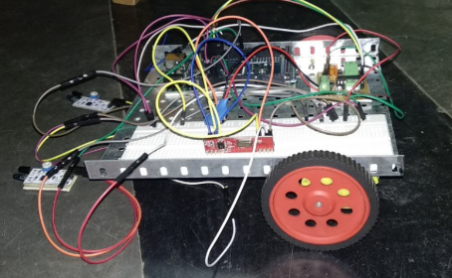

**Fig. 5.2**: Train Simulator

The above LFR which simulates the Train is embedded with the receiver for the transmitter on the Guard Pilot. This RF-receiver receives the data from the sender in the form of unsigned hexadecimal which can be used as it is or for the ease of use can be converted to the ASCII format and then further actions can be taken upon that.

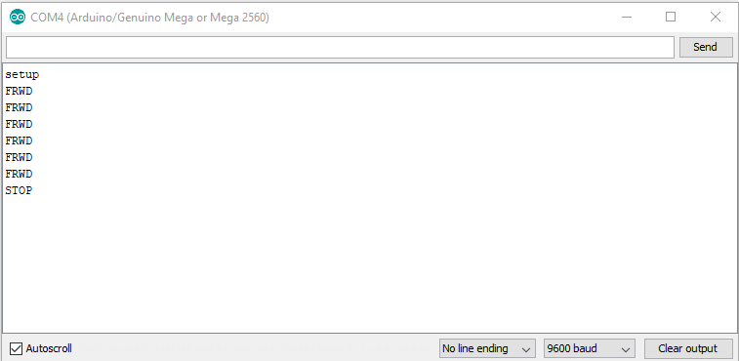

**Fig. 5.3**: Output on Serial Monitor

The **Fig. 5.3** is an example of how the communication is taking place. The above figure shows the receiver side which is continuously moving forward and upon receiving a signal from the sender about the anomaly ahead, it processes the input and tells the LFR to stop.

The final outcome of the project was the development of this prototype which implements some of the modules of the solution as described above. The two LFRs work in synch and perfectly communicate with each other for the detection and prevention purposes. Along with this the cost efficiency of this project is an added advantage for it.

Further establishment on the specified groundwork can be done to propose and introduce a working model of the solution which can be deployed during real time scenarios and implementation of that model can help curb down the problem of derailment in the Railway system.

**CHAPTER 6**

**CONCLUSION AND FUTURE ENHANCEMENTS**

**6.1 CONCLUSION**

The idea proposed in this project on live implementation would be extensively used by the railway authority to monitor the railway lines. The solution presented for the issue at hand is one of the most probable and simplest possible way for solving the problem of train derailment. The proposed setup would make the inspection and maintenance of railways tracks easier and help them to monitor efficiently by replacing the human inspection which is currently followed. The design of this setup is very simple and can be easily adopted by the present system. The proposed “Guard Pilot” is capable of saving not just the lives of the passengers aboard on the train but it also saves the money that would potentially be spent on repairing the train damaged due to its derailment. The proposed solution requires less amount of capital input than the other existing proposed solutions. Further, by reporting the train driver about the upcoming danger well in advance the train can be brought to a halt by applying normal breaking system. This prevents the railway tracks from getting damaged due to sudden application of emergency brakes. A significant cost savings would be realized through avoidance of a derailment at a turnout, which can result in repair costs of several lakhs of rupees [7]. The Guard Pilot would be appreciated by all the travelers travelling in the train. From the business prospective, the expenses involved in getting the “Guard Pilot” into the operational state is much less than getting a train damaged due to derailment back into operation.

**6.2 FUTURE ENHANCEMENTS**

Since our “Guard Pilot” enables detection of various anomalies by a simple variation it could also be able to detect the exact location of fault and hence inform the railway authority about the same. The inspector’s time on the track infrastructure is minimized, providing more efficient revenue operations and minimizing the inspector’s exposure to the hazardous environment. This would not just prevent trains from getting derailed but would also enable proper maintenance of the railway lines. Lastly, the value of a life is indefinitely costlier than any other form of money in the world.

**REFERENCES**

1. “An Arduino based Method for Detecting Cracks and Obstacles in Railway Tracks” Er.Kunduru Umamaheswari1 , Er.Polepogu Rajesh Assistant Professor Department of E.I.E, V.R.Siddhartha Engineering College, Vijayawada , Andhra Pradesh, India
2. “Railway track crack detection based on GSM technique “ by Mr. Anand S. Muley, Mr. Siddhant B. Patil and Prof. A.H.Shelar3 ; © 2017, IRJET, Impact Factor value: 5.181, ISO 9001:2008 Certified Journal, Page 1252
3. “Detection of Cracks and Railway Collision Avoidance System” by S. Ramesh, Asst. Prof., S.R.M. University 2010-2011, Uttar Pradesh (Ghaziabad), India
4. “Automated Visual Inspection Of Detecting Cracks And Obstacles On Rail Road Track Using Robot And Automatic Gate Control” by Prof. & Head Dr.B.Paulchamy, Asst. Prof. T.Sivamani, S.Viswanathan, R.Sugumaran, M.Ramadoss, and S.Sakthive published in International Journal of Innovative Research in Technology & Science(IJIRTS).
5. “Computer Vision Based Railroad Tracks Defect Detection, Segmentation and Assessment” by Miss. Pranali Vairagade, M.E.Scholar, Department of ETC, MGM’s COE, Nanded, India and Mr. D. J. Tuptewar, Associate Professor, Department of ETC, MGM’s COE, Nanded, India published in International Journal For Research In Emerging Science And Technology, Special-Issue-1-Jan-2017.
6. “Automatic Railway Track Crack Detection System” by Er.Nisthul G 1Assistant Professor, ME Dept, Saintgits College Of Engineering, Pathamuttom, Kerala, India Lijo George, Nelson Varghese, Sebin Jose, Nithin John and Nandhumon K R, Saintgits College Of Engineering,Pathamuttom,Kerala,India published in Imperial Journal of Interdisciplinary Research (IJIR), Vol-3, Issue-4, 2017, ISSN: 2454-1362
7. “Preventing Derailments at” by ALLAN M. ZAREMBSKI
8. Project report on “Railway Security Monitoring System” by ASwathy VG, Student at Annu University, Chennai, India