**Day_5**

**Date – 22/5/2024**

**Assignment 1**

**Write Linux Command**

**Commands :**

**1.ls**

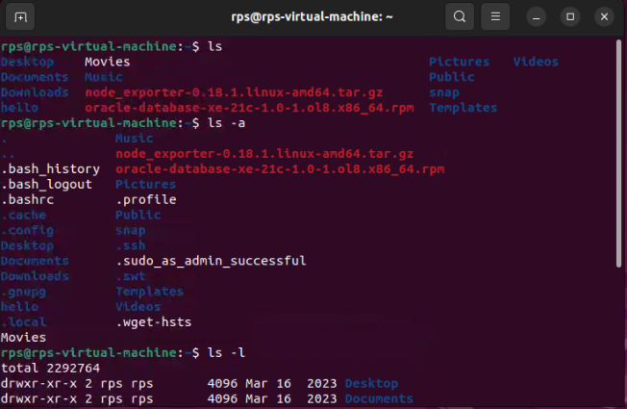

The ls command is used to list files and directories in the current working directory.

Different Options

ls –a : including hidden files

ls –l : long listing format

**2. pwd**

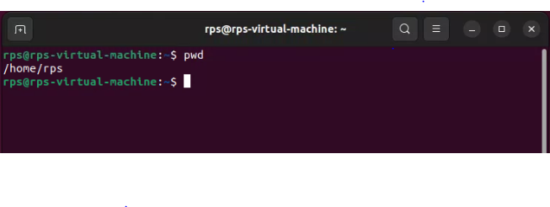

The pwd command allows you to print the current working directory on your terminal.

**3. mkdir**

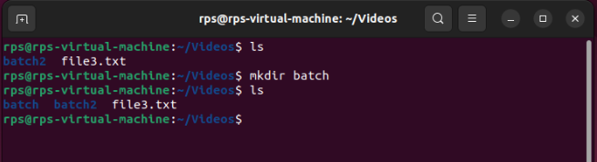

**4. rmdir**

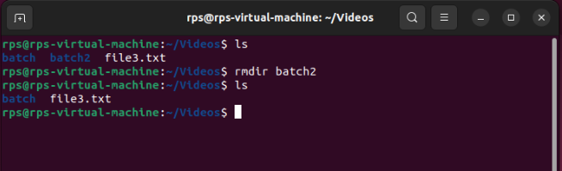

**5. cd**

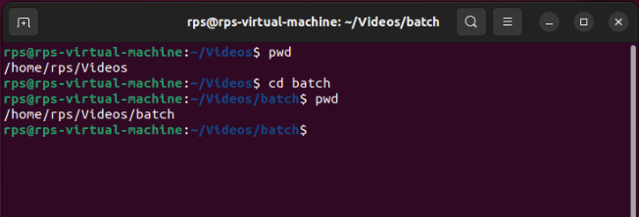

**6.cp**

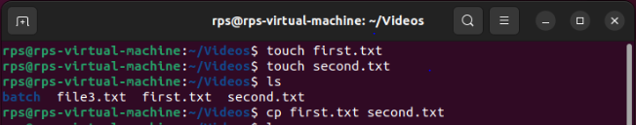

**7. mv commnd**

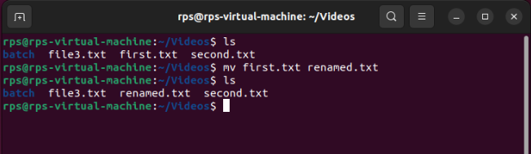

**8. rm command**

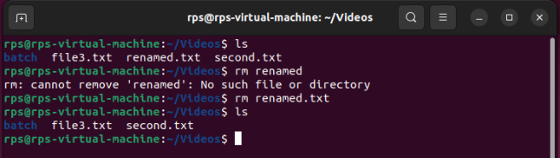

**9. touch command**

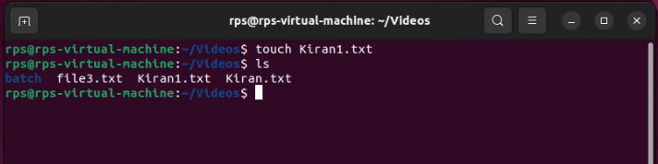

**10.linked command**

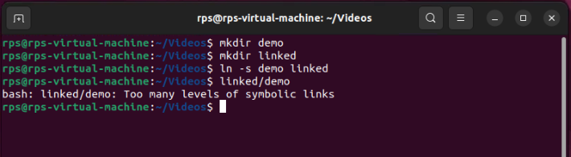

**11. cat command**

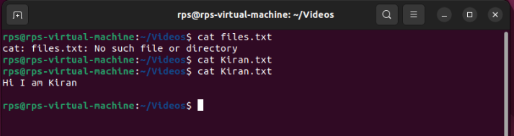

**12. clear command**

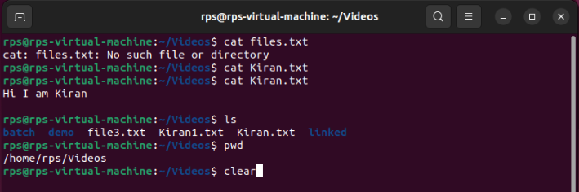 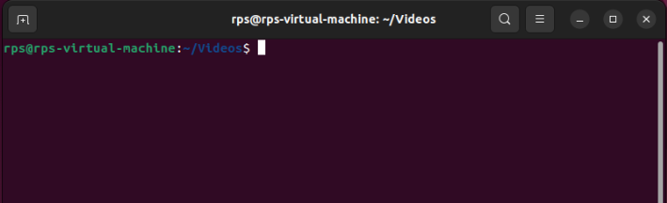

**13. ps command**

ps command in Linux is used to check the active processes in the terminal.

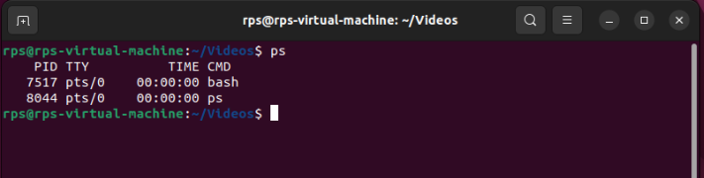

**14. man command**

man command displays a user manual for any commands or utilities available in the Terminal, including their name, description, and options.

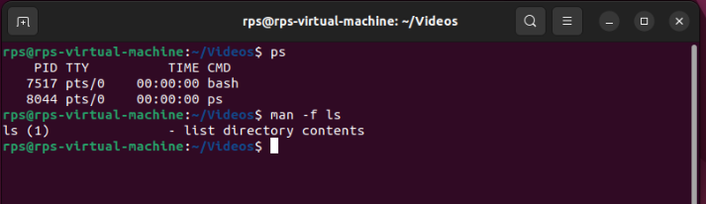

**15. echo command**

echo command in Linux is specially used to print something in the terminal

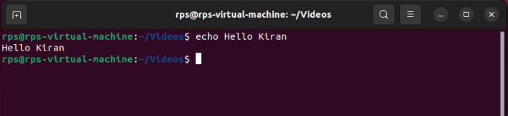

**16.wget command**

Wget command in the Linux command line allows you to download files from the internet. It runs in the background and does not interfere with other processes.

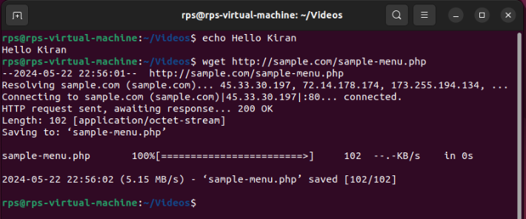

**17.whoami command**

Whoami command provides basic information that is extremely useful when working on multiple systems. In general, if you are working with a single computer, you will not require it as frequently as a network administrator.

