**Day_9**

**SQL Database**

**Assignment 1:**

Write a SELECT query to retrieve all columns from a 'customers' table, and modify it to return only the customer name and email address for customers in a specific city.

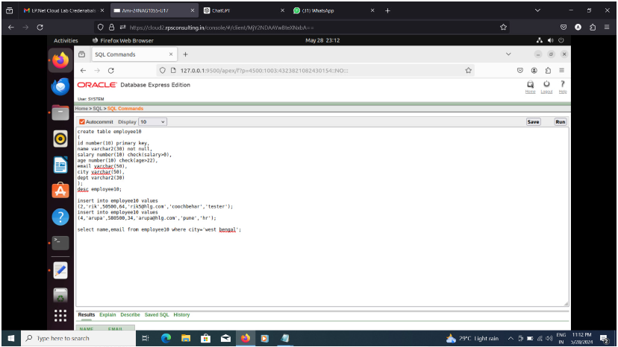

Output –

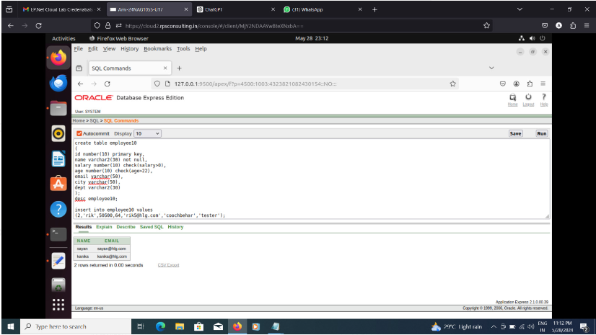

**Assignment 2:**

Craft a query using an INNER JOIN to combine 'orders' and 'customers' tables for customers in a specified region, and a LEFT JOIN to display all customers including those without orders.

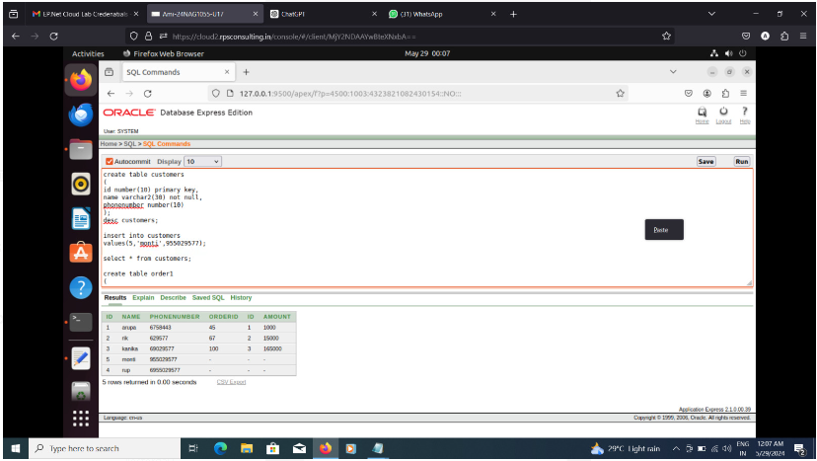

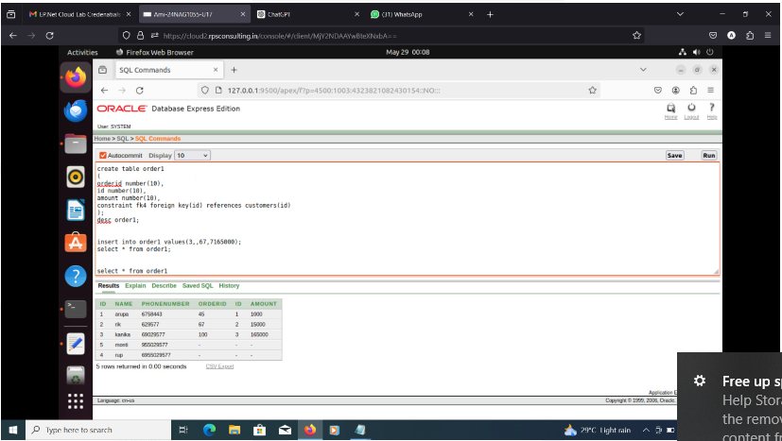

Inner Join

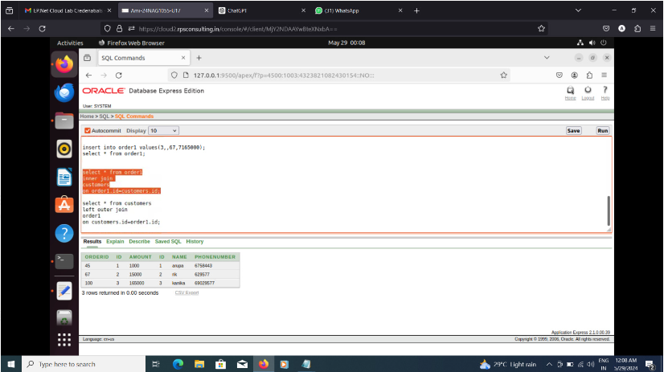

Left outer join

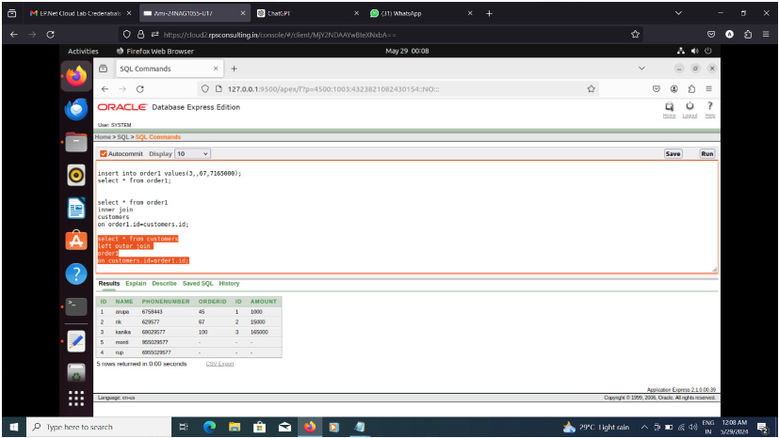

**Assignment 3:**

Design a database schema for a library system, including tables, fields, and constraints like NOT NULL, UNIQUE, and CHECK. Include primary and foreign keys to establish relationships between tables.

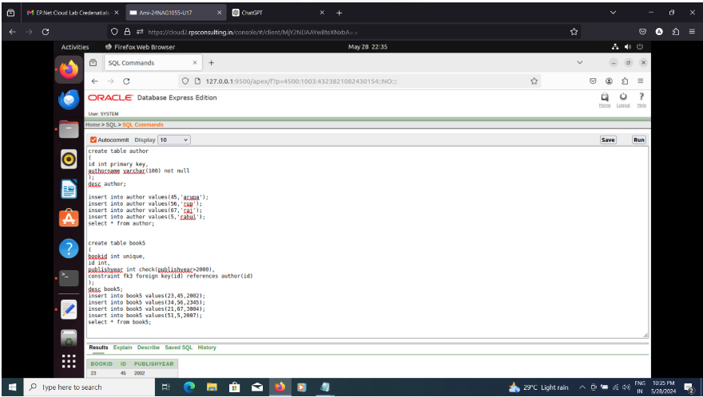

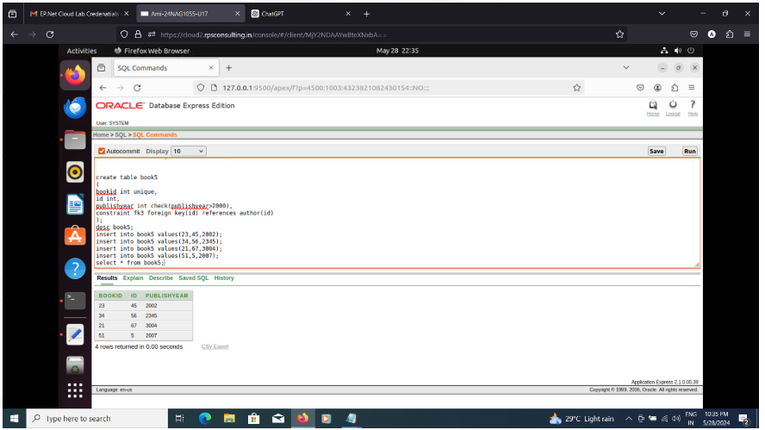

**Assignment 4:**

Write SQL statements to CREATE a new database and tables that reflect the library schema you designed earlier. Use ALTER statements to modify the table structures and DROP statements to remove a redundant table.

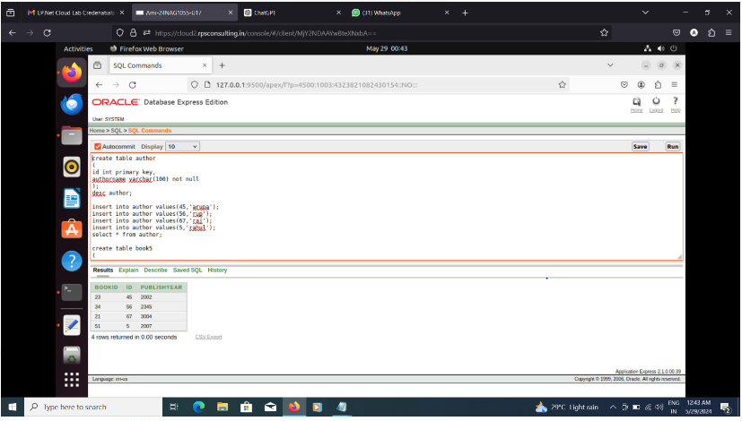

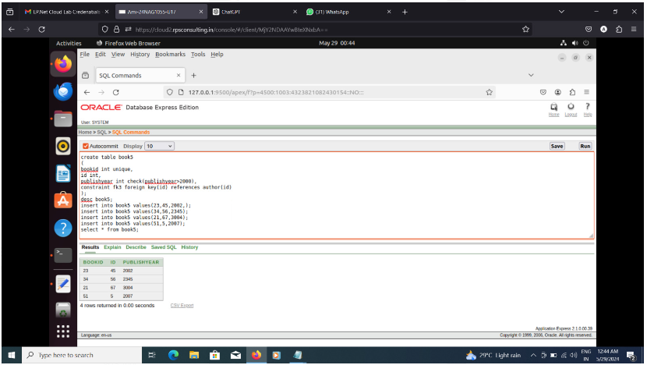

Alter Output

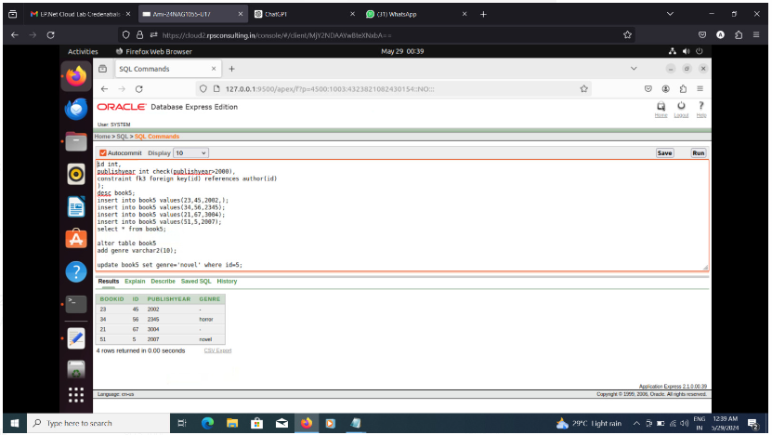

Drop command -

