**Day_7 - Shell Script Assignments**

**Assignment 1:**

Ensure the script checks if a specific file (e.g., myfile.txt) exists in the current directory. If it exists, print "File exists", otherwise print "File not found".

**Program –**

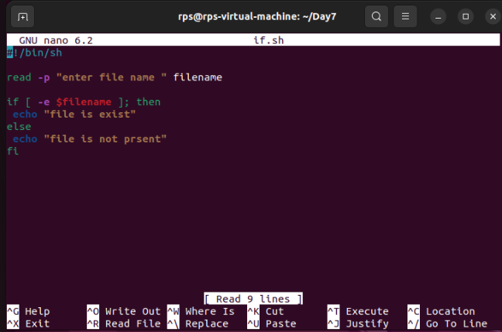

**Output –**

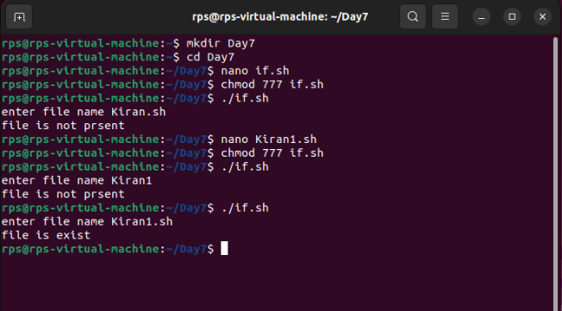

**Assignment 2:**

Write a script that reads numbers from the user until they enter '0'. The script should also print whether each number is odd or even.

**Program –**

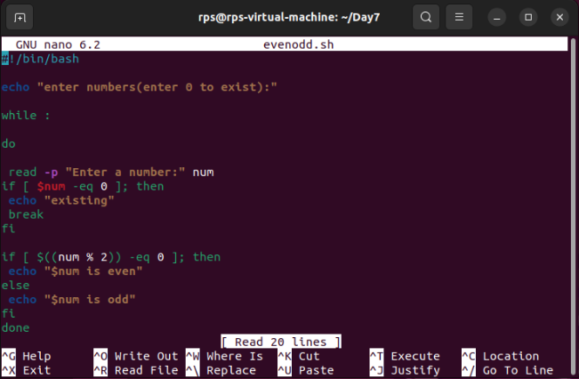

**Output –**

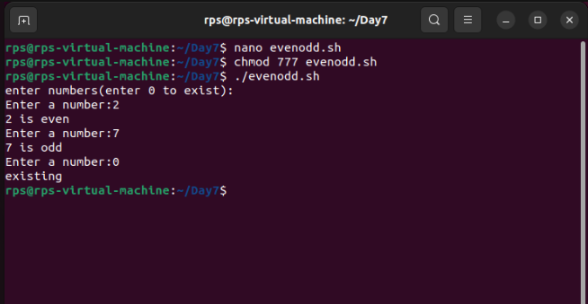

**Assignment 3 –**

Take a user enter, display weather the even or odd.

**Program –**

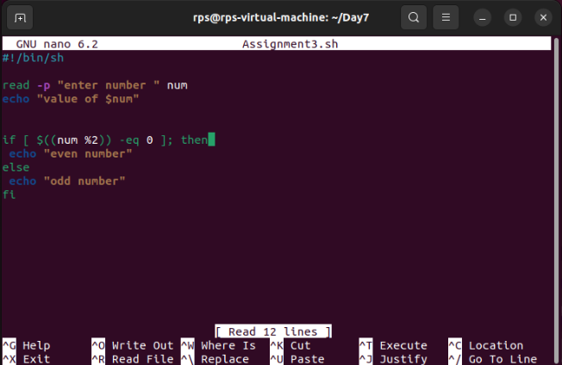

**Output –**

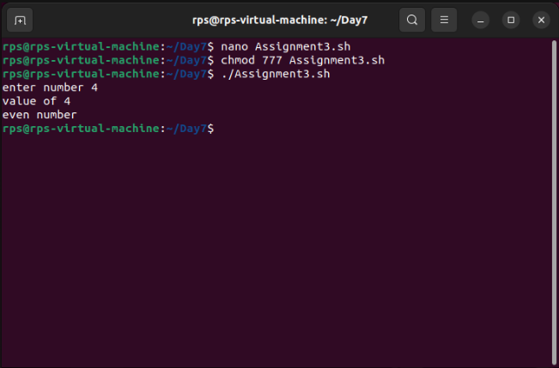

**Assignment 4:**

Count the number of directory and files in specific folder.

**Program –**

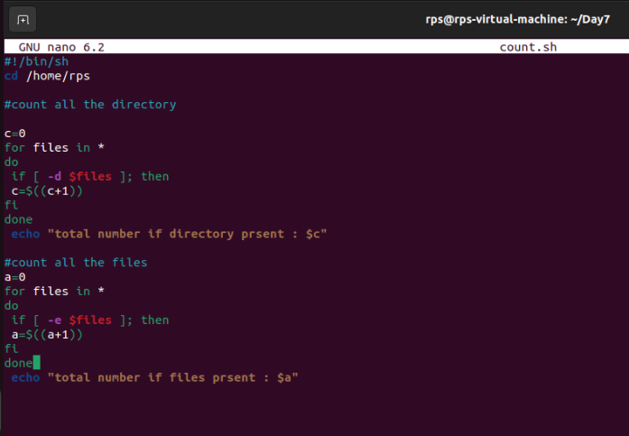

**Output –**

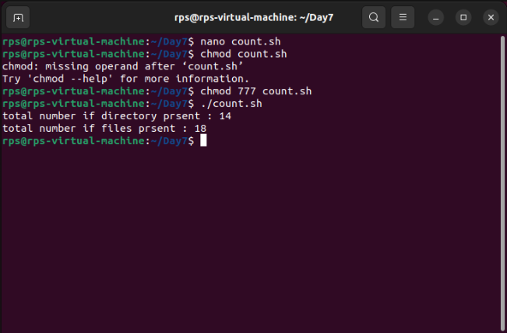

**Assignment 5 –**

Find the smallest number from the array.

**Program –**

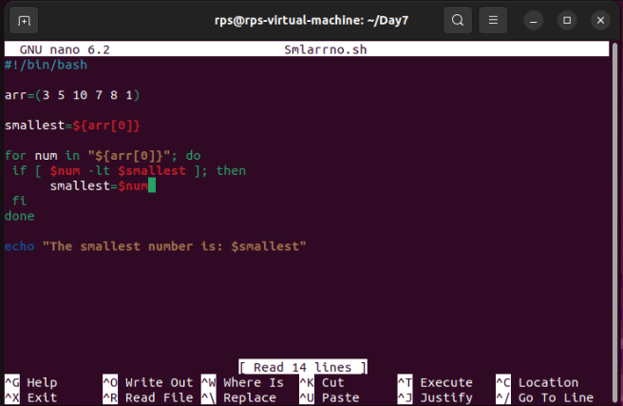

**Output –**

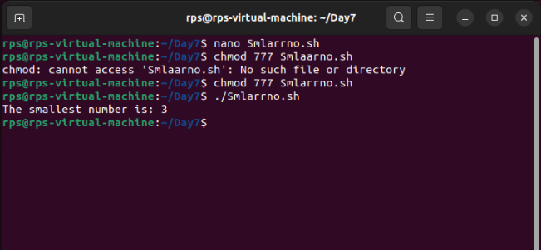

**Assignment 6 –**

Find the sum of the array.

**Program –**

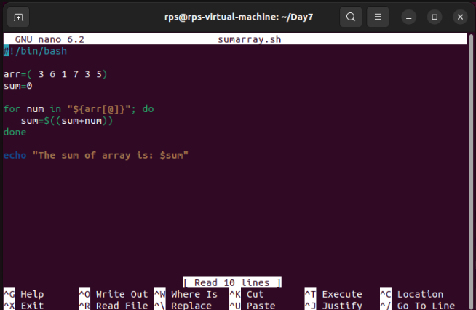

**Output –**

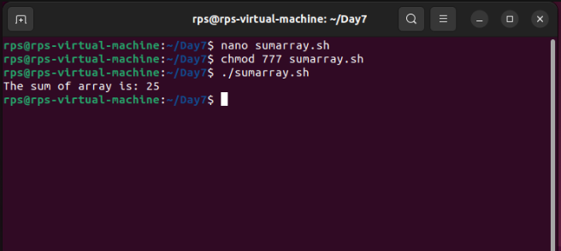

**Assignment 7 –**

Display all the directory names.

**Program –**

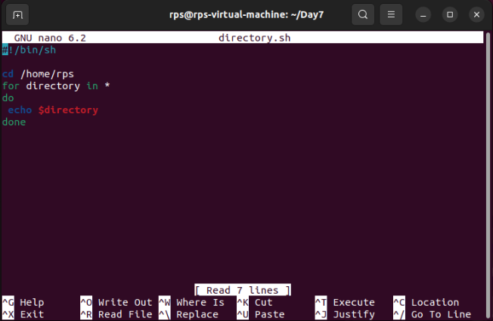

**Output –**

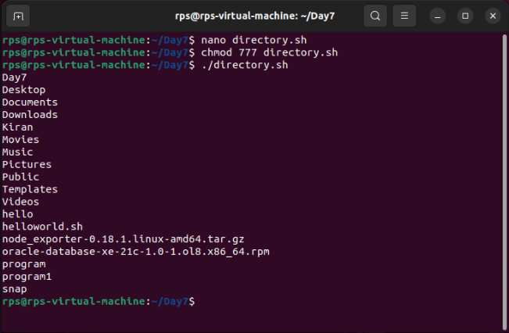

**Assignment 8 –**

Check whether the number is palindrome or not.

**Program –**

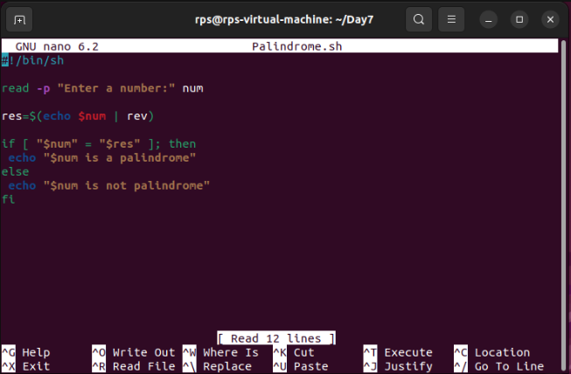

Output –

