**ONLINE FEE PAYMENT FOR APPLICATION FORM**

1. In Payment tab of your Application login, there is a link “[**PLEASE CLICK HERE TO MAKE YOUR PAYMENT.**](https://www.onlinesbi.com/sbicollect/icollecthome.htm)”
2. Click on the link and you will be redirected to following screen:

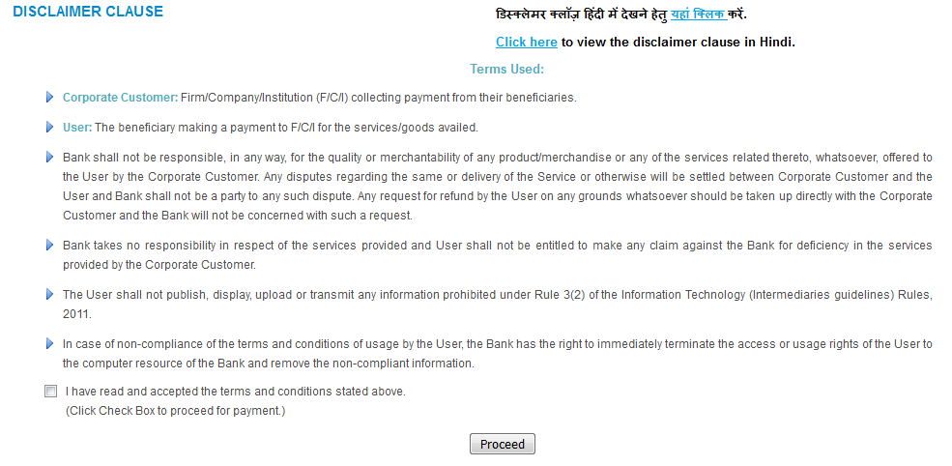

1. Read the Disclaimer clause carefully and Click on the “**Proceed**” Button.

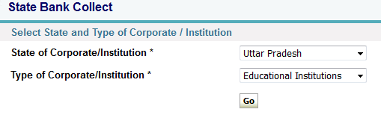

1. “**Uttar Pradesh**” must be chosen in the state of Corporate/Institution option box and “**Educational Institutions**” must be chosen in the Type of Corporate/Institution option box. Then Click on the “GO” Button.

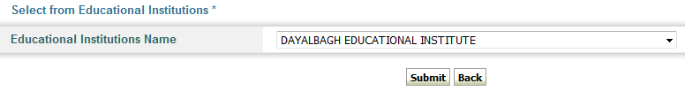

1. ”**DAYALBAGH EDUCATIONAL INSTITUTE**” must be chosen in the Educational Institutions Name option box and click on the “Submit” Button.



1. “**ADMISSION FEE**” option must be chosen in the select Payment category option box.

Total Semester fees

1. Fill all the Details in form. Enter correct Application number and Fee Password and submit. Enter your details and Fee amount carefully **as payment can be made only once against any application number**.
2. You can make payment through any of the following modes:
   1. Net Banking
   2. Credit Card
   3. Debit Card
   4. Cash deposit at SBI Branch

