Software Requirements
Specification
for
ResearchForge
Version 1.0 approved
Prepared by
Pankhudi Raina(2427030730) &
Arushi Srivastava(2427030204)
Manipal University Jaipur
September 7, 2026

Copyright © 1999 by Karl E. Wiegers. Permission is granted to use, modify, and distribute this document

Table of Contents
Table of Contents 2
Revision History 3
1. Introduction 4
1.1 Purpose 4
1.2 Document Conventions 4
1.3 Intended Audience and Reading Suggestions 4
1.4 Product Scope 5
1.5 References 5
2. Overall Description 6
2.1 Product Perspective 6
2.2 Product Functions 6
2.3 User Classes and Characteristics 6
2.4 Operating Environment 6
2.5 Design and Implementation Constraints 6
2.6 User Documentation 7
2.7 Assumptions and Dependencies 7
3. External Interface Requirements 8
3.1 User Interfaces 8
3.2 Hardware Interfaces 8
3.3 Software Interfaces 8
3.4 Communications Interfaces 8
4. System Features 9
4.1 Research Discovery and Import 9
4.2 Information Extraction and Organization 9
4.3 Comparative Analysis and Gap Identification 10
4.4 AI-Assisted Research Analysis 10
4.5 Project Documentation Generation and Export 11
5. Other Nonfunctional Requirements 12
5.1 Performance Requirements 12
5.2 Safety Requirements 12
5.3 Security Requirements 12
5.4 Software Quality Attributes 12
5.5 Business Rules 12
6. Other Requirements 13
Appendix A: Glossary 14
Appendix B: Analysis Models 15
Use Case Diagram 15
Class Diagram 16
Object Diagram 17
Package Diagram 18
Component Diagram 19
Deployment Diagram 20
Appendix C: To Be Determined List 21

Revision History
Name | Date | Reason For Changes | Version
Pankhudi Raina,  Arushi Srivastava | 07-Sep-2026 | Initial draft for CSE3132 Lab 1 assignment | 1.0

1. Introduction

1.1 Purpose
This Software Requirements Specification (SRS) defines the functional and non-functional requirements for ResearchForge: A Software Platform for Research-Driven Software Project Planning (Version 1.0).
ResearchForge is a software platform that supports students, researchers, software developers, and project teams during the initial stages of software development by providing a centralized environment for research discovery, literature organization, comparative analysis, and project planning. The platform enables users to identify relevant research publications, extract key technical information, compare existing approaches, identify research gaps, and organize findings into structured project artifacts.
This document serves as the primary reference for the design, development, implementation, testing, deployment, and maintenance of ResearchForge. It provides a common understanding of the system requirements for developers, project managers, testers, instructors, and other stakeholders. This SRS specifies the requirements for the first release of the complete ResearchForge system.

1.2 Document Conventions
This document follows the IEEE Software Requirements Specification (SRS) standard and maintains consistent terminology throughout.
The following conventions are used:
- Functional requirements are identified using FR-x.
- Non-functional requirements are identified using NFR-x.
- System features are categorized as High, Medium, or Low priority.
- The terms shall, should, and may indicate mandatory, recommended, and optional requirements respectively.
- UML diagrams, flow diagrams, and architectural models follow standard Unified Modeling Language (UML) conventions.
All requirements defined in this document are uniquely identifiable, traceable, verifiable, and testable.

1.3 Intended Audience and Reading Suggestions
This document is intended for software developers, software architects, project managers, quality assurance engineers, system administrators, academic evaluators, instructors, and end users including students, researchers, and software professionals.
Developers will use this document to implement system functionality, architects for system and database design, testers to derive test cases, project managers for planning and resource management, administrators for deployment and maintenance, and evaluators to assess compliance with software engineering principles.
Readers should begin with the Introduction and Overall Description sections, followed by the Functional Requirements, External Interface Requirements, and Non-functional Requirements sections for implementation and testing details.

1.4 Product Scope
ResearchForge is a software platform that streamlines the research and project planning phase of software development by integrating literature discovery, information extraction, comparative analysis, and project organization into a unified workspace.
Developers and researchers often spend considerable time searching academic databases, reviewing research papers, comparing methodologies, and manually documenting findings before starting development. Existing research tools provide access to publications but lack an integrated environment for organizing research knowledge and converting it into structured software project planning artifacts.
ResearchForge addresses this challenge by enabling users to discover relevant research publications, organize literature, compare methodologies, identify research gaps, manage project references, and generate structured documentation that supports software development activities.
The primary objectives of ResearchForge are to:
- Simplify research and literature review for software projects.
- Reduce the time required to analyze research publications.
- Improve organization and accessibility of technical knowledge.
- Support informed decision-making during project planning.
- Facilitate the generation of structured project documentation.
The platform aims to improve the efficiency, consistency, and quality of research-driven software project planning while supporting standard software engineering practices.

1.5 References
The following references were used in preparing this Software Requirements Specification:
- IEEE Computer Society. IEEE Recommended Practice for Software Requirements Specifications (IEEE Std 830-1998).
- Roger S. Pressman and Bruce R. Maxim, Software Engineering: A Practitioner's Approach, 8th Edition, McGraw-Hill Education, 2019.
- Ian Sommerville, Software Engineering, 10th Edition, Pearson Education, 2016.
- Object Management Group (OMG), Unified Modeling Language (UML) Specification, Version 2.5.
- Agile Alliance, Manifesto for Agile Software Development, 2001.

2. Overall Description

2.1 Product Perspective
ResearchForge is a new, self-contained web-based platform. It is not a follow-on to an existing product and does not replace any prior system. It operates as an independent application accessed through a standard web browser, with a backend service that integrates with external research-paper sources and stores user-submitted research and project data.

2.2 Product Functions
The major functions ResearchForge must perform are summarized below; details are provided in Section 4 (System Features):
- Discover and import research publications from external sources and via manual upload.
- Extract key technical information from imported publications.
- Compare methodologies and approaches across selected publications.
- Identify research gaps relevant to a project's planning needs.
- Organize and manage project references and findings.
- Generate and export structured project documentation from organized research.

2.3 User Classes and Characteristics
ResearchForge supports two primary modes of use, confirmed for this release:
- Individual users (single-user mode) — students or researchers working alone on literature review and project planning for a single project.
- Team members (team mode) — multiple users collaborating on the same project workspace with shared access to imported publications, comparisons, and generated documentation. All team members have equal, undifferentiated access; the system does not define separate roles (such as owner/admin vs. member) for this release.
Further distinctions in technical expertise or frequency of use across user classes are TBD (see Appendix C).

2.4 Operating Environment
ResearchForge is a web application accessed through standard modern web browsers, requiring only an internet connection and no local installation on the client side.
The specific backend platform, hosting environment, and supported browser versions are TBD, as the technology stack has not yet been finalized (see Appendix C).

2.5 Design and Implementation Constraints
The following constraints are known for this release:
- The system must be able to integrate with external research-publication APIs (TBD which specific APIs) in addition to accepting manually uploaded PDF documents.
- The system must support exporting generated project artifacts in both PDF and Word document formats, as well as in-app viewing of the same content.
- The system must support simple user authentication (see Section 5.3) for both individual and team-based access.
The specific technology stack (frontend framework, backend framework, database, and hosting) has not been finalized and is marked TBD in Appendix C.

2.6 User Documentation
User documentation components (user manual, on-line help, tutorials) to be delivered with the software are TBD (see Appendix C).

2.7 Assumptions and Dependencies
The following assumptions and dependencies apply to this release:
- The system assumes users have a stable internet connection to access the web application and external research APIs.
- The system depends on the continued availability and accessibility of the external research-publication APIs it integrates with (specific providers TBD).
- The system assumes uploaded manual documents are primarily in PDF format.
- Requirements in this document may be affected if these assumptions change or prove incorrect.

3. External Interface Requirements

3.1 User Interfaces
ResearchForge provides a web-based graphical user interface accessible through standard browsers. Key interface areas include:
- A dashboard listing the user's or team's active projects.
- A search/import screen for discovering publications via external APIs or uploading PDFs manually.
- A workspace view for reviewing extracted information and comparing selected publications side by side.
- A documentation/export screen for generating and downloading project artifacts (PDF/Word) or viewing them in-app.
- A login/registration screen for account access.
Detailed screen layouts, wireframes, and UI style guidelines are TBD and will be documented in a separate user interface specification (see Appendix C).

3.2 Hardware Interfaces
ResearchForge does not require any dedicated or specialized hardware. It requires only a standard end-user computing device (desktop, laptop, or equivalent) capable of running a modern web browser with an internet connection.

3.3 Software Interfaces
ResearchForge interfaces with the following software components:
- External research-publication APIs (TBD) for discovering and retrieving publication metadata and content.
- A database system (TBD) for storing user accounts, projects, imported publications, extracted information, and generated documentation.
- Document generation/export libraries (TBD) for producing PDF and Word format outputs.
- An authentication mechanism (TBD implementation) for managing user login and session access.
Specific product names, versions, and API protocols are TBD pending finalization of the technology stack (see Appendix C).

3.4 Communications Interfaces
ResearchForge communicates with external research-publication APIs and its own backend services over standard secure web protocols (HTTPS).
Specific message formats, data transfer rates, and any email/notification communications are TBD (see Appendix C).

4. System Features
The functional requirements of ResearchForge are organized into five major system features, corresponding to the core product functions identified in Section 2.2.

4.1 Research Discovery and Import

4.1.1 Description and Priority
This feature allows users to bring research publications into ResearchForge, either by searching and importing from external research-publication APIs or by manually uploading PDF documents. Priority: High.

4.1.2 Stimulus/Response Sequences
- User searches for publications by keyword; system returns a list of matching results from external APIs.
- User selects one or more search results to import into a project; system retrieves and stores the publication data.
- User manually uploads a PDF document; system stores it and associates it with the selected project.

4.1.3 Functional Requirements
FR-1: The system shall allow a user to search for research publications by keyword via external research-publication APIs (TBD).
FR-2: The system shall allow a user to import selected search results into a project workspace.
FR-3: The system shall allow a user to manually upload a PDF document and associate it with a project.
FR-4: The system shall display an appropriate error message if a search, import, or upload operation fails.

4.2 Information Extraction and Organization

4.2.1 Description and Priority
This feature enables the system to extract key technical information from imported publications and allows users to organize this information within a project workspace. Priority: High.

4.2.2 Stimulus/Response Sequences
- User selects an imported publication; system displays extracted key information (e.g., title, authors, methodology, findings).
- User organizes publications into categories or tags within a project.

4.2.3 Functional Requirements
FR-5: The system shall extract key technical information (such as title, authors, methodology, and findings) from imported publications.
FR-6: The system shall allow a user to view extracted information for any publication imported into a project.
FR-7: The system shall allow a user to organize publications within a project using categories or tags.

4.3 Comparative Analysis and Gap Identification

4.3.1 Description and Priority
This feature allows users to compare the methodologies and findings of multiple selected publications and to identify gaps relevant to their project planning. Priority: High.

4.3.2 Stimulus/Response Sequences
- User selects two or more publications within a project; system displays a side-by-side comparison of extracted information.
- User marks or annotates identified gaps or open questions arising from the comparison.

4.3.3 Functional Requirements
FR-8: The system shall allow a user to select two or more publications within a project for comparison.
FR-9: The system shall display a side-by-side comparison of the extracted information for the selected publications.
FR-10: The system shall allow a user to record notes or annotations identifying research gaps found during comparison.

4.4 AI-Assisted Research Analysis

4.4.1 Description and Priority
This feature provides on-demand AI-assisted research analysis for publications and projects. It supports paper summarization, research gap identification, smart recommendations, comparison generation, citation analysis, and natural-language questions and answers. AI results include optional expandable reasoning and are available only to users with an active Premium subscription. Priority: High.

4.4.2 Stimulus/Response Sequences
- User selects an AI-assisted feature and requests analysis; the system verifies Premium access and returns the requested result.
- User expands an explanation associated with an AI-generated result; the system displays the supporting reasoning or analysis details.

4.4.3 Functional Requirements
FR-11: The system shall generate an AI-assisted summary of a selected imported or uploaded research publication.
FR-12: The system shall identify potential research gaps and unexplored areas from selected or imported publications.
FR-13: The system shall recommend publications relevant to a project based on the project context and available research.
FR-14: The system shall generate an AI-assisted comparison of selected publications, including relevant similarities and differences.
FR-15: The system shall analyze citation information to identify highly cited and influential publications relevant to a project.
FR-16: The system shall allow a user to ask natural-language questions about uploaded or imported publications and shall provide answers grounded in the available publication content.
FR-17: The system shall perform AI-assisted analysis only when a user explicitly requests it.
FR-18: The system shall provide optional expandable reasoning or explanations for each AI-generated analysis result.
FR-19: The system shall restrict AI-assisted research analysis capabilities to users with an active Premium subscription.

4.5 Project Documentation Generation and Export

4.5.1 Description and Priority
This feature allows users to generate structured project documentation (research summaries, comparisons, and gap analyses) from the organized project data, and to export or view that documentation. Priority: Medium.

4.5.2 Stimulus/Response Sequences
- User requests generation of a project document; system compiles organized research data into a structured document.
- User chooses to export the generated document as PDF or Word, or to view it within the application.

4.5.3 Functional Requirements
FR-20: The system shall generate a structured project document from a project's organized publications, extracted information, comparisons, and gap notes.
FR-21: The system shall allow a user to export a generated project document in PDF format.
FR-22: The system shall allow a user to export a generated project document in Word document format.
FR-23: The system shall allow a user to view a generated project document within the application without exporting it.

5. Other Nonfunctional Requirements

5.1 Performance Requirements
NFR-1: The system should return search results from external research-publication APIs within a reasonable response time under normal network conditions.
Specific numeric performance targets (e.g., exact response-time thresholds, concurrent user limits) are TBD (see Appendix C).

5.2 Safety Requirements
ResearchForge does not control physical hardware or safety-critical systems. No safety requirements beyond standard data-integrity precautions (see Section 5.3) apply to this release.

5.3 Security Requirements
NFR-2: The system shall require users to authenticate using an email address and password before accessing any project workspace.
NFR-3: The system shall restrict access to a project's data (publications, comparisons, and generated documents) to the individual user or team members associated with that project.
For this release, team-based access is shared equally among all members of a project; the system does not enforce differentiated roles or permission levels within a team.
Additional security measures (e.g., password policies, session timeout, data encryption at rest) are TBD (see Appendix C).

5.4 Software Quality Attributes
The following quality attributes are important to this product:
- Usability — the interface should be straightforward for students and researchers with varying levels of technical expertise.
- Reliability — imported publication data and generated documents should not be lost or corrupted during normal operation.
- Maintainability — the system should be structured to allow new research-source integrations to be added with minimal rework.
- Scalability — the system should support growth in the number of users, projects, and imported publications.

5.5 Business Rules
This release has no team-role distinctions (see Section 2.3). Any additional operating rules governing which users may perform which functions are TBD (see Appendix C).
BR-1: AI-assisted research analysis features shall be accessible only to users with an active Premium subscription.

6. Other Requirements
No additional requirements (database-specific, internationalization, legal, or reuse) beyond those stated above have been identified for this release. This section will be updated as such requirements are identified (see Appendix C).

Appendix A: Glossary
- SRS — Software Requirements Specification.
- API — Application Programming Interface; used here to refer to external research-publication data sources.
- FR — Functional Requirement.
- NFR — Non-Functional Requirement.
- TBD — To Be Determined; a placeholder for information not yet finalized.
- Project workspace — The collection of imported publications, extracted information, comparisons, and generated documents associated with a single project in ResearchForge.

Appendix B: Analysis Models

Use Case Diagram
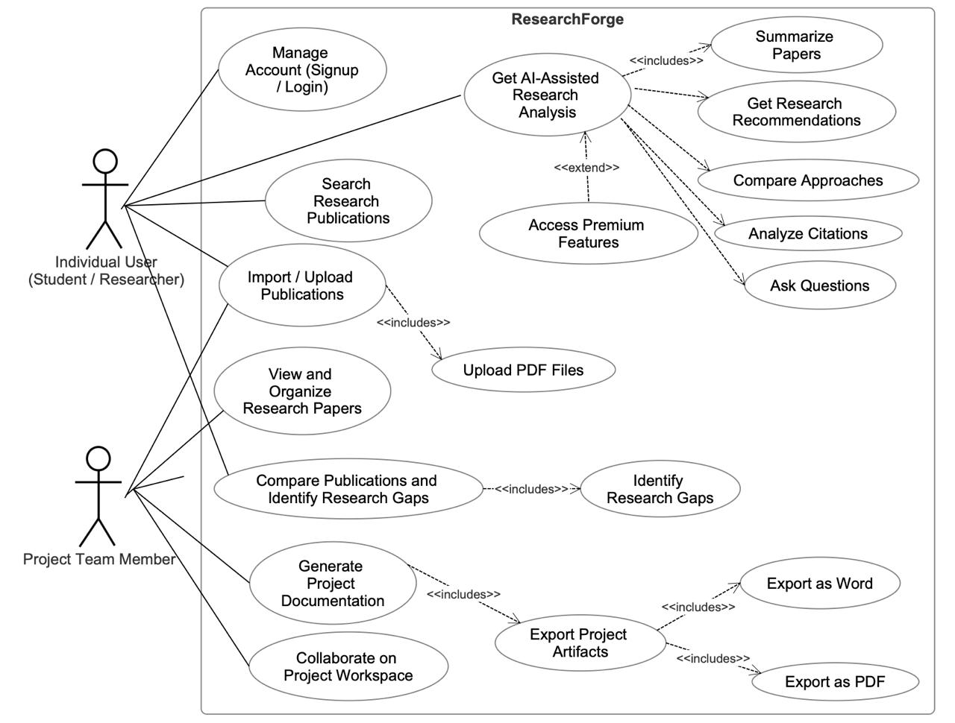
⁠Description:
The Use Case Diagram illustrates the functional interaction between ResearchForge and its users. It shows how individual users and team members can authenticate, search and import research publications, upload PDFs, view and organize extracted information, compare publications, identify research gaps, use AI-assisted research analysis, and generate or export project documentation. External research-publication APIs are shown as supporting external systems.

Class Diagram
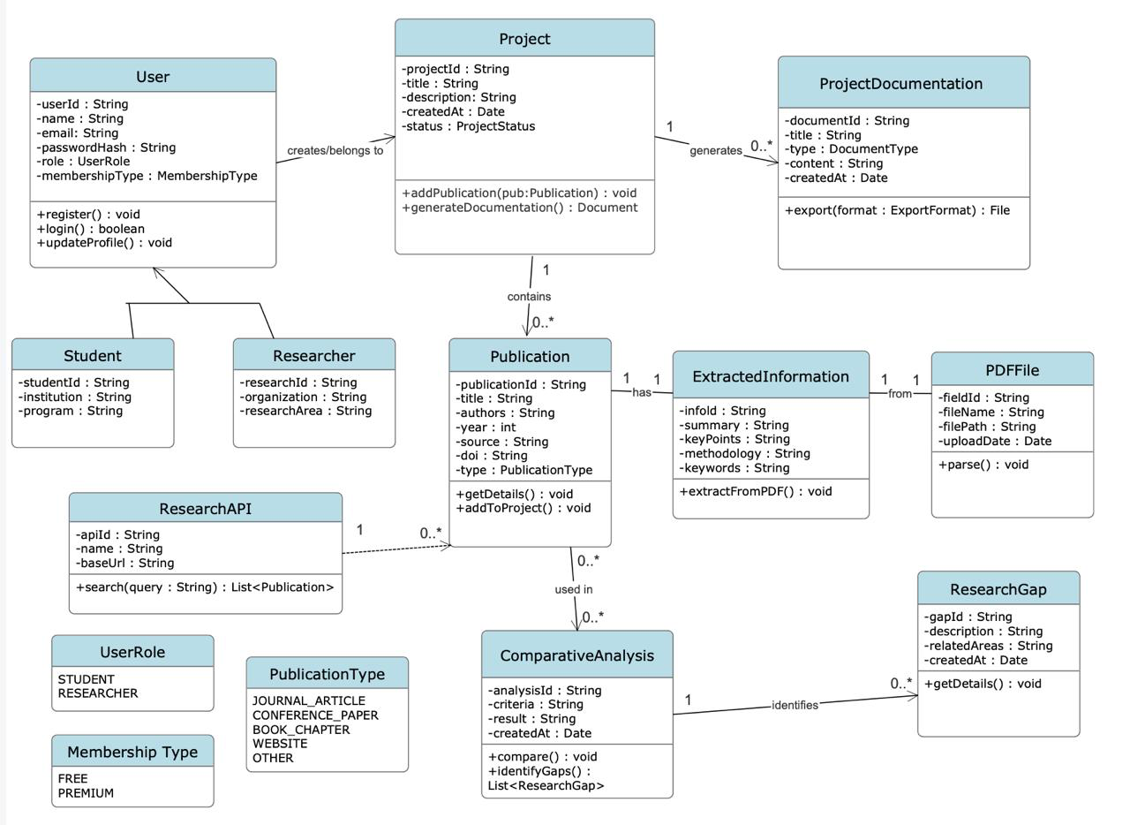
Description:
The Class Diagram represents the main structural entities of ResearchForge and their relationships. It models users, projects, publications, extracted information, PDF files, comparative analysis, research gaps, and project documents, along with their attributes, operations, and relationships. The diagram provides a static view of how research and project-related data are organized within the system.

Object Diagram
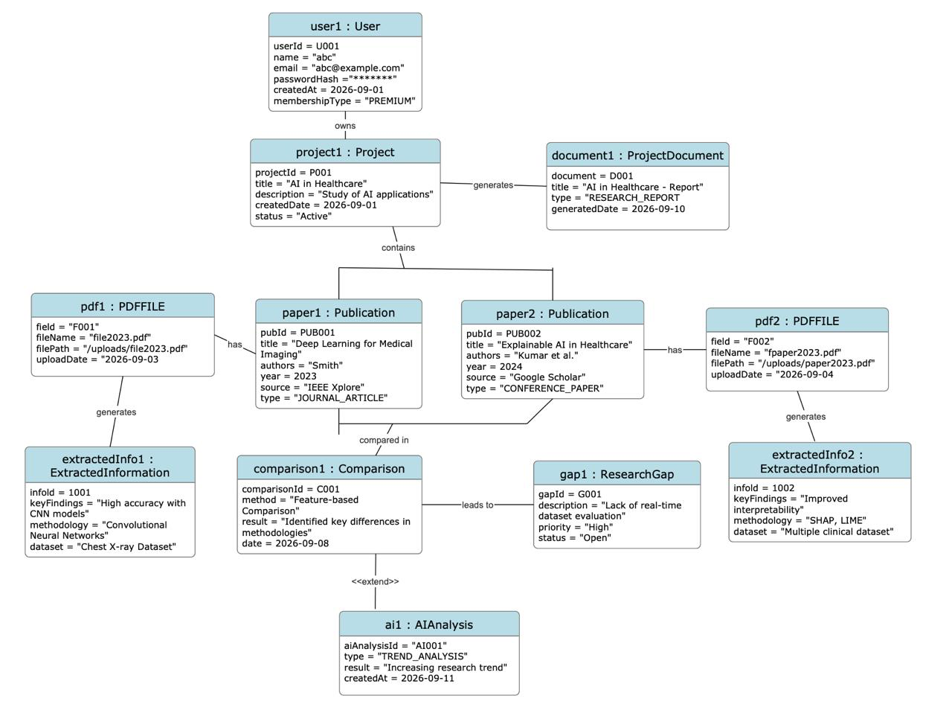
Description:
The Object Diagram represents a specific snapshot of ResearchForge objects at runtime. It shows an individual user associated with a project, where the project contains research publications and their extracted information. Two publications are connected through a comparison, which leads to the identification of a research gap. The project also generates a project document. This diagram illustrates how the main entities of ResearchForge are connected in a particular instance of the system.

Package Diagram
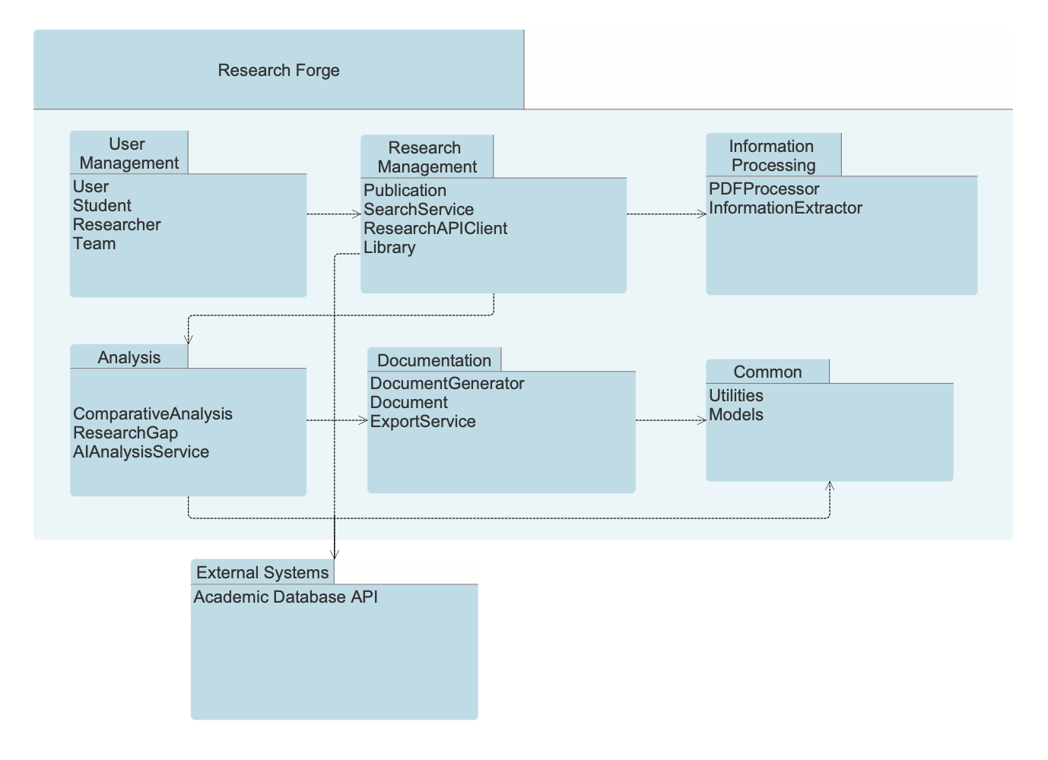
Description:
The Package Diagram organizes the ResearchForge system into logical groups according to their responsibilities. The main packages include User Management, Research Discovery and Import, Information Extraction and Organization, Comparative Analysis, AI-Assisted Research Analysis, Documentation and Export, and External Research Sources. The diagram shows the dependencies between these packages and provides a high-level view of the system organization.

Component Diagram
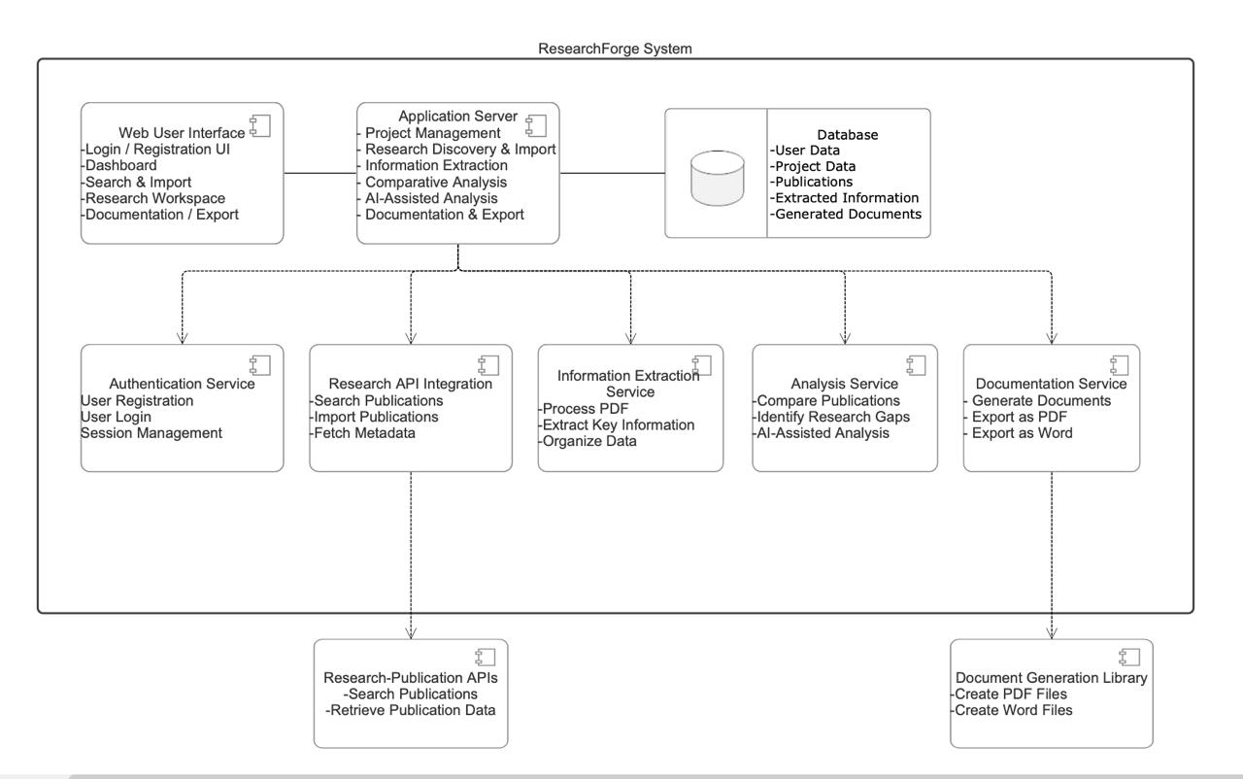
Description:
The Component Diagram represents the major software components of ResearchForge and how they interact. The Web User Interface communicates with the backend application services, which handle authentication, research discovery and import, information extraction, comparative analysis, AI-assisted analysis, and documentation/export. The system also interacts with the database and external research-publication APIs. The SRS specifically identifies external APIs, a database, document-generation libraries, and an authentication mechanism as software interfaces.

Deployment Diagram
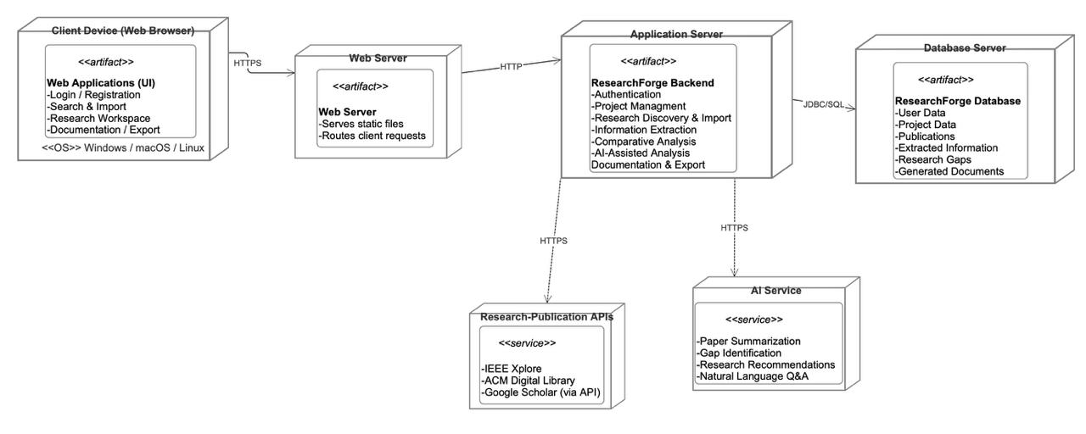
Description:
The Deployment Diagram shows the physical deployment structure of ResearchForge. Users access the web application through a desktop or mobile browser, which communicates with the web/application server. The application server interacts with the database for storing users, projects, publications, extracted information, and generated documents, and communicates with external research-publication APIs. The SRS defines ResearchForge as a web-based application accessed through standard browsers, while the specific backend technology, hosting environment, and database technology remain TBD.

Appendix C: To Be Determined List
The following items remain TBD and should be tracked to closure as the project progresses:
TBD-1: Specific external research-publication APIs to be integrated (e.g., arXiv, Semantic Scholar, IEEE Xplore, or others).
TBD-2: Final technology stack: frontend framework, backend framework, database, and hosting environment.
TBD-3: Supported browser versions and minimum client-side requirements.
TBD-4: Detailed UI screen layouts and style guidelines (to be documented in a separate UI specification).
TBD-5: Specific document-generation/export library or service used for PDF and Word output.
TBD-6: Numeric performance targets (response times, concurrent user limits).
TBD-7: Additional security measures: password policy, session timeout, and data encryption approach.
TBD-8: User documentation components to be delivered (manual, on-line help, tutorials).
TBD-9: Any database-specific, internationalization, or legal requirements not yet identified.
TBD-10: Analysis models (data flow diagrams, class diagrams) to be produced during system design.

