Charts
Chart 1 — two bars showing win rate of toss winners vs toss losers
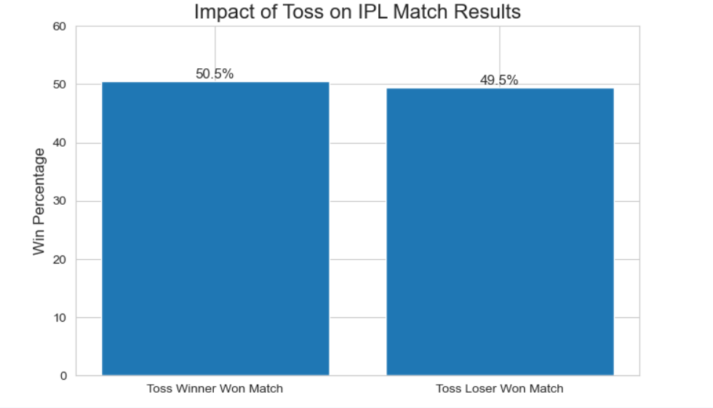

Chart 2 — average runs per phase for winning teams vs losing teams

