ARCHITECTING A SERVERLESS MICROSERVICES PLATFORM
FOR A HIGH-TRAFFIC FINTECH APPLICATION ON AWS
A Case Study Report

Submitted by
Arushi Gupta
B.Tech – Computer Science
KIET Group of Institutions, Delhi-NCR, Ghaziabad
Academic Year 2026–27

Declaration
I hereby declare that this case study report titled “Architecting a Serverless Microservices Platform for a High-Traffic FinTech Application on AWS” presents the design and implementation work carried out as an academic study. The report describes the AWS services, architecture, deployment approach, testing strategy, scalability considerations, security controls, and monitoring used for the case study.

Abstract
Financial technology applications must handle highly variable traffic while maintaining availability, secure access, reliable transaction processing, and operational visibility. This case study presents a serverless microservices architecture for a high-traffic FinTech application on Amazon Web Services (AWS). The platform uses Amazon API Gateway as the REST entry point, AWS Lambda for independently deployable business services, Amazon DynamoDB for scalable NoSQL persistence, Amazon EventBridge for event-driven integration, AWS Step Functions for payment workflow orchestration, Amazon S3 for audit/object storage, AWS Identity and Access Management (IAM) for access control, and Amazon CloudWatch for monitoring and logging. The implementation is designed for deployment through AWS CLI in the ap-south-1 region. Lambda reserved and provisioned concurrency and API throttling demonstrate scalability and traffic protection.

Keywords
Serverless Computing, AWS Lambda, API Gateway, DynamoDB, EventBridge, Step Functions, FinTech, Microservices, CloudWatch, AWS CLI

1. Introduction
Modern FinTech applications process user requests, payments, transactions, fraud checks, notifications, and audit information under rapidly changing workloads. Conventional server-based architectures require capacity planning and continuous infrastructure management. Serverless architecture shifts much of this responsibility to managed AWS services while allowing application components to scale independently.
The proposed platform uses independent Lambda microservices. API Gateway provides the external API interface, DynamoDB provides persistence, EventBridge decouples asynchronous events, and Step Functions coordinates the payment workflow.

2. Problem Statement
The objective is to design a scalable and reliable FinTech application architecture capable of handling variable and potentially high traffic while maintaining secure access, transaction reliability, asynchronous processing, monitoring, and manageable operational complexity.

3. Objectives
- Design a serverless microservices architecture for a high-traffic FinTech application.
- Implement independent business services using AWS Lambda.
- Provide REST APIs using Amazon API Gateway.
- Store users, payments, and transactions using Amazon DynamoDB.
- Use EventBridge for decoupled payment events.
- Use Step Functions Standard workflows for payment processing.
- Demonstrate Lambda reserved and provisioned concurrency.
- Apply API Gateway throttling.
- Use IAM for access control and CloudWatch for monitoring.
- Deploy and verify the solution using AWS CLI.

4. Proposed System
A client sends requests to API Gateway, which invokes the appropriate Lambda service. The Payment service persists a pending payment and publishes a payment event. EventBridge routes the event to fraud and notification services. Step Functions provides controlled orchestration for payment processing and transaction recording. DynamoDB provides scalable persistence, while CloudWatch provides logs and monitoring.

4.1 High-Level Architecture
Client → API Gateway → Lambda Microservices → DynamoDB. Payment events flow through EventBridge to Fraud Detection and Notification services. Payment processing is orchestrated by Step Functions. IAM controls service permissions and CloudWatch provides logging and alarms.

5. AWS Services Used
AWS Service | Role
API Gateway | Regional REST API and throttling
Lambda | User, payment, transaction, fraud and notification microservices
DynamoDB | Users, payments and transactions storage
EventBridge | Custom event bus and event routing
Step Functions | Standard payment workflow
S3 | Audit/object storage
IAM | Access control and execution roles
CloudWatch | Logs, metrics and alarms

6. Microservices Design

6.1 User Service
FinTechUserService creates user records in FinTechUsers and can scale independently.

6.2 Payment Service
FinTechPaymentService accepts payment information, creates a payment ID, stores the payment as PENDING, and publishes a payment event.

6.3 Transaction Service
FinTechTransactionService records transaction information in FinTechTransactions and supports transaction retrieval.

6.4 Fraud Service
FinTechFraudService provides a demonstration risk classification using LOW, MEDIUM, and HIGH categories. A production system would use a sophisticated rules engine or machine-learning model.

6.5 Notification Service
FinTechNotificationService consumes notification events and records notification processing. Production integration could use approved email, SMS, or push providers.

7. API Design
Endpoint | Method | Service | Purpose
/users | POST | User Lambda | Create a user
/payments | POST | Payment Lambda | Initiate a payment
/transactions/{transactionId} | GET | Transaction Lambda | Retrieve a transaction
API Gateway is the controlled entry point to the application and uses Lambda proxy integration.

8. Event-Driven Architecture
The Payment service publishes a domain event to FinTechEventBus. PaymentCreatedRule matches the payment event and routes it to Fraud and Notification Lambda functions. This reduces direct coupling and allows additional event consumers to be added later.

9. Step Functions Payment Workflow
The Standard workflow is: Validate Payment → Fraud Check → Process Payment → Record Transaction → Send Notification. Standard workflows are appropriate for auditable business processes requiring detailed execution history; Express workflows are better suited to very high-volume, short-duration processing.

10. Scalability and Performance

10.1 Lambda Concurrency
Reserved concurrency limits the maximum concurrent executions allocated to the Payment service and protects account capacity.

10.2 Provisioned Concurrency
Provisioned concurrency keeps execution environments initialized and can reduce cold-start latency for latency-sensitive requests.

10.3 DynamoDB
PAY_PER_REQUEST capacity is suitable for variable traffic because capacity planning is reduced.

10.4 API Gateway Throttling
A demonstration configuration uses 100 requests per second with a burst limit of 200 to protect downstream services.

11. Security Architecture
- IAM roles are used for Lambda and Step Functions execution.
- Permissions are restricted to required actions wherever practical.
- S3 audit storage uses server-side encryption.
- Production extension should add Cognito/JWT authentication, AWS WAF, stronger key-management controls, and compliance-specific controls.
- AWS access keys and secrets must never be committed to GitHub.

12. Monitoring and Observability
Lambda execution logs are delivered to CloudWatch Logs. CloudWatch metrics can observe invocations, errors, duration, throttles, and concurrency. A payment-service error alarm can be used to demonstrate operational monitoring.

13. AWS CLI Implementation
The implementation is designed for deployment through AWS CLI from Windows PowerShell in ap-south-1. The deployment sequence creates DynamoDB, IAM roles, Lambda services, EventBridge, Step Functions, API Gateway, monitoring, and test requests. CLI-based deployment makes the process repeatable.
Representative commands include aws sts get-caller-identity, aws dynamodb create-table, aws lambda create-function, aws events create-event-bus, aws stepfunctions create-state-machine, and API Gateway CLI commands.

14. Testing Strategy
Test | Expected Result
POST /users | User stored in FinTechUsers
POST /payments | Payment created with PENDING status
Payment event | EventBridge routes event to configured targets
Fraud test: ₹25,000 | LOW-risk demonstration path
Fraud test: ₹150,000 | HIGH-risk / REVIEW demonstration path
Step Functions execution | Workflow completes or reports a failed state
DynamoDB verification | Records visible in tables
CloudWatch verification | Lambda logs available
Insert actual AWS Console and CLI screenshots as evidence of the final deployed environment.

15. Results
The case study demonstrates a serverless FinTech platform composed of five Lambda microservices and an API Gateway REST API, with DynamoDB persistence, EventBridge event routing, Step Functions workflow orchestration, S3 storage, IAM security, and CloudWatch observability. Actual execution outputs should be included with screenshots.
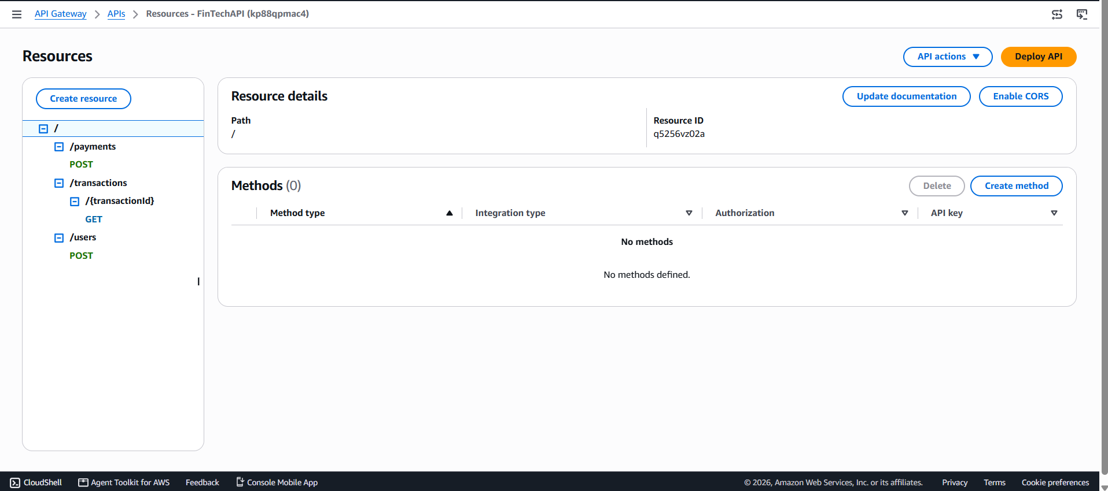
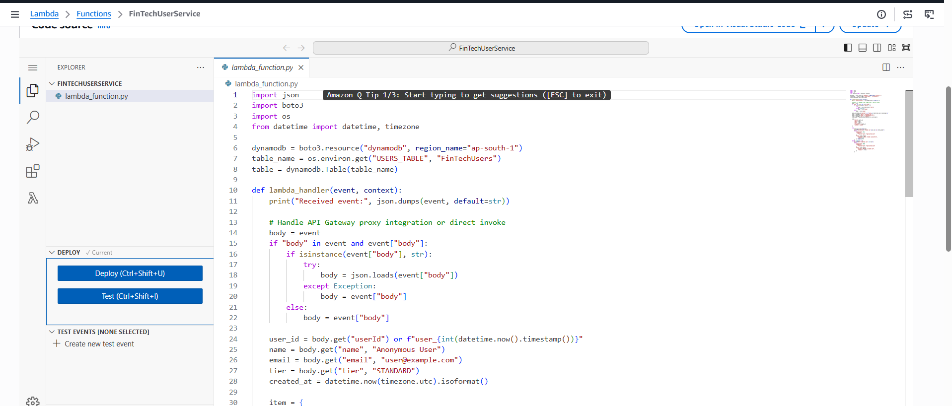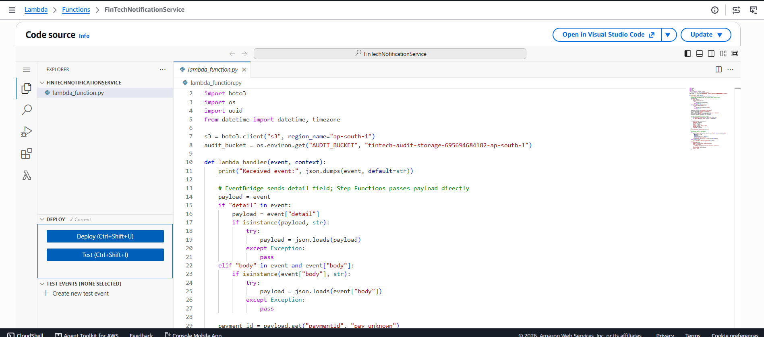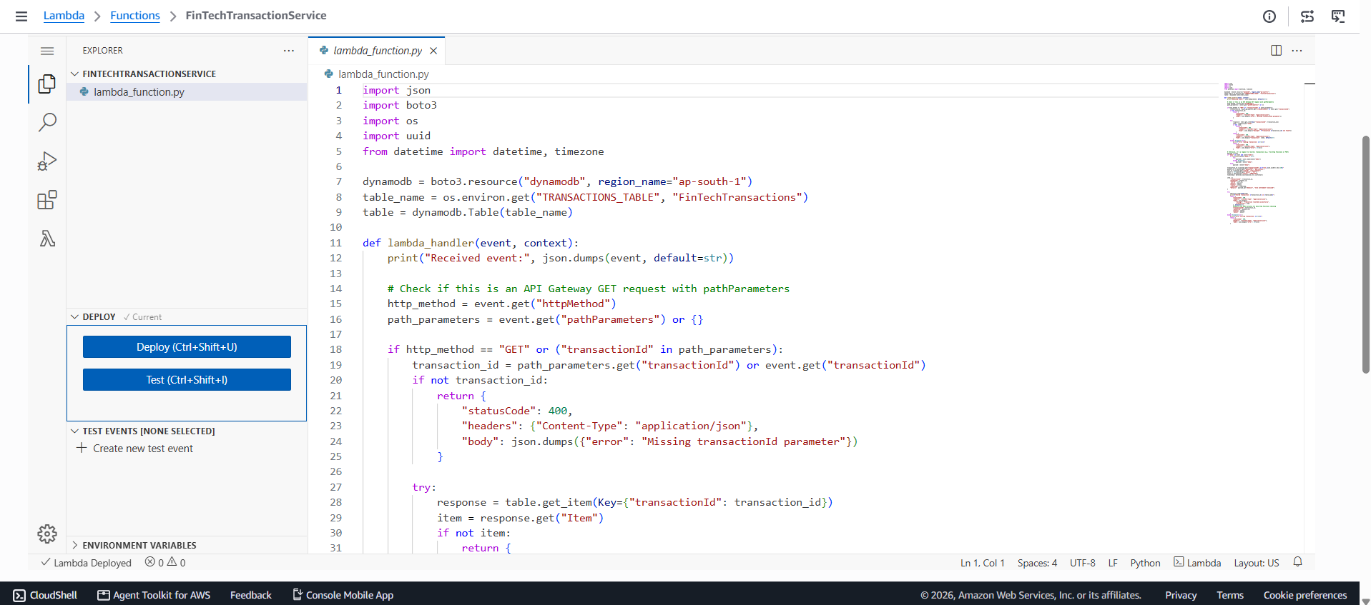
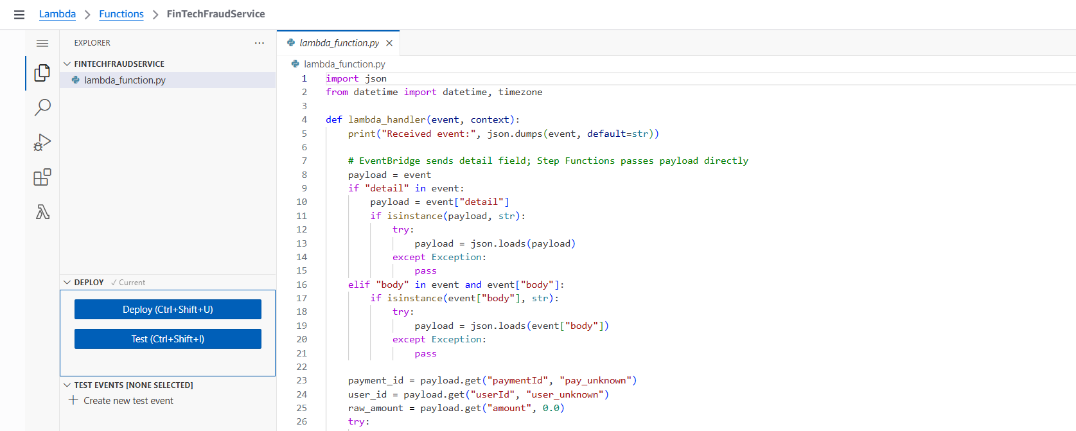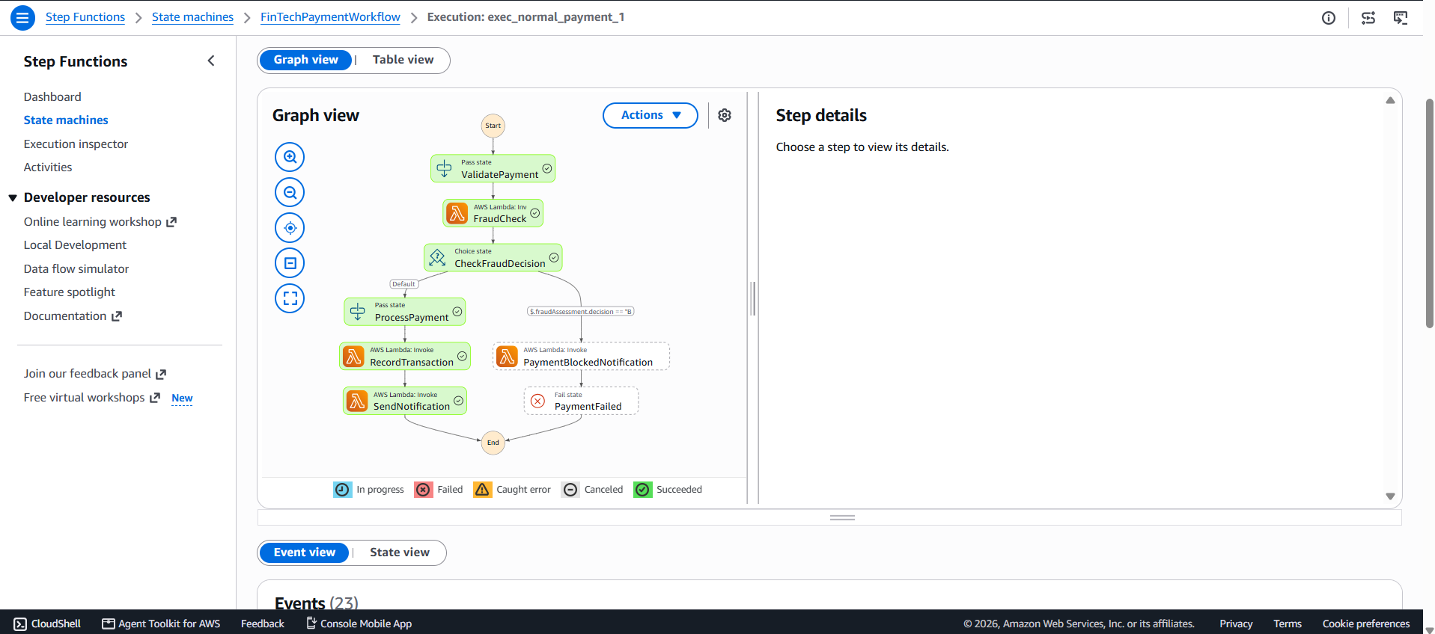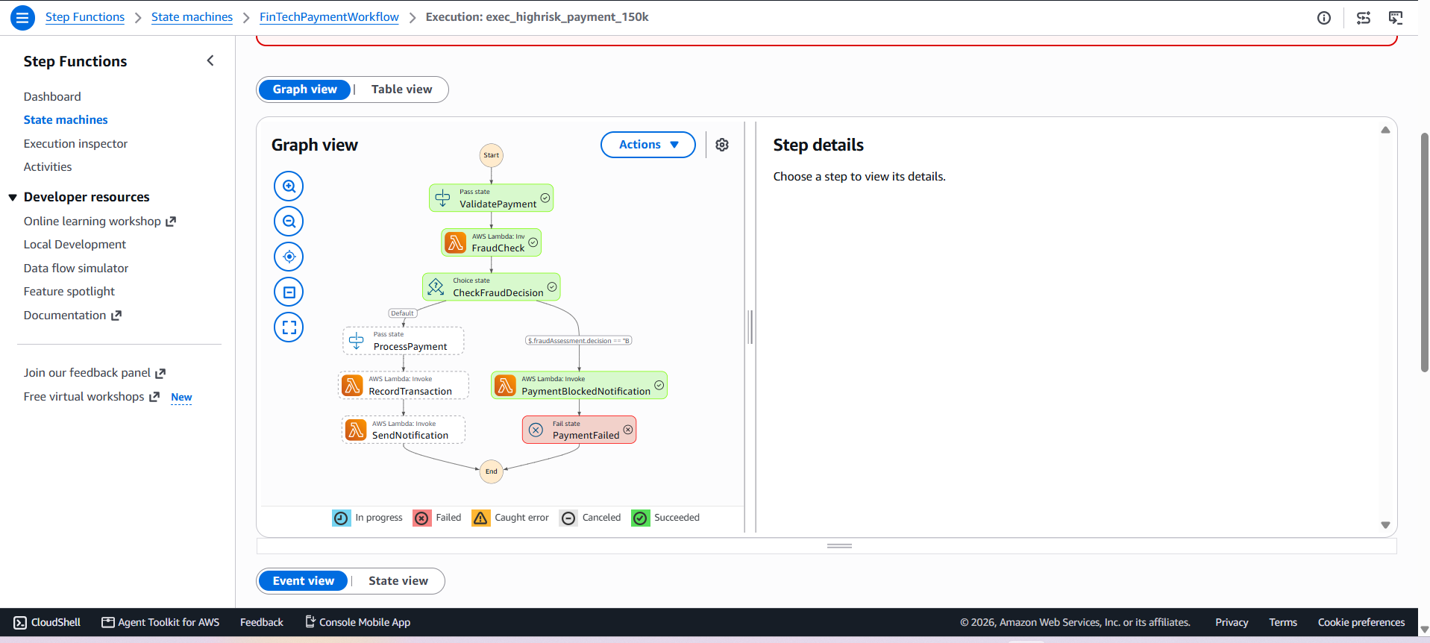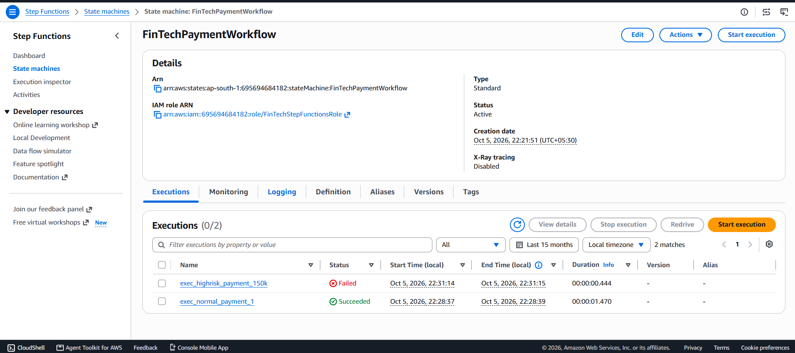
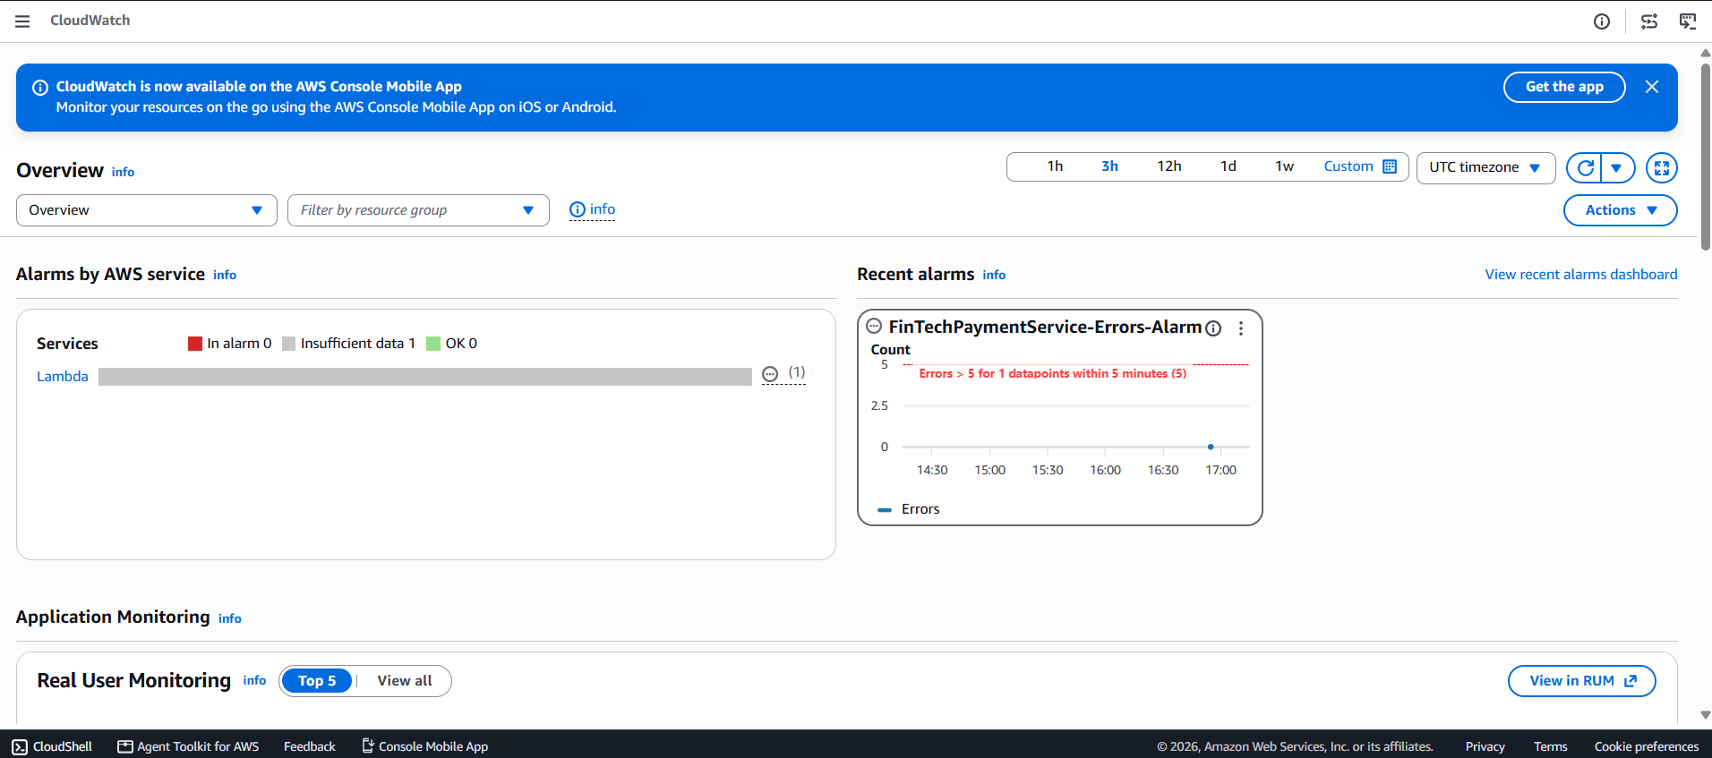
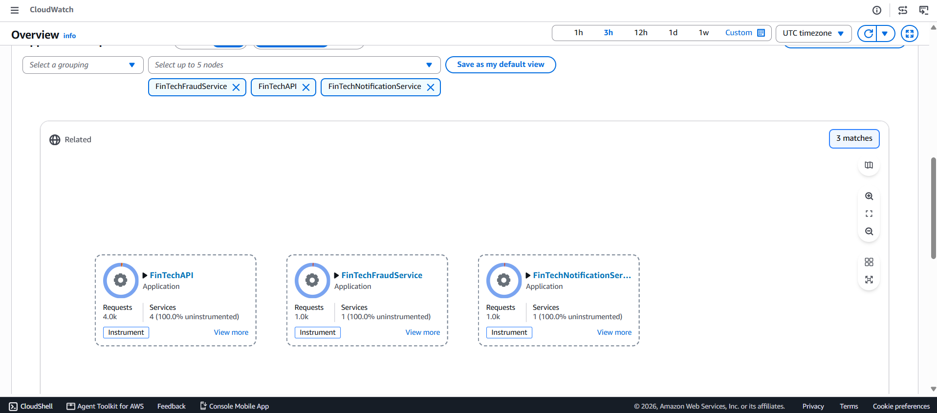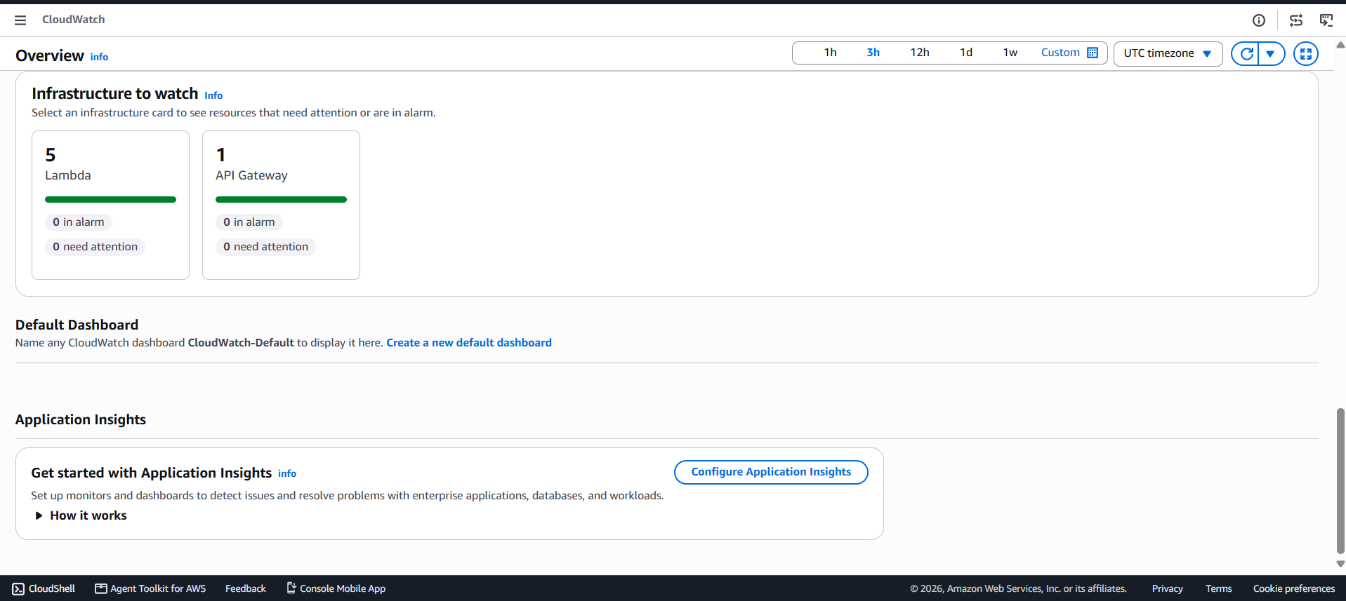

16. Advantages
- Independent and automatic Lambda scaling.
- Reduced infrastructure management.
- Loose coupling through EventBridge.
- Managed workflow orchestration.
- On-demand DynamoDB capacity.
- API throttling for backend protection.
- Centralized monitoring.
- Fine-grained IAM permissions.

17. Limitations
- Prototype fraud logic is not a production fraud-detection system.
- Distributed serverless systems can be harder to debug.
- AWS service quotas and downstream limits must be considered.
- Production FinTech applications require stronger authentication, compliance, encryption, audit and disaster-recovery controls.

18. Future Scope
- Amazon Cognito and JWT authorization.
- AWS WAF protection.
- ML-based fraud detection.
- Multi-region resilience and Route 53 failover.
- CI/CD using GitHub Actions or AWS services.
- Distributed tracing and dashboards.
- Event archival and analytics.
- Evaluation of ECS/EKS or EC2 for workloads unsuitable for serverless.

19. Syllabus Mapping
Syllabus Topic | Application
Lambda concurrency | Reserved concurrency for Payment service
Provisioned concurrency | Payment service production alias
Lambda execution environment | Independent Python Lambda services
API Gateway REST | FinTechAPI
API throttling | 100 requests/sec; burst 200
Step Functions | Standard payment workflow
EventBridge | Custom event bus and payment rule
DynamoDB | Application persistence
S3 | Encrypted audit storage
IAM | Execution roles and least privilege
CloudWatch | Logs, metrics and alarm
EC2/ASG | Alternative architecture; not used in serverless core
ECS/EKS | Container alternatives
CloudFront/Route 53 | Potential delivery/global routing extension
Direct Connect/Snow/Storage Gateway | Hybrid enterprise extensions

20. Conclusion
This case study demonstrates how AWS managed and serverless services can be combined to build a scalable FinTech microservices platform. API Gateway provides the API boundary, Lambda implements independent services, DynamoDB provides persistence, EventBridge enables event-driven integration, and Step Functions provides workflow orchestration. IAM and CloudWatch support security and observability, while concurrency controls and throttling address scalability and traffic protection. The architecture provides a practical foundation for a high-traffic financial application and demonstrates key AWS cloud architecture concepts.

21. References
- AWS Documentation – AWS Lambda
- AWS Documentation – Amazon API Gateway
- AWS Documentation – Amazon DynamoDB
- AWS Documentation – Amazon EventBridge
- AWS Documentation – AWS Step Functions
- AWS Documentation – Amazon CloudWatch
- AWS Documentation – AWS Identity and Access Management
- AWS Documentation – Amazon S3

