README

#Installation
sudo apt-get update && sudo apt-get -y upgrade
sudo apt-get install python-pip
sudo apt-get install sqlitebrowser
sudo pip install tabulate
sudo -H pip install pandas

#Commands
1) Type "sqlitebrowser" on terminal to run sqlite browser. This can be used to dochanges in database if required. Used the sql data base instead of Csv/xsl as it is easy to load and store.
2) To run python code type "python code.py" on terminal.

#Working
Screenshot of the part of database tables
A. Passengers
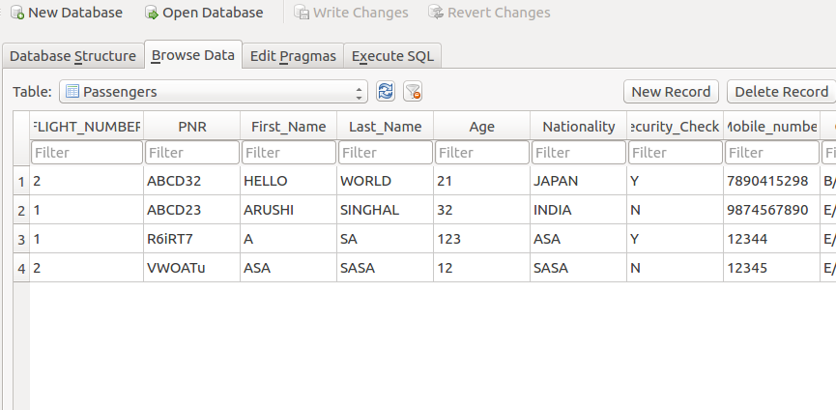

B. Flights
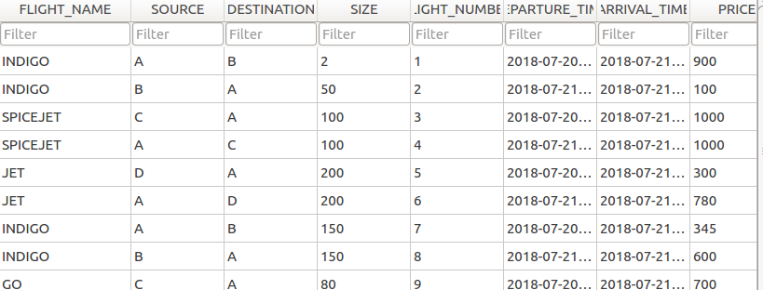

3) Run code
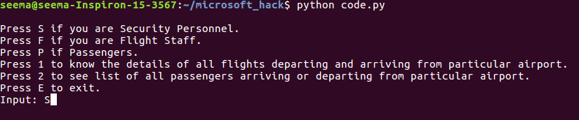

4) Press S if want to see Security Functionality
4.a
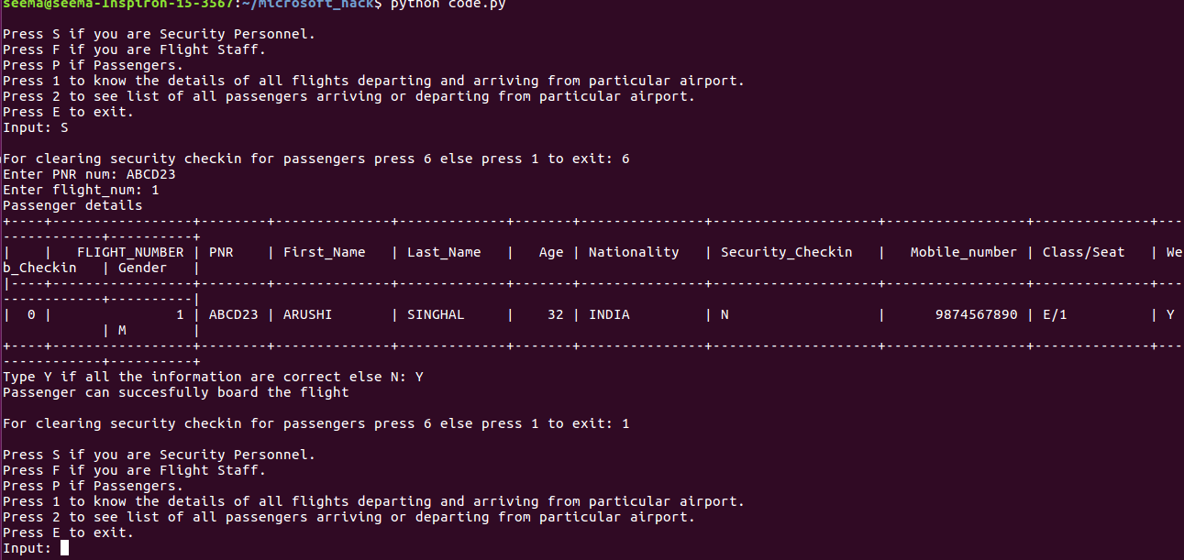

There are many other options to choose and is explained in the code itself.

5)Press F if flight staff
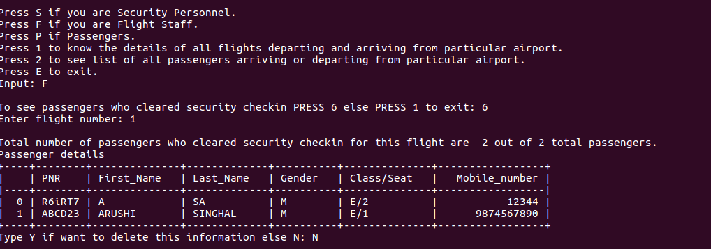

6) Press P if you are passenger

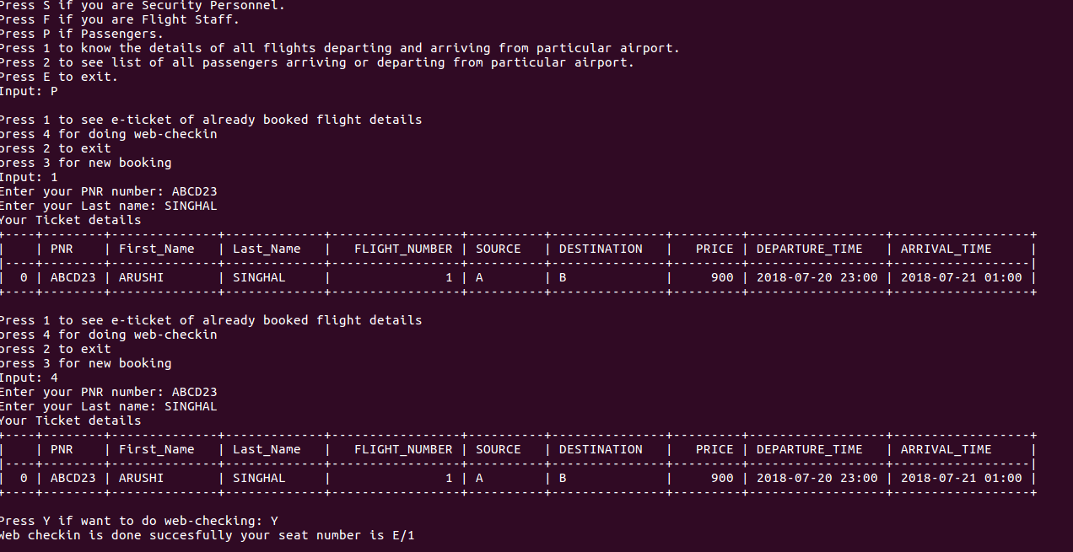

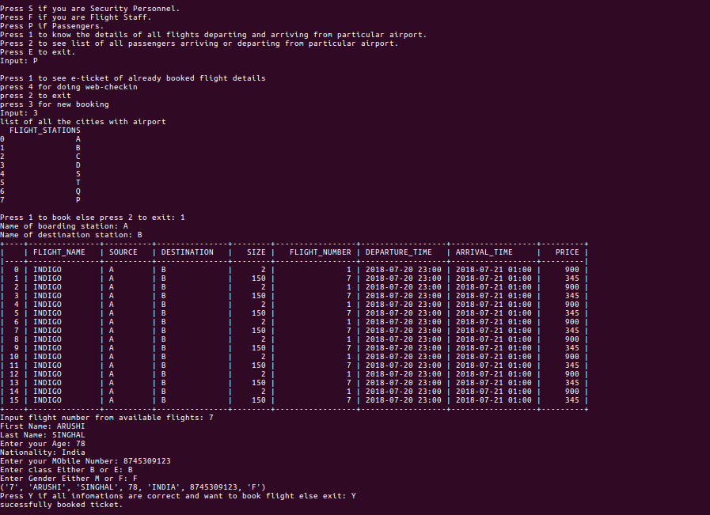

7) See list of flight coming and going from a station

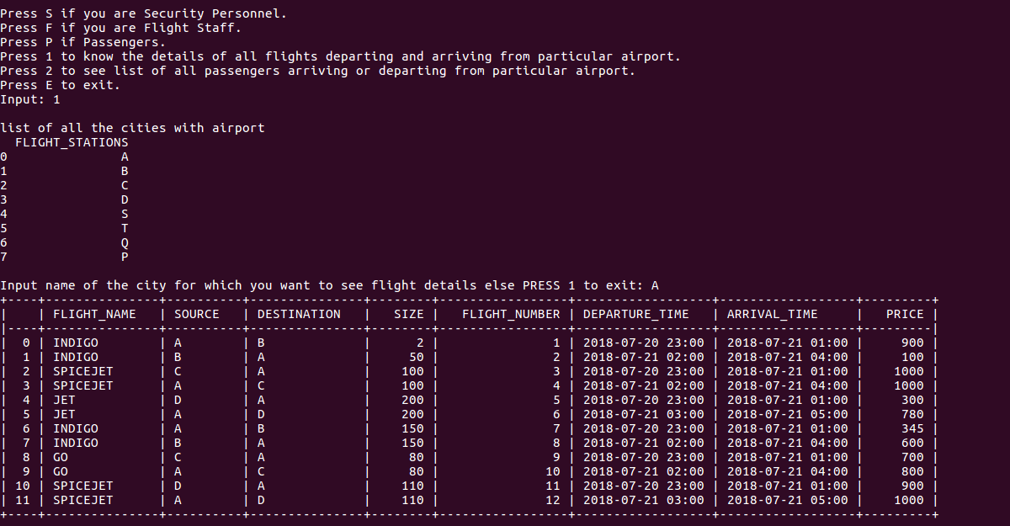

8) List of passengers going or coming from a particular route.
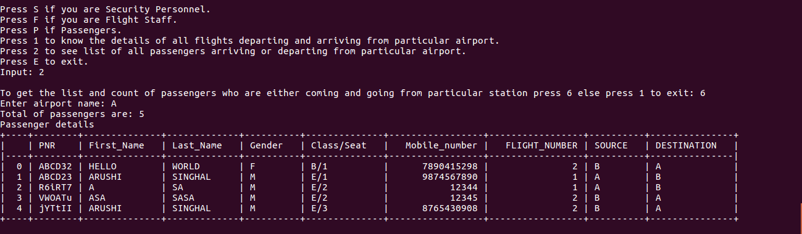

#Special Note
Apart from all this there are many other functionalities and cases. All of them are considered in the code and this code will not stop until exit from it so can test all the functionalities.
And all the possible type of input cases is considered and explained via comments.

#Configuration
- Entity Relationship (ER) Diagram of the Airport Managment system:-ER_Diagram.png
- Code for all the functionality:- code.py
- Operating System used:- Ubuntu 16.04
- Python version:- Python 2.7.12
- Screencast of all the commands:- Screencast.mp4

