Configuration of the System
System | Ubuntu 16.04 LTS
memory | 3.7 GiB
Procssor | Intel® Core™ i3-6006U CPU @ 2.00GHz × 4
Graphics | Intel® HD Graphics 520 (Skylake GT2)
OS type | 64-bit
Disk | 479.3 GB

SortMerge
Memory blocks (M) | Execution Time
50 | 0m23.971s
60 | 0m21.546s
70 | 0m20.689s
80 | 0m19.273s
90 | 0m18.508s
100 | 0m17.243s

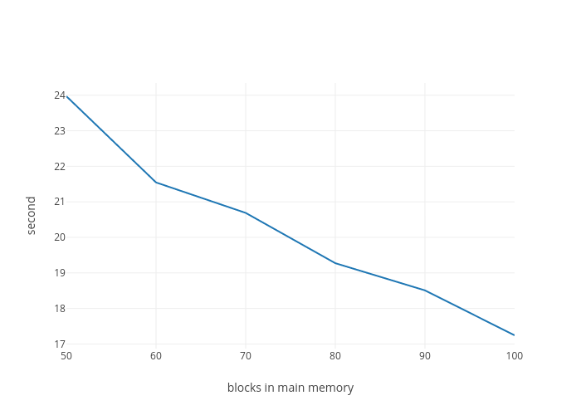

HashJoin
Memory blocks (M) | Execution Time
50
60
70
80
90
100

Graph of HashJoin

