1. Team members:
Simran Singhal: 201516190
Arushi Singhal : 201516178
Tool used for creating diagrams: Creately online app.
2. Class Diagram:
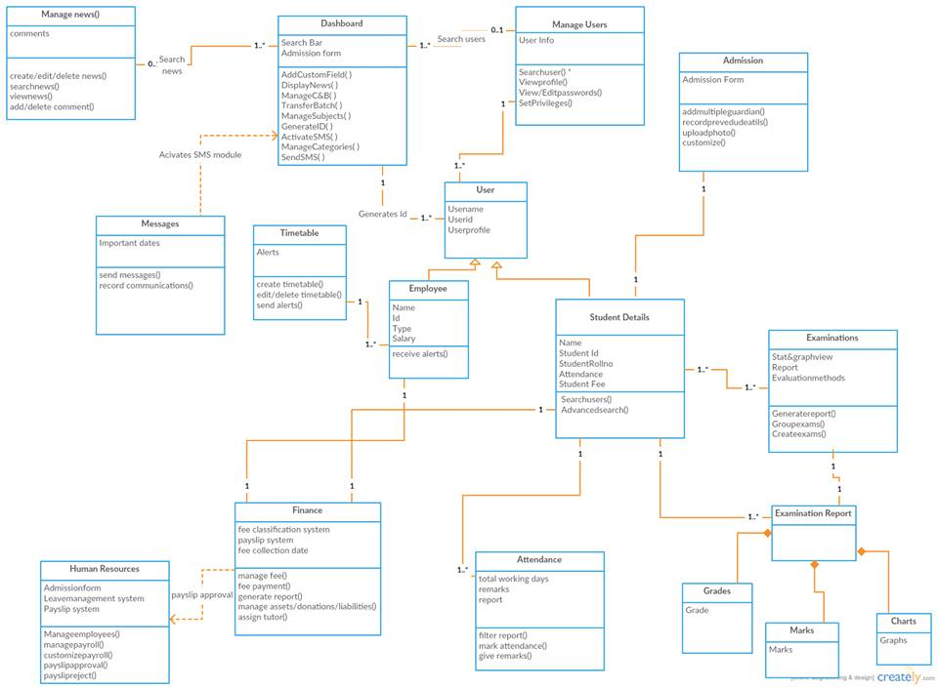
3. Summary for all the major classes

Manage Users | This helps us to view all the users based on their roles and set privileges to users. You can also change the user password and privileges. It allows organization to set standards for different roles based on their responsibilty.
Dashborad | It should have user friendly interface with highly powerful user experience design. It also displays latest news on dashboard and basic institute education information. Language, country, currency, time zone etc can be set. There should be enabling of grading system for students. Unique id for all the users. It should be managing courses batches, subjects. There is a custom field for admission form. Set SMS configuration for alerts to one single user or group of people.
Admission | It should consists of a comprehensive admission form and giving unique id to every student. There should be photo upload facility. Multiple guardian can be added. Previous education details and emergency contact can be recorded. Customize as per school standard.
Student details | This class will be used for student’s deatils. It should have normal student view facilities based on the batches. Search of existing and former students and also large number of filters to search specific student.
Examinations | It will help us create different types of exams based on grades, number of people giving exams etc. It can aslo generate report for required exams. Statistical and graohical view of all reports. Automated report generation. GPA, CCE, CWA etc evaluation method.
Human Resources | Manage all employees from admission to exit. Customizable admission form and payroll form. Manage entire payroll efficiency. Efficient leave management system available. Authenticated payslip approval system. Normal and advanced search facility.
Finance | Separate fee collection date designing system for faster finance process. Easy analysis for fee defaulter and fee structure available. Easy fee submission process. Customize and manage different categories of expense and incomes and manage and pay instant fees. Different report generation and automatic transaction facility.
Timetable | This is used by users to drag and drop to make timetable. Alert on subject limits per week stats. Alerts on employee subject limits while creating time table. Edit and delete time table.
Manage news | Create , delete, edit news. Search for any news in search bar. View all news facility. Add news in text format. Published news has facility to comment on it or delete comments by the users.
User | It is the class used for taking all the users related to the institute. It has two children, employee and student details. It will have different class to manage students and employees. It saves the unique user id, user name and user profile.

4. UML use case diagram:
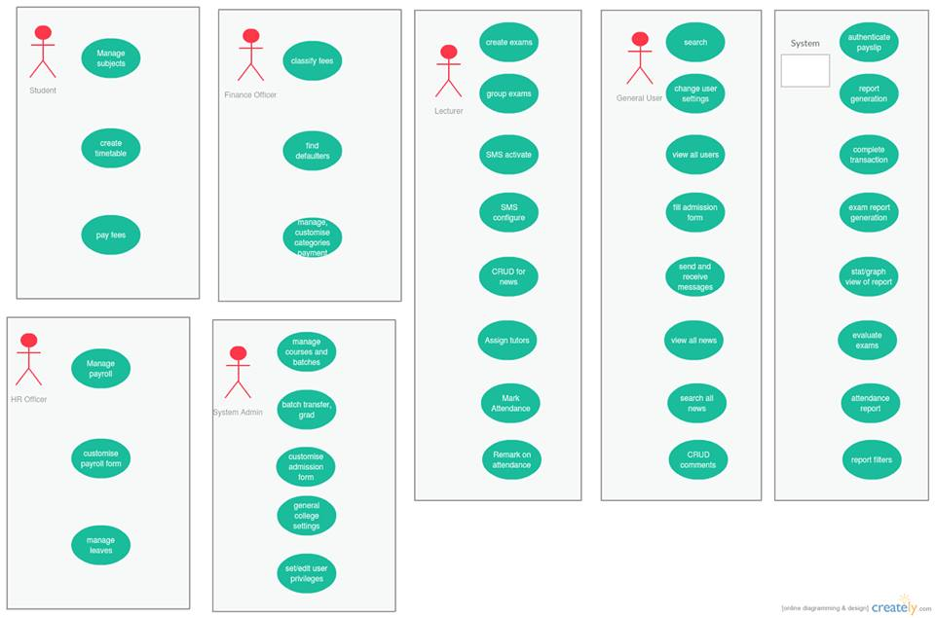
Use case diagram (modified):
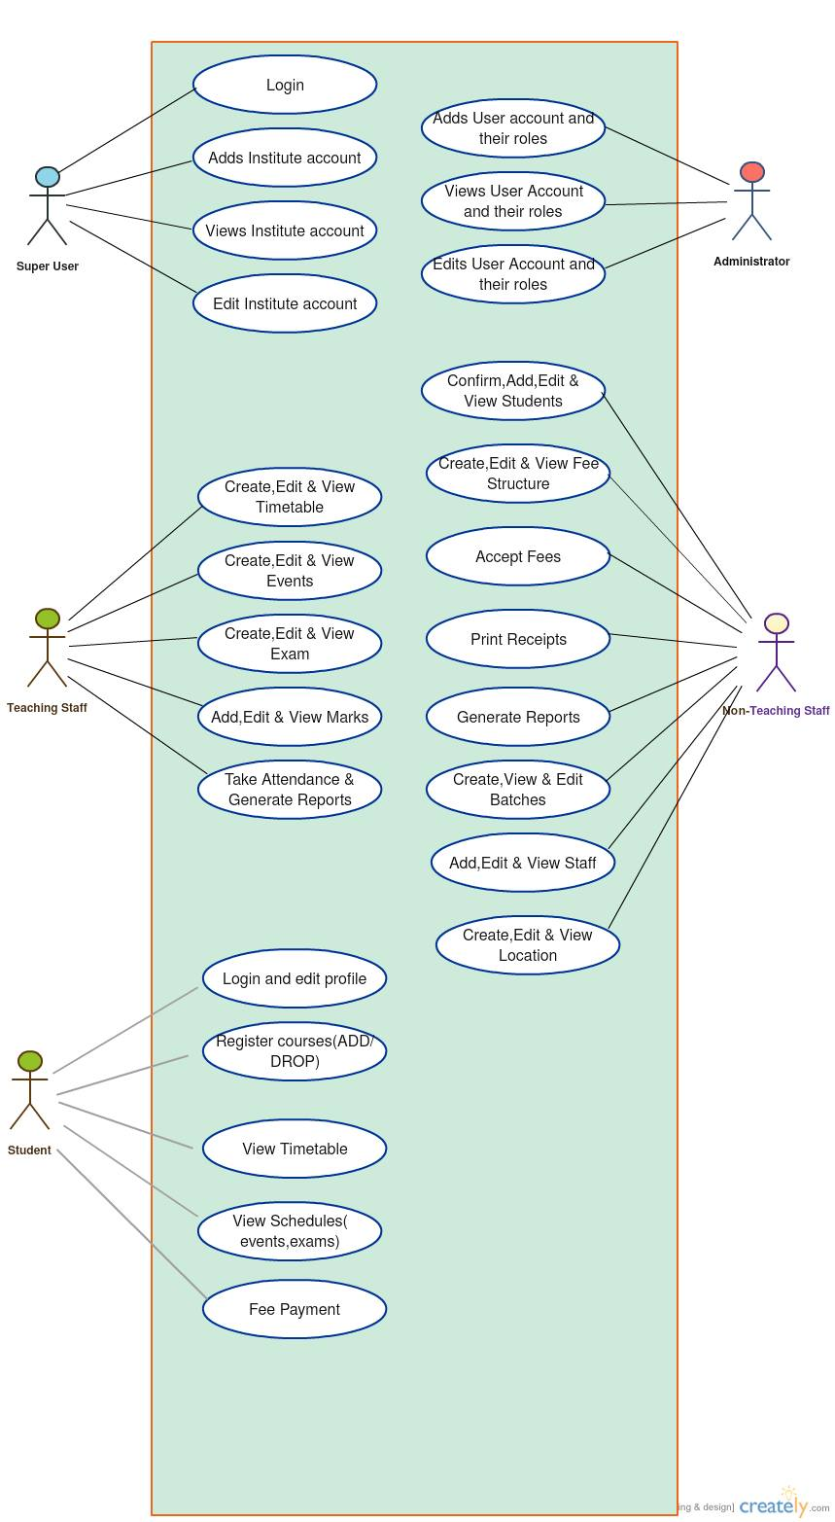
5. Principles such as coupling, cohesion, delegation vs. inheritance, assignment of
responsibilities, elimination of bad code smells, metric values, etc. should be in your
consideration while choosing the metrics plug-in for doing the analysis and
refactoring. The refactored design should have some connection to the original
design; the intention is not to throw away the design and start with a clean sheet of
paper. The new implementation should not have any behavioral change.

Cohesion, as the name suggests, indicates that software entities– a class or function or a module – should have closely related responsibilities. The tasks performed should closely relate to each other. A good software design should have high cohesion. Having high cohesion increases maintainability and decreases dependency (coupling)

Coupling, measures the level of dependency between two software entities. Simply said two components A and B are said to be coupled if you can’t change A without changing B. Good software design should have low coupling between components. Having low coupling increases the maintainability and reuse of software.

Object – Oriented Design (OOD) Principles: One major programming paradigm shift was from Procedural Programming (PP) to Object Oriented Programming. In Object Oriented programming real world entities and their interactions are represented as objects.

A principle is "a comprehensive and fundamental law, doctrine, or assumption". Software design principles are key notions that provide the basis for many different software design approaches and concepts. Software design principles include abstraction; coupling and cohesion; decomposition and modularization; encapsulation/information hiding; separation of interface and implementation; sufficiency, completeness, and primitiveness; and separation of concerns.

Abstraction is "a view of an object that focuses on the information relevant to a particular purpose and ignores the remainder of the information" In the context of software design, two key abstraction mechanisms are parameterization and specification. Abstraction by parameterization abstracts from the details of data representations by representing the data as named parameters. Abstraction by specification leads to three major kinds of abstraction: procedural abstraction, data abstraction, and control (iteration) abstraction.
Coupling and Cohesion. -> Coupling is defined as “a measure of the interdependence among modules in a computer program,” whereas cohesion is defined as “a measure of the strength of association of the elements within a module” .
Decomposition and modularization.-> Decomposing and modularizing means that large software is divided into a number of smaller named components having well-defined interfaces that describe component interactions. Usually the goal is to place different functionalities and responsibilities in different components.
Sufficiency, completeness, and primitiveness.-> Achieving sufficiency and completeness means ensuring that a software component captures all the important characteristics of an abstraction and nothing more. Primitiveness means the design should be based on patterns that are easy to implement.
Separation of concerns.-> A concern is an "area of interest with respect to a software design" . A design concern is an area of design that is relevant to one or more of its stakeholders. Each architecture view frames one or more concerns. Separating concerns by views allows interested stakeholders to focus on a few things at a time and offers a means of managing complexity.
6.) Disadvantages :
1.) no proper algo to store data ( data persistence) - This design issue is concerned with how to handle long-lived data
2.) server slow
3.) time-table scheduling
4.) lack of security
Advantages =
• All the general information of a student/faculty
can be displayed on a single click.
• Makes easy to maintain the student’s course info
and their performance details.
• Maintain the attendance entry, leave entry
and all the holidays of institution.
• Event management is easy.
• Easy registration process for students.
•
Maintain staff record easily.
•
Management of inventories is easy

