Product Design
Team | 5  Fanish Jain  Jyoti Sunkara  Pranav Tademeti  Sartak Periwal  Swastik Murawat

Design Overview

Architectural design-
It will have the following modules :-
1.Login/Sign up Module
2.BACnet Module
3. User Module
4. Data Analytics Module
First BACnet system need to be set up , then designing of several web pages and data analytics of the data collected.

System interfaces

User Interface
The main page will contain a navigation bar and login/sign up process.
There will be several web pages for each super user, space user(private access to respective labs), and data analytic page for public users (open for all , no need for sign in)
The space user can control the AC of their rooms , they can access the data of past several days.
The super user can control AC and access data of all labs.

APIs
In final Release we will have following APIs:
1. API for accessing the data in required format.
2. API for controlling the AC.

Model

.

Sequence Diagram(s)
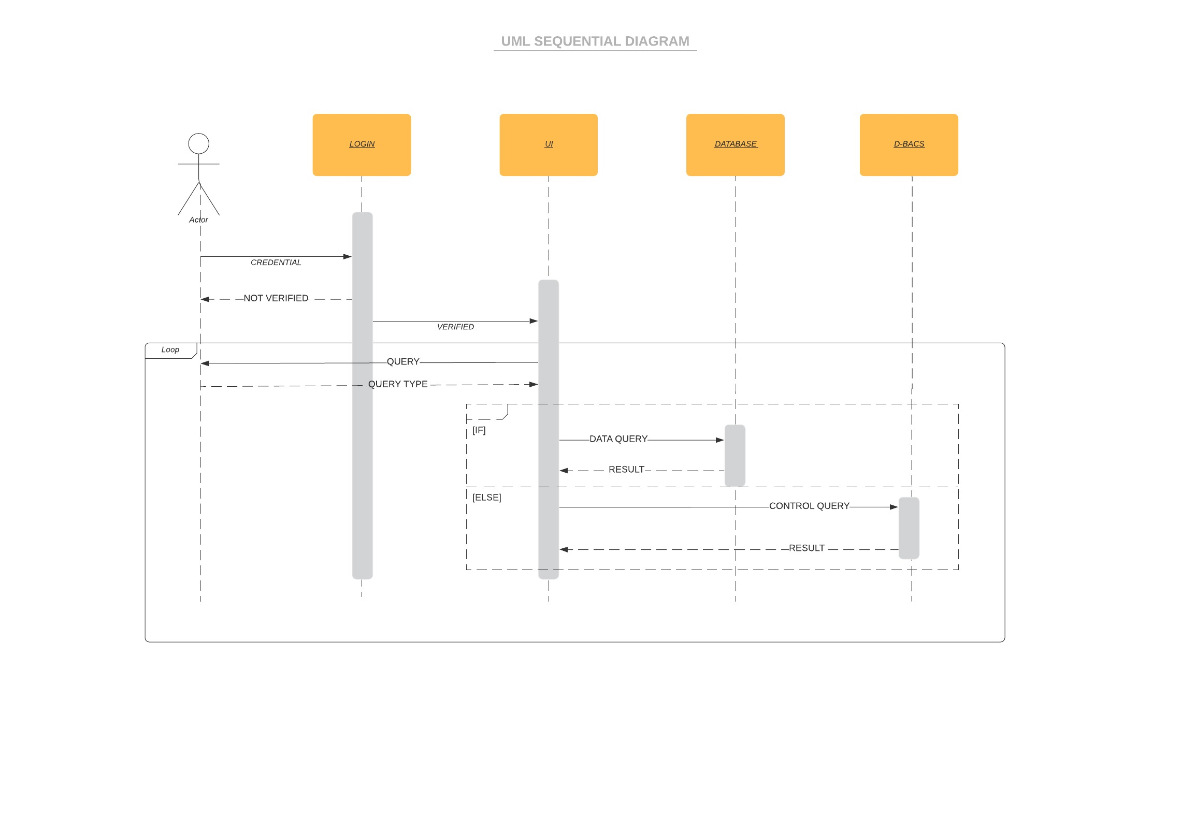

Design Rationale
Will be added later.

