MSE-1-DEVOPS
3RD Year -5TH SEMESTER
Arushi Singh
202401100200090
CSE-B
- GitHub repository URL
https://github.com/Arushis35/github-skills-challenge
- Pull request URL used to validate the workflows
https://github.com/Arushis35/github-skills-challenge/pull/1

- Screenshot showing the GitHub Actions workflows
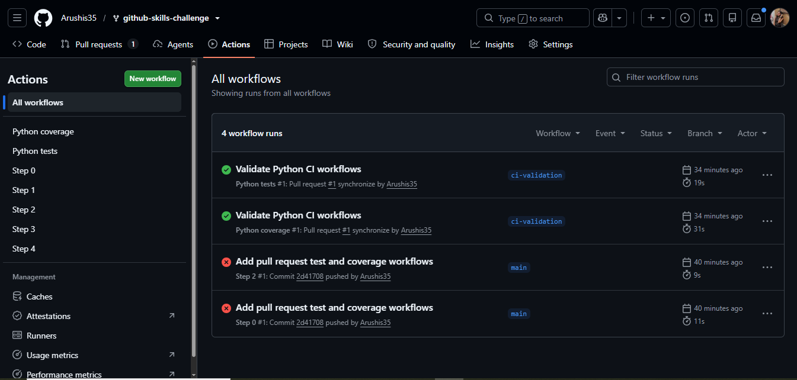

- Screenshot showing a successful test workflow execution
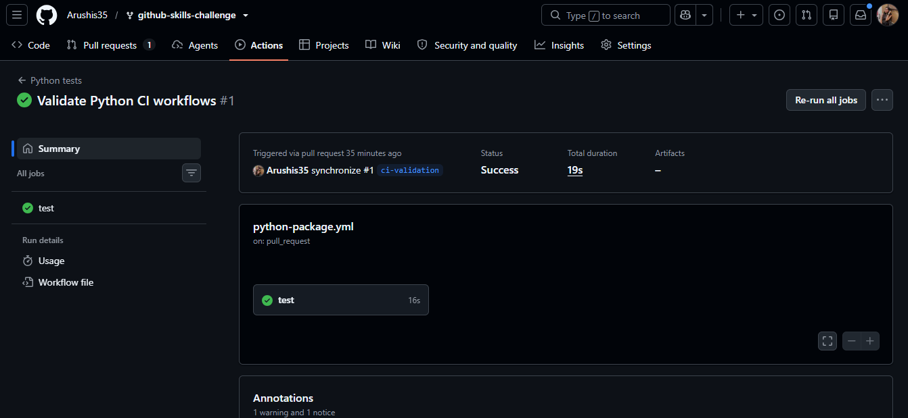
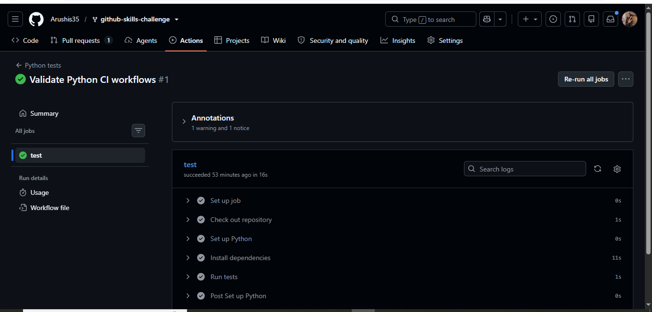

- Screenshot showing the coverage result/comment on the pull request

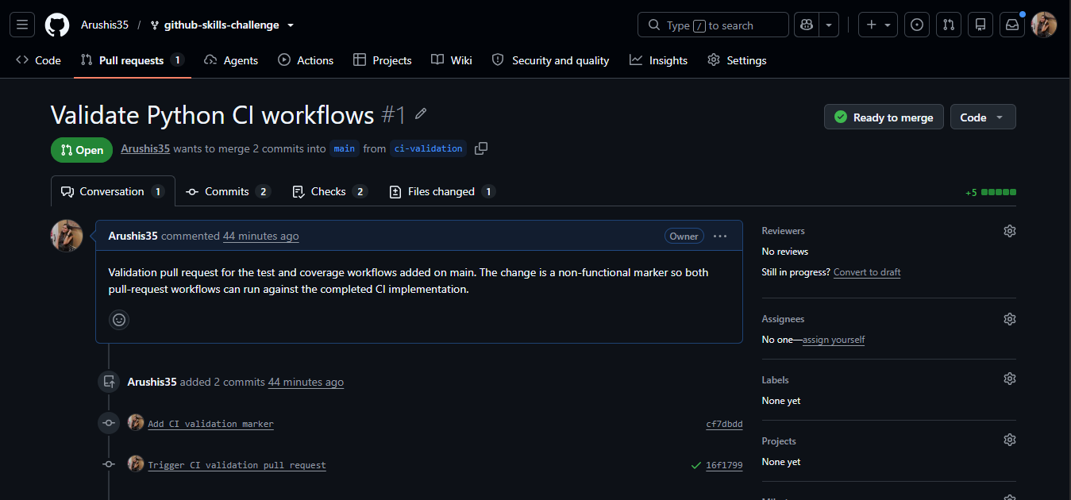
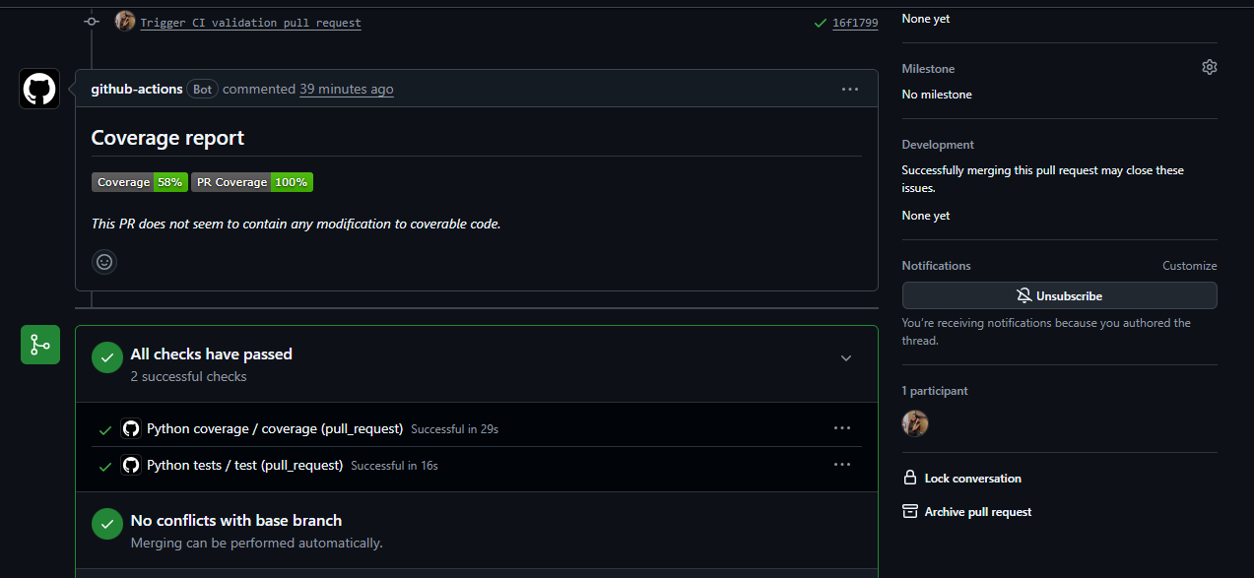

- Screenshot showing the final repository/workflow files

