NovaSphere
Cellular Network Performance Intelligence Brief
Market Intelligence Research Brief | Udacity Nanodegree Project 2 (Amazon Quick Suite)
Student: Aruthra S M | October 4, 2026

Audience | Technology leadership, telecom strategy and network engineering teams
Dataset | 5G_Cellular_Network_Performance.csv: 16,829 records, 12 fields, 20 localities (Patna, India, inferred from locality names and coordinates), 4 network types, May 5 to June 10, 2023
Evidence | Amazon Quick screenshots (Figures 01 to 34) in Quick_Screenshots/ (figure numbers are used throughout); Quick Research report (PDF); Market Analysis; Verification Log
Evidence labels | [VERIFIED DATASET FACT] computed in Quick on all 16,829 records. [SUPPLEMENTARY CSV CHECK] recomputed outside Quick, not used as a stand-alone finding. [EXTERNAL SIGNAL] from a named outside source. [INTERPRETATION] reasoning from the data. [LIMITATION] constraint on use.

1. Research Objective
Decision-oriented research question
Which factors (network technology, locality, signal strength, time) explain the throughput and latency observed in this 20-locality cellular measurement campaign, how does the observed 5G performance compare with external reference points, and what should a technology or network-strategy team validate before making any 5G network-investment or enterprise private-5G decision?

The brief supports a "what to investigate next" decision. The dataset records measured speed and delay only. It holds no cost, revenue, subscriber or demand data, so it cannot by itself support an investment decision.

2. Scope of Research
Dimension | Included | Excluded (and effect on conclusions)
Market / geography | 20 named localities in one metropolitan area (Patna, India) | Other cities, states, countries. Findings cannot be generalized beyond this campaign.
Technology (competitor categories) | Four network types: 3G (4,208 records), 4G (4,219), LTE (4,224), 5G (4,178) | Operators, carriers, device brands. No market-share or operator comparison is possible.
Timeframe | May 5, 2023 12:50:40 to June 10, 2023 23:56:52 (37 consecutive days, 16,829 unique timestamps) | Anything after June 2023, seasons, holidays. Trends beyond 37 days cannot be assessed.
Metrics | Data Throughput (Mbps), Latency (ms), Signal Strength (dBm); Signal Quality and three SDR fields reviewed for usability | Frequency band, spectrum, architecture (NSA/SA), cell load, device, application-level outcomes. Causes of performance cannot be identified.
External context | ITU-R IMT-2020 requirements; Ookla Speedtest Intelligence reports; sources in Appendix C | Pricing, revenue, ROI, adoption data. No business case can be built.
Key constraints | Full dataset used with no sampling and no filters; Quick Research hours limited, so effort was prioritized (Section 3) | Primary field measurements and any collection documentation were not available.

3. Research Approach

3.1 Types of questions asked
- Structure questions: how many records per network type and locality; does the cross-tab reconcile to 16,829 (Figures 15A, 16).
- Comparison questions: average throughput and latency by network type, then by locality x network type (Figures 15B, 17A to 17C).
- Integrity and recalculation questions: nulls, zeros, duplicates, independent SUM / COUNT recalculation, final reconciliation (Figures 18A to 20C).
- Relationship questions: Pearson and Spearman correlations of signal strength with throughput and latency, overall and within each network type; Signal Quality and SDR field usability (Figures 21A to 25F).
- Time questions: timestamp range, daily series, trend test, final time reconciliation (Figures 26A to 28G).
- External-context questions: how does 5G in this dataset compare with ITU-R targets and Ookla medians (Figures 12 to 14).

3.2 How effort was prioritized
Effort followed decision value. First the largest comparison that drives most decisions (technology type), then locality, signal and time, then external benchmarks. Quick Research was used once, broadly, for external context. All numeric claims were then re-verified on the full dataset in Quick Chat, because a research report is exploratory until tested. Low-value questions, such as individual coordinates, were not pursued. Where Quick Research and the full-dataset result disagreed, the dataset result was used (Section 8).

3.3 Amazon Quick Suite tools used
Tool | Used for | Output and evidence
Quick Research | External 5G context and hypotheses | Research report v1.0 (Figures 12, 13, 14); PDF in Supporting_Reports/
Quick Chat (My Assistant) | Full-dataset counts, averages, cross-tabs, correlations, time series, reconciliations | Figures 15A to 28G and 34
Quick Sight analysis | Seven visuals on the sheet "NovaSphere - Visual Analysis" | Figures 05 to 11
Chat agent | Cellular Network Performance Intelligence Agent, grounded in the dataset, instructed not to fabricate data | Figures 29 to 32C
Spaces | Dataset, report, analysis, verification log, brief and dashboard organized for review | Figure 33

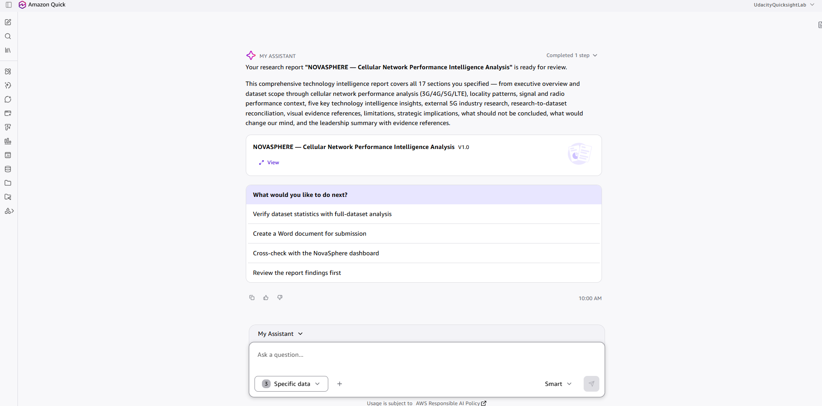
Figure 12: Quick Research report generated from the uploaded dataset (research chat result).
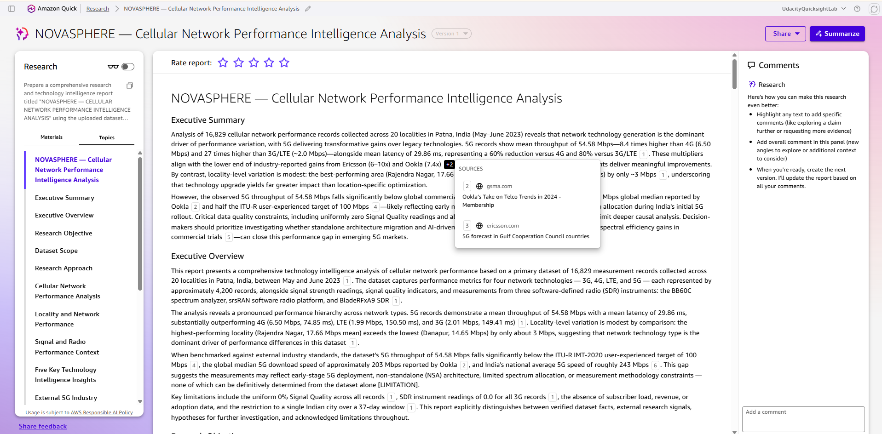
Figure 14: Quick Research report with the source panel open, showing sources behind the external claims.

4. Key Market Insights
Five insights, each with an Insight Summary, Supporting Evidence/Signals, and Why It Matters. Confidence for each insight is assessed in Section 6.

Insight 1: 5G delivers a far higher observed throughput than every other network type

Insight Summary
[VERIFIED DATASET FACT] 5G averages 54.58 Mbps, against 6.50 Mbps for 4G, 2.01 Mbps for 3G and 1.99 Mbps for LTE. The gap is 8.4x over 4G and about 27x over 3G and LTE, and holds in all 20 localities.

Supporting Evidence / Signals
- Quantitative: 5G throughput range 10.02 to 99.99 Mbps (standard deviation 26.09); 4G 3.00 to 10.00; 3G and LTE 1.00 to 3.00. All 8 averages were recalculated independently with zero discrepancies (34 of 34 comparisons; 42 of 42 final reconciliation checks).
- Quantitative: the 10 strongest locality x network combinations are all 5G (51.18 to 57.36 Mbps by locality); the 10 weakest are all LTE or 3G (about 1.9 to 2.0 Mbps).
- Qualitative: the box plot (Figure 06) shows the whole 5G distribution shifted upward, so the gap is not caused by a few outliers.
- Observation: LTE (1.99 Mbps) performs like 3G, not like 4G. This is unexpected and is treated as a data-definition question (Section 7).

Why It Matters
Technology type should be the first segmentation variable in any performance review: it separates records far more than location, signal or day. Leadership can treat the 5G throughput advantage as a robust pattern of this dataset. It should not be quoted as a general 5G speed.
Evidence: Figures 15A, 15B, 17A to 17C, 19A to 19C, 20A to 20C; visuals 05, 06, 07 (Section 5).

Insight 2: 5G also shows much lower observed latency

Insight Summary
[VERIFIED DATASET FACT] 5G averages 29.86 ms, against 74.85 ms for 4G, 149.41 ms for 3G and 150.50 ms for LTE. That is about 60% lower than 4G and about 80% lower than 3G and LTE (2.5x and 5.0x lower).

Supporting Evidence / Signals
- Quantitative: latency bands do not overlap: 5G 10.02 to 49.98 ms, 4G 50.01 to 99.99 ms, 3G and LTE 100.00 to 199.99 ms. The 10 lowest-latency combinations are all 5G; the 10 highest are all LTE or 3G.
- External signal: ITU-R sets an eMBB user-plane latency requirement of 4 ms and a URLLC requirement of 1 ms (ITU-R M.2410, 2017). The dataset's 5G minimum is 10.02 ms and no 5G record is at or below 4 ms (supplementary check). The ITU figures describe the radio interface under test conditions, not end-to-end latency, so they are context and not a pass/fail test.
- Qualitative: Quick Research cites an Ookla global 5G median latency of about 44 ms; this figure was not independently re-checked and is not relied on.

Why It Matters
The latency gap suggests 5G is worth investigating for responsiveness-sensitive uses such as interactive cloud applications. Sub-10 ms applications (industrial control) are not supported by this evidence: the observed 5G minimum is 10.02 ms and the mean is 29.86 ms.
Evidence: Figures 15B, 19A to 19C, 20A to 20C; visuals 05 and 09.

Insight 3: Observed 5G throughput sits well below external 5G reference points, but the comparisons are not like-for-like

Insight Summary
[VERIFIED DATASET FACT] No record in the dataset reaches 100 Mbps (maximum 99.99 Mbps); the 5G mean is 54.58 Mbps.
[EXTERNAL SIGNAL] ITU-R IMT-2020 sets a downlink user-experienced data-rate target of 100 Mbps (the 5th percentile of user throughput, dense-urban eMBB test environment). Ookla reports Indian 5G median download speeds of 316.24 Mbps in August 2023 and 301.86 Mbps in Q4 2023, versus 14.97 and 16.05 Mbps for 4G.

Supporting Evidence / Signals
Reference | Metric, date, geography | Dataset comparison | Comparability
ITU-R M.2410 (2017) | DL user-experienced data rate 100 Mbps, 5th percentile, dense urban eMBB (global design target) | 5G mean 54.58; 5G 5th percentile 14.20 Mbps (supplementary) | Low: a design requirement, not a deployment average
Ookla via tele.net.in (data Aug 2023, India) | 5G median 316.24 Mbps; 4G 14.97 Mbps (about 21x) | 5G mean 54.58; 4G mean 6.50 (8.4x) | Medium: direction agrees; levels and ratio differ; crowd-sourced median vs measurement-campaign mean
Ookla via Communications Today (Q4 2023, India) | 5G median 301.86 Mbps; 4G 16.05 Mbps (about 19x) | Same | Medium, same caveats
Quick Research (citing Ookla / GSMA, Q3 2023, global) | Global 5G median about 203 Mbps; "India national average about 243 Mbps" (GSMA) | Same | Low: as cited by Quick Research; the India figure differs from Ookla's 301.86 to 316.24 Mbps and is not relied on
Ookla SA report (Q4 2025, global) | Global median 5G SA download 269.51 Mbps, a 52% premium over NSA | No NSA/SA field in dataset | Context only: shows architecture can move speeds, cannot be tested here

Why It Matters
Leadership should not describe this campaign's 5G as "meeting 5G standards" or as "typical of Indian 5G". The gap is a reason to find out why (spectrum band, SA or NSA deployment, cell load, device, test method). None of these is recorded in the dataset, so the cause cannot be identified from it.
Evidence: Figures 13, 14 (Quick Research and sources), 20A to 20C; visuals 06 and 08. External sources: Appendix C.

Insight 4: The signal-strength correlation reflects network-type mix, not a performance driver

Insight Summary
[VERIFIED DATASET FACT] Across all 16,829 records, Signal Strength has Pearson r = -0.4838 with throughput and +0.5036 with latency (Spearman -0.5022 and +0.5013). Inside each network type, every coefficient is below 0.03 in absolute value.
[INTERPRETATION] dBm values closer to zero are stronger signals, so the pooled result means stronger signal goes with lower throughput and higher latency. That is the opposite of normal radio expectations and arises because 3G has the strongest average signal (-85.01 dBm) and lowest speed, while 5G has the weakest signal (-95.15 dBm) and highest speed. This is a Simpson's paradox pattern: the association comes from differences between network types, not from signal strength acting inside any one type.

Supporting Evidence / Signals
Scope | r (signal vs throughput) | r (signal vs latency) | Mean signal (dBm)
All records (n = 16,829) | -0.4838 | +0.5036 | -90.07
3G (n = 4,208) | +0.0154 | -0.0055 | -85.01
4G (n = 4,219) | +0.0271 | -0.0231 | -90.17
5G (n = 4,178) | -0.0252 | -0.0072 | -95.15
LTE (n = 4,224) | +0.0037 | +0.0100 | -90.00

- Qualitative: Signal Quality is 0 for all 16,829 records and the three SDR fields are 0.0 for all 4,208 3G records, so neither can be used to check or control the signal result.

Why It Matters
Signal strength should not be treated as a stand-alone driver of speed or delay, and "improve signal" cannot be derived from this dataset as a way to raise throughput. A dashboard or model that pools network types would show a misleading relationship, so analysis must be done within network type.
Evidence: Figures 21A to 21C, 22A to 22C, 23A to 23C, 24A to 24E, 25A to 25F.
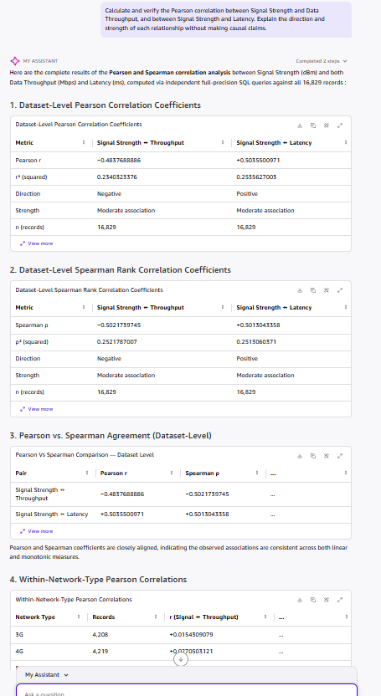
Figure 22A: Quick verification of the signal-to-throughput and signal-to-latency correlations (pooled).

Insight 5: Network technology separates performance far more than locality does, and locality gaps largely track 5G sample share

Insight Summary
[VERIFIED DATASET FACT] The 5G-versus-4G gap is about 48 Mbps, while overall locality averages span about 3 Mbps (Rajendra Nagar 17.66 Mbps, Danapur 14.65 Mbps), a ratio of about 16 to 1.
[VERIFIED DATASET FACT] Locality averages track each locality's share of 5G records: Pearson r = 0.9016 (r-squared 0.8129, p = 5.72 x 10^-8, n = 20 localities; Quick Figure 34 (34_Locality_5G_Share_Correlation.png)). Danapur has the lowest 5G share (21.88%, 177 of 809 records) and Rajendra Nagar the highest (27.42%). The 5G-share range is narrow, and Quick itself flags that a Simpson's paradox check is warranted.
[SUPPLEMENTARY CSV CHECK] That check, done on the CSV outside Quick, weights every network type equally: the locality spread falls from about 3.01 Mbps to about 1.45 Mbps.

Supporting Evidence / Signals
- Quantitative (Quick): within 5G, locality averages range from 51.18 Mbps (S.K. Puri) to 57.36 Mbps (Kankarbagh), a 6.18 Mbps spread; within 4G, 3G and LTE the spread is 0.73, 0.13 and 0.19 Mbps.
- Quantitative (Quick): Danapur holds the fewest 5G records (177 of 809), consistent with its lowest overall average. Pataliputra has the lowest overall latency (97.80 ms).
- Qualitative: Anisabad has both the best single-combination latency (5G, 28.75 ms) and the weakest throughput (LTE, 1.92 Mbps), so performance follows network type more than place.

Why It Matters
Ranking localities by overall averages would reward or penalize them for how many 5G samples they contain. Locality-level planning should compare localities within the same network type, where differences are small. The 5G-share link is verified in Quick (Figure 34); it shows association, and does not prove the cause.
Evidence: Figures 16, 17A to 17C, 34; visual 07 (heatmap).

5. Visual Evidence
Seven Amazon Quick visuals were built on the sheet "NovaSphere - Visual Analysis". Four are shown here, each with its chart type, what it shows, and the insight it supports. All seven appear together in Figure 11.
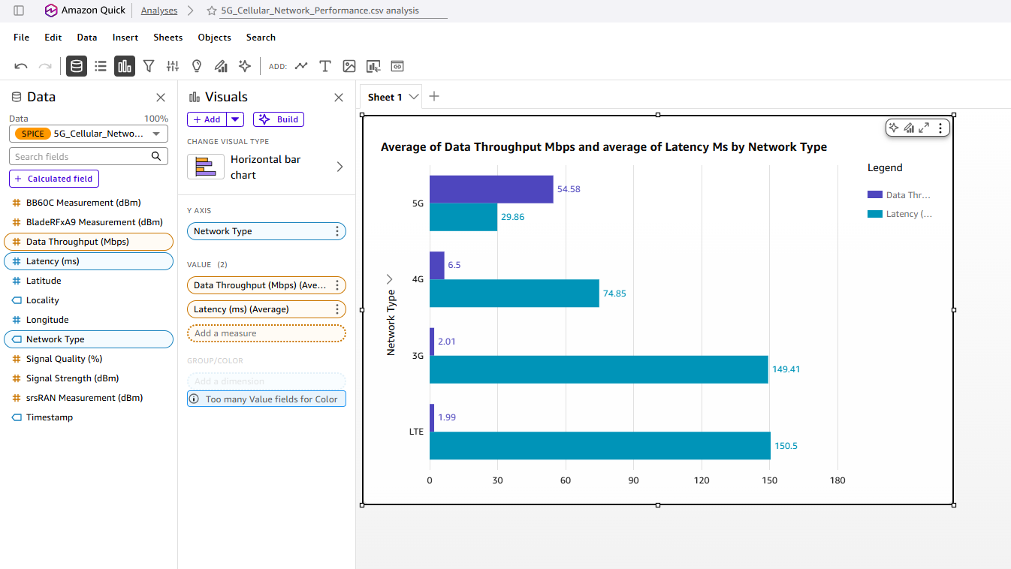
Figure 05 (V1): Average throughput and latency by network type.
Chart type: horizontal bar chart with two measures. What it shows: 5G 54.58 Mbps and 29.86 ms; 4G 6.50 and 74.85; 3G 2.01 and 149.41; LTE 1.99 and 150.50. Supports: Insights 1 and 2: the same ordering holds for both metrics.
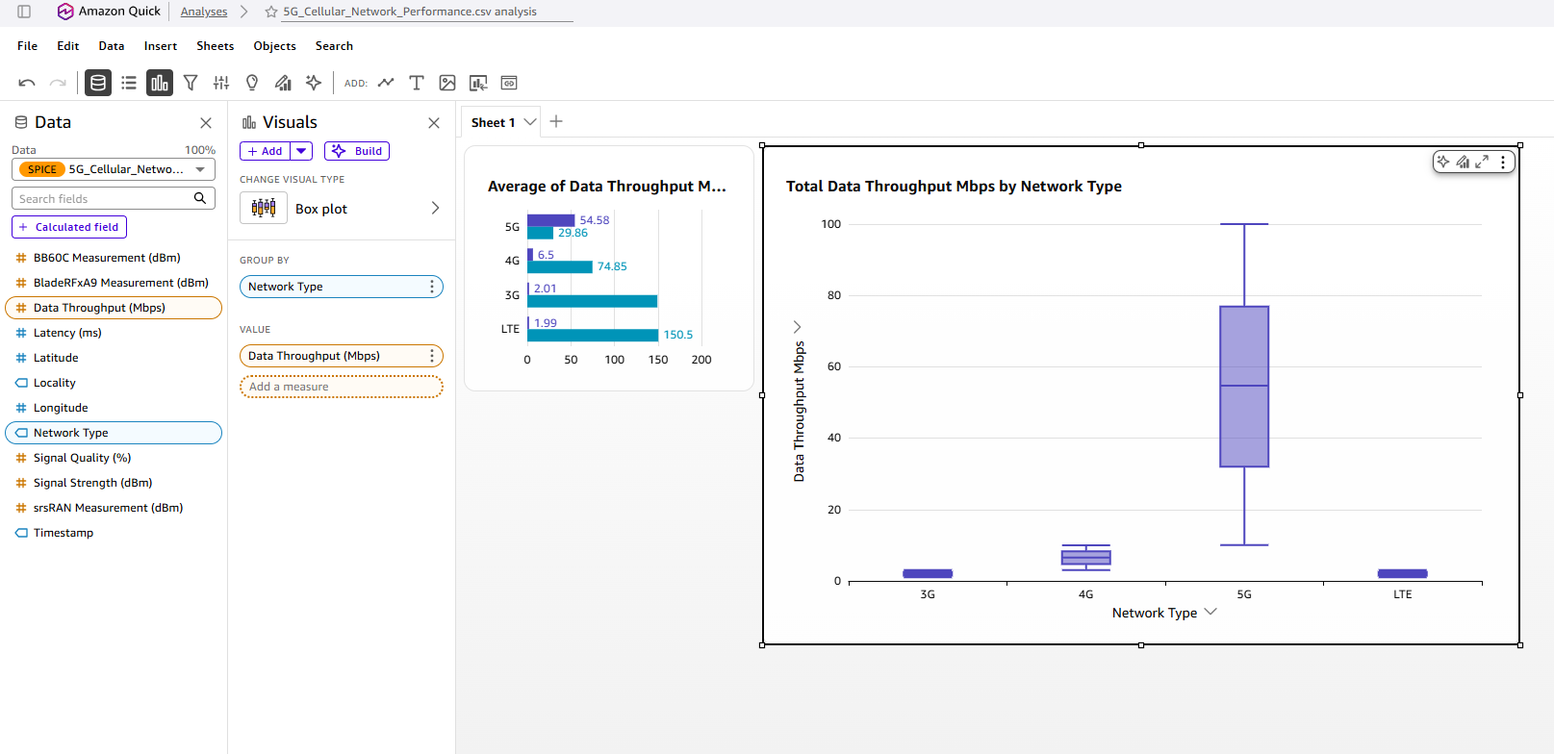
Figure 06 (V2): Throughput distribution by network type (box plot).
Chart type: box plot. What it shows: the 5G box sits far above the others, with whiskers from about 10 to 100 Mbps, while 3G, 4G and LTE sit below 10 Mbps. Supports: Insights 1 and 3: the 5G advantage is a shift of the whole distribution, and no 5G value reaches 100 Mbps.
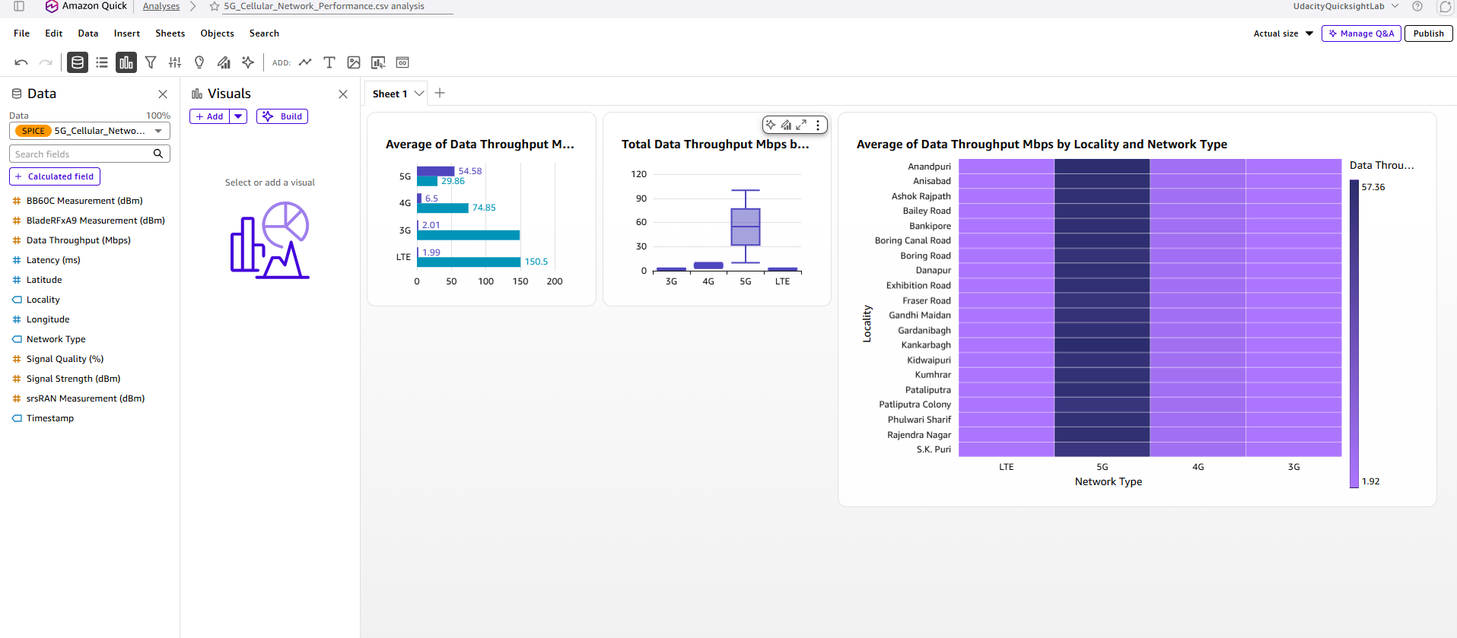
Figure 07 (V3): Average throughput by locality and network type (heatmap, scale 1.92 to 57.36 Mbps).
Chart type: heatmap (20 localities x 4 network types). What it shows: the 5G column is uniformly the darkest (highest) in every locality, and rows look alike. Supports: Insights 1 and 5: network type, not locality, drives the pattern.
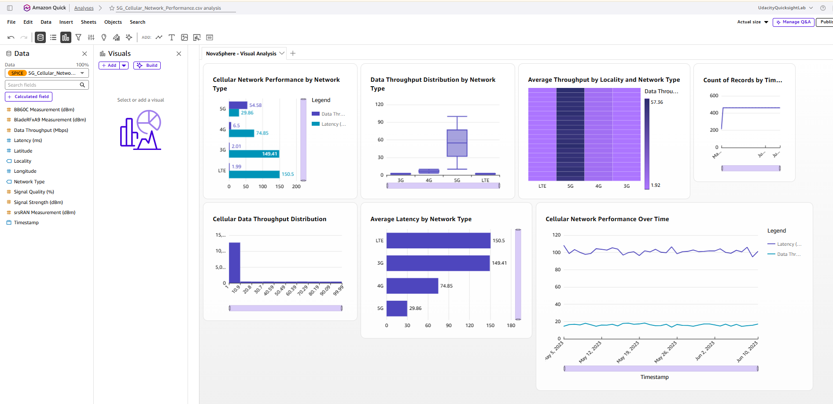
Figure 10 (V6): Daily average latency and throughput, May 5 to June 10, 2023 (line chart).
Chart type: line chart. What it shows: daily latency stays between about 95 and 108 ms and throughput between about 14 and 18 Mbps, with no trend (slopes -0.0165 Mbps/day, p = 0.365; -0.0272 ms/day, p = 0.543). Both measures share one axis, so throughput looks flatter than it is; the numeric statistics are authoritative. Supports: the stability finding in Section 6 and the limitation on trends (Section 7).
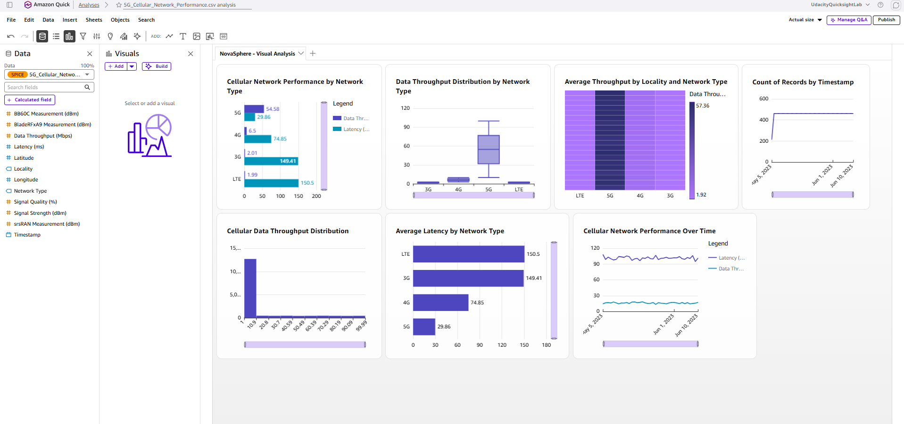
Figure 11: Full visual-analysis dashboard (all seven visuals).
The remaining visuals are Figure 08 (throughput histogram) and Figure 09 (average latency by network type).

6. Confidence Assessment
Each rating considers source quality, consistency across sources, and timeliness. "High" is used only where the statistic was recalculated on the full dataset and agrees across independent checks.
Insight | Source quality | Consistency across sources | Timeliness | Overall confidence
1. 5G throughput advantage | High: full dataset, 0 nulls, 34 of 34 recalculation checks matched | High: Quick Research and Quick Chat figures identical; holds in all 20 localities | Medium: data from May to June 2023 | High for the statistic; Medium for what it means for real networks
2. 5G latency advantage | High: same checks | High: non-overlapping latency bands in every locality | Medium: 2023 data; ITU context from 2017 | High for the statistic; Medium for real-world meaning
3. Gap to external benchmarks | Medium: ITU requirement confirmed; Ookla figures confirmed through news reports of Ookla data; some Quick Research citations unconfirmed | Medium: sources agree 5G is far above this dataset but disagree on the size (203 to 316 Mbps) | Medium to Low: 2023 for most; one 2025 report on SA | Medium to Low: context only, not a benchmark
4. Signal correlation is a mix effect | High: Pearson and Spearman computed on all records and within each type | High for the coefficients; the pooled direction and within-network interpretation were verified. | Medium: same 2023 window | High for the coefficients; Low for any predictive or causal use
5. Technology beats locality | High: averages and the 5G-share correlation both computed in Quick on all records (Figures 17A to 17C, 34) | Medium to High: Quick Research treated locality gaps as a location effect; the full-dataset check shows they track 5G share (r = 0.90) | Medium | High (technology larger than locality; locality gaps track 5G share); Medium that mix is the whole explanation (equal-weight check is supplementary)

Overall confidence: Medium-High for the descriptive figures and Medium to Low for real-world interpretation, because of the limitations below.

7. Limitations and Risks
Limitation or risk | What it is | How it could affect the decision
Patterns suggest controlled or generated data | Throughput and latency fall in exact per-type bands (for example 3G and LTE 1 to 3 Mbps and 100 to 200 ms; 4G 3 to 10 Mbps and 50 to 100 ms; 5G 10 to 100 Mbps and 10 to 50 ms); within each type mean is about equal to median; type counts are near-equal; every value is unique; daily counts alternate 462 and 461. | The size of the gaps (8.4x, 27x) may reflect how the data were produced, not real network behaviour. Treat them as patterns of this dataset only.
LTE behaves like 3G | LTE averages 1.99 Mbps and 150.50 ms, almost identical to 3G. | LTE results should not be used for decisions until the data owner explains the label.
Signal Quality is constant | 0 for all 16,829 records (zero variance). | It cannot be used as a predictor, filter or control variable.
SDR fields are zero for all 3G | 4,208 records (25.00%) have 0.0 in BB60C, srsRAN and BladeRFxA9; srsRAN reads about 7.5 dB below the other two on 4G, 5G and LTE. | Dataset-level SDR statistics are distorted; 3G can only be analysed on Signal Strength.
No spectrum, architecture, load or device metadata | No frequency band, NSA/SA, cell ID, subscribers or device model. | The cause of the 5G gap to benchmarks cannot be identified.
Single city and 37 days | 20 localities; first day partial (215 records). | No regional, seasonal or long-term conclusions.
Pooled averages are confounded by network mix | Network-type mix drives the signal correlation (Figures 22A to 22C) and the locality averages (Figure 34); the daily-average link is a supplementary check. | Pooled rankings can mislead; compare within network type.
External sources are partly secondary | Ookla figures reached through news reports; some Quick Research citations (for example a membership page and a Gulf-region forecast) do not clearly support the numbers attached. | Benchmark comparisons carry Medium to Low confidence.

8. Strategic Implications
These are investigation priorities, not recommendations to invest. Each is tied to the insight that supports it.
Decision this intelligence could inform | Supported by | Next step | Impact / effort
Treat network type as the first segmentation variable in any network review | Insights 1, 2, 5 | Report all performance by network type; compare localities within type | High impact / Low effort
Do not use signal strength alone to prioritize site upgrades | Insight 4 | Collect frequency band, cell load and device data before modelling | High / Medium
Resolve data definitions before relying on results | Limitations 1 to 4 | Ask the data owner about the LTE label, Signal Quality, the 3G SDR zeros and how values were generated | High / Low
Investigate why 5G is below external references before any enterprise or private-5G decision | Insight 3 | Obtain spectrum band, NSA/SA status, load and a like-for-like test method | High / High
Plan a longer, documented collection | Limitation 6 | Collect 12 or more months across multiple cities with metadata | Medium / High

What should not be concluded
- The 5G average of 54.58 Mbps is not a typical or universal 5G speed; it is the mean of this campaign.
- The observed correlations do not establish causation. The pooled relationship is influenced by differences across network types, while within-network associations are substantially weaker.
- The locality ranking does not show that Rajendra Nagar is better engineered than Danapur; it largely reflects each locality's 5G sample count.
- The gap to the ITU 100 Mbps target does not show the network fails the standard; the target is a 5th-percentile design requirement in a specific test environment.
- The dataset does not support a private-5G or investment decision; it contains no cost, demand, revenue or private-network data.
- Stable performance over 37 days does not mean performance is stable over a year or at peak seasons.
- LTE performing like 3G does not mean real LTE networks are that slow.
- Signal Quality of 0 does not mean poor signal quality; the field is unusable.

What would change our mind
Insight | Data point that would materially change it
1 and 2 | Documentation showing the data were measured on live networks, or an LTE subset with a 4G-like profile
3 | A like-for-like benchmark (same method, band and period) showing this 5G result is in line with comparable networks
4 | A within-type correlation above about 0.3 once load and frequency band are controlled
5 | Equal 5G sample counts per locality still producing locality gaps above 3 Mbps

9. Summary for Leadership
Summary (6 sentences)
Across 16,829 measurements in 20 localities between May 5 and June 10, 2023, network technology is the dominant source of performance difference: 5G averages 54.58 Mbps at 29.86 ms, against 6.50 Mbps at 74.85 ms for 4G and about 2 Mbps at about 150 ms for 3G and LTE. Locality gaps are small and strongly track each locality's share of 5G samples (r = 0.90), and performance shows no significant trend over the 37 days. The apparent link between stronger signal and lower throughput is influenced by mixing network types; within each type the correlation is negligible, so signal strength should not be used as a stand-alone predictor of performance. The 5G average is well below ITU and Ookla reference points, but those use different statistics and methods, so the comparison is context and not a benchmark. Overall confidence is Medium-High for the descriptive figures and Medium to Low for real-world interpretation, because the dataset lacks spectrum, load and cost data and shows range patterns that suggest controlled generation. The key takeaway is to use this brief to decide what to validate next (data definitions, causes of the 5G gap, a longer multi-city collection), not to make a network-investment decision.

Appendix A: Best Prompts Used
# | Prompt (shortened) | Evidence it produced
1 | Verify the record distribution by Network Type; confirm counts sum to 16,829. | Figure 15A
2 | Verify average Data Throughput and Latency for 5G, 4G, LTE, 3G; compare across types. | Figure 15B
3 | Create a cross-tabulation of Locality by Network Type with totals; verify the grand total. | Figure 16
4 | Independently recalculate the averages by network type and identify discrepancies. | Figures 19A to 19C (34 of 34 matched)
5 | Calculate Pearson correlation of Signal Strength with Throughput and Latency; no causal claims. | Figures 22A to 22C
6 | Verify the Timestamp field and calculate daily average throughput and latency; test for a trend. | Figures 26A to 27D
7 | For each locality, calculate the percentage of records that are 5G and the average throughput, then the Pearson correlation between the two across the 20 localities. | Figure 34: r = 0.9016, p = 5.72 x 10^-8 (supports Insight 5)

Appendix B: Agent and Space Evidence
The Cellular Network Performance Intelligence Agent was created with the dataset as its knowledge source and an instruction to ground every conclusion in observed data and to separate measurements, calculations and interpretations (Figures 29 to 31). It was then used for evidence-labelled answers (Figures 32A to 32C). The dataset, Quick Research report, Market Analysis, Verification Log, this brief and a dashboard are organized in one Space (Figure 33).
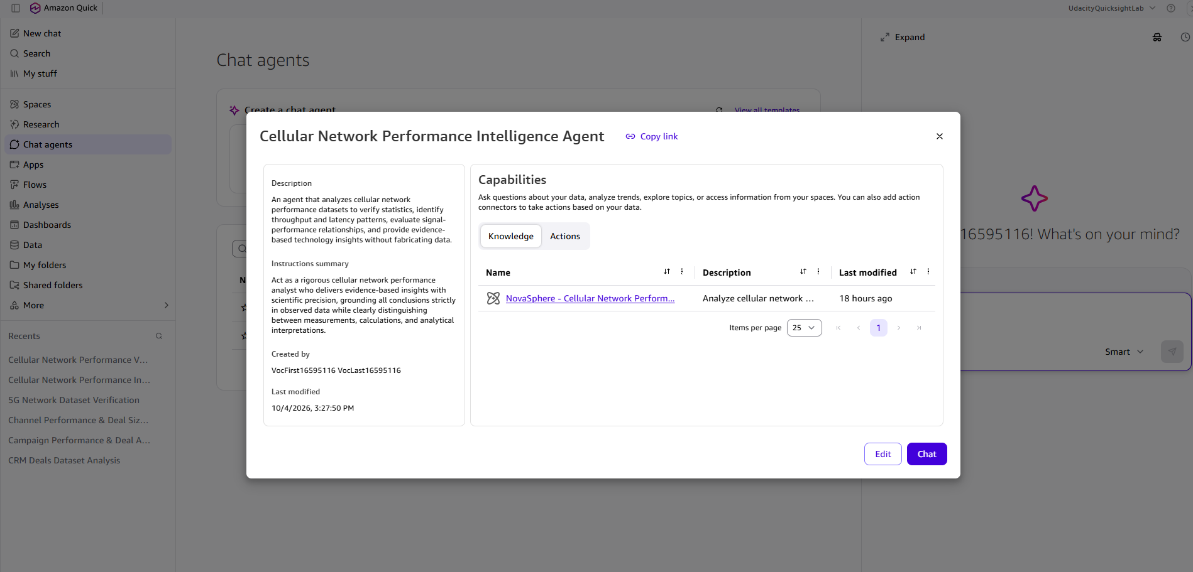
Figure 31: The created chat agent, with the dataset attached as knowledge.
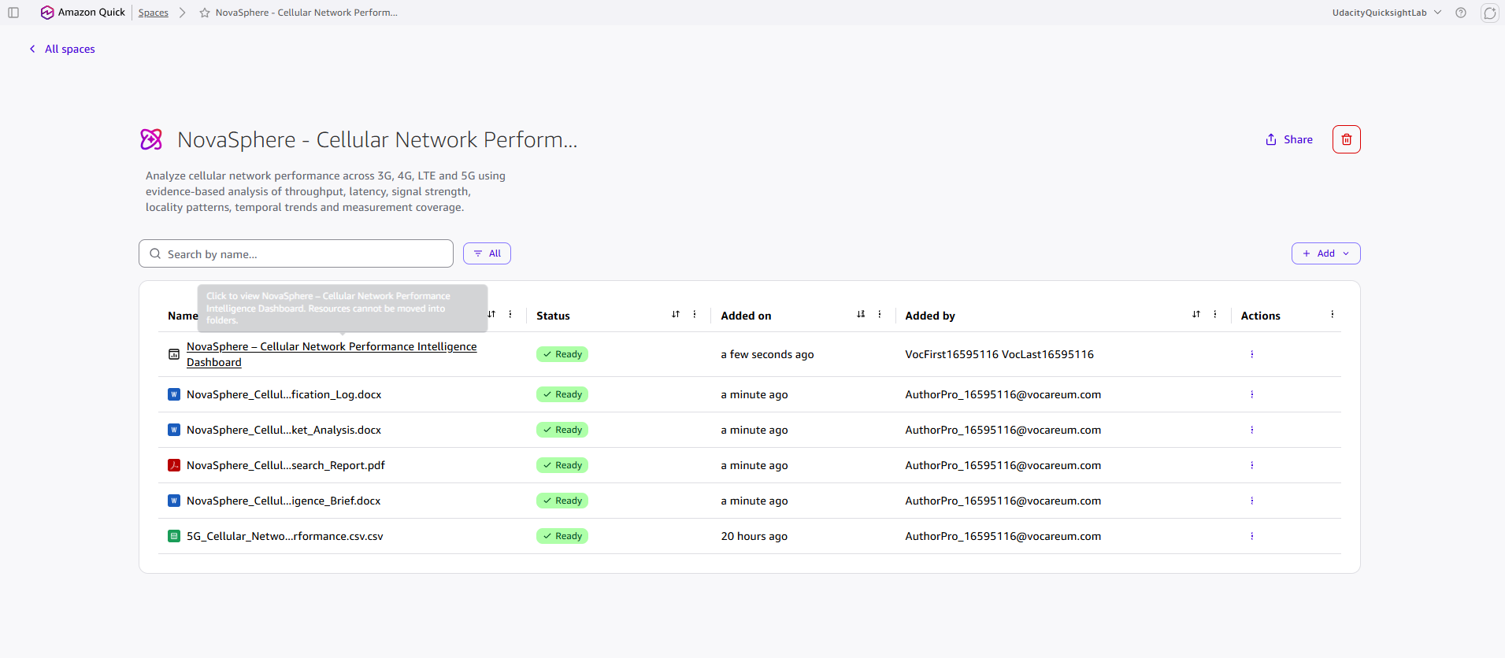
Figure 33: The Space holding the dataset, research report, analysis, verification log, brief and dashboard.

Appendix C: External Sources and Signal Freshness
Source | Used for | Date of data / checked | Status
ITU-R, Requirements for IMT-2020 (workshop slides) and Report ITU-R M.2410 (2017) | 100 Mbps user-experienced DL rate = 5th percentile, dense urban eMBB | Standard 2017; checked Oct 4, 2026 | Confirmed
TelecomTV, "ITU agrees on key 5G performance requirements for IMT-2020" | eMBB user-plane latency 4 ms | 2017; checked Oct 4, 2026 | Confirmed (secondary report of ITU)
tele.net.in, Ookla India study | 5G median 316.24 Mbps vs 4G 14.97 Mbps | Aug 2023 data; checked Oct 4, 2026 | Secondary report: open the Ookla original and capture it
Communications Today, Ookla India Q4 2023 | 5G median 301.86 Mbps vs 4G 16.05 Mbps | Q4 2023; checked Oct 4, 2026 | Secondary report: same
Ookla / Omdia, "A Global Reality Check on 5G SA and 5G Advanced" (via FoneArena, ISPreview) | SA median 269.51 Mbps; 52% premium over NSA | Q4 2025 data, published Feb 2026; checked Oct 4, 2026 | Confirmed (secondary reports)
Quick Research source panel (gsma.com, ericsson.com and others) | 203 Mbps global median, 243 Mbps India, 44 ms latency, private-network counts | As cited by Quick Research | Not independently confirmed; used as context only

Appendix D: Evidence Traceability
Insight / section | Primary screenshots
Objective, scope, approach | 01 to 04C, 12 to 14, 29 to 33
Insight 1 (throughput) | 15A, 15B, 17A to 17C, 19A to 20C; visuals 05, 06, 07
Insight 2 (latency) | 15B, 19A to 20C; visuals 05, 09
Insight 3 (external gap) | 13, 14, 20A to 20C; visuals 06, 08
Insight 4 (signal) | 21A to 22C, 23A to 24E, 25A to 25F
Insight 5 (technology vs locality) | 16, 17A to 17C, 34; visual 07
Time stability and limitations | 18A to 18D, 26A to 28G; visual 10

Final evidence note: Figure 34 is supported by the Quick Suite screenshot 34_Locality_5G_Share_Correlation.png included in Quick_Screenshots/.

