TASKORA
Team Management Application

SOFTWARE REQUIREMENTS DOCUMENT
Prepared by:
Raynald (Programmer) | Duard (System Analyst)
Yovela (Product Owner) | Nicholas (Tech Lead)

1. Introduction

1.1 Purpose of this Document
This Software Requirements Document (SRD) defines the complete functional and non-functional requirements for Taskora, a web-based team management application. It serves as the authoritative technical reference for all development, design, and deployment activities, and is intended for use by developers, system analysts, product owners, stakeholders, and academic evaluators.

1.2 Project Overview
Taskora is a collaborative task management platform designed to help teams organize their work, assign responsibilities, track individual contributions, and meet deadlines efficiently. The application targets student groups, startup teams, and small-to-medium professional teams that suffer from coordination overhead and lack of accountability in distributed workflows.

2. Background
Group projects often become inefficient not because members lack ability, but because coordination is poorly managed. Teams typically rely on multiple separate platforms such as, chat applications, shared documents, and personal reminders, which leads to unclear responsibilities, missed deadlines, and uneven workload distribution. As a result, some members contribute significantly more than others with no reliable record to objectively evaluate participation.

2.1 Problem Statement
Modern collaborative teams, especially in academic and early-stage startup environments, face systemic coordination failures. These failures are not attributable to individual incompetence but arise from structural gaps in tooling and process. The primary problems identified are:
- Unclear task distribution and responsibilities
- Missed deadlines due to lack of centralized tracking
- Uneven workload distribution among members
- No reliable system to objectively measure individual contributions
- Difficulty accessing shared project resources
- Limited visibility for leaders to monitor overall progress.

3. Proposed Solution
Taskora addresses these issues by providing a centralized workspace where tasks, deadlines, contributions, and shared resources are managed in one system. Features such as task assignment, contribution tracking, calendars, and resource shortcuts make responsibilities clear and visible to all members. By organizing collaboration and automatically recording activity, the application improves accountability, reduces miscommunication, and allows fair evaluation of each member’s contribution.

3.1 Core Features
- Centralized task management
- Task assignment with priority and status tracking
- Calendar with deadlines (end date)
- Contribution tracking system
- Task verification system (verified by leader)
- Shared resource shortcuts (Google Drive, Docs, Canva, etc.)
- Member management & role-based access
- Comment section on each task and optional team chat / forum
- Authentication & Authorization

4. Requirements Gathering

4.1 Methodology
Requirement gathering was conducted using online questionnaires (Google Forms) distributed to university students who frequently participate in group projects. This approach enables efficient collection from a large number of students (the target users of Taskora). Anonymous responses encourage honest feedback, and the method is time-efficient for a student project with limited resources.

4.2 Respondents Profile
A total of 22 responses were collected between March 2–10, 2026. Respondents came from a wide range of majors, indicating broad cross-disciplinary applicability. The overwhelming majority (20 out of 22) are 2nd-year students, the stage at which university group projects are most frequent and intensive.

4.3 Validated Problems Data
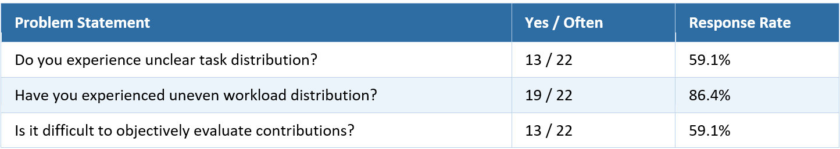

4.3 Challenges Identified
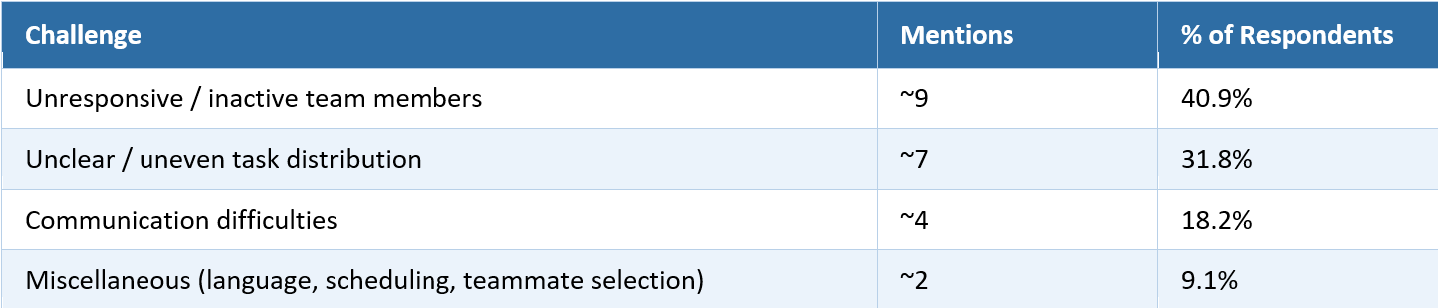
The most prominent pain point is unresponsive or non-contributing team members. This is closely followed by ambiguity in task ownership, many teams lack a clear system for distributing and monitoring work. Communication gaps complete the top three issues, reinforcing the need for a centralized, structured workspace.

5. User of the System
Taskora identifies two primary user roles. All four team members are expected to contribute to development. The Product Owner and System Analyst roles are organizational responsibilities and do not exempt members from coding duties given the team size. Both are filled by university students; the distinction is organizational rather than demographic.
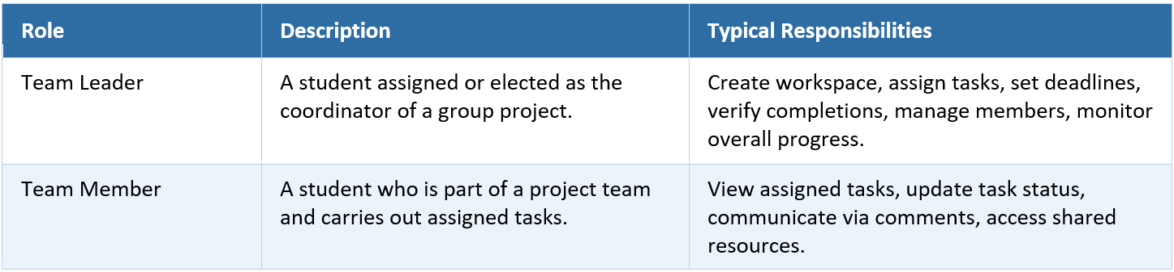

6. Key Features & Priority
Respondents rated the importance of each proposed feature on a scale of 1–5
(1 = Not important, 5 = Very important).
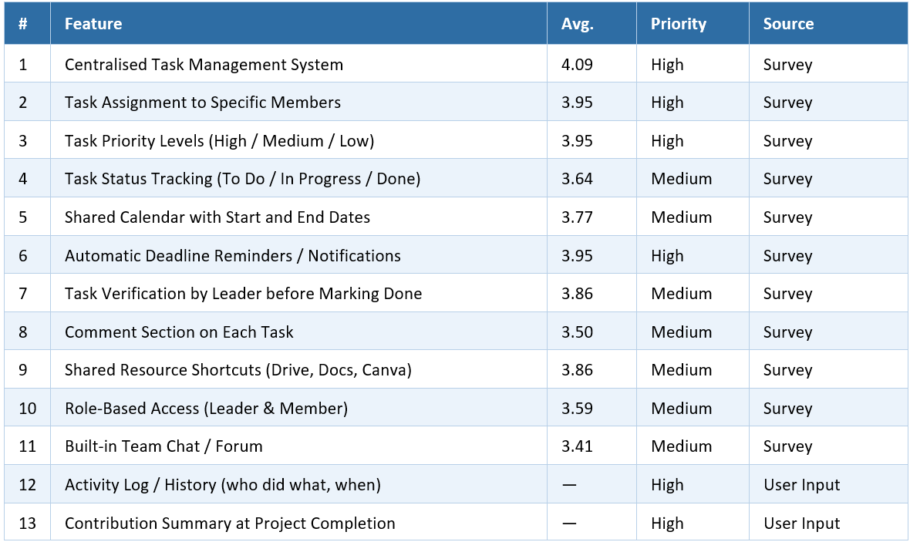

7. Functional Requirements
Functional requirements define what the system shall do. They are derived from the validated features and survey findings, organized by module.

7.1 Workspace & Project Management
The system shall allow a Team Leader to create a project workspace and invite members via link or email. A dashboard shall give all members a clear overview of project status, task progress, and team activity.

7.2 Task Management
The system shall allow the Team Leader to create tasks with a title, assignee, priority level (High / Medium / Low), start date, and deadline. Members shall update task status across three stages: To Do, In Progress, and Done. Tasks shall require Team Leader verification before being marked complete. The Team Leader shall be able to edit or delete tasks as needed.

7.3 Deadline & Calendar
The system shall provide a shared calendar displaying all task deadlines for the workspace. In-app reminder notifications shall be delivered in real time via Socket.io to the assigned member and Team Leader as deadlines approach, and overdue tasks shall be visually flagged.

7.4 Contribution Tracking
The system shall automatically record each member’s completed and verified tasks. Contribution is measured by the total number of verified tasks completed by each member. This metric reflects task quantity only. Task complexity and time spent are not currently weighted. This is a known limitation and may be addressed in a post-MVP iteration. A contribution summary showing each member’s task count and percentage share shall be visible to all members at any time, with a final breakdown generated at project completion.

7.5 Activity Log
The system shall maintain a timestamped log of key workspace events, including task creation, status changes, and member activity. Each entry shall show the acting user, action type, and timestamp. The log shall be read-only and visible to all members.

7.6 Communication
The system shall provide a comment thread on each task for context-specific discussion. An optional team-level chat or forum shall be available for general project communication.

7.7 Shared Resource Shortcuts
The system shall allow members to save named links to external resources such as Google Drive, Google Docs, and Canva. All shortcuts shall be displayed in a dedicated panel within the workspace.

8. Non-Functional Requirements
Non-functional requirements define how the system shall perform and constrain overall system quality. They are derived from the target user profile and the operational context of a university student environment.
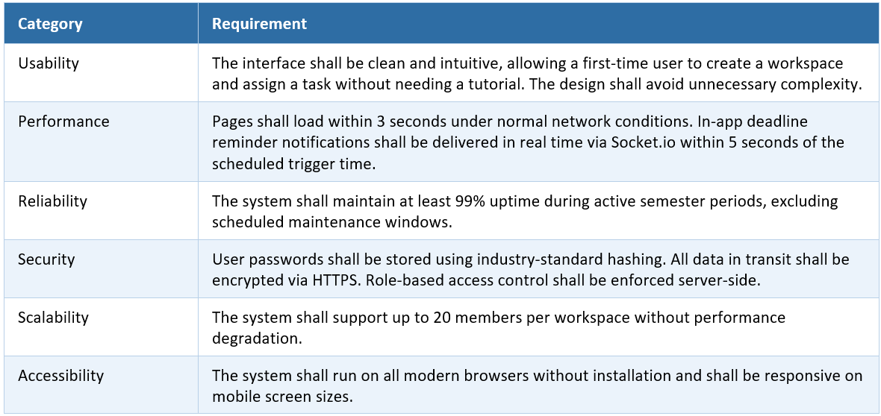

9. Feature List Summary
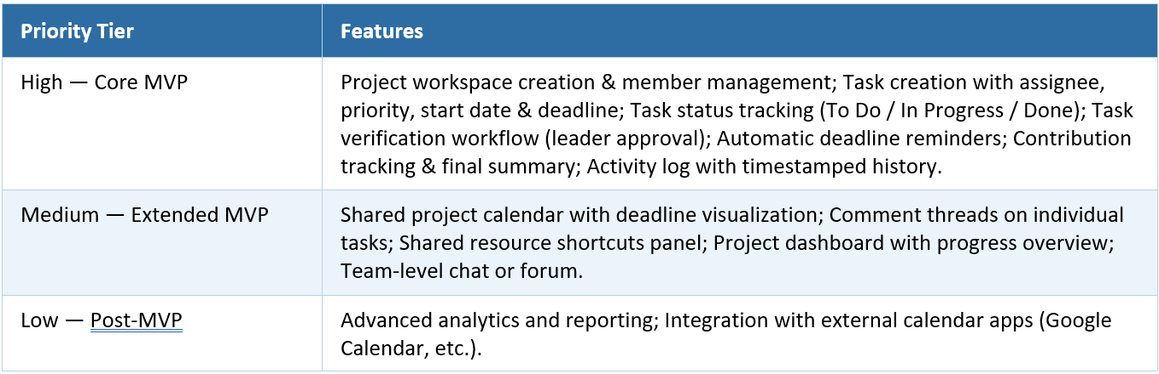

10. System Constraints
Constraints are conditions the system must operate within, regardless of design decisions. They are non-negotiable limits imposed by the environment, team, budget, or technology.
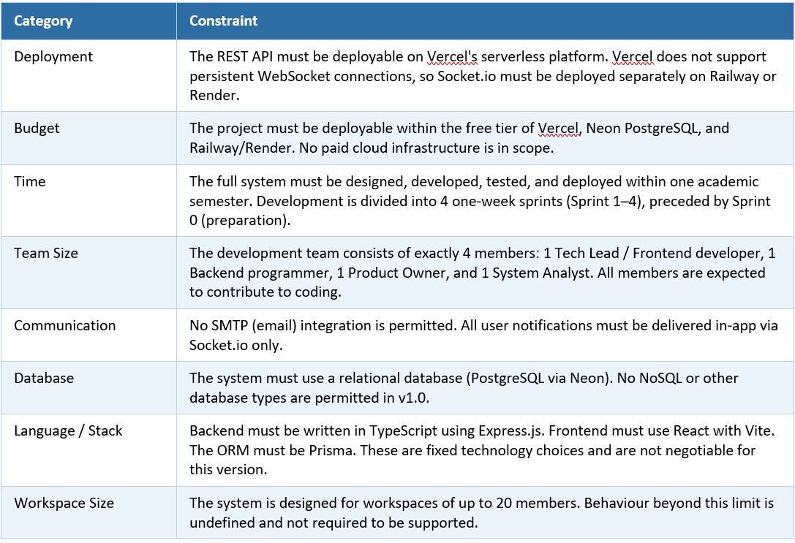

11. Assumptions & Dependencies

11.1 Assumptions
The following are assumed to be true for the duration of this project. If any assumption proves false, the affected requirements may need to be revisited.
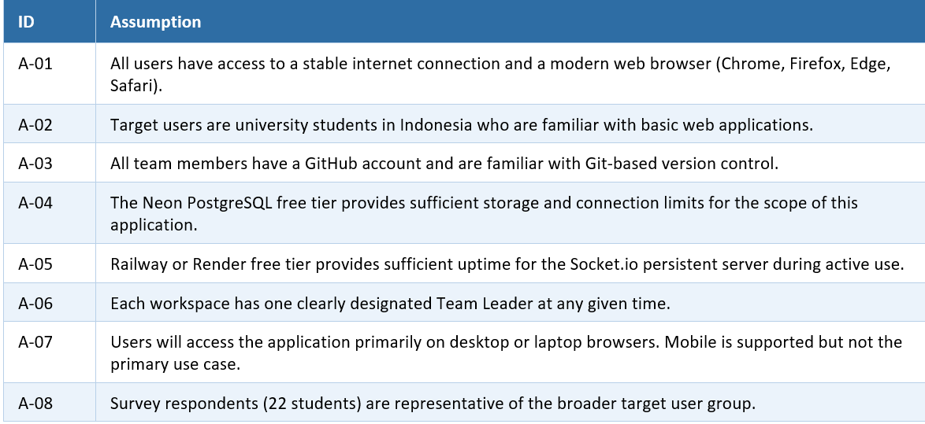

11.2 Dependencies
The following are external systems and services that Taskora depends on. Unavailability of any dependency may impact system functionality.
