RESEARCH PAPER
Customer Engagement & Product Utilization Analytics
for Retention Strategy
A Behavioral and Relationship-Strength Approach to Understanding Bank Customer Churn
Prepared for: Unified Mentor — European Central Bank Retention Analytics Engagement
Dataset: European_Bank.csv | 10,000 customer records | Reference Year 2025
Prepared by: Customer Analytics & Retention Strategy Team
August 2026

Abstract
Customer churn in retail banking is commonly analyzed through demographic and financial lenses — age, income, balance — yet these variables alone provide limited explanatory power for why customers leave. This study analyzes 10,000 customer records from a European retail bank operating across France, Germany, and Spain, shifting the analytical focus from “who the customer is” to “how the customer behaves.” Using engagement classification, product utilization analysis, and a composite Relationship Strength Index (RSI), the study finds that behavioral engagement is a far stronger predictor of retention than income or balance. Customers holding two products and remaining active churn at roughly one-third the rate of single-product, inactive customers. A concentrated segment of disengaged, high-balance customers — close to a quarter of the customer base — represents the bank's highest-value churn exposure. The findings support a shift from generic, demographic-led retention programs toward engagement-triggered, product-depth-driven retention strategy.

Table of Contents
1. Introduction and Background
2. Problem Statement and Objectives
3. Dataset Description and Methodology
4. Exploratory Data Analysis
4.1 Overall Churn Landscape
4.2 Engagement Segmentation
4.3 Product Utilization Analysis
4.4 Financial Commitment vs. Engagement
4.5 Demographic and Geographic Patterns
4.6 Correlation Analysis
5. Key Performance Indicators
6. Retention Strength Assessment (Relationship Strength Index)
7. Key Insights
8. Recommendations
9. Limitations and Future Work
10. Conclusion
Appendix A: Data Dictionary

1. Introduction and Background
Retail banks increasingly recognize that customer behavior and engagement — not just demographics — determine long-term retention. A customer may appear financially strong, carrying a high account balance or a large estimated salary, and still leave the bank. Conversely, a customer with modest financial resources but deep product engagement may remain loyal for years. This disconnect between financial profile and loyalty is the starting point for this analysis.
Understanding how customers use banking products and services is essential to designing effective cross-sell strategies, loyalty programs, and engagement-driven retention initiatives. This project, conducted for Unified Mentor in a European Central Bank retention-analytics context, evaluates retention through the lens of customer behavior and relationship strength rather than static demographic segmentation.

2. Problem Statement and Objectives

2.1 Problem Statement
Despite having granular data on customer engagement and product usage, banks often lack quantitative insight into which behaviors actually drive retention, clarity on whether product depth meaningfully reduces churn, and evidence on whether high account balances alone are sufficient to ensure loyalty. As a result, retention strategies are frequently generic — built around broad demographic segments — and misaligned with actual customer behavior. This leads to wasted retention spend on customers who were never at risk, and missed intervention on customers who were.

2.2 Primary Objectives
- Evaluate the relationship between engagement and churn.
- Measure the retention impact of product count and product mix.
- Identify disengaged yet high-value customers who represent silent churn risk.

2.3 Secondary Objectives
- Support the design of engagement-driven retention strategies.
- Improve product bundling and cross-sell decisions.
- Reduce silent churn among premium (high-balance, high-salary) customers.

3. Dataset Description and Methodology

3.1 Dataset Overview
The analysis is based on European_Bank.csv, containing 10,000 customer-level records for a single reference year (2025) across three markets: France, Germany, and Spain. Each row represents one customer and combines demographic attributes, financial standing, product holdings, and behavioral flags, together with a binary churn indicator (Exited). No missing values were found in any field, and all binary and categorical fields (Geography, Gender, HasCrCard, IsActiveMember, Exited) were validated for consistent coding prior to analysis.
Field | Description | Type
CustomerId | Unique customer identifier | Numeric (ID)
Surname | Customer surname | Text
CreditScore | Customer creditworthiness (350–850) | Numeric
Geography | France / Germany / Spain | Categorical
Gender | Male / Female | Categorical
Age | Customer age in years | Numeric
Tenure | Years with the bank (0–10) | Numeric
Balance | Account balance | Numeric (currency)
NumOfProducts | Number of bank products held (1–4) | Numeric
HasCrCard | Credit card ownership (0/1) | Binary
IsActiveMember | Activity indicator (0/1) | Binary
EstimatedSalary | Estimated annual salary | Numeric (currency)
Exited | Churn indicator — target variable (0/1) | Binary

3.2 Analytical Methodology
The analysis followed a five-stage methodology aligned with the project's analytical framework:
- Data Ingestion & Validation — loading the dataset, validating engagement and product fields, confirming binary variable consistency, and verifying churn labeling accuracy.
- Engagement Classification — assigning each customer to one of four behavioral profiles based on activity status and product depth (Section 4.2).
- Product Utilization Analysis — measuring churn rate by product count and comparing single- vs. multi-product retention (Section 4.3).
- Financial Commitment vs. Engagement Analysis — cross-analyzing balance and activity status to detect at-risk premium customers (Section 4.4).
- Retention Strength Assessment — constructing a composite Relationship Strength Index (RSI) and measuring churn stability across index tiers (Section 6).
All statistics reported in this paper are computed directly from the 10,000-record dataset using Python (pandas) for aggregation and matplotlib/seaborn for visualization. Churn rate is defined throughout as the percentage of customers within a given group for whom Exited = 1.

4. Exploratory Data Analysis

4.1 Overall Churn Landscape
Across the full customer base of 10,000, the overall churn rate is 20.37% — roughly one in five customers exited the bank during the observed period. This baseline provides the reference point against which every behavioral and financial segment in this paper is compared.
Baseline Churn Rate
20.37% of customers (2,037 of 10,000) exited the bank — the benchmark against which all segment-level churn rates below should be read.

4.2 Engagement Segmentation
Each customer was classified into one of four engagement profiles based on activity status, product depth, and balance:
- Active Engaged — currently active and holding 2 or more products.
- Active Low-Product — currently active but holding only 1 product.
- Inactive Disengaged — currently inactive with balance below €100,000.
- Inactive High-Balance — currently inactive with balance at or above €100,000.
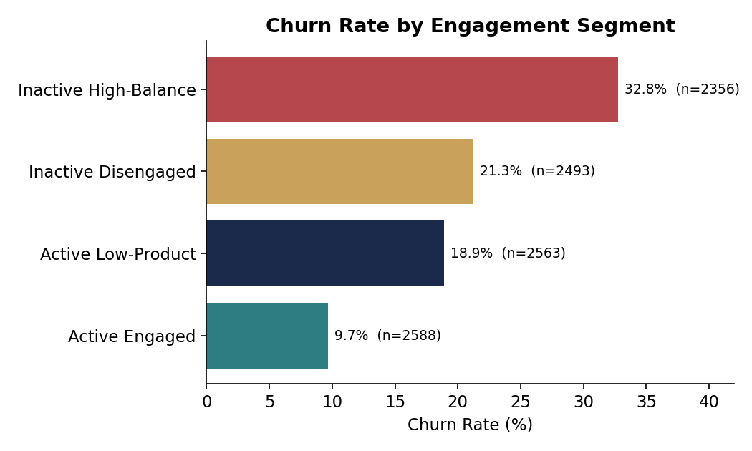
Figure 1. Churn rate by engagement segment (n = customer count per segment).
Segment | Customers | Share | Churn Rate | Avg. Balance
Active Engaged | 2,588 | 25.9% | 9.7% | €53,071
Active Low-Product | 2,563 | 25.6% | 18.9% | €98,902
Inactive Disengaged | 2,493 | 24.9% | 21.3% | €24,773
Inactive High-Balance | 2,356 | 23.6% | 32.8% | €132,541

The segmentation reveals a clear and consistent gradient: churn risk rises as engagement falls, and the single worst-performing segment — Inactive High-Balance customers — also holds the largest average balance of any group. These are customers the bank can least afford to lose, and they are churning at more than three times the rate of Active Engaged customers.

4.3 Product Utilization Analysis
Product count shows the strongest and most actionable pattern in the entire dataset. Churn does not decline steadily with more products — it drops sharply from one product to two, then reverses catastrophically at three and four products:
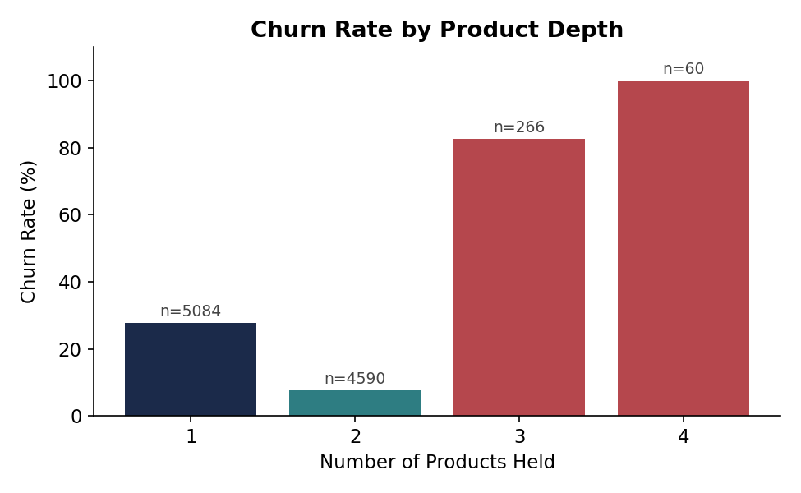
Figure 2. Churn rate by number of products held.
Products Held | Customers | Share | Churn Rate
1 | 5,084 | 50.8% | 27.7%
2 | 4,590 | 45.9% | 7.6%
3 | 266 | 2.7% | 82.7%
4 | 60 | 0.6% | 100.0%

Key Finding — The Product Depth Cliff
Moving a customer from 1 to 2 products is associated with a 72.6% relative reduction in churn (27.7% → 7.6%). But customers pushed to 3 or 4 products churn at 82.7% and 100% respectively — almost certainly reflecting forced or mis-sold bundling, service friction, or dissatisfaction that leads to full account closure rather than genuine multi-product loyalty.

This non-linear relationship is the single most important finding for product strategy: the goal should be reaching exactly two well-matched products per customer, not maximizing product count indiscriminately. Because this relationship is non-monotonic, standard linear correlation understates its importance (see Section 4.6).

4.4 Financial Commitment vs. Engagement Analysis
Balance alone is a weak and misleading predictor of loyalty. Restricting the dataset to the top quartile of account balances (≥ €127,644) and splitting by activity status shows that even among the bank's wealthiest customers, disengagement drives churn:
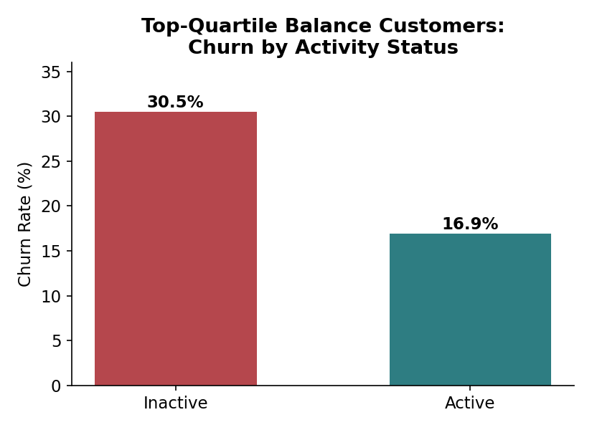
Figure 3. Churn rate among top-quartile-balance customers, by activity status.
Inactive customers in the top balance quartile churn at 30.5%, nearly double the 16.9% rate of active customers in the same balance bracket — confirming that a high balance does not protect against churn once engagement drops.

A further, tightly defined “at-risk premium” segment — customers simultaneously in the top quartile for both balance and estimated salary, and currently inactive — comprises 324 customers (3.2% of the base) and churns at 32.1%, more than 1.5 times the overall baseline. These are the customers Section 8 (Recommendations) targets first: financially valuable, behaviorally invisible, and actively leaving.

4.5 Demographic and Geographic Patterns
While this study centers on behavior rather than demographics, demographic cuts provide useful context for targeting and resourcing retention efforts.
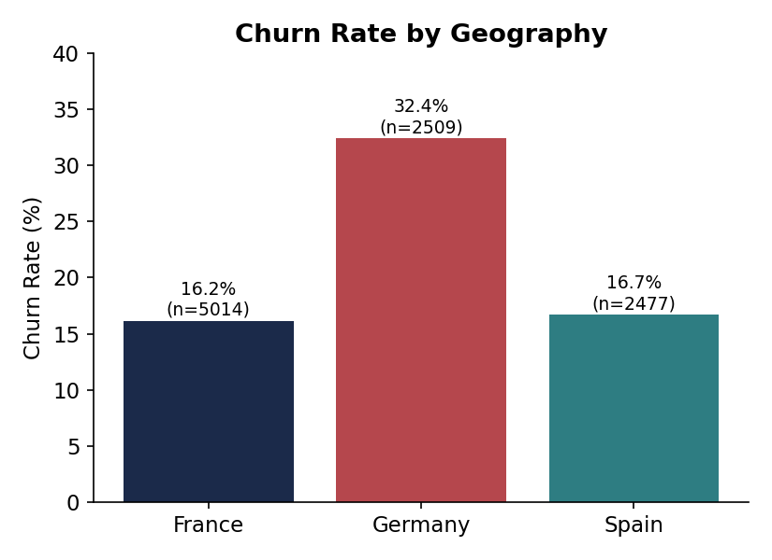
Figure 4. Churn rate by geography.
Germany stands out sharply: despite holding only 25.1% of the customer base, German customers churn at 32.0% — roughly double the rate in France (16.0%) and Spain (17.0%) — and carry the highest average balance (€119,730) of the three markets. This combination of elevated churn and elevated balance makes Germany a geography-level priority, not just a segment-level one.

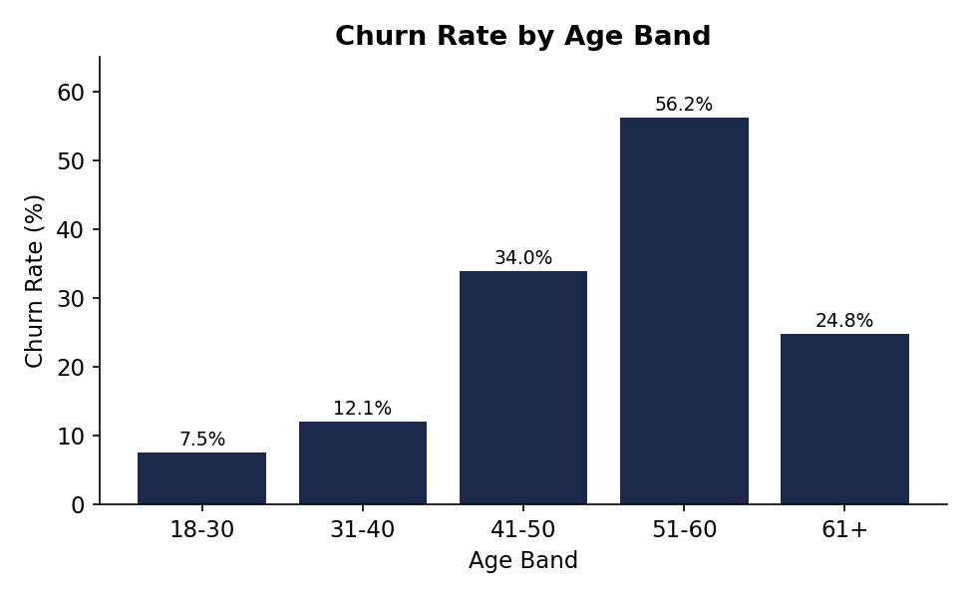
Figure 5. Churn rate by age band.
Churn rises sharply through mid-life: customers aged 41–50 churn at 34.0% and those aged 51–60 at 56.2%, before falling back to 24.8% for customers over 60. This pattern suggests that mid-career and pre-retirement customers — often at points of financial re-evaluation (career change, mortgage payoff, retirement planning) — are the most likely to re-shop their banking relationship.

Cut | Group | Customers | Churn Rate
Gender | Female | 4,543 | 25.1%
Gender | Male | 5,457 | 16.5%
Credit Card | Has Card | 7,055 | 20.2%
Credit Card | No Card | 2,945 | 20.8%

Female customers churn at a meaningfully higher rate than male customers (25.1% vs. 16.5%), a gap worth further qualitative investigation. Credit card ownership, by contrast, shows almost no relationship to churn (20.2% vs. 20.8%) — simply issuing a card does not appear to build loyalty on its own (see Section 5, Credit Card Stickiness Score).

4.6 Correlation Analysis
A correlation matrix across the numeric and behavioral fields confirms the segmentation findings and highlights an important methodological caveat: linear correlation understates the importance of non-monotonic relationships such as product count.
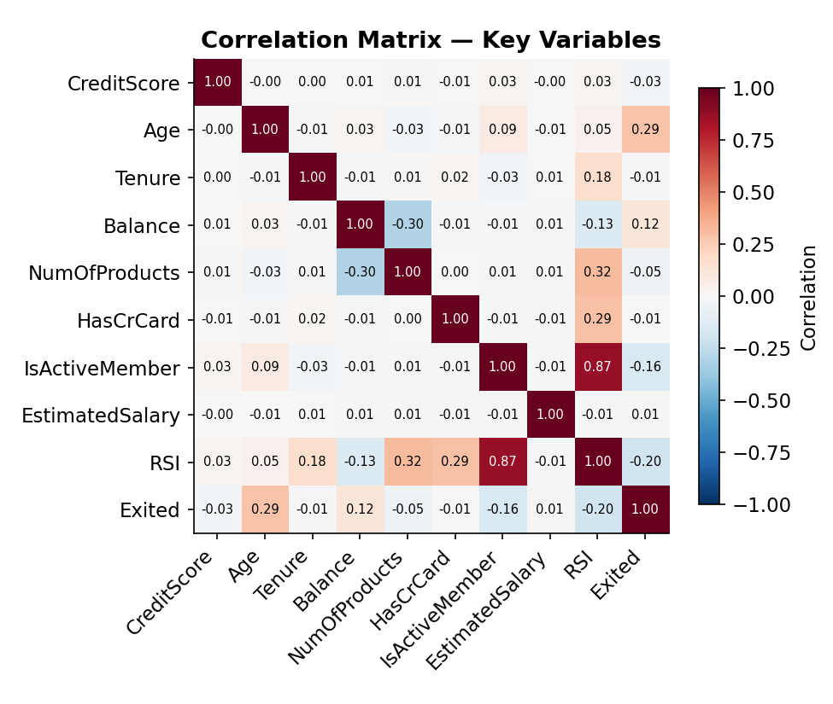
Figure 6. Correlation matrix of key variables against churn (Exited).
Age (+0.285) and IsActiveMember (–0.156) are the strongest linear correlates of churn, followed by Balance (+0.119). NumOfProducts shows only a weak linear correlation (–0.048) despite being the most operationally powerful lever identified in this study — because its relationship with churn is U-shaped (protective at 2 products, sharply damaging at 3–4), not linear. This is precisely why the segment-level and tier-level analysis in Sections 4.2–4.3 and Section 6 is more decision-useful than correlation alone.

5. Key Performance Indicators
Five KPIs were defined to translate the analysis into ongoing, trackable metrics for retention strategy governance.
KPI | Definition | Result
Engagement Retention Ratio | Inactive churn rate ÷ active churn rate | 1.88× (26.9% vs. 14.3%)
Product Depth Index | Relative churn reduction from 1 to 2 products | 72.6% reduction
High-Balance Disengagement Rate | Churn rate of inactive, top-quartile-balance customers | 30.5%
Credit Card Stickiness Score | Churn-rate gap between card and non-card holders | 0.6 pts (negligible)
Relationship Strength Index (RSI) | Composite 0–100 score of activity, product depth, tenure, card | Mean 61.1 / 100

The Engagement Retention Ratio confirms that inactive customers are nearly twice as likely to churn as active ones. The Product Depth Index quantifies the single largest controllable lever available to the bank. The High-Balance Disengagement Rate flags the segment carrying the greatest financial exposure. The near-zero Credit Card Stickiness Score indicates that card issuance, on its own, is not an effective retention tool and should not be treated as a loyalty proxy. The Relationship Strength Index is explored in full in Section 6.

6. Retention Strength Assessment (Relationship Strength Index)
To combine engagement and product depth into a single, trackable “sticky customer” score, this study constructs a Relationship Strength Index (RSI) on a 0–100 scale, weighted as follows: activity status (40%), product depth capped at two products (30%), tenure (15%), and credit card ownership (15%). The cap on product depth deliberately prevents the index from rewarding the over-bundling pattern identified in Section 4.3.
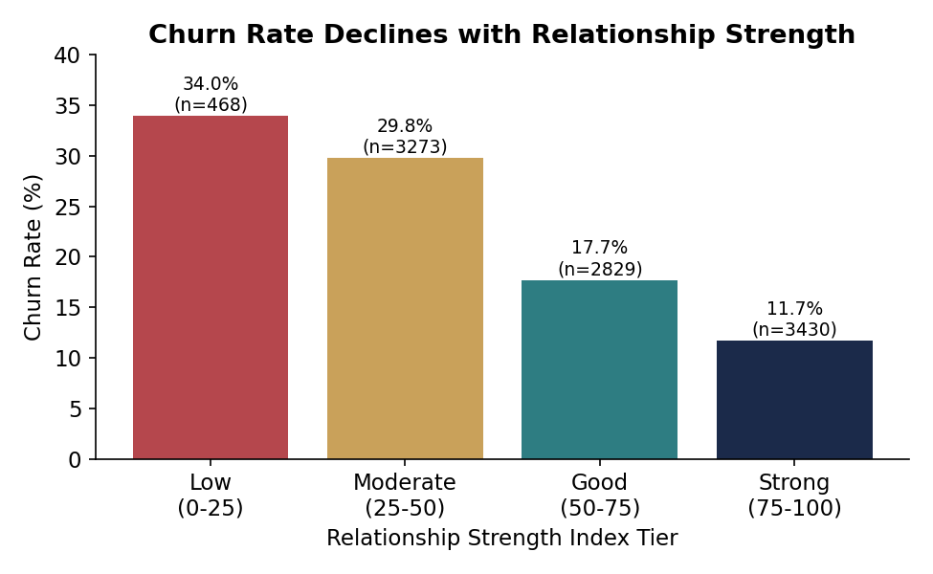
Figure 7. Churn rate by Relationship Strength Index tier.
RSI Tier | Score Range | Customers | Share | Churn Rate
Low | 0–25 | 468 | 4.7% | 34.0%
Moderate | 25–50 | 3,273 | 32.7% | 29.8%
Good | 50–75 | 2,829 | 28.3% | 17.7%
Strong | 75–100 | 3,430 | 34.3% | 11.7%

Key Finding — Relationship Strength Predicts Retention Stability
Churn falls monotonically and substantially across every RSI tier, from 34.0% at the lowest tier to 11.7% at the highest — a nearly 3× spread. Unlike raw balance or salary, RSI is directly actionable: every one of its inputs (activity, product fit, tenure, card) can be influenced by a retention program.

Roughly 37% of the customer base (Low + Moderate tiers) sits below the “Good” relationship threshold and churns at more than double the rate of the Strong tier. This population — not the bank's demographic profile of “typical” churners — is the addressable core of any engagement-driven retention strategy.

7. Key Insights

Insight 1 — Engagement beats income as a retention predictor
Active customers churn at 14.3% versus 26.9% for inactive customers — a gap that dwarfs any split available from balance or salary alone. Activity status, not financial capacity, is the leading behavioral signal of churn risk.

Insight 2 — Product depth has a sweet spot, not a straight line
Two products is the retention-optimal product count (7.6% churn). One product under-serves the relationship (27.7% churn); three or four products are associated with churn rates of 82.7% and 100%, respectively — a pattern consistent with over-selling, mis-selling, or bundled products the customer did not want and ultimately closed the whole relationship over.

Insight 3 — High balance does not equal loyalty
Inactive High-Balance customers are the single worst-performing engagement segment (32.8% churn) despite holding the highest average balance of any segment (€132,541). Balance-based VIP treatment, without an engagement check, is targeting the wrong signal.

Insight 4 — A small, identifiable group carries outsized financial risk
The at-risk premium segment — high balance, high salary, inactive — is only 3.2% of customers but churns at 32.1%, and by definition holds disproportionate deposit and revenue value relative to its size.

Insight 5 — Germany is a geography-specific retention priority
German customers churn at 32.0%, roughly double the rate in France and Spain, while also holding the highest average balance of the three markets — combining elevated risk with elevated stakes.

Insight 6 — Credit card ownership is not a retention lever
The churn-rate gap between card holders and non-holders is under one percentage point. Card issuance should not be relied upon as a stickiness mechanism in isolation.

Insight 7 — Mid-life customers are the highest-risk age group
Churn rises to 34.0% for ages 41–50 and peaks at 56.2% for ages 51–60, well above the 7.5%–12.1% seen in customers under 40 — pointing to a specific life-stage window for proactive retention outreach.

8. Recommendations

8.1 Immediate (0–3 months)
- Launch a targeted outreach program for the 324 at-risk premium customers (high balance, high salary, inactive) identified in Section 4.4 — this is the highest financial-exposure, most tractable segment to act on immediately.
- Freeze or tightly review any incentive structure that rewards staff for pushing customers to 3+ products until the over-bundling pattern in Section 4.3 is root-caused.
- Stand up a Germany-specific retention task force given its 32.0% churn rate and above-average balances.

8.2 Near-Term (3–12 months)
- Redesign cross-sell programs around a target of exactly two well-matched products per customer, rather than maximizing product count.
- Build an engagement-triggered alert: any customer moving from active to inactive status, especially combined with balance in the top quartile, should generate an automatic relationship-manager follow-up.
- Investigate the gender churn gap (25.1% female vs. 16.5% male) through qualitative research (surveys, exit interviews) to determine root cause before designing an intervention.
- Design a mid-life (ages 41–60) retention journey — proactive financial check-ins, refreshed product review, and loyalty recognition — targeting the age band responsible for the highest observed churn.

8.3 Structural (12+ months)
- Adopt the Relationship Strength Index (RSI) as a standing operational KPI, tracked monthly per customer and used to prioritize retention spend toward the Low and Moderate tiers, which together hold 37% of customers and churn at more than double the Strong tier's rate.
- Replace demographic-only churn models with engagement-weighted models that incorporate activity status, product depth, and tenure alongside financial variables.
- Re-evaluate the role of credit card issuance in the loyalty program; pair card ownership with usage-based engagement triggers rather than treating issuance itself as a retention outcome.

9. Limitations and Future Work
- Cross-sectional data: the dataset represents a single reference year (2025) snapshot. Churn and engagement are observed, not tracked over time, so the analysis identifies association, not proven causal direction — for example, it cannot distinguish whether inactivity causes churn or whether customers already planning to leave become inactive first.
- The Relationship Strength Index weighting (40/30/15/15) is a reasoned, business-driven construction rather than a statistically fitted model; it should be validated and re-weighted against a predictive model (e.g., logistic regression or gradient boosting) once outcome-tracked, multi-period data is available.
- The dataset does not include product-level detail (which specific products drive the 3–4-product churn spike), channel/service-interaction data, or complaint records, all of which would sharpen the root-cause diagnosis behind Insight 2.
- Geographic and gender findings are descriptive; they should inform hypotheses for further qualitative research rather than be read as final root causes.

10. Conclusion
This study reframes customer churn from a behavioral and relationship-strength perspective rather than a purely demographic one. The evidence is consistent across every method applied — segmentation, product analysis, financial cross-analysis, and the composite Relationship Strength Index: engagement and product fit predict retention far more reliably than income, balance, or card ownership alone. The bank's highest-value churn risk is not the customer who looks financially weak; it is the financially strong customer who has quietly disengaged. By focusing retention strategy on engagement triggers, right-sized product depth, and a small number of high-value at-risk segments, the bank can move from generic, broad-based retention spend to precise, behavior-driven interventions — improving loyalty program design, cross-sell decisions, and overall retention ROI.

Appendix A: Data Dictionary
Field | Description
CustomerId | Unique customer identifier
Surname | Customer surname
CreditScore | Customer creditworthiness score
Geography | Customer's market: France, Germany, or Spain
Gender | Male or Female
Age | Customer age in years
Tenure | Number of years as a bank customer
Balance | Current account balance
NumOfProducts | Number of bank products held (1–4)
HasCrCard | Whether the customer holds a credit card (0/1)
IsActiveMember | Whether the customer is currently an active member (0/1)
EstimatedSalary | Estimated annual salary
Exited | Churn indicator: 1 = churned, 0 = retained (target variable)

All figures and tables in this paper were computed from European_Bank.csv (10,000 records, reference year 2025) using Python (pandas, matplotlib, seaborn). Companion deliverables: the interactive Streamlit dashboard (live_analytics_dashboard.py) and the Executive Summary (executive_summary.docx).

