Aruzhan Amirova

IS-1601

Book Swapping System

The book swapping system has 5 microservices: Book Catalog, Book Info, Book Rating, Readed Book, User Details.

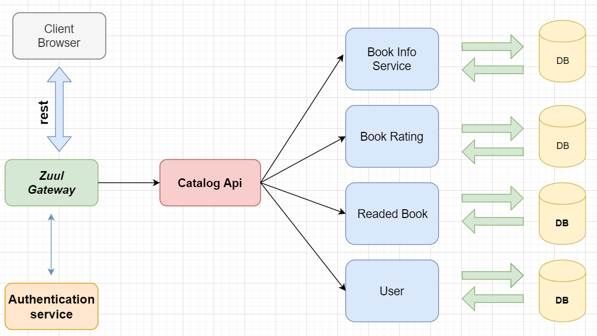

Book Catalog connects web part with back end, and between microservices.

Book Info storage all information about book as title, description, genre, author, publisher, image of the book, is this book for swapping or not, and price.

Book Rating keeps rating of each book.

Read Book keep data about which book read by determined client.

Microservice User keeps information about user as email, username, password.

Web part wrote in Angular Cli.