1. By using SQL%ROWCOUNT we update the most cheap books price to some valuable price.

BEGIN UPDATE BOOKS

SET PRICE = '1000' WHERE PRICE <= 500;

DBMS_OUTPUT.put_line ('THE_MOST_CHEAP_BOOKS = ' || SQL%ROWCOUNT);

END;

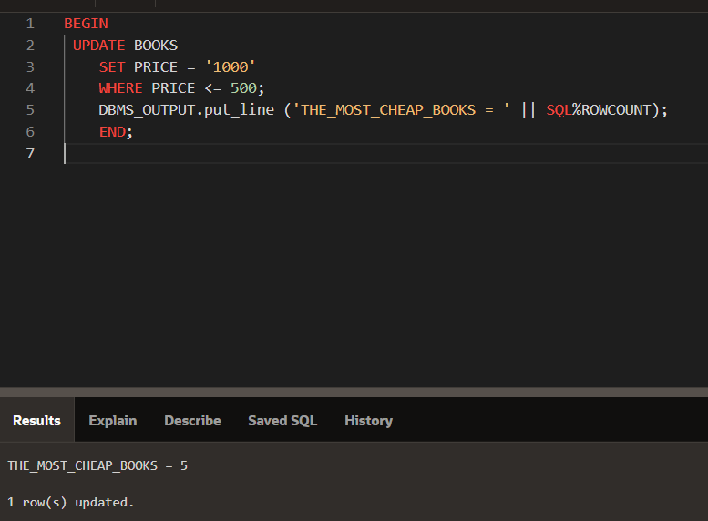

1. Procedure which does group by READERSHIP AND GENRE as book_count, so it shows every readerships book_count by it’s genre.

CREATE OR REPLACE PROCEDURE count_by_readership_and_genre IS

BEGIN

FOR BC IN (SELECT READERSHIP, GENRE, COUNT(*) AS BOOK_COUNT

FROM CATEGORIES

GROUP BY READERSHIP, GENRE)

LOOP

DBMS_OUTPUT.PUT_LINE('Readership: ' BC.READERSHIP ', || Genre: ' BC.GENRE ', Book Count: ' || BC.BOOK_COUNT);

END LOOP;

END;

BEGIN count_by_readership_and_genre;

END;

