**Jenkins 2 – Beyond the Basics**

**Spring, 2018**

**Brent Laster**

**Version 1.1**

**IMPORTANT SETUP INSTRUCTIONS - TO BE COMPLETED BEFORE THE ONLINE SESSIONS!**

**Hello and thank you for signing up for this online class. In order to be able to work through the labs and effectively understand the material, it is essential that you prepare in advance following the instructions below. Please be aware that it is the user’s responsibility to have their systems setup in advance and there will not be time during the online training for the instructor to help debug problems with getting the image or running Virtualbox. We will begin the sessions expecting that everyone already has their systems setup and ready to go as outlined below.**

1. You must have a system that can support virtualization and run Virtualbox without problems. Download and install Virtualbox on your system and verify that it runs correctly. Note that some systems may require special access or BIOS settings to support virtualization. Please ensure that you have sorted out any issues with this prior to the start of the first online session. Virtualbox can be obtained and installed from <http://www.virtualbox.org>

2a. The class uses a VirtualBox VM with all of the applications installed and configured that we will need. This file needs to be downloaded and verified to run in Virtualbox. If you previously took the Jenkins 2, Up and Running course and still have that image, you can use it and skip the rest of this setup document. Otherwise, continue to step 2b.

2b. You can download a new virtual image for this course from the location you received or that is posted. Note that this file is multiple gigs in size, so it may take some time to download (30 minutes or more on a slow connection). It is not recommended to try to download this while you are using a VPN connection as that will greatly slow down the download.

Checksums to check your file downloaded:

MD5 Checksum: BF40E8C0AFF3C17DAF787A447300FBC8

SHA-1 Checksum: 7296F90501F5FA2A8DED7CD39374C8FDBD482D36

SHA-256 Checksum: 3F51CF113AE541075F964AAB414D802B5B9FB2FF770E8FC41CC3092B2CB30067

3. Once you have Virtualbox installed and the image downloaded and are ready to proceed, do the steps below to import the appliance.

a. Open **VirtualBox** on your system.

b. From the **File** menu, select **“Import Appliance…”.**

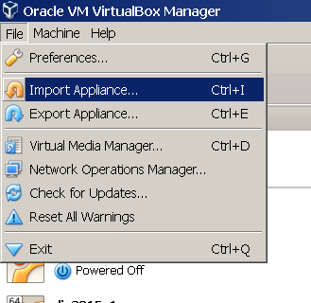

c. From there, you can type in (or browse to, using the folder icon circled in the picture) the path of the **j2bb.ova** file. Then click **Next**.

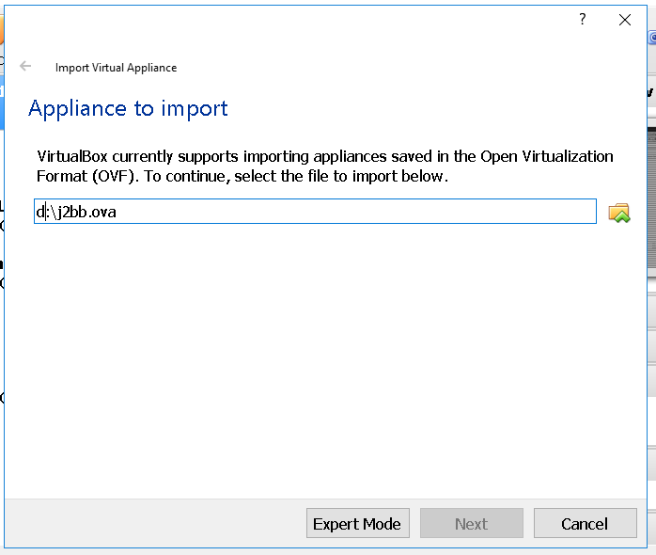

4. On the next screen, click the box to reinitialize the MAC addresses. You can just accept the rest of the **Appliance Settings** and then click the **Import** button.

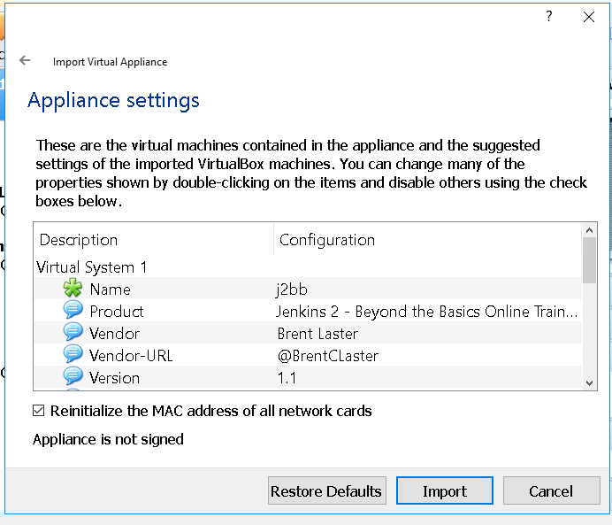

5.You may get a pop-up box for the “license” info. Read and click the **Agree** button. Your system will then start processing the import. This may take a while.

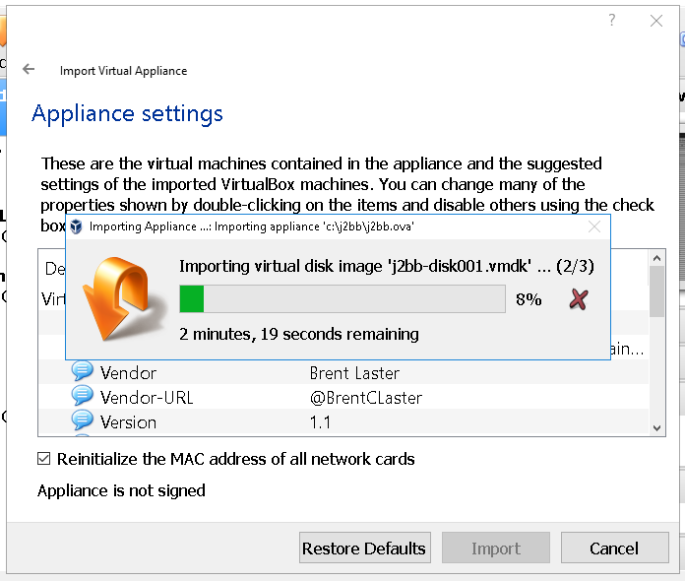

5. After the import is finished, you should have a VM listed in VirtualBox named **m2j2v2**.

6. **(OPTIONAL)** At this point, depending on the settings of your physical system, you can adjust the amount of memory for the image if you need/want. You can do this by clicking on the **Settings** icon in the menu bar, then **System** in the pop-up box for the settings. Then you can adjust the amount of memory for the virtual machine with the slider.

The system can run with as little as 3 gig although performance will be degraded. 12 gig is not necessary but will yield improved performance if your underlying physical machine can support it.

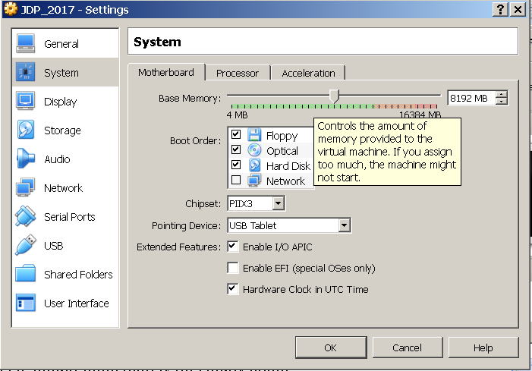

7. At this point, you can start up the virtual image by right-clicking on the image name and then selecting **Normal Start.**

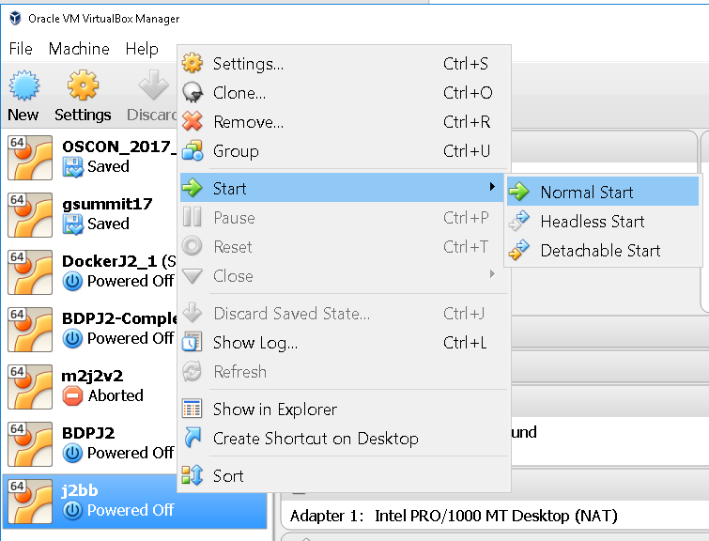

8. If a boot menu appears, just select “Ubuntu”. You may receive an error about network adapters here similar to the one below.

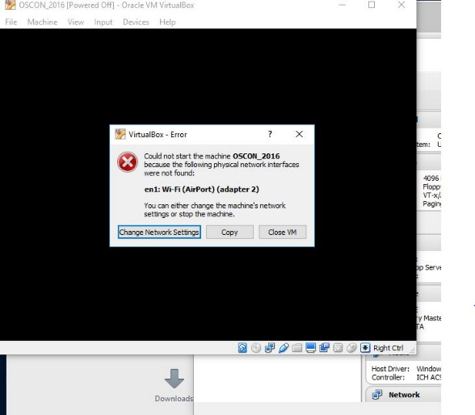

If so, just click on the option given to “Change Network Settings”. Then click on “Ok” in the network settings. You can also enable enable “**Auto Ethernet**” in the networking menu (click on double arrors in upper-right corner) but that is probably not necessary.

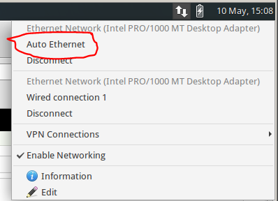

9. After starting up the VM, you should see the desktop of the VM.

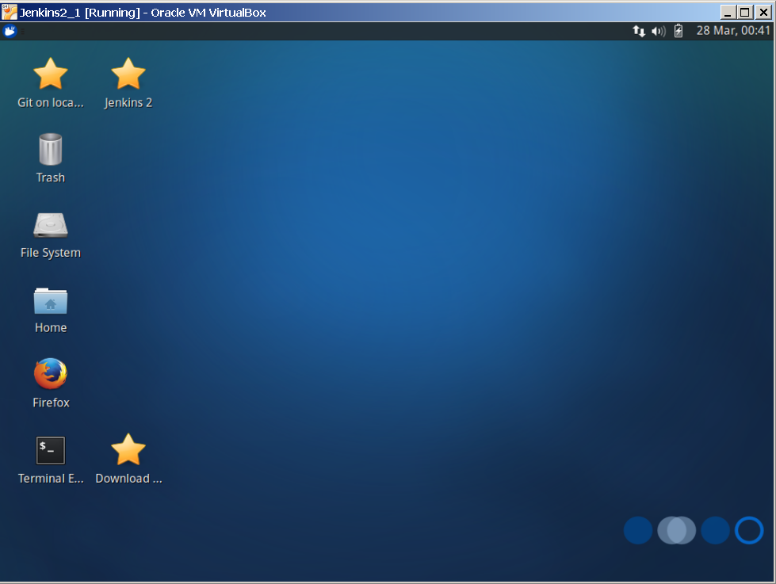

10. If you are on Windows and get a Windows firewall dialog, you can click both boxes and tell Windows to “Allow access”.

11. If you are given an option to upgrade ubuntu, just decline that.

12. If you have messages at the top of the screen about “Auto capture keyboard” and “mouse pointer integration” you can just click the x on the far right of the messages to dismiss those.

13. Verify that you have internet connectivity from the VM. Open up terminal session from the VM’s desktop and type something like “ping google.com” to make sure you get a response.

14. There is one more **important** task to do for setup if you are not in the Eastern Timezone - change the system to have the correct date/time. To do this:

a. Click on the mouse icon in the upper left corner of the screen.

b. In the drop down menu, select “Settings” on the right-hand side.

c. In the left-hand side, select “Time and Date”.

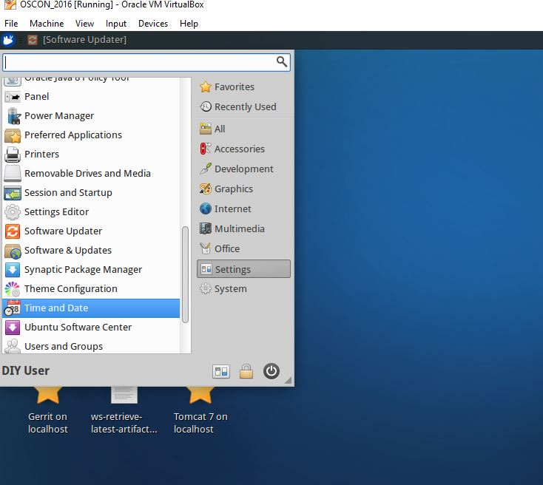

d. The Time and Date Settings dialog will pop up. In order to change this, you need to click on the “Unlock” button on the bottom and then authenticate to unlock it. The password to use here is “diyuser2”.

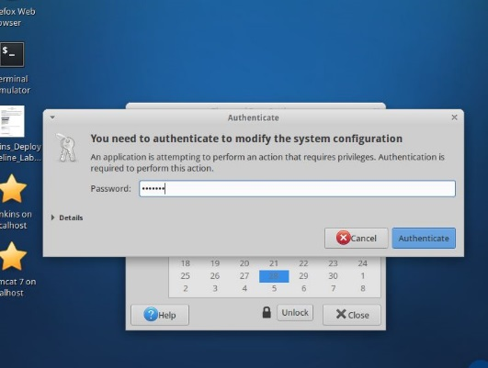

e. Click on the “Time zone” selection at the top and then find a city that is in the timezone where you are (probably prefixed by America/ if you’re in the US). Select it and close the “Time zone” choosing dialog.

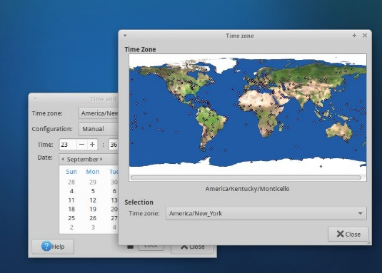

f. Back on the main “Time and Date” settings dialog, the time should have changed to reflect the timezone you selected.

g. Select the Lock button to lock the settings again and then the close button.16. To persist the date/time changes, you just need to logout and log back in. To log out select the mouse icon again in the upper left corner, then click on the “Power” button.

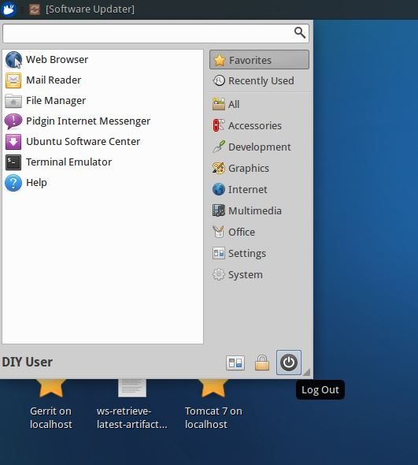

15. After logging out, you can log back in with user=diyuser2 and password=diyuser2. Confirm that your date and time are set as expected.

16. Some labs in the course utilize email. To configure this appropriately in Jenkins, you will need an email address where you can send and receive email, and the appropriate configuration information.

Most typically, these are the kinds of things you will need to have to configure your email setup:

* SMTP server name
* Default email suffix (the part from “@” on in your address)
* Email account user name and password for sending email
* Know if your email account uses/requires SSL

Collect this information if you don’t already have it to use in the next steps.

17. Start Jenkins by clicking on the “**Jenkins 2**” shortcut on the desktop OR opening the Firefox browser and navigating to “**http://localhost:8080**”.

18. You should be on the login screen. Log in to Jenkins with User = **jenkins2** and Password = **jenkins2**

19. From the Jenkins dashboard (starting screen), click on **Manage Jenkins** in the left side menu. Then click on **Configure System** to open the main configuration screen.

20. Scroll down on the configuration page until you find the **E-mail Notification** section. Fill in the main fields in this section with the requested information.

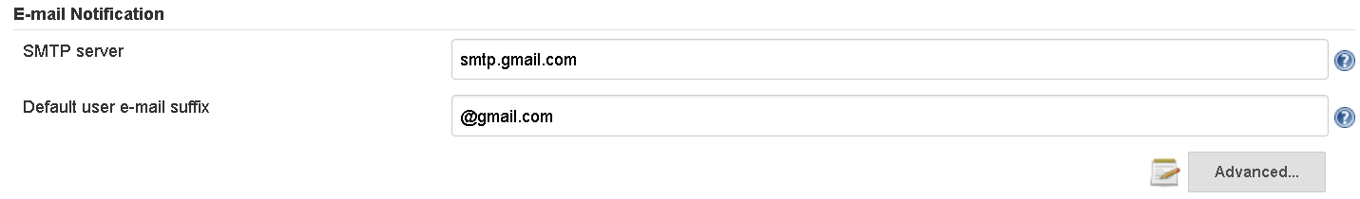

21. Click on the **Advanced** button and fill in the needed fields in this section.

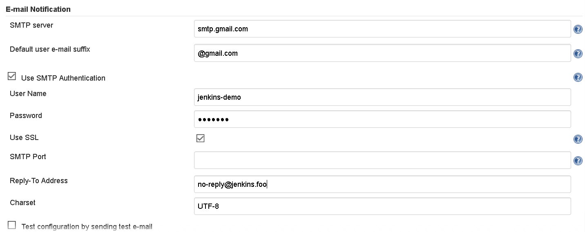

22. Click the checkbox for testing the email configuration. Enter an email address where you can receive email in the text box and then click the **Test configuration** button.

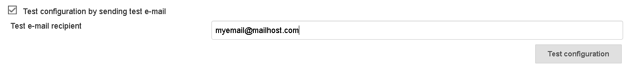

23. You should receive a test email from Jenkins at the email address you provided in the step above. If not, check the settings you entered and validate that they are correct.