### Continuous Delivery and Containerization

### Levering Jenkins 2 and Docker to simplify and standardize your pipeline

### Setup Instructions

**Safari Online Training**

**Version 1.5 – 8/8/18**

**Brent Laster**

**IMPORTANT SETUP INSTRUCTIONS – PLEASE COMPLETE BEFORE THE CLASS.**

**YOU MAY WANT TO HAVE AN ELECTRONIC COPY OF THE LABS AVAILABLE FOR REFERENCING. ALSO, IF YOU PREFER TO WORK FROM A PAPER COPY, PLEASE PRINT THE LABS PRIOR TO CLASS. THE LABS ARE SIGNIFICANT.**

**You can get a copy of the labs online at**

<https://github.com/brentlaster/safaridocs/blob/master/cdc-labs.pdf>

**To be able to work through the labs and effectively understand the material, it will be to your advantage to get your system setup following the instructions below.**

1. You must have a system that can support virtualization and run Virtualbox without problems. Download and install Virtualbox on your system and verify that it runs correctly. Note that some systems may require special access or BIOS settings to support virtualization. Please ensure that you have sorted out any issues with this prior to the start of the first online session. Virtualbox can be obtained and installed from <http://www.virtualbox.org>

2. The class uses a VirtualBox VM with all the applications installed and configured that we will need. You can download the virtual image from the location below:.

[**https://www.dropbox.com/s/81xz4sax4l9u6qu/cdc.ova?dl=0**](https://www.dropbox.com/s/81xz4sax4l9u6qu/cdc.ova?dl=0)

Note that this file is approximately 3.6 gig in size, so it may take some time to download (30 minutes or more on a slow connection). It is not recommended to try to download this while you are using a VPN connection as that will greatly slow down the download.

**Checksums to check your file downloaded correctly:**

MD5: 6c8a739ea047c3628b19a6057c6bf35f

SHA-1: a99965a1d930d24b436fc80dbc2590b0ff229d70

SHA-256: 6d22ec84adeae8c638aed8a12d850ca8aecfcc0d4534784a1948efee7f358e52

3. Once you have Virtualbox installed and the image downloaded and are ready to proceed, do the steps below to import the appliance.

a. Open **VirtualBox** on your system.

b. From the **File** menu, select **“Import Appliance…”.**

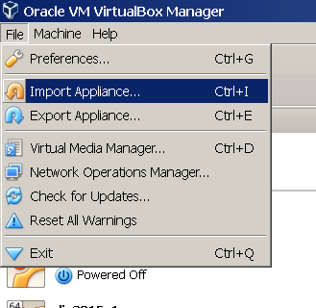

c. From there, you can type in (or browse to, using the folder icon circled in the picture) the path of the **cdc.ova** file. Then click **Next**.

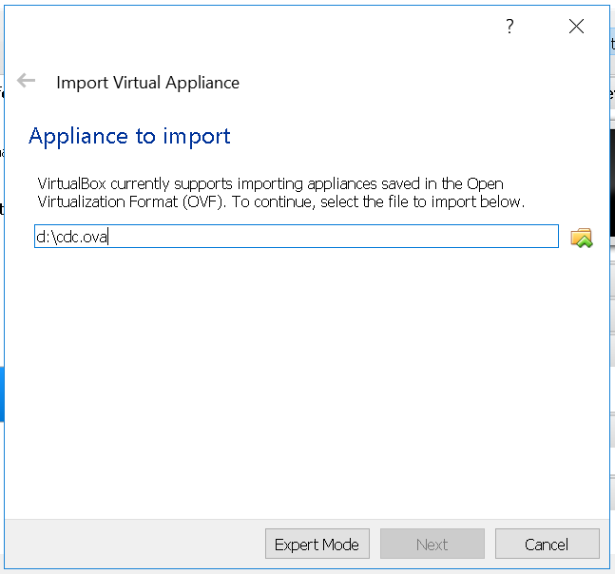

4. On the next screen, click the box to reinitialize the MAC addresses. You can just accept the rest of the **Appliance Settings** and then click the **Import** button.

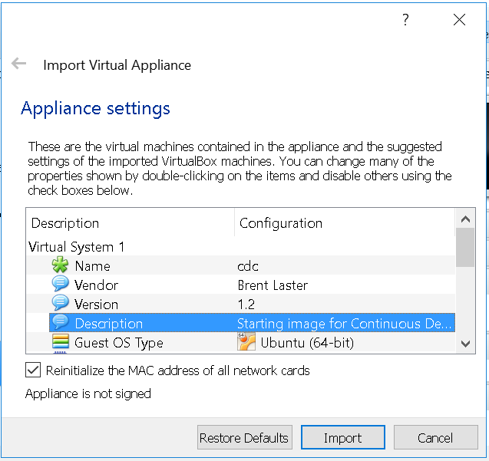

5.You will get a pop-up box for the “license” info. Just click the **Agree** button. Your system will then start processing the import. This may take a while.

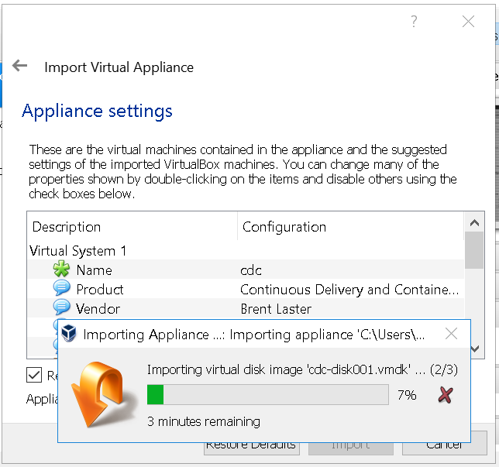

6. After the import is finished, you should have a VM listed in VirtualBox named DockerJ2.

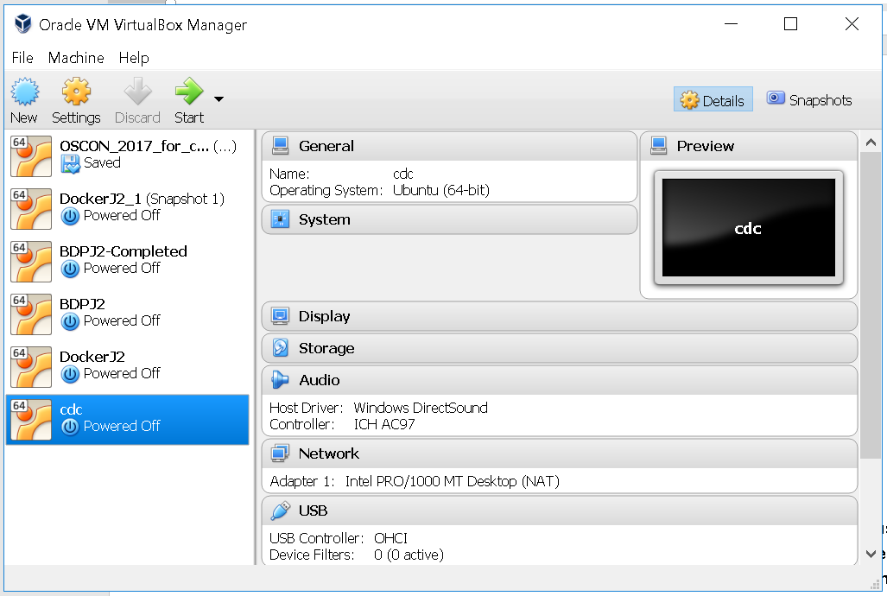

7. **(OPTIONAL)** At this point, depending on the settings of your physical system, you can adjust the number of processors, amount of video memory, or amount of working memory for the image if you need/want. You can do this by clicking on the **Settings** icon in the menu bar, then **System** in the pop-up box for the settings. Use your best judgment based on how powerful your laptop is. If you make changes and your system fails to start or seems extremely slow, you can back out these changes in the same way. Note that to provide the most power to the VM, you should close any unnecessary running applications on your laptop. Also note that these settings can only be adjusted when the system is not currently running.

1. To adjust the number of processors (only available if you have hardware virtualization support on your system):

Select the Processor tab in the System area and bump up the number of processors. It is not recommended to go beyond 2. If you are not able to make changes, then your system does not have support to allow altering this.

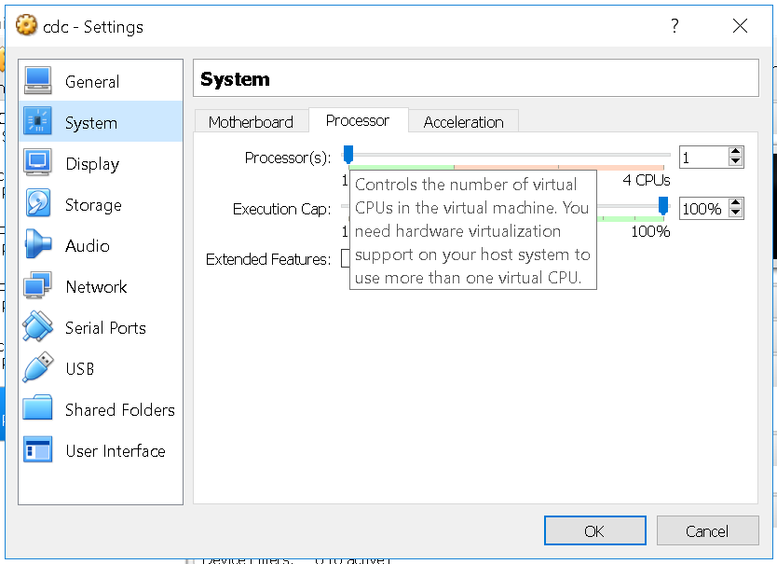

1. To adjust the amount of video memory: Select the **Display** section, then the **Screen** tab. If enabled, you can drag the slider to provide more video memory to the system.

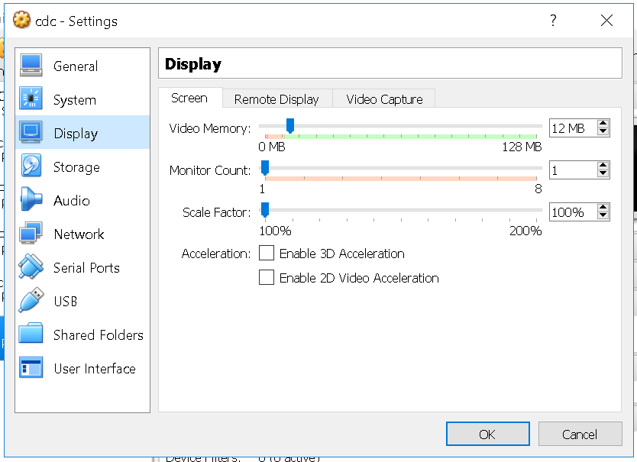

1. To adjust the amount of working memory for the virtual machine:

Select the **System** section, then the **Motherboard** tab. Then you can adjust the amount of memory with the slider.

The default is 4 gig. The system can run with as little as 4 gig although performance will be degraded. 8 gig is not necessary but **may** yield improved performance **if** your underlying physical machine can support it. **If you are unsure, you can just leave it at the default.**

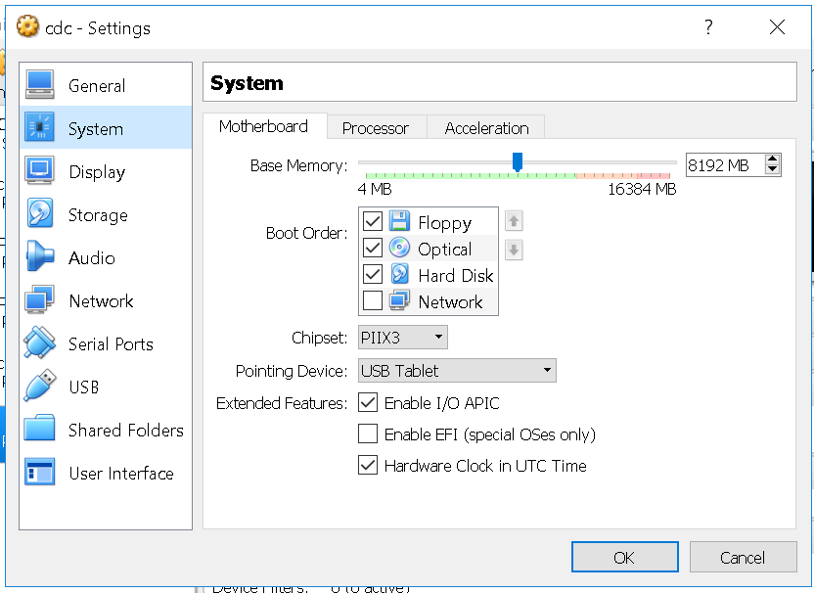

8. At this point, you can start up the virtual image by right-clicking on the image name and then selecting **Normal Start.**

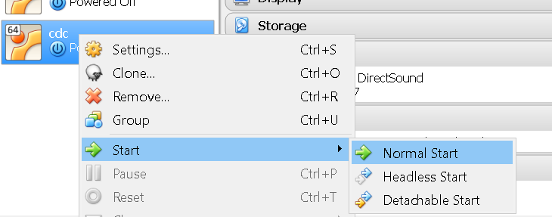

9. You may receive an error about network adapters here like the one below.

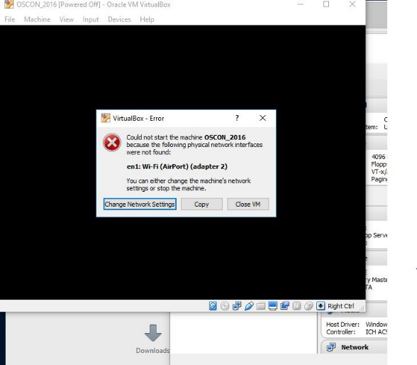

If so, just click on the option given to “Change Network Settings”. Then click on “Ok” in the network settings. ( After the system starts, you can also enable enable “**Auto Ethernet**” in the networking menu (click on double arrows in upper-right corner) but that is probably not necessary).

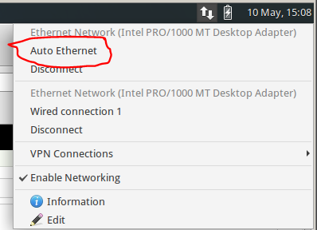

10. If you get a warning dialog that pops up like the one below, it is due to a missing shared directory. (You can see that if you click the Details – not required.) This is not important for using the VM and you can just click OK to proceed and ignore the warning.

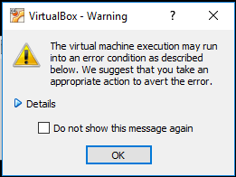

11. It may take several minutes for the desktop to appear. If, after several minutes, you don’t see the desktop, try switching to full screen mode (Host key + F) or access the menu item for it through the View menu. On most systems, the Host key here will be the right Ctrl key. (Note: Windows 10 seems to have issues if you try to switch to scaled mode. If on a Windows 10 system, you may want to avoid that setting. If you do go into scaled mode and the screen seems to disappear, try using the Host key + F to switch out. Or the menu may still be accessible, although hidden, at the very top of the screen.)

12. After starting up the VM, you should see the desktop of the VM.

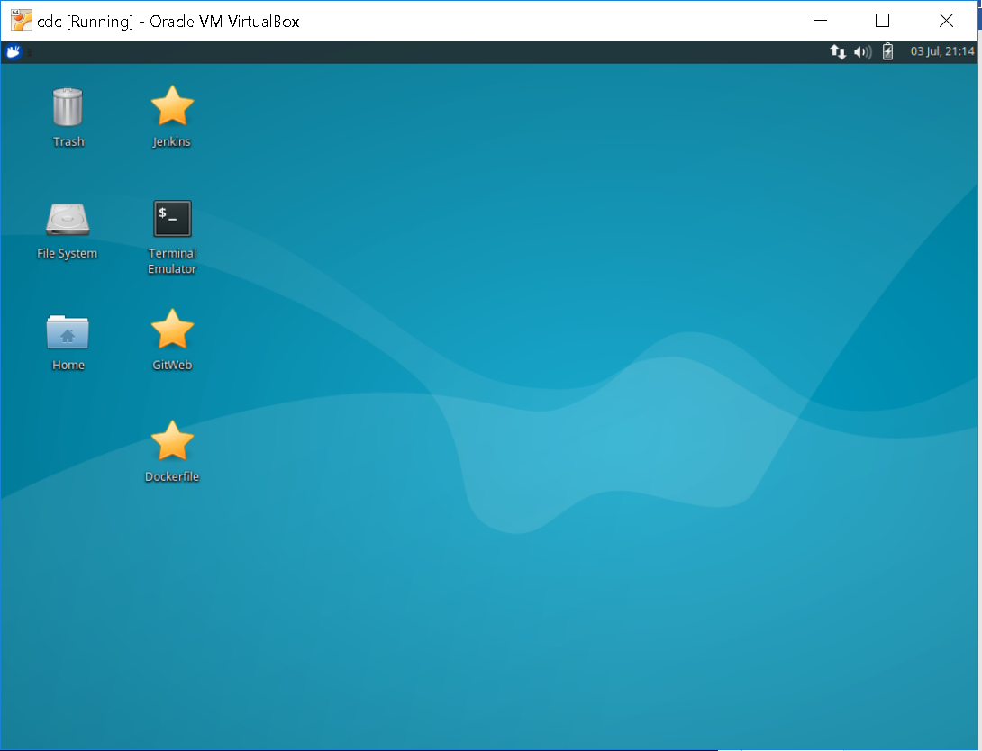

13. If you are on Windows and get a Windows firewall dialog, you can click both boxes and tell Windows to “Allow access”.

14. If you are given an option to upgrade ubuntu, just decline that.

15. If you have messages at the top of the screen about “Auto capture keyboard” and “mouse pointer integration” you can just click the x on the far right of the messages to dismiss those.

16. Verify that you have internet connectivity from the VM. Open a terminal session from the VM’s desktop and type something like “ping google.com” to make sure you get a response.

17. Login for system is diyuser2, diyuser2.