**Introduction to Continuous Integration - Setup**

**Summer, 2019**

**Version 1.2 – 6/16/19**

**Brent Laster**

**IMPORTANT SETUP INSTRUCTIONS – PLEASE COMPLETE BEFORE THE CLASS IF POSSIBLE.**

**ALSO, IT IS HIGHLY RECOMMENDED TO PRINT A COPY OF THE CLASS LABS TO HAVE WITH YOU IF YOU PREFER TO WORK FROM A PAPER COPY. THE LABS ARE SIGNIFICANT.**

**You can print a copy by downloading the PDF at**

**https://github.com/brentlaster/safaridocs/blob/master/ci-labs.pdf**

**Hello and thank you for registering for this session. In order to be able to work through the labs and effectively understand the material, it will be to your advantage to get your system setup following the instructions below.**

1. You must have a system that can support virtualization and run Virtualbox without problems. Download and install Virtualbox on your system and verify that it runs correctly. Note that some systems may require special access or BIOS settings to support virtualization. Please ensure that you have sorted out any issues with this prior to the start of the first online session. Virtualbox can be obtained and installed from <http://www.virtualbox.org>

2. The class uses a VirtualBox VM with all of the applications installed and configured that we will need. You can download the virtual image from the location noted on the course’s landing page. Note that this file is about 6 gig in size, so it may take some time to download (an hour or more on a slow connection). It is not recommended to try to download this while you are using a VPN connection as that will greatly slow down the download.

**Checksums to check your file downloaded:**

**MD5 Checksum: 97813DE21705C33BE03852A22F1CCB50**

**SHA-1 Checksum: 0B68290CEBD6F674405107F7D244EBEC39603C18**

**SHA-256 Checksum:**

**A1DD2281DE4533858C90B50F78A0400319F7666AAC4D25FA00B99E155713096D**

**SHA-512 Checksum:**

**A513620AD62A725057B813C735E07E1BDADBD03B4EA2142BAC0BFF9CBB2569513A5F493D6645DC146DF23F31A2BBC48F91A6886A92B4110258B0342F5A2182EE**

3. Once you have Virtualbox installed and the image downloaded and are ready to proceed, do the steps below to import the appliance.

a. Open **VirtualBox** on your system.

b. From the **File** menu, select **“Import Appliance…”.**

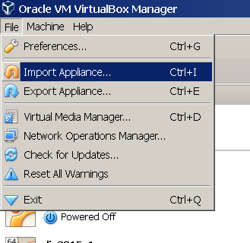

c. From there, you can type in (or browse to, using the folder icon circled in the picture) the path of the **ci.ova** file. Then click **Next**.

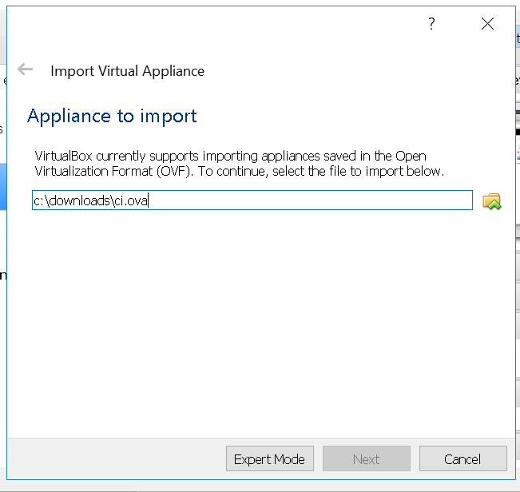

4. On the next screen, click the box to reinitialize the MAC addresses. You can just accept the rest of the **Appliance Settings** and then click the **Import** button.

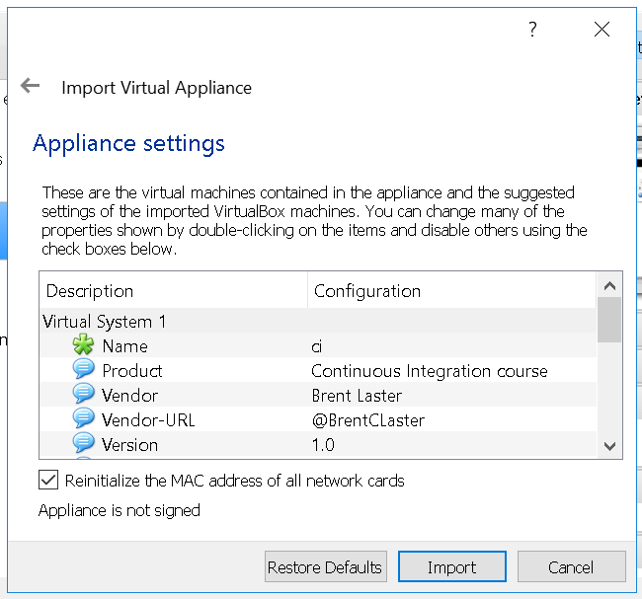

5.You will get a pop-up box for the “license” info. Just click the **Agree** button. Your system will then start processing the import. This may take a while.

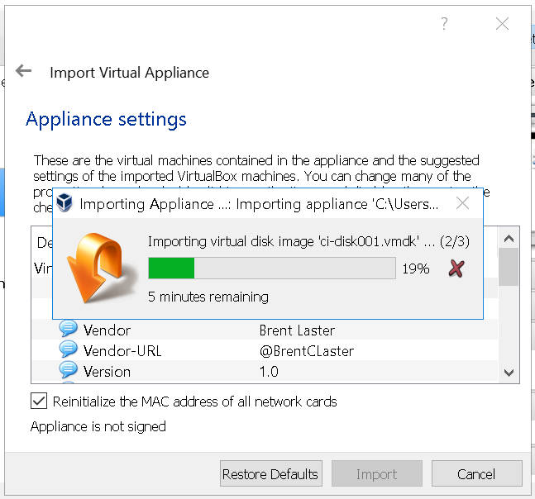

6. After the import is finished, you should have a VM listed in VirtualBox named **ci.**

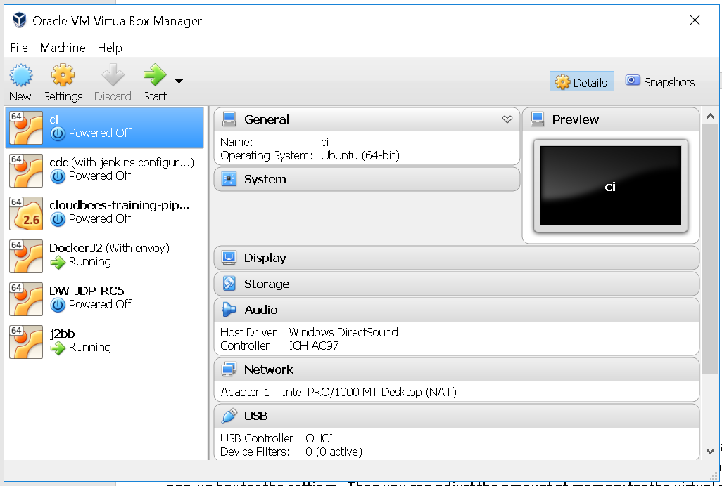

7. **(OPTIONAL)** At this point, depending on the settings of your physical system, you can adjust the amount of memory for the image if you need/want. You can do this by clicking on the **Settings** icon in the menu bar, then **System** in the pop-up box for the settings. Then you can adjust the amount of memory for the virtual machine with the slider.

The default is 8 gig. The system can run with as little as 4 gig although performance will be degraded. 12 gig is not necessary but will yield improved performance if your underlying physical machine can support it. **If you are unsure, you can just leave it at the default.**

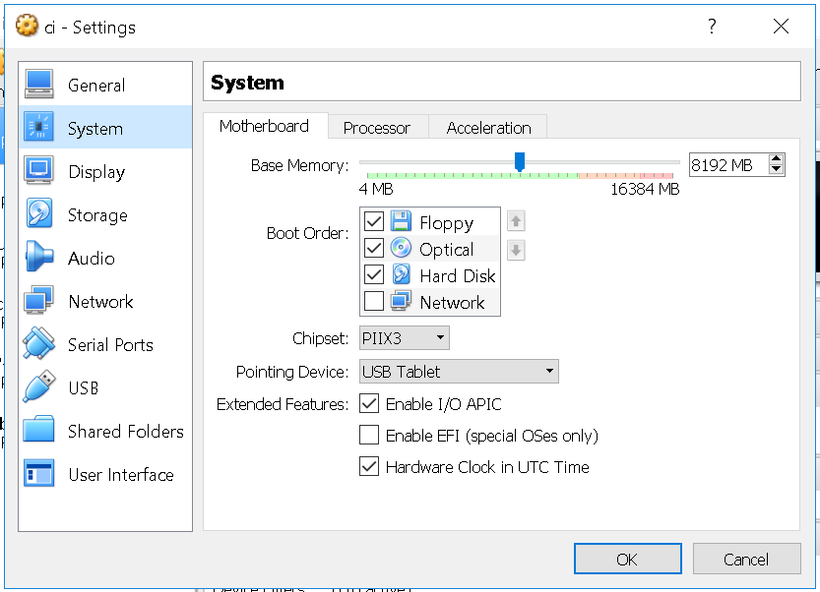

8. At this point, you can start up the virtual image by right-clicking on the image name and then selecting **Normal Start.**

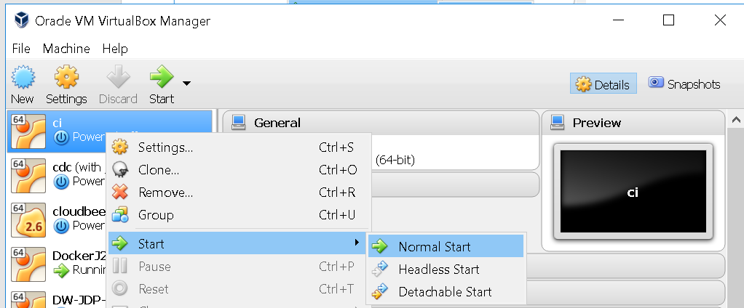

9. You may receive an error about network adapters here similar to the one below.

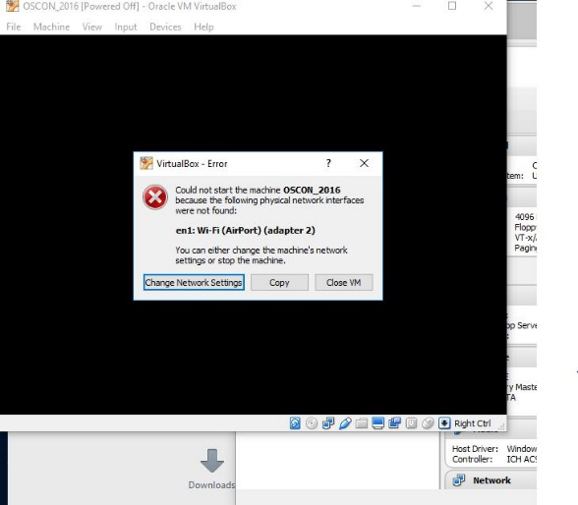

If so, just click on the option given to “Change Network Settings”. Then click on “Ok” in the network settings. ( After the system starts, yYou can also enable enable “**Auto Ethernet**” in the networking menu (click on double arrors in upper-right corner) but that is probably not necessary).

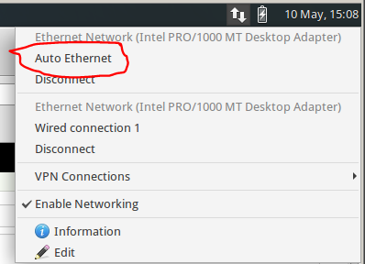

10. If you get a warning dialog that pops up like the one below, it is due to a missing shared directory. (You can see that if you click the Details – not required.) This is not important for using the VM and you can just click OK to proceed and ignore the warning.

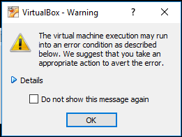

11. It may take several minutes for the desktop to appear. If, after several minutes, you don’t see the desktop, try switching to full screen mode (Host key + F) or access the menu item for it through the View menu. On most systems, the Host key here will be the right Ctrl key. (Note: Windows 10 seems to have issues if you try to switch to scaled mode. If on a Windows 10 system, you may want to avoid that setting. If you do go into scaled mode and the screen seems to disappear, try using the Host key + F to switch out. Or the menu may still be accessible, although hidden, at the very top of the screen.)

12. After starting up the VM, you should see the desktop of the VM.

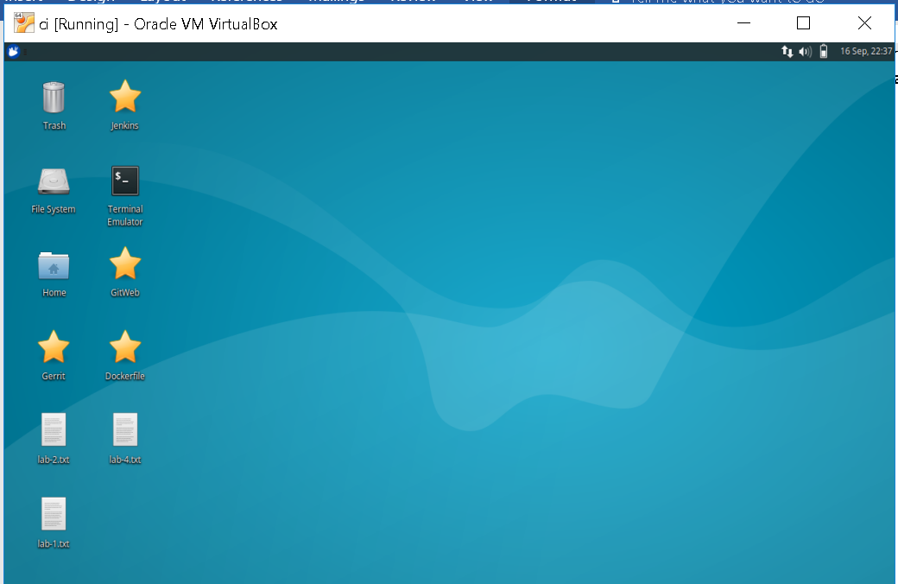

13. If you are on Windows and get a Windows firewall dialog, you can click both boxes and tell Windows to “Allow access”.

14. If you are given an option to upgrade ubuntu, just decline that.

15. If you have messages at the top of the screen about “Auto capture keyboard” and “mouse pointer integration” you can just click the x on the far right of the messages to dismiss those.

16. Verify that you have internet connectivity from the VM. Open up a terminal session from the VM’s desktop and type something like “ping google.com” to make sure you get a response.

17. Login is jenkins2, jenkins2.

18. Optionally, if you are not in the Eastern time zone - you can change the system to have the correct date/time. To do this:

a. Click on the mouse icon in the upper left corner of the screen.

b. In the drop down menu, select “Settings” on the right-hand side.

c. In the left-hand side, select “Time and Date”.

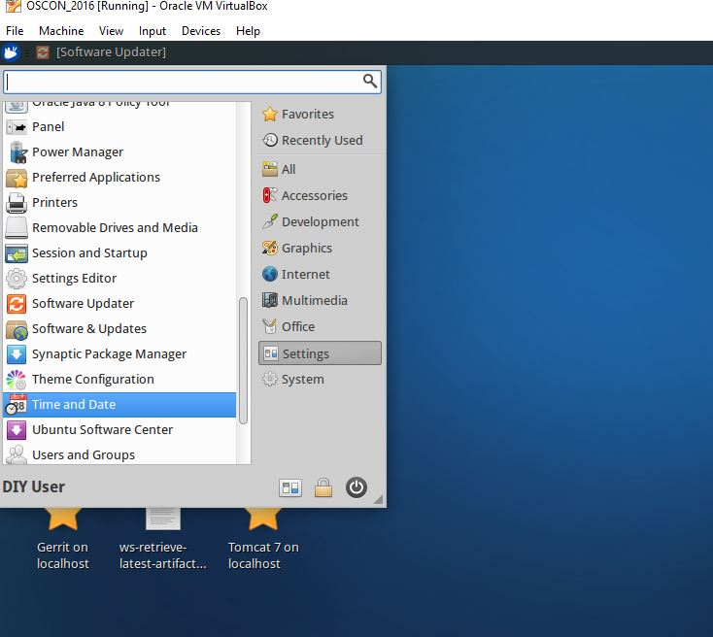

d. The Time and Date Settings dialog will pop up. In order to change this, you need to click on the “Unlock” button on the bottom and then authenticate to unlock it. The password to use here is “diyuser2”.

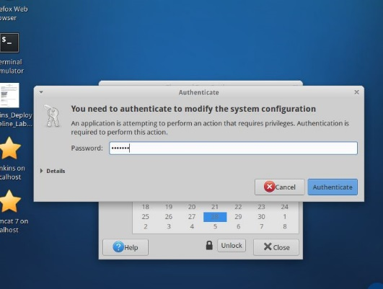

e. Click on the “Time zone” selection at the top and then find a city that is in the timezone where you are (probably prefixed by America/ if you’re in the US). Select it and close the “Time zone” choosing dialog.

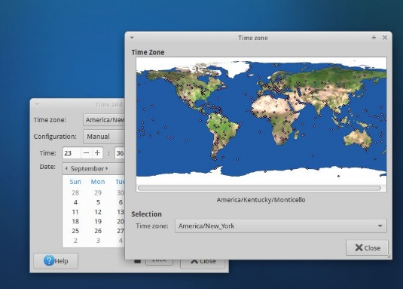

f. Back on the main “Time and Date” settings dialog, the time should have changed to reflect the timezone you selected.

g. Select the Lock button to lock the settings again and then the close button.16. To persist the date/time changes, you just need to logout and log back in. To log out select the mouse icon again in the upper left corner, then click on the “Power” button.

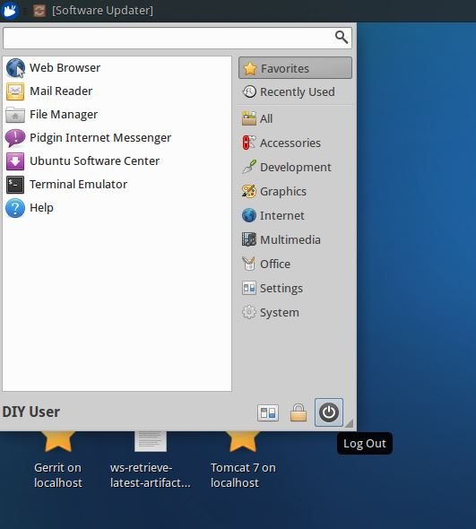

19. After logging out, you can log back in with user=diyuser2 and password=diyuser2. Confirm that your date and time are set as expected.

20. Optional - some labs in the course may utilize email. To configure this appropriately in Jenkins, you will need an email address where you can send and receive email, and the appropriate configuration information.

Most typically, these are the kinds of things you will need to have to configure your email setup:

* SMTP server name
* Default email suffix (the part from “@” on in your address)
* Email account user name and password for sending email
* Know if your email account uses/requires SSL

Collect this information if you don’t already have it to use in the next steps.

21. Start Jenkins by clicking on the “**Jenkins 2**” shortcut on the desktop OR opening the Firefox browser and navigating to “**http://localhost:8080**”.

22. You should be on the login screen. Log in to Jenkins with User = **jenkins2** and Password = **jenkins2**

23. From the Jenkins dashboard (starting screen), click on **Manage Jenkins** in the left side menu. Then click on **Configure System** to open the main configuration screen.

24. Scroll down on the configuration page until you find the **E-mail Notification** section. Fill in the main fields in this section with the requested information, substituting the information for your email setup.

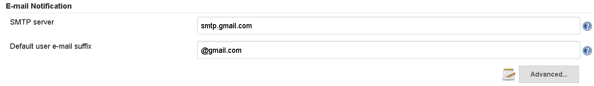

25. Click on the **Advanced** button and fill in the needed fields in this section, substituting the information for your email setup.

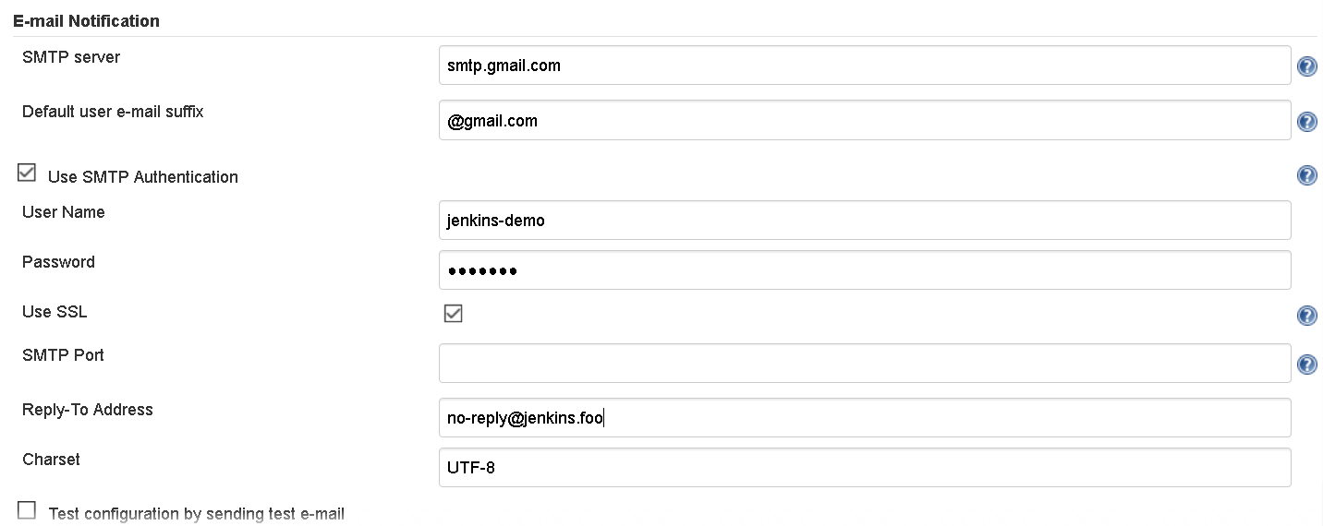

26. Click the checkbox for testing the email configuration. Enter an email address where you can receive email in the text box and then click the **Test configuration** button.

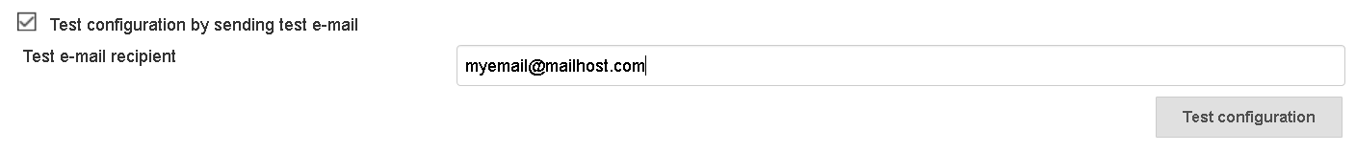

27. You should receive a test email from Jenkins at the email address you provided in the step above. If not, check the settings you entered and validate that they are correct.