Contents
Arrays

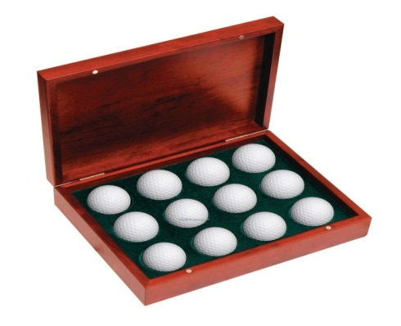
Arrays
Arrays are used to group elements of either of primitive or reference (non-primitive) types.
- All elements of array are of SAME TYPE.
- Array is FIXED-LENGTH data structure having ZERO - based indexing.

Array Declaration & Initialization
Declaration | int arr1[];  arr1 = new int[4];
Short form of above Declaration | int arr1[] = new int[4]; (or) int[] arr1 = new int[4];
Declaration with Initialization | int arr1[] = {2,3,4,5};
Initialization in case of Declaration 1,2 | arr1[0]=2; arr1[1]=3; arr1[2]=4; arr1[3]=5;
Declaring Array Object | Student stu = new Student[3]; // creates 3 objects of Student class
2D Array Declaration | int arr1[][] ={ {2,3},{4,5},{34,56}};  int arr1[][] = new int[3][2];

Foreach loop
//Syntax
for (variable : collection)

{ //code}
//Example
for (int val : arr1)
{ System.out.println (val); }

Varargs (Variable Argument List) or ellipsis (…)
//Valid Code
void print(int a,int b,String...c)
{ //code }
//Invalid Code
void print(int a, int b…,float c)
{ //code }

Rule : Varargs can be used only in the final argument position.

Methods in java.util.Arrays class
Method Name | Use
asList | Creates a new List from array
binarySearch | searches an element in an array
copyOf(array,n) | Creates new array of n size and copy all elements from array to new one
copyOfRange(array,n,from,to) | Creates new array of n size and copy specified elements from array to new one
Sort | Sort elements in array
Equals | Compare two array elements
Fill | Inserts specified value to each element of an array

