Contents
Exception Handling

Exception Handling
It occurs during the execution of a program that disrupts the normal flow of instructions:
Eg: Hard disk crash, Out of bounds array access, Divide by zero etc.
When an exception occurs, the executing method creates an Exception object and hands it to the runtime system —”throwing an exception”. The runtime system searches the runtime call stack for a method with an appropriate handler, to handle/catch the exception.

Hierarchy of Exception Classes
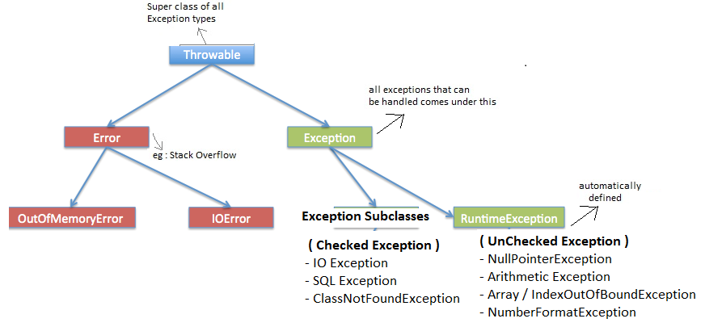

try–catch-finally
try : regular code where exceptions are thrown
catch : handle exception thrown in try block
finally : executes compulsorily whether or not an exception is thrown.
A java program can have :
- multiple try and multiple catch block
- One finally block

Throwing an Exception
It is possible for your program to throw an exception explicitly, using the throw statement. You can throw your own runtime errors: To enforce restrictions on use of a method, To "disable" an inherited method, To indicate a specific runtime problem, To throw an error, use the throw statement

throw ThrowableInstance
where ThrowableInstance is any Throwable Object
User-specific Exception
To create your own exception class, you must inherit from an existing exception class.

