***16.480/552 Microprocessor Design II and Embedded Systems***

***Lab 1: Sensor Design and Analog Digital Conversion***

***Instructor:*** *Prof. Yan Luo*

*Group-12*

*Due:10/2/17*

*Submitted: 10/2/17*

***Team Members:***

***Aravind Dhulipalla & Zubair Sikindar Nadaph***

**Contributions:**

**1.** Group Member I - Aravind Dhulipalla

To use the ADC module in the pic microcontroller to convert the analog values to digital values and troubleshooting those components in circuit.

2. Group Member II – Zubair Sikindar Nadaph

He used the pwm module in the pic microcontroller to give the pulses to the servo motor ad troubleshooting those components in circuit.

We both worked on the schematic part which is same for both of us.

Schematics: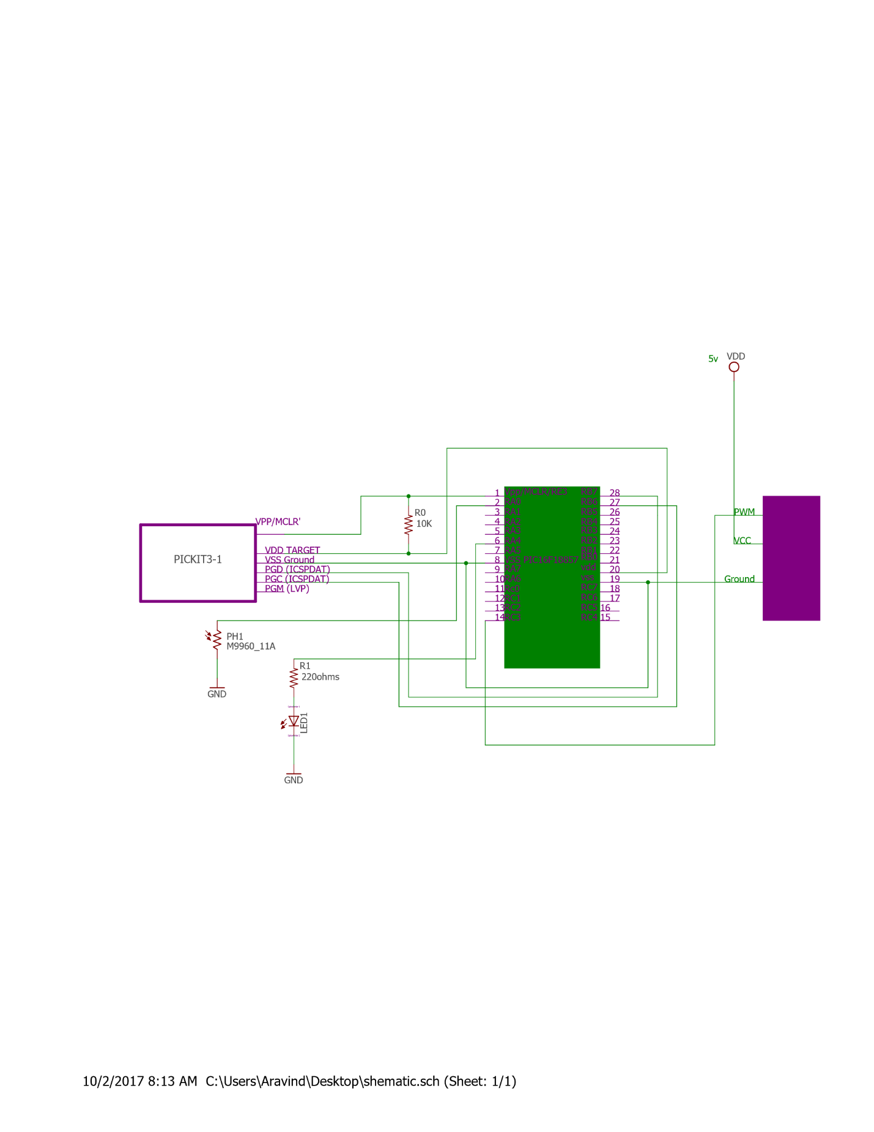

Purpose:

To Design a embedded system where its actuator device(servo motor) affects te sensor device(LDR) that triggers a visible indicator (LED) light on/off

Introduction:

Understand the ADC and PWM module in the Pic 16F18857 microcontroller and read the data from the LDR which is analog value and convert it to the digital value and turn on the led if the value is less tan certain threshold and run the servo motor in timeintervals so that it covers the LDR in timely fashion.

Materials,Devices and Instruments:

1. PIC16F18857 microcontroller

2. PICKIT3

3. LDR

4. Bread Board, Jumper cables

5. 10k and 220ohms resistor

6.Voltage Supply (5v for servo)

7. Servo Motor

Lab Methods and Procedures:

Pickit3 is connected to the PIC 16F18857 . refer to the two figures below which shows the pin description.

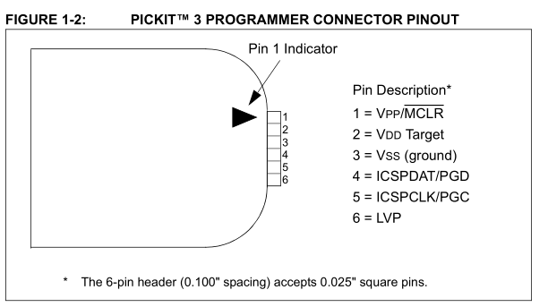

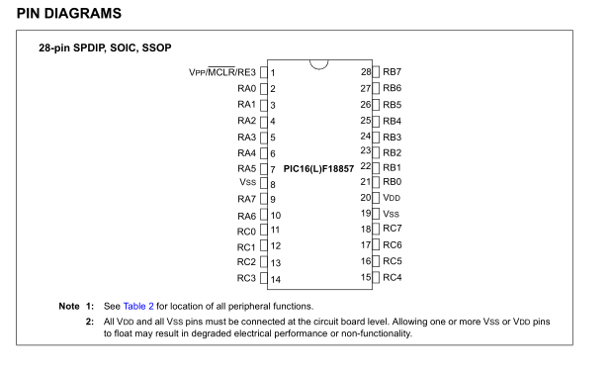

Here In PIC 16f18857 the ICSSPDAt is pin 27 and ICSPCL is 28 so these two pins are connected to pins 4 and 5 respetively while VPP of pickit3 is connected to the vpp of pic16f18857 so as the vdd and gnd.The vpp/MCLR’ is connected to vdd with 10kohms resistor. The LDR is connected to the portA pin4 which is configured as an analog input and the LDR is connected to the LED with a voltage divider circuit with a resistance of 220ohms. The operating voltage of pic16f18857 is 3.3v and it is provided through pickit3 and the operating voltage of the servo is 5v so the servo is powered through FTDI cable.

Software Design:

We used ADC , PWM, Timer2 modules and all the three need to be configured. Adc is configured by setting the control registers 1 and 2 to 0 , setting threshold register and nonoverflowed to 0, disabling ADC capacitors, setting ADC CLK and setting ADCON0 in required mode.

The ADG0 bit is set when a conversion is complete and is reset to 1 for the next conversion wait until the ADG0 bit is set to 0and then collect the results. ADC Results are stored in ADRESH and ADRESL Registers since it is a 10 bit ADC result the ADRESH is lef shifted by 8 and ADRESL is added to get the 10bit value.

Since it is a 10bit value i.e it can have values from 0 to 1023

Resolution : (Vref+ - Vref-)/1023 = 3.3/1023 = 0.004887v

FLOW Chart:

NO

Yes

Yes

Yes

Rotate the Servo by 180 degrees



ADC Value Aquired



LED OFF



LED ON



Wait till the conversion is done

ADC is in Progress



Set the Tristate register of porta pin4 and portcpin 3 to 0

Initialise the system,ADC,Timer and PWM



Troubleshooting:

1. We have to figure out a way to power the pic with 3.3v and the servo with 5v so we used pickit3 to power the pic with the required 3.3v and FTDI cable to power servo. We checked the voltage across the sensor during good light and low light conditions. The measured voltages are 2.8v during good light and 1v during low light.

For 2.8V sample = 868 and for 1v sample = 310

300 treshold is chosen so that if the ADC value is below 300 then the LED blinks and if it is greater LED turn off.

Figuring out the PWM signal is the bigger part. PWM6 is selected to RC3 pin and servo motor is connected which is rotated by giving different duty cycles with some delay.

Source Code: