PROJECT REPORT

AXOVRIM
AI-Powered Toolkit Quality Inspection
Computer Vision • RGB-D Metrology • Industrial Inspection

Project information | Details
Project title | AXOVRIM — AI-Powered Toolkit Quality Inspection
Domain | Manufacturing quality control / machine vision
Team / Group | Smartlab students
Institution | Sanjivani University
Guide / Mentor | Dr. Arvind Mukundan
GitHub repository
Report date | 15 October 2026
Submission note: This report documents known implementation features and developer-reported checks. Numerical performance claims require independently reproducible test data. Add approved logo and names before final submission.

Abstract
AXOVRIM is a computer-vision-assisted toolkit quality inspection system intended for manufacturing and maintenance environments, using a Raspberry Pi 5 with a connected screen as the proposed primary inspection host and a compatible laptop as an alternative. Its current implementation concentrates on recognizing tools in a toolkit, comparing detected category counts against company-defined reference quantities, identifying sockets in a linear arrangement, and estimating socket outer diameters using an Intel RealSense RGB-D camera.
The software combines a YOLO11 instance-segmentation model with image-derived rim geometry, depth information, geometric ordering, and Excel-based references. Book1.xlsx stores expected tool inventory by company, while Book2.xlsx stores socket identities and reference dimensions. These workbooks remain editable and are intended to synchronize with the operator interface.
A four-panel operator interface displays the live camera, annotated detections, inventory and dimensional verification. The Raspberry Pi 5 inspection station uses a connected screen and an existing Linux .sh launcher; Windows laptops use AXOVRIM.exe. Both are intended to support worker identification, reviewable decisions, records and reports. Launcher availability does not itself verify full hardware operation or metrology accuracy.
The immediate value is more structured, repeatable toolkit checking rather than a claim of universal defect detection. Automated regression outcomes and startup checks have been reported during development, but large-scale detection accuracy, measurement uncertainty, inspection cycle time, and multi-laptop industrial validation are not established by the supplied evidence.
Keywords: manufacturing quality inspection; toolkit inventory; YOLO11-seg; depth sensing; socket metrology; traceability.

Table of Contents
01 Cover Page ·············· 1
02 Abstract ·············· 2
03 Table of Contents ·············· 3
04 Introduction ·············· 4
05 Problem Statement ·············· 5
06 Objectives ·············· 6
07 Existing System / Literature Review ·············· 7
08 Proposed System ·············· 8
09 System Architecture ·············· 9
10 Methodology / Workflow ·············· 10
11 Dataset / Input Data ·············· 11
12 Preprocessing / Data Preparation ·············· 12
13 Models / Algorithms Used ·············· 13
14 Implementation Details ·············· 14
15 Hardware / System Integration ·············· 15
16 Results and Evaluation ·············· 16
17 Application / Prototype Screenshots ·············· 17
18 Advantages, Limitations and Discussion ·············· 18
19 Future Scope and Conclusion ·············· 19
20 References and GitHub Repository ·············· 20
Numbering follows the submitted maximum-20-page format. Figure locations and screenshots should be updated after final approved images are supplied.

1. Introduction
Quality inspection of hand-tool kits is important wherever a defined set of tools must be available, correctly returned, and safe to release for use. Manual inspection typically relies on visual counting and occasional handheld dimensional checks. These steps can become slow, subjective, and difficult to trace when multiple companies, toolkits, and reference standards are involved.
AXOVRIM focuses on AI tool recognition, reference-driven quantity verification and depth-assisted socket checks. The primary inspection station uses a Raspberry Pi 5 with an attached screen, launched through a Linux .sh script. Windows laptops can run a separately packaged AXOVRIM.exe. Each platform requires its own dependency and hardware validation.

1.1 Domain context
The project sits at the intersection of machine vision, RGB-D sensing, practical geometric measurement, and digital inspection records. Computer vision estimates what items appear in the camera view. Reference workbooks define what ought to be present and, for sockets, what dimensions are expected. The difference between observed and expected values determines which items need review.

1.2 Motivation
A system that consistently records tool count discrepancies and highlights possible socket size deviations can assist inspectors, reduce repeated manual tabulation, and create a reviewable inspection history. Measurement and final disposition remain dependent on calibration quality, camera geometry, and a well-defined toolkit layout.

2. Problem Statement
Industrial toolkits can contain many visually similar components. A missing socket, an extra item, or a socket of the wrong size may not be obvious during a rapid visual inspection. Human counting and matching can be affected by fatigue, clutter, reflections, and differing experience among operators.

2.1 Core problem
Develop an operator-oriented system that (a) identifies tool categories, (b) compares detected quantities with company-defined expected quantities, (c) measures the outer diameter of visible sockets against reference values, and (d) records the inspection outcome transparently.

2.2 Engineering challenges
- Metallic sockets create highlights and weak or noisy depth readings, complicating rim extraction and dimensional measurement.
- Detection order is not physical socket order; raw instance IDs cannot be used as reliable sequential socket labels.
- Separate workbooks may contain multiple company reference sets, requiring correct selection and live updates.
- Missing or displaced items can make reference-slot assignment ambiguous even when visible sockets can be ordered.
- A deployable EXE must bundle AI dependencies while keeping workbook data and reports writable.

2.3 Target users
Primary users are manufacturing inspectors, maintenance personnel, toolkit custodians, and supervisors reviewing traceable inspection results. The proposed workflow is designed for supervised quality checking; it does not establish autonomous release authority.

3. Objectives

3.1 Main objective
Design and package an AI-assisted toolkit quality inspection application that unifies tool recognition, reference inventory checking, socket dimensional verification, and report generation within a repeatable manufacturing workflow.

3.2 Specific technical objectives
- Acquire synchronized color and depth information from a compatible Intel RealSense camera.
- Segment and classify tools using the selected trained YOLO11-seg model.
- Compare detected tool quantities against company-specific expected counts in Book1.xlsx.
- Extract socket rim geometry and estimate physical outer diameters using calibrated depth information.
- Assign sequential IDs S01–SN according to spatial row order, anchored at the smaller reliable endpoint.
- Compare measured socket ODs against Book2.xlsx reference dimensions without altering measured values.
- Represent PASS, REVIEW and FAIL outcomes with explicit handling of missing or uncertain measurements.
- Record Worker ID, inspection history, reviewed status changes, and generated inspection reports.
- Support Raspberry Pi 5 with an attached display and existing .sh launcher, alongside a separately packaged AXOVRIM.exe for Windows laptops; validate both platforms.

3.3 Evaluation criteria
Evaluate detection precision and recall, count agreement, socket-ID assignment, caliper-referenced OD error, ambiguous cases, inspection time, record integrity, and operation on Raspberry Pi 5 and a laptop. Platform compatibility and performance require separate verification; these are not claimed results.

4. Existing System / Literature Review
Conventional toolkit inspection relies on manual counting, checklists, visual comparison with tool silhouettes, and calipers for dimensional confirmation. Basic image-based counting systems can reduce effort but typically lack calibrated three-dimensional measurements. General object detectors classify and localize components but do not inherently guarantee correct physical ordering or dimensional accuracy.

4.1 Relevant technical approaches
Approach | Utility | Limitation in this application
Manual inspection | Simple, flexible | Operator dependent; limited automatic traceability
Object detection | Class/count estimates | Bounding boxes alone are insufficient for rim metrology
Instance segmentation | Per-item masks | Masks may include body edges rather than true top rim
RGB-D sensing | Per-pixel depth information | Specular metal and depth noise require calibration
Spreadsheet reference checks | Editable company rules | Reference quality and identity matching are critical

4.2 Gap addressed
AXOVRIM integrates instance segmentation, geometric socket ordering, depth-assisted metrology, and two independent company reference workflows in a single operator interface. It is intended for a Raspberry Pi 5 inspection station with display and for laptop operation using appropriate platform builds. Comparative superiority and deployment performance require controlled testing.

5. Proposed System
The proposed system performs a camera-driven toolkit inspection. It detects visible tools, presents annotated analysis, and checks inventory against Book1.xlsx. Socket-specific observations are forwarded to a metrology path that estimates outer-rim geometry and physical size, labels a single spatial socket row from S01 onward, and compares available dimensions with Book2.xlsx.

5.1 Key functions
- Live RGB-D camera display and capture for analysis.
- YOLO11-seg instance detection of a defined 14-category toolkit class set.
- Independent company selection for inventory and socket dimensional references.
- Socket identification independent of Excel availability, with guarded uncertainty handling.
- Operator-visible automatic decisions and controlled manual socket-status review.
- Saved inspection data and generation of toolkit or batch reports.

5.2 Intended differentiation
The project prioritizes a manufacturing toolkit task with explicit reference files and a spatial numbering rule. It keeps geometric sequence identification distinct from spreadsheet matching, helping avoid the incorrect practice of renumbering observed objects solely to fit a reference. Only the present tool-and-socket inspection scenario is documented; broader industrial surface-defect detection remains outside the validated scope.

6. System Architecture
The system comprises acquisition, inference, geometry, reference verification, user interaction, and persistence layers. The packaged operator application includes required AI libraries and external editable resources.
Layer | Input | Output / responsibility
Capture | RealSense RGB + depth | Color frame, aligned depth, intrinsics
Detection | RGB frame + model | Tool classes, masks, confidence, raw IDs
Socket geometry | Masks + image edges | Rim centers, ellipse candidates
Metrology | Rim + calibrated depth | Physical OD and measurement validity
Sequence | Socket centers + valid OD | PCA row order and S01–SN
Reference check | Book1 + Book2 | Count and dimensional differences
Presentation | All observations | Four dashboard panels, review actions
Persistence | Worker + inspection state | Records, outputs, reports

6.1 Architecture flow diagram
RealSense RGB + Depth → Calibration / Alignment
↓
YOLO11-seg → Tool Count Verification (Book1)
↓
Socket Rim Geometry → 3D OD → PCA Ordering
↓
Socket Dimensional Verification (Book2)
↓
Operator Review → Save Results → Inspection Report
Figure 1. Logical AXOVRIM inspection architecture (schematic, not a hardware wiring diagram).

7. Methodology / Workflow

7.1 End-to-end inspection sequence
- Operator launches AXOVRIM and registers a Worker ID before starting an inspection.
- The application loads configuration, model weights and the two editable Excel workbooks.
- The RealSense camera supplies aligned RGB/depth frames; the platform is calibrated as required.
- YOLO11-seg detects tool instances and estimates their categories and segmentation masks.
- Tool detections are counted and compared against the chosen Book1 company reference.
- Socket-family masks are processed to obtain candidate top-rim ellipse centers and geometry.
- Depth and camera calibration are used to estimate physical socket outer diameters.
- PCA organizes one approximately linear socket row; a reliable smaller endpoint anchors S01.
- Sequential socket results are compared against Book2 only where reference assignment is trustworthy.
- Automatic outcomes are presented; authorized operator review is tracked; results and reports are saved.

7.2 Decision safeguards
Invalid depth, an unreliable ellipse, an ambiguous endpoint, a missing item, or an uncertain reference correspondence must be identified explicitly. Such cases should not be silently converted to PASS. The operator can review eligible final socket status while the underlying measurement and automated verdict remain traceable.

8. Dataset / Input Data
AXOVRIM operates on two classes of input: visual/depth observations from a calibrated inspection setup and editable company reference workbooks. A trained segmentation weight file is available, but a verified current-model training manifest and full dataset provenance were not supplied for this report.

8.1 Inspection inputs
Input | Purpose
RGB camera frames | Detection masks and ellipse/rim analysis
Aligned depth frames | Base-plane, socket height and metric OD estimation
Camera intrinsics | Back-projection and physical geometry
Book1.xlsx | Expected quantities for tool categories per company
Book2.xlsx | Socket IDs, nominal sizes and reference/caliper ODs
Calibration files | Geometric measurement setup

8.2 Tool categories and data splits
The documented model class space has 14 tool categories; standard sockets, deep sockets, and bit sockets are the categories routed to the socket measurement path. A complete verified mapping of all 14 names should be taken directly from class_mapping.json for the release version. Current training/validation/test counts and annotation statistics should be reported only after auditing the actual dataset manifest.
Archived experiments include dataset counts and benchmark metrics from earlier project stages. They cannot safely be equated with the present selected AXOVRIM weight file, so they are not presented here as current-model results.

9. Preprocessing / Data Preparation
Preprocessing must preserve pixel-to-depth correspondence. The color image is supplied to the segmentation model using its configured inference transformations, while the corresponding depth image is geometrically aligned so image-space rim points can be mapped into three-dimensional camera rays.

9.1 Camera and geometric preparation
- Confirm frame validity and compatible color/depth dimensions and intrinsics.
- Acquire empty-platform depth samples and fit an approximate reference plane; the existing specification describes a 30-frame acquisition with robust plane fitting.
- Reject invalid or implausible depth points and flag high-noise measurements.
- Preserve full-frame coordinates when translating between mask crops and camera pixels.

9.2 Socket-specific image preparation
For candidate socket regions, crop with padding, apply blur and edge filtering, and use segmentation geometry to reduce interference from neighboring objects. Select the top outer rim rather than inner drive opening or body silhouette. Fit and validate an ellipse; a fallback centroid can support low-confidence spatial ordering but does not establish metrology validity.

9.3 Reference preparation
Book1 and Book2 are structured independently and should be validated for missing company names, blank/duplicate socket IDs, nonnumeric OD values, and unit consistency. Editing either workbook should refresh the relevant dropdown and expected values without silently switching company contexts.

10. Models / Algorithms Used

10.1 YOLO11 instance segmentation
The selected YOLO11-seg model produces tool instance masks, class predictions and confidence estimates. The segmentation mask supports downstream socket-specific rim extraction. Model performance is not inferred solely from successful loading or a sample detection.

10.2 RealSense depth metrology
A calibrated plane provides a local geometric reference. For a pixel (u,v) at depth Z, approximate camera coordinates follow X=(u−cx)Z/fx and Y=(v−cy)Z/fy. Candidate top-rim points are projected into 3D using aligned depth and plane/height estimates. The computed physical diameter is compared with reference measurements; invalid rays or unstable depth must be flagged.

10.3 PCA-based sequential numbering
Socket rim centers are projected onto the primary axis of their approximately linear layout using principal component analysis. After ordering centers geometrically, the reliable smaller physical endpoint is selected as S01; subsequent sockets receive S02, S03, and so on. Intermediate items are not globally sorted by diameter. When endpoint size is ambiguous or layout is unsuitable, sequence identity requires review.

10.4 Reference decisions
For each matched socket, signed OD error equals measured OD minus reference OD. Acceptance thresholds depend on the configured inspection rules and must be verified in the actual software and company reference, not assumed from a generic value.

11. Implementation Details
The application is consolidated in main.py with a PyQt5 interface. Ultralytics/PyTorch provides inference; OpenCV and numerical methods support geometry; openpyxl reads Excel references; RealSense bindings acquire RGB-D frames. Raspberry Pi 5 uses its Linux .sh launcher and attached screen, while Windows laptops use a packaged AXOVRIM.exe. Both require compatible platform-specific dependencies.

11.1 Principal interface elements
Dashboard area | Function
Live Camera | Operator view and camera control
Socket Analysis Results | Annotated masks, socket IDs and analysis overlay
Tool Detection & Count Verification | Detected/expected quantities and differences
Socket Dimensional Verification | Reference and measured OD, error and status

11.2 Operator controls
The current interface includes Worker ID, Start Camera, Capture Analyze, Clear Results, Save Results, Generate Report, and Engineering Settings. Both comparison panels use independent company selection. Worker status overrides are intended to be confirmed and auditable, while automatic calculations are retained.

11.3 Deployment structure
The Windows laptop distribution uses a PyInstaller one-directory build with AXOVRIM.exe, bundled libraries and editable application resources. The Raspberry Pi 5 has a .sh launcher to start its Linux application; the script is a launcher, not a Windows executable or proof of a self-contained package. Its exact commands, dependency installation and executable permissions must be checked against the actual .sh file. Verify ARM64-compatible PyTorch, PyQt5, Ultralytics and RealSense support on the Pi.

12. Hardware / System Integration

12.1 Raspberry Pi 5, display and laptop integration
The primary station uses a Raspberry Pi 5 with a connected display, an Intel RealSense RGB-D camera, suitable power supply and USB 3 connection. The Raspberry Pi application is launched using an existing .sh script under Linux. An alternative Windows laptop uses AXOVRIM.exe. Each platform needs matching libraries, RealSense support and camera-specific calibration; the .sh file was not supplied for command-level verification.

12.2 Integration boundaries
- Camera streams: synchronized color/depth acquisition and alignment must be validated with the installed device.
- Calibration: camera intrinsic parameters and platform geometry must correspond to the actual setup.
- Environment: metallic reflections, shadows, vibration and changing camera pose may affect 3D measurement.
- Software: the EXE must contain the required Python/native runtime, while system drivers may still be necessary.
- Portability: the application package must be copied as a complete folder, not as an isolated EXE.

12.3 Deployment acceptance
On the Raspberry Pi 5, execute the existing .sh launcher and verify GUI startup, RealSense RGB-D streams, YOLO inference, dimension measurements and report saving. Independently validate AXOVRIM.exe on Windows laptops. The .sh launcher cannot run the Windows EXE natively on Raspberry Pi OS, and copied calibration does not guarantee measurement accuracy on a different setup.

13. Results and Evaluation
The available evidence primarily concerns the software assembly and developer-reported checks. It does not yet provide a comprehensive, independent industrial trial or statistically sufficient metrology benchmark. The table below deliberately separates reported checks from measurements not established.
Area | Available evidence | Interpretation
Automated regression | Most recent developer report: 183 passed, 3 skipped | Reported software checks; verify with current release
EXE startup | Prior onedir build reportedly launched | Startup is not full hardware portability
YOLO and Excel resources | Loading checks reported | Does not quantify detection performance
Socket-ordering logic | PCA and endpoint test scenarios documented | Not a field accuracy estimate
RealSense inspection | No complete independent target-laptop trial supplied | Hardware validation pending
Detection and metrology | No verified production benchmark in sources | Accuracy and uncertainty unreported

13.1 Recommended evaluation protocol
Use labeled toolkit configurations and traceable caliper measurements. Record true and predicted tool counts, each socket reference identity, measured OD, signed and absolute OD errors, invalid/ambiguous cases, camera geometry and inspection duration. Report precision/recall, confusion matrices, mean absolute OD error, error distribution and repeatability across lighting and devices.
Table 3. Current development-evidence status; not a certification or production acceptance report.

14. Application / Prototype Screenshots
The figures below are screenshots captured from the running AXOVRIM application during a test inspection (Worker 213, BATCH-001, 14 October 2026). The table summarizes what each figure demonstrates.
Figure | Screenshot shown | What it demonstrates
Figure 2 | Main dashboard | Four-panel application layout and branding
Figure 3 | Live toolkit detection | Tool masks and tool category labels
Figure 4 | Tool-count verification | Book1 company reference, counts and status
Figure 5 | Socket dimensional inspection | S01–SN and measured vs reference OD
Figure 6 | Report generation dialog | Worker and batch selection before PDF report generation
Figure 7 | Report output | Worker/batch traceability and saved verdicts

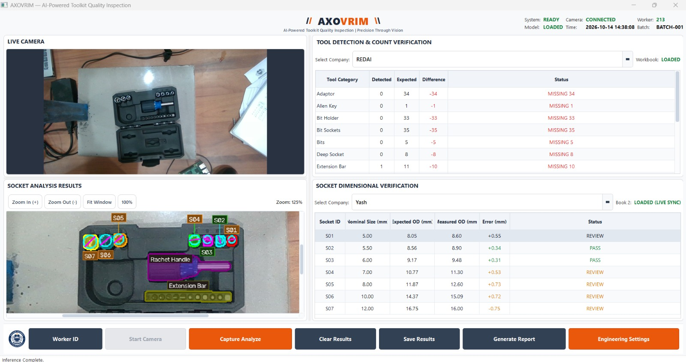
Figure 2. AXOVRIM main dashboard showing the four-panel layout: live camera, socket analysis results, tool detection and count verification, and socket dimensional verification.
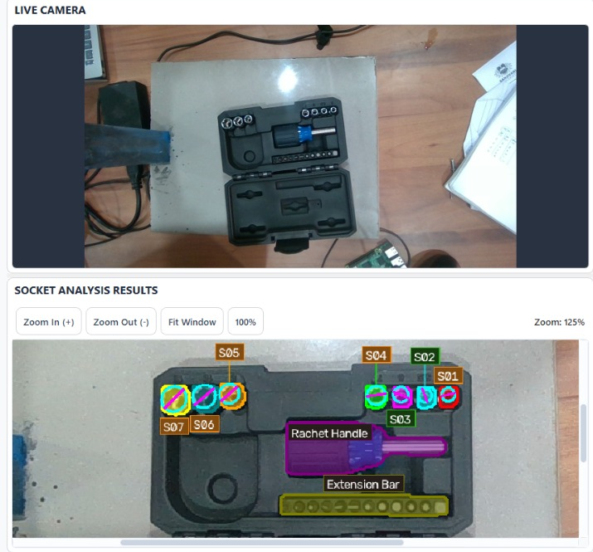
Figure 3. Live toolkit view and annotated socket analysis, with segmentation masks and tool/socket labels (S01–S07, Rachet Handle, Extension Bar).
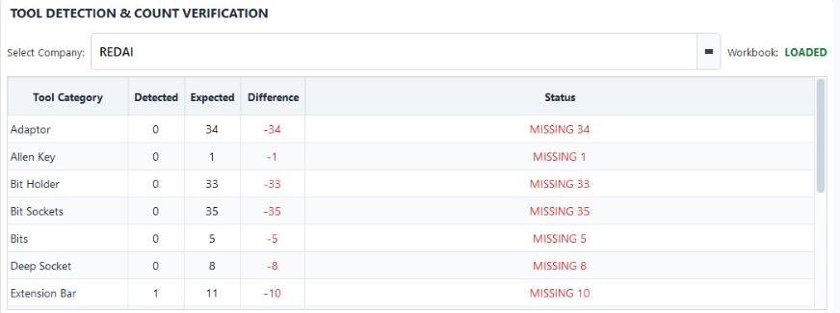
Figure 4. Tool detection and count verification against the Book1 company reference (REDAI), showing detected, expected and difference counts with status.
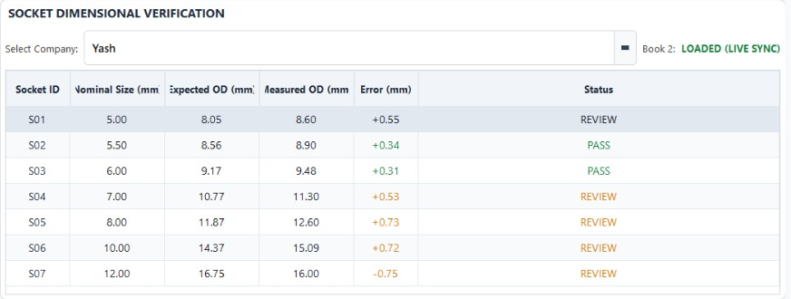
Figure 5. Socket dimensional verification against the Book2 reference, listing nominal size, expected OD, measured OD, error and PASS/REVIEW status for S01–S07.
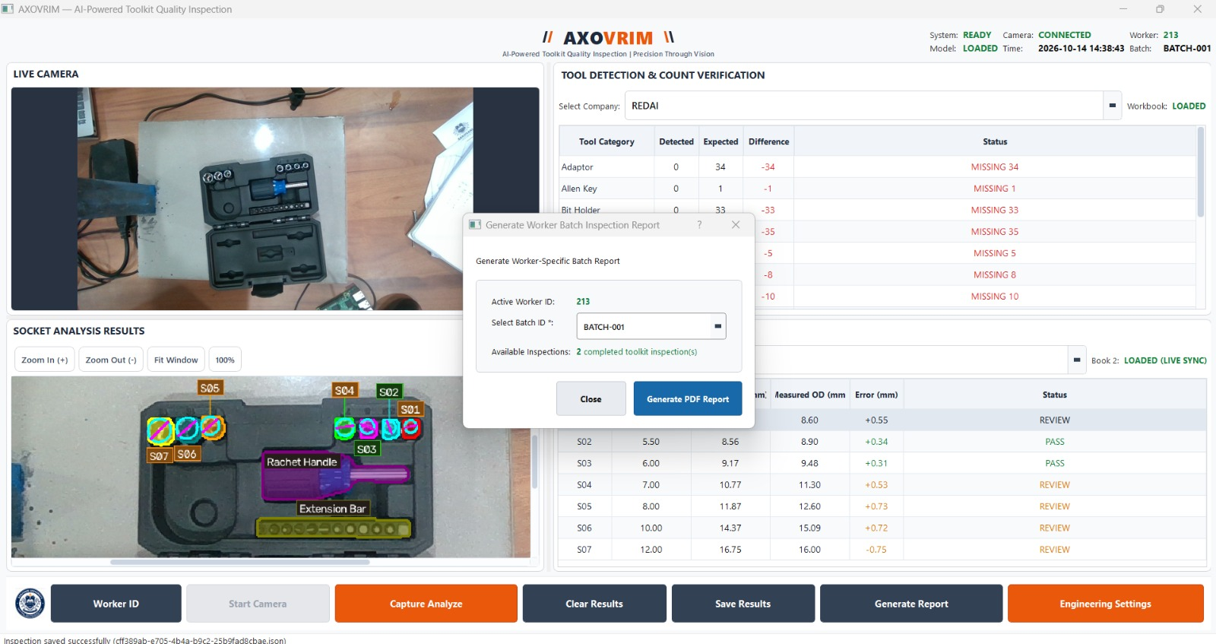
Figure 6. Generate Worker Batch Inspection Report dialog showing the active Worker ID, selected Batch ID and the number of completed toolkit inspections.
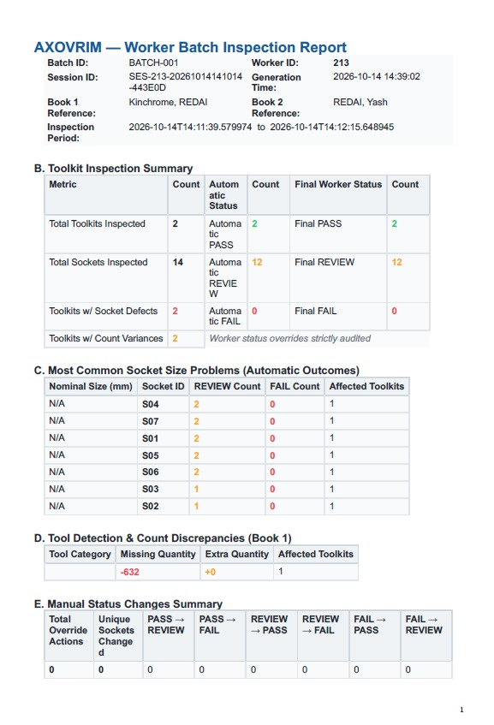
Figure 7. Generated Worker Batch Inspection Report (PDF) with batch/worker traceability, toolkit inspection summary, socket size problems, count discrepancies and manual status changes.

14.1 Screenshot acceptance
Capture images from the actual built application rather than an illustrative mockup. Mask or replace confidential worker identities and customer data. Where an image shows PASS, its corresponding raw measurements and reference data should be available for audit.
Figure captions should identify the software version, test setup and date, particularly when the interface changes between development builds.

15. Advantages, Limitations and Discussion

15.1 Advantages
- Combines tool inventory counts and socket dimensional checks in a single operator workflow.
- Uses editable company-specific references instead of hard-coded toolkit quantities.
- Separates image detection order from physically meaningful spatial socket numbering.
- Maintains worker-linked records and reviewable inspection decisions.
- Supports Raspberry Pi 5 with attached display and existing .sh launcher, plus Windows laptop operation using AXOVRIM.exe; both require platform-specific validation.

15.2 Limitations and operational risks
- Reflective metal can produce unstable depth and misleading rim boundaries.
- Single-row PCA ordering is not a general algorithm for grids, L-shapes or arbitrary multi-row arrangements.
- A missing socket can shift visible sequence labels unless a taught layout or reliable registration resolves its slot.
- Outer diameter alone cannot confirm all socket features, internal drive condition or surface integrity.
- No independently verified full-system detection accuracy, metrology uncertainty or multi-machine portability benchmark is supplied.

15.3 Discussion
AXOVRIM should be treated as a decision-support inspection prototype whose reliability depends on the visual environment, camera calibration, workbook quality, and handling of uncertain cases. Responsible operation includes retaining original measurements, distinguishing REVIEW from PASS, and checking critical items manually when the system cannot establish a reliable match.

16. Future Scope and Conclusion

16.1 Future development
- Validate the released model against a versioned, representative industrial toolkit dataset.
- Quantify dimensional repeatability and agreement with traceable caliper measurements under different camera geometries.
- Add tested layout registration for missing slots, non-linear tool arrangements and multiple toolkit types.
- Improve robustness to specular reflections, varying illumination and occlusion.
- Verify the existing .sh launcher, inference speed, power, temperature and RealSense support on Raspberry Pi 5; test the Windows AXOVRIM.exe separately.
- Consider supervisor review workflows, production traceability interfaces and signed report exports after validation.

16.2 Conclusion
AXOVRIM demonstrates a practical architecture for bringing AI-supported toolkit recognition, reference inventory checks, and depth-assisted socket measurement into one manufacturing quality-inspection interface. Its distinctive implemented workflow is the combination of tool instance segmentation, Excel-driven verification and geometry-aware socket numbering, with traceable operator actions and reporting.
The immediate next milestone is comprehensive validation: test the final packaged EXE independently of the development environment, assess the RealSense camera on representative hardware, verify calibration, and collect quantitative inspection outcomes. Only after these steps should claims of industrial-grade accuracy, measurement precision, and broad portability be made.

17. References and GitHub Repository
Project-specific technical material consulted for this report:
- AXOVRIM Complete Project Report — Project Only (13 October 2026), supplied project documentation.
- CURRENT_SOCKET_LOGIC_AND_FUNCTIONALITIES.md (October 2026), supplied socket processing notes.
- AXOVRIM implementation and packaging execution reports (October 2026), developer-reported evidence.
- 20_Page_Project_Report_Format_Template(1).docx, user-provided reporting structure.

17.1 Software and technical resources
- Ultralytics — YOLO model framework and documentation: https://docs.ultralytics.com/
- PyTorch — tensor inference and deployment: https://pytorch.org/
- Intel RealSense SDK — RGB-D camera software: https://github.com/IntelRealSense/librealsense
- OpenCV — image processing library: https://opencv.org/
- PyInstaller — Windows executable packaging: https://pyinstaller.org/
- openpyxl — Excel workbook handling: https://openpyxl.readthedocs.io/

17.2 Repository and acknowledgements
GitHub repository: [Insert verified public or approved private repository URL]. Do not publish proprietary datasets, model weights or confidential company records without permission. Team, mentor, institution, and acknowledgment text should be completed from approved project information.
Reporting integrity: results quoted from earlier experimentation or developer logs must not be represented as independently repeated testing of the released AXOVRIM package.

