SMART INDIA HACKATHON 2026
Problem Statement ID: SIH26031 | Theme: Smart Automation | Category: Software
ONION AI INSPECTION SYSTEM
Quality Assessment and Grading of Onions
PROJECT REPORT
Project Title:
Onion AI Inspection System
Team / Group:
Team CepaMetric (Team ID 167398)
Institution: Sanjivani University, Kopargaon

Guide / Mentor: Dr. Arvind Mukundan

GitHub Repository:
https://github.com/SMARTLAB-SU/SIH-CepaMetric-26031
Date:
07 October 2026

1. Abstract
Quality assessment and grading of onions are often subjective and vary across procurement centers, resulting in disputes and inconsistencies. This report presents the Onion AI Inspection System, developed by Team CepaMetric (Team ID 167398) for Smart India Hackathon 2026 under Problem Statement SIH26031.
In the proposed system, onions travel on a conveyor under an Intel RealSense D455f RGB-D camera. Classical 3D vision detects each onion, measures its true diameter in millimetres and tracks it with a unique ID. The cropped onion is classified by five CNNs (ConvNeXt-Tiny, EfficientNetV2-B0, DenseNet121, ResNet50V2 and Xception) and a stacking meta-classifier into four health classes: Moldy, Normal, Rotten and Sprouted. Grad-CAM shows why each decision was made. An Arduino drives servos or pneumatic pushers to drop each onion into one of four size bins (<40, 40-50, 50-60 and >60 mm) or the reject bin. A hyperspectral double check compares each onion's reflectance with the average of 3000 normal onions.
The system is implemented in Python with OpenCV, TensorFlow/Keras and a PyQt5 dashboard. In the prototype measurements, the mean absolute diameter error over five onions was 1.6 mm and the size grade accuracy was 94%.
Keywords: onion grading, RealSense D455f, 3D vision, CNN ensemble, Grad-CAM, Arduino sorting, smart automation.

Table of Contents
Cover Page 1
1. Abstract 2
Table of Contents 3
2. Introduction 4
3. Problem Statement 5
4. Objectives 6
5. Literature Review / Existing System 7
6. Proposed System 8
7. System Architecture 9
8. Methodology 10
9. Dataset / Input Data 11
10. Data Preprocessing 12
11. Models / Algorithms 13
12. Implementation 14
13. Hardware / Software Integration 15
14. Results and Evaluation 16
15. Prototype / Application 17
16. Discussion and 17. Limitations 18
18. Future Scope and 19. Conclusion 19
20. References and GitHub Repository 20

2. Introduction

2.1 Background
Onion lots are handled by farmers and FPOs, mandi traders and exporters, processors and cold storage, and finally reach consumers. At every stage the size grade of the onion and its health matter. Grading and disease checks are traditionally done by hand, which is slow and subjective.

2.2 Domain Overview
The project falls under the theme Smart Automation (software category). It combines depth sensing, classical computer vision, deep learning, explainable AI and Arduino-based actuator control in a PyQt5 desktop application for live agricultural quality inspection.

2.3 Motivation
- Replace slow, subjective manual grading and disease checks with consistent, automated decisions.
- Remove moldy and rotten onions early so infection does not spread through stored lots.
- Uniform size grades improve market price and simplify packing and export.

2.4 Project Context
The work was carried out by Team CepaMetric for Smart India Hackathon 2026. The source code, models and documentation are available in the project GitHub repository listed on the cover page.

3. Problem Statement

3.1 Problem Definition
Quality assessment and grading of onions are often subjective and vary across procurement centers, resulting in disputes and inconsistencies. Manual inspection is slow, inconsistent and difficult to scale on a conveyor or packing line.

3.2 Need
Inspectors must assess visible disease condition, count individual onions without duplication, estimate size, assign a grade and maintain batch-level records while the product continues moving. An automated system must therefore combine reliable image classification with stable physical tracking and measurement, and expose enough evidence for operators to review incorrect or uncertain decisions.

3.3 Key Challenges
- Variable lighting, dust and belt glare on a real conveyor.
- Onions touching, overlapping or rolling on the belt.
- Look-alike diseases that cause misclassification.
- Running five heavy CNNs without slowing the line.
- Actuator timing drift or camera failure.

3.4 Target Users
Farmers and FPOs, mandi traders and exporters, processors and cold storage, and consumers.

4. Objectives

4.1 Main Objective
To replace subjective, manual onion grading and disease checks with a consistent, automated inspection system that measures size, judges health and sorts each onion.

4.2 Specific Technical Objectives
- Detect each onion on a conveyor using classical 3D vision with an Intel RealSense D455f RGB-D camera.
- Measure the true diameter of each onion in millimetres from 3D deprojection and track it with a persistent ID.
- Classify each cropped onion into four health classes (Moldy, Normal, Rotten, Sprouted) using five CNNs and a stacking meta-classifier.
- Explain the AI decisions with Grad-CAM heatmaps.
- Check each onion's reflectance against the average of 3000 normal onions as a hyperspectral double check.
- Drive an Arduino with servos or pneumatic pushers to drop each onion into its size bin (<40, 40-50, 50-60, >60 mm) or the reject bin.
- Provide a single PyQt5 dashboard for live operation, counters and history, and keep the project reproducible through GitHub.

5. Literature Review / Existing System

5.1 Existing System
The existing practice is manual grading and disease checking, which is slow and subjective and varies across procurement centers, leading to disputes and inconsistencies.

5.2 Related Work
Three references informed the project. Raj et al. [1] present YOLO-ODD, an improved YOLOv8s model for onion foliar disease detection. Asnakew et al. [2] describe an ensemble deep learning approach for detection and classification of onion diseases. Yang et al. [3] review hyperspectral imaging and deep learning for quality and safety inspection of fruits and vegetables.

5.3 Identified Gap and Position of This Work
The ensemble approach of [2] is reflected in the five-model stacked ensemble used here, and the hyperspectral review [3] relates to the hyperspectral double check. The project differs by using a hybrid design: 3D depth finds where an onion is and how big it is, while deep learning only judges health, so no heavy YOLO or Mask R-CNN is run on every frame. Sizes are given in millimetres from 3D deprojection rather than pixel counts, and Grad-CAM makes each disease call explainable.

6. Proposed System

6.1 Proposed Solution
The Onion AI Inspection System combines four functional layers:
- Image acquisition: RGB and depth capture from an Intel RealSense D455f, or simulated input.
- Tracking and measurement: classical OpenCV geometry, persistent IDs, depth sampling and physical-size estimation.
- Quality classification: TensorFlow/Keras models predict one of four onion-condition classes.
- Operator interface: a PyQt5 dashboard with the live feed, model selection, counters, history, size and grade information, and Grad-CAM explanations.

6.2 Novelty
- Hybrid design: 3D depth finds where and how big; deep learning only judges health.
- True sizing in mm from 3D deprojection, not pixel counts.
- A five-model stacked ensemble with Grad-CAM gives accurate, explainable disease calls.
- Hyperspectral double check against the average of 3000 normal onions; large deviations are rejected directly.

6.3 Key Features
Live camera and simulated-input workflows, five selectable base models, a stacking meta-classifier, persistent object IDs, batch and slot workflow with disease and size counters, capture-history navigation, on-demand Grad-CAM and Arduino serial commands for external actuation.

7. System Architecture
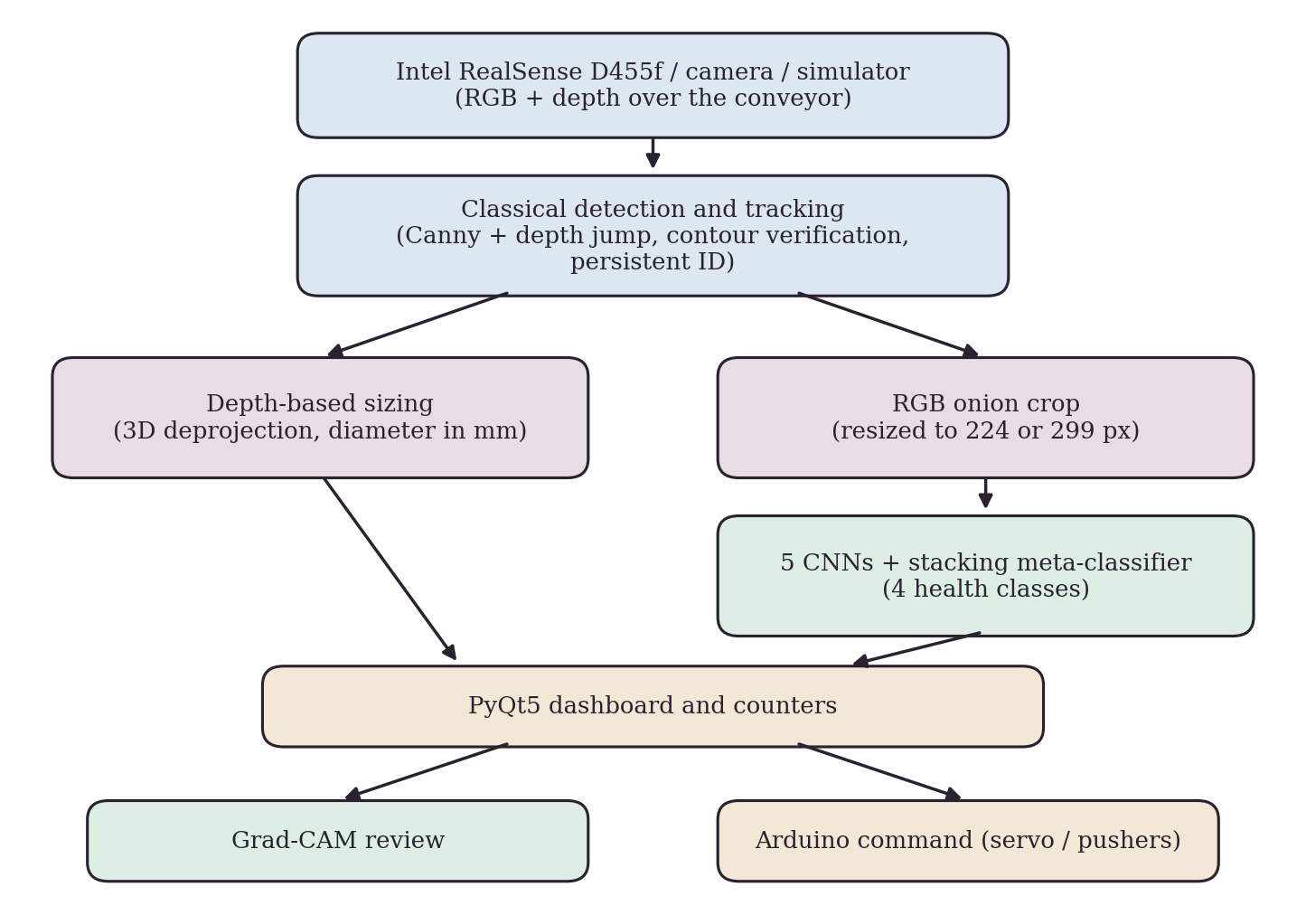
Figure 1: System architecture of the Onion AI Inspection System
Acquisition: the D455f (or a camera or simulator) supplies RGB and depth frames. Detection and tracking: Canny edges and a depth jump isolate each onion, contours, circularity and moments confirm it is round, and each onion keeps a persistent ID. Sizing: depth sampling and 3D deprojection give the diameter in mm. Classification: the RGB crop is classified by the selected Keras model, the stacking meta-classifier or the ensemble. Dashboard and actuation: the PyQt5 dashboard shows counters, Grad-CAM review is generated on demand, and an Arduino command drives the sorting hardware.

8. Methodology
The complete system works in nine steps, from input to output. Steps 1 to 4 use classical 3D vision, steps 5 to 8 form the deep learning lane that judges only the cropped onion, and step 9 performs the sort.
- Capture: RealSense D455f RGB and depth over the conveyor.
- Segment: Canny edges and a depth jump greater than 12 mm isolate each onion.
- Verify: contours, circularity and moments confirm a round onion.
- Size and track: 3D deprojection gives the diameter in mm, with a persistent ID.
- Crop ROI: the tracked onion is resized to 224 or 299 px.
- Five CNNs: ConvNeXt, EfficientNetV2, DenseNet121, ResNet and Xception.
- Meta-classifier: 5 x 4 probabilities give 20 features and the final class.
- Grad-CAM: a heatmap shows the pixels behind Moldy or Rotten calls.
- Sort: the Arduino firmware receives the serial payload and actuates the pushers into the size bins or the reject bin for diseased onions.
In addition, each captured onion's reflectance is compared with the average of 3000 normal onions, and a large deviation rejects it directly.

9. Dataset / Input Data

9.1 Data Source
The Xception training notebook references the Kaggle dataset “Onion Dataset Combined” (kaggle.com/datasets/yashraneja2/onion-dataset-combined). No raw dataset is copied into the repository; the Dataset folder contains a README with access and verification requirements.

9.2 Classes and Input Details
Table 1: Classification classes
Application label | Notebook label | Intended category
Moldy | molded | Onion showing visible mold-related deterioration
Normal | normal | Onion without the targeted visible defects
Rotten | rotten | Onion showing visible rot or decay
Sprouted | sprouted | Onion showing visible sprouting

The classifiers take the RGB crop of a tracked onion (224 x 224 for four base models, 299 x 299 for Xception). The depth stream is used for sizing, and the hyperspectral check uses the average reflectance of 3000 normal onions as its reference.

9.3 Sample Count and Split
The sample count, class distribution, train/validation/test split and license details of the dataset are not recorded in the repository and require confirmation from the dataset owner.

10. Data Preprocessing

10.1 Detection and Verification
Each frame is processed with classical computer vision. Canny edges and a depth jump greater than 12 mm isolate each onion; contours, circularity and moments then confirm that the object is a round onion.

10.2 Measurement Preparation
Depth values are sampled and converted to metric units, and 3D deprojection gives the diameter in millimetres. When the RealSense runtime is not used, pyrealsense2 is replaced by a pinhole-model fallback. The default conveyor depth in the application is 850 mm and must be calibrated for the deployment environment.

10.3 Classifier Input Preparation
The tracked onion is cropped as the region of interest and resized to 224 or 299 px, depending on the model (299 px for Xception). Only this crop is passed to the CNNs, so the deep models never process the full frame.

10.4 Training-time Handling
Augmentation during training is used to handle lighting variation. The Xception notebook uses ImageNet transfer learning with class weights and optional focal loss, and class-balanced retraining is used to reduce misclassification of look-alike diseases.

11. Models / Algorithms
Table 2: Models used in the classification stage
Model | Input size | Output
ConvNeXt-Tiny | 224 x 224 | 4 class probabilities
EfficientNetV2-B0 | 224 x 224 | 4 class probabilities
DenseNet121 | 224 x 224 | 4 class probabilities
ResNet50V2 | 224 x 224 | 4 class probabilities
Xception | 299 x 299 | 4 class probabilities
Stacking meta-classifier | 20 values (5 x 4) | Final health class

The application builds each base architecture in code and loads its weights on demand. The stacking meta-classifier takes the five four-class probability vectors in a fixed order. Ensemble mode averages the five vectors directly and needs no separate checkpoint. DenseNet121 is the default selected model.
The Xception notebook describes 300 epochs, ImageNet transfer learning, class weights, optional focal loss, the AdamW optimizer and checkpointing on validation Macro-F1, with balanced accuracy, per-class metrics and confusion-matrix analysis. Grad-CAM (integrated, 5 steps) produces heatmaps for the Moldy and Rotten calls.
The five-model stacked ensemble with Grad-CAM was selected because it gives accurate and explainable disease calls. Classical 3D vision handles detection and sizing, so no heavy detector is needed on each frame.

12. Implementation
Table 3: Technology stack
Layer | Tools
Programming | Python with OpenCV, NumPy and SciPy
AI / ML | TensorFlow/Keras (ConvNeXt-Tiny, EfficientNetV2-B0, DenseNet121, ResNet50V2, Xception), stacking meta-classifier, Grad-CAM
Application | PyQt5 dashboard with QThread workers
Hardware I/O | pyrealsense2 (pinhole-model fallback), pySerial link to Arduino
Deployment | GitHub, requirements.txt, model files through Git LFS, README

Table 4: Default application settings
Setting | Default
Arduino port / baud rate | COM3 / 9600
Camera index | 0
Capture interval | 4000 ms
Conveyor depth | 850 mm
Default selected model | DenseNet121

The integrated application is started with python SRC/Classification_App/main.py. Inference and Grad-CAM run in worker threads so the interface stays responsive, models are cached, and the CNNs run on crops only. The detection and measurement application runs with a camera or with the --simulate option.

13. Hardware / Software Integration

13.1 Hardware Components
- Intel RealSense D455f depth camera.
- Conveyor belt with enclosed LED lighting.
- Arduino with servo or pneumatic pushers.
- Sorting bins: four size grades and a reject bin.

13.2 Software and Hardware Integration
The depth subsystem provides RGB and depth acquisition, camera-device inspection, contour and edge analysis, persistent multi-object tracking, depth sampling with metric conversion, simulator-based offline operation and CSV measurement output. The tracker is velocity-compensated for onions moving on the belt.
The sketch SRC/Hardware/arduino_servo_control.ino contains the servo-control code and is uploaded with the Arduino IDE. The main application connects to the Arduino through pySerial at startup (COM3, 9600 baud by default); if no controller is attached it reports a warning and continues. For each onion, the serial payload carries the decision, and the Arduino firmware actuates the pushers into the <40, 40-50, 50-60 and >60 mm bins or the reject bin.
A simulated-camera mode allows testing without hardware, and a calibrated actuation delay with periodic recalibration addresses actuator timing drift.

14. Results and Evaluation
Table 5: Diameter measurement, actual vs app
Onion | Actual (mm) | App (mm) | Error (mm) | Abs. error (mm)
1 | 38.5 | 39.7 | +1.2 | 1.2
2 | 44.2 | 42.9 | -1.3 | 1.3
3 | 52.8 | 54.6 | +1.8 | 1.8
4 | 58.6 | 57.1 | -1.5 | 1.5
5 | 66.1 | 68.3 | +2.2 | 2.2
Mean |  |  |  | 1.6
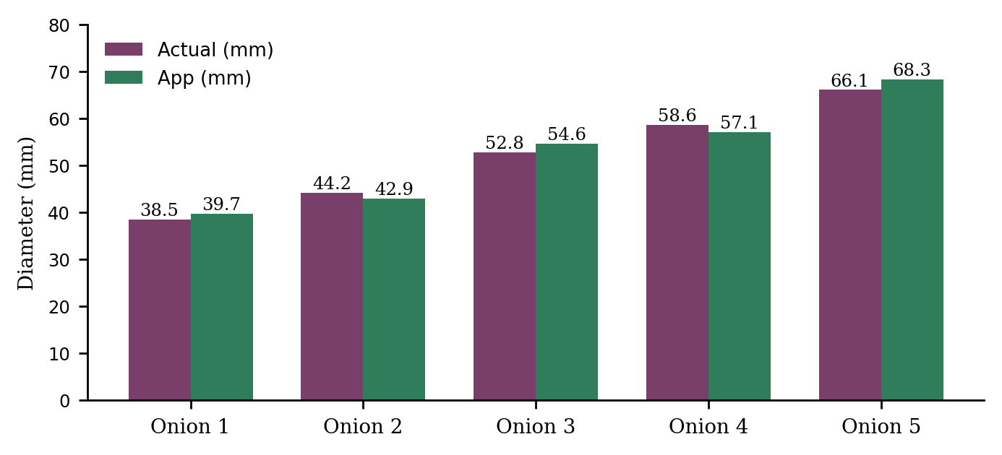
Figure 2: Actual and app-measured onion diameters
The mean absolute error over five onions is 1.6 mm and the size grade accuracy is 94%. Overall classification metrics (accuracy, Macro-F1, balanced accuracy and confusion matrix) are not reported in the repository and are to be recomputed on the confirmed dataset split; the three Grad-CAM examples in the repository must not be treated as an accuracy estimate.

15. Prototype / Application
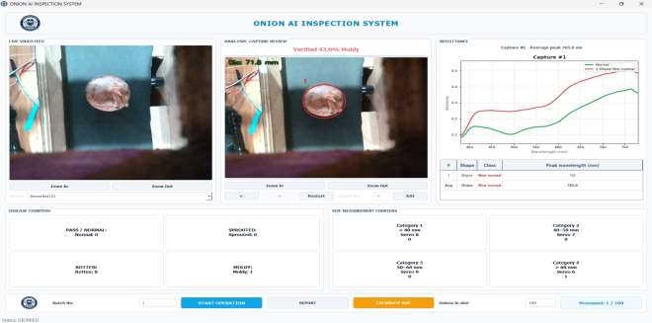
Figure 3: Dashboard with live video feed, capture review (size and class), reflectance plot, disease and size counters and batch controls
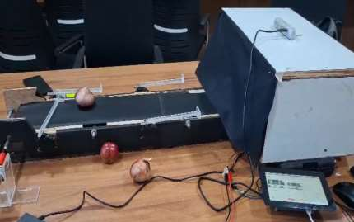
Figure 4: Working prototype with conveyor belt and camera enclosure
The dashboard shows the live feed, the verified capture with the measured size and predicted class, and the counters for each disease class and size category.

16. Discussion

16.1 Advantages
- Consistent, automated decisions replace slow, subjective manual grading.
- Early removal of moldy and rotten onions limits spread of infection in stored lots.
- Light classical CV suits edge deployment; CNNs run on crops only.
- Grad-CAM makes AI decisions explainable, and the design is modular.

16.2 Challenges and Strategies
Table 6: Challenges and strategies
Challenge | Strategy
Lighting, dust, belt glare | Enclosed LED lighting; lighting-independent depth channel; augmentation
Touching or rolling onions | Depth-discontinuity segmentation; velocity-compensated tracker
Look-alike diseases | Stacking ensemble, Grad-CAM audit, class-balanced retraining
Heavy CNNs slow the line | CNNs on crops only, in QThread workers with cached models
Actuator drift, camera failure | Calibrated delay, periodic recalibration, simulated-camera fallback

17. Limitations
- Dataset statistics and license details require confirmation; overall model metrics were not supplied.
- RealSense sizing accuracy depends on calibration and scene geometry; hardware defaults are hard-coded.
- The depth subsystem was originally documented for boxes, so its suitability for onion geometry needs dedicated validation.
- No installer or demo video has been packaged yet.

18. Future Scope
- Recompute accuracy, Macro-F1, balanced accuracy, per-class precision/recall/F1 and a confusion matrix on the confirmed dataset split.
- Build and test an installer: validate model and asset paths, package the TensorFlow and RealSense runtimes, and test installation on a clean computer.
- Validate depth sizing for onion geometry and replace hard-coded hardware defaults after calibration.
- Extend the approach to other round produce.
Because the camera, models and sorting hardware can each be swapped or upgraded, and the hardware cost is modest, the system suits FPOs and packhouses.

19. Conclusion
The Onion AI Inspection System addresses subjective and inconsistent onion grading with a working prototype in which 3D sizing, tracking, five-model AI classification and the dashboard are built. The hybrid design lets depth sensing find and size each onion while deep learning only judges health, and Grad-CAM keeps the decisions explainable. In the prototype measurements, the mean absolute diameter error was 1.6 mm and the size grade accuracy was 94%. Remaining work is to complete the evaluation of the classifiers and package the system for deployment.

20. References
[1] Raj, Anusha, et al. “YOLO-ODD: an improved YOLOv8s model for onion foliar disease detection.” Frontiers in Plant Science 16 (2025): 1551794.
[2] Asnakew, Asrat Kibret, et al. “A novel ensemble deep learning approach for detection and classification of onion diseases.” Discover Applied Sciences 7.5 (2025): 482.
[3] Yang, Chen, et al. “Hyperspectral imaging and deep learning for quality and safety inspection of fruits and vegetables: A review.” Journal of Agricultural and Food Chemistry 73.17 (2025): 10019-10035.
[4] Onion Dataset Combined, Kaggle: kaggle.com/datasets/yashraneja2/onion-dataset-combined.

Tools and Libraries
Python, OpenCV, NumPy, SciPy, TensorFlow/Keras, pyrealsense2, PyQt5, pySerial, Arduino IDE, Git LFS.

GitHub Repository
https://github.com/SMARTLAB-SU/SIH-CepaMetric-26031

QR code to the GitHub repository

Acknowledgements
The team thanks the Farmer Producer Company at Sanvatsar, Maharashtra, which provided guidance and technical inputs, as recorded in its Certificate of Guidance.

