PROJECT REPORT
LOW-COST
HYPERSPECTRAL
IMAGING SYSTEM
A Portable RGB-Based Spectral Imaging Prototype

Prepared by
Vedika Pangavhane
B.Tech 2nd Year – Artificial Intelligence & Machine Learning
Sanjivani University, Kopargaon, Maharashtra

Guide / Mentor
Dr. Arvind Mukundan

Individual Project

GitHub: github.com/SMARTLAB-SU/Hyperspectral-Imaging

2. ABSTRACT
The Low-Cost Hyperspectral Imaging System is a compact imaging prototype developed to make spectral imaging more accessible using commonly available imaging hardware and software-based spectral reconstruction. Conventional hyperspectral cameras can be specialized and costly, while an RGB camera provides only three broad colour channels. The proposed system addresses this gap by taking an RGB or white-light image and processing it to generate an HSI-style spectral representation with selectable wavelength bands.
The project is based on the Spectrum-Aided Vision Enhancer (SAVE) spectral reconstruction approach. The underlying method establishes a relationship between camera colour information and spectral measurements using a 24-colour Macbeth Color Checker. RGB values are normalized and transformed into the CIE 1931 XYZ colour space, followed by camera correction. Principal Component Analysis (PCA) is then used to reduce the spectral information and multiple regression is used for reconstruction. The source study reports that six principal components captured 99.64% of the information, with a mean spectral RMSE of 0.056 and an average colour difference of 0.75.
The developed prototype integrates a Raspberry Pi 5, Camera Module 3, 64 GB SD card, 7-inch display, power supply, connecting wires and a protective outer body. The application provides gain adjustment, wavelength-band selection, sample number entry, live/photo modes, image upload, capture and save functions. The interface displays the original image beside the processed spectral view, allowing immediate visual comparison.
The resulting system demonstrates a practical route toward portable and lower-cost spectral imaging experimentation. The present prototype is intended as an imaging and research platform rather than a clinically validated diagnostic device. Future work can improve spectral calibration, expand wavelength coverage, optimize real-time processing and evaluate the system on application-specific datasets.

3. TABLE OF CONTENTS
No. | Section | Page
1 | Cover Page | 1
2 | Abstract | 2
3 | Table of Contents | 3
4 | Introduction | 4
5 | Problem Statement | 5
6 | Objectives | 6
7 | Literature Review / Existing System | 7
8 | Proposed System | 8
9 | System Architecture | 9
10 | Methodology / Workflow | 10
11 | Dataset / Input Data | 11
12 | Data Preprocessing | 12
13 | Models / Algorithms Used | 13
14 | Implementation Details | 14
15 | Hardware / System Integration | 15
16 | Results and Evaluation | 16
17 | Application / Prototype Screenshots | 17
18 | Advantages, Limitations and Discussion | 18
19 | Future Scope and Conclusion | 19
20 | References and GitHub Repository | 20
Note: The report follows the supplied maximum-20-page project-report structure and keeps the technical results of the SAVE research separate from measurements that have not yet been independently benchmarked on the present hardware prototype.

4. INTRODUCTION
Hyperspectral imaging (HSI) extends conventional imaging by representing a scene across multiple wavelength bands rather than only the three channels of a standard RGB image. The additional spectral information can reveal differences in material composition, surface characteristics and reflectance that may not be obvious in ordinary colour images. This makes spectral imaging relevant to medical imaging, agriculture, food inspection, material analysis and computer vision research.
A major practical challenge is the cost and complexity of dedicated hyperspectral acquisition hardware. A full HSI camera generally requires specialized sensors, optics, illumination and data-processing hardware. For educational laboratories, rapid prototyping and early-stage research, such systems may be difficult to deploy widely. An RGB-based spectral reconstruction approach offers an alternative by using an accessible camera and computational processing to estimate spectral information.
The SAVE research supplied with this project describes a band-selection mechanism that transforms RGB or white-light images into hyperspectral images and simulated narrow-band imaging (NBI). Its calibration workflow uses the X-Rite/Macbeth 24-colour chart and spectrometer-derived spectral data. The RGB camera data are transformed to CIE XYZ and corrected before PCA and regression are used for spectral reconstruction. The source document demonstrates that the reconstructed spectra can closely reproduce the calibration colours. fileciteturn3file0L5-L38
The present project converts this research concept into a portable low-cost prototype. The system combines the imaging hardware, an integrated 7-inch display and an interactive application so that a user can observe the original image and the processed spectral representation in one interface. The prototype therefore acts as a bridge between a research algorithm and a usable imaging instrument.

5. PROBLEM STATEMENT
The central problem addressed by this project is the difficulty of obtaining useful hyperspectral information with a compact, affordable and easy-to-operate imaging system. Standard RGB cameras are inexpensive and widely available, but their three-channel representation cannot directly provide the dense spectral information available from a dedicated hyperspectral sensor.
The project therefore focuses on developing a low-cost system that can capture an RGB/white-light image and computationally reconstruct spectral information while keeping the acquisition hardware simple. The solution should be portable, provide an interactive interface and allow the user to inspect selected wavelength bands rather than requiring a large laboratory imaging system.
The key technical challenges are camera response variation, nonlinear colour response, dark current, colour distortion, spectral reconstruction accuracy and real-time visualization. The SAVE source study specifically treats camera calibration as a crucial part of the reconstruction process and reports a substantial reduction in mean chromatic aberration after calibration. fileciteturn3file0L339-L358
Target users include students, researchers, laboratory teams and prototype developers who need a practical platform for spectral-imaging experimentation. The present system is not positioned as a replacement for a certified hyperspectral camera or as a clinically approved diagnostic device. Instead, it provides a low-cost research and demonstration platform on which spectral reconstruction, band selection and imaging workflows can be studied.

6. OBJECTIVES
The main objective is to develop a portable low-cost hyperspectral imaging prototype that uses an RGB/white-light image as input and produces a processed spectral representation through software-based reconstruction.
- Develop a compact imaging unit using Raspberry Pi 5, Camera Module 3 and an integrated 7-inch display.
- Implement an application capable of acquiring live images and processing uploaded or captured images.
- Apply spectral reconstruction principles based on camera calibration, PCA and regression.
- Provide adjustable gain control to improve the visibility of image details during processing.
- Provide user-selectable wavelength bands for spectral visualization.
- Display the original image and processed spectral image together for direct comparison.
- Support capture and saving of processed results for later analysis.
- Evaluate the reconstruction approach using established colour and image-similarity metrics reported in the SAVE research.
- Create a foundation for future application-specific spectral analysis and classification.
The objectives intentionally combine hardware development and computational imaging. This makes the project more than a software demonstration: the final outcome is a portable integrated prototype with an imaging interface.

7. LITERATURE REVIEW / EXISTING SYSTEM
The supplied SAVE document describes a spectral reconstruction method for transforming an RGB or white-light endoscopic image into a hyperspectral representation and a simulated NBI image. The method first establishes the relationship between camera colour response and spectrometer measurements using a 24-colour Macbeth/X-Rite Color Checker. The camera image is converted from sRGB into CIE 1931 XYZ space, while spectral reflectance data are also converted into the same colour space for comparison. fileciteturn3file0L14-L38
The source methodology further introduces camera-response corrections for nonlinear response and dark current. PCA is applied to spectral reflectance data and the most significant components are used for multivariate regression. Six principal components were reported to account for 99.64% of the information. The resulting reconstruction produced a mean RMSE of 0.056 for the 24 colour blocks and an average colour difference of 0.75. fileciteturn3file0L205-L244
The research also extends the spectral representation to NBI-style imaging. It identifies 415 nm blue and 540 nm green as important bands because of their relationship with hemoglobin absorption, and additionally considers spectral regions around 600, 700 and 780 nm. fileciteturn3file0L522-L555 fileciteturn3file0L637-L657
The gap addressed by the present project is practical integration. Instead of stopping at a research algorithm, the project packages the imaging workflow into a compact hardware unit with a display and interactive controls. This makes the reconstruction approach easier to demonstrate, operate and extend in a laboratory setting.

8. PROPOSED SYSTEM
The proposed system is a portable RGB-based spectral imaging platform. A Camera Module 3 captures the scene and provides the RGB input. The Raspberry Pi 5 acts as the computing unit and runs the imaging application. The processed output is shown on a 7-inch display mounted within the enclosure.
The application provides a practical interface for spectral inspection. The current interface includes Gain Settings, four band slots, Sample Settings, Photo and Video modes, Upload Image, Resume Live, Capture and Save. In the shared prototype screen, Band 1 is set to 405–435 nm, Band 2 to 515–555 nm and Band 3 to 600–650 nm, while Band 4 is available for another selected range.
The proposed workflow is: capture image → preprocess and normalize RGB data → apply camera/spectral calibration → reconstruct spectral information → select wavelength bands → generate processed visualization → display and save the result. This structure allows the user to change band settings without changing the physical camera hardware.
The main novelty of the prototype is the integration of a research-oriented RGB-to-spectral reconstruction workflow into a low-cost portable unit. The system emphasizes accessibility, modularity and interactive visualization. It can therefore serve as a development platform for future work in medical imaging, plant analysis, food inspection and other areas where spectral differences may be useful.

9. SYSTEM ARCHITECTURE
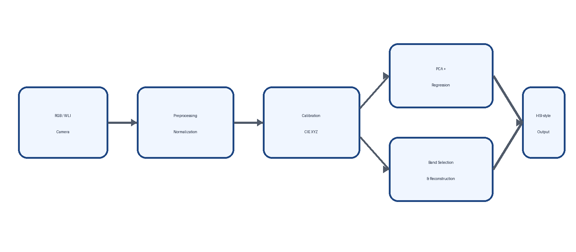
Figure 1. Proposed system architecture for the low-cost hyperspectral imaging prototype.
The architecture begins with image acquisition from the RGB/white-light camera. The captured image is passed to preprocessing, where image values are normalized and prepared for the reconstruction pipeline. Calibration maps the camera response toward a standard colour representation, reducing errors caused by nonlinear camera behaviour and other response differences.
The spectral reconstruction stage uses dimensionality reduction and regression principles described in the SAVE research. PCA extracts the most significant spectral components, while regression maps the calibrated colour variables to the spectral representation. The resulting information can then be sampled into user-defined wavelength bands.
The final band-selection stage generates the processed visualization displayed to the user. The application maintains the original image and processed image as separate views, which allows the user to compare the visible scene with the spectral-enhanced representation.
The hardware and software are therefore tightly integrated: the Raspberry Pi performs computation, the camera provides input, the display provides feedback, and the enclosure provides a portable physical form.

10. METHODOLOGY / WORKFLOW
Step 1 – Image Acquisition
The Camera Module 3 captures an RGB image of the target. The application can operate in photo/live modes or accept an uploaded image.
Step 2 – RGB Preparation
The input RGB values are normalized. In the SAVE methodology, sRGB values are converted to a 0–1 range and linearized using gamma correction.
Step 3 – Colour Calibration
Camera RGB values are converted into CIE 1931 XYZ. The calibration stage accounts for camera response and aligns the camera representation with spectral reference information.
Step 4 – Spectral Representation
Spectral reflectance information is represented using principal components. The SAVE method uses the most significant PCs and multiple regression to reconstruct spectral information.
Step 5 – Band Selection
The application allows wavelength intervals to be selected for multiple bands. These bands determine how the processed image is visualized.
Step 6 – Visualization
The reconstructed/selected spectral information is converted into a displayable processed image and shown beside the original image.
Step 7 – Output
The user can capture or save the processed result for documentation and later analysis.
The research source also explains that the spectral data were organized from approximately 380–780 nm at 1 nm intervals and converted to XYZ using the light-source spectrum and colour-matching functions. fileciteturn3file0L92-L120

11. DATASET / INPUT DATA
The project does not depend on a conventional machine-learning class dataset for the current prototype demonstration. Instead, the primary input is an RGB/white-light image acquired from the camera or supplied as an uploaded image. The reconstruction method is calibrated using spectral reference information.
The underlying SAVE research uses the Macbeth/X-Rite Classic 24-colour Color Checker. The chart contains 24 colour patches representing a range of colours and grey levels. Camera images of the chart are compared with spectrometer-derived spectral information. This provides a controlled reference for establishing the relationship between camera colour response and spectral data. fileciteturn3file0L18-L38
Spectral reflectance data in the source study are represented over approximately 380–780 nm with 1 nm intervals. The spectra are organized as a matrix with wavelength samples and the 24 colour patches. PCA is then applied to the spectral dataset to obtain the principal components used for reconstruction. fileciteturn3file0L179-L201
Input / Reference | Role in System
RGB / WLI image | Primary image input
24-colour checker | Camera colour calibration
Spectral reflectance data | Reference spectral information
380–780 nm spectral range | Source reconstruction range
User-selected bands | Output visualization ranges
Table 1. Main input and reference data used by the reconstruction workflow.

12. DATA PREPROCESSING / PREPARATION
Preprocessing is required because raw RGB camera values do not directly represent physical spectral reflectance. The SAVE workflow first converts the camera's sRGB values from the 0–255 representation into normalized values between 0 and 1. A gamma-based linearization step is then applied to compensate for the nonlinear response of the sRGB representation. fileciteturn3file0L41-L80
The normalized and linearized RGB values are transformed into the CIE 1931 XYZ colour space. This provides a common colour representation that can be related to spectral reference data. The source document also considers non-linear camera response and dark current as factors that may introduce differences between camera and spectrometer measurements. fileciteturn3file0L52-L60
For the prototype interface, preprocessing also includes preparing the captured frame for display and applying the selected gain. Band limits entered by the user are used to determine which spectral intervals contribute to the processed visualization. The application therefore combines scientific preprocessing with user-controlled image presentation.
- Normalize input image values.
- Linearize sRGB values using gamma correction.
- Convert camera colour information into CIE XYZ representation.
- Apply camera-response correction based on calibration.
- Prepare spectral components for reconstruction.
- Select wavelength ranges specified by the user.
- Generate the processed display image.
The preprocessing stage is critical because poor calibration can propagate errors through the complete reconstruction pipeline. The source study reports that camera calibration reduced average chromatic aberration from 10.76 to 0.63 for the 24 colour blocks. fileciteturn3file0L339-L358

13. MODELS / ALGORITHMS USED
The core of the system is a spectral reconstruction workflow rather than a conventional image-classification model. The major mathematical components are colour-space transformation, camera correction, Principal Component Analysis and multiple regression.
CIE 1931 XYZ Transformation
Linearized RGB values are mapped to XYZ to create a standardized colour representation suitable for calibration.
Camera Correction
Correction variables account for colour response, nonlinear response and dark-current effects.
Principal Component Analysis
PCA reduces the spectral dimensionality. The SAVE study reports that six principal components captured 99.64% of the information.
Multiple Regression
The significant spectral components are related to calibrated colour variables to estimate the spectral representation.
Band Selection
Specific wavelength intervals are selected to produce the processed spectral view and support NBI-style visualization.
The source study reports that six principal components were selected from the spectral reflectance data and used in multivariate regression. The six PCs accounted for 99.64% of the information. The mean RMSE between reconstructed and reference spectral information for the 24 colours was 0.056. fileciteturn3file0L205-L244
For NBI-style processing, the source identifies 415 nm and 540 nm as important blue and green bands, with additional regions around 600, 700 and 780 nm considered in the complete spectral process. fileciteturn3file0L522-L555 fileciteturn3file0L653-L657

14. IMPLEMENTATION DETAILS
The project is implemented as an integrated hardware-software imaging system. The computing platform is a Raspberry Pi 5 connected to a Camera Module 3 and a 7-inch display. The application provides a graphical interface for image acquisition, processing and output visualization.
The interface shown in the prototype includes the following controls: Gain Settings, Band Settings for four bands, Sample Settings, Photo, Video, Upload Image, Resume Live, Capture and Save. The current demonstration image shows a gain value of 2.5× and wavelength ranges of 405–435 nm, 515–555 nm and 600–650 nm for the first three bands. The fourth band is available for configuration.
The implementation is designed around an interactive processing loop. The camera or uploaded image is passed to the processing module, the reconstruction and selected bands are applied, and the processed image is displayed alongside the original. The user can change parameters and observe the effect on the processed visualization.
Software / Interface Element | Purpose
Gain Settings | Adjust processing intensity / image visibility
Band Settings | Set wavelength limits for selected bands
Sample No. | Identify or track the current sample
Photo / Video | Select image or live acquisition mode
Upload Image | Process an existing image
Capture / Save | Store a result for documentation
Table 2. Main application controls visible in the prototype interface.

15. HARDWARE / SYSTEM INTEGRATION
The physical prototype packages the imaging and computing components into a portable enclosure. The selected hardware is intended to keep the system compact while providing enough processing capability for the application and a dedicated screen for user interaction.
Hardware | Function
Raspberry Pi 5 | Main computing and control platform.
Camera Module 3 | Captures RGB/white-light images for processing.
7-inch Display | Provides the graphical interface and original/processed image views.
64 GB SD Card | Stores the operating system, application and project data.
Power Supply | Provides electrical power to the computing and display system.
Connecting Wires | Provide required electrical and signal connections between components.
Outer Body / Enclosure | Protects and holds the components as a portable unit.
Table 3. Hardware components used in the prototype.
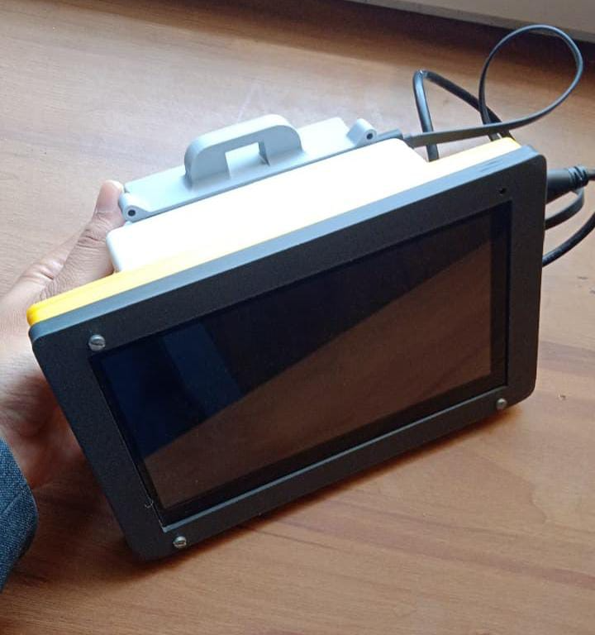
Figure 2. Physical low-cost hyperspectral imaging prototype with integrated display and enclosure.

16. RESULTS AND EVALUATION
The available quantitative validation results originate from the SAVE spectral reconstruction research and are included here as evidence for the underlying reconstruction method. They should not be interpreted as independently measured accuracy of the present Raspberry Pi hardware unless a separate hardware benchmark is performed.
Metric | Reported result
PCA information | 99.64% captured by six principal components.
Spectral reconstruction RMSE | Mean RMSE of 0.056 for the 24 colour blocks.
Average colour difference | 0.75 between reconstructed and reference colour representations.
Camera chromatic aberration | Reduced from 10.76 before calibration to 0.63 after calibration.
NBI colour difference | Average CIEDE2000 difference of 2.79 after NBI colour calibration.
SSIM | Average reported SSIM was 93.992% for Olympus and 90.680% for VCE in the study.
Table 4. Selected validation results from the SAVE source study.
The source study reports that six PCs accounted for 99.64% of the information, the mean spectral RMSE was 0.056 and the average colour difference was 0.75. fileciteturn3file0L205-L244 The camera calibration reduced mean chromatic aberration to 0.63. fileciteturn3file0L353-L390 The reported SSIM averages were 90.680% for VCE and 93.992% for Olympus. fileciteturn6file8

17. APPLICATION / PROTOTYPE SCREENSHOTS
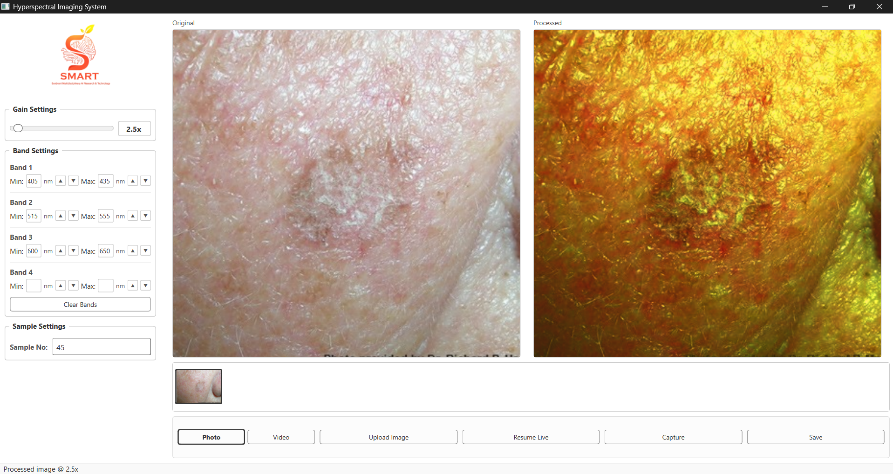
Figure 3. Current application interface showing original and processed views, gain control, wavelength-band settings and capture controls.
The application provides a side-by-side visualization of the input and processed image. The left panel contains gain and band controls, while the main workspace shows the original and processed images. A thumbnail area provides the current sample preview, and the lower control bar provides Photo, Video, Upload Image, Resume Live, Capture and Save operations.
In the demonstrated configuration, the gain is set to 2.5×. Band 1 is configured for 405–435 nm, Band 2 for 515–555 nm and Band 3 for 600–650 nm. These controls make the application suitable for experimenting with different spectral regions and observing their effect on the processed visualization.
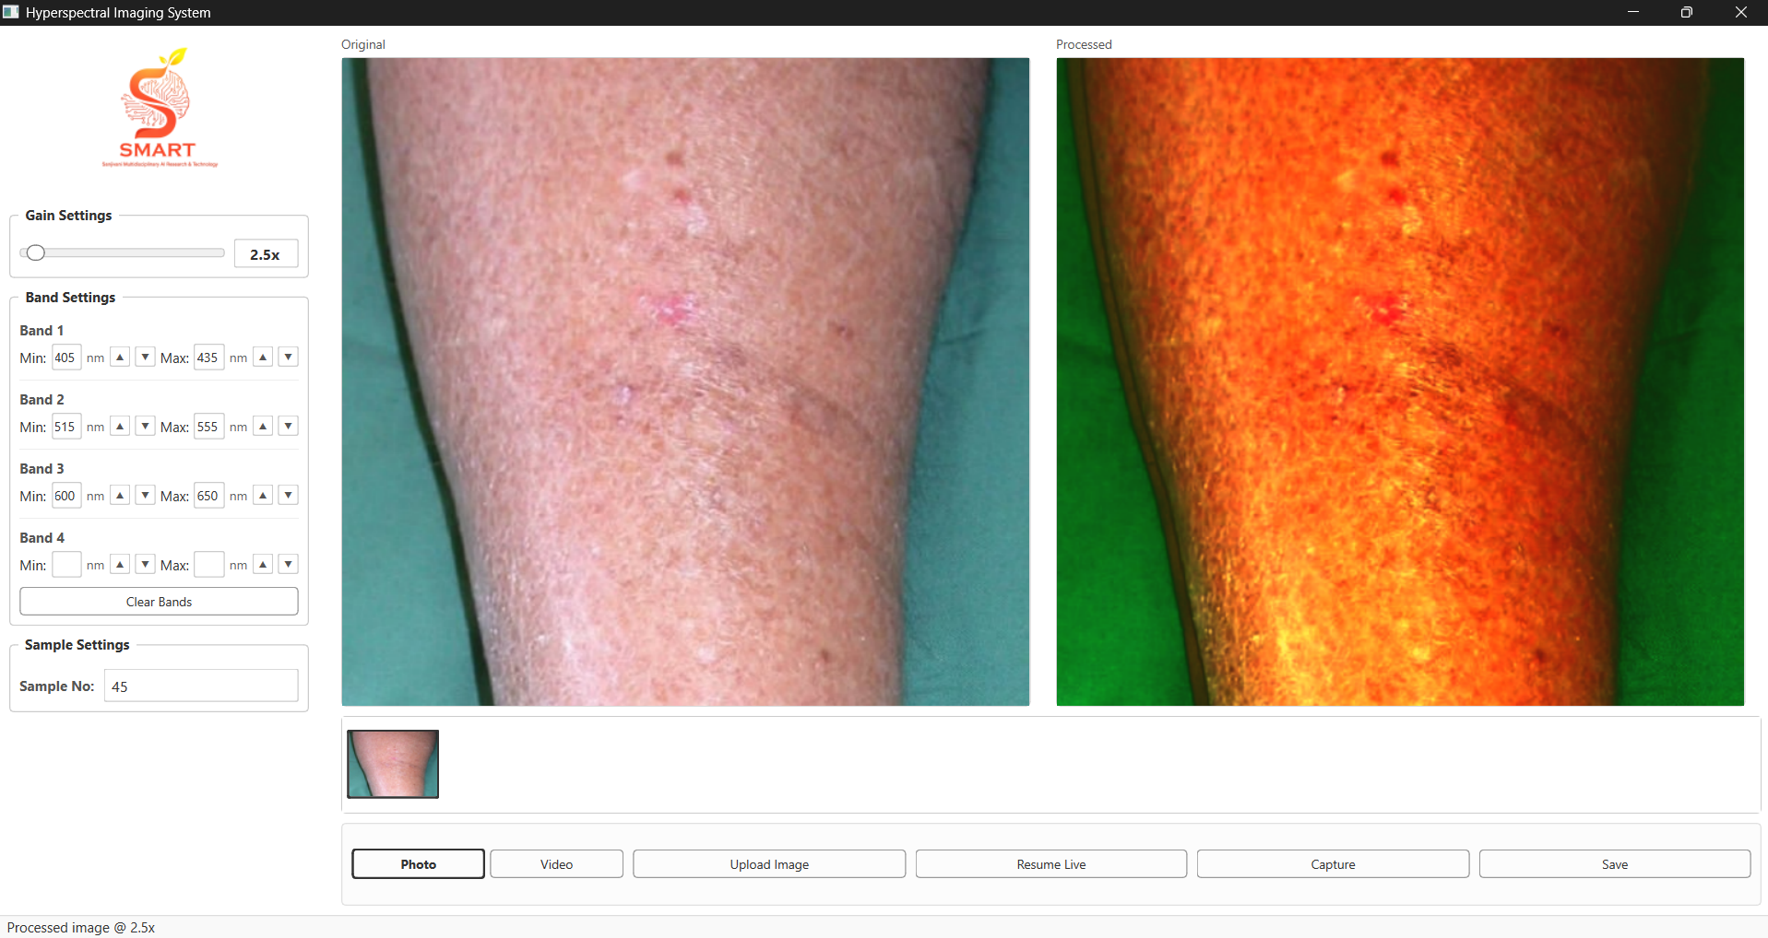
Figure 4. Second application sample showing a different processed spectral visualization.

18. ADVANTAGES, LIMITATIONS AND DISCUSSION
Advantages
- Lower-cost and more accessible than a dedicated hyperspectral camera for prototyping.
- Portable form factor with integrated computing and display.
- Interactive gain and wavelength-band controls.
- Supports live acquisition as well as uploaded images.
- Provides original-versus-processed visual comparison.
- Provides a platform for future application-specific spectral analysis.
Limitations
- The current RGB-based reconstruction estimates spectral information; it is not equivalent to direct measurement by a dedicated hyperspectral sensor.
- Hardware-specific spectral calibration and quantitative benchmarking still need to be performed on the final prototype.
- Reconstruction quality depends on camera characteristics, illumination and calibration.
- The source study identifies larger spectral discrepancy for the red colour region, particularly around 600–780 nm.
- Clinical or industrial decisions should not be based on the current prototype without application-specific validation.
The source study explicitly identifies the red colour block as having the greatest disparity between simulated and observed reflectance, particularly in the 600–780 nm range. It also notes that the VCE SSIM evaluation used 50 randomly selected images and that increasing the number of images could improve the evaluation. fileciteturn3file0L353-L390 fileciteturn3file0L744-L764

19. FUTURE SCOPE AND CONCLUSION
Future Scope
- Perform complete hardware calibration against a reference spectrometer for the actual Camera Module 3 and illumination setup.
- Improve spectral reconstruction accuracy and extend validated wavelength coverage.
- Optimize the processing pipeline for smoother real-time operation on Raspberry Pi 5.
- Add automatic band presets for specific applications such as plant health, food inspection or surface analysis.
- Develop application-specific detection/classification models after collecting appropriately labelled spectral data.
- Improve enclosure design, mounting, thermal management and cable organization for field deployment.
- Expand the validation dataset and compare reconstructed spectra against direct hyperspectral measurements.
Conclusion
The Low-Cost Hyperspectral Imaging System demonstrates how RGB imaging, spectral reconstruction and portable embedded computing can be combined into a practical research prototype. The system uses Raspberry Pi 5, Camera Module 3, a 7-inch display and a compact enclosure to provide an integrated imaging platform. Its application exposes gain and wavelength-band controls and displays the original image together with a processed spectral visualization.
The underlying SAVE methodology provides a strong technical basis for this approach. Its reported calibration and reconstruction results demonstrate that meaningful spectral information can be estimated from RGB/white-light imaging when camera response is properly calibrated and the reconstruction model is trained against spectral reference data. The current prototype is therefore a foundation for further experimental validation and application-specific development.

20. REFERENCES AND GITHUB REPOSITORY
[1] Spectrum-Aided Vision Enhancer (SAVE), supplied project research document, used as the technical basis for RGB/WLI-to-HSI spectral reconstruction, camera calibration, PCA, regression, band selection and evaluation.
[2] SMARTLAB-SU, “Hyperspectral-Imaging,” GitHub repository. https://github.com/SMARTLAB-SU/Hyperspectral-Imaging
[3] X-Rite / Macbeth ColorChecker Classic, 24-colour reference chart, used in the SAVE calibration methodology.
[4] CIE 1931 XYZ colour space and colour-matching functions, as used in the spectral-to-colour conversion workflow described in the supplied SAVE document.
[5] Structural Similarity Index (SSIM), used in the supplied SAVE study for reconstructed-image comparison.
[6] CIEDE2000 colour-difference metric, used in the supplied SAVE study for colour calibration and comparison.
PROJECT GITHUB REPOSITORY
https://github.com/SMARTLAB-SU/Hyperspectral-Imaging
Acknowledgement: The project documentation uses the supplied SAVE research document as the technical reference for the spectral reconstruction methodology and uses the supplied prototype images to document the current hardware and application implementation.
Prepared by: Vedika Pangavhane | B.Tech 2nd Year – AIML | Sanjivani University, Kopargaon, Maharashtra
Guide / Mentor: Dr. Arvind Mukundan

