Spectrum-Aided Vision Enhancer (SAVE)
The research developed a spectral reconstruction through band selection mechanism capable of transforming an RGB or a white-light image (WLI) captured from an endoscope into a hyperspectral image (HSI) and a simulated NBI image similar to Olympus’s NBI known as SAVE as depicted in Figure 1. Firstly, it is necessary to establish the correlation between the WLI image and the spectrometer for various colors. The Macbeth Color Checker (X-Rite Classic) is specifically marked as the set of colors to be used for calibration purposes. This tool comprises 24 squares displaying various color samples typically encountered in nature, including hues such as red, green, blue, cyan, magenta, and yellow, with six tons of gray. X-Rite has gained popularity as a preferred option for color calibration in recent years. The endoscopic camera was predominantly employed to collect photos that accurately represented the colors of the X-Rite board, also known as the target. The image consisting of 24 colors was converted to the CIE 1931 XYZ color space. The endoscopic images were saved in JPEG format using the standard RGB (sRGB) color scheme. The R, G, and B values of the sRGB color space, ranging from 0 to 255, were first converted to a narrower range between 0 and 1. Subsequently, the Gamma function was employed to convert the reduced sRGB values into linearized RGB values. A translation matrix was employed to convert the linearized RGB values into the CIE 1931 color space and depict the numerical relationship between the wavelengths in the visible spectrum and the perceived colors in nature. On the other hand, images taken with an endoscope can be influenced by non-linear response, dark current, incorrect color separation, or color distortion. Subsequently, the CIE XYZ tristimulus values are derived by converting these normalized RGB values into XYZ values as XYZcamera. This conversion is facilitated through the application of a specific transformation formula as shown in Equation 1.
$$\left[\begin{aligned}X \\ Y \\ Z\end{aligned}\right]=[M_{A}]\left[T\right]\left[\begin{aligned}f\left(R_{sRGB}\right) \\ f\left(G_{sRGB}\right) \\ f(B_{sRGB})\end{aligned}\right]×100 , 0≤{R_{sRGB} \atop \begin{aligned}G_{sRGB} \\ B_{sRGB}\end{aligned}} ≤1$$ | (1)
$$\left[T\right]=\left[\begin{aligned}0.4104 0.3576 0.1805 \\ 0.2126 0.7152 0.0722 \\ 0.0193 0.1192 0.9505\end{aligned}\right]$$ | (2)
$$\left[M_{A}\right]=\left[\begin{aligned}{X_{SW}}/{X_{CW}} 0 0 \\ 0 {Y_{SW}}/{Y_{CW}} 0 \\ 0 0 {Z_{SW}}/{Z_{CW}}\end{aligned}\right]$$ | (3)
where 0≤ R_{sRGB}, G_{sRGB}, B_{sRGB} ≤1. Here, R_{sRGB}, G_{sRGB}, and B_{sRGB} denote the three color channels of the sRGB image. These channel values are linearized through a function defined by gamma correction. For sRGB images, this correction can be approximated by a power function with an exponent of 2.4, incorporating a linear segment for lower values to account for the non-linear sensitivity of human vision at these intensities. The formula for removing gamma correction, or linearization, is defined in Equation 4.
$$f\left(n\right)= \left\{\begin{aligned}{(\frac{n+0.055}{1.055})}^{2.4}, n>0.04045 \\ \left(\frac{n}{12.92}\right), otherwise\end{aligned}\right.$$ | (4)
Converting the obtained spectral data R(λ) (380 nm ~ 780 nm, 1 nm) into the XYZ color gamut space requires the light source spectrum S(λ) of the ophthalmoscope hyperspectral system, and the XYZ color matching function. Through equations 5, 6 and 7, the spectral data are converted into the XYZ values as XYZ_{spectrometer}. The brightness ratios is given in Equation 8.
$$X=k\int_{400nm}^{700nm}{S\left(λ\right)R\left(λ\right)\overline{x}\left(λ\right)dλ}$$ | (5)
$$Y=k\int_{400nm}^{700nm}{S\left(λ\right)R\left(λ\right)\overline{y}\left(λ\right)dλ}$$ | (6)
$$Z=k\int_{400nm}^{700nm}{S\left(λ\right)R\left(λ\right)\overline{z}\left(λ\right)dλ}$$ | (7)
$$k=100/\int_{400nm}^{700nm}{S\left(λ\right)\overline{y}\left(λ\right)dλ}$$ | (8)
where S(λ) is the light source spectrum in XYZ color gamut space, $\overline{x}$(λ), $\overline{y}$(λ), and $\overline{z}$(λ) are the XYZ values of color matching function. The spectral data signal R(λ) from the spectrometer are converted to the XYZ color space. Equation 9 was employed to find the color correlation between the spectrophotometer and camera. Equation 10 was used to calculate the updated X, Y, and Z values (XYZ_{correct}) after error correction.
$$\left[C\right]=\left[{XYZ}_{Spectrum}\right]×pinv(\left[V\right])$$ | (9)
$$\left[{XYZ}_{Correct}\right]=\left[C\right]×[V]$$ | (10)
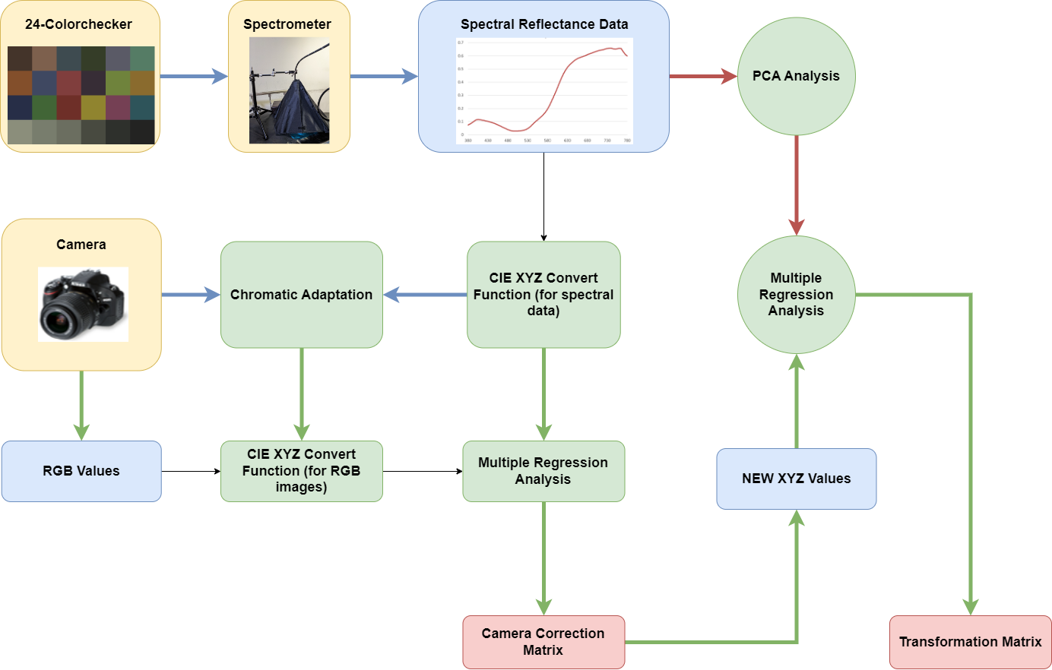
Figure 1. VIS-HSI imaging algorithm
The camera's nonlinear response can be adjusted using a third-order formula, and the variable that represents the modification of the nonlinear response is defined as V_{Non-linear}.
$$V_{Non-linear}={\left[X^{3} Y^{3} Z^{3} X^{2} Y^{2} Y^{2} X Y Z 1\right]}^{T}$$ | (11)
In the dark current component of an imaging device, the dark current remains constant regardless of the amount of light it receives. Therefore, a specific value is assigned to reflect the contribution of the dark current, and the variable for modifying the dark current is established appropriately as V_{Dark}.
$$V_{Dark}=[a]$$ | (12)
The variable matrix V is obtained by standardizing the product of V_{Color} and V_{Non-linear}, together with the inclusion of V_{Dark}. To avoid excessive correction, the standardization is restricted to the third order.
$$V_{Color}={[XYZ XY XZ YZ X Y Z]}^{T}$$ | (13)
$$V={\left[\begin{aligned}X^{3} Y^{3} Z^{3} \\ X^{2}Y X^{2}Z Y^{2}Z \\ XY^{2} XZ^{2} YZ^{2} \\ XYZ X^{2} Y^{2} Y^{2} \\ XY XZ YZ X Y Z a\end{aligned}\right]}^{T}$$ | (14)
Before using CIE DE2000 to calculate color differences, it is essential to translate XYZ_{Correct} and XYZ_{Spectrum} from the XYZ color system to the lab color space. The equation for conversion is as shown in Equation 15 and 16:
$${L^{*} = 116f\left(\frac{Y}{Y_{n}}\right)-16 \atop \begin{aligned}a^{*} = 500\left[f(\frac{X}{X_{n}})-f(\frac{Y}{Y_{n}})\right] \\ b^{*} = 200\left[f(\frac{Y}{Y_{n}})-f(\frac{Z}{Z_{n}})\right]\end{aligned}}$$ | (15)
$f\left(n\right)= \left\{\begin{aligned}n^{\frac{1}{3}}, n>0.008856 \\ 7.787n+0.137931, otherwise\end{aligned}\right.$ | (16)
The spectra were organized into a matrix, denoted as (R(λ))_{401 × 24}, where the columns represent the number of color checkers, and the rows correspond to the intensities of the wavelengths at 1 nm intervals. 12 eigenvectors, identified as having the most significant contribution, were established as the basis for spectral calculation and organized into a matrix (E)_{12 × 401} by calculating the eigen system and utilizing principal component analysis (PCA). The corresponding eigenvalues of these six eigenvectors, denoted as (α)_{12 × 24}, were determined using Equation 17.
$${[α]}^{T}={[R(λ)}^{T}]pinv[E]$$ | (17)
The reflectance spectrum data were converted into XYZ values (XYZ_{Spectrum}), which were then normalized inside the XYZ color gamut space. The correction coefficient matrix C was derived by the process of multiple regression, specifically using Equation 18. The reflectance spectrum data (R_{spectrum}) was utilized to calculate the transformation matrix (M) for the colors included in the X-Rite board. Principal Component Analysis (PCA) was conducted on the R_{spectrum} dataset to extract the six most significant principal components (PCs) and their corresponding eigenvectors. The six PCs were able to account for 99.64% of the information. The mean root mean square error (RMSE) of the 24 desired colors between XYZ_{Correct} and XYZ_{Spectrum} was 0.19, indicating that the difference is insignificant. Subsequently, a multiple regression analysis was conducted on variable M and its correlation with the six significant principal components was examined. The six PCs were utilized for conducting a multivariate regression analysis of XYZ_{Correct}. In this study, the variable V_{color} was selected with great care due to its ability to encompass all possible combinations of the X, Y, and Z values.
$$\left[M\right]=\left[Score\right]×pinv(\left[V_{Color}\right])$$ | (18)
The analog spectrum (S_{Spectrum}) was computed from XYZ_{correct} using equation 19. Next, S_{Spectrum} was assessed in comparison to R_{spectrum}. The mean RMSE of the 24 color blocks was merely 0.056, while the average discrepancy in color between the acquired analog spectrum and the reflectance spectrum produced by the spectrometer was only 0.75. This discovery suggests that the colors derived from the reflectance spectrum closely matched the colors representing the observed values. Thus, by employing the aforementioned technique, it is possible to convert an RGB image captured by an endoscope into an HSI image.
${[SSpectrum]}_{380\sim 780nm}=\left[EV\right]\left[M\right][V_{Color}]$ | (19)
The simulated data were utilized to conduct an initial assessment of the system's performance. The spectrum emissions of the LEDs were analyzed during their characterization, taking into account the sensitivities provided by the camera manufacturers. The spectral curves of the 24-color Macbeth Color Checker chart were used for the training and validation sets of the samples. The RMSE measurement for each of the 24 colors is displayed in Table 1.
Table 1. RMSEs of the XYZ values before and after calibration.
S.no | Before calibration |  |  | After calibration |  |  | RMSE | SD
S.no | X | Y | Z | X | Y | Z | RMSE | SD
1 | 10.96 | 9.92 | 4.63 | 11.14 | 9.87 | 4.26 | 0.24 | 0.30
2 | 38.74 | 35.80 | 18.65 | 38.57 | 35.94 | 18.66 | 0.13 | 0.08
3 | 16.62 | 19.07 | 24.13 | 16.48 | 18.79 | 24.11 | 0.18 | 0.17
4 | 10.33 | 12.86 | 4.62 | 10.16 | 13.03 | 4.85 | 0.19 | 0.19
5 | 24.05 | 23.87 | 31.55 | 24.16 | 24.07 | 31.60 | 0.13 | 0.08
6 | 30.12 | 42.15 | 32.40 | 30.10 | 42.17 | 32.42 | 0.02 | 0.002
7 | 38.10 | 30.24 | 4.28 | 38.04 | 30.37 | 4.22 | 0.09 | 0.04
8 | 11.70 | 11.47 | 25.90 | 11.64 | 11.37 | 25.91 | 0.07 | 0.02
9 | 29.01 | 19.91 | 9.62 | 29.20 | 19.78 | 9.60 | 0.13 | 0.08
10 | 8.26 | 6.49 | 9.63 | 8.06 | 6.49 | 9.86 | 0.18 | 0.17
11 | 34.15 | 44.06 | 8.44 | 34.15 | 44.02 | 8.53 | 0.06 | 0.01
12 | 47.99 | 44.55 | 6.05 | 48.05 | 44.34 | 6.17 | 0.15 | 0.11
13 | 6.82 | 5.79 | 21.07 | 6.90 | 5.91 | 21.00 | 0.09 | 0.04
14 | 14.55 | 23.55 | 7.22 | 14.58 | 23.51 | 7.12 | 0.07 | 0.02
15 | 21.08 | 12.25 | 3.57 | 21.01 | 12.28 | 3.65 | 0.06 | 0.01
16 | 58.40 | 60.69 | 7.54 | 58.38 | 60.79 | 7.42 | 0.09 | 0.04
17 | 28.98 | 19.54 | 20.67 | 28.94 | 19.52 | 20.66 | 0.02 | 0.002
18 | 12.81 | 19.01 | 28.54 | 12.84 | 19.10 | 28.56 | 0.05 | 0.01
19 | 82.12 | 88.54 | 67.20 | 82.31 | 88.73 | 67.51 | 0.24 | 0.30
20 | 54.74 | 58.92 | 45.52 | 54.28 | 58.40 | 44.75 | 0.60 | 1.89
21 | 33.08 | 35.73 | 27.24 | 33.26 | 35.82 | 27.54 | 0.21 | 0.23
22 | 18.18 | 19.62 | 14.94 | 18.86 | 20.31 | 15.62 | 0.68 | 2.43
23 | 9.13 | 10.01 | 8.13 | 8.56 | 9.26 | 7.21 | 0.76 | 3.04
24 | 2.87 | 3.19 | 2.39 | 3.10 | 3.35 | 2.68 | 0.23 | 0.27
Average |  |  |  |  |  |  | 0.19 | 0.39

The color calibration of the endoscope camera is a crucial aspect of the SAVE algorithm. The color disparity between the pre and post-calibration data is illustrated in Figure 2. Once the camera was calibrated, the color closely matched that acquired by the spectral analyzer, making it challenging to discern any differences. The mean chromatic aberration of all 24-color blocks prior to camera calibration was 10.76. After calibrating the camera, the average chromatic aberration decreased significantly to a minimum of 0.63. Figure 3 demonstrates the reflectance values of the six primary colors in the 24-color block: blue (13), red (15), green (14), yellow (16), magenta (17), and cyan (18). Out of the 24-color blocks, the color red showed the greatest disparity between the simulated and observed reflectance values, particularly in the wavelengths ranging from 600 to 780 nm. This characteristic is considered to be one of the constraints of the study. Among the 23 remaining color blocks, all had RMSEs that were below 0.1. The color block representing black had the lowest RMSE, measuring at 0.015. The mean RMSE was a mere 0.056, suggesting that the majority of the color was successfully replicated. RMSE values can be visually and mathematically expressed as the discrepancy between simulated and measured colors. A color can be denoted as LAB, with L representing lightness, and channel A and channel B representing the color channels. The numerical values of L, A, and B can be adjusted to define any color. Figure 4 displays the L, A, and B values for both the simulated and computed colors. The average color difference was merely 0.75, suggesting that the color reproduction was visually precise as well.
S.no | Before Camera Calibration | Spectrometer | Chromatic Aberration | After Camera Calibration | Spectrometer | Chromatic Aberration
1 |  |  | 7.08 |  |  | 1.24
2 |  |  | 7.63 |  |  | 0.78
3 |  |  | 16.43 |  |  | 0.86
4 |  |  | 12.45 |  |  | 1.68
5 |  |  | 14.92 |  |  | 0.45
6 |  |  | 10.80 |  |  | 0.05
7 |  |  | 7.47 |  |  | 0.52
8 |  |  | 18.46 |  |  | 0.22
9 |  |  | 13.19 |  |  | 0.62
10 |  |  | 8.09 |  |  | 1.30
11 |  |  | 8.03 |  |  | 0.09
12 |  |  | 6.43 |  |  | 0.58
13 |  |  | 10.32 |  |  | 0.30
14 |  |  | 12.19 |  |  | 0.23
15 |  |  | 13.31 |  |  | 0.17
16 |  |  | 7.00 |  |  | 0.18
17 |  |  | 17.80 |  |  | 0.03
18 |  |  | 22.22 |  |  | 0.19
19 |  |  | 0.00 |  |  | 0.08
20 |  |  | 5.30 |  |  | 0.30
21 |  |  | 9.77 |  |  | 0.42
22 |  |  | 12.71 |  |  | 0.81
23 |  |  | 13.34 |  |  | 2.01
24 |  |  | 3.37 |  |  | 1.96
Average Color Difference |  |  | 10.76 | Average Color Difference |  | 0.63

Figure 2. The color difference before and after camera calibration
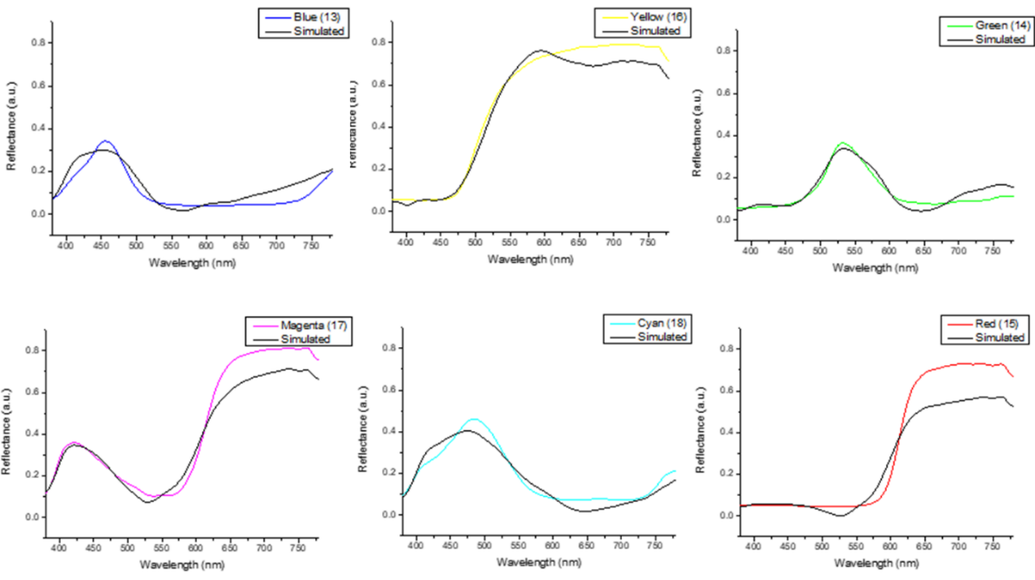
Figure 3. RMSEs between analog and measured spectra of each color block
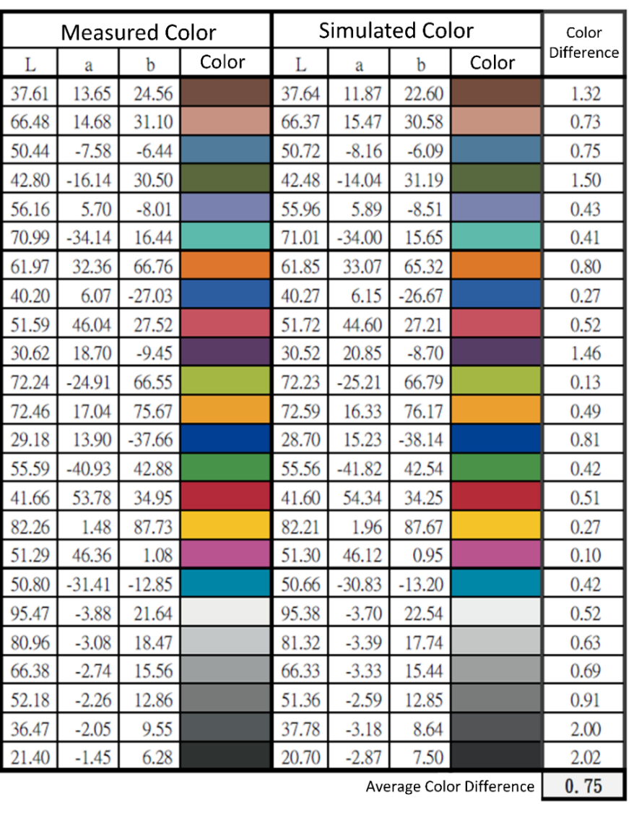
Figure 4. LAB values of the simulated and observed colors.
Even though an HSI conversion technique to convert an RGB image to an HSI image along with the reflectance data has been developed, an NBI image that is similar to the Olympus endoscope’s NBI image needs to be simulated for the traditional endoscope and VCE has to be developed based on band selection to detect various cancer types. NBI is an imaging technique for endoscopic diagnostic medical tests, where light of specific blue and green wavelengths is used to enhance the detail of certain aspects of the surface of the mucosa. A special filter is electronically activated by a switch in the endoscope leading to the use of ambient light of wavelengths of 415 nm (blue) and 540 nm (green). Because the peak light absorption of hemoglobin occurs at these wavelengths, blood vessels will appear very dark, allowing for their improved visibility and the improved identification of other surface structures. However, as shown in Figure 5, the Olympus endoscope’s NBI images do not only contain the red and blue colors in it, rather it also contain hues of brown, orange and red in it.
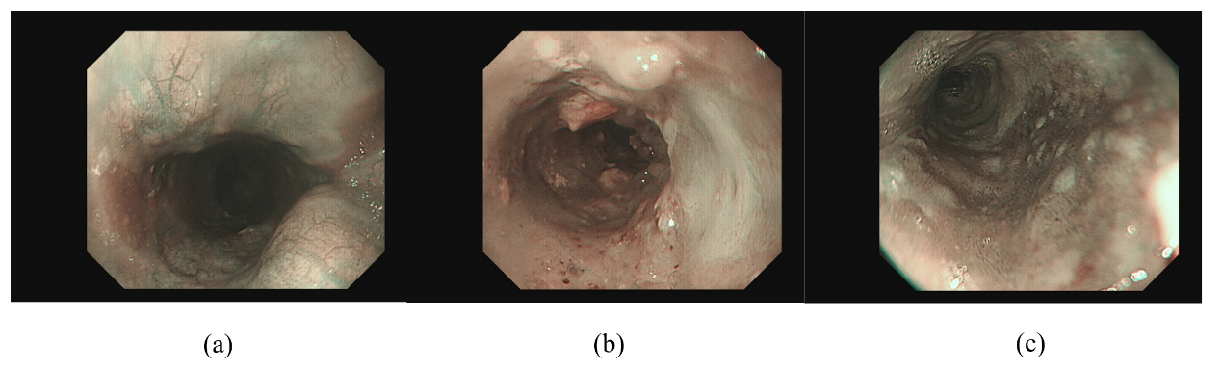
Figure 5. Shows the Olympus Endoscope’s NBI images with orange, red, and brown hues.
For the Olympus endoscope, there is a reference NBI capture mode through which an algorithm developed which be compared. However for VCE there is no reference NBI capture mode. Hence, in this study, the NBI color calibration done for the Olympus endoscope is used for VCE also. The simulated NBI image from the HSI conversion algorithm must be similar to the real NBI image captured by the Olympus endoscope. For this calibration also, the standard 24-color checker has been used. The NBI image simulated from the HSI conversion algorithm is compared with the real NBI image captured by the Olympus endoscope. The CIEDE 2000 color difference between each of the 24 color blocks is measured and minimized. After the correction, the average color difference of the 24 color blocks was found to be only 2.79 which is negligible.
Once the color is matched between the simulated NBI which is also known as SAVE and the real NBI of the Olympus endoscope, the NBI image for the capsule endoscope must also be fine-tuned. Three factors will affect the color difference between the real NBI and SAVE images. These factors correspond to the light spectrum, the color-matching function, reflection spectrum. At first, the CIEDE 2000 color difference between WLI images of the capsule endoscope and the Olympus endoscope was found. At the same 24-standard color checker has been given to the Olympus endoscope and the VCE. This huge difference is caused between two different endoscopes because of the stark contrast in the lighting spectrum of the two different equipment. As shown in Figure 6 the spectrum of the light used in the VCE and the Olympus endoscope are different.
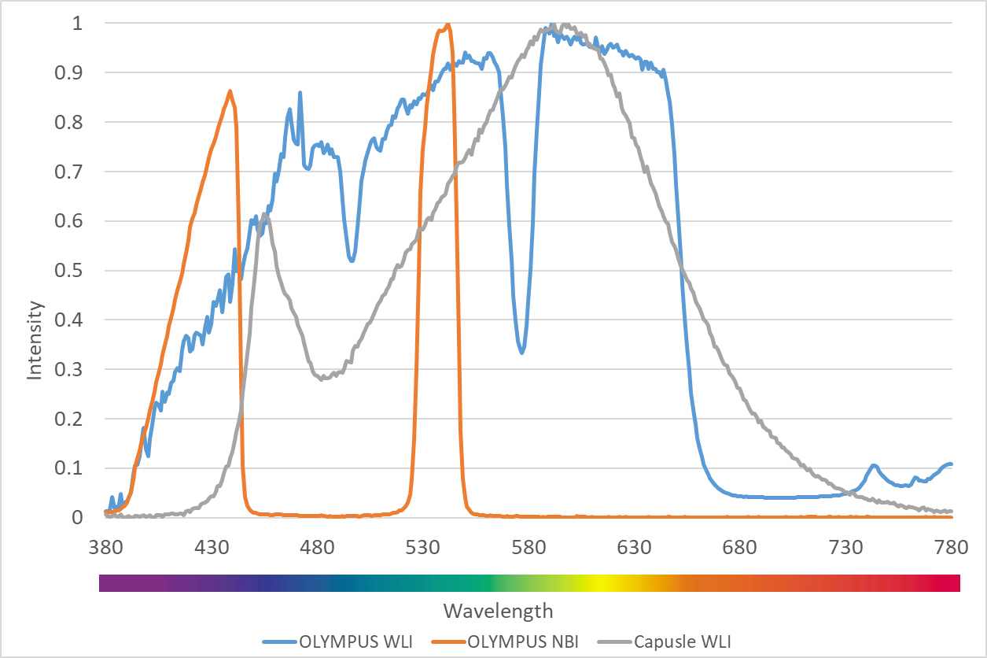
Figure 6. The lighting spectrum difference between the Olympus WLI, Olympus NBI, and the Capsule WLI.
Even though in some wavelengths the intensity is similar there is a huge difference in the band between 450 – 540 nm range. Since this is the region at which the peak light absorption of hemoglobin occurs, the lighting spectrum must also be calibrated. It was done using the Cauchy-Lorentz visiting distribution as shown in Equation 20.
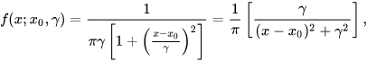 (20)
A 24-color checker is again used for calibrating the real Olympus NBI image with the NBI image from VCE. For optimizing the lighting spectrum, the dual annealing optimization function is used. This aleatory technique evolved from a generalized simulated annealing algorithm that blends the simplified classical simulated annealing (CSA) and fast simulated annealing (FSA), along with an approach for executing a local search based on only certain parameters. Previously the same algorithm has been used for global optimization. The average standard CIEDE 2000 color difference between the 24 color is 5.36 which is negligible. The difference between the SAVE image from the Olympus and the simulated NBI from VCE is shown in Figure 6Error! Reference source not found.. Hence in this study, apart from 415 and 540 nm three other regions in the wavelength of 600, 700, and 780 nm have also light spectrum. The complete process is shown in Figure 8. Table 1 shows the difference between Traditional and SAVE imaging modalities.
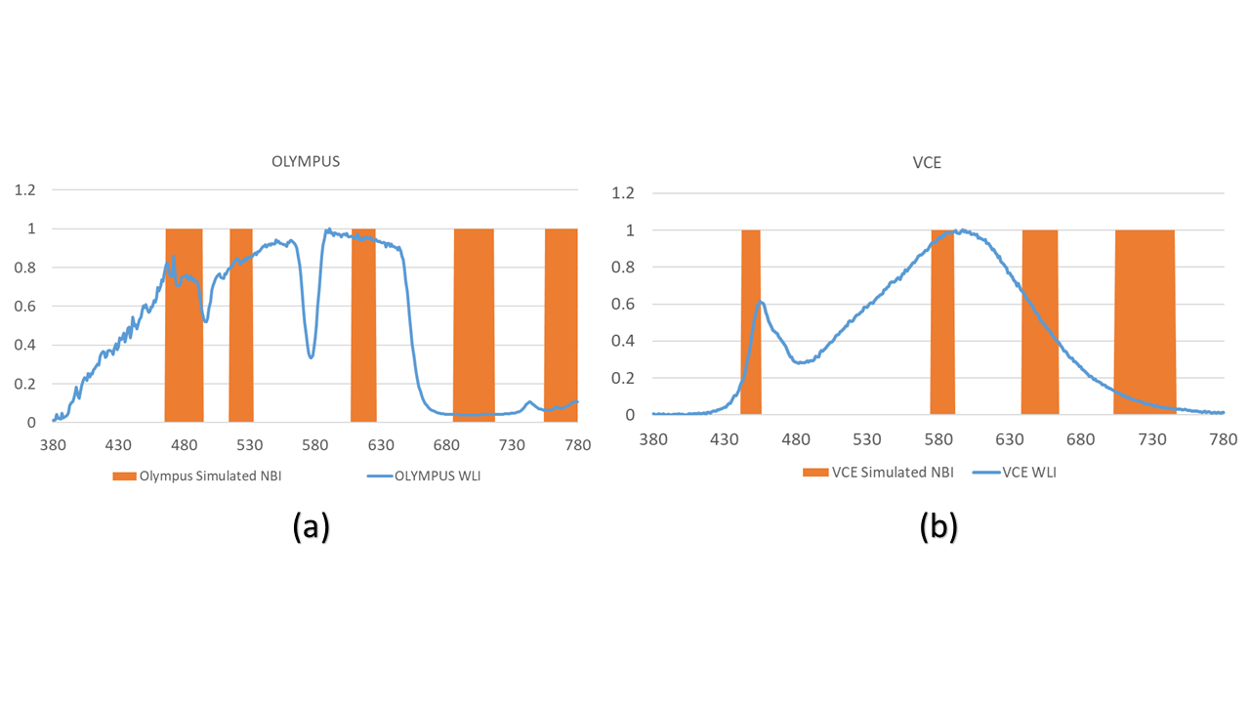
Figure 7. The Difference between the Olympus SAVE and the VCE simulated NBI lighting. (a) shows the difference between the Olympus SAVE and Olympus WLI. (b) shows the difference between VCE SAVE and VCE WLI images.
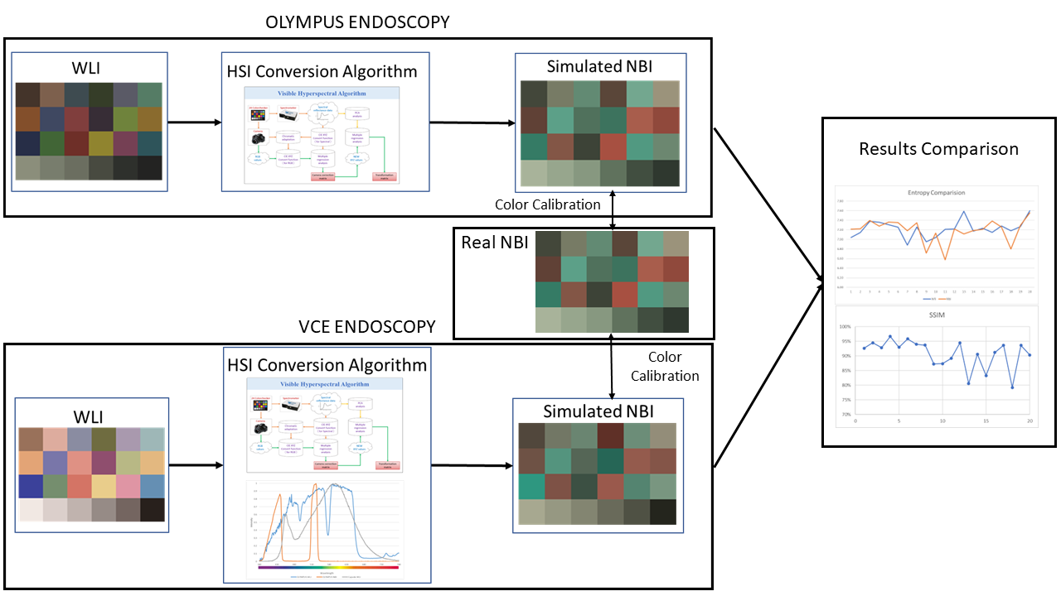
Figure 8. The complete conversion process of WLI image to NBI Image.
Table 2. Shows the difference between Traditional and SAVE imaging modalities
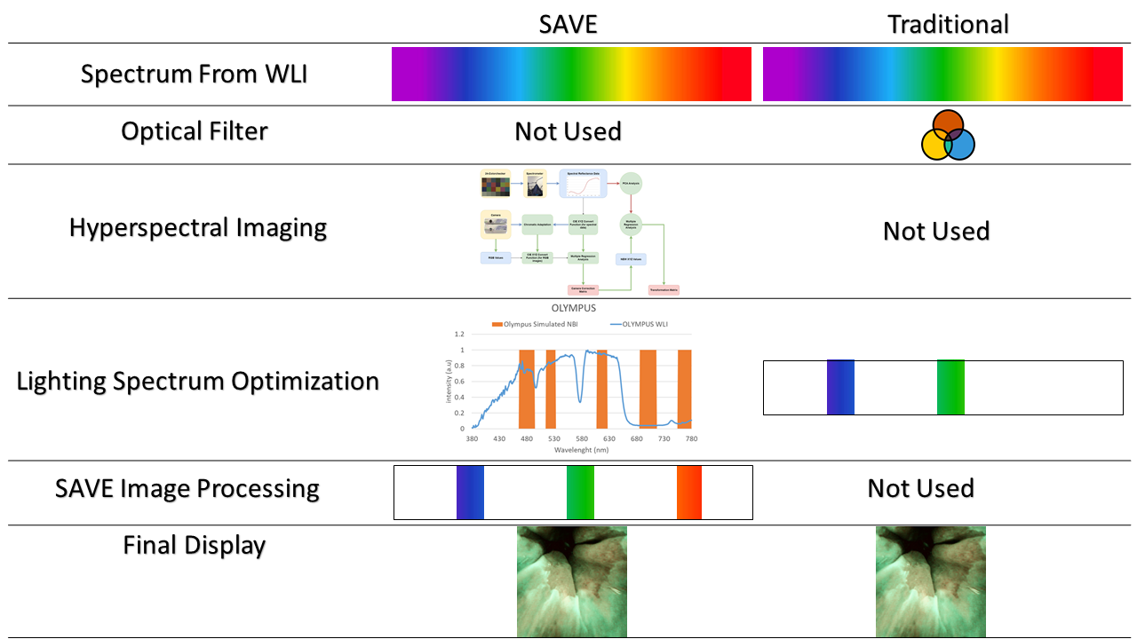
The major advantages of SAVE are:
- Enhanced Image Contrast
- Accurate Diagnoses
- Early Detection of Pathologies
- Reduced Invasive Procedures
- Versatility in Specialties
- Improved Training & Education
- Time-Efficient Diagnosis
The valuation of the SAVE algorithm is comprehensively assessed through its performance metrics, specifically the Structural Similarity Index Metric (SSIM), pixel signal to noise ratio (PSNR) and entropy, which provide quantitative insights into the algorithm's effectiveness in image reproduction.
At first SSIM between the simulated and the real WLI of the Olympus endoscope can be compared with the SAVE image from the HSI conversion algorithm developed in this study. SSIM can be defined as the amount of similarities between the simulated and the real image. The values range between 0% to 100% where 100% means the images are completely the same and 0% means the images are completely different. It is measured for the images that are reconstructed from a base image. Therefore, this parameter fits our criteria of comparison. Similarly, the WLI image of the VCE can also be compared with the SAVE images obtained from the HSI conversion algorithm. Figure 9 shows the SSIM for both the Olympus images and the VCE images. It can be seen that the Olympus images have a better SSIM rate with an average of 94.27% while the VCE has a comparatively lesser. Still, the average SSIM for VCE was found to be around 90%. This is because for NBI the CIEDE 2000 color calibration was possible for the traditional endoscope with the real NBI. After all, there was a reference real NBI image available. But for VCE no such reference is available. So, the same calibration that was done for the NBI images of the Olympus was done for VCE. Even though without any reference the algorithm achieved a SSIM of 90%. It can also be seen that the top three highest achieved SSIM values was from the VCE of 96%. From this, we can infer that the results of the study are accurate. In this study 50 randomly chosen VCE images were used for calculating the SSIM. However, by increasing the number of images the SSIM can be significantly improved. Table 3 shows the SSIM comparison of twenty randomly chosen images in VCE and Olympus endoscope.
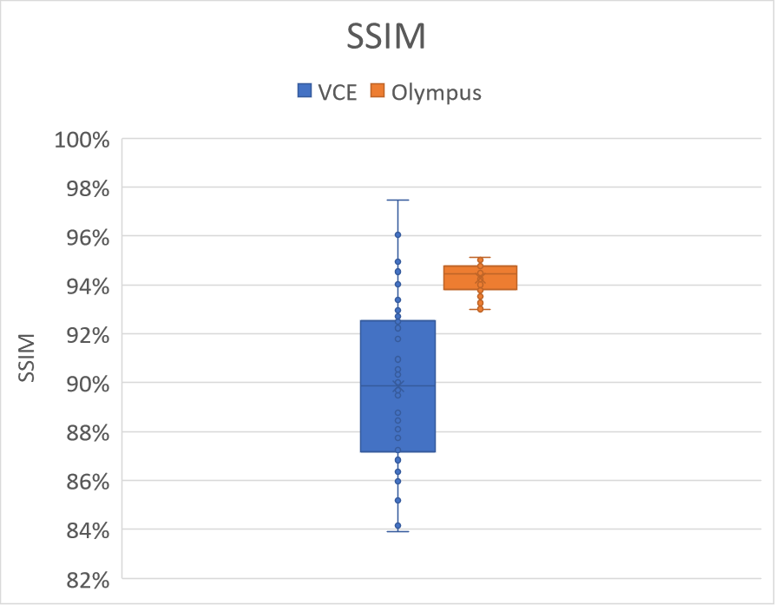
Figure 9. Comparison of SSIM between the simulated NBI images and the WLI images of VCE and Olympus
Table 3. SSIM of twenty randomly chosen images in VCE and Olympus endoscope.
Index | SSIM in VCE | SSIM in Olympus
1 | 0.925984794 | 0.94883467
2 | 0.944862636 | 0.948624384
3 | 0.928211385 | 0.94554478
4 | 0.966524653 | 0.937769205
5 | 0.92933774 | 0.941602499
6 | 0.958101429 | 0.945524249
7 | 0.939473779 | 0.935284698
8 | 0.936779292 | 0.933442268
9 | 0.872748906 | 0.938402164
10 | 0.873266671 | 0.936314054
11 | 0.891602213 | 0.934205211
12 | 0.944929655 | 0.949261138
13 | 0.805573811 | 0.941545835
14 | 0.90568673 | 0.946374234
15 | 0.83298981 | 0.945601764
16 | 0.912076221 | 0.932277471
17 | 0.936323837 | 0.930091206
18 | 0.792020729 | 0.939289678
19 | 0.936141641 | 0.932559509
20 | 0.903283862 | 0.935927389
Avg. | 90.680% | 93.992%

The second criterion that was used to evaluate the algorithm developed in this study was entropy. The entropy was also calculated similarly to the SSIM. The difference in entropy between the WLI images obtained from the Olympus endoscope is compared with the SAVE images simulated from the HSI conversion algorithm. In image processing, entropy might be used to classify textures, a certain texture might have a certain entropy as certain patterns repeat themselves in approximately certain ways. In the context of the paper low entropy means low disorder, low variance within the component. Therefore, lower the entropy better reproduction of the image is obtained. The difference in entropy between the WLI images obtained from VCE is compared with the SAVE images from the HSI-NBI conversion algorithm. Figure 10 shows the entropy difference in Olympus endoscope and VCE. As it can be seen from Table 4 the entropy difference in both the VCE and the Olympus endoscope have similar values. The average entropy difference in VCE was 1.17% while the average difference in the Olympus endoscope was 0.37%. However, in VCE the majority difference was found to be caused by only one image (image number 11). If we remove that image the entropy difference value is just 0.03% which is better than the Olympus endoscope. Table 4 shows the entropy comparison of the WLI and SAVE images in Olympus and VCE endoscope of twenty random images.
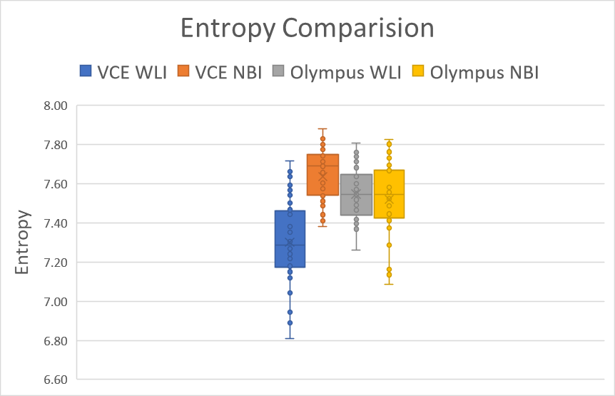
Figure 5. Comparison of entropy between the simulated NBI images and the WLI images. (a) Entropy for Olympus Endoscopy while (b) shows the entropy for the VCE camera.
Table 2. Entropy comparison of the WLI and NBI images in Olympus and VCE endoscope
Index | VCE |  | Endoscope |  | Difference in VCE | Difference in Olympus
Index | WLI | NBI | WLI | NBI | Difference in VCE | Difference in Olympus
1 | 7.04162 | 7.213345 | 7.60896 | 7.576404 | 0.024387 | -0.004298
2 | 7.14502 | 7.220075 | 7.56380 | 7.494327 | 0.010504 | -0.009271
3 | 7.37728 | 7.396152 | 7.65457 | 7.522734 | 0.002557 | -0.017526
4 | 7.35948 | 7.278474 | 7.41264 | 7.283070 | -0.011008 | -0.017791
5 | 7.30720 | 7.363200 | 7.63545 | 7.680663 | 0.007663 | 0.005886
6 | 7.25352 | 7.350173 | 7.57114 | 7.546219 | 0.013325 | -0.003167
7 | 6.88228 | 7.182308 | 7.53630 | 7.557263 | 0.043593 | 0.002773
8 | 7.25791 | 7.345877 | 7.71332 | 7.804702 | 0.012119 | 0.011708
9 | 6.95063 | 6.713150 | 7.56143 | 7.669351 | -0.034167 | 0.014072
10 | 7.04094 | 7.134570 | 7.57816 | 7.676892 | 0.013297 | 0.012860
11 | 7.21094 | 6.575100 | 7.52565 | 7.372113 | -0.088178 | -0.020827
12 | 7.21771 | 7.219500 | 7.43596 | 7.422078 | 0.000247 | -0.001871
13 | 7.58770 | 7.112978 | 7.57403 | 7.671311 | -0.062566 | 0.012680
14 | 7.17281 | 7.184375 | 7.55415 | 7.667614 | 0.001612 | 0.014797
15 | 7.23312 | 7.210437 | 7.63470 | 7.693241 | -0.003137 | 0.007608
16 | 7.14741 | 7.384973 | 7.71922 | 7.729203 | 0.033237 | 0.001291
17 | 7.28176 | 7.259479 | 7.75930 | 7.761126 | -0.003061 | 0.000234
18 | 7.18062 | 6.801497 | 7.74727 | 7.801845 | -0.052799 | 0.006994
19 | 7.26419 | 7.290983 | 7.74532 | 7.825175 | 0.003688 | 0.010205
20 | 7.59704 | 7.555495 | 7.736022 | 7.807877 | -0.005469 | 0.009203
Avg | 7.2254647 | 7.189607 | 7.61332 | 7.628160 | -0.47% | 0.19%

PSNR is typically utilized in the context of image compression algorithms as a parameter to evaluate the quality of the reproduced image. In a comparison of quality that is comparable to that of the SSIM, the PSNR values of twenty randomly selected WLI images and their SAVE equivalents are measured. The plot of the PSNR for each of the twenty images is displayed in Figure 10. The PSNR of the VCE images came in at an average of 28.0216 db, while the PSNR of the Olympus images was 27.8819 db. Table 5 shows the comparison of PSNR of the twenty randomly chosen images in Olympus and VCE
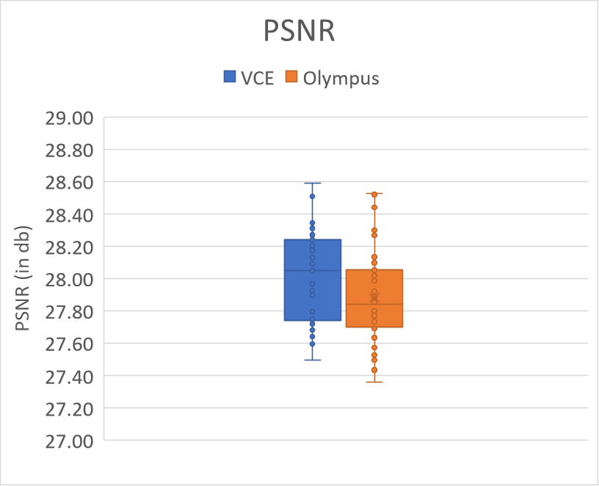
Figure 6. Comparison of PSNR of the twenty randomly chosen images in Olympus and VCE
Table 3. Comparison of PSNR of the twenty randomly chosen images in Olympus and VCE
Index | PSNR of Olympus images | PSNR of VCE images
1 | 27.5737493 | 28.51448883
2 | 27.4460567 | 27.72258326
3 | 27.46222796 | 27.66114567
4 | 27.36380762 | 27.49849716
5 | 27.82132106 | 27.67697859
6 | 27.49987858 | 28.1142441
7 | 27.78251246 | 27.90179575
8 | 27.71866018 | 27.6486571
9 | 27.78163772 | 27.65547302
10 | 27.63666623 | 28.0393251
11 | 27.58337722 | 28.20507339
12 | 27.70590967 | 27.99117518
13 | 27.53574671 | 28.26982928
14 | 27.68741185 | 27.9901207
15 | 27.74701762 | 28.26732897
16 | 27.81360865 | 27.7055983
17 | 27.87955844 | 27.90082759
18 | 27.71300104 | 28.50043856
19 | 27.73324857 | 27.68852332
20 | 28.02414942 | 27.68115621
Avg. | 27.67547735 | 27.931663
