Tutorial

Main screen:

Buttons:

Add iterations: add one iteration for loop of drawing the image.

Reset: Set everything to how it is on the beginning.

Zoom out: zooms out back (if you zoomed).

Change main color: change main color which is used in some coloring modes.

Add 20 iterations: adds 20 more iterations.

Change options for Julia set: changes numbers from witch is Julia set generated. Labels:

Top right label: shows coordination of top right corner of picture.

Label under “add 20 iterations” button: show coordination of cursor.

Numeric up downs:

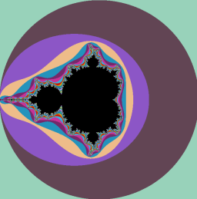Size of window: automatically changes size of the window according to size of your screen.

Color of background:

Normal: shows random color for every iteration:

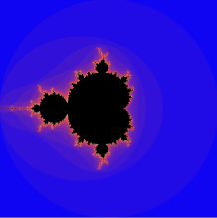

Shadowing: uses random colors with smooth transition:

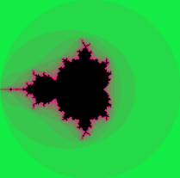

One color change: smoothly changes color between main color and secondary color (if is that radio button checked button will appear):

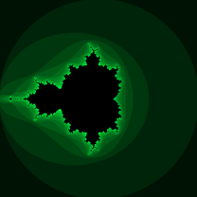

Dark/Light: go from darker/lighter color to main color:

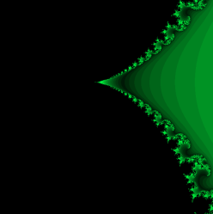Darker: go between main color and darker variant of that color in 15 color steps:

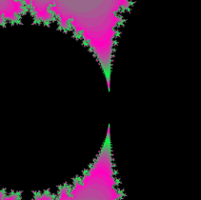

Negative: go between main color and its negative in 15 color steps:

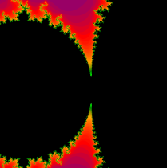Professional: is like shadowing but you can chose all colors and color steps between them:

Color of set: each radiobuttons sets color of the set to its value.

Powers: sets n of formula z = z^n \* c, first 5 are much faster to calculate, but the custom can have decimal places and even complex numbers.

Saving: you can chose in what resolution you want to save your image.

Optiosn:

Close: closes the application.

Save picture: saves a picture that is on display right now.

Ideas for Julia set: have good looking julia sets.

Dark/Light mode: changes app mode between light and dark mode.

Save/Load position: saves/loads position in whitch are you white now.

Zooming: to zoom you must click on some point and drag mouse (red square will be drawn). And release.

Changing to julia set: you can use mouse wheel click to pick a point to change the point as c in  
 z = z^n \* c Julia set formula.