Setup Procedure for Relay Station (vind-rly) with SSH Tunneling

Prerequisites

Hardware:
Raspberry Pi 5 (or similar) as vind-rly

Wi-Fi adapter (e.g., wlan1) compatible with wfb-ng for the tunnel

Ethernet connection for eth0 to the ground station network (10.5.6.0/24)

Companion computer (e.g., another Raspberry Pi) at 10.5.5.87 with SSH enabled

Ground station device (e.g., a laptop at 10.5.6.50) with an SSH client

Software:
Fresh Ubuntu 24.04 LTS installation on vind-rly

Internet access (initially via wlan0 or eth0) for package installation

Assumptions:
wfb-ng is pre-installed on the companion computer (10.5.5.87) and configured to connect to vind-rly via wlan1

SSH server is running on 10.5.5.87 (user roz)

1. Initial System Setup

Install Ubuntu on vind-rly

Flash Ubuntu 24.04 LTS to an SD card using Raspberry Pi Imager.

Boot the Pi, log in with default credentials (e.g., ubuntu:ubuntu), and change the password:

Set Hostname

sudo hostnamectl set-hostname vind-rly

Create User vind-admin

sudo adduser vind-admin sudo usermod -aG sudo vind-admin

2. Configure DHCP Server on eth0

Install DHCP Server

sudo apt install isc-dhcp-server

Configure DHCP Server

sudo nano /etc/dhcp/dhcpd.conf

Replace contents with your current configuration:

authoritative; default-lease-time 600;
max-lease-time 7200;
# Define subnet and assign IP range for DHCP clients
subnet 10.5.6.0 netmask 255.255.255.0 {
range 10.5.6.50 10.5.6.100; # Range of IPs to assign dynamically
option routers 10.5.6.1;
option domain-name-servers 8.8.8.8, 8.8.4.4; # Google DNS servers
option broadcast-address 10.5.6.255;
default-lease-time 600;
max-lease-time 7200;
}

Specify the interface:

sudo nano /etc/default/isc-dhcp-server

INTERFACESv4="eth0"

Start DHCP Service

sudo systemctl enable isc-dhcp-server ]
sudo systemctl start isc-dhcp-server
sudo systemctl status isc-dhcp-server

sudo netstat -uap | grep dhcp # Should show dhcpd listening

Add Delay to DHCP Service
Create an override file to add a 10-second delay:

sudo systemctl edit isc-dhcp-server.service

Paste the following:

[Service]
ExecStartPre=/bin/sleep 10

Save and exit (this creates /etc/systemd/system/isc-dhcp-server.service.d/override.conf with the delay).
Reload systemd:
sudo systemctl daemon-reload

Test DHCP
Connect a ground station (e.g., vind-gs) to eth0 via Ethernet or a switch.

On vind-gs:
ip addr show # Should get an IP like 10.5.6.50 ping 10.5.6.100 # Should work

3. Network Configuration

Install Network Tools

sudo apt install net-tools network-manager
Configure netplan

sudo nano /etc/netplan/50-cloud-init.yaml
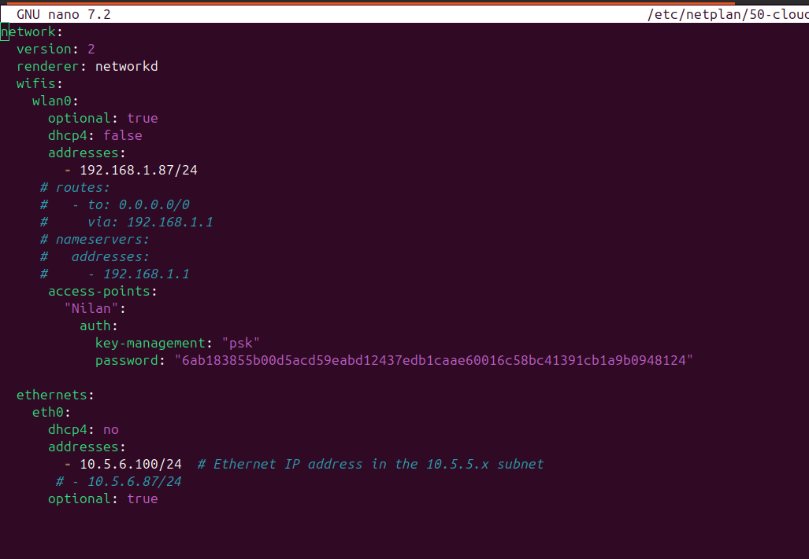

Paste the following:

network:
version: 2
renderer: networkd
wifis:
wlan0:
optional: true
dhcp4: false
addresses:
- 192.168.1.87/24
# routes:
# - to: 0.0.0.0/0
# via: 192.168.1.1
# nameservers:
# addresses:
# - 192.168.1.1
access-points:
"Nilan":
auth:
key-management: "psk"
password: "6ab183855b00d5acd59eabd12437edb1caae60016c58bc41391cb1a9b0948124"

ethernets:
eth0:
dhcp4: no
addresses:
- 10.5.6.100/24 # Ethernet IP address in the 10.5.5.x subnet
# - 10.5.6.87/24
optional: true

Apply the configuration:
sudo chmod 600 /etc/netplan/50-cloud-init.yaml
sudo netplan apply

Verify Network

ip addr show eth0 # Should show 10.5.6.100/24 ip addr show wlan0 # Should show 192.168.1.87/24
ping 192.168.1.1 # Should work if wlan0 connects
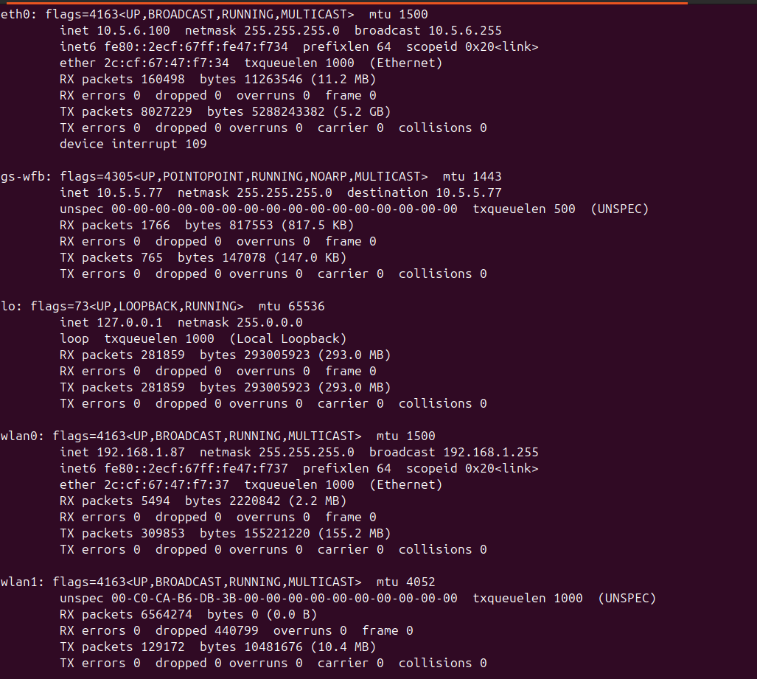

Enable IP Forwarding

sudo sysctl -w net.ipv4.ip_forward=1
sudo nano /etc/sysctl.conf

Add the following line:
net.ipv4.ip_forward=1

Apply:
sudo sysctl -p

4. Install and Configure wfb-ng
Install Realtek Patched Driver
Alfa -Wi-Fi Adapter Patch Driver Installation
pip3 install --user --break-system-packages pyroute2 msgpack
sudo apt install python3-msgpack
sudo apt-get install dkms
git clone -b v5.2.20 https://github.com/svpcom/rtl8812au.git
cd rtl8812au/
sudo apt install linux-headers-$(uname -r) – if unsure about kernel version use this otherwise use below command with correct kernel version.
sudo apt install linux-headers-6.8.0-1013-raspi – mention correct kernel version .
sudo ./dkms-install.sh
iw dev wlx00c0cab6db1a info

Rename above Adapter to Wlan1
sudo nano /etc/udev/rules.d/70-persistent-net.rules
Add Below Line for wlx00c0cab6db1a
SUBSYSTEM=="net", ACTION=="add", ATTR{address}=="00:c0:ca:b6:db:1a", NAME="wlan1"

Installing Wfb-Ng On Relay Station

git clone https://github.com/svpcom/wfb-ng.git
cd wfb-ng/
sudo ./scripts/install_gs.sh wlan1
Ip route and check for wfb - GS route

vind-admin@vind-rly:~$ ip route
default dev gs-wfb proto static
10.5.5.0/24 dev gs-wfb proto kernel scope link src 10.5.5.77
10.5.6.0/24 dev eth0 proto kernel scope link src 10.5.6.100
192.168.1.0/24 dev wlan0 proto kernel scope link src 192.168.1.87

Relay –station config file

sudo nano /etc/wifibroadcast.cfg
[path]
conf_dir = '/etc'
bin_dir = '/usr/bin'
tmp_dir = '/tmp'
log_dir = '/var/log'

[common]
wifi_channel = 161
wifi_region = 'BO'
wifi_txpower = 4000

[gs_video]
peer = 'connect://10.5.6.50:5600'
#peer = 'connect://255.255.255.255:5600'
#frame_type = 'data'
#fec_k = 8
#fec_n = 14
#fec_timeout = 0
#fec_delay = 500
bandwidth = 20
short_gi = False
stbc = 1
ldpc = 1
mcs_index = 1

[gs_mavlink]
peer = 'connect://10.5.6.50:14550'
#peer = 'connect://255.255.255.255:14550'
#frame_type = 'data'
#fec_k = 1
#fec_n = 3
#fec_timeout = 0
#fec_delay = 500
bandwidth = 20
short_gi = False
stbc = 1
ldpc = 1
mcs_index = 1

[gs_tunnel]
peer = '10.5.5.87/24'
ifname = 'gs-wfb'
ifaddr = '10.5.5.77/24'
default_route = True
frame_type = 'data'
#fec_k = 2
#fec_n = 4
fec_timeout = 0
fec_delay = 500
bandwidth = 20
short_gi = False
stbc = 1
ldpc = 1
mcs_index = 1

sudo systemctl enable wifibroadcast@gs.service
sudo systemctl enable wifibroadcast.service
sudo systemctl start wifibroadcast.service
sudo systemctl start wifibroadcast@gs.service
sudo systemctl status wifibroadcast@gs.service

Test Companion Connectivity

ping 10.5.5.87

5. Configure SSH

Install SSH Server

sudo apt install openssh-server
sudo systemctl enable ssh
sudo systemctl start ssh

Set Up Persistent SSH Tunnel

Setting Up Key-Based SSH Authentication to Companion Computer
1. Generate SSH Key
To create an SSH key pair, run:
ssh-keygen -t ed25519 -f ~/.ssh/id_ed25519 -N ""
- -t ed25519 → Uses the secure Ed25519 key type.
- -f ~/.ssh/id_ed25519 → Specifies the key file location.
- -N "" → Creates a key without a passphrase for automation
2. Copy Public Key to Companion Computer
ssh-copy-id -i ~/.ssh/id_ed25519.pub roz@10.5.5.87
This adds the key to ~/.ssh/authorized_keys on roz.
3. Verify Passwordless SSH Login
ssh -i ~/.ssh/id_ed25519 roz@10.5.5.87
4. Backup SSH Keys
cp ~/.ssh/id_ed25519 ~/.ssh/id_ed25519.pub /path/to/backup/

Install autossh

sudo apt install autossh
Create Log File

sudo touch /var/log/ssh-tunnel.log sudo chown vind-admin:vind-admin /var/log/ssh-tunnel.log
sudo chmod 644 /var/log/ssh-tunnel.log

Configure Tunnel Service
sudo nano /etc/systemd/system/ssh-tunnel-to-companion.service

Paste the following:
[Unit] Description=SSH Tunnel to Companion Computer
After=network.target wifibroadcast@gs.service
[Service]
ExecStart=/usr/bin/autossh -M 0 -L 0.0.0.0:2222:10.5.5.87:22 roz@10.5.5.87 -N -i /home/vind-admin/.ssh/id_rsa -v
Restart=always
User=vind-admin
Environment=AUTOSSH_LOGFILE=/var/log/ssh-tunnel.log
Environment=AUTOSSH_DEBUG=1
StandardOutput=journal
StandardError=journal
[Install]
WantedBy=multi-user.target

Apply the service:
sudo systemctl daemon-reload
sudo systemctl enable ssh-tunnel-to-companion.service
sudo systemctl start ssh-tunnel-to-companion.service

Verify Tunnel

sudo systemctl status ssh-tunnel-to-companion.service # Active (running) sudo netstat -tuln | grep 2222 # 0.0.0.0:2222 LISTEN

Apply Delay
sudo systemctl edit ssh-tunnel-to-companion.service

Paste:

[Service]
ExecStartPre=/bin/sleep 10

sudo systemctl daemon-reload
sudo reboot

7. Test from Ground Station

From any system on 10.5.6.0/24 (e.g., vind-gs):
ssh roz@10.5.6.100 -p 2222

Windows (PuTTY): Host 10.5.6.100, Port 2222, User roz
macOS/Linux: As above.

8. Optional: Enable Internet via wlan0 (Development)
Edit netplan:
sudo nano /etc/netplan/50-cloud-init.yaml
Uncomment the routes and nameservers sections:

wifis: wlan0:
optional: true
dhcp4: false
addresses:
- 192.168.1.87/24
routes:
- to: 0.0.0.0/0
via: 192.168.1.1
nameservers:
addresses:
- 192.168.1.1
access-points:
"Nilan":
auth:
key-management: "psk"
password: "February@09" # Replace with your Wi-Fi password

Apply and adjust default route:

sudo ip route del default dev gs-wfb sudo netplan apply
ping 8.8.8.8 # Confirm internet access

P2P Over Wifi
🔧 Step-by-Step: Wi-Fi Direct (P2P) Auto-Setup on Boot

sudo nano /etc/wpa_supplicant/wpa_supplicant.conf
Add following lines

ctrl_interface=/var/run/wpa_supplicant
update_config=1
device_name=VIND_RLY_P2P

✅ 2. Create the P2P Startup Script
sudo nano /home/vind-admin/rely_p2p.sh
Paste this:

#!/bin/bash

# Start wpa_supplicant on wlan0 with control interface
wpa_supplicant -B -i wlan0 -c /etc/wpa_supplicant/wpa_supplicant.conf -C /var/run/wpa_supplicant

# Create a temporary P2P group

wpa_cli -i wlan0 p2p_group_add persistent=0

# Wait for interface to be created
sleep 2

# Assign static IP
ifconfig p2p-wlan0-0 10.5.6.101 netmask 255.255.255.0 up

# Start WPS PIN mode (optional for phone pairing)
wpa_cli -i p2p-wlan0-0 wps_pin any 1987
Make the script executable:

sudo chmod +x /home/vind-admin/rely_p2p.sh
✅ 3. Add to crontab for Boot-Time Execution
sudo crontab -e
Add this line:
@reboot /home/vind-admin/rely_p2p.sh
✅ 4. Reboot & Confirm
After reboot:

