Django

查看Django版本
django-admin.py version

创建实例
# 1. Install Module [Django]
pip install django

# 2. Set environment be using django on Windows Flat
Path: C:\Python27\Lib\site-packages\django\bin

# 3. Create New Project
Cd project_path
D:\Material\python\workspace\SimpleBlog>django-admin.py startproject my_blog

# 4. Run server
D:\Material\python\workspace\SimpleBlog>cd my_blog
D:\Material\python\workspace\SimpleBlog\my_blog>manage.py runserver

# 5. Test in browser
Open browser and input http://127.0.0.1:8000/

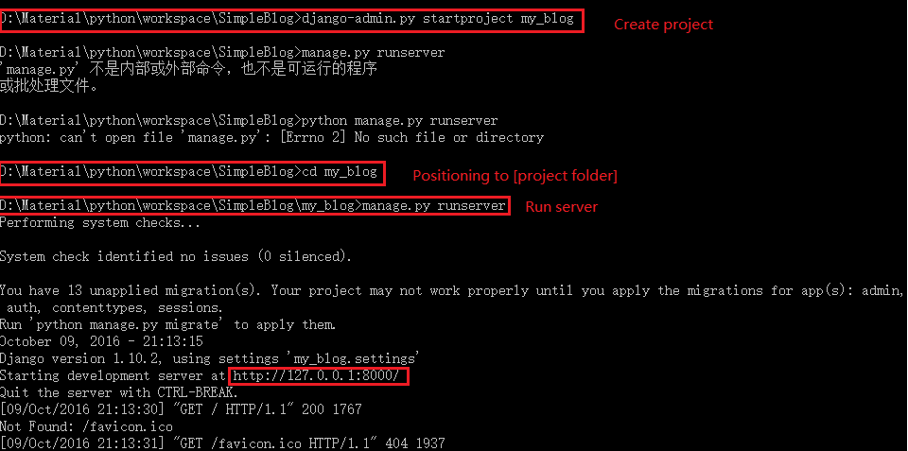

同步数据库
python manage.py makemigrations
python manage.py migrate

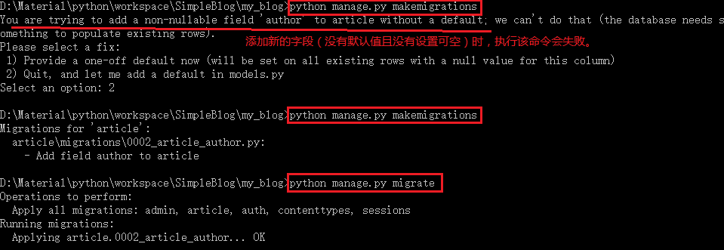

启动server
python manage.py runserver 9000

