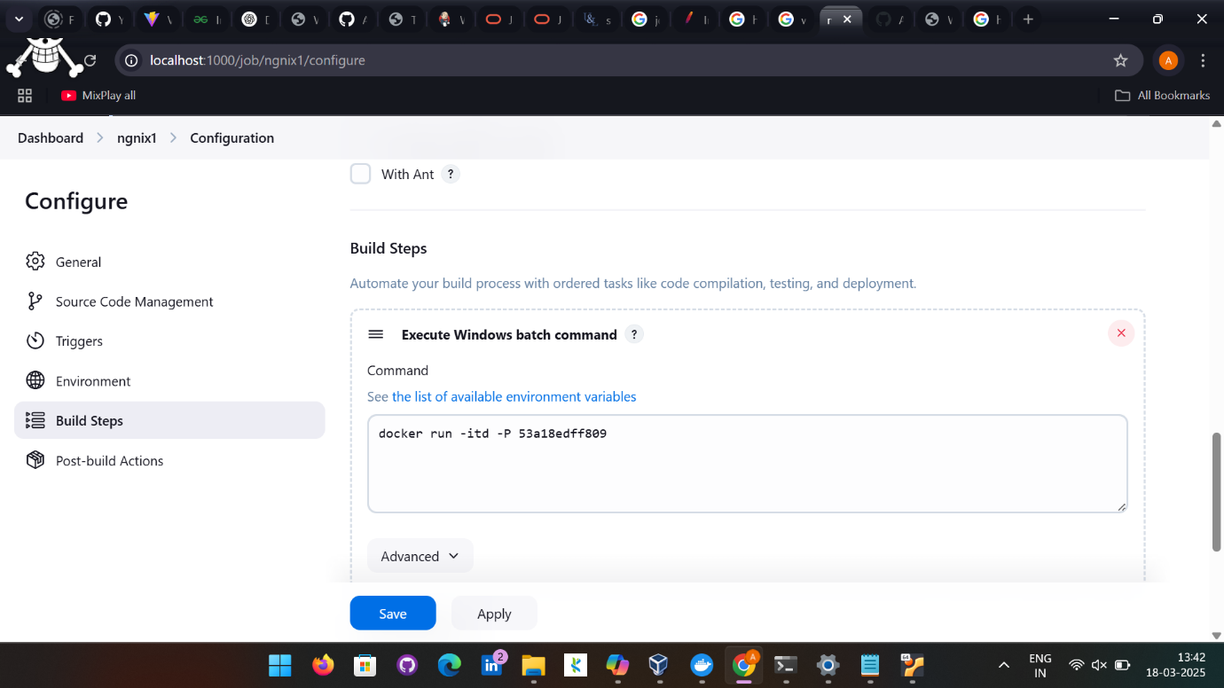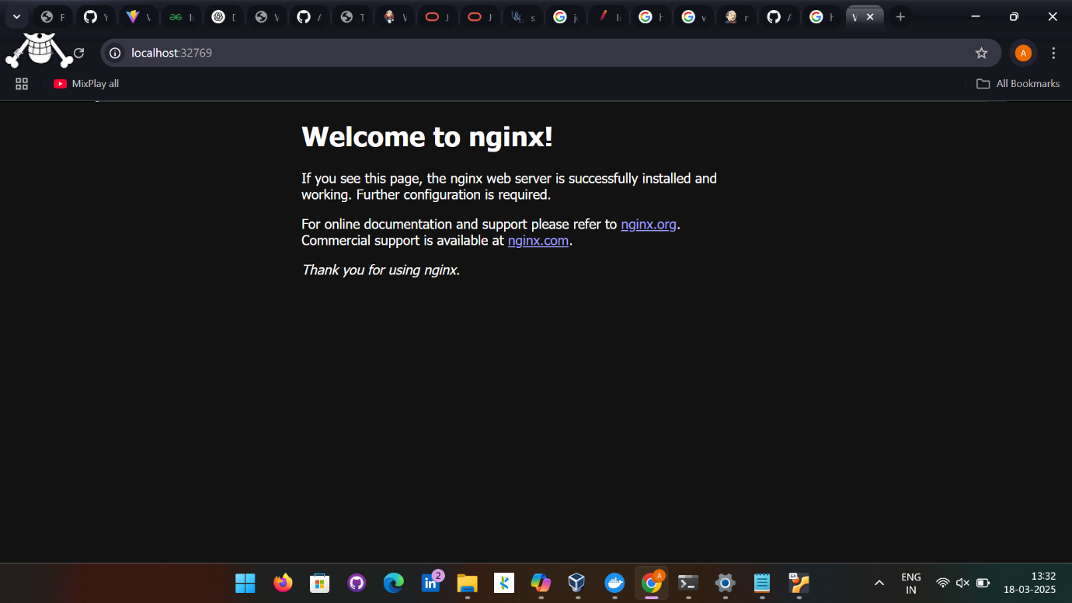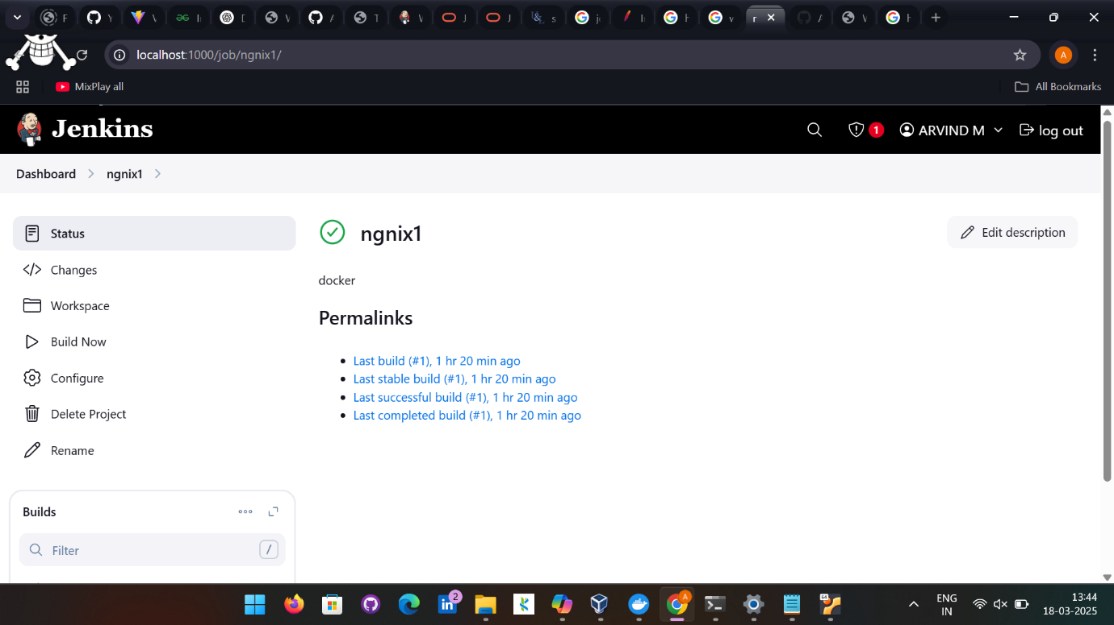

Code:
pipeline {
agent any

stages {
stage('SCM') {
steps {
git 'https://github.com/Arvind22cse/Devops_Guivi.git'
}
}
stage('Build'){
steps {
bat 'mvn clean install'
}
}
stage('build to images'){
steps {
bat 'docker build -t arvindm2004/mysimplewebapplication .'
}
}
stage('docker push hub'){
steps{
script{
// This step should not normally be used in your script. Consult the inline help for details.
withDockerRegistry(credentialsId: 'docker_cred', url: 'https://index.docker.io/v1/') {
bat 'docker push arvindm2004/mysimplewebapplication'
// some block
}
}

}
}
}
}

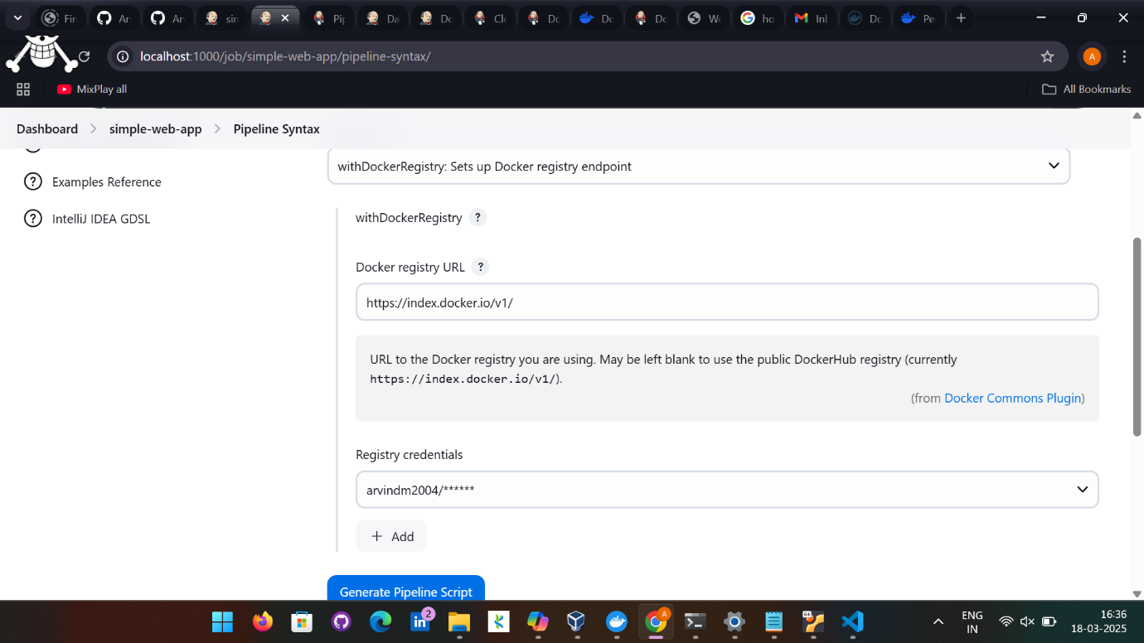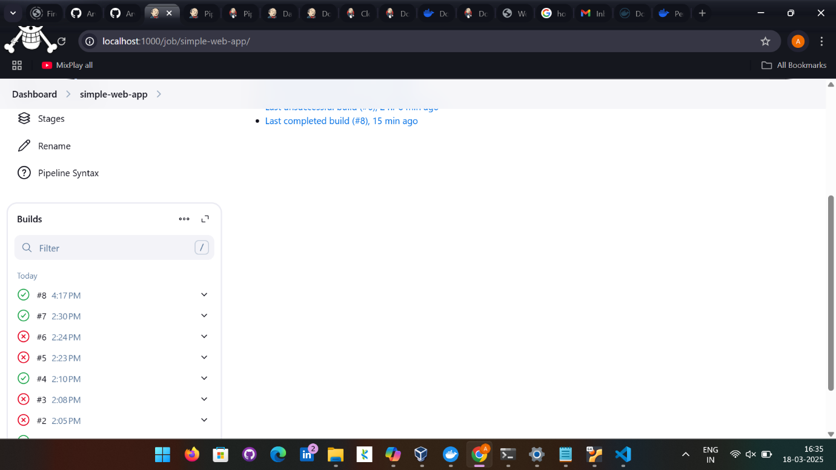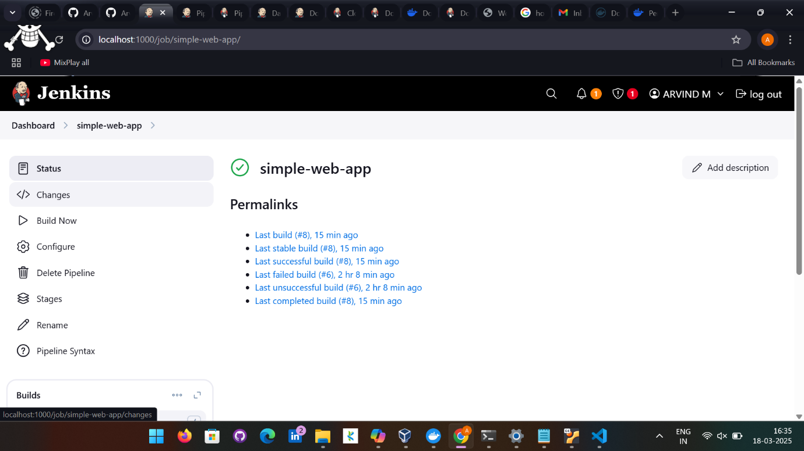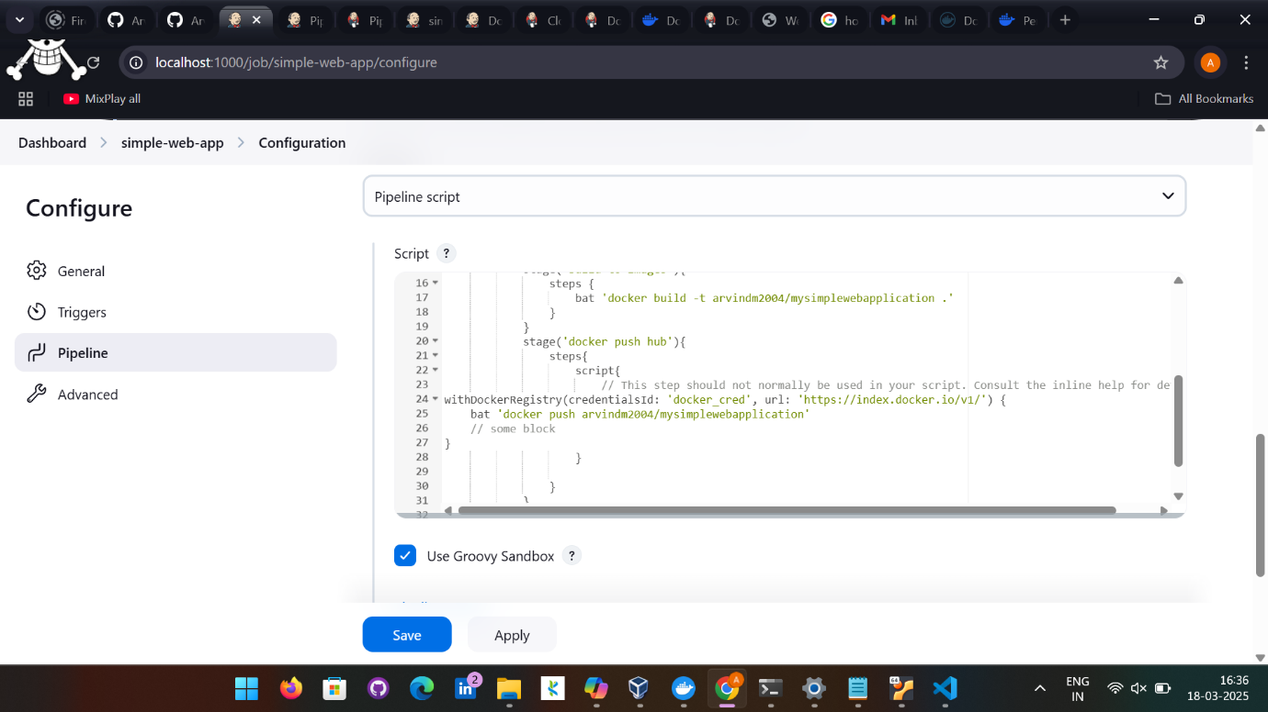

Using Ubuntu:

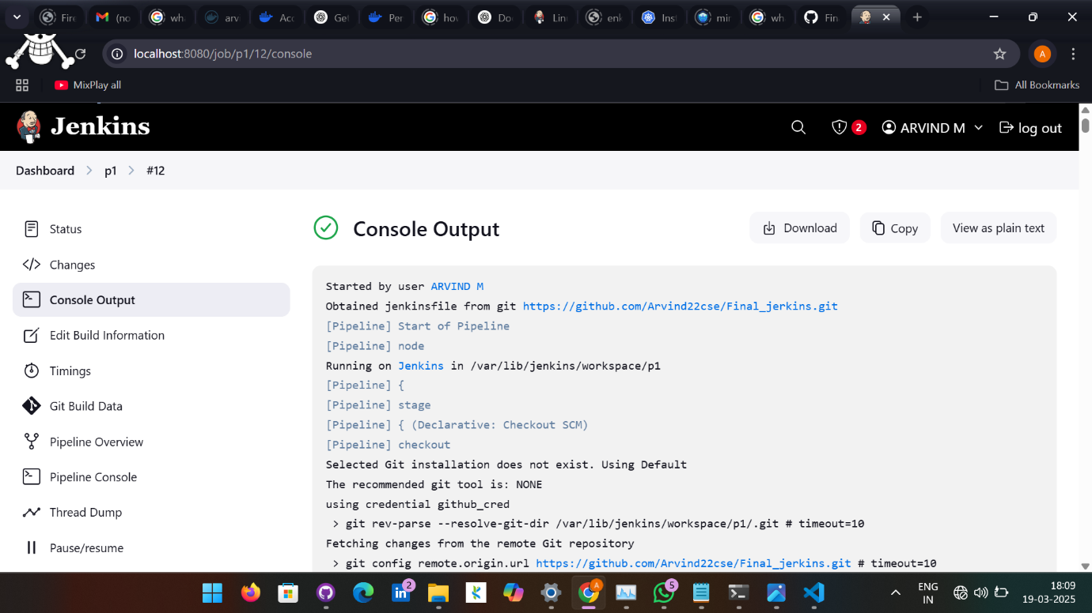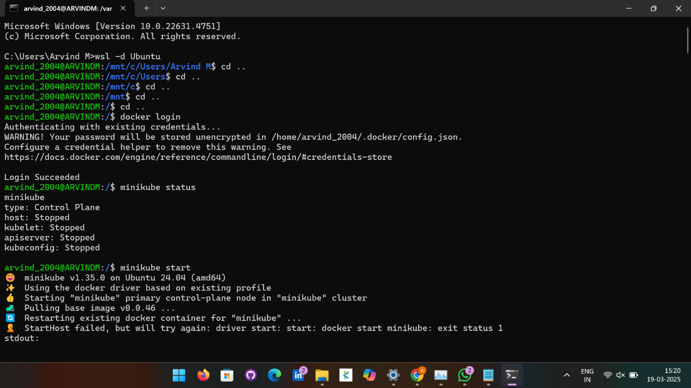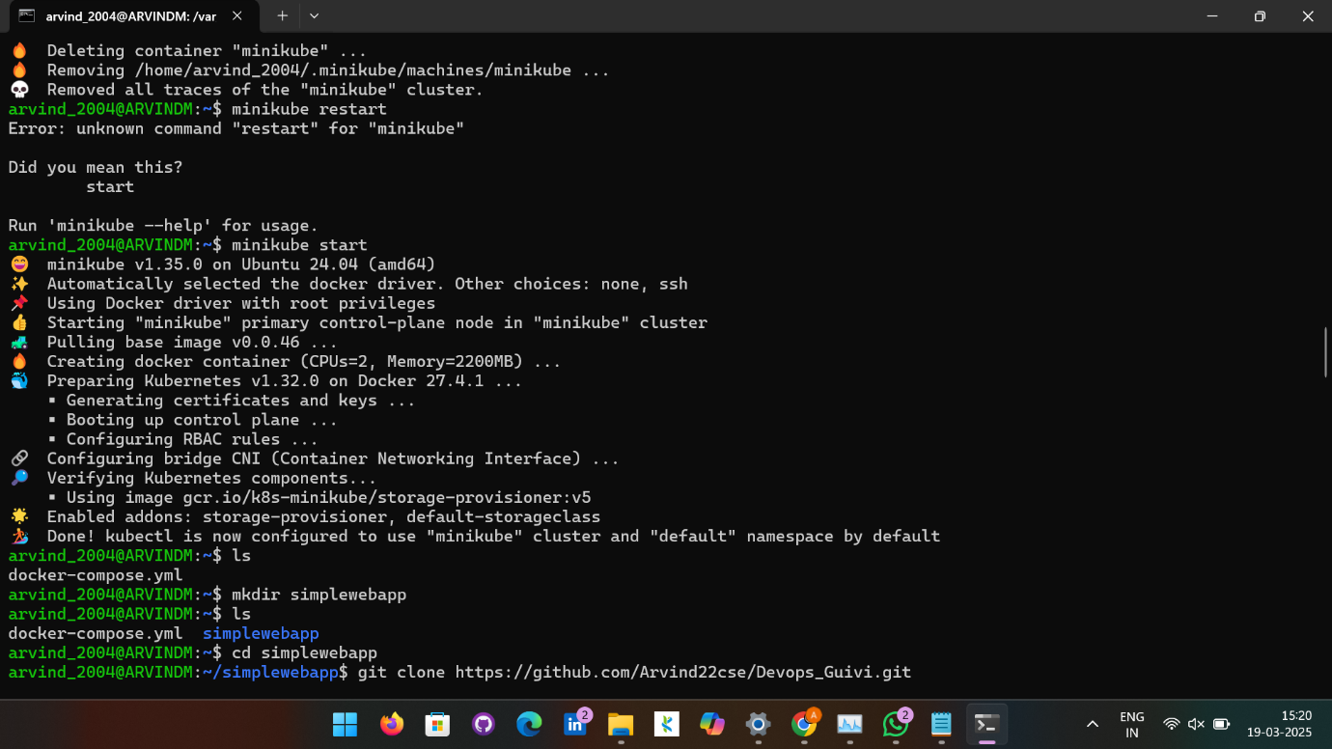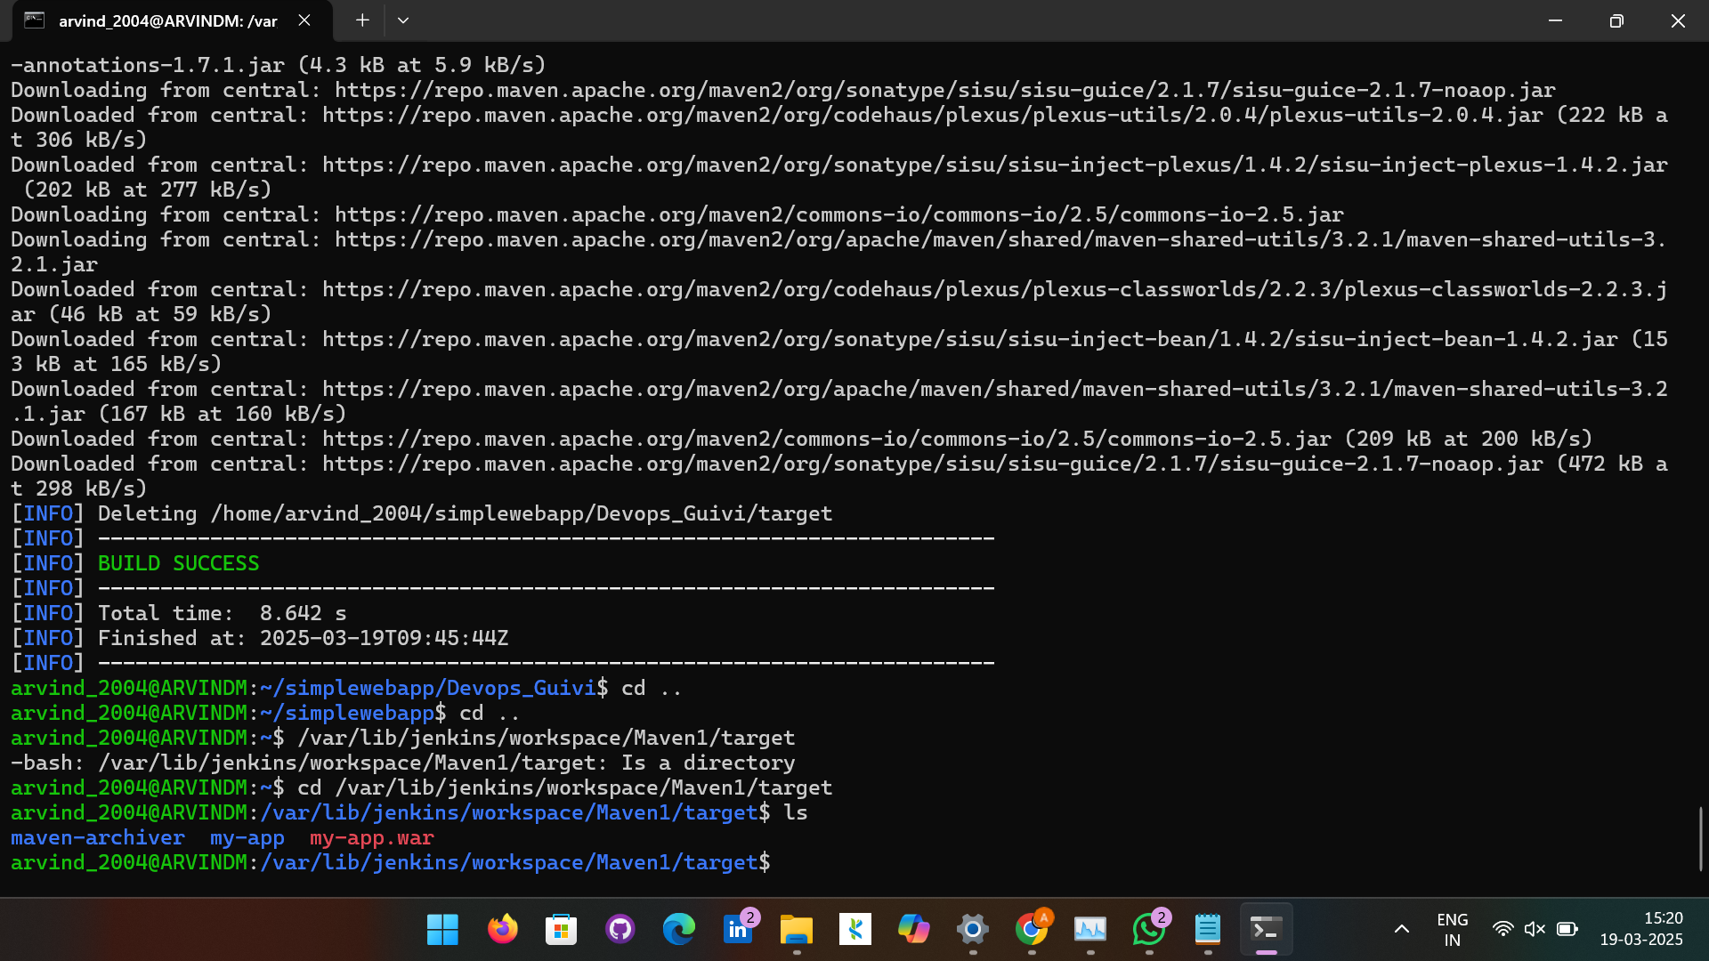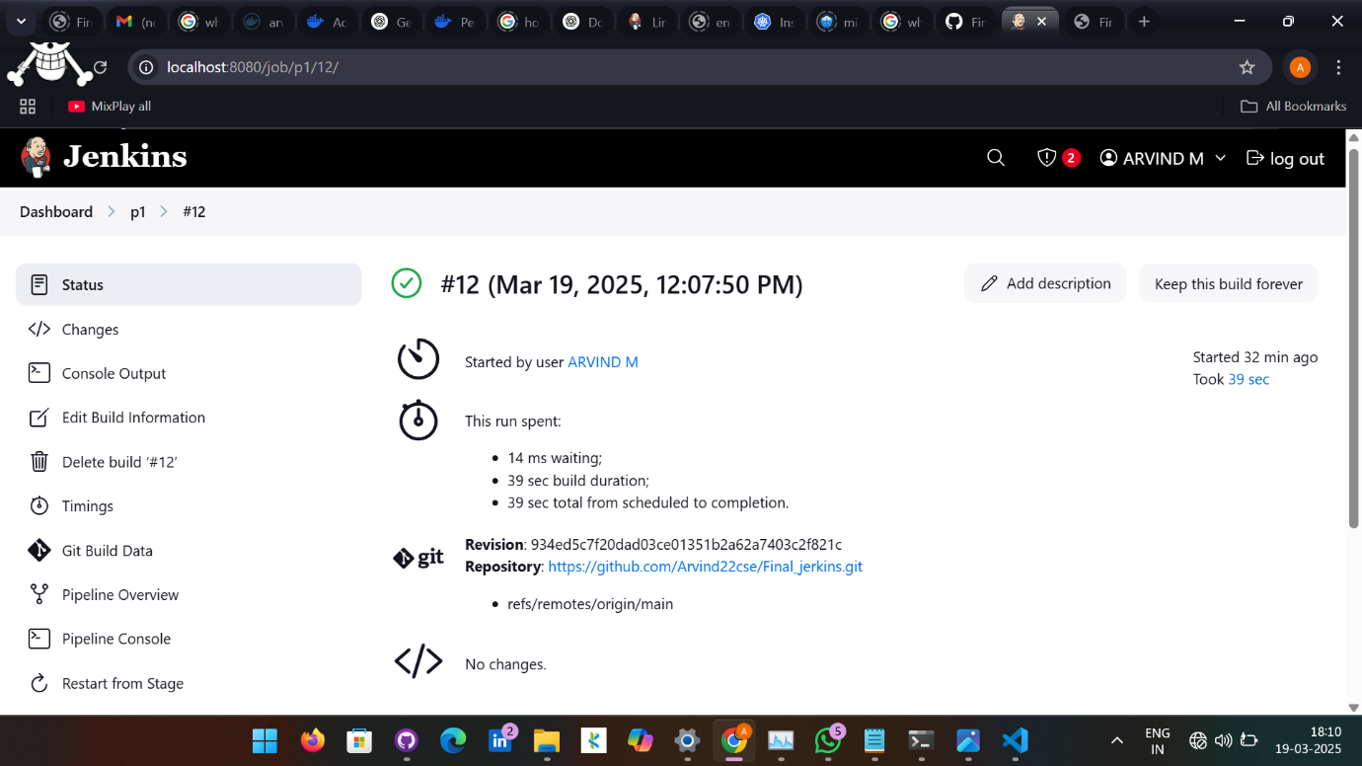

arvind_2004@ARVINDM:/$ sudo apt install openjdk-17-jdk
Reading package lists... Done
Building dependency tree... Done
Reading state information... Done
The following additional packages will be installed:
alsa-topology-conf alsa-ucm-conf ca-certificates-java fonts-dejavu-extra java-common libasound2-data libasound2t64
libatk-wrapper-java libatk-wrapper-java-jni libgif7 libice-dev libice6 libnspr4 libnss3 libpcsclite1 libpthread-stubs0-dev
libsm-dev libsm6 libx11-dev libxau-dev libxaw7 libxcb-shape0 libxcb1-dev libxdmcp-dev libxft2 libxkbfile1 libxmu6 libxpm4
libxt-dev libxt6t64 libxv1 libxxf86dga1 openjdk-17-jdk-headless openjdk-17-jre openjdk-17-jre-headless x11-utils x11proto-dev
xorg-sgml-doctools xtrans-dev
Suggested packages:
default-jre alsa-utils libasound2-plugins libice-doc pcscd libsm-doc libx11-doc libxcb-doc libxt-doc openjdk-17-demo
openjdk-17-source visualvm libnss-mdns fonts-ipafont-gothic fonts-ipafont-mincho fonts-wqy-microhei | fonts-wqy-zenhei
fonts-indic mesa-utils
Recommended packages:
luit
The following NEW packages will be installed:
alsa-topology-conf alsa-ucm-conf ca-certificates-java fonts-dejavu-extra java-common libasound2-data libasound2t64
libatk-wrapper-java libatk-wrapper-java-jni libgif7 libice-dev libice6 libnspr4 libnss3 libpcsclite1 libpthread-stubs0-dev
libsm-dev libsm6 libx11-dev libxau-dev libxaw7 libxcb-shape0 libxcb1-dev libxdmcp-dev libxft2 libxkbfile1 libxmu6 libxpm4
libxt-dev libxt6t64 libxv1 libxxf86dga1 openjdk-17-jdk openjdk-17-jdk-headless openjdk-17-jre openjdk-17-jre-headless x11-utils
x11proto-dev xorg-sgml-doctools xtrans-dev
0 upgraded, 40 newly installed, 0 to remove and 56 not upgraded.
Need to get 123 MB/128 MB of archives.
After this operation, 298 MB of additional disk space will be used.
Do you want to continue? [Y/n] Y
Get:1 http://archive.ubuntu.com/ubuntu noble/main amd64 xorg-sgml-doctools all 1:1.11-1.1 [10.9 kB]
Get:2 http://archive.ubuntu.com/ubuntu noble/main amd64 x11proto-dev all 2023.2-1 [602 kB]
Get:3 http://archive.ubuntu.com/ubuntu noble/main amd64 libice-dev amd64 2:1.0.10-1build3 [51.0 kB]
Get:4 http://archive.ubuntu.com/ubuntu noble/main amd64 libnspr4 amd64 2:4.35-1.1build1 [117 kB]
Get:5 http://archive.ubuntu.com/ubuntu noble/main amd64 libpcsclite1 amd64 2.0.3-1build1 [21.4 kB]
Get:6 http://archive.ubuntu.com/ubuntu noble/main amd64 libpthread-stubs0-dev amd64 0.4-1build3 [4746 B]
Get:7 http://archive.ubuntu.com/ubuntu noble/main amd64 libsm-dev amd64 2:1.2.3-1build3 [17.8 kB]
Get:8 http://archive.ubuntu.com/ubuntu noble/main amd64 libxau-dev amd64 1:1.0.9-1build6 [9570 B]
Get:9 http://archive.ubuntu.com/ubuntu noble/main amd64 libxdmcp-dev amd64 1:1.1.3-0ubuntu6 [26.5 kB]
Get:10 http://archive.ubuntu.com/ubuntu noble/main amd64 xtrans-dev all 1.4.0-1 [68.9 kB]
Err:10 http://archive.ubuntu.com/ubuntu noble/main amd64 xtrans-dev all 1.4.0-1
Hash Sum mismatch
Hashes of expected file:
- SHA512:bd7b220c57f705f7f6274f1c12166042f5f82d4a39ef54c8b968c8fc58fa3439233431a6a175ab41487a45ce09e035eecd6baffb1eebac845328d4d50363d16f
- SHA256:45277c51d5d83db351b61859314b59595c9626ac372fbb2fc0d5542e169d9086
- SHA1:edb12d6a666d507e1cb1589ab0c24434001878d5 [weak]
- MD5Sum:5411362f7caeccc1185750f3a1a508ee [weak]
- Filesize:68900 [weak]
Hashes of received file:
- SHA512:2a6e68c4a1c1e77686e91587d22af07d3794bd032800b941c48b515d96753cc21846cc32aa6ddb8bfe67c87897986e19856436635a582943346164be6bb7b52d
- SHA256:fe422a124ab303029cec066dfba7d87094a4642903c32a5fbf9994bedadb77cf
- SHA1:51f6d51aeca59415e4e507bc3f794812d8e5028f [weak]
- MD5Sum:c4ba840f3e252e9d260f93314664a208 [weak]
- Filesize:68900 [weak]
Last modification reported: Wed, 26 Feb 2020 17:23:28 +0000
Get:11 http://archive.ubuntu.com/ubuntu noble/main amd64 libxcb1-dev amd64 1.15-1ubuntu2 [85.8 kB]
Ign:11 http://archive.ubuntu.com/ubuntu noble/main amd64 libxcb1-dev amd64 1.15-1ubuntu2
Err:12 http://archive.ubuntu.com/ubuntu noble/main amd64 libx11-dev amd64 2:1.8.7-1build1
403 Forbidden [IP: 185.125.190.83 80]
Get:13 http://archive.ubuntu.com/ubuntu noble/main amd64 libxt-dev amd64 1:1.2.1-1.2build1 [394 kB]
Ign:14 http://archive.ubuntu.com/ubuntu noble-updates/main amd64 openjdk-17-jre-headless amd64 17.0.14+7-1~24.04
Err:14 http://security.ubuntu.com/ubuntu noble-updates/main amd64 openjdk-17-jre-headless amd64 17.0.14+7-1~24.04
403 Forbidden [IP: 185.125.190.83 80]
Get:15 http://archive.ubuntu.com/ubuntu noble-updates/main amd64 openjdk-17-jdk-headless amd64 17.0.14+7-1~24.04 [71.4 MB]
Ign:15 http://archive.ubuntu.com/ubuntu noble-updates/main amd64 openjdk-17-jdk-headless amd64 17.0.14+7-1~24.04
Get:16 http://archive.ubuntu.com/ubuntu noble-updates/main amd64 openjdk-17-jdk amd64 17.0.14+7-1~24.04 [1523 kB]
Get:11 http://archive.ubuntu.com/ubuntu noble/main amd64 libxcb1-dev amd64 1.15-1ubuntu2 [85.8 kB]
Err:11 http://archive.ubuntu.com/ubuntu noble/main amd64 libxcb1-dev amd64 1.15-1ubuntu2
Hash Sum mismatch
Hashes of expected file:
- SHA512:ea9c0f7f5e00aa3abe0b885a04733859f50fb819734531ce96a9d29ccc3dd01b3d95fbf4119e26750ad44aee995847638128416685b36a00e467880254f94763
- SHA256:1bafe3432feafc9e57f858721da524dfb3ee1f6fc4ef6b0c73023e79eadb9c28
- SHA1:ca750f2589dde1d1a48188e9c79d3474cae94622 [weak]
- MD5Sum:1e4450158a96673730029fda74fdfac6 [weak]
- Filesize:85790 [weak]
Hashes of received file:
- SHA512:6f7431b7066973975db79a949c112a17ad51a44f8d46079b35bb7937092c56e568419f923fefc1b094e14b7e3a06615fbc5a7fecfe153216c476ba3ac99bf7c6
- SHA256:7d678d7e1ff07f42de7d3427c98fdfad995baac89589a36fb1bd919eb2aba9e6
- SHA1:4c0058efc85d5d15261ff447b931a9af125f19aa [weak]
- MD5Sum:3c0c7a86fe5eb36ec050dd4d5e44422a [weak]
- Filesize:85790 [weak]
Last modification reported: Thu, 18 Apr 2024 16:08:56 +0000
Ign:15 http://archive.ubuntu.com/ubuntu noble-updates/main amd64 openjdk-17-jdk-headless amd64 17.0.14+7-1~24.04
Ign:15 http://archive.ubuntu.com/ubuntu noble-updates/main amd64 openjdk-17-jdk-headless amd64 17.0.14+7-1~24.04
Err:15 http://security.ubuntu.com/ubuntu noble-updates/main amd64 openjdk-17-jdk-headless amd64 17.0.14+7-1~24.04
Connection timed out [IP: 185.125.190.83 80]
Fetched 2916 kB in 1min 52s (26.0 kB/s)
E: Failed to fetch http://archive.ubuntu.com/ubuntu/pool/main/x/xtrans/xtrans-dev_1.4.0-1_all.deb Hash Sum mismatch
Hashes of expected file:
- SHA512:bd7b220c57f705f7f6274f1c12166042f5f82d4a39ef54c8b968c8fc58fa3439233431a6a175ab41487a45ce09e035eecd6baffb1eebac845328d4d50363d16f
- SHA256:45277c51d5d83db351b61859314b59595c9626ac372fbb2fc0d5542e169d9086
- SHA1:edb12d6a666d507e1cb1589ab0c24434001878d5 [weak]
- MD5Sum:5411362f7caeccc1185750f3a1a508ee [weak]
- Filesize:68900 [weak]
Hashes of received file:
- SHA512:2a6e68c4a1c1e77686e91587d22af07d3794bd032800b941c48b515d96753cc21846cc32aa6ddb8bfe67c87897986e19856436635a582943346164be6bb7b52d
- SHA256:fe422a124ab303029cec066dfba7d87094a4642903c32a5fbf9994bedadb77cf
- SHA1:51f6d51aeca59415e4e507bc3f794812d8e5028f [weak]
- MD5Sum:c4ba840f3e252e9d260f93314664a208 [weak]
- Filesize:68900 [weak]
Last modification reported: Wed, 26 Feb 2020 17:23:28 +0000
E: Failed to fetch http://archive.ubuntu.com/ubuntu/pool/main/libx/libxcb/libxcb1-dev_1.15-1ubuntu2_amd64.deb Hash Sum mismatch
Hashes of expected file:
- SHA512:ea9c0f7f5e00aa3abe0b885a04733859f50fb819734531ce96a9d29ccc3dd01b3d95fbf4119e26750ad44aee995847638128416685b36a00e467880254f94763
- SHA256:1bafe3432feafc9e57f858721da524dfb3ee1f6fc4ef6b0c73023e79eadb9c28
- SHA1:ca750f2589dde1d1a48188e9c79d3474cae94622 [weak]
- MD5Sum:1e4450158a96673730029fda74fdfac6 [weak]
- Filesize:85790 [weak]
Hashes of received file:
- SHA512:6f7431b7066973975db79a949c112a17ad51a44f8d46079b35bb7937092c56e568419f923fefc1b094e14b7e3a06615fbc5a7fecfe153216c476ba3ac99bf7c6
- SHA256:7d678d7e1ff07f42de7d3427c98fdfad995baac89589a36fb1bd919eb2aba9e6
- SHA1:4c0058efc85d5d15261ff447b931a9af125f19aa [weak]
- MD5Sum:3c0c7a86fe5eb36ec050dd4d5e44422a [weak]
- Filesize:85790 [weak]
Last modification reported: Thu, 18 Apr 2024 16:08:56 +0000
E: Failed to fetch http://archive.ubuntu.com/ubuntu/pool/main/libx/libx11/libx11-dev_1.8.7-1build1_amd64.deb 403 Forbidden [IP: 185.125.190.83 80]
E: Failed to fetch http://security.ubuntu.com/ubuntu/pool/main/o/openjdk-17/openjdk-17-jre-headless_17.0.14%2b7-1%7e24.04_amd64.deb 403 Forbidden [IP: 185.125.190.83 80]
E: Failed to fetch http://security.ubuntu.com/ubuntu/pool/main/o/openjdk-17/openjdk-17-jdk-headless_17.0.14%2b7-1%7e24.04_amd64.deb Connection timed out [IP: 185.125.190.83 80]
E: Unable to fetch some archives, maybe run apt-get update or try with --fix-missing?
arvind_2004@ARVINDM:/$ java --version
Command 'java' not found, but can be installed with:
sudo apt install openjdk-17-jre-headless # version 17.0.14+7-1~24.04, or
sudo apt install openjdk-21-jre-headless # version 21.0.6+7-1~24.04.1
sudo apt install default-jre # version 2:1.17-75
sudo apt install openjdk-11-jre-headless # version 11.0.26+4-1ubuntu1~24.04
sudo apt install openjdk-8-jre-headless # version 8u442-b06~us1-0ubuntu1~24.04
sudo apt install openjdk-19-jre-headless # version 19.0.2+7-4
sudo apt install openjdk-20-jre-headless # version 20.0.2+9-1
sudo apt install openjdk-22-jre-headless # version 22~22ea-1
arvind_2004@ARVINDM:/$ sudo apt-get update --fix-missing
Hit:1 http://security.ubuntu.com/ubuntu noble-security InRelease
Hit:2 http://archive.ubuntu.com/ubuntu noble InRelease
Hit:3 http://archive.ubuntu.com/ubuntu noble-updates InRelease
Err:4 http://archive.ubuntu.com/ubuntu noble-backports InRelease
403 Forbidden [IP: 91.189.91.81 80]
Reading package lists... Done
E: Failed to fetch http://archive.ubuntu.com/ubuntu/dists/noble-backports/InRelease 403 Forbidden [IP: 91.189.91.81 80]
E: The repository 'http://archive.ubuntu.com/ubuntu noble-backports InRelease' is not signed.
N: Updating from such a repository can't be done securely, and is therefore disabled by default.
N: See apt-secure(8) manpage for repository creation and user configuration details.
arvind_2004@ARVINDM:/$ sudo apt install openjdk-17-jdk
Reading package lists... Done
Building dependency tree... Done
Reading state information... Done
The following additional packages will be installed:
alsa-topology-conf alsa-ucm-conf ca-certificates-java fonts-dejavu-extra java-common libasound2-data libasound2t64
libatk-wrapper-java libatk-wrapper-java-jni libgif7 libice-dev libice6 libnspr4 libnss3 libpcsclite1 libpthread-stubs0-dev
libsm-dev libsm6 libx11-dev libxau-dev libxaw7 libxcb-shape0 libxcb1-dev libxdmcp-dev libxft2 libxkbfile1 libxmu6 libxpm4
libxt-dev libxt6t64 libxv1 libxxf86dga1 openjdk-17-jdk-headless openjdk-17-jre openjdk-17-jre-headless x11-utils x11proto-dev
xorg-sgml-doctools xtrans-dev
Suggested packages:
default-jre alsa-utils libasound2-plugins libice-doc pcscd libsm-doc libx11-doc libxcb-doc libxt-doc openjdk-17-demo
openjdk-17-source visualvm libnss-mdns fonts-ipafont-gothic fonts-ipafont-mincho fonts-wqy-microhei | fonts-wqy-zenhei
fonts-indic mesa-utils
Recommended packages:
luit
The following NEW packages will be installed:
alsa-topology-conf alsa-ucm-conf ca-certificates-java fonts-dejavu-extra java-common libasound2-data libasound2t64
libatk-wrapper-java libatk-wrapper-java-jni libgif7 libice-dev libice6 libnspr4 libnss3 libpcsclite1 libpthread-stubs0-dev
libsm-dev libsm6 libx11-dev libxau-dev libxaw7 libxcb-shape0 libxcb1-dev libxdmcp-dev libxft2 libxkbfile1 libxmu6 libxpm4
libxt-dev libxt6t64 libxv1 libxxf86dga1 openjdk-17-jdk openjdk-17-jdk-headless openjdk-17-jre openjdk-17-jre-headless x11-utils
x11proto-dev xorg-sgml-doctools xtrans-dev
0 upgraded, 40 newly installed, 0 to remove and 56 not upgraded.
Need to get 120 MB/128 MB of archives.
After this operation, 298 MB of additional disk space will be used.
Do you want to continue? [Y/n] Y
Get:1 http://archive.ubuntu.com/ubuntu noble/main amd64 xtrans-dev all 1.4.0-1 [68.9 kB]
Get:2 http://archive.ubuntu.com/ubuntu noble/main amd64 libxcb1-dev amd64 1.15-1ubuntu2 [85.8 kB]
Get:3 http://archive.ubuntu.com/ubuntu noble/main amd64 libx11-dev amd64 2:1.8.7-1build1 [732 kB]
Get:4 http://archive.ubuntu.com/ubuntu noble-updates/main amd64 openjdk-17-jre-headless amd64 17.0.14+7-1~24.04 [47.9 MB]
Get:5 http://archive.ubuntu.com/ubuntu noble-updates/main amd64 openjdk-17-jdk-headless amd64 17.0.14+7-1~24.04 [71.4 MB]
Fetched 893 kB in 5s (185 kB/s)
Extracting templates from packages: 100%
Selecting previously unselected package alsa-topology-conf.
(Reading database ... 40768 files and directories currently installed.)
Preparing to unpack .../00-alsa-topology-conf_1.2.5.1-2_all.deb ...
Unpacking alsa-topology-conf (1.2.5.1-2) ...
Selecting previously unselected package libasound2-data.
Preparing to unpack .../01-libasound2-data_1.2.11-1build2_all.deb ...
Unpacking libasound2-data (1.2.11-1build2) ...
Selecting previously unselected package libasound2t64:amd64.
Preparing to unpack .../02-libasound2t64_1.2.11-1build2_amd64.deb ...
Unpacking libasound2t64:amd64 (1.2.11-1build2) ...
Selecting previously unselected package alsa-ucm-conf.
Preparing to unpack .../03-alsa-ucm-conf_1.2.10-1ubuntu5.4_all.deb ...
Unpacking alsa-ucm-conf (1.2.10-1ubuntu5.4) ...
Selecting previously unselected package ca-certificates-java.
Preparing to unpack .../04-ca-certificates-java_20240118_all.deb ...
Unpacking ca-certificates-java (20240118) ...
Selecting previously unselected package fonts-dejavu-extra.
Preparing to unpack .../05-fonts-dejavu-extra_2.37-8_all.deb ...
Unpacking fonts-dejavu-extra (2.37-8) ...
Selecting previously unselected package java-common.
Preparing to unpack .../06-java-common_0.75+exp1_all.deb ...
Unpacking java-common (0.75+exp1) ...
Selecting previously unselected package libice6:amd64.
Preparing to unpack .../07-libice6_2%3a1.0.10-1build3_amd64.deb ...
Unpacking libice6:amd64 (2:1.0.10-1build3) ...
Selecting previously unselected package libsm6:amd64.
Preparing to unpack .../08-libsm6_2%3a1.2.3-1build3_amd64.deb ...
Unpacking libsm6:amd64 (2:1.2.3-1build3) ...
Selecting previously unselected package libxt6t64:amd64.
Preparing to unpack .../09-libxt6t64_1%3a1.2.1-1.2build1_amd64.deb ...
Unpacking libxt6t64:amd64 (1:1.2.1-1.2build1) ...
Selecting previously unselected package libxmu6:amd64.
Preparing to unpack .../10-libxmu6_2%3a1.1.3-3build2_amd64.deb ...
Unpacking libxmu6:amd64 (2:1.1.3-3build2) ...
Selecting previously unselected package libxpm4:amd64.
Preparing to unpack .../11-libxpm4_1%3a3.5.17-1build2_amd64.deb ...
Unpacking libxpm4:amd64 (1:3.5.17-1build2) ...
Selecting previously unselected package libxaw7:amd64.
Preparing to unpack .../12-libxaw7_2%3a1.0.14-1build2_amd64.deb ...
Unpacking libxaw7:amd64 (2:1.0.14-1build2) ...
Selecting previously unselected package libxcb-shape0:amd64.
Preparing to unpack .../13-libxcb-shape0_1.15-1ubuntu2_amd64.deb ...
Unpacking libxcb-shape0:amd64 (1.15-1ubuntu2) ...
Selecting previously unselected package libxft2:amd64.
Preparing to unpack .../14-libxft2_2.3.6-1build1_amd64.deb ...
Unpacking libxft2:amd64 (2.3.6-1build1) ...
Selecting previously unselected package libxkbfile1:amd64.
Preparing to unpack .../15-libxkbfile1_1%3a1.1.0-1build4_amd64.deb ...
Unpacking libxkbfile1:amd64 (1:1.1.0-1build4) ...
Selecting previously unselected package libxv1:amd64.
Preparing to unpack .../16-libxv1_2%3a1.0.11-1.1build1_amd64.deb ...
Unpacking libxv1:amd64 (2:1.0.11-1.1build1) ...
Selecting previously unselected package libxxf86dga1:amd64.
Preparing to unpack .../17-libxxf86dga1_2%3a1.1.5-1build1_amd64.deb ...
Unpacking libxxf86dga1:amd64 (2:1.1.5-1build1) ...
Selecting previously unselected package x11-utils.
Preparing to unpack .../18-x11-utils_7.7+6build2_amd64.deb ...
Unpacking x11-utils (7.7+6build2) ...
Selecting previously unselected package libatk-wrapper-java.
Preparing to unpack .../19-libatk-wrapper-java_0.40.0-3build2_all.deb ...
Unpacking libatk-wrapper-java (0.40.0-3build2) ...
Selecting previously unselected package libatk-wrapper-java-jni:amd64.
Preparing to unpack .../20-libatk-wrapper-java-jni_0.40.0-3build2_amd64.deb ...
Unpacking libatk-wrapper-java-jni:amd64 (0.40.0-3build2) ...
Selecting previously unselected package libgif7:amd64.
Preparing to unpack .../21-libgif7_5.2.2-1ubuntu1_amd64.deb ...
Unpacking libgif7:amd64 (5.2.2-1ubuntu1) ...
Selecting previously unselected package xorg-sgml-doctools.
Preparing to unpack .../22-xorg-sgml-doctools_1%3a1.11-1.1_all.deb ...
Unpacking xorg-sgml-doctools (1:1.11-1.1) ...
Selecting previously unselected package x11proto-dev.
Preparing to unpack .../23-x11proto-dev_2023.2-1_all.deb ...
Unpacking x11proto-dev (2023.2-1) ...
Selecting previously unselected package libice-dev:amd64.
Preparing to unpack .../24-libice-dev_2%3a1.0.10-1build3_amd64.deb ...
Unpacking libice-dev:amd64 (2:1.0.10-1build3) ...
Selecting previously unselected package libnspr4:amd64.
Preparing to unpack .../25-libnspr4_2%3a4.35-1.1build1_amd64.deb ...
Unpacking libnspr4:amd64 (2:4.35-1.1build1) ...
Selecting previously unselected package libnss3:amd64.
Preparing to unpack .../26-libnss3_2%3a3.98-1build1_amd64.deb ...
Unpacking libnss3:amd64 (2:3.98-1build1) ...
Selecting previously unselected package libpcsclite1:amd64.
Preparing to unpack .../27-libpcsclite1_2.0.3-1build1_amd64.deb ...
Unpacking libpcsclite1:amd64 (2.0.3-1build1) ...
Selecting previously unselected package libpthread-stubs0-dev:amd64.
Preparing to unpack .../28-libpthread-stubs0-dev_0.4-1build3_amd64.deb ...
Unpacking libpthread-stubs0-dev:amd64 (0.4-1build3) ...
Selecting previously unselected package libsm-dev:amd64.
Preparing to unpack .../29-libsm-dev_2%3a1.2.3-1build3_amd64.deb ...
Unpacking libsm-dev:amd64 (2:1.2.3-1build3) ...
Selecting previously unselected package libxau-dev:amd64.
Preparing to unpack .../30-libxau-dev_1%3a1.0.9-1build6_amd64.deb ...
Unpacking libxau-dev:amd64 (1:1.0.9-1build6) ...
Selecting previously unselected package libxdmcp-dev:amd64.
Preparing to unpack .../31-libxdmcp-dev_1%3a1.1.3-0ubuntu6_amd64.deb ...
Unpacking libxdmcp-dev:amd64 (1:1.1.3-0ubuntu6) ...
Selecting previously unselected package xtrans-dev.
Preparing to unpack .../32-xtrans-dev_1.4.0-1_all.deb ...
Unpacking xtrans-dev (1.4.0-1) ...
Selecting previously unselected package libxcb1-dev:amd64.
Preparing to unpack .../33-libxcb1-dev_1.15-1ubuntu2_amd64.deb ...
Unpacking libxcb1-dev:amd64 (1.15-1ubuntu2) ...
Selecting previously unselected package libx11-dev:amd64.
Preparing to unpack .../34-libx11-dev_2%3a1.8.7-1build1_amd64.deb ...
Unpacking libx11-dev:amd64 (2:1.8.7-1build1) ...
Selecting previously unselected package libxt-dev:amd64.
Preparing to unpack .../35-libxt-dev_1%3a1.2.1-1.2build1_amd64.deb ...
Unpacking libxt-dev:amd64 (1:1.2.1-1.2build1) ...
Selecting previously unselected package openjdk-17-jre-headless:amd64.
Preparing to unpack .../36-openjdk-17-jre-headless_17.0.14+7-1~24.04_amd64.deb ...
Unpacking openjdk-17-jre-headless:amd64 (17.0.14+7-1~24.04) ...
Selecting previously unselected package openjdk-17-jre:amd64.
Preparing to unpack .../37-openjdk-17-jre_17.0.14+7-1~24.04_amd64.deb ...
Unpacking openjdk-17-jre:amd64 (17.0.14+7-1~24.04) ...
Selecting previously unselected package openjdk-17-jdk-headless:amd64.
Preparing to unpack .../38-openjdk-17-jdk-headless_17.0.14+7-1~24.04_amd64.deb ...
Unpacking openjdk-17-jdk-headless:amd64 (17.0.14+7-1~24.04) ...
Selecting previously unselected package openjdk-17-jdk:amd64.
Preparing to unpack .../39-openjdk-17-jdk_17.0.14+7-1~24.04_amd64.deb ...
Unpacking openjdk-17-jdk:amd64 (17.0.14+7-1~24.04) ...
Setting up libice6:amd64 (2:1.0.10-1build3) ...
Setting up libxft2:amd64 (2.3.6-1build1) ...
Setting up libxpm4:amd64 (1:3.5.17-1build2) ...
Setting up java-common (0.75+exp1) ...
Setting up libxcb-shape0:amd64 (1.15-1ubuntu2) ...
Setting up libxxf86dga1:amd64 (2:1.1.5-1build1) ...
Setting up libpthread-stubs0-dev:amd64 (0.4-1build3) ...
Setting up libasound2-data (1.2.11-1build2) ...
Setting up xtrans-dev (1.4.0-1) ...
Setting up libasound2t64:amd64 (1.2.11-1build2) ...
Setting up libnspr4:amd64 (2:4.35-1.1build1) ...
Setting up libxv1:amd64 (2:1.0.11-1.1build1) ...
Setting up libpcsclite1:amd64 (2.0.3-1build1) ...
Setting up libgif7:amd64 (5.2.2-1ubuntu1) ...
Setting up fonts-dejavu-extra (2.37-8) ...
Setting up alsa-topology-conf (1.2.5.1-2) ...
Setting up xorg-sgml-doctools (1:1.11-1.1) ...
Setting up libxkbfile1:amd64 (1:1.1.0-1build4) ...
Setting up ca-certificates-java (20240118) ...
No JRE found. Skipping Java certificates setup.
Setting up libsm6:amd64 (2:1.2.3-1build3) ...
Setting up alsa-ucm-conf (1.2.10-1ubuntu5.4) ...
Setting up libnss3:amd64 (2:3.98-1build1) ...
Setting up libxt6t64:amd64 (1:1.2.1-1.2build1) ...
Setting up openjdk-17-jre-headless:amd64 (17.0.14+7-1~24.04) ...
update-alternatives: using /usr/lib/jvm/java-17-openjdk-amd64/bin/java to provide /usr/bin/java (java) in auto mode
update-alternatives: using /usr/lib/jvm/java-17-openjdk-amd64/bin/jpackage to provide /usr/bin/jpackage (jpackage) in auto mode
update-alternatives: using /usr/lib/jvm/java-17-openjdk-amd64/bin/keytool to provide /usr/bin/keytool (keytool) in auto mode
update-alternatives: using /usr/lib/jvm/java-17-openjdk-amd64/bin/rmiregistry to provide /usr/bin/rmiregistry (rmiregistry) in auto m
ode
update-alternatives: using /usr/lib/jvm/java-17-openjdk-amd64/lib/jexec to provide /usr/bin/jexec (jexec) in auto mode
Setting up libxmu6:amd64 (2:1.1.3-3build2) ...
Setting up libxaw7:amd64 (2:1.0.14-1build2) ...
Setting up x11-utils (7.7+6build2) ...
Setting up libatk-wrapper-java (0.40.0-3build2) ...
Setting up libatk-wrapper-java-jni:amd64 (0.40.0-3build2) ...
Processing triggers for libc-bin (2.39-0ubuntu8.4) ...
Processing triggers for man-db (2.12.0-4build2) ...
Processing triggers for sgml-base (1.31) ...
Setting up x11proto-dev (2023.2-1) ...
Processing triggers for fontconfig (2.15.0-1.1ubuntu2) ...
Setting up libxau-dev:amd64 (1:1.0.9-1build6) ...
Processing triggers for hicolor-icon-theme (0.17-2) ...
Setting up libice-dev:amd64 (2:1.0.10-1build3) ...
Setting up libsm-dev:amd64 (2:1.2.3-1build3) ...
Setting up libxdmcp-dev:amd64 (1:1.1.3-0ubuntu6) ...
Setting up libxcb1-dev:amd64 (1.15-1ubuntu2) ...
Setting up libx11-dev:amd64 (2:1.8.7-1build1) ...
Setting up libxt-dev:amd64 (1:1.2.1-1.2build1) ...
Processing triggers for ca-certificates-java (20240118) ...
Adding debian:ACCVRAIZ1.pem
Adding debian:AC_RAIZ_FNMT-RCM.pem
Adding debian:AC_RAIZ_FNMT-RCM_SERVIDORES_SEGUROS.pem
Adding debian:ANF_Secure_Server_Root_CA.pem
Adding debian:Actalis_Authentication_Root_CA.pem
Adding debian:AffirmTrust_Commercial.pem
Adding debian:AffirmTrust_Networking.pem
Adding debian:AffirmTrust_Premium.pem
Adding debian:AffirmTrust_Premium_ECC.pem
Adding debian:Amazon_Root_CA_1.pem
Adding debian:Amazon_Root_CA_2.pem
Adding debian:Amazon_Root_CA_3.pem
Adding debian:Amazon_Root_CA_4.pem
Adding debian:Atos_TrustedRoot_2011.pem
Adding debian:Atos_TrustedRoot_Root_CA_ECC_TLS_2021.pem
Adding debian:Atos_TrustedRoot_Root_CA_RSA_TLS_2021.pem
Adding debian:Autoridad_de_Certificacion_Firmaprofesional_CIF_A62634068.pem
Adding debian:BJCA_Global_Root_CA1.pem
Adding debian:BJCA_Global_Root_CA2.pem
Adding debian:Baltimore_CyberTrust_Root.pem
Adding debian:Buypass_Class_2_Root_CA.pem
Adding debian:Buypass_Class_3_Root_CA.pem
Adding debian:CA_Disig_Root_R2.pem
Adding debian:CFCA_EV_ROOT.pem
Adding debian:COMODO_Certification_Authority.pem
Adding debian:COMODO_ECC_Certification_Authority.pem
Adding debian:COMODO_RSA_Certification_Authority.pem
Adding debian:Certainly_Root_E1.pem
Adding debian:Certainly_Root_R1.pem
Adding debian:Certigna.pem
Adding debian:Certigna_Root_CA.pem
Adding debian:Certum_EC-384_CA.pem
Adding debian:Certum_Trusted_Network_CA.pem
Adding debian:Certum_Trusted_Network_CA_2.pem
Adding debian:Certum_Trusted_Root_CA.pem
Adding debian:CommScope_Public_Trust_ECC_Root-01.pem
Adding debian:CommScope_Public_Trust_ECC_Root-02.pem
Adding debian:CommScope_Public_Trust_RSA_Root-01.pem
Adding debian:CommScope_Public_Trust_RSA_Root-02.pem
Adding debian:Comodo_AAA_Services_root.pem
Adding debian:D-TRUST_BR_Root_CA_1_2020.pem
Adding debian:D-TRUST_EV_Root_CA_1_2020.pem
Adding debian:D-TRUST_Root_Class_3_CA_2_2009.pem
Adding debian:D-TRUST_Root_Class_3_CA_2_EV_2009.pem
Adding debian:DigiCert_Assured_ID_Root_CA.pem
Adding debian:DigiCert_Assured_ID_Root_G2.pem
Adding debian:DigiCert_Assured_ID_Root_G3.pem
Adding debian:DigiCert_Global_Root_CA.pem
Adding debian:DigiCert_Global_Root_G2.pem
Adding debian:DigiCert_Global_Root_G3.pem
Adding debian:DigiCert_High_Assurance_EV_Root_CA.pem
Adding debian:DigiCert_TLS_ECC_P384_Root_G5.pem
Adding debian:DigiCert_TLS_RSA4096_Root_G5.pem
Adding debian:DigiCert_Trusted_Root_G4.pem
Adding debian:Entrust.net_Premium_2048_Secure_Server_CA.pem
Adding debian:Entrust_Root_Certification_Authority.pem
Adding debian:Entrust_Root_Certification_Authority_-_EC1.pem
Adding debian:Entrust_Root_Certification_Authority_-_G2.pem
Adding debian:Entrust_Root_Certification_Authority_-_G4.pem
Adding debian:GDCA_TrustAUTH_R5_ROOT.pem
Adding debian:GLOBALTRUST_2020.pem
Adding debian:GTS_Root_R1.pem
Adding debian:GTS_Root_R2.pem
Adding debian:GTS_Root_R3.pem
Adding debian:GTS_Root_R4.pem
Adding debian:GlobalSign_ECC_Root_CA_-_R4.pem
Adding debian:GlobalSign_ECC_Root_CA_-_R5.pem
Adding debian:GlobalSign_Root_CA.pem
Adding debian:GlobalSign_Root_CA_-_R3.pem
Adding debian:GlobalSign_Root_CA_-_R6.pem
Adding debian:GlobalSign_Root_E46.pem
Adding debian:GlobalSign_Root_R46.pem
Adding debian:Go_Daddy_Class_2_CA.pem
Adding debian:Go_Daddy_Root_Certificate_Authority_-_G2.pem
Adding debian:HARICA_TLS_ECC_Root_CA_2021.pem
Adding debian:HARICA_TLS_RSA_Root_CA_2021.pem
Adding debian:Hellenic_Academic_and_Research_Institutions_ECC_RootCA_2015.pem
Adding debian:Hellenic_Academic_and_Research_Institutions_RootCA_2015.pem
Adding debian:HiPKI_Root_CA_-_G1.pem
Adding debian:Hongkong_Post_Root_CA_3.pem
Adding debian:ISRG_Root_X1.pem
Adding debian:ISRG_Root_X2.pem
Adding debian:IdenTrust_Commercial_Root_CA_1.pem
Adding debian:IdenTrust_Public_Sector_Root_CA_1.pem
Adding debian:Izenpe.com.pem
Adding debian:Microsec_e-Szigno_Root_CA_2009.pem
Adding debian:Microsoft_ECC_Root_Certificate_Authority_2017.pem
Adding debian:Microsoft_RSA_Root_Certificate_Authority_2017.pem
Adding debian:NAVER_Global_Root_Certification_Authority.pem
Adding debian:NetLock_Arany_=Class_Gold=_Főtanúsítvány.pem
Adding debian:OISTE_WISeKey_Global_Root_GB_CA.pem
Adding debian:OISTE_WISeKey_Global_Root_GC_CA.pem
Adding debian:QuoVadis_Root_CA_1_G3.pem
Adding debian:QuoVadis_Root_CA_2.pem
Adding debian:QuoVadis_Root_CA_2_G3.pem
Adding debian:QuoVadis_Root_CA_3.pem
Adding debian:QuoVadis_Root_CA_3_G3.pem
Adding debian:SSL.com_EV_Root_Certification_Authority_ECC.pem
Adding debian:SSL.com_EV_Root_Certification_Authority_RSA_R2.pem
Adding debian:SSL.com_Root_Certification_Authority_ECC.pem
Adding debian:SSL.com_Root_Certification_Authority_RSA.pem
Adding debian:SSL.com_TLS_ECC_Root_CA_2022.pem
Adding debian:SSL.com_TLS_RSA_Root_CA_2022.pem
Adding debian:SZAFIR_ROOT_CA2.pem
Adding debian:Sectigo_Public_Server_Authentication_Root_E46.pem
Adding debian:Sectigo_Public_Server_Authentication_Root_R46.pem
Adding debian:SecureSign_RootCA11.pem
Adding debian:SecureTrust_CA.pem
Adding debian:Secure_Global_CA.pem
Adding debian:Security_Communication_ECC_RootCA1.pem
Adding debian:Security_Communication_RootCA2.pem
Adding debian:Security_Communication_RootCA3.pem
Adding debian:Security_Communication_Root_CA.pem
Adding debian:Starfield_Class_2_CA.pem
Adding debian:Starfield_Root_Certificate_Authority_-_G2.pem
Adding debian:Starfield_Services_Root_Certificate_Authority_-_G2.pem
Adding debian:SwissSign_Gold_CA_-_G2.pem
Adding debian:SwissSign_Silver_CA_-_G2.pem
Adding debian:T-TeleSec_GlobalRoot_Class_2.pem
Adding debian:T-TeleSec_GlobalRoot_Class_3.pem
Adding debian:TUBITAK_Kamu_SM_SSL_Kok_Sertifikasi_-_Surum_1.pem
Adding debian:TWCA_Global_Root_CA.pem
Adding debian:TWCA_Root_Certification_Authority.pem
Adding debian:TeliaSonera_Root_CA_v1.pem
Adding debian:Telia_Root_CA_v2.pem
Adding debian:TrustAsia_Global_Root_CA_G3.pem
Adding debian:TrustAsia_Global_Root_CA_G4.pem
Adding debian:Trustwave_Global_Certification_Authority.pem
Adding debian:Trustwave_Global_ECC_P256_Certification_Authority.pem
Adding debian:Trustwave_Global_ECC_P384_Certification_Authority.pem
Adding debian:TunTrust_Root_CA.pem
Adding debian:UCA_Extended_Validation_Root.pem
Adding debian:UCA_Global_G2_Root.pem
Adding debian:USERTrust_ECC_Certification_Authority.pem
Adding debian:USERTrust_RSA_Certification_Authority.pem
Adding debian:XRamp_Global_CA_Root.pem
Adding debian:certSIGN_ROOT_CA.pem
Adding debian:certSIGN_Root_CA_G2.pem
Adding debian:e-Szigno_Root_CA_2017.pem
Adding debian:ePKI_Root_Certification_Authority.pem
Adding debian:emSign_ECC_Root_CA_-_C3.pem
Adding debian:emSign_ECC_Root_CA_-_G3.pem
Adding debian:emSign_Root_CA_-_C1.pem
Adding debian:emSign_Root_CA_-_G1.pem
Adding debian:vTrus_ECC_Root_CA.pem
Adding debian:vTrus_Root_CA.pem
done.
Setting up openjdk-17-jre:amd64 (17.0.14+7-1~24.04) ...
Setting up openjdk-17-jdk-headless:amd64 (17.0.14+7-1~24.04) ...
update-alternatives: using /usr/lib/jvm/java-17-openjdk-amd64/bin/jar to provide /usr/bin/jar (jar) in auto mode
update-alternatives: using /usr/lib/jvm/java-17-openjdk-amd64/bin/jarsigner to provide /usr/bin/jarsigner (jarsigner) in auto mode
update-alternatives: using /usr/lib/jvm/java-17-openjdk-amd64/bin/javac to provide /usr/bin/javac (javac) in auto mode
update-alternatives: using /usr/lib/jvm/java-17-openjdk-amd64/bin/javadoc to provide /usr/bin/javadoc (javadoc) in auto mode
update-alternatives: using /usr/lib/jvm/java-17-openjdk-amd64/bin/javap to provide /usr/bin/javap (javap) in auto mode
update-alternatives: using /usr/lib/jvm/java-17-openjdk-amd64/bin/jcmd to provide /usr/bin/jcmd (jcmd) in auto mode
update-alternatives: using /usr/lib/jvm/java-17-openjdk-amd64/bin/jdb to provide /usr/bin/jdb (jdb) in auto mode
update-alternatives: using /usr/lib/jvm/java-17-openjdk-amd64/bin/jdeprscan to provide /usr/bin/jdeprscan (jdeprscan) in auto mode
update-alternatives: using /usr/lib/jvm/java-17-openjdk-amd64/bin/jdeps to provide /usr/bin/jdeps (jdeps) in auto mode
update-alternatives: using /usr/lib/jvm/java-17-openjdk-amd64/bin/jfr to provide /usr/bin/jfr (jfr) in auto mode
update-alternatives: using /usr/lib/jvm/java-17-openjdk-amd64/bin/jimage to provide /usr/bin/jimage (jimage) in auto mode
update-alternatives: using /usr/lib/jvm/java-17-openjdk-amd64/bin/jinfo to provide /usr/bin/jinfo (jinfo) in auto mode
update-alternatives: using /usr/lib/jvm/java-17-openjdk-amd64/bin/jlink to provide /usr/bin/jlink (jlink) in auto mode
update-alternatives: using /usr/lib/jvm/java-17-openjdk-amd64/bin/jmap to provide /usr/bin/jmap (jmap) in auto mode
update-alternatives: using /usr/lib/jvm/java-17-openjdk-amd64/bin/jmod to provide /usr/bin/jmod (jmod) in auto mode
update-alternatives: using /usr/lib/jvm/java-17-openjdk-amd64/bin/jps to provide /usr/bin/jps (jps) in auto mode
update-alternatives: using /usr/lib/jvm/java-17-openjdk-amd64/bin/jrunscript to provide /usr/bin/jrunscript (jrunscript) in auto mode
update-alternatives: using /usr/lib/jvm/java-17-openjdk-amd64/bin/jshell to provide /usr/bin/jshell (jshell) in auto mode
update-alternatives: using /usr/lib/jvm/java-17-openjdk-amd64/bin/jstack to provide /usr/bin/jstack (jstack) in auto mode
update-alternatives: using /usr/lib/jvm/java-17-openjdk-amd64/bin/jstat to provide /usr/bin/jstat (jstat) in auto mode
update-alternatives: using /usr/lib/jvm/java-17-openjdk-amd64/bin/jstatd to provide /usr/bin/jstatd (jstatd) in auto mode
update-alternatives: using /usr/lib/jvm/java-17-openjdk-amd64/bin/serialver to provide /usr/bin/serialver (serialver) in auto mode
update-alternatives: using /usr/lib/jvm/java-17-openjdk-amd64/bin/jhsdb to provide /usr/bin/jhsdb (jhsdb) in auto mode
Setting up openjdk-17-jdk:amd64 (17.0.14+7-1~24.04) ...
update-alternatives: using /usr/lib/jvm/java-17-openjdk-amd64/bin/jconsole to provide /usr/bin/jconsole (jconsole) in auto mode
arvind_2004@ARVINDM:/$ java --version
openjdk 17.0.14 2025-01-21
OpenJDK Runtime Environment (build 17.0.14+7-Ubuntu-124.04)
OpenJDK 64-Bit Server VM (build 17.0.14+7-Ubuntu-124.04, mixed mode, sharing)
arvind_2004@ARVINDM:/$ ls
bin boot etc init lib.usr-is-merged lost+found mnt proc run sbin.usr-is-merged srv tmp var
bin.usr-is-merged dev home lib lib64 media opt root sbin snap sys usr
arvind_2004@ARVINDM:/$ sudo apt install maven -y
Reading package lists... Done
Building dependency tree... Done
Reading state information... Done
The following additional packages will be installed:
libaopalliance-java libapache-pom-java libatinject-jsr330-api-java libcdi-api-java libcommons-cli-java libcommons-io-java
libcommons-lang3-java libcommons-parent-java liberror-prone-java libgeronimo-annotation-1.3-spec-java
libgeronimo-interceptor-3.0-spec-java libguava-java libguice-java libjansi-java libjsr305-java libmaven-parent-java
libmaven-resolver-java libmaven-shared-utils-java libmaven3-core-java libplexus-cipher-java libplexus-classworlds-java
libplexus-component-annotations-java libplexus-interpolation-java libplexus-sec-dispatcher-java libplexus-utils2-java
libsisu-inject-java libsisu-plexus-java libslf4j-java libwagon-file-java libwagon-http-shaded-java libwagon-provider-api-java
Suggested packages:
libatinject-jsr330-api-java-doc libel-api-java libcommons-io-java-doc libasm-java libcglib-java libjsr305-java-doc
libmaven-shared-utils-java-doc liblogback-java libplexus-utils2-java-doc junit4 testng libcommons-logging-java liblog4j1.2-java
The following NEW packages will be installed:
libaopalliance-java libapache-pom-java libatinject-jsr330-api-java libcdi-api-java libcommons-cli-java libcommons-io-java
libcommons-lang3-java libcommons-parent-java liberror-prone-java libgeronimo-annotation-1.3-spec-java
libgeronimo-interceptor-3.0-spec-java libguava-java libguice-java libjansi-java libjsr305-java libmaven-parent-java
libmaven-resolver-java libmaven-shared-utils-java libmaven3-core-java libplexus-cipher-java libplexus-classworlds-java
libplexus-component-annotations-java libplexus-interpolation-java libplexus-sec-dispatcher-java libplexus-utils2-java
libsisu-inject-java libsisu-plexus-java libslf4j-java libwagon-file-java libwagon-http-shaded-java libwagon-provider-api-java
maven
0 upgraded, 32 newly installed, 0 to remove and 56 not upgraded.
Need to get 10.1 MB of archives.
After this operation, 13.1 MB of additional disk space will be used.
Get:1 http://archive.ubuntu.com/ubuntu noble/universe amd64 libapache-pom-java all 29-2 [5284 B]
Get:2 http://archive.ubuntu.com/ubuntu noble/universe amd64 libatinject-jsr330-api-java all 1.0+ds1-5 [5348 B]
Get:3 http://archive.ubuntu.com/ubuntu noble/universe amd64 libgeronimo-interceptor-3.0-spec-java all 1.0.1-4fakesync [8616 B]
Get:4 http://archive.ubuntu.com/ubuntu noble/universe amd64 libcdi-api-java all 1.2-3 [54.3 kB]
Get:5 http://archive.ubuntu.com/ubuntu noble/universe amd64 libcommons-cli-java all 1.6.0-1 [59.9 kB]
Get:6 http://archive.ubuntu.com/ubuntu noble/universe amd64 libcommons-parent-java all 56-1 [10.7 kB]
Get:7 http://archive.ubuntu.com/ubuntu noble/universe amd64 libcommons-io-java all 2.11.0-2 [297 kB]
Get:8 http://archive.ubuntu.com/ubuntu noble/universe amd64 libcommons-lang3-java all 3.14.0-1 [586 kB]
Get:9 http://archive.ubuntu.com/ubuntu noble/universe amd64 libjsr305-java all 0.1~+svn49-11 [27.0 kB]
Get:10 http://archive.ubuntu.com/ubuntu noble/universe amd64 libguava-java all 32.0.1-1 [2692 kB]
Get:11 http://archive.ubuntu.com/ubuntu noble/universe amd64 liberror-prone-java all 2.18.0-1 [22.5 kB]
Get:12 http://archive.ubuntu.com/ubuntu noble/universe amd64 libgeronimo-annotation-1.3-spec-java all 1.3-1 [11.2 kB]
Get:13 http://archive.ubuntu.com/ubuntu noble/universe amd64 libaopalliance-java all 20070526-7 [8166 B]
Get:14 http://archive.ubuntu.com/ubuntu noble/universe amd64 libguice-java all 4.2.3-2 [1434 kB]
Get:15 http://archive.ubuntu.com/ubuntu noble/universe amd64 libjansi-java all 2.4.1-2 [83.0 kB]
Get:16 http://archive.ubuntu.com/ubuntu noble/universe amd64 libmaven-parent-java all 35-1 [5810 B]
Get:17 http://archive.ubuntu.com/ubuntu noble/universe amd64 libplexus-utils2-java all 3.4.2-1 [256 kB]
Get:18 http://archive.ubuntu.com/ubuntu noble/universe amd64 libwagon-provider-api-java all 3.5.3-1 [47.9 kB]
Get:19 http://archive.ubuntu.com/ubuntu noble/universe amd64 libmaven-resolver-java all 1.6.3-1 [544 kB]
Get:20 http://archive.ubuntu.com/ubuntu noble/universe amd64 libmaven-shared-utils-java all 3.3.4-1 [137 kB]
Get:21 http://archive.ubuntu.com/ubuntu noble/universe amd64 libplexus-cipher-java all 2.0-1 [14.7 kB]
Get:22 http://archive.ubuntu.com/ubuntu noble/universe amd64 libplexus-classworlds-java all 2.7.0-1 [50.0 kB]
Get:23 http://archive.ubuntu.com/ubuntu noble/universe amd64 libplexus-component-annotations-java all 2.1.1-1 [6550 B]
Get:24 http://archive.ubuntu.com/ubuntu noble/universe amd64 libplexus-interpolation-java all 1.26-1 [76.8 kB]
Get:25 http://archive.ubuntu.com/ubuntu noble/universe amd64 libplexus-sec-dispatcher-java all 2.0-3 [28.1 kB]
Get:26 http://archive.ubuntu.com/ubuntu noble/universe amd64 libslf4j-java all 1.7.32-1 [141 kB]
Get:27 http://archive.ubuntu.com/ubuntu noble/universe amd64 libsisu-inject-java all 0.3.4-2 [347 kB]
Get:28 http://archive.ubuntu.com/ubuntu noble/universe amd64 libsisu-plexus-java all 0.3.4-3 [181 kB]
Get:29 http://archive.ubuntu.com/ubuntu noble/universe amd64 libmaven3-core-java all 3.8.7-2 [1565 kB]
Get:30 http://archive.ubuntu.com/ubuntu noble/universe amd64 libwagon-file-java all 3.5.3-1 [7918 B]
Get:31 http://archive.ubuntu.com/ubuntu noble/universe amd64 libwagon-http-shaded-java all 3.5.3-1 [1332 kB]
Get:32 http://archive.ubuntu.com/ubuntu noble/universe amd64 maven all 3.8.7-2 [18.3 kB]
Fetched 10.1 MB in 7s (1530 kB/s)
Extracting templates from packages: 100%
Selecting previously unselected package libapache-pom-java.
(Reading database ... 42827 files and directories currently installed.)
Preparing to unpack .../00-libapache-pom-java_29-2_all.deb ...
Unpacking libapache-pom-java (29-2) ...
Selecting previously unselected package libatinject-jsr330-api-java.
Preparing to unpack .../01-libatinject-jsr330-api-java_1.0+ds1-5_all.deb ...
Unpacking libatinject-jsr330-api-java (1.0+ds1-5) ...
Selecting previously unselected package libgeronimo-interceptor-3.0-spec-java.
Preparing to unpack .../02-libgeronimo-interceptor-3.0-spec-java_1.0.1-4fakesync_all.deb ...
Unpacking libgeronimo-interceptor-3.0-spec-java (1.0.1-4fakesync) ...
Selecting previously unselected package libcdi-api-java.
Preparing to unpack .../03-libcdi-api-java_1.2-3_all.deb ...
Unpacking libcdi-api-java (1.2-3) ...
Selecting previously unselected package libcommons-cli-java.
Preparing to unpack .../04-libcommons-cli-java_1.6.0-1_all.deb ...
Unpacking libcommons-cli-java (1.6.0-1) ...
Selecting previously unselected package libcommons-parent-java.
Preparing to unpack .../05-libcommons-parent-java_56-1_all.deb ...
Unpacking libcommons-parent-java (56-1) ...
Selecting previously unselected package libcommons-io-java.
Preparing to unpack .../06-libcommons-io-java_2.11.0-2_all.deb ...
Unpacking libcommons-io-java (2.11.0-2) ...
Selecting previously unselected package libcommons-lang3-java.
Preparing to unpack .../07-libcommons-lang3-java_3.14.0-1_all.deb ...
Unpacking libcommons-lang3-java (3.14.0-1) ...
Selecting previously unselected package libjsr305-java.
Preparing to unpack .../08-libjsr305-java_0.1~+svn49-11_all.deb ...
Unpacking libjsr305-java (0.1~+svn49-11) ...
Selecting previously unselected package libguava-java.
Preparing to unpack .../09-libguava-java_32.0.1-1_all.deb ...
Unpacking libguava-java (32.0.1-1) ...
Selecting previously unselected package liberror-prone-java.
Preparing to unpack .../10-liberror-prone-java_2.18.0-1_all.deb ...
Unpacking liberror-prone-java (2.18.0-1) ...
Selecting previously unselected package libgeronimo-annotation-1.3-spec-java.
Preparing to unpack .../11-libgeronimo-annotation-1.3-spec-java_1.3-1_all.deb ...
Unpacking libgeronimo-annotation-1.3-spec-java (1.3-1) ...
Selecting previously unselected package libaopalliance-java.
Preparing to unpack .../12-libaopalliance-java_20070526-7_all.deb ...
Unpacking libaopalliance-java (20070526-7) ...
Selecting previously unselected package libguice-java.
Preparing to unpack .../13-libguice-java_4.2.3-2_all.deb ...
Unpacking libguice-java (4.2.3-2) ...
Selecting previously unselected package libjansi-java.
Preparing to unpack .../14-libjansi-java_2.4.1-2_all.deb ...
Unpacking libjansi-java (2.4.1-2) ...
Selecting previously unselected package libmaven-parent-java.
Preparing to unpack .../15-libmaven-parent-java_35-1_all.deb ...
Unpacking libmaven-parent-java (35-1) ...
Selecting previously unselected package libplexus-utils2-java.
Preparing to unpack .../16-libplexus-utils2-java_3.4.2-1_all.deb ...
Unpacking libplexus-utils2-java (3.4.2-1) ...
Selecting previously unselected package libwagon-provider-api-java.
Preparing to unpack .../17-libwagon-provider-api-java_3.5.3-1_all.deb ...
Unpacking libwagon-provider-api-java (3.5.3-1) ...
Selecting previously unselected package libmaven-resolver-java.
Preparing to unpack .../18-libmaven-resolver-java_1.6.3-1_all.deb ...
Unpacking libmaven-resolver-java (1.6.3-1) ...
Selecting previously unselected package libmaven-shared-utils-java.
Preparing to unpack .../19-libmaven-shared-utils-java_3.3.4-1_all.deb ...
Unpacking libmaven-shared-utils-java (3.3.4-1) ...
Selecting previously unselected package libplexus-cipher-java.
Preparing to unpack .../20-libplexus-cipher-java_2.0-1_all.deb ...
Unpacking libplexus-cipher-java (2.0-1) ...
Selecting previously unselected package libplexus-classworlds-java.
Preparing to unpack .../21-libplexus-classworlds-java_2.7.0-1_all.deb ...
Unpacking libplexus-classworlds-java (2.7.0-1) ...
Selecting previously unselected package libplexus-component-annotations-java.
Preparing to unpack .../22-libplexus-component-annotations-java_2.1.1-1_all.deb ...
Unpacking libplexus-component-annotations-java (2.1.1-1) ...
Selecting previously unselected package libplexus-interpolation-java.
Preparing to unpack .../23-libplexus-interpolation-java_1.26-1_all.deb ...
Unpacking libplexus-interpolation-java (1.26-1) ...
Selecting previously unselected package libplexus-sec-dispatcher-java.
Preparing to unpack .../24-libplexus-sec-dispatcher-java_2.0-3_all.deb ...
Unpacking libplexus-sec-dispatcher-java (2.0-3) ...
Selecting previously unselected package libslf4j-java.
Preparing to unpack .../25-libslf4j-java_1.7.32-1_all.deb ...
Unpacking libslf4j-java (1.7.32-1) ...
Selecting previously unselected package libsisu-inject-java.
Preparing to unpack .../26-libsisu-inject-java_0.3.4-2_all.deb ...
Unpacking libsisu-inject-java (0.3.4-2) ...
Selecting previously unselected package libsisu-plexus-java.
Preparing to unpack .../27-libsisu-plexus-java_0.3.4-3_all.deb ...
Unpacking libsisu-plexus-java (0.3.4-3) ...
Selecting previously unselected package libmaven3-core-java.
Preparing to unpack .../28-libmaven3-core-java_3.8.7-2_all.deb ...
Unpacking libmaven3-core-java (3.8.7-2) ...
Selecting previously unselected package libwagon-file-java.
Preparing to unpack .../29-libwagon-file-java_3.5.3-1_all.deb ...
Unpacking libwagon-file-java (3.5.3-1) ...
Selecting previously unselected package libwagon-http-shaded-java.
Preparing to unpack .../30-libwagon-http-shaded-java_3.5.3-1_all.deb ...
Unpacking libwagon-http-shaded-java (3.5.3-1) ...
Selecting previously unselected package maven.
Preparing to unpack .../31-maven_3.8.7-2_all.deb ...
Unpacking maven (3.8.7-2) ...
Setting up libslf4j-java (1.7.32-1) ...
Setting up libplexus-utils2-java (3.4.2-1) ...
Setting up libplexus-classworlds-java (2.7.0-1) ...
Setting up libjsr305-java (0.1~+svn49-11) ...
Setting up libaopalliance-java (20070526-7) ...
Setting up libcommons-cli-java (1.6.0-1) ...
Setting up libplexus-component-annotations-java (2.1.1-1) ...
Setting up libgeronimo-annotation-1.3-spec-java (1.3-1) ...
Setting up libgeronimo-interceptor-3.0-spec-java (1.0.1-4fakesync) ...
Setting up libjansi-java (2.4.1-2) ...
Setting up libapache-pom-java (29-2) ...
Setting up libatinject-jsr330-api-java (1.0+ds1-5) ...
Setting up libplexus-interpolation-java (1.26-1) ...
Setting up libwagon-http-shaded-java (3.5.3-1) ...
Setting up libcdi-api-java (1.2-3) ...
Setting up libwagon-provider-api-java (3.5.3-1) ...
Setting up libmaven-parent-java (35-1) ...
Setting up libcommons-parent-java (56-1) ...
Setting up libsisu-inject-java (0.3.4-2) ...
Setting up libplexus-cipher-java (2.0-1) ...
Setting up libsisu-plexus-java (0.3.4-3) ...
Setting up libcommons-lang3-java (3.14.0-1) ...
Setting up libplexus-sec-dispatcher-java (2.0-3) ...
Setting up libwagon-file-java (3.5.3-1) ...
Setting up libcommons-io-java (2.11.0-2) ...
Setting up libmaven-resolver-java (1.6.3-1) ...
Setting up libmaven-shared-utils-java (3.3.4-1) ...
Setting up libguava-java (32.0.1-1) ...
Setting up liberror-prone-java (2.18.0-1) ...
Setting up libguice-java (4.2.3-2) ...
Setting up libmaven3-core-java (3.8.7-2) ...
Setting up maven (3.8.7-2) ...
update-alternatives: using /usr/share/maven/bin/mvn to provide /usr/bin/mvn (mvn) in auto mode
arvind_2004@ARVINDM:/$ sudo wget -O /usr/share/keyrings/jenkins-keyring.asc \
https://pkg.jenkins.io/debian-stable/jenkins.io-2023.key
echo "deb [signed-by=/usr/share/keyrings/jenkins-keyring.asc]" \
https://pkg.jenkins.io/debian-stable binary/ | sudo tee \
/etc/apt/sources.list.d/jenkins.list > /dev/null
sudo apt-get update
sudo apt-get install jenkins
--2025-03-19 05:38:22-- https://pkg.jenkins.io/debian-stable/jenkins.io-2023.key
Resolving pkg.jenkins.io (pkg.jenkins.io)... 151.101.158.133, 2a04:4e42:25::645
Connecting to pkg.jenkins.io (pkg.jenkins.io)|151.101.158.133|:443... connected.
HTTP request sent, awaiting response... 200 OK
Length: 3175 (3.1K) [application/pgp-keys]
Saving to: ‘/usr/share/keyrings/jenkins-keyring.asc’

/usr/share/keyrings/jenkins-keyri 100%[==========================================================>] 3.10K --.-KB/s in 0s

2025-03-19 05:38:22 (13.0 MB/s) - ‘/usr/share/keyrings/jenkins-keyring.asc’ saved [3175/3175]

Hit:1 http://security.ubuntu.com/ubuntu noble-security InRelease
Ign:2 https://pkg.jenkins.io/debian-stable binary/ InRelease
Hit:3 http://archive.ubuntu.com/ubuntu noble InRelease
Get:4 https://pkg.jenkins.io/debian-stable binary/ Release [2044 B]
Get:5 http://archive.ubuntu.com/ubuntu noble-updates InRelease [126 kB]
Get:6 https://pkg.jenkins.io/debian-stable binary/ Release.gpg [833 B]
Get:7 https://pkg.jenkins.io/debian-stable binary/ Packages [28.7 kB]
Get:8 http://archive.ubuntu.com/ubuntu noble-backports InRelease [126 kB]
Get:9 http://archive.ubuntu.com/ubuntu noble-backports/main amd64 Components [208 B]
Get:10 http://archive.ubuntu.com/ubuntu noble-backports/main amd64 c-n-f Metadata [112 B]
Get:11 http://archive.ubuntu.com/ubuntu noble-backports/universe amd64 Packages [14.2 kB]
Get:12 http://archive.ubuntu.com/ubuntu noble-backports/universe Translation-en [12.1 kB]
Get:13 http://archive.ubuntu.com/ubuntu noble-backports/universe amd64 Components [20.0 kB]
Get:14 http://archive.ubuntu.com/ubuntu noble-backports/universe amd64 c-n-f Metadata [1256 B]
Get:15 http://archive.ubuntu.com/ubuntu noble-backports/restricted amd64 Components [212 B]
Get:16 http://archive.ubuntu.com/ubuntu noble-backports/restricted amd64 c-n-f Metadata [116 B]
Get:17 http://archive.ubuntu.com/ubuntu noble-backports/multiverse amd64 Components [212 B]
Get:18 http://archive.ubuntu.com/ubuntu noble-backports/multiverse amd64 c-n-f Metadata [116 B]
Fetched 332 kB in 7s (51.1 kB/s)
Reading package lists... Done
Reading package lists... Done
Building dependency tree... Done
Reading state information... Done
The following additional packages will be installed:
net-tools
The following NEW packages will be installed:
jenkins net-tools
0 upgraded, 2 newly installed, 0 to remove and 56 not upgraded.
Need to get 95.0 MB of archives.
After this operation, 97.6 MB of additional disk space will be used.
Do you want to continue? [Y/n] y
Get:1 http://archive.ubuntu.com/ubuntu noble/main amd64 net-tools amd64 2.10-0.1ubuntu4 [204 kB]
Get:2 https://pkg.jenkins.io/debian-stable binary/ jenkins 2.492.2 [94.8 MB]
Fetched 95.0 MB in 49s (1959 kB/s)
Selecting previously unselected package net-tools.
(Reading database ... 43816 files and directories currently installed.)
Preparing to unpack .../net-tools_2.10-0.1ubuntu4_amd64.deb ...
Unpacking net-tools (2.10-0.1ubuntu4) ...
Selecting previously unselected package jenkins.
Preparing to unpack .../jenkins_2.492.2_all.deb ...
Unpacking jenkins (2.492.2) ...
Setting up net-tools (2.10-0.1ubuntu4) ...
Setting up jenkins (2.492.2) ...
Created symlink /etc/systemd/system/multi-user.target.wants/jenkins.service → /usr/lib/systemd/system/jenkins.service.
Processing triggers for man-db (2.12.0-4build2) ...
arvind_2004@ARVINDM:/$ sudo service jenkins restart
arvind_2004@ARVINDM:/$ jenkins --version
2.492.2
arvind_2004@ARVINDM:/$ sudo cat var/lib/jenkins/secrets/initialAdminPassword
59edc6648f0446a5a1e4e8aed37c699c
arvind_2004@ARVINDM:/$ sudo service jenkins status
● jenkins.service - Jenkins Continuous Integration Server
Loaded: loaded (/usr/lib/systemd/system/jenkins.service; enabled; preset: enabled)
Active: active (running) since Wed 2025-03-19 05:40:21 UTC; 10min ago
Main PID: 3353 (java)
Tasks: 62 (limit: 9329)
Memory: 923.0M ()
CGroup: /system.slice/jenkins.service
└─3353 /usr/bin/java -Djava.awt.headless=true -jar /usr/share/java/jenkins.war --webroot=/var/cache/jenkins/war --httpP>

Mar 19 05:50:17 ARVINDM jenkins[3353]: 2025-03-19 05:50:17.284+0000 [id=102] INFO h.m.UpdateCenter$UpdateCenterConfigu>
Mar 19 05:50:20 ARVINDM jenkins[3353]: 2025-03-19 05:50:20.732+0000 [id=102] INFO h.model.UpdateCenter$DownloadJob#run>
Mar 19 05:50:20 ARVINDM jenkins[3353]: 2025-03-19 05:50:20.733+0000 [id=102] INFO h.model.UpdateCenter$DownloadJob#run>
Mar 19 05:50:20 ARVINDM jenkins[3353]: 2025-03-19 05:50:20.734+0000 [id=102] INFO h.m.UpdateCenter$UpdateCenterConfigu>
Mar 19 05:50:23 ARVINDM jenkins[3353]: 2025-03-19 05:50:23.780+0000 [id=102] INFO h.model.UpdateCenter$DownloadJob#run>
Mar 19 05:50:23 ARVINDM jenkins[3353]: 2025-03-19 05:50:23.780+0000 [id=102] INFO h.model.UpdateCenter$DownloadJob#run>
Mar 19 05:50:23 ARVINDM jenkins[3353]: 2025-03-19 05:50:23.781+0000 [id=102] INFO h.m.UpdateCenter$UpdateCenterConfigu>
Mar 19 05:50:26 ARVINDM jenkins[3353]: 2025-03-19 05:50:26.852+0000 [id=102] INFO h.model.UpdateCenter$DownloadJob#run>
Mar 19 05:50:26 ARVINDM jenkins[3353]: 2025-03-19 05:50:26.852+0000 [id=102] INFO h.model.UpdateCenter$DownloadJob#run>
Mar 19 05:50:26 ARVINDM jenkins[3353]: 2025-03-19 05:50:26.853+0000 [id=102] INFO h.m.UpdateCenter$UpdateCenterConfigu>

arvind_2004@ARVINDM:/$ sudo apt install docker.io -y
Reading package lists... Done
Building dependency tree... Done
Reading state information... Done
The following additional packages will be installed:
bridge-utils containerd dns-root-data dnsmasq-base iptables libip4tc2 libip6tc2 libnetfilter-conntrack3 libnfnetlink0
libnftables1 libnftnl11 nftables pigz runc ubuntu-fan
Suggested packages:
ifupdown aufs-tools btrfs-progs cgroupfs-mount | cgroup-lite debootstrap docker-buildx docker-compose-v2 docker-doc rinse
zfs-fuse | zfsutils firewalld
The following NEW packages will be installed:
bridge-utils containerd dns-root-data dnsmasq-base docker.io iptables libip4tc2 libip6tc2 libnetfilter-conntrack3 libnfnetlink0
libnftables1 libnftnl11 nftables pigz runc ubuntu-fan
0 upgraded, 16 newly installed, 0 to remove and 56 not upgraded.
Need to get 79.6 MB of archives.
After this operation, 306 MB of additional disk space will be used.
Get:1 http://archive.ubuntu.com/ubuntu noble/universe amd64 pigz amd64 2.8-1 [65.6 kB]
Get:2 http://archive.ubuntu.com/ubuntu noble/main amd64 libip4tc2 amd64 1.8.10-3ubuntu2 [23.3 kB]
Get:3 http://archive.ubuntu.com/ubuntu noble/main amd64 libip6tc2 amd64 1.8.10-3ubuntu2 [23.7 kB]
Get:4 http://archive.ubuntu.com/ubuntu noble/main amd64 libnfnetlink0 amd64 1.0.2-2build1 [14.8 kB]
Get:5 http://archive.ubuntu.com/ubuntu noble/main amd64 libnetfilter-conntrack3 amd64 1.0.9-6build1 [45.2 kB]
Get:6 http://archive.ubuntu.com/ubuntu noble/main amd64 libnftnl11 amd64 1.2.6-2build1 [66.0 kB]
Get:7 http://archive.ubuntu.com/ubuntu noble/main amd64 iptables amd64 1.8.10-3ubuntu2 [381 kB]
Get:8 http://archive.ubuntu.com/ubuntu noble/main amd64 libnftables1 amd64 1.0.9-1build1 [358 kB]
Get:9 http://archive.ubuntu.com/ubuntu noble/main amd64 nftables amd64 1.0.9-1build1 [69.8 kB]
Get:10 http://archive.ubuntu.com/ubuntu noble/main amd64 bridge-utils amd64 1.7.1-1ubuntu2 [33.9 kB]
Get:11 http://archive.ubuntu.com/ubuntu noble-updates/main amd64 runc amd64 1.1.12-0ubuntu3.1 [8599 kB]
Get:12 http://archive.ubuntu.com/ubuntu noble-updates/main amd64 containerd amd64 1.7.24-0ubuntu1~24.04.1 [37.0 MB]
Get:13 http://archive.ubuntu.com/ubuntu noble-updates/main amd64 dns-root-data all 2024071801~ubuntu0.24.04.1 [5918 B]
Get:14 http://archive.ubuntu.com/ubuntu noble/main amd64 dnsmasq-base amd64 2.90-2build2 [375 kB]
Get:15 http://archive.ubuntu.com/ubuntu noble-updates/universe amd64 docker.io amd64 26.1.3-0ubuntu1~24.04.1 [32.4 MB]
Get:16 http://archive.ubuntu.com/ubuntu noble/universe amd64 ubuntu-fan all 0.12.16 [35.2 kB]
Fetched 79.6 MB in 28s (2819 kB/s)
Preconfiguring packages ...
Selecting previously unselected package pigz.
(Reading database ... 43879 files and directories currently installed.)
Preparing to unpack .../00-pigz_2.8-1_amd64.deb ...
Unpacking pigz (2.8-1) ...
Selecting previously unselected package libip4tc2:amd64.
Preparing to unpack .../01-libip4tc2_1.8.10-3ubuntu2_amd64.deb ...
Unpacking libip4tc2:amd64 (1.8.10-3ubuntu2) ...
Selecting previously unselected package libip6tc2:amd64.
Preparing to unpack .../02-libip6tc2_1.8.10-3ubuntu2_amd64.deb ...
Unpacking libip6tc2:amd64 (1.8.10-3ubuntu2) ...
Selecting previously unselected package libnfnetlink0:amd64.
Preparing to unpack .../03-libnfnetlink0_1.0.2-2build1_amd64.deb ...
Unpacking libnfnetlink0:amd64 (1.0.2-2build1) ...
Selecting previously unselected package libnetfilter-conntrack3:amd64.
Preparing to unpack .../04-libnetfilter-conntrack3_1.0.9-6build1_amd64.deb ...
Unpacking libnetfilter-conntrack3:amd64 (1.0.9-6build1) ...
Selecting previously unselected package libnftnl11:amd64.
Preparing to unpack .../05-libnftnl11_1.2.6-2build1_amd64.deb ...
Unpacking libnftnl11:amd64 (1.2.6-2build1) ...
Selecting previously unselected package iptables.
Preparing to unpack .../06-iptables_1.8.10-3ubuntu2_amd64.deb ...
Unpacking iptables (1.8.10-3ubuntu2) ...
Selecting previously unselected package libnftables1:amd64.
Preparing to unpack .../07-libnftables1_1.0.9-1build1_amd64.deb ...
Unpacking libnftables1:amd64 (1.0.9-1build1) ...
Selecting previously unselected package nftables.
Preparing to unpack .../08-nftables_1.0.9-1build1_amd64.deb ...
Unpacking nftables (1.0.9-1build1) ...
Selecting previously unselected package bridge-utils.
Preparing to unpack .../09-bridge-utils_1.7.1-1ubuntu2_amd64.deb ...
Unpacking bridge-utils (1.7.1-1ubuntu2) ...
Selecting previously unselected package runc.
Preparing to unpack .../10-runc_1.1.12-0ubuntu3.1_amd64.deb ...
Unpacking runc (1.1.12-0ubuntu3.1) ...
Selecting previously unselected package containerd.
Preparing to unpack .../11-containerd_1.7.24-0ubuntu1~24.04.1_amd64.deb ...
Unpacking containerd (1.7.24-0ubuntu1~24.04.1) ...
Selecting previously unselected package dns-root-data.
Preparing to unpack .../12-dns-root-data_2024071801~ubuntu0.24.04.1_all.deb ...
Unpacking dns-root-data (2024071801~ubuntu0.24.04.1) ...
Selecting previously unselected package dnsmasq-base.
Preparing to unpack .../13-dnsmasq-base_2.90-2build2_amd64.deb ...
Unpacking dnsmasq-base (2.90-2build2) ...
Selecting previously unselected package docker.io.
Preparing to unpack .../14-docker.io_26.1.3-0ubuntu1~24.04.1_amd64.deb ...
Unpacking docker.io (26.1.3-0ubuntu1~24.04.1) ...
Selecting previously unselected package ubuntu-fan.
Preparing to unpack .../15-ubuntu-fan_0.12.16_all.deb ...
Unpacking ubuntu-fan (0.12.16) ...
Setting up libip4tc2:amd64 (1.8.10-3ubuntu2) ...
Setting up libip6tc2:amd64 (1.8.10-3ubuntu2) ...
Setting up libnftnl11:amd64 (1.2.6-2build1) ...
Setting up runc (1.1.12-0ubuntu3.1) ...
Setting up dns-root-data (2024071801~ubuntu0.24.04.1) ...
Setting up bridge-utils (1.7.1-1ubuntu2) ...
Setting up pigz (2.8-1) ...
Setting up libnfnetlink0:amd64 (1.0.2-2build1) ...
Setting up containerd (1.7.24-0ubuntu1~24.04.1) ...
Created symlink /etc/systemd/system/multi-user.target.wants/containerd.service → /usr/lib/systemd/system/containerd.service.
Setting up libnftables1:amd64 (1.0.9-1build1) ...
Setting up nftables (1.0.9-1build1) ...
Setting up libnetfilter-conntrack3:amd64 (1.0.9-6build1) ...
Setting up iptables (1.8.10-3ubuntu2) ...
update-alternatives: using /usr/sbin/iptables-legacy to provide /usr/sbin/iptables (iptables) in auto mode
update-alternatives: using /usr/sbin/ip6tables-legacy to provide /usr/sbin/ip6tables (ip6tables) in auto mode
update-alternatives: using /usr/sbin/iptables-nft to provide /usr/sbin/iptables (iptables) in auto mode
update-alternatives: using /usr/sbin/ip6tables-nft to provide /usr/sbin/ip6tables (ip6tables) in auto mode
update-alternatives: using /usr/sbin/arptables-nft to provide /usr/sbin/arptables (arptables) in auto mode
update-alternatives: using /usr/sbin/ebtables-nft to provide /usr/sbin/ebtables (ebtables) in auto mode
Setting up docker.io (26.1.3-0ubuntu1~24.04.1) ...
info: Selecting GID from range 100 to 999 ...
info: Adding group `docker' (GID 109) ...
Created symlink /etc/systemd/system/multi-user.target.wants/docker.service → /usr/lib/systemd/system/docker.service.
Created symlink /etc/systemd/system/sockets.target.wants/docker.socket → /usr/lib/systemd/system/docker.socket.
Setting up dnsmasq-base (2.90-2build2) ...
Setting up ubuntu-fan (0.12.16) ...
Created symlink /etc/systemd/system/multi-user.target.wants/ubuntu-fan.service → /usr/lib/systemd/system/ubuntu-fan.service.
Processing triggers for man-db (2.12.0-4build2) ...
Processing triggers for dbus (1.14.10-4ubuntu4.1) ...
Processing triggers for libc-bin (2.39-0ubuntu8.4) ...
arvind_2004@ARVINDM:/$ sudo service docker restart
arvind_2004@ARVINDM:/$ sudo service docker status
● docker.service - Docker Application Container Engine
Loaded: loaded (/usr/lib/systemd/system/docker.service; enabled; preset: enabled)
Active: active (running) since Wed 2025-03-19 05:55:19 UTC; 17s ago
TriggeredBy: ● docker.socket
Docs: https://docs.docker.com
Main PID: 4479 (dockerd)
Tasks: 16
Memory: 35.3M ()
CGroup: /system.slice/docker.service
└─4479 /usr/bin/dockerd -H fd:// --containerd=/run/containerd/containerd.sock

Mar 19 05:55:19 ARVINDM dockerd[4479]: time="2025-03-19T05:55:19.602923236Z" level=info msg="Default bridge (docker0) is assigned wi>
Mar 19 05:55:19 ARVINDM dockerd[4479]: time="2025-03-19T05:55:19.777283894Z" level=info msg="Loading containers: done."
Mar 19 05:55:19 ARVINDM dockerd[4479]: time="2025-03-19T05:55:19.816833574Z" level=warning msg="WARNING: No blkio throttle.read_bps_>
Mar 19 05:55:19 ARVINDM dockerd[4479]: time="2025-03-19T05:55:19.816895864Z" level=warning msg="WARNING: No blkio throttle.write_bps>
Mar 19 05:55:19 ARVINDM dockerd[4479]: time="2025-03-19T05:55:19.816903517Z" level=warning msg="WARNING: No blkio throttle.read_iops>
Mar 19 05:55:19 ARVINDM dockerd[4479]: time="2025-03-19T05:55:19.816909308Z" level=warning msg="WARNING: No blkio throttle.write_iop>
Mar 19 05:55:19 ARVINDM dockerd[4479]: time="2025-03-19T05:55:19.816945065Z" level=info msg="Docker daemon" commit="26.1.3-0ubuntu1~>
Mar 19 05:55:19 ARVINDM dockerd[4479]: time="2025-03-19T05:55:19.817041446Z" level=info msg="Daemon has completed initialization"
Mar 19 05:55:19 ARVINDM dockerd[4479]: time="2025-03-19T05:55:19.863331403Z" level=info msg="API listen on /run/docker.sock"
Mar 19 05:55:19 ARVINDM systemd[1]: Started docker.service - Docker Application Container Engine.
lines 1-21/21 (END)
arvind_2004@ARVINDM:/$ sudo usermod -aG docker $USER
arvind_2004@ARVINDM:/$ docker images
permission denied while trying to connect to the Docker daemon socket at unix:///var/run/docker.sock: Head "http://%2Fvar%2Frun%2Fdocker.sock/_ping": dial unix /var/run/docker.sock: connect: permission denied
arvind_2004@ARVINDM:/$ sudo systemctl start docker
arvind_2004@ARVINDM:/$ sudo systemctl enable docker
arvind_2004@ARVINDM:/$ sudo docker images
REPOSITORY TAG IMAGE ID CREATED SIZE
arvind_2004@ARVINDM:/$ sudo docker ps
CONTAINER ID IMAGE COMMAND CREATED STATUS PORTS NAMES
arvind_2004@ARVINDM:/$ sudo usermod -aG docker $USER
arvind_2004@ARVINDM:/$ newgrp docker
arvind_2004@ARVINDM:/$ docker images
REPOSITORY TAG IMAGE ID CREATED SIZE
arvind_2004@ARVINDM:/$ docker ps
CONTAINER ID IMAGE COMMAND CREATED STATUS PORTS NAMES
arvind_2004@ARVINDM:/$ sudo chmod 666 /var/run/docker.sock
arvind_2004@ARVINDM:/$ minikube
Command 'minikube' not found, did you mean:
command 'minitube' from deb minitube (3.9.3-2)
Try: sudo apt install <deb name>
arvind_2004@ARVINDM:/$ docker --version
Docker version 26.1.3, build 26.1.3-0ubuntu1~24.04.1
arvind_2004@ARVINDM:/$ curl -LO https://dl.k8s.io/release/v1.32.0/bin/linux/amd64/kubectl
% Total % Received % Xferd Average Speed Time Time Time Current
Dload Upload Total Spent Left Speed
100 138 100 138 0 0 234 0 --:--:-- --:--:-- --:--:-- 234
Warning: Failed to open the file kubectl: Permission denied
0 54.6M 0 0 0 0 0 0 --:--:-- 0:00:01 --:--:-- 0
curl: (23) Failure writing output to destination
arvind_2004@ARVINDM:/$ cd ~
arvind_2004@ARVINDM:~$ curl -LO https://dl.k8s.io/release/v1.32.0/bin/linux/amd64/kubectl
% Total % Received % Xferd Average Speed Time Time Time Current
Dload Upload Total Spent Left Speed
100 138 100 138 0 0 226 0 --:--:-- --:--:-- --:--:-- 226
100 54.6M 100 54.6M 0 0 2683k 0 0:00:20 0:00:20 --:--:-- 3563k
arvind_2004@ARVINDM:~$ sudo install -o root -g root -m 0755 kubectl /usr/local/bin/kubectl
arvind_2004@ARVINDM:~$ chmod +x kubectl
mkdir -p ~/.local/bin
mv ./kubectl ~/.local/bin/kubectl
arvind_2004@ARVINDM:~$
kubectl version --client
error: unknown command "version\u00a0--client" for "kubectl"
arvind_2004@ARVINDM:~$ kubectl version --client
error: unknown command "version\u00a0--client" for "kubectl"
arvind_2004@ARVINDM:~$ kubectl version --client
Client Version: v1.32.0
Kustomize Version: v5.5.0
arvind_2004@ARVINDM:~$ curl -LO https://github.com/kubernetes/minikube/releases/latest/download/minikube-linux-amd64
sudo install minikube-linux-amd64 /usr/local/bin/minikube && rm minikube-linux-amd64
% Total % Received % Xferd Average Speed Time Time Time Current
Dload Upload Total Spent Left Speed
0 0 0 0 0 0 0 0 --:--:-- 0:00:01 --:--:-- 0
0 0 0 0 0 0 0 0 --:--:-- 0:00:02 --:--:-- 0
100 119M 100 119M 0 0 3604k 0 0:00:33 0:00:33 --:--:-- 5394k'
'arvind_2004@ARVINDM:~$ docker login
Log in with your Docker ID or email address to push and pull images from Docker Hub. If you don't have a Docker ID, head over to https://hub.docker.com/ to create one.
You can log in with your password or a Personal Access Token (PAT). Using a limited-scope PAT grants better security and is required for organizations using SSO. Learn more at https://docs.docker.com/go/access-tokens/

Username: Arvind
Password:
Error response from daemon: Get "https://registry-1.docker.io/v2/": unauthorized: incorrect username or password
arvind_2004@ARVINDM:~$ docker login
Log in with your Docker ID or email address to push and pull images from Docker Hub. If you don't have a Docker ID, head over to https://hub.docker.com/ to create one.
You can log in with your password or a Personal Access Token (PAT). Using a limited-scope PAT grants better security and is required for organizations using SSO. Learn more at https://docs.docker.com/go/access-tokens/

Username: arvind
Password:
Error response from daemon: Get "https://registry-1.docker.io/v2/": unauthorized: incorrect username or password
arvind_2004@ARVINDM:~$ docker logout
Removing login credentials for https://index.docker.io/v1/
arvind_2004@ARVINDM:~$ docker login
Log in with your Docker ID or email address to push and pull images from Docker Hub. If you don't have a Docker ID, head over to https://hub.docker.com/ to create one.
You can log in with your password or a Personal Access Token (PAT). Using a limited-scope PAT grants better security and is required for organizations using SSO. Learn more at https://docs.docker.com/go/access-tokens/

Username: arvind
Password:
Error response from daemon: Get "https://registry-1.docker.io/v2/": unauthorized: incorrect username or password
arvind_2004@ARVINDM:~$ docker logout
Removing login credentials for https://index.docker.io/v1/
arvind_2004@ARVINDM:~$ docker login -u "arvind" -p "31-Aug-04"
WARNING! Using --password via the CLI is insecure. Use --password-stdin.
Error response from daemon: Get "https://registry-1.docker.io/v2/": unauthorized: incorrect username or password
arvind_2004@ARVINDM:~$ docker login -u "arvind"
Password:
Error response from daemon: Get "https://registry-1.docker.io/v2/": unauthorized: incorrect username or password
arvind_2004@ARVINDM:~$ docker login -u "arvindm2004"
Password:
WARNING! Your password will be stored unencrypted in /home/arvind_2004/.docker/config.json.
Configure a credential helper to remove this warning. See
https://docs.docker.com/engine/reference/commandline/login/#credentials-store

Login Succeeded
arvind_2004@ARVINDM:~$ minikube start
😄 minikube v1.35.0 on Ubuntu 24.04 (amd64)
✨ Automatically selected the docker driver. Other choices: none, ssh
📌 Using Docker driver with root privileges
👍 Starting "minikube" primary control-plane node in "minikube" cluster
🚜 Pulling base image v0.0.46 ...
💾 Downloading Kubernetes v1.32.0 preload ...
> preloaded-images-k8s-v18-v1...: 333.57 MiB / 333.57 MiB 100.00% 1.14 Mi
> gcr.io/k8s-minikube/kicbase...: 500.31 MiB / 500.31 MiB 100.00% 1.15 Mi
🔥 Creating docker container (CPUs=2, Memory=2200MB) ...
🐳 Preparing Kubernetes v1.32.0 on Docker 27.4.1 ...
▪ Generating certificates and keys ...
▪ Booting up control plane ...
▪ Configuring RBAC rules ...
🔗 Configuring bridge CNI (Container Networking Interface) ...
🔎 Verifying Kubernetes components...
▪ Using image gcr.io/k8s-minikube/storage-provisioner:v5
🌟 Enabled addons: storage-provisioner, default-storageclass
🏄 Done! kubectl is now configured to use "minikube" cluster and "default" namespace by default
arvind_2004@ARVINDM:~$ minikube status
minikube
type: Control Plane
host: Running
kubelet: Running
apiserver: Running
kubeconfig: Configured

arvind_2004@ARVINDM:~$ kubectl get pod
No resources found in default namespace.
arvind_2004@ARVINDM:~$ kubectl get deploy
No resources found in default namespace.
arvind_2004@ARVINDM:~$ kubectl cluster-info
Kubernetes control plane is running at https://127.0.0.1:32769
CoreDNS is running at https://127.0.0.1:32769/api/v1/namespaces/kube-system/services/kube-dns:dns/proxy

To further debug and diagnose cluster problems, use 'kubectl cluster-info dump'.
arvind_2004@ARVINDM:~$ kubectl get namespaces
NAME STATUS AGE
default Active 6m47s
kube-node-lease Active 6m47s
kube-public Active 6m47s
kube-system Active 6m48s
arvind_2004@ARVINDM:~$ kubectl get pods -n default
No resources found in default namespace.
arvind_2004@ARVINDM:~$ kubectl get pods --all-namespaces
NAMESPACE NAME READY STATUS RESTARTS AGE
kube-system coredns-668d6bf9bc-6lcpd 1/1 Running 0 7m41s
kube-system etcd-minikube 1/1 Running 0 7m45s
kube-system kube-apiserver-minikube 1/1 Running 0 7m48s
kube-system kube-controller-manager-minikube 1/1 Running 0 7m45s
kube-system kube-proxy-cpvwc 1/1 Running 0 7m41s
kube-system kube-scheduler-minikube 1/1 Running 0 7m45s
kube-system storage-provisioner 1/1 Running 1 (7m8s ago) 7m43s
arvind_2004@ARVINDM:~$ kubectl get deployments --all-namespaces
NAMESPACE NAME READY UP-TO-DATE AVAILABLE AGE
kube-system coredns 1/1 1 1 8m6s
arvind_2004@ARVINDM:~$ kubectl get services --all-namespaces
NAMESPACE NAME TYPE CLUSTER-IP EXTERNAL-IP PORT(S) AGE
default kubernetes ClusterIP 10.96.0.1 <none> 443/TCP 8m18s
kube-system kube-dns ClusterIP 10.96.0.10 <none> 53/UDP,53/TCP,9153/TCP 8m17s
arvind_2004@ARVINDM:~$ kubectl get nodes
NAME STATUS ROLES AGE VERSION
minikube Ready control-plane 8m35s v1.32.0
arvind_2004@ARVINDM:~$ kubectl create deployment nginx --image=nginx
deployment.apps/nginx created
arvind_2004@ARVINDM:~$ kubectl get pods
NAME READY STATUS RESTARTS AGE
nginx-5869d7778c-skzgz 0/1 ContainerCreating 0 7s
arvind_2004@ARVINDM:~$ kubectl config view --minify | grep namespace
namespace: default
arvind_2004@ARVINDM:~$ kubectl get pod
NAME READY STATUS RESTARTS AGE
nginx-5869d7778c-skzgz 1/1 Running 0 64s
arvind_2004@ARVINDM:~$ kubeclt get deploy
kubeclt: command not found
arvind_2004@ARVINDM:~$ kubectl get deploy
NAME READY UP-TO-DATE AVAILABLE AGE
nginx 1/1 1 1 112s
arvind_2004@ARVINDM:~$ kubectl get pod -o wide
kubectl get pod -o wide: command not found
arvind_2004@ARVINDM:~$ kubectl get pod -o wide
NAME READY STATUS RESTARTS AGE IP NODE NOMINATED NODE READINESS GATES
nginx-5869d7778c-skzgz 1/1 Running 0 2m44s 10.244.0.3 minikube <none> <none>
arvind_2004@ARVINDM:~$

Microsoft Windows [Version 10.0.22631.4751]
(c) Microsoft Corporation. All rights reserved.

C:\Users\Arvind M>wsl -d Ubuntu
arvind_2004@ARVINDM:/mnt/c/Users/Arvind M$ cd ..
arvind_2004@ARVINDM:/mnt/c/Users$ cd ..
arvind_2004@ARVINDM:/mnt/c$ cd ..
arvind_2004@ARVINDM:/mnt$ cd ..
arvind_2004@ARVINDM:/$ cd ..
arvind_2004@ARVINDM:/$ docker login
Authenticating with existing credentials...
WARNING! Your password will be stored unencrypted in /home/arvind_2004/.docker/config.json.
Configure a credential helper to remove this warning. See
https://docs.docker.com/engine/reference/commandline/login/#credentials-store

Login Succeeded
arvind_2004@ARVINDM:/$ minikube status
minikube
type: Control Plane
host: Stopped
kubelet: Stopped
apiserver: Stopped
kubeconfig: Stopped

arvind_2004@ARVINDM:/$ minikube start
😄 minikube v1.35.0 on Ubuntu 24.04 (amd64)
✨ Using the docker driver based on existing profile
👍 Starting "minikube" primary control-plane node in "minikube" cluster
🚜 Pulling base image v0.0.46 ...
🔄 Restarting existing docker container for "minikube" ...
🤦 StartHost failed, but will try again: driver start: start: docker start minikube: exit status 1
stdout:

stderr:
Error response from daemon: failed to create task for container: failed to create shim task: OCI runtime create failed: runc create failed: unable to start container process: error during container init: error setting cgroup config for procHooks process: failed to write "a *:* rwm": write /sys/fs/cgroup/devices/docker/12b267417d8b3be2eb4ba7f5f62ccae26497c699239886050de0aa72f5e90e5d/devices.allow: invalid argument: unknown
Error: failed to start containers: minikube

^C
arvind_2004@ARVINDM:/$ minikube start
😄 minikube v1.35.0 on Ubuntu 24.04 (amd64)
✨ Using the docker driver based on existing profile
👍 Starting "minikube" primary control-plane node in "minikube" cluster
🚜 Pulling base image v0.0.46 ...
🔄 Restarting existing docker container for "minikube" ...
🐳 Preparing Kubernetes v1.32.0 on Docker 27.4.1 ...
🔎 Verifying Kubernetes components...
▪ Using image gcr.io/k8s-minikube/storage-provisioner:v5
🌟 Enabled addons: storage-provisioner, default-storageclass
🏄 Done! kubectl is now configured to use "minikube" cluster and "default" namespace by default
arvind_2004@ARVINDM:/$ minikube status
minikube
type: Control Plane
host: Running
kubelet: Running
apiserver: Running
kubeconfig: Configured

arvind_2004@ARVINDM:/$ git --version
git version 2.43.0
arvind_2004@ARVINDM:/$ mvn --version
Apache Maven 3.8.7
Maven home: /usr/share/maven
Java version: 17.0.14, vendor: Ubuntu, runtime: /usr/lib/jvm/java-17-openjdk-amd64
Default locale: en, platform encoding: UTF-8
OS name: "linux", version: "5.15.167.4-microsoft-standard-wsl2", arch: "amd64", family: "unix"
arvind_2004@ARVINDM:/$ sudo apt install docker-compose -y
[sudo] password for arvind_2004:
Reading package lists... Done
Building dependency tree... Done
Reading state information... Done
E: Unable to locate package docker-compose -y
arvind_2004@ARVINDM:/$ docker-compose.yml simple-web-app
docker-compose.yml: command not found
arvind_2004@ARVINDM:/$ kubectl get pod
NAME READY STATUS RESTARTS AGE
nginx-5869d7778c-skzgz 1/1 Running 1 (7m10s ago) 126m
arvind_2004@ARVINDM:/$ docker start david-db-1
Error response from daemon: No such container: david-db-1
Error: failed to start containers: david-db-1
arvind_2004@ARVINDM:/$ docker-compose up -d
ERROR:
Can't find a suitable configuration file in this directory or any
parent. Are you in the right directory?

Supported filenames: docker-compose.yml, docker-compose.yaml, compose.yml, compose.yaml

arvind_2004@ARVINDM:/$ docker-compose.yml
docker-compose.yml: command not found
arvind_2004@ARVINDM:/$ docker-compose.yml up -d
docker-compose.yml: command not found
arvind_2004@ARVINDM:/$ docker ps -a
CONTAINER ID IMAGE COMMAND CREATED STATUS PORTS
NAMES
12b267417d8b gcr.io/k8s-minikube/kicbase:v0.0.46 "/usr/local/bin/entr…" 2 hours ago Up 9 minutes 127.0.0.1:32777->22/tcp, 127.0.0.1:32776->2376/tcp, 127.0.0.1:32775->5000/tcp, 127.0.0.1:32774->8443/tcp, 127.0.0.1:32773->32443/tcp minikube
arvind_2004@ARVINDM:/$ docker-compose up -d
ERROR:
Can't find a suitable configuration file in this directory or any
parent. Are you in the right directory?

Supported filenames: docker-compose.yml, docker-compose.yaml, compose.yml, compose.yaml

arvind_2004@ARVINDM:/$ ls
bin boot etc init lib.usr-is-merged lost+found mnt proc run sbin.usr-is-merged srv tmp var
bin.usr-is-merged dev home lib lib64 media opt root sbin snap sys usr
arvind_2004@ARVINDM:/$ find ~ -name "docker-compose.yml"
/home/arvind_2004/docker-compose.yml
arvind_2004@ARVINDM:/$ cd /home/arvind_2004/docker-compose.yml
-bash: cd: /home/arvind_2004/docker-compose.yml: Not a directory
arvind_2004@ARVINDM:/$ cd /home/arvind_2004
arvind_2004@ARVINDM:~$ docker-compose up -d
Creating network "arvind_2004_default" with the default driver
Pulling web (nginx:latest)...
latest: Pulling from library/nginx
6e909acdb790: Pull complete
5eaa34f5b9c2: Pull complete
417c4bccf534: Pull complete
e7e0ca015e55: Pull complete
373fe654e984: Pull complete
97f5c0f51d43: Pull complete
c22eb46e871a: Pull complete
Digest: sha256:124b44bfc9ccd1f3cedf4b592d4d1e8bddb78b51ec2ed5056c52d3692baebc19
Status: Downloaded newer image for nginx:latest
Pulling db (mysql:latest)...
latest: Pulling from library/mysql
804bb8ae89de: Pull complete
1b515e7ceb69: Pull complete
eaa11c0a9f08: Pull complete
8d18181893b8: Pull complete
e0a910cc8604: Pull complete
bc0c792ca096: Pull complete
8d73d2a73425: Pull complete
4a7e00d873b9: Pull complete
27a2553d6a80: Pull complete
69e76254f502: Pull complete
Digest: sha256:9b9d0aab4860798acff13d2a0ece3bc26639fe18b83fa5cd3e3d0e16b3ed05dd
Status: Downloaded newer image for mysql:latest
Creating arvind_2004_db_1 ... done
Creating arvind_2004_web_1 ... done
arvind_2004@ARVINDM:~$ docker exec -it david-db-1 /bin/bash
Error response from daemon: No such container: david-db-1
arvind_2004@ARVINDM:~$ sudo curl -L "https://github.com/docker/compose/releases/latest/download/docker-compose-$(uname -s)-$(uname -m)" -o /usr/local/bin/docker-compose
% Total % Received % Xferd Average Speed Time Time Time Current
Dload Upload Total Spent Left Speed
0 0 0 0 0 0 0 0 --:--:-- --:--:-- --:--:-- 0
0 0 0 0 0 0 0 0 --:--:-- --:--:-- --:--:-- 0
100 71.4M 100 71.4M 0 0 3706k 0 0:00:19 0:00:19 --:--:-- 4355k
arvind_2004@ARVINDM:~$ remove
Command 'remove' not found, did you mean:
command 'remote' from snap remote (1.09)
See 'snap info <snapname>' for additional versions.
arvind_2004@ARVINDM:~$ minikub remove
minikub: command not found
arvind_2004@ARVINDM:~$ minikube delete
🔥 Deleting "minikube" in docker ...
🔥 Deleting container "minikube" ...
🔥 Removing /home/arvind_2004/.minikube/machines/minikube ...
💀 Removed all traces of the "minikube" cluster.
arvind_2004@ARVINDM:~$ minikube restart
Error: unknown command "restart" for "minikube"

Did you mean this?
start

Run 'minikube --help' for usage.
arvind_2004@ARVINDM:~$ minikube start
😄 minikube v1.35.0 on Ubuntu 24.04 (amd64)
✨ Automatically selected the docker driver. Other choices: none, ssh
📌 Using Docker driver with root privileges
👍 Starting "minikube" primary control-plane node in "minikube" cluster
🚜 Pulling base image v0.0.46 ...
🔥 Creating docker container (CPUs=2, Memory=2200MB) ...
🐳 Preparing Kubernetes v1.32.0 on Docker 27.4.1 ...
▪ Generating certificates and keys ...
▪ Booting up control plane ...
▪ Configuring RBAC rules ...
🔗 Configuring bridge CNI (Container Networking Interface) ...
🔎 Verifying Kubernetes components...
▪ Using image gcr.io/k8s-minikube/storage-provisioner:v5
🌟 Enabled addons: storage-provisioner, default-storageclass
🏄 Done! kubectl is now configured to use "minikube" cluster and "default" namespace by default
arvind_2004@ARVINDM:~$ ls
docker-compose.yml
arvind_2004@ARVINDM:~$ mkdir simplewebapp
arvind_2004@ARVINDM:~$ ls
docker-compose.yml simplewebapp
arvind_2004@ARVINDM:~$ cd simplewebapp
arvind_2004@ARVINDM:~/simplewebapp$ git clone https://github.com/Arvind22cse/Devops_Guivi.git
Cloning into 'Devops_Guivi'...
remote: Enumerating objects: 14, done.
remote: Counting objects: 100% (14/14), done.
remote: Compressing objects: 100% (10/10), done.
remote: Total 14 (delta 0), reused 14 (delta 0), pack-reused 0 (from 0)
Receiving objects: 100% (14/14), done.
arvind_2004@ARVINDM:~/simplewebapp$ ls
Devops_Guivi
arvind_2004@ARVINDM:~/simplewebapp$ cd Devops_Guivi
arvind_2004@ARVINDM:~/simplewebapp/Devops_Guivi$ mvn --version
Apache Maven 3.8.7
Maven home: /usr/share/maven
Java version: 17.0.14, vendor: Ubuntu, runtime: /usr/lib/jvm/java-17-openjdk-amd64
Default locale: en, platform encoding: UTF-8
OS name: "linux", version: "5.15.167.4-microsoft-standard-wsl2", arch: "amd64", family: "unix"
arvind_2004@ARVINDM:~/simplewebapp/Devops_Guivi$ mvn clean
[INFO] Scanning for projects...
[INFO]
[INFO] ----------------------< com.mycompany.app:my-app >----------------------
[INFO] Building my-app Maven Webapp 1.0-SNAPSHOT
[INFO] --------------------------------[ war ]---------------------------------
Downloading from central: https://repo.maven.apache.org/maven2/org/apache/maven/plugins/maven-clean-plugin/3.1.0/maven-clean-plugin-3.1.0.pom
Downloaded from central: https://repo.maven.apache.org/maven2/org/apache/maven/plugins/maven-clean-plugin/3.1.0/maven-clean-plugin-3.1.0.pom (5.2 kB at 9.2 kB/s)
Downloading from central: https://repo.maven.apache.org/maven2/org/apache/maven/plugins/maven-plugins/31/maven-plugins-31.pom
Downloaded from central: https://repo.maven.apache.org/maven2/org/apache/maven/plugins/maven-plugins/31/maven-plugins-31.pom (10 kB at 78 kB/s)
Downloading from central: https://repo.maven.apache.org/maven2/org/apache/maven/maven-parent/31/maven-parent-31.pom
Downloaded from central: https://repo.maven.apache.org/maven2/org/apache/maven/maven-parent/31/maven-parent-31.pom (43 kB at 230 kB/s)
Downloading from central: https://repo.maven.apache.org/maven2/org/apache/apache/19/apache-19.pom
Downloaded from central: https://repo.maven.apache.org/maven2/org/apache/apache/19/apache-19.pom (15 kB at 127 kB/s)
Downloading from central: https://repo.maven.apache.org/maven2/org/apache/maven/plugins/maven-clean-plugin/3.1.0/maven-clean-plugin-3.1.0.jar
Downloaded from central: https://repo.maven.apache.org/maven2/org/apache/maven/plugins/maven-clean-plugin/3.1.0/maven-clean-plugin-3.1.0.jar (30 kB at 256 kB/s)
[INFO]
[INFO] --- maven-clean-plugin:3.1.0:clean (default-clean) @ my-app ---
Downloading from central: https://repo.maven.apache.org/maven2/org/apache/maven/maven-plugin-api/3.0/maven-plugin-api-3.0.pom
Downloaded from central: https://repo.maven.apache.org/maven2/org/apache/maven/maven-plugin-api/3.0/maven-plugin-api-3.0.pom (2.3 kB at 17 kB/s)
Downloading from central: https://repo.maven.apache.org/maven2/org/apache/maven/maven/3.0/maven-3.0.pom
Downloaded from central: https://repo.maven.apache.org/maven2/org/apache/maven/maven/3.0/maven-3.0.pom (22 kB at 175 kB/s)
Downloading from central: https://repo.maven.apache.org/maven2/org/apache/maven/maven-parent/15/maven-parent-15.pom
Downloaded from central: https://repo.maven.apache.org/maven2/org/apache/maven/maven-parent/15/maven-parent-15.pom (24 kB at 192 kB/s)
Downloading from central: https://repo.maven.apache.org/maven2/org/apache/apache/6/apache-6.pom
Downloaded from central: https://repo.maven.apache.org/maven2/org/apache/apache/6/apache-6.pom (13 kB at 85 kB/s)
Downloading from central: https://repo.maven.apache.org/maven2/org/apache/maven/maven-model/3.0/maven-model-3.0.pom
Downloaded from central: https://repo.maven.apache.org/maven2/org/apache/maven/maven-model/3.0/maven-model-3.0.pom (3.9 kB at 41 kB/s)
Downloading from central: https://repo.maven.apache.org/maven2/org/codehaus/plexus/plexus-utils/2.0.4/plexus-utils-2.0.4.pom
Downloaded from central: https://repo.maven.apache.org/maven2/org/codehaus/plexus/plexus-utils/2.0.4/plexus-utils-2.0.4.pom (3.3 kB at 34 kB/s)
Downloading from central: https://repo.maven.apache.org/maven2/org/codehaus/plexus/plexus/2.0.6/plexus-2.0.6.pom
Downloaded from central: https://repo.maven.apache.org/maven2/org/codehaus/plexus/plexus/2.0.6/plexus-2.0.6.pom (17 kB at 143 kB/s)
Downloading from central: https://repo.maven.apache.org/maven2/org/apache/maven/maven-artifact/3.0/maven-artifact-3.0.pom
Downloaded from central: https://repo.maven.apache.org/maven2/org/apache/maven/maven-artifact/3.0/maven-artifact-3.0.pom (1.9 kB at 20 kB/s)
Downloading from central: https://repo.maven.apache.org/maven2/org/sonatype/sisu/sisu-inject-plexus/1.4.2/sisu-inject-plexus-1.4.2.pom
Downloaded from central: https://repo.maven.apache.org/maven2/org/sonatype/sisu/sisu-inject-plexus/1.4.2/sisu-inject-plexus-1.4.2.pom (5.4 kB at 39 kB/s)
Downloading from central: https://repo.maven.apache.org/maven2/org/sonatype/sisu/inject/guice-plexus/1.4.2/guice-plexus-1.4.2.pom
Downloaded from central: https://repo.maven.apache.org/maven2/org/sonatype/sisu/inject/guice-plexus/1.4.2/guice-plexus-1.4.2.pom (3.1 kB at 22 kB/s)
Downloading from central: https://repo.maven.apache.org/maven2/org/sonatype/sisu/inject/guice-bean/1.4.2/guice-bean-1.4.2.pom
Downloaded from central: https://repo.maven.apache.org/maven2/org/sonatype/sisu/inject/guice-bean/1.4.2/guice-bean-1.4.2.pom (2.6 kB at 20 kB/s)
Downloading from central: https://repo.maven.apache.org/maven2/org/sonatype/sisu/sisu-inject/1.4.2/sisu-inject-1.4.2.pom
Downloaded from central: https://repo.maven.apache.org/maven2/org/sonatype/sisu/sisu-inject/1.4.2/sisu-inject-1.4.2.pom (1.2 kB at 10 kB/s)
Downloading from central: https://repo.maven.apache.org/maven2/org/sonatype/sisu/sisu-parent/1.4.2/sisu-parent-1.4.2.pom
Downloaded from central: https://repo.maven.apache.org/maven2/org/sonatype/sisu/sisu-parent/1.4.2/sisu-parent-1.4.2.pom (7.8 kB at 52 kB/s)
Downloading from central: https://repo.maven.apache.org/maven2/org/sonatype/forge/forge-parent/6/forge-parent-6.pom
Downloaded from central: https://repo.maven.apache.org/maven2/org/sonatype/forge/forge-parent/6/forge-parent-6.pom (11 kB at 23 kB/s)
Downloading from central: https://repo.maven.apache.org/maven2/org/codehaus/plexus/plexus-component-annotations/1.7.1/plexus-component-annotations-1.7.1.pom
Downloaded from central: https://repo.maven.apache.org/maven2/org/codehaus/plexus/plexus-component-annotations/1.7.1/plexus-component-annotations-1.7.1.pom (770 B at 7.5 kB/s)
Downloading from central: https://repo.maven.apache.org/maven2/org/codehaus/plexus/plexus-containers/1.7.1/plexus-containers-1.7.1.pom
Downloaded from central: https://repo.maven.apache.org/maven2/org/codehaus/plexus/plexus-containers/1.7.1/plexus-containers-1.7.1.pom (5.0 kB at 38 kB/s)
Downloading from central: https://repo.maven.apache.org/maven2/org/codehaus/plexus/plexus/4.0/plexus-4.0.pom
Downloaded from central: https://repo.maven.apache.org/maven2/org/codehaus/plexus/plexus/4.0/plexus-4.0.pom (22 kB at 110 kB/s)
Downloading from central: https://repo.maven.apache.org/maven2/org/sonatype/forge/forge-parent/10/forge-parent-10.pom
Downloaded from central: https://repo.maven.apache.org/maven2/org/sonatype/forge/forge-parent/10/forge-parent-10.pom (14 kB at 40 kB/s)
Downloading from central: https://repo.maven.apache.org/maven2/org/codehaus/plexus/plexus-classworlds/2.2.3/plexus-classworlds-2.2.3.pom
Downloaded from central: https://repo.maven.apache.org/maven2/org/codehaus/plexus/plexus-classworlds/2.2.3/plexus-classworlds-2.2.3.pom (4.0 kB at 16 kB/s)
Downloading from central: https://repo.maven.apache.org/maven2/org/codehaus/plexus/plexus-utils/2.0.5/plexus-utils-2.0.5.pom
Downloaded from central: https://repo.maven.apache.org/maven2/org/codehaus/plexus/plexus-utils/2.0.5/plexus-utils-2.0.5.pom (3.3 kB at 14 kB/s)
Downloading from central: https://repo.maven.apache.org/maven2/org/sonatype/sisu/sisu-inject-bean/1.4.2/sisu-inject-bean-1.4.2.pom
Downloaded from central: https://repo.maven.apache.org/maven2/org/sonatype/sisu/sisu-inject-bean/1.4.2/sisu-inject-bean-1.4.2.pom (5.5 kB at 25 kB/s)
Downloading from central: https://repo.maven.apache.org/maven2/org/sonatype/sisu/sisu-guice/2.1.7/sisu-guice-2.1.7.pom
Downloaded from central: https://repo.maven.apache.org/maven2/org/sonatype/sisu/sisu-guice/2.1.7/sisu-guice-2.1.7.pom (11 kB at 49 kB/s)
Downloading from central: https://repo.maven.apache.org/maven2/org/apache/maven/shared/maven-shared-utils/3.2.1/maven-shared-utils-3.2.1.pom
Downloaded from central: https://repo.maven.apache.org/maven2/org/apache/maven/shared/maven-shared-utils/3.2.1/maven-shared-utils-3.2.1.pom (5.6 kB at 31 kB/s)
Downloading from central: https://repo.maven.apache.org/maven2/org/apache/maven/shared/maven-shared-components/30/maven-shared-components-30.pom
Downloaded from central: https://repo.maven.apache.org/maven2/org/apache/maven/shared/maven-shared-components/30/maven-shared-components-30.pom (4.6 kB at 22 kB/s)
Downloading from central: https://repo.maven.apache.org/maven2/org/apache/maven/maven-parent/30/maven-parent-30.pom
Downloaded from central: https://repo.maven.apache.org/maven2/org/apache/maven/maven-parent/30/maven-parent-30.pom (41 kB at 169 kB/s)
Downloading from central: https://repo.maven.apache.org/maven2/org/apache/apache/18/apache-18.pom
Downloaded from central: https://repo.maven.apache.org/maven2/org/apache/apache/18/apache-18.pom (16 kB at 71 kB/s)
Downloading from central: https://repo.maven.apache.org/maven2/commons-io/commons-io/2.5/commons-io-2.5.pom
Downloaded from central: https://repo.maven.apache.org/maven2/commons-io/commons-io/2.5/commons-io-2.5.pom (13 kB at 59 kB/s)
Downloading from central: https://repo.maven.apache.org/maven2/org/apache/commons/commons-parent/39/commons-parent-39.pom
Downloaded from central: https://repo.maven.apache.org/maven2/org/apache/commons/commons-parent/39/commons-parent-39.pom (62 kB at 187 kB/s)
Downloading from central: https://repo.maven.apache.org/maven2/org/apache/apache/16/apache-16.pom
Downloaded from central: https://repo.maven.apache.org/maven2/org/apache/apache/16/apache-16.pom (15 kB at 70 kB/s)
Downloading from central: https://repo.maven.apache.org/maven2/org/apache/maven/maven-plugin-api/3.0/maven-plugin-api-3.0.jar
Downloading from central: https://repo.maven.apache.org/maven2/org/apache/maven/maven-model/3.0/maven-model-3.0.jar
Downloading from central: https://repo.maven.apache.org/maven2/org/codehaus/plexus/plexus-utils/2.0.4/plexus-utils-2.0.4.jar
Downloading from central: https://repo.maven.apache.org/maven2/org/apache/maven/maven-artifact/3.0/maven-artifact-3.0.jar
Downloading from central: https://repo.maven.apache.org/maven2/org/sonatype/sisu/sisu-inject-plexus/1.4.2/sisu-inject-plexus-1.4.2.jar
Downloaded from central: https://repo.maven.apache.org/maven2/org/apache/maven/maven-model/3.0/maven-model-3.0.jar (165 kB at 329 kB/s)
Downloading from central: https://repo.maven.apache.org/maven2/org/codehaus/plexus/plexus-component-annotations/1.7.1/plexus-component-annotations-1.7.1.jar
Downloaded from central: https://repo.maven.apache.org/maven2/org/apache/maven/maven-plugin-api/3.0/maven-plugin-api-3.0.jar (49 kB at 81 kB/s)
Downloading from central: https://repo.maven.apache.org/maven2/org/codehaus/plexus/plexus-classworlds/2.2.3/plexus-classworlds-2.2.3.jar
Downloaded from central: https://repo.maven.apache.org/maven2/org/apache/maven/maven-artifact/3.0/maven-artifact-3.0.jar (52 kB at 86 kB/s)
Downloading from central: https://repo.maven.apache.org/maven2/org/sonatype/sisu/sisu-inject-bean/1.4.2/sisu-inject-bean-1.4.2.jar
Downloaded from central: https://repo.maven.apache.org/maven2/org/codehaus/plexus/plexus-component-annotations/1.7.1/plexus-component-annotations-1.7.1.jar (4.3 kB at 5.9 kB/s)
Downloading from central: https://repo.maven.apache.org/maven2/org/sonatype/sisu/sisu-guice/2.1.7/sisu-guice-2.1.7-noaop.jar
Downloaded from central: https://repo.maven.apache.org/maven2/org/codehaus/plexus/plexus-utils/2.0.4/plexus-utils-2.0.4.jar (222 kB at 306 kB/s)
Downloaded from central: https://repo.maven.apache.org/maven2/org/sonatype/sisu/sisu-inject-plexus/1.4.2/sisu-inject-plexus-1.4.2.jar (202 kB at 277 kB/s)
Downloading from central: https://repo.maven.apache.org/maven2/commons-io/commons-io/2.5/commons-io-2.5.jar
Downloading from central: https://repo.maven.apache.org/maven2/org/apache/maven/shared/maven-shared-utils/3.2.1/maven-shared-utils-3.2.1.jar
Downloaded from central: https://repo.maven.apache.org/maven2/org/codehaus/plexus/plexus-classworlds/2.2.3/plexus-classworlds-2.2.3.jar (46 kB at 59 kB/s)
Downloaded from central: https://repo.maven.apache.org/maven2/org/sonatype/sisu/sisu-inject-bean/1.4.2/sisu-inject-bean-1.4.2.jar (153 kB at 165 kB/s)
Downloaded from central: https://repo.maven.apache.org/maven2/org/apache/maven/shared/maven-shared-utils/3.2.1/maven-shared-utils-3.2.1.jar (167 kB at 160 kB/s)
Downloaded from central: https://repo.maven.apache.org/maven2/commons-io/commons-io/2.5/commons-io-2.5.jar (209 kB at 200 kB/s)
Downloaded from central: https://repo.maven.apache.org/maven2/org/sonatype/sisu/sisu-guice/2.1.7/sisu-guice-2.1.7-noaop.jar (472 kB at 298 kB/s)
[INFO] Deleting /home/arvind_2004/simplewebapp/Devops_Guivi/target
[INFO] ------------------------------------------------------------------------
[INFO] BUILD SUCCESS
[INFO] ------------------------------------------------------------------------
[INFO] Total time: 8.642 s
[INFO] Finished at: 2025-03-19T09:45:44Z
[INFO] ------------------------------------------------------------------------
arvind_2004@ARVINDM:~/simplewebapp/Devops_Guivi$ cd ..
arvind_2004@ARVINDM:~/simplewebapp$ cd ..
arvind_2004@ARVINDM:~$ /var/lib/jenkins/workspace/Maven1/target
-bash: /var/lib/jenkins/workspace/Maven1/target: Is a directory
arvind_2004@ARVINDM:~$ cd /var/lib/jenkins/workspace/Maven1/target
arvind_2004@ARVINDM:/var/lib/jenkins/workspace/Maven1/target$ ls
maven-archiver my-app my-app.war
arvind_2004@ARVINDM:/var/lib/jenkins/workspace/Maven1/target$ sudo nano Jenkinsfile
[sudo] password for arvind_2004:
arvind_2004@ARVINDM:/var/lib/jenkins/workspace/Maven1/target$ git config --global user.name "Arvind22cse"
arvind_2004@ARVINDM:/var/lib/jenkins/workspace/Maven1/target$ git config --global user.email "arvindm.22cse@kongu.edu"
arvind_2004@ARVINDM:/var/lib/jenkins/workspace/Maven1/target$ git init
/var/lib/jenkins/workspace/Maven1/target/.git: Permission denied
arvind_2004@ARVINDM:/var/lib/jenkins/workspace/Maven1/target$ sudo git init
hint: Using 'master' as the name for the initial branch. This default branch name
hint: is subject to change. To configure the initial branch name to use in all
hint: of your new repositories, which will suppress this warning, call:
hint:
hint: git config --global init.defaultBranch <name>
hint:
hint: Names commonly chosen instead of 'master' are 'main', 'trunk' and
hint: 'development'. The just-created branch can be renamed via this command:
hint:
hint: git branch -m <name>
Initialized empty Git repository in /var/lib/jenkins/workspace/Maven1/target/.git/
arvind_2004@ARVINDM:/var/lib/jenkins/workspace/Maven1/target$ sudo chown -R arvind_2004:arvind_2004 /var/lib/jenkins/workspace/Maven1/target
arvind_2004@ARVINDM:/var/lib/jenkins/workspace/Maven1/target$ git init
Reinitialized existing Git repository in /var/lib/jenkins/workspace/Maven1/target/.git/
arvind_2004@ARVINDM:/var/lib/jenkins/workspace/Maven1/target$ git add .
arvind_2004@ARVINDM:/var/lib/jenkins/workspace/Maven1/target$ git commit -m "Jenkins"
[master (root-commit) 4d49c54] Jenkins
5 files changed, 49 insertions(+)
create mode 100644 Jenkinsfile
create mode 100644 maven-archiver/pom.properties
create mode 100644 my-app.war
create mode 100644 my-app/WEB-INF/web.xml
create mode 100644 my-app/index.jsp
arvind_2004@ARVINDM:/var/lib/jenkins/workspace/Maven1/target$ git branch -M master
arvind_2004@ARVINDM:/var/lib/jenkins/workspace/Maven1/target$ git remote add origin https://github.com/Arvind22cse/sample_jerkins.git
arvind_2004@ARVINDM:/var/lib/jenkins/workspace/Maven1/target$ git push -u origin master
Username for 'https://github.com': Arvind22cse
Password for 'https://Arvind22cse@github.com':
remote: Support for password authentication was removed on August 13, 2021.
remote: Please see https://docs.github.com/get-started/getting-started-with-git/about-remote-repositories#cloning-with-https-urls for information on currently recommended modes of authentication.
fatal: Authentication failed for 'https://github.com/Arvind22cse/sample_jerkins.git/'
arvind_2004@ARVINDM:/var/lib/jenkins/workspace/Maven1/target$ git push -u origin master
Username for 'https://github.com': Arvind22cse
Password for 'https://Arvind22cse@github.com':
remote: Support for password authentication was removed on August 13, 2021.
remote: Please see https://docs.github.com/get-started/getting-started-with-git/about-remote-repositories#cloning-with-https-urls for information on currently recommended modes of authentication.
fatal: Authentication failed for 'https://github.com/Arvind22cse/sample_jerkins.git/'
arvind_2004@ARVINDM:/var/lib/jenkins/workspace/Maven1/target$ git push -u origin master
Username for 'https://github.com': Arvind22cse
Password for 'https://Arvind22cse@github.com':
remote: Support for password authentication was removed on August 13, 2021.
remote: Please see https://docs.github.com/get-started/getting-started-with-git/about-remote-repositories#cloning-with-https-urls for information on currently recommended modes of authentication.
fatal: Authentication failed for 'https://github.com/Arvind22cse/sample_jerkins.git/'
arvind_2004@ARVINDM:/var/lib/jenkins/workspace/Maven1/target$ git push -u origin master
Username for 'https://github.com': Arvind22cse
Password for 'https://Arvind22cse@github.com':
Enumerating objects: 10, done.
Counting objects: 100% (10/10), done.
Delta compression using up to 12 threads
Compressing objects: 100% (8/8), done.
Writing objects: 100% (10/10), 2.56 KiB | 2.56 MiB/s, done.
Total 10 (delta 0), reused 0 (delta 0), pack-reused 0
To https://github.com/Arvind22cse/sample_jerkins.git
* [new branch] master -> master
branch 'master' set up to track 'origin/master'.
arvind_2004@ARVINDM:/var/lib/jenkins/workspace/Maven1/target$ cat Jenkinsfile
pipeline {
agent any

stages {
stage('scm') {
steps {
git 'https://github.com/Arvind22cse/Devops_Guivi.git'
}
}
stage('build') {
steps {
sh "mvn clean"
sh "mvn install"
}
}
stage('build to images') {
steps {
script{
sh 'docker build -t arvindm2004/simplewebapp .'
}
}
}
stage('push to hub') {
steps {
script{
withDockerRegistry(credentialsId: 'docker_ctl', url: 'https://index.docker.io/v1/') {
sh 'docker push arvindm2004/simplewebapp'
}
}
}
}
}
}
arvind_2004@ARVINDM:/var/lib/jenkins/workspace/Maven1/target$ cd ..
arvind_2004@ARVINDM:/var/lib/jenkins/workspace/Maven1$ ls
Dockerfile pom.xml src target
arvind_2004@ARVINDM:/var/lib/jenkins/workspace/Maven1$ cd target
arvind_2004@ARVINDM:/var/lib/jenkins/workspace/Maven1/target$ ls
Jenkinsfile maven-archiver my-app my-app.war
arvind_2004@ARVINDM:/var/lib/jenkins/workspace/Maven1/target$ cd/
-bash: cd/: No such file or directory
arvind_2004@ARVINDM:/var/lib/jenkins/workspace/Maven1/target$ cd /
arvind_2004@ARVINDM:/$ ls
bin boot etc init lib.usr-is-merged lost+found mnt proc run sbin.usr-is-merged srv tmp var
bin.usr-is-merged dev home lib lib64 media opt root sbin snap sys usr
arvind_2004@ARVINDM:/$ cd home
arvind_2004@ARVINDM:/home$ ls
arvind_2004
arvind_2004@ARVINDM:/home$ cd arvind_2004]
-bash: cd: arvind_2004]: No such file or directory
arvind_2004@ARVINDM:/home$ cd arvind_2004
arvind_2004@ARVINDM:~$ ls
docker-compose.yml simplewebapp
arvind_2004@ARVINDM:~$ mkdir day2
arvind_2004@ARVINDM:~$ cd /
arvind_2004@ARVINDM:/$ cd var/lib/jenkins/workspace/Maven1
arvind_2004@ARVINDM:/var/lib/jenkins/workspace/Maven1$ cd target
arvind_2004@ARVINDM:/var/lib/jenkins/workspace/Maven1/target$ ls
Jenkinsfile maven-archiver my-app my-app.war
arvind_2004@ARVINDM:/var/lib/jenkins/workspace/Maven1/target$ mv Jenkinsfile day2
arvind_2004@ARVINDM:/var/lib/jenkins/workspace/Maven1/target$ cd /
arvind_2004@ARVINDM:/$ cd home/arvind_2004
arvind_2004@ARVINDM:~$ cd day2
arvind_2004@ARVINDM:~/day2$ ls
arvind_2004@ARVINDM:~/day2$ cat Jenkinsfile
cat: Jenkinsfile: No such file or directory
arvind_2004@ARVINDM:~/day2$ cd /
arvind_2004@ARVINDM:/$ cd /var/lib/jenkins/workspace/Maven1/target
arvind_2004@ARVINDM:/var/lib/jenkins/workspace/Maven1/target$ cat Jenkinsfile
cat: Jenkinsfile: No such file or directory
arvind_2004@ARVINDM:/var/lib/jenkins/workspace/Maven1/target$ ls
day2 maven-archiver my-app my-app.war
arvind_2004@ARVINDM:/var/lib/jenkins/workspace/Maven1/target$ cat day2
pipeline {
agent any

stages {
stage('scm') {
steps {
git 'https://github.com/Arvind22cse/Devops_Guivi.git'
}
}
stage('build') {
steps {
sh "mvn clean"
sh "mvn install"
}
}
stage('build to images') {
steps {
script{
sh 'docker build -t arvindm2004/simplewebapp .'
}
}
}
stage('push to hub') {
steps {
script{
withDockerRegistry(credentialsId: 'docker_ctl', url: 'https://index.docker.io/v1/') {
sh 'docker push arvindm2004/simplewebapp'
}
}
}
}
}
}
arvind_2004@ARVINDM:/var/lib/jenkins/workspace/Maven1/target$ mv day2 Jenkinsfile
arvind_2004@ARVINDM:/var/lib/jenkins/workspace/Maven1/target$ ls
Jenkinsfile maven-archiver my-app my-app.war
arvind_2004@ARVINDM:/var/lib/jenkins/workspace/Maven1/target$ cat Jenkinsfile
pipeline {
agent any

stages {
stage('scm') {
steps {
git 'https://github.com/Arvind22cse/Devops_Guivi.git'
}
}
stage('build') {
steps {
sh "mvn clean"
sh "mvn install"
}
}
stage('build to images') {
steps {
script{
sh 'docker build -t arvindm2004/simplewebapp .'
}
}
}
stage('push to hub') {
steps {
script{
withDockerRegistry(credentialsId: 'docker_ctl', url: 'https://index.docker.io/v1/') {
sh 'docker push arvindm2004/simplewebapp'
}
}
}
}
}
}
arvind_2004@ARVINDM:/var/lib/jenkins/workspace/Maven1/target$ cd /
arvind_2004@ARVINDM:/$ cd home/arvind_2004/day2
arvind_2004@ARVINDM:~/day2$ sudo nano Jenkinsfile.txt
[sudo] password for arvind_2004:
arvind_2004@ARVINDM:~/day2$ git init
hint: Using 'master' as the name for the initial branch. This default branch name
hint: is subject to change. To configure the initial branch name to use in all
hint: of your new repositories, which will suppress this warning, call:
hint:
hint: git config --global init.defaultBranch <name>
hint:
hint: Names commonly chosen instead of 'master' are 'main', 'trunk' and
hint: 'development'. The just-created branch can be renamed via this command:
hint:
hint: git branch -m <name>
Initialized empty Git repository in /home/arvind_2004/day2/.git/
arvind_2004@ARVINDM:~/day2$ git add Jenkinsfile.txt
arvind_2004@ARVINDM:~/day2$ git commit -m "JF"
[master (root-commit) 84bb3f9] JF
1 file changed, 33 insertions(+)
create mode 100644 Jenkinsfile.txt
arvind_2004@ARVINDM:~/day2$ git branch -M "JF"
arvind_2004@ARVINDM:~/day2$ git branch -M master
arvind_2004@ARVINDM:~/day2$ git remote add origin https://github.com/Arvind22cse/Jenkins_Ubuntu.git
arvind_2004@ARVINDM:~/day2$ git push -u origin master
Username for 'https://github.com': Arvind22cse
Password for 'https://Arvind22cse@github.com':
Enumerating objects: 3, done.
Counting objects: 100% (3/3), done.
Delta compression using up to 12 threads
Compressing objects: 100% (2/2), done.
Writing objects: 100% (3/3), 483 bytes | 483.00 KiB/s, done.
Total 3 (delta 0), reused 0 (delta 0), pack-reused 0
To https://github.com/Arvind22cse/Jenkins_Ubuntu.git
* [new branch] master -> master
branch 'master' set up to track 'origin/master'.
arvind_2004@ARVINDM:~/day2$ [Pipeline] }
[Pipeline] // stage
[Pipeline] stage
[Pipeline] { (build to images)
[Pipeline] script
[Pipeline] {
[Pipeline] sh
+ docker build -t arvindm2004/simplewebapp .
DEPRECATED: The legacy builder is deprecated and will be removed in a future release.
Install the buildx component to build images with BuildKit:
https://docs.docker.com/go/buildx/

permission denied while trying to connect to the Docker daemon socket at unix:///var/run/docker.sock: Post "http://%2Fvar%2Frun%2Fdocker.sock/v1.45/build?buildargs=%7B%7D&cachefrom=%5B%5D&cgroupparent=&cpuperiod=0&cpuquota=0&cpusetcpus=&cpusetmems=&cpushares=0&dockerfile=Dockerfile&labels=%7B%7D&memory=0&memswap=0&networkmode=default&rm=1&shmsize=0&t=arvindm2004%2Fsimplewebapp&target=&ulimits=%5B%5D&version=1": dial unix /var/run/docker.sock: connect: permission denied
[Pipeline] }
[Pipeline] // script
[Pipeline] }
[Pipeline] // stage
[Pipeline] stage
[Pipeline] { (push to hub)
Stage "push to hub" skipped due to earlier failure(s)
[Pipeline] getContext
[Pipeline] }
[Pipeline] // stage
[Pipeline] }
[Pipeline] // withEnv
[Pipeline] }
[Pipeline] // node
[Pipeline] End o^C
arvind_2004@ARVINDM:~/day2$ sudo usermod -aG docker $USER
[sudo] password for arvind_2004:
31Sorry, try again.
[sudo] password for arvind_2004:
Sorry, try again.
[sudo] password for arvind_2004:
sudo: 2 incorrect password attempts
arvind_2004@ARVINDM:~/day2$ cd ..
arvind_2004@ARVINDM:~$ sudo chmod 666 /var/run/docker.sock
[sudo] password for arvind_2004:
arvind_2004@ARVINDM:~$ sudo nano Jenkins
arvind_2004@ARVINDM:~$ git init
hint: Using 'master' as the name for the initial branch. This default branch name
hint: is subject to change. To configure the initial branch name to use in all
hint: of your new repositories, which will suppress this warning, call:
hint:
hint: git config --global init.defaultBranch <name>
hint:
hint: Names commonly chosen instead of 'master' are 'main', 'trunk' and
hint: 'development'. The just-created branch can be renamed via this command:
hint:
hint: git branch -m <name>
Initialized empty Git repository in /home/arvind_2004/.git/
arvind_2004@ARVINDM:~$ git add Jenkins
arvind_2004@ARVINDM:~$ git commit -m "JK"
[master (root-commit) c264aa9] JK
1 file changed, 36 insertions(+)
create mode 100644 Jenkins
arvind_2004@ARVINDM:~$ git remote add origin https://github.com/Arvind22cse/JK_UB.git
arvind_2004@ARVINDM:~$ git branch -u master
warning: not setting branch 'master' as its own upstream
arvind_2004@ARVINDM:~$ git branch -M master
arvind_2004@ARVINDM:~$ git push -u origin master
Username for 'https://github.com': Arvind22cse
Password for 'https://Arvind22cse@github.com':
Enumerating objects: 3, done.
Counting objects: 100% (3/3), done.
Delta compression using up to 12 threads
Compressing objects: 100% (2/2), done.
Writing objects: 100% (3/3), 493 bytes | 493.00 KiB/s, done.
Total 3 (delta 0), reused 0 (delta 0), pack-reused 0
To https://github.com/Arvind22cse/JK_UB.git
* [new branch] master -> master
branch 'master' set up to track 'origin/master'.
arvind_2004@ARVINDM:~$ docker login
Authenticating with existing credentials...
WARNING! Your password will be stored unencrypted in /home/arvind_2004/.docker/config.json.
Configure a credential helper to remove this warning. See
https://docs.docker.com/engine/reference/commandline/login/#credentials-store

Login Succeeded
arvind_2004@ARVINDM:~$

