Interview Questions

1.What is SDLC and what are the phases of it?

## Software Development Life Cycle Process

SDLC is a process which defines the various stages involved in the development of software for delivering a high-quality product. SDLC stages cover the complete life cycle of a software i.e. from inception to retirement of the product.

Adhering to the SDLC process leads to the development of the software in a systematic and disciplined manner.

**Purpose:**

Purpose of SDLC is to deliver a high-quality product which is as per the customer’s requirement.

SDLC has defined its phases as, Requirement gathering, Designing, Coding, Testing, and Maintenance. It is important to adhere to the phases to provide the Product in a systematic manner.

**For Example,** A software has to be developed and a team is divided to work on a feature of the product and is allowed to work as they want. One of the developers decides to design first whereas the other decides to code first and the other on the documentation part.

This will lead to project failure because of which it is necessary to have a good knowledge and understanding among the team members to deliver an expected product.

## SDLC Cycle

SDLC Cycle represents the process of developing software.

**Below is the diagrammatic representation of the SDLC cycle:**

[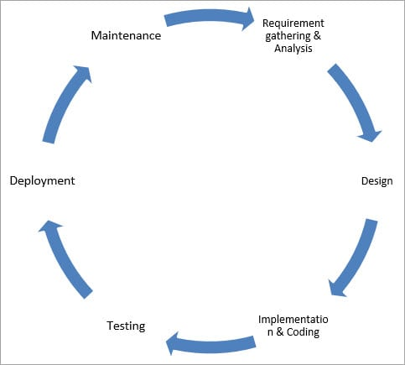](https://cdn.softwaretestinghelp.com/wp-content/qa/uploads/2018/04/SDLC-Cycle.jpg)

## SDLC Phases

**Given below are the various phases:**

* Requirement gathering and analysis
* Design
* Implementation or coding
* Testing
* Deployment
* Maintenance

### #1) Requirement Gathering and Analysis

During this phase, all the relevant information is collected from the customer to develop a product as per their expectation. Any ambiguities must be resolved in this phase only.

Business analyst and Project Manager set up a meeting with the customer to gather all the information like what the customer wants to build, who will be the end-user, what is the purpose of the product. Before building a product a core understanding or knowledge of the product is very important.

**For Example,** A customer wants to have an application which involves money transactions. In this case, the requirement has to be clear like what kind of transactions will be done, how it will be done, in which currency it will be done, etc.

Once the requirement gathering is done, an analysis is done to check the feasibility of the development of a product. In case of any ambiguity, a call is set up for further discussion.

Once the requirement is clearly understood, the SRS (Software Requirement Specification) document is created. This document should be thoroughly understood by the developers and also should be reviewed by the customer for future reference.

### #2) Design

In this phase, the requirement gathered in the SRS document is used as an input and software architecture that is used for implementing system development is derived.

### #3) Implementation or Coding

Implementation/Coding starts once the developer gets the Design document. The Software design is translated into source code. All the components of the software are implemented in this phase.

### #4) Testing

Testing starts once the coding is complete and the modules are released for testing. In this phase, the developed software is tested thoroughly and any defects found are assigned to developers to get them fixed.

Retesting, regression testing is done until the point at which the software is as per the customer’s expectation. Testers refer SRS document to make sure that the software is as per the customer’s standard.

### #5) Deployment

Once the product is tested, it is deployed in the production environment or first [UAT (User Acceptance testing)](https://www.softwaretestinghelp.com/what-is-user-acceptance-testing-uat/) is done depending on the customer expectation.

In the case of UAT, a replica of the production environment is created and the customer along with the developers does the testing. If the customer finds the application as expected, then sign off is provided by the customer to go live.

### #6) Maintenance

After the deployment of a product on the production environment, maintenance of the product i.e. if any issue comes up and needs to be fixed or any enhancement is to be done is taken care by the developers.

#1) Waterfall Model

[Waterfall model](https://www.softwaretestinghelp.com/what-is-sdlc-waterfall-model/) is the very first model that is used in SDLC. It is also known as the linear sequential model.

In this model, the outcome of one phase is the input for the next phase. Development of the next phase starts only when the previous phase is complete.

* First, Requirement gathering and analysis is done. Once the requirement is freeze then only the System Design can start. Herein, the SRS document created is the output for the Requirement phase and it acts as an input for the System Design.
* In System Design Software architecture and Design, documents which act as an input for the next phase are created i.e. Implementation and coding.
* In the Implementation phase, coding is done and the software developed is the input for the next phase i.e. testing.
* In the testing phase, the developed code is tested thoroughly to detect the defects in the software. Defects are logged into the defect tracking tool and are retested once fixed. Bug logging, Retest, Regression testing goes on until the time the software is in go-live state.
* In the Deployment phase, the developed code is moved into production after the sign off is given by the customer.
* Any issues in the production environment are resolved by the developers which come under maintenance.

[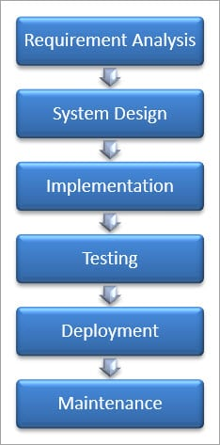](https://cdn.softwaretestinghelp.com/wp-content/qa/uploads/2018/04/Waterfall-Model-1.jpg)

**Advantages of the Waterfall Model:**

* Waterfall model is the simple model which can be easily understood and is the one in which all the phases are done step by step.
* Deliverables of each phase are well defined, and this leads to no complexity and makes the project easily manageable.

**Disadvantages of Waterfall model:**

* Waterfall model is time-consuming & cannot be used in the short duration projects as in this model a new phase cannot be started until the ongoing phase is completed.
* Waterfall model cannot be used for the projects which have uncertain requirement or wherein the requirement keeps on changing as this model expects the requirement to be clear in the requirement gathering and analysis phase itself and any change in the later stages would lead to cost higher as the changes would be required in all the phases.

**(i) Unit Testing:**

[Unit testing](https://www.softwaretestinghelp.com/unit-testing/) is performed using the unit test cases that are designed and is done in the Low-level design phase. Unit testing is performed by the developer itself. It is performed on individual components which lead to early defect detection.

**(ii) Integration Testing:**

[Integration testing](https://www.softwaretestinghelp.com/what-is-integration-testing/) is performed using integration test cases in High-level Design phase. Integration testing is the testing that is done on integrated modules. It is performed by testers.

**(iii) System Testing:**

[System testing](https://www.softwaretestinghelp.com/system-testing/) is performed in the System Design phase. In this phase, the complete system is tested i.e. the entire system functionality is tested.

**(iv) Acceptance Testing:**

Acceptance testing is associated with the Requirement Analysis phase and is done in the customer’s environment.

# 2. Linux command to Check CPU Usage in Linux?

Top

3.Differnce between git pull and git clone?

**Clone** is generally used to get remote repo copy. **Pull** is used to view other team mates added code, if you are working in teams(if there is any update in the remote repository then it will get that copy). **git clone** is used for just downloading exactly what is currently working on the remote server repository and saving it in your machine's folder where that project is placed.

git-init - Create an empty Git repository or reinitialize an existing one

git-status - Show the working tree status.

git-diff - Show changes between commits.

git-commit - Record changes to the repository.