Clc

clear all

close all

x=input('enter the frist sequence x(n)=')

h=input('enter the second sequence h(n)=')

lx=length(x)

lh=length(h)

ly=lx+lh-1

%to generate c1

x1=[x';zeros(ly-lx,1)];

x2=x1;

%looping to genetate c

for i=1:lh-1

x2=[0;x2(1:end-1)]

x1=[x1,x2]

end

y=x1\*h';

disp('liner convolution output is=')

disp(y')

disp ('using inbuilt function=')

k=conv(x,h);

disp(k)

%plot

figure(1)

subplot(2,2,1);

stem(0:lx-1,x);

xlabel('n');

ylabel('x(n)');

title('input sequence x(n)');

subplot(2,2,2);

stem(0:lh-1,h);

xlabel('n');

ylabel('h(n)');

title('input sequence h(n)');

subplot(2,2,3:4);

stem(0:ly-1,y);

xlabel('n');

ylabel('y(n)');

title('convolve sequence y(n)');

OUTPUT:

x1 = 1 0 0 0

2 1 0 0

3 2 1 0

4 3 2 1

0 4 3 2

0 0 4 3

0 0 0 4

liner convolution output is= 1 4 8 14 15 10 8

using inbuilt function= 1 4 8 14 15 10 8

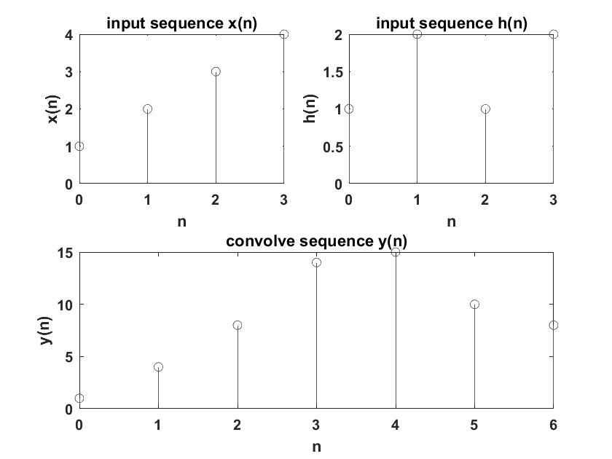

clc

clear all

close all

x=[2 4 1 5 6]

h=[2 3 3 1 4]

%x=input('enter the frist sequence x(n)=')

%h=input('enter the second sequence h(n)=')

h1=fliplr(h)

lx=length(x)

lh=length(h)

ly=lx+lh-1

%to generate c1

x1=[x';zeros(ly-lx,1)];

x2=x1;

%looping to genetate c

for i=1:lh-1

x2=[0;x2(1:ly-1)]

x1=[x1,x2]

end

y=x1\*h1';

disp('cross corelation output is=')

disp(y')

disp ('using inbuilt function=')

k=xcorr(x,h);

disp(k)

%plot

figure(1)

subplot(2,2,1);

stem(0:lx-1,x);

xlabel('n');

ylabel('x(n)');

title('input sequence x(n)');

subplot(2,2,2);

stem(0:lh-1,h);

xlabel('n');

ylabel('h(n)');

title('input sequence h(n)');

subplot(2,2,3:4);

stem(0:ly-1,y);

xlabel('n');

ylabel('y(n)');

title('corelation sequence y(n)');

OUTPUT:

x1 = 2 0 0 0 0

4 2 0 0 0

1 4 2 0 0

5 1 4 2 0

6 5 1 4 2

0 6 5 1 4

0 0 6 5 1

0 0 0 6 5

0 0 0 0 6

cross corelation output is= 8 18 14 39 48 32 35 28 12

using inbuilt function= 8.0000 18.0000 14.0000 39.0000 48.0000 32.0000 35.0000 28.0000 12.0000

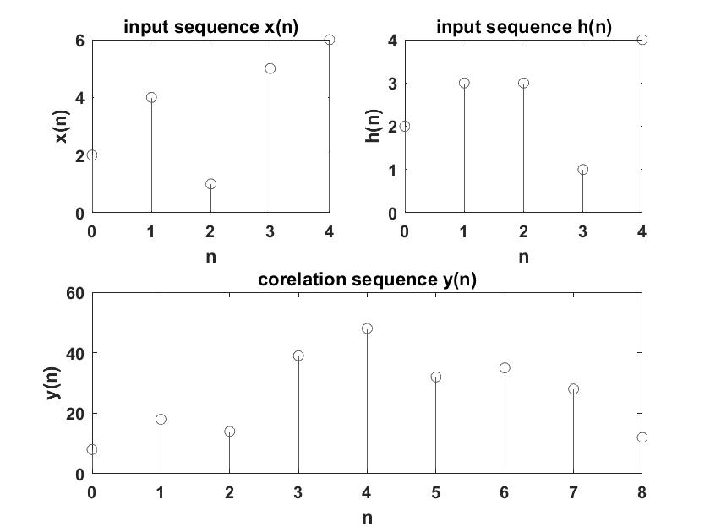

%y[n]+2y[n-1]=3y[n-2]=x[n]

%to find natural response yn[n], forced response yf[n] and total response

%yt[n] with initial conditons [-n] and y[-2] and input (1/2)^n u(n)

N=10

n=0:N-1

disp('input is')

x=(1/2).^n

a=[1 2 3] %coefficients of y

b=1 %coefficients of x

ic=[1,-1] %initial conditions

yn(1)= -2\*ic(1)-3\*ic(2);

yn(2)= -2\*yn(1)-3\*ic(1);

for i=3:N

yn(i)= -2\*yn(i-1)-3\*yn(i-2);

end

disp('natural response=');

disp(yn);

yf(1)=x(1);

yf(2)=x(2)-2\*yf(1);

for k=3:N

yf(k)=x(k)-2\*yf(k-1)-3\*yf(k-2);

end

disp('forced response=');

disp(yf);

% % total response

for d=1:N

yt(d)=yn(d)+yf(d);

end

yf(1)=x(1);

yf(2)=x(2)-2\*yf(1);

for k=3:N

yf(k)=x(k)-2\*yf(k-1)-3\*yf(k-2);

end

disp('forced response=');

disp(yf);

% % total response

for d=1:N

yt(d)=yn(d)+yf(d);

end

disp('total response=');

disp(yt);

p=filtic(b,a,ic);

ynatural=filter(b,a,zeros(1,N),p);

disp('using inbuilt natural is=');

disp(ynatural);

yforced=filter(b,a,x);

disp('using inbuilt forced is=');

disp(yforced);

for f=1:N

ytotal(f)=ynatural(f)+yforced(f);

end

disp('using inbuilt toatl is=');

disp(ytotal);

%%to plot

n=0:9;

subplot(2,2,1);

stem(n,x);

xlabel('n');

ylabel('x(n)');

title('input sequence x(n)');

subplot(2,2,2);

stem(n,yn);

xlabel('n');

ylabel('x(n)');

title('natural response');

subplot(2,2,3);

stem(n,yf);

xlabel('n');

ylabel('x(n)');

title('forced response');

subplot(2,2,4);

stem(n,yt);

xlabel('n');

ylabel('x(n)');

title('total response');

figure(2);

zplane(b,a);

xlabel('real axixs');

ylabel('imaginary axix');

title('zplane');

q=roots(a);

if abs(q)<1

disp('system is stable ');

else disp('system is unstable ');

end

OUTPUT:

natural response= 1 -5 7 1 -23 43 -17 -95 241 -197

forced response=1.0000 -1.5000 0.2500 4.1250 -8.9375 5.5313 15.7656 -48.1172 48.9414 46.4707

total response= 2.0000 -6.5000 7.2500 5.1250 -31.9375 48.5313 -1.2344 -143.1172 289.9414 -150.5293

using inbuilt natural is= 1 -5 7 1 -23 43 -17 -95 241 -197

using inbuilt forced is= 1.0000 -1.5000 0.2500 4.1250 -8.9375 5.5313 15.7656 -48.1172 48.9414 46.4707

using inbuilt toatl is= 2.0000 -6.5000 7.2500 5.1250 -31.9375 48.5313 -1.2344 -143.1172 289.9414 -150.5293

system is unstable 