**1.ASP.NET MVC – ViewBag**

**Transfer data from controller to view using ViewBag.**

**Using Student Table**

**Fields: id, Name, Fee**

**OUTPUT:**

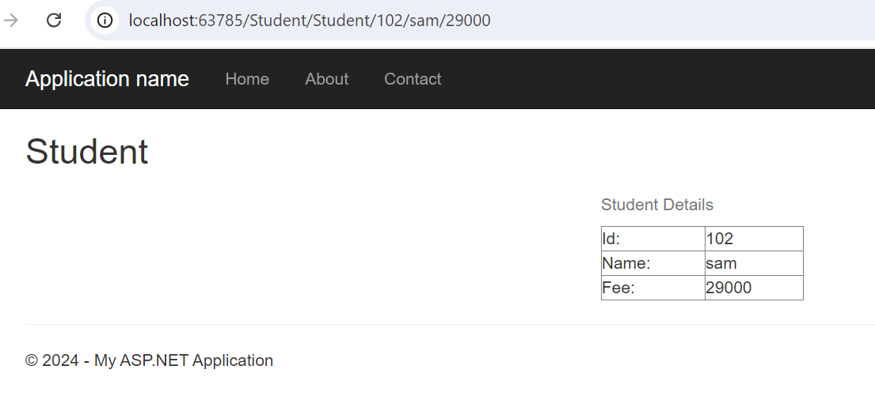

**2.ASP.NET MVC – ViewData**

**Transfer data from controller to view using ViewData.**

**Using Employee Table**

**Fields: Eid, Ename, Esalary**

**OUTPUT:**

