AEM is a CMS (content management system) tool used for building managing deploying websites and services.

AEM is based on 3 major building blocks

1. OSGI (open services gateway initiative)
2. Apache Sling
3. JCR (java content repository)

Latest version of 6.3 .old name is CQ5 (COMMINIQUE)

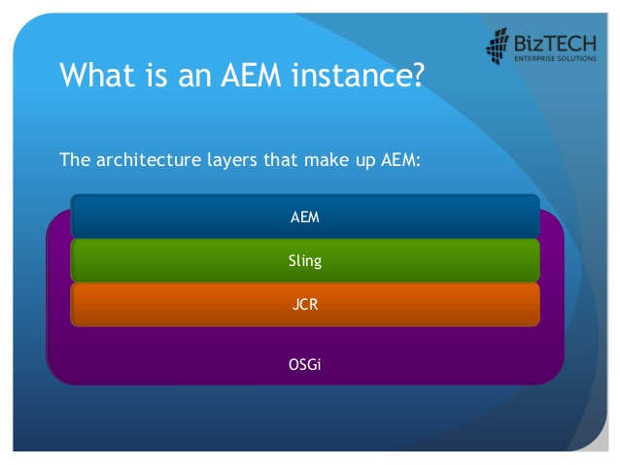

**OSGi**

Major building block in AEM architecture which makes it modular.

Java frame for developing and deploying modular application and libraries

It allows you to break application into individual modules called Bundles.

Bundle is nothing but a jar file along with special manifest file MENIFEST.MF

Manifest is required by osgi to manage the visibility of classes across the bundles

OSGI is a specification the implementation is APACHE FELIX in AEM.

Other implementations are : [Eclipse Equinox](https://en.wikipedia.org/wiki/Eclipse_Equinox), Knopflerfish, ProSyst

<http://localhost:4502/system/console> 🡪 osgi console

JCR

JCR is a Object database that supports structured and unstructured content

It is java API to access the content repository in a uniform manner.

It is made up of nodes and properties

It stores any kind media, text, css , images, videos

JCR is a specification and AEM implementation for JCR is CRX (Content Repository Extreme)

AEM also work with other JCR for example Apache JackRabbit

File system provide storage for unstructured data and database provides storage for structured data and JCR provides best of the both.

<http://localhost:4502/crx/de> 🡪

Apache Sling

It is a web application framework based on rest principles

In apache sling everything is resource

Url -> Resource ->Script/ Servlet

It exposes JCR to the web.

**AEM INSTALLATION**

Create Author folder and Publish folder

In Auther folder rename the jar file as aem-author-4502.jar

In Publish folder rename the jar as aem-publish-4503.jar

Double click on the jar file in both the environment to install the application

**Opening AEM with command line**

F:\aem workspace\Author>java -Xmx1024m -jar aem-author-4502.jar –gui

Or

Else double click on the jar to start any of the environment

**Working with packages**

1. Packge Manager

To import/export content

To transfer content between other instances

To backup repository content

Link: <http://localhost:4502/crx/packmgr>

From admin login to go to tool -> deployment -> packages

1. Package Share

Centralized server that contains both private and public packages which may include

Hotfixes, packages provided by adobe.

Link: <https://www.adobeaemcloud.com/content/packageshare.html>

To create download and share your own package

go to tool -> deployment -> packages

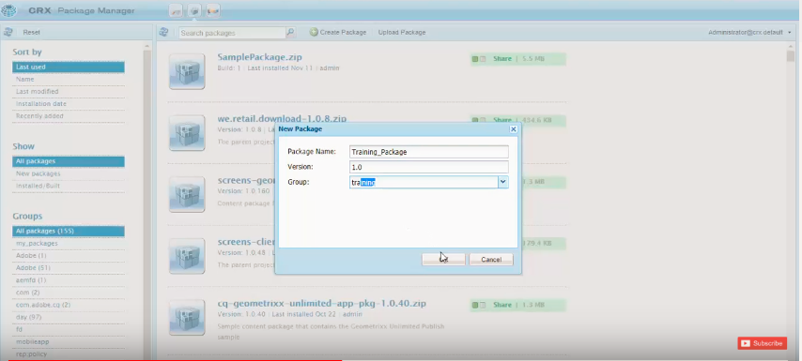

Click edit on the created package and add filter to select the package

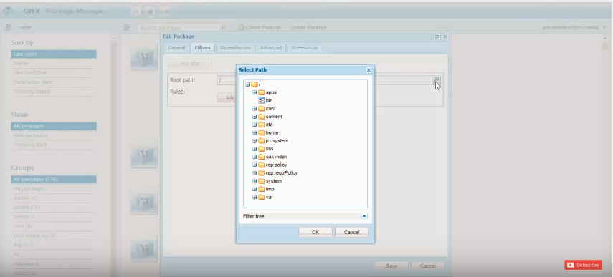



Click ok -> done -> save

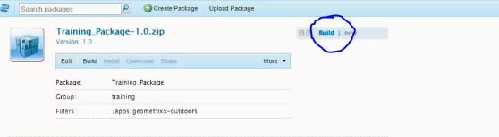

Click on build after that we can download the package by clicking download button.

Opening your project using bracket application

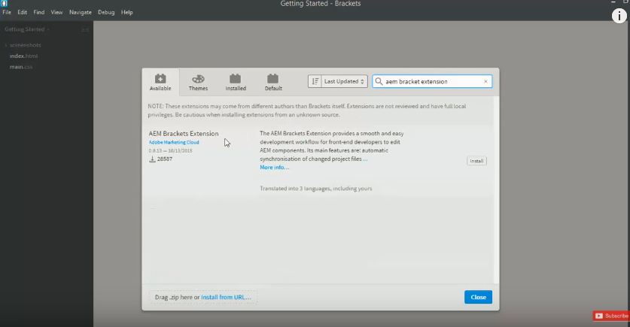

File -> extension manager-> install aem bracket extension

Unzip the package you want to open and select the jcr-root

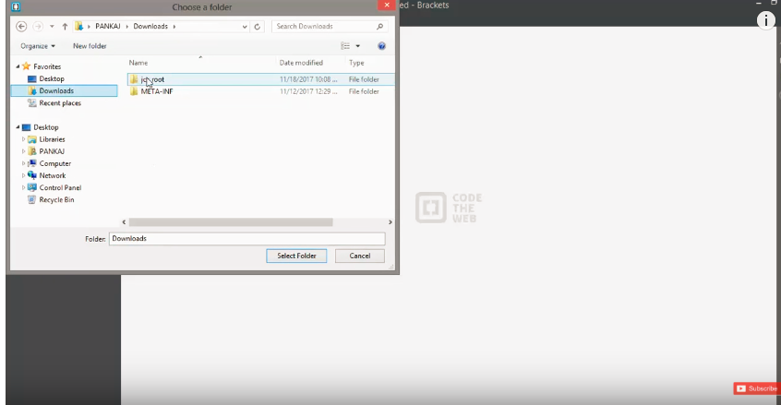

AEM -> project setting check server url it’s pointing to correct author environment.

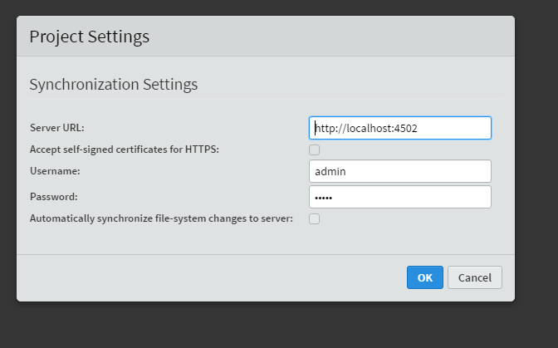

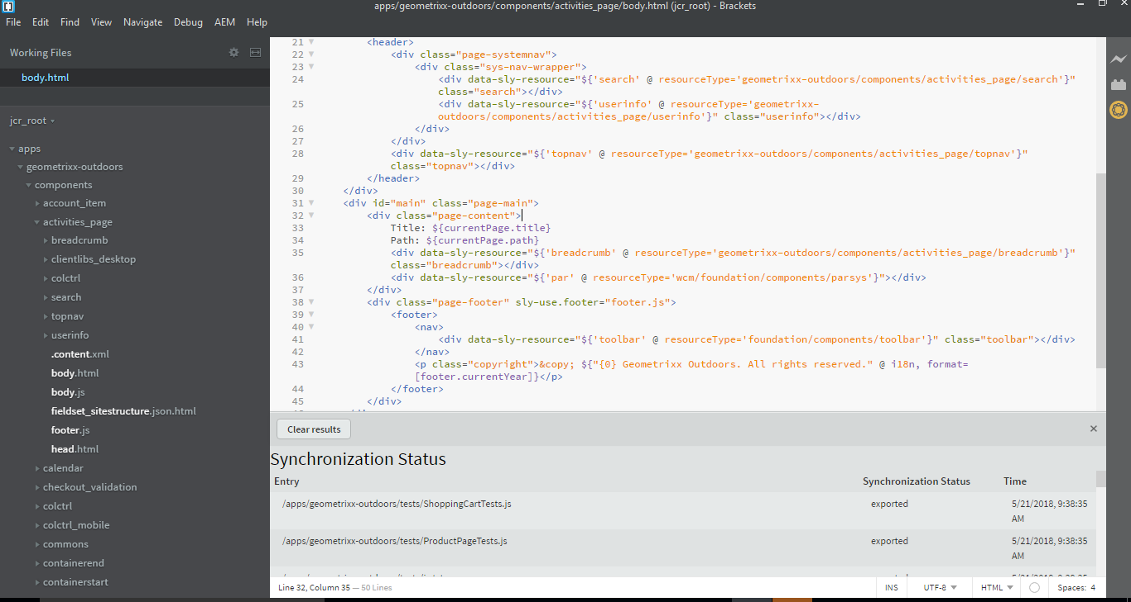

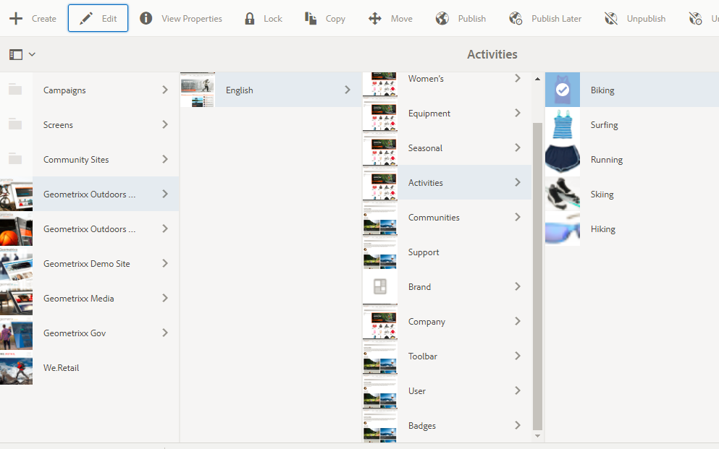

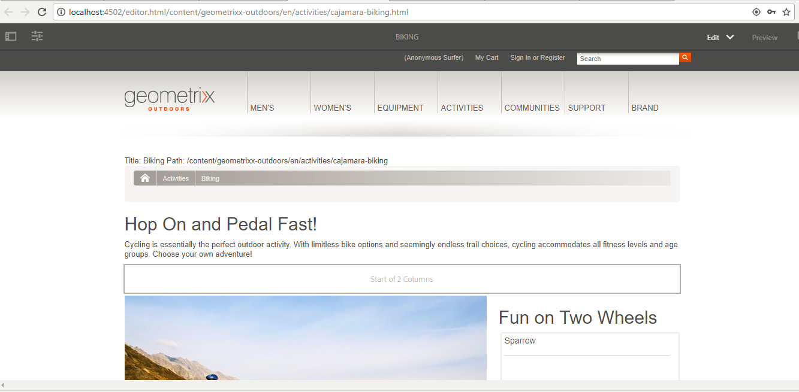

C:\Users\nirpanig\git\demo-aem-platform>mvn clean install –PautoInstallPackage

Dispatcher

Dispatcher.any

<http://localhost:4502/aem/start.html>

editor.html to cf#

<http://localhost:4502/crx/explorer/index.jsp>

core/target in osgi

data-sly-use – to load java objects

we can pass parameters also

data-sly-element put inside any tag removes that after rendering

data-sly-attribute can be used to replace default value of any attribute

Resource

Node

Page

ValueMap

ModifiableValueMap

Session.save()

ResourceResolver.connect()

Resource resource=resourceResolver.atResouce()

If(resource !=null && resource instanceof Resource)

Scheduler

Event handler

Service

ModelObject

1. Simple Sightly with dialog without java
2. Slightly with java

/libs/granite/ui/components/foundation/form/pathbrowser

<http://localhost:4502/crx/explorer/index.jsp>

<http://localhost:4502/crx/packmgr>

<http://localhost:4502/aem/start.html>

<http://localhost:4502/system/console/bundles>

<http://localhost:4502/siteadmin#/content/demopage>

<http://localhost:4502/crx/de>

Multifield

Banner and nad carousol

Navigation flyout

Column grid

Dialog reusability

List of links

Login auth handler

Auto page creation

Catalogs

Asset manager

Page manager

Tag manager

Work flows

Searching

Feed importers

Social feeds

Configuration management

queryBuilder in aem for searching

jsoup

solar for search

oak index